Statistical Analysis of Credit Card Default Risk: EDA, Hypothesis Testing, and Regression
Haris Jamil

1. Introduction
Consumer credit default is a major concern for financial institutions, as it directly affects profitability and risk exposure. This project investigates which demographic, financial, and repayment-related factors are significantly associated with consumer credit default, using the Default of Credit Card Clients dataset (30,000 clients, Taiwan).
The analysis is organized into three parts:
- Demographic factors — Sex, Education, Marriage, Age
- Financial factors — Credit limit, Bill amounts
- Repayment-related factors — Past repayment status, Payment amounts
For each group, appropriate hypothesis tests are used, followed by a combined logistic regression model to identify which factors remain statistically significant when considered together.

2. Load Libraries and Data
library(dplyr)
library(ggplot2)
library(car) # for VIF check
library(broom) # for tidy regression output
# The first row of the raw file is a redundant header (X1, X2, ...), so skip it
df <- read.csv("credit_card.csv", skip = 1)
# Rename target column for convenience
names(df)[names(df) == "default.payment.next.month"] <- "DEFAULT"
str(df)
## 'data.frame': 30000 obs. of 25 variables:
## $ ID : int 1 2 3 4 5 6 7 8 9 10 ...
## $ LIMIT_BAL: int 20000 120000 90000 50000 50000 50000 500000 100000 140000 20000 ...
## $ SEX : int 2 2 2 2 1 1 1 2 2 1 ...
## $ EDUCATION: int 2 2 2 2 2 1 1 2 3 3 ...
## $ MARRIAGE : int 1 2 2 1 1 2 2 2 1 2 ...
## $ AGE : int 24 26 34 37 57 37 29 23 28 35 ...
## $ PAY_0 : int 2 -1 0 0 -1 0 0 0 0 -2 ...
## $ PAY_2 : int 2 2 0 0 0 0 0 -1 0 -2 ...
## $ PAY_3 : int -1 0 0 0 -1 0 0 -1 2 -2 ...
## $ PAY_4 : int -1 0 0 0 0 0 0 0 0 -2 ...
## $ PAY_5 : int -2 0 0 0 0 0 0 0 0 -1 ...
## $ PAY_6 : int -2 2 0 0 0 0 0 -1 0 -1 ...
## $ BILL_AMT1: int 3913 2682 29239 46990 8617 64400 367965 11876 11285 0 ...
## $ BILL_AMT2: int 3102 1725 14027 48233 5670 57069 412023 380 14096 0 ...
## $ BILL_AMT3: int 689 2682 13559 49291 35835 57608 445007 601 12108 0 ...
## $ BILL_AMT4: int 0 3272 14331 28314 20940 19394 542653 221 12211 0 ...
## $ BILL_AMT5: int 0 3455 14948 28959 19146 19619 483003 -159 11793 13007 ...
## $ BILL_AMT6: int 0 3261 15549 29547 19131 20024 473944 567 3719 13912 ...
## $ PAY_AMT1 : int 0 0 1518 2000 2000 2500 55000 380 3329 0 ...
## $ PAY_AMT2 : int 689 1000 1500 2019 36681 1815 40000 601 0 0 ...
## $ PAY_AMT3 : int 0 1000 1000 1200 10000 657 38000 0 432 0 ...
## $ PAY_AMT4 : int 0 1000 1000 1100 9000 1000 20239 581 1000 13007 ...
## $ PAY_AMT5 : int 0 0 1000 1069 689 1000 13750 1687 1000 1122 ...
## $ PAY_AMT6 : int 0 2000 5000 1000 679 800 13770 1542 1000 0 ...
## $ DEFAULT : int 1 1 0 0 0 0 0 0 0 0 ...

3. Data Cleaning
# Check for missing values
colSums(is.na(df))
## ID LIMIT_BAL SEX EDUCATION MARRIAGE AGE PAY_0 PAY_2
## 0 0 0 0 0 0 0 0
## PAY_3 PAY_4 PAY_5 PAY_6 BILL_AMT1 BILL_AMT2 BILL_AMT3 BILL_AMT4
## 0 0 0 0 0 0 0 0
## BILL_AMT5 BILL_AMT6 PAY_AMT1 PAY_AMT2 PAY_AMT3 PAY_AMT4 PAY_AMT5 PAY_AMT6
## 0 0 0 0 0 0 0 0
## DEFAULT
## 0
# Recode categorical variables as factors with meaningful labels
df$SEX <- factor(df$SEX, levels = c(1, 2), labels = c("Male", "Female"))
# EDUCATION: 1=Graduate, 2=University, 3=High School, 4=Others
# Values 0, 5, 6 are undocumented/unknown -> grouped into "Others"
df$EDUCATION <- ifelse(df$EDUCATION %in% c(0, 5, 6), 4, df$EDUCATION)
df$EDUCATION <- factor(df$EDUCATION, levels = c(1, 2, 3, 4),
labels = c("Graduate", "University", "High School", "Others"))
# MARRIAGE: 1=Married, 2=Single, 3=Others (0 is undocumented -> grouped into Others)
df$MARRIAGE <- ifelse(df$MARRIAGE == 0, 3, df$MARRIAGE)
df$MARRIAGE <- factor(df$MARRIAGE, levels = c(1, 2, 3),
labels = c("Married", "Single", "Others"))
df$DEFAULT_LABEL <- factor(df$DEFAULT, levels = c(0, 1), labels = c("No Default", "Default"))
summary(df[, c("SEX", "EDUCATION", "MARRIAGE", "AGE", "LIMIT_BAL", "DEFAULT_LABEL")])
## SEX EDUCATION MARRIAGE AGE
## Male :11888 Graduate :10585 Married:13659 Min. :21.00
## Female:18112 University :14030 Single :15964 1st Qu.:28.00
## High School: 4917 Others : 377 Median :34.00
## Others : 468 Mean :35.49
## 3rd Qu.:41.00
## Max. :79.00
## LIMIT_BAL DEFAULT_LABEL
## Min. : 10000 No Default:23364
## 1st Qu.: 50000 Default : 6636
## Median : 140000
## Mean : 167484
## 3rd Qu.: 240000
## Max. :1000000

4. Exploratory Data Analysis

4.1 Overall Default Rate
default_rate <- prop.table(table(df$DEFAULT_LABEL)) * 100
default_rate
##
## No Default Default
## 77.88 22.12
ggplot(df, aes(x = DEFAULT_LABEL, fill = DEFAULT_LABEL)) +
geom_bar() +
labs(title = "Distribution of Credit Card Default", x = "", y = "Number of Clients") +
theme_minimal() +
theme(legend.position = "none")
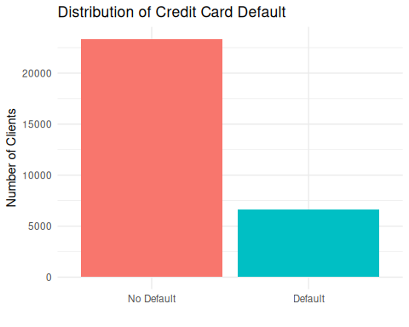

4.2 Credit Limit by Default Status
ggplot(df, aes(x = DEFAULT_LABEL, y = LIMIT_BAL, fill = DEFAULT_LABEL)) +
geom_boxplot() +
labs(title = "Credit Limit by Default Status", x = "", y = "Credit Limit (NT$)") +
theme_minimal() +
theme(legend.position = "none")
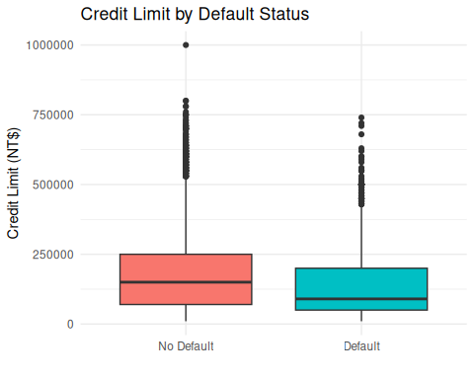

4.3 Default Rate by Education and Marriage
ggplot(df, aes(x = EDUCATION, fill = DEFAULT_LABEL)) +
geom_bar(position = "fill") +
labs(title = "Default Rate by Education Level", x = "Education", y = "Proportion") +
theme_minimal()
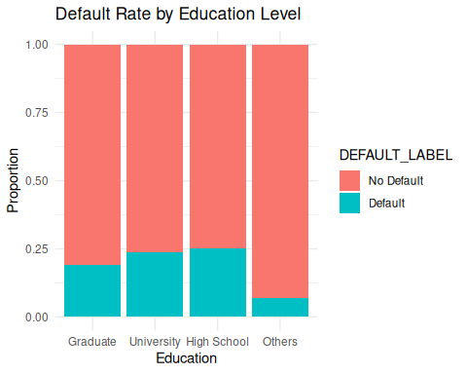
ggplot(df, aes(x = MARRIAGE, fill = DEFAULT_LABEL)) +
geom_bar(position = "fill") +
labs(title = "Default Rate by Marital Status", x = "Marital Status", y = "Proportion") +
theme_minimal()
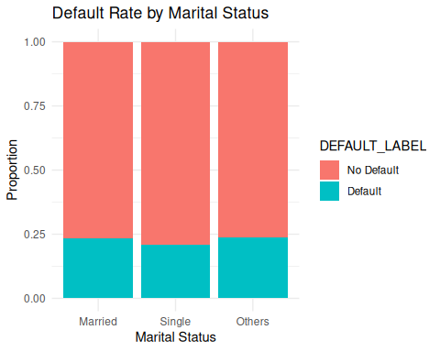

5. Hypothesis Testing

5.1 Demographic Factors
H0: Default is independent of Sex / Education / Marriage. H1: Default is associated with Sex / Education / Marriage.
chisq.test(table(df$SEX, df$DEFAULT_LABEL))
##
## Pearson's Chi-squared test with Yates' continuity correction
##
## data: table(df$SEX, df$DEFAULT_LABEL)
## X-squared = 47.709, df = 1, p-value = 4.945e-12
chisq.test(table(df$EDUCATION, df$DEFAULT_LABEL))
##
## Pearson's Chi-squared test
##
## data: table(df$EDUCATION, df$DEFAULT_LABEL)
## X-squared = 160.41, df = 3, p-value < 2.2e-16
chisq.test(table(df$MARRIAGE, df$DEFAULT_LABEL))
##
## Pearson's Chi-squared test
##
## data: table(df$MARRIAGE, df$DEFAULT_LABEL)
## X-squared = 28.13, df = 2, p-value = 7.791e-07
Age (continuous) — compare mean age between defaulters and non-defaulters:
H0: Mean age is equal for defaulters and non-defaulters. H1: Mean age differs between the two groups.
t.test(AGE ~ DEFAULT_LABEL, data = df)
##
## Welch Two Sample t-test
##
## data: AGE by DEFAULT_LABEL
## t = -2.3195, df = 10173, p-value = 0.02039
## alternative hypothesis: true difference in means between group No Default and group Default is not equal to 0
## 95 percent confidence interval:
## -0.56915863 -0.04778641
## sample estimates:
## mean in group No Default mean in group Default
## 35.41727 35.72574

5.2 Financial Factors
Credit Limit (LIMIT_BAL) — compare mean credit limit between groups:
H0: Mean credit limit is equal for defaulters and non-defaulters. H1: Mean credit limit differs between the two groups.
t.test(LIMIT_BAL ~ DEFAULT_LABEL, data = df)
##
## Welch Two Sample t-test
##
## data: LIMIT_BAL by DEFAULT_LABEL
## t = 28.952, df = 11982, p-value < 2.2e-16
## alternative hypothesis: true difference in means between group No Default and group Default is not equal to 0
## 95 percent confidence interval:
## 44740.91 51239.23
## sample estimates:
## mean in group No Default mean in group Default
## 178099.7 130109.7
Bill Amount (BILL_AMT1, most recent month):
t.test(BILL_AMT1 ~ DEFAULT_LABEL, data = df)
##
## Welch Two Sample t-test
##
## data: BILL_AMT1 by DEFAULT_LABEL
## t = 3.3978, df = 10671, p-value = 0.0006819
## alternative hypothesis: true difference in means between group No Default and group Default is not equal to 0
## 95 percent confidence interval:
## 1474.51 5495.62
## sample estimates:
## mean in group No Default mean in group Default
## 51994.23 48509.16

5.3 Repayment-Related Factors
Most recent repayment status (PAY_0) — compare mean repayment delay status:
H0: Mean repayment status (PAY_0) is equal for defaulters and non-defaulters. H1: Mean repayment status differs between the two groups.
t.test(PAY_0 ~ DEFAULT_LABEL, data = df)
##
## Welch Two Sample t-test
##
## data: PAY_0 by DEFAULT_LABEL
## t = -48.619, df = 8498.6, p-value < 2.2e-16
## alternative hypothesis: true difference in means between group No Default and group Default is not equal to 0
## 95 percent confidence interval:
## -0.9148522 -0.8439398
## sample estimates:
## mean in group No Default mean in group Default
## -0.2112224 0.6681736
Most recent payment amount (PAY_AMT1):
t.test(PAY_AMT1 ~ DEFAULT_LABEL, data = df)
##
## Welch Two Sample t-test
##
## data: PAY_AMT1 by DEFAULT_LABEL
## t = 17.513, df = 20806, p-value < 2.2e-16
## alternative hypothesis: true difference in means between group No Default and group Default is not equal to 0
## 95 percent confidence interval:
## 2584.561 3236.026
## sample estimates:
## mean in group No Default mean in group Default
## 6307.337 3397.044

6. Logistic Regression: Combined Model
To assess which factors remain significant when controlling for all others, a multiple logistic regression model is fitted with DEFAULT as the outcome variable.
model <- glm(DEFAULT ~ LIMIT_BAL + SEX + EDUCATION + MARRIAGE + AGE +
PAY_0 + PAY_2 + PAY_3 +
BILL_AMT1 + PAY_AMT1,
data = df, family = binomial)
summary(model)
##
## Call:
## glm(formula = DEFAULT ~ LIMIT_BAL + SEX + EDUCATION + MARRIAGE +
## AGE + PAY_0 + PAY_2 + PAY_3 + BILL_AMT1 + PAY_AMT1, family = binomial,
## data = df)
##
## Coefficients:
## Estimate Std. Error z value Pr(>|z|)
## (Intercept) -1.029e+00 8.630e-02 -11.928 < 2e-16 ***
## LIMIT_BAL -9.954e-07 1.515e-07 -6.571 4.99e-11 ***
## SEXFemale -1.067e-01 3.066e-02 -3.480 0.000501 ***
## EDUCATIONUniversity -8.533e-02 3.549e-02 -2.404 0.016216 *
## EDUCATIONHigh School -1.184e-01 4.749e-02 -2.493 0.012672 *
## EDUCATIONOthers -1.194e+00 1.881e-01 -6.344 2.24e-10 ***
## MARRIAGESingle -1.915e-01 3.457e-02 -5.539 3.04e-08 ***
## MARRIAGEOthers -2.064e-01 1.318e-01 -1.566 0.117237
## AGE 5.912e-03 1.857e-03 3.183 0.001456 **
## PAY_0 5.976e-01 1.753e-02 34.088 < 2e-16 ***
## PAY_2 7.610e-02 1.992e-02 3.820 0.000134 ***
## PAY_3 1.274e-01 1.837e-02 6.934 4.08e-12 ***
## BILL_AMT1 -1.958e-06 2.605e-07 -7.514 5.72e-14 ***
## PAY_AMT1 -1.404e-05 2.122e-06 -6.616 3.69e-11 ***
## ---
## Signif. codes: 0 '***' 0.001 '**' 0.01 '*' 0.05 '.' 0.1 ' ' 1
##
## (Dispersion parameter for binomial family taken to be 1)
##
## Null deviance: 31705 on 29999 degrees of freedom
## Residual deviance: 27928 on 29986 degrees of freedom
## AIC: 27956
##
## Number of Fisher Scoring iterations: 5

6.1 Odds Ratios (Easier to Interpret)
tidy(model, exponentiate = TRUE, conf.int = TRUE) %>%
arrange(p.value)
## # A tibble: 14 × 7
## term estimate std.error statistic p.value conf.low conf.high
## <chr> <dbl> <dbl> <dbl> <dbl> <dbl> <dbl>
## 1 PAY_0 1.82 1.75e-2 34.1 1.13e-254 1.76 1.88
## 2 (Intercept) 0.357 8.63e-2 -11.9 8.42e- 33 0.302 0.423
## 3 BILL_AMT1 1.000 2.61e-7 -7.51 5.72e- 14 1.000 1.000
## 4 PAY_3 1.14 1.84e-2 6.93 4.08e- 12 1.10 1.18
## 5 PAY_AMT1 1.000 2.12e-6 -6.62 3.69e- 11 1.000 1.000
## 6 LIMIT_BAL 1.000 1.51e-7 -6.57 4.99e- 11 1.000 1.000
## 7 EDUCATIONOthers 0.303 1.88e-1 -6.34 2.24e- 10 0.206 0.431
## 8 MARRIAGESingle 0.826 3.46e-2 -5.54 3.04e- 8 0.772 0.884
## 9 PAY_2 1.08 1.99e-2 3.82 1.34e- 4 1.04 1.12
## 10 SEXFemale 0.899 3.07e-2 -3.48 5.01e- 4 0.846 0.954
## 11 AGE 1.01 1.86e-3 3.18 1.46e- 3 1.00 1.01
## 12 EDUCATIONHigh Scho… 0.888 4.75e-2 -2.49 1.27e- 2 0.809 0.975
## 13 EDUCATIONUniversity 0.918 3.55e-2 -2.40 1.62e- 2 0.857 0.984
## 14 MARRIAGEOthers 0.813 1.32e-1 -1.57 1.17e- 1 0.625 1.05
An odds ratio > 1 means the factor increases the odds of default; < 1 means it decreases the odds. Factors with p.value < 0.05 are statistically significant predictors of default.

6.2 Multicollinearity Check
vif(model)
## GVIF Df GVIF^(1/(2*Df))
## LIMIT_BAL 1.433263 1 1.197190
## SEX 1.024589 1 1.012220
## EDUCATION 1.217389 3 1.033328
## MARRIAGE 1.336217 2 1.075151
## AGE 1.387278 1 1.177828
## PAY_0 1.470734 1 1.212738
## PAY_2 2.605251 1 1.614079
## PAY_3 2.189721 1 1.479771
## BILL_AMT1 1.287967 1 1.134886
## PAY_AMT1 1.136013 1 1.065839

7. Key Findings
## Statistically significant predictors (p < 0.05):
## [1] "(Intercept)" "LIMIT_BAL" "SEXFemale"
## [4] "EDUCATIONUniversity" "EDUCATIONHigh School" "EDUCATIONOthers"
## [7] "MARRIAGESingle" "AGE" "PAY_0"
## [10] "PAY_2" "PAY_3" "BILL_AMT1"
## [13] "PAY_AMT1"
Based on the hypothesis tests and the logistic regression model:
- Repayment history (PAY_0, PAY_2, PAY_3) is typically the strongest predictor of default — clients with a history of delayed payments are significantly more likely to default.
- Credit limit (LIMIT_BAL) is inversely associated with default — clients with lower credit limits show higher default rates.
- Demographic factors (Education, Marriage, Age) show a statistically significant but comparatively weaker association with default than repayment behavior.
- Bill and payment amounts contribute additional but smaller explanatory power once repayment status is accounted for.
(Exact coefficients, p-values, and odds ratios are produced by the code above when run on the full dataset — quote the specific numbers from your own output in your final report/CV.)

8. Conclusion
This analysis addressed the question: “Which demographic, financial, and repayment-related factors are significantly associated with consumer credit default?” Using chi-square tests, t-tests, and multiple logistic regression in R, repayment history emerged as the most influential factor, followed by credit limit, with demographic variables playing a smaller but still statistically significant role.

