PROJECT REPORT
CLOUD ARCHITECTURE DESIGN – AWS CLOUD PROJECT

EXPLAINABLE AI-BASED CLOUD PERFORMANCE ANALYTICS
FOR DIGITAL BANKING USING GRAPH NEURAL NETWORKS

Submitted by
Haris K — 24BIT0468
Keshav Gokaram — 24BIT0454
Harish Kumar — 24BIT0472

B.Tech Information Technology, Third Year
Course Code and Name: BCSE355L — Cloud Architecture Design
Vellore Institute of Technology, Vellore
Course Instructor: Dr. Priya V
Team Number: Not assigned
Submission Date: 16 October 2026
Academic Year: 2026–2027

GitHub: github.com/Haris757518/ExplainableAI_Cloud_Banking_Cloud_Project_2026

Abstract
Digital banking transactions depend on interconnected application and data services whose performance degradation can be difficult to localize from aggregate response-time measurements. This project presents an explainable cloud-performance investigation platform with an instrumented academic banking workload, recorded microservice benchmarks, and AWS observability. Three local FastAPI services implement balance enquiry, atomic test fund transfer, and transaction history using dedicated SQLite storage. Actual HTTP and SQL timings support chronological anomaly detection, trace-based service localization, evidence-qualified explanations, conditional recommendations, and independent verification. The frozen local study recorded 270 normal requests and three bounded application-delay repetitions; no false-positive requests occurred among 54 held-out normal requests. All three controlled cases were detected and correctly localized, with measured return toward the frozen reference. The graph model produced held-out next-request mean-squared error of 0.575263 against 0.574412 for the feature-only model, providing no established graph advantage. The AWS extension explicitly published ten existing measured banking requests as 118 metric values to ExplainableAI/Banking in us-east-1. CloudWatch subsequently returned 30 service-operation metric series across eight metric types. The dashboard displays these measurements with local-workload provenance, publication checkpoint status, and missing-data evidence. AWS discovery found one running EC2 instance and no RDS databases. The published subset contains insufficient independent minute windows for cloud anomaly or root-cause validation; cloud-hosted banking and causal recovery are not established. Historical Alibaba, Microsoft, and RCAEval results remain separate and unchanged.
Keywords: Digital banking; cloud performance; microservices; graph neural networks; anomaly detection; root-cause localization; explainability; AWS.

Table of Contents
1. Introduction 4
2. Literature Survey and Related Work 5
3. Project Objectives 7
4. Novelty Summary 8
5. System and Architecture 8
6. Dataset Description 11
7. AWS Services and Deployment Evidence 12
8. Methodology 14
9. Implementation and Development 16
10. Testing, Results, and Observations 20
11. Discussion, Limitations, and Risk Analysis 23
12. Team Contribution and GitHub Management 24
13. Conclusion and Future Enhancements 25
References 26
Appendix A. Reproducibility and Recorded Artifacts 28
Appendix B. Screenshot Evidence Register 29

List of Figures
Figure 1. AWS Cloud Monitoring Architecture
Figure 2. Complete Implemented System Architecture
Figure 3. Measured Local Banking Transaction Latency
Figure 4. Banking Graph versus Feature-only Model
Figures 5–9. Recorded application screenshots

List of Tables
Table 1. Literature Review of 15 Research Studies
Table 2. Research Gap Analysis
Table 3. Novelty Summary
Table 4. Dataset and Telemetry Sources
Table 5. AWS Service Status
Table 6. Principal Implemented Modules
Table 7. Final Test Cases
Table 8. Banking Experiment Summary
Table 9. GNN Comparison

1. Introduction

1.1 Background
The performance of digital banking services depends on timely execution of account, transfer, and ledger operations. A request can appear slow at the user interface even when its immediate handler is waiting on another service. Service-level traces and resource measurements are therefore required to distinguish a visible symptom from its likely origin. Microservice research has addressed this problem with statistical anomaly detection, graph representations, distributed tracing, and root-cause ranking (Wu et al., 2020; Yu et al., 2021; Lee et al., 2023).

1.2 Problem Statement
Aggregate transaction latency identifies a performance symptom but does not establish which internal component is responsible or what mechanism produced the delay. The implemented work addresses this distinction through measured request traces, service-specific deviations, evidence-gated mechanism hypotheses, and independent comparisons with bounded experimental conditions.

1.3 Motivation and Significance
A banking-oriented workload provides an operationally meaningful context for examining latency, rather than presenting unrelated microservice benchmark names as financial services. The supporting AWS module preserves visibility into actual cloud resources. Because internal cloud faults and banking transaction traces are not supplied by the same public dataset, the application workload, research benchmarks, and cloud observations are evaluated separately.

1.4 Scope
The implemented academic system uses fictitious accounts and test balances. Balance enquiry, fund transfer, and transaction history run in separate local FastAPI services. One bounded application-processing delay was exercised and measured. The platform does not handle real money, financial credentials, UPI, cloud-hosted bank transactions, or automated production remediation.

1.5 Report Organisation
The report presents related work, research gap, objectives, implemented architecture, datasets, AWS services, methodology, implementation evidence, measured results, limitations, team and GitHub management, and concluding observations.

2. Literature Survey and Related Work
Fifteen relevant publications were examined, prioritizing root-cause localization, metric and trace analytics, graph-based anomaly detection, and methods evaluated on actual microservice recordings. Papers published before 2023 are retained where they provide the methodological foundation for the implementation. The review distinguishes reported research methods from the components actually reproduced in this project.
Table 1. Literature review of 15 research studies
ID | Study | Method / architecture | Data / evaluation | Finding relevant to this work
P1 | Wu et al. (2020)  MicroRCA | Attributed service-resource graph and anomaly propagation | Fault-injected Kubernetes microservices | Links service latency to infrastructure; needs suitable metrics.
P2 | Yu et al. (2021)  MicroRank | Normal/abnormal trace comparison and PageRank spectrum scoring | Distributed microservice execution traces | Relevant to end-to-end latency localization; depends on trace coverage.
P3 | Deng & Hooi (2021)  GDN | Learned dependency graph with feature forecasting | Industrial / sensor multivariate time series | Shows graph-based prediction evidence; transfer across domains is limited.
P4 | Liu et al. (2021)  MicroHECL | Dynamic call graphs and propagation-chain pruning | Alibaba industrial microservices | Efficient ranking; needs reliable anomaly onset and dependencies.
P5 | Ying et al. (2019)  GNNExplainer | Relevant subgraph and feature attribution | Graph learning benchmarks | Supports interpretable model evidence, not physical causal proof.
P6 | Guan et al. (2022)  GTAD | Graph and temporal feature modeling | Industrial multivariate time series | Highlights the value of temporal context; different workload domain.
P7 | Lee et al. (2023)  Eadro | Joint anomaly detection and localization from metrics, logs, traces | Two microservice testbeds | Supports integrated diagnosis; requires aligned multimodal telemetry.
P8 | Pham et al. (2024)  BARO | Multivariate Bayesian online change-point analysis | Microservice fault recordings | Change-point baseline; sensitive to observation quality.
P9 | Pham et al. (2024)  Causal inference evaluation | Systematic comparison of causal discovery and RCA | Microservice synthetic and system recordings | Warns that no RCA method dominates on every dataset.
P10 | Lin et al. (2024)  RUN | Neural Granger causality with contextual forecasting | Synthetic and real microservice datasets | Accounts for temporal precedence; not proof of intervention causality.
P11 | Zhao et al. (2024)  CHASE | Heterogeneous metrics/logs/traces graph | Two public microservice datasets | Rich multimodal RCA; requires more data than local lab provides.
P12 | Pham et al. (2025)  RCAEval | Uniform independent fault-case RCA evaluation | 735 fault cases across three microservice systems | Provides service-level ground truth; not banking production telemetry.
P13 | Pham et al. (2026)  TORAI | Multi-source root-cause localization under tracing blind spots | Microservice benchmarks and real failures | Shows limitations of assuming complete service-call graphs.
P14 | Pham et al. (2026)  EventADL | Event-semantic / frequency pattern detection and event localization | Real cloud service event data | Demonstrates event-centric alternatives; event data absent from banking lab.
P15 | Ding et al. (2022)  MST-GAT | Spatial and temporal graph attention plus prediction/reconstruction | Four multivariate benchmarks | Supports graph-aware anomaly modeling; heavy multi-modal variant not reproduced.

2.1 Synthesis and Comparison
Graph-based and trace-based approaches generally improve the representation of distributed service relationships but make different assumptions about data availability. MicroRCA and MicroRank emphasize performance evidence and transaction paths; GDN and related graph models learn expected feature behavior; Eadro and CHASE combine multiple sources; RCAEval provides standardized incident labels. More recent studies highlight incomplete traces and inconsistent generalization across root-cause methods (Pham et al., 2024; Pham et al., 2026).

2.2 Study-Specific Research Gap Analysis
Table 2. Research gaps derived from the reviewed studies
Study IDs | Established contribution | Limitation or gap | Project-specific response
P1–P2 | Source and trace correlations | Requires dependable coverage | Use measured own-time and direct database spans.
P3, P6, P15 | Graph temporal models | Domain transfer and false alarms | Evaluate locally trained graph/identity models.
P4 | Dynamic graph pruning | Incomplete graph risk | Preserve recorded edges only.
P5 | Model attribution | Explanation is not causality | Label attribution as model evidence.
P7, P11 | Multimodal fusion | Needs logs and full traces | Use only actually observed modalities.
P8–P10 | Change-point/causal analysis | Parameter sensitivity and observational ambiguity | Separate detection and mechanism verification.
P12 | Recorded RCA labels | Benchmarks are not banking traffic | Evaluate benchmarking separately.
P13–P14 | Blind spots and cloud events | Local event data not collected | Abstain on unsupported mechanisms.

2.3 Consolidated Research Gap
The gap addressed by this project is the absence of a compact, banking-oriented demonstration that traces an observed transaction slowdown through service localization, mechanism investigation, corrective guidance, and independent verification. The contribution is an integration and measured evaluation of these stages. Neither algorithmic novelty nor superiority over published graph-based methods is claimed.

3. Project Objectives
- Develop a local academic digital banking workload with balance enquiry, atomic transfer, and transaction-history operations.
- Collect actual HTTP and SQL timing observations with identifiers sufficient to reconstruct the monitored request path.
- Detect deviations from a frozen normal baseline and localize the component with the strongest relevant execution evidence.
- Provide mechanism-qualified explanations, conditional corrective recommendations, and traceable investigation records.
- Evaluate a graph-based next-request predictor against a feature-only baseline, and compare diagnostic outputs with independent controlled-fault labels.
- Integrate the banking investigation dashboard with preserved research results and separate AWS resource monitoring, while retaining explicit source and deployment boundaries.

3.1 Recorded Outcomes
All three banking operations and the bounded local application-delay experiment were implemented and exercised. The GNN comparison and supporting benchmark evaluation remain preserved. The AWS extension publishes actual local banking timing observations to CloudWatch without moving the banking services to AWS. A bounded ten-request publication and subsequent retrieval were verified independently of EC2/RDS availability.

4. Novelty Summary
The work combined established techniques in a single evidence-driven banking performance investigation process. Its contribution is system integration and constrained empirical analysis, not a claim to have invented graph anomaly detection or causal inference.
Table 3. Implemented contribution compared with common baseline practice
Dimension | Common baseline | Implemented distinction | Evidence
Application | Generic microservice monitoring | Measured academic banking transaction workflow | Balance, transfer, history execution
Diagnosis | Latency alert or abnormal resource | Own-time-based origin ranking and mechanism hypotheses | Three controlled delay cases
Explainability | Unqualified root-cause labels | Supporting, missing and contradictory evidence | Ledger service investigation
Graph modeling | Graph diagram alone | Compatible trained banking graph model and identity baseline | Held-out MSE comparison
Observability | Broad metric display | Bounded TC-CFAO field inspection | 3 of 8 stored evidence fields

5. System and Architecture

5.1 System Overview
The deployed academic banking workload consists of a local FastAPI gateway on port 8000, an Account Service on port 8101, a Ledger Service on port 8102, and a dedicated SQLite test database. The user interface and investigation engine run through the gateway. The separate AWS monitoring component uses credentialed, read-only collection of EC2 and relevant resource observations; it is not described as the host of the academic banking workload.

5.2 AWS Cloud Architecture
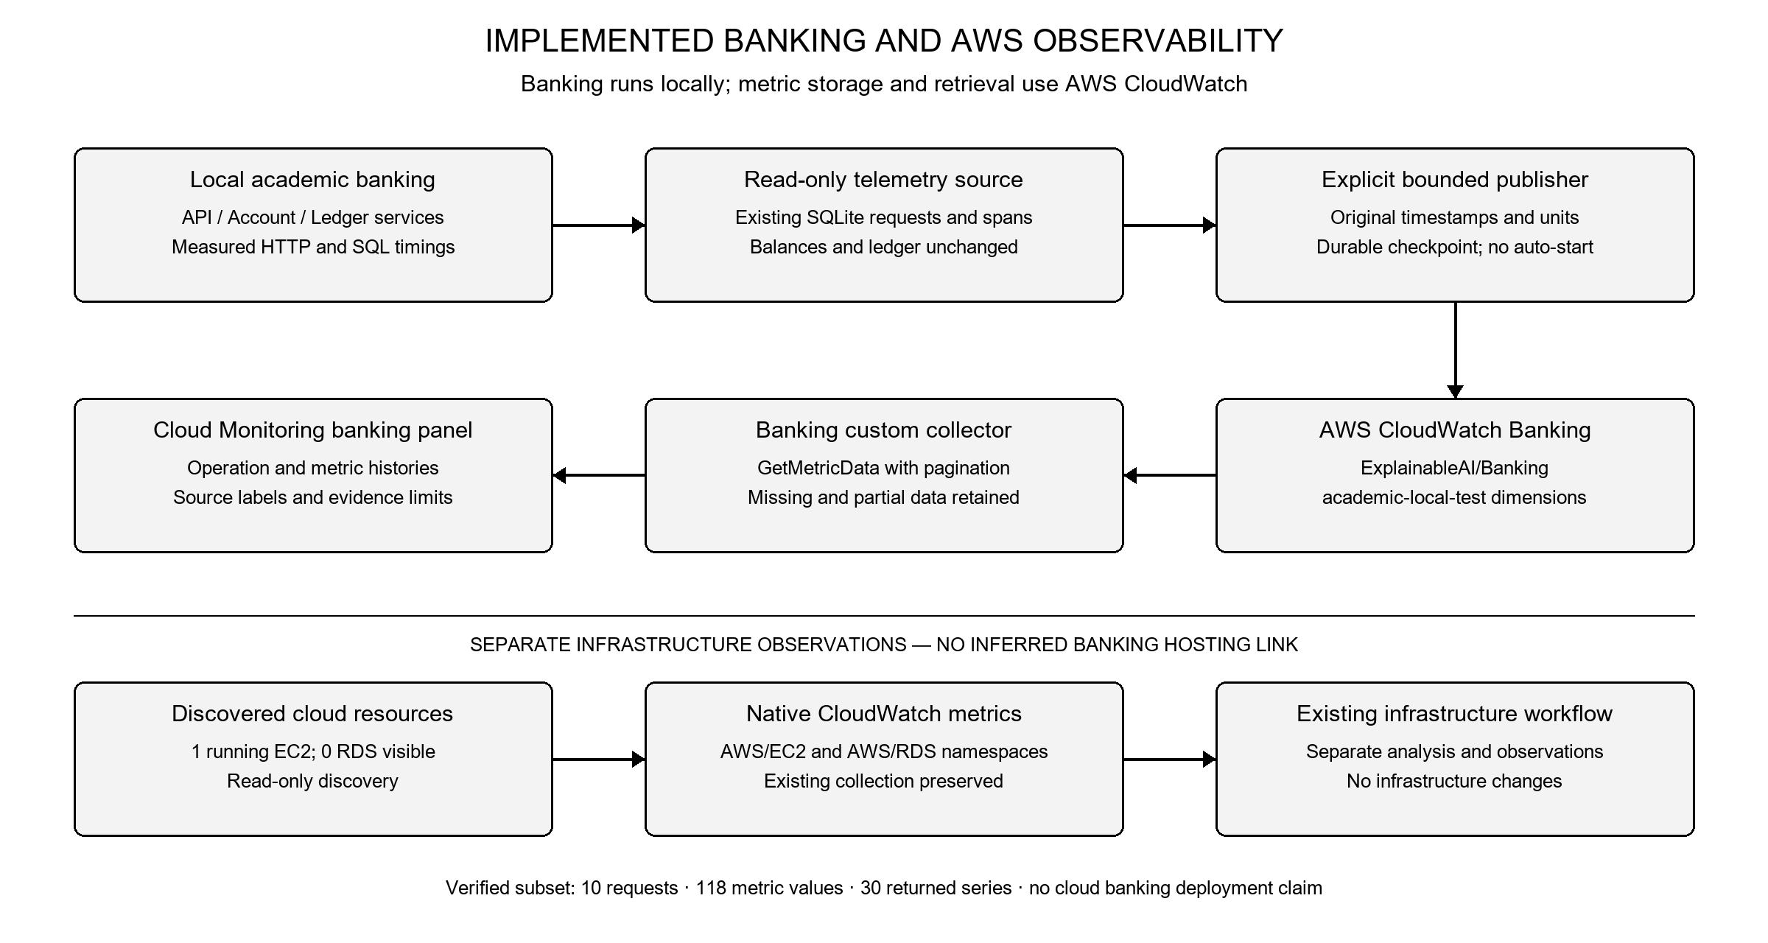
Figure 1. Implemented AWS observability architecture: explicit publication of local measured banking telemetry to a dedicated CloudWatch namespace, alongside separate native infrastructure collection.
The AWS session was reverified on 16 October 2026 at 16:19 UTC in us-east-1. Authentication succeeded, resource discovery found one running EC2 instance and zero RDS databases, and the existing native infrastructure collector returned three metric series without API errors. After explicit operator approval, the banking publisher sent ten existing measured requests as 118 values. Subsequent CloudWatch reads returned 30 banking metric series. The banking workload itself remained local, with no inferred service-to-EC2/RDS hosting relationship.

5.3 Complete System Architecture
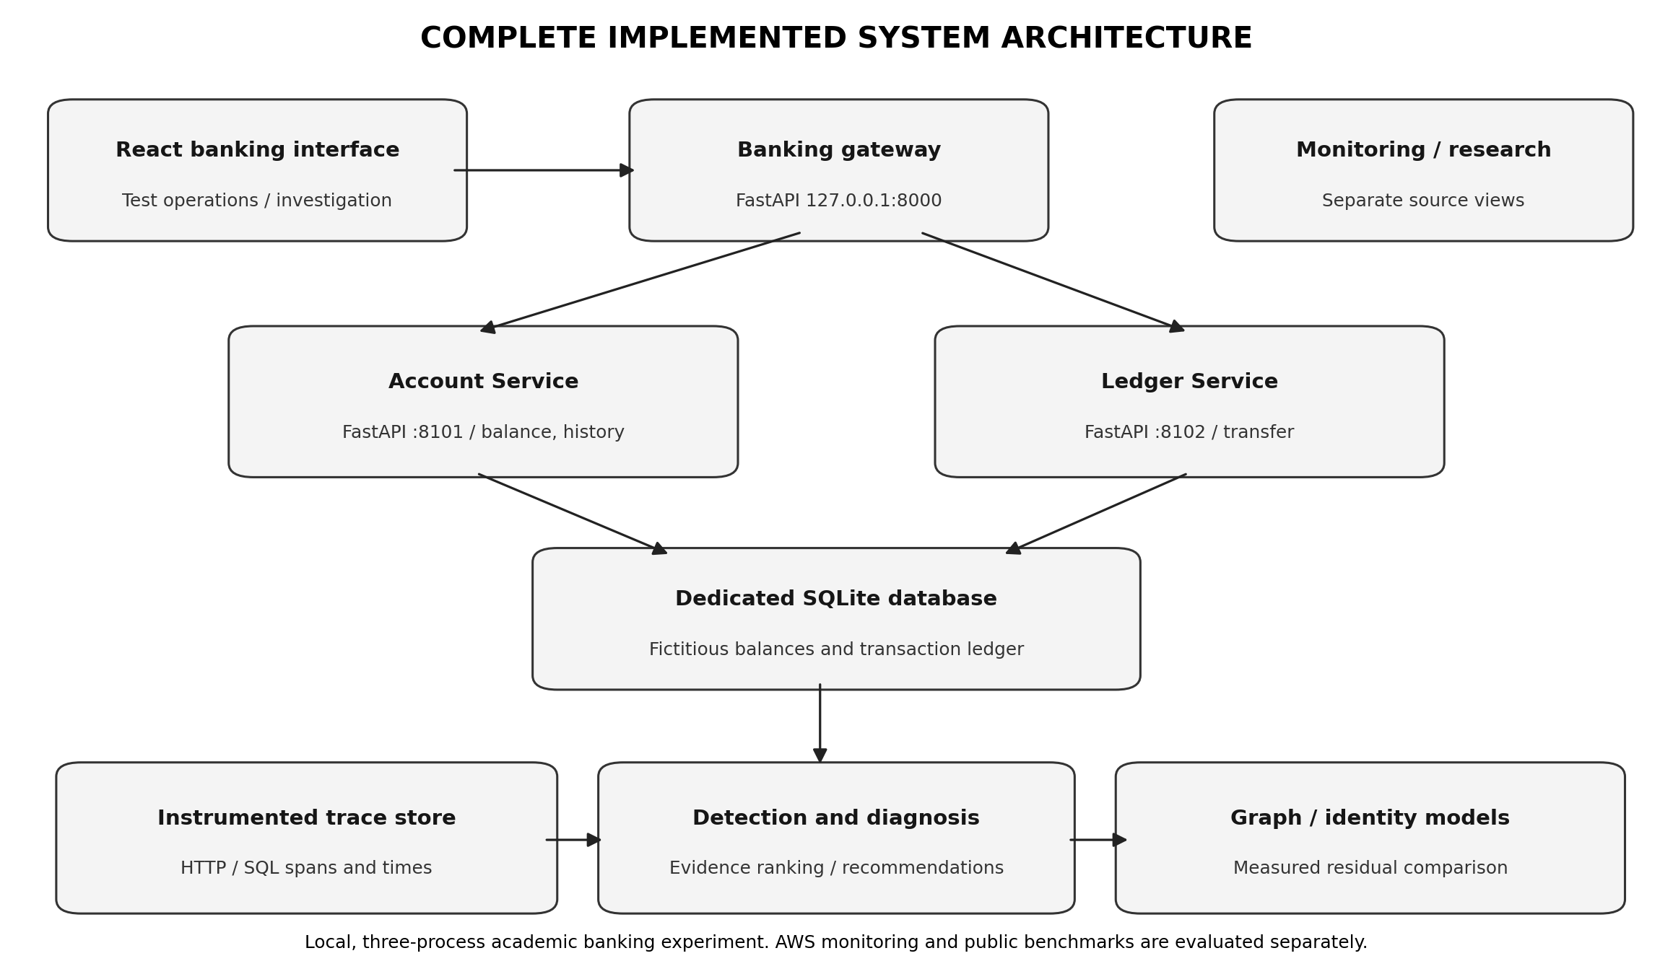
Figure 2. Complete implemented banking application and performance investigation architecture.

5.4 Workflow and Use Cases
Balance enquiry reads a test account; transfer performs a transactional debit, credit, and ledger insertion; history retrieves the stored transfer record. For measured faults, the investigation processes chronological spans, checks baseline deviation, ranks components by relevant own-time and downstream evidence, examines mechanism-specific measurements, produces conditional actions, and compares the frozen output with independent experimental annotations.

5.5 Security, Availability, and Scalability Considerations
Fictitious accounts, localhost service binding, dedicated database files, idempotent transfers, bounded local delay controls, exclusion of operational credentials from Git, and explicit operator triggering reduce test risk. The application was evaluated on one machine with sequential requests; production scalability, cloud redundancy, and banking-grade security were not established.

6. Dataset Description
The primary data for the final banking study comprises measured local HTTP and SQL request traces. Public datasets support independent method investigation and are not presented as banking transaction observations. Counts below refer to the documented imported subsets, not the full size of every original public release.
Table 4. Dataset and telemetry source summary
Source | Imported scope / format | Purpose | Interpretation
Local banking observations | 270 normal HTTP requests; structured SQL/HTTP traces; 3 controlled repetitions | Banking application detection and diagnosis | Fictitious accounts; measured local timings
Alibaba Microservices v2021 | 100,000-row bounded scan; 77,375 valid measured calls; 40 nodes, 80 edges in study | Observed production service graphs and GNN research | No banking operation or fault labels
Microsoft Cloud Monitoring | 60 official CSV series, 225,445 raw rows | Expert-labelled time-series anomaly evaluation | No service-level root cause labels
RCAEval RE1 and RE2 | 150 imported RE1 cases; 5 selected RE2 cases; recorded metrics / trace data where available | Fault localization and mechanism research | Controlled benchmark labels, not banking failures
AWS CloudWatch / host probes | Native resource observations plus ten measured banking requests published to a dedicated custom namespace | Separate cloud monitoring | Local banking source; AWS CloudWatch storage; separate EC2/RDS metrics

6.1 Source Links and Data Preparation
Alibaba: https://github.com/alibaba/clusterdata/tree/master/cluster-trace-microservices-v2021. The selected trace prefix was parsed into measured calls and recorded dependencies.
Microsoft: https://github.com/microsoft/cloud-monitoring-dataset. Chronological ordering, duplicate handling, missing-value preservation, and train/validation/test separation were applied.
RCAEval: https://github.com/phamquiluan/RCAEval. Official incident annotations were isolated from inference, with recorded cases used for independent scoring.
Banking study: service handlers, client requests, and SQL spans were collected through the local application and stored in excluded runtime files. The frozen final summary is committed under results/banking/measured_20261016/report.json.
Original raw file sizes and per-column feature counts differ across the heterogeneous benchmark sources; the final repository contains the imported counts and schema adapters rather than a single merged dataset with a common feature count. No unsupported aggregate dataset size is stated. Public releases are subject to their respective licenses and source terms.

7. AWS Services and Deployment Evidence
Table 5. AWS service use and final recorded status
AWS component | Role | Recorded status | Security / cost consideration
Amazon EC2 | Monitored compute / test host | Live discovery: one running EC2 instance; native infrastructure collection returned three metric series | Read-only IAM inspection; no infrastructure mutation
Amazon CloudWatch | Native/cloud custom resource observations | Ten measured banking requests published as 118 metric values; 30 series retrieved across eight metric types | Bounded explicit PutMetricData; GetMetricData reads; no sensitive transaction data or automatic publication
AWS IAM / STS | Authentication and resource discovery | STS authentication succeeded in us-east-1 on 16 October 2026 at 16:19 UTC | Temporary academy credentials excluded from Git
AWS Systems Manager | Read-only EC2/PostgreSQL diagnostic collection | Previously implemented, not newly fault-tested | Least-privilege monitoring and command access
Amazon RDS | Discovery check only | Live discovery succeeded; zero RDS databases visible; no banking RDS deployment claimed | No RDS deployment or cost attributed

7.1 Deployment and Network Design
The banking gateway and services operated on 127.0.0.1 using ports 8000, 8101, and 8102. The dedicated SQLite runtime files were local and excluded from Git. This separation prevented the academic delay experiment from affecting the monitored EC2/PostgreSQL environment.

7.2 Cost and Credential Management
No AWS resources, permissions, security groups or databases were provisioned or modified. The approved custom-metric publication consisted of ten existing measured requests; it did not execute a banking transfer or start a fault. Custom metrics may incur charges, but no measured cost or savings claim is made. Credentials remained outside source control, and unrelated environment settings were unchanged.

7.3 Banking Telemetry Integration Status
The AWS extension adds a read-only telemetry publisher, persistent publication checkpoint, banking-specific CloudWatch collector, explicit publication CLI, AWS-only API endpoints, and a Cloud Monitoring banking panel. Eight measured metric types are supported: request and error counts; handler and client latency; service latency and exclusive processing; SQL execution and connection timing. Original measurement timestamps and units are retained. Only bounded service, operation and academic-local-test dimensions are published. No account identifiers, balances, transfer identifiers, trace identifiers, credentials or raw request payloads enter CloudWatch. Definite API failures preserve unsuccessful work; ambiguous network outcomes block replay because PutMetricData does not provide an idempotency key. Publication is not triggered by startup or dashboard viewing.

7.4 AWS Banking Results and Analysis Limits
The retrieved request totals were four balance enquiries, three transfers and three transaction-history requests, matching the ten published source rows. These observations came from an earlier measured academic run and are not additional repetitions of the frozen research study. Thirty non-empty metric series were retrieved across the three operations. The first post-publication read exposed only thirteen series during propagation; later independent reads exposed all thirty. The observations occupy a single 60-second measurement bucket, so they do not establish a normal cloud baseline, a latency trend, anomaly accuracy, a verified mechanism or recovery. The AWS panel therefore reports insufficient_evidence and root cause not_established. Native infrastructure measurements remain separate from these local application observations.

8. Methodology

8.1 Overall Procedure
The methodology followed a repeatable chronological sequence: collect normal requests, freeze baseline, record measured request spans, detect significant deviations, localize the probable originating component, assess mechanism-specific evidence, recommend further checks, and verify against independent bounded experiment labels and later measured observations.

8.2 Tools and Technologies
Technology | Usage | Verified context
Python 3.12 / FastAPI | Banking APIs, workload and investigation | Three local processes
SQLite | Dedicated test account and ledger storage | Transactional and idempotent tests
React / Vite | Banking and research dashboards | Production build verified
PyTorch | Banking graph and feature-only prediction models | 100-epoch measured comparison
AWS EC2 / CloudWatch / SSM | Explicit banking metric publication and native resource reads | Local workload; separate AWS metric storage
Git / GitHub | Versioned source and experimental artifacts | Main commit 839b525

8.3 Normal Baseline and Anomaly Detection
The normal workload produced 90 balance, 90 transfer, and 90 history requests, with concurrency one. Its chronological 60/20/20 split was used for reference, threshold calibration, and held-out normal testing. Robust deviations were evaluated with a persistence condition. The selected local threshold was approximately 75.1464 in the detector score scale; it is neither a response-time SLO nor a calibrated failure probability.

8.4 Graph Analysis and Root-Cause Localization
Each monitored transaction produced a service call path and timed spans. The primary banking localization method examined exclusive Ledger Service processing time in conjunction with inherited gateway latency and direct database timing. A trained graph next-request predictor provided additional residual evidence; its results were kept separate from the primary ranking because the controlled comparison showed no measured graph advantage.

8.5 Mechanism Assessment, Recommendations, and Verification
Mechanism assessment distinguished a measured application-processing delay from unverified explanations such as lock contention or network loss. Results retained supporting and missing evidence and produced conditional investigation advice. The service and mechanism predictions were frozen at the tenth completed transfer under the controlled condition; labels were loaded only afterwards. Subsequent actual request timings were compared with the original frozen reference.

9. Implementation and Development

9.1 Implemented Modules
Table 6. Principal implemented modules and evidence
Module | Implementation evidence | Status
Banking operations | Gateway / account / ledger services, atomic and idempotent transfers | Implemented and tested
Custom tracing | Cross-process HTTP and measured SQL spans | Implemented and tested
Statistical detection | Frozen normal calibration, held-out test, evidence gating | Evaluated locally
Mechanism investigation | Service own-time analysis and evidence-linked advice | Validated for application delay
Banking graph models | Graph and identity predictors from measured local traces | Trained and compared
TC-CFAO | Focused inspection of selected recorded fields | Measured scope reported
Research benchmark evaluation | Preserved Alibaba/Microsoft/RCAEval artifacts | Verified prior results
AWS cloud monitoring | Banking publisher, persistent checkpoint, custom collector, read-only APIs and Cloud Monitoring panel | Live publication and retrieval verified
React presentation | Banking-first workflow, research validation and cloud monitoring | Build and browser tested

9.2 Screenshots and Configuration Evidence
Figures 5–8 reproduce saved banking application captures supplied with the project. Figure 9 is a new capture of the implemented Cloud Monitoring panel after successful publication and retrieval of actual banking measurements. Crops retain original displayed measurements and source labels. Interface screenshots are not additional cases in the frozen three-repetition local study.
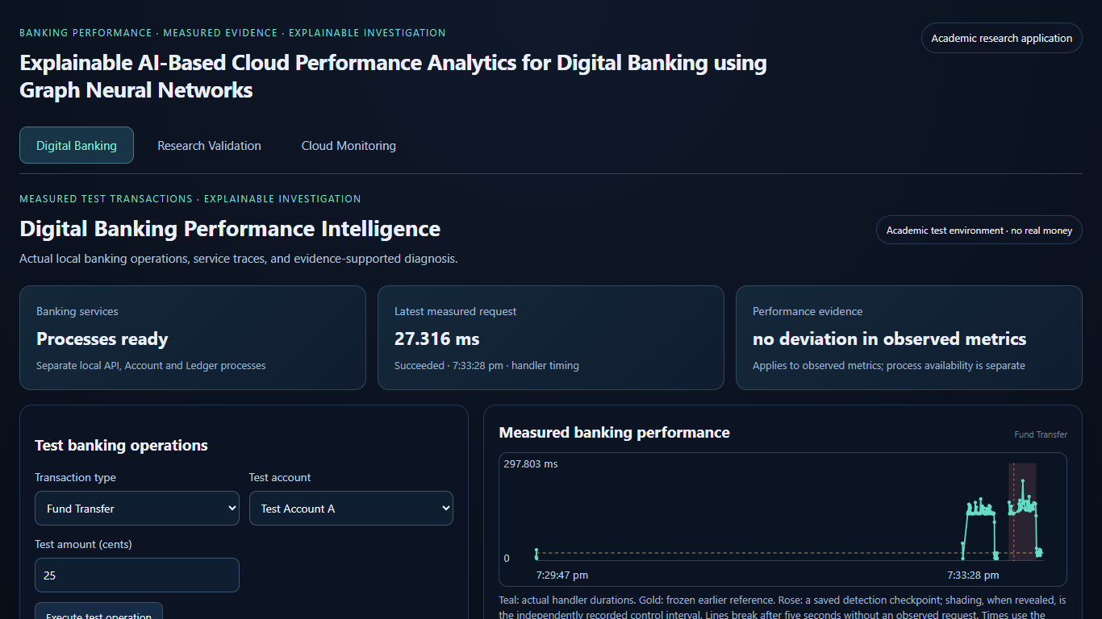
Figure 5. Recorded Digital Banking Performance Intelligence dashboard, showing local service readiness, measured request latency, and the test banking interface.
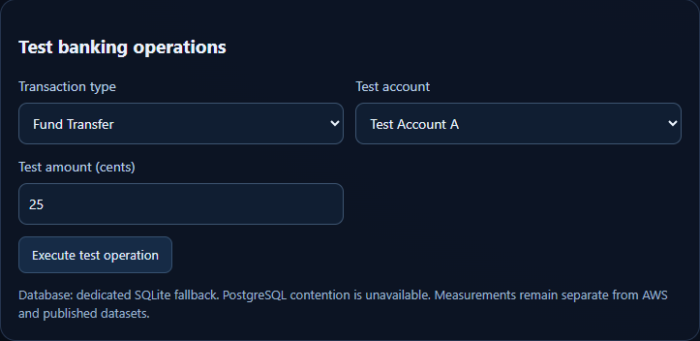
Figure 6. Fund Transfer controls in the dedicated SQLite academic test environment. The panel identifies the operation, fictitious test account, and test amount; it is not a payment receipt.
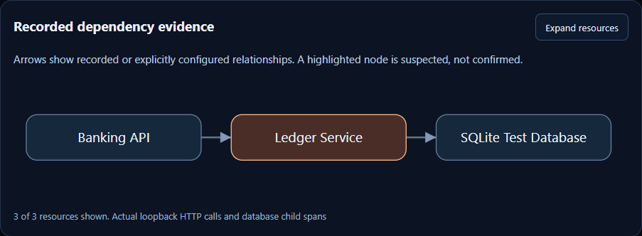
Figure 7. Recorded transfer dependency graph: Banking API → Ledger Service → SQLite Test Database. The highlighted Ledger Service denotes a suspected origin, not confirmed causal proof.
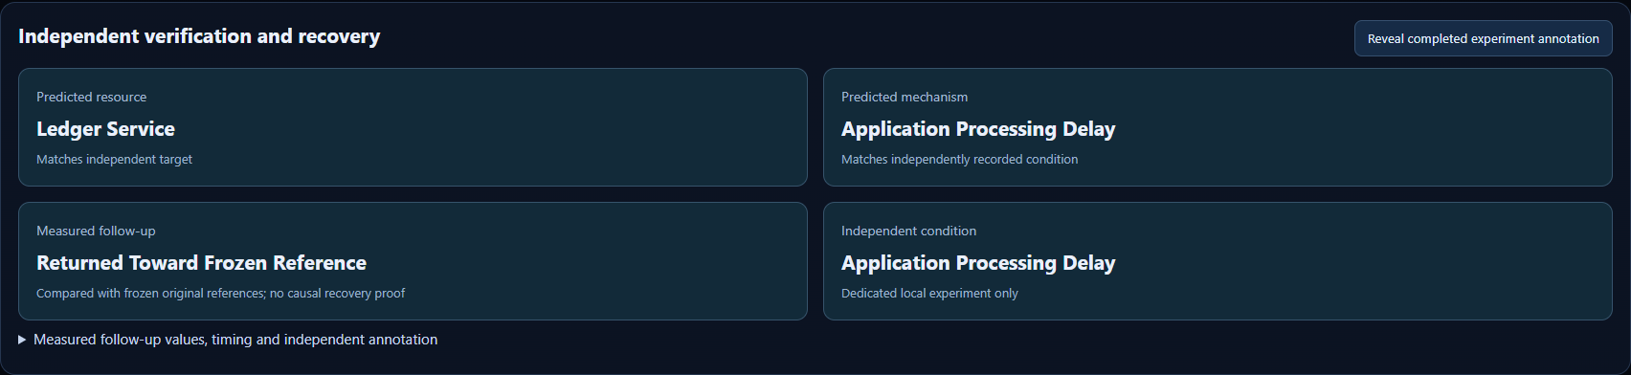
Figure 8. Recorded independent verification and measured follow-up from a browser validation run. Service and mechanism annotation agreement and return toward the frozen reference are displayed separately; this capture is not an additional frozen-study repetition.
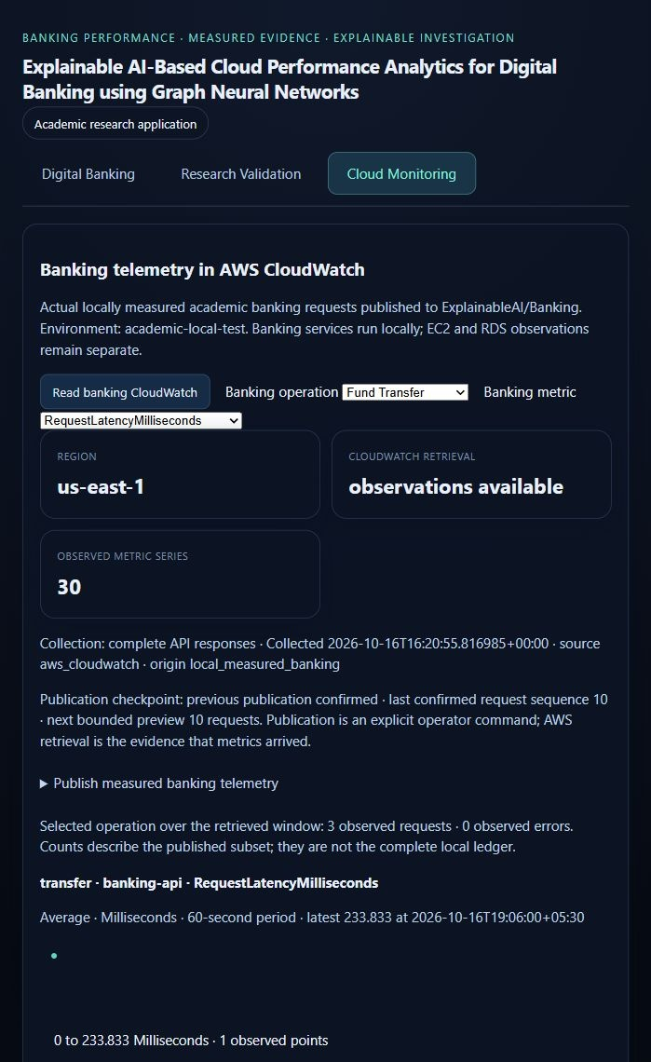
Figure 9. Implemented Cloud Monitoring banking panel after live AWS verification. CloudWatch returns 30 observed metric series in us-east-1; the checkpoint confirms ten published source requests. The selected Fund Transfer view shows three requests and the original measured latency timestamp. The workload remains local.

9.3 Repository and Version Evidence
The source repository is maintained at https://github.com/Haris757518/ExplainableAI_Cloud_Banking_Cloud_Project_2026. The supplied main checkout references baseline commit 839b52599ff542ed4e04d033b69e5edd282d39a5 (16 October 2026). The AWS telemetry extension was implemented and verified as local working-tree changes on that baseline. Frozen measured results remain independent of runtime databases, credentials, and the bounded CloudWatch verification subset.

10. Testing, Results, and Observations

10.1 Test Plan and Execution
Table 7. Final test cases and verification status
Test | Scenario | Recorded observation | Status
T01 | Balance enquiry | Test account lookup and returned fictitious balance | Passed
T02 | Fund transfer | Atomic debit/credit and ledger record | Passed
T03 | Transfer retry | Duplicate transfer ID did not create a second debit | Passed
T04 | Transaction history | Stored test transfer entries returned | Passed
T05 | Normal workload | 270 requests and frozen chronological baseline | Passed
T06 | Controlled application delay | 3 of 3 detections and service/mechanism matches | Passed within study
T07 | Graph model comparison | Both predictors trained/evaluated; no graph advantage | Evaluated
T08 | PostgreSQL lock contention | Dedicated PostgreSQL test environment unavailable | Not executed
T09 | Frontend/backend regression | 124 backend tests passed and frontend production build passed; new AWS panel checked in a live browser | Passed; earlier 16 browser tests remain historical
T10 | Live cloud fault/recovery | Not performed within final measured study | Not validated
T11 | AWS banking telemetry | 10 existing requests; 118 values; 30 CloudWatch series; counts 4/3/3 | Verified live

10.2 Measured Banking Experiment
Table 8. Banking experiment summary from frozen final report
Measurement | Recorded result
Normal requests | 270 (90 per banking operation)
Held-out normal false-positive requests | 0 of 54
Controlled delay repetitions | 3; 150-ms ledger delay, maximum 12 s each
Incident detection / root-service Top-1 | 3 / 3; 3 / 3
Application-delay annotation agreement | 3 / 3
Measured return toward reference | 3 / 3
Normal transfer-handler median | 26.113 ms
Condition-handler medians | 181.240, 167.189, and 167.640 ms
Focused inspection | 3 of 8 recorded fields; 2 of 3 resources

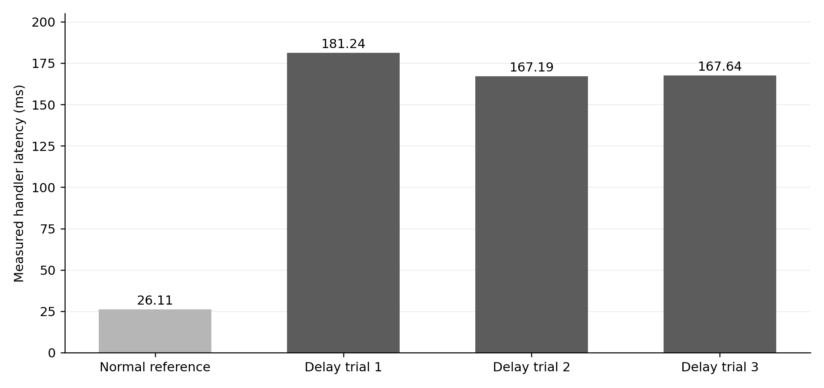
Figure 3. Measured normal and controlled-condition transfer-handler latency. Values are from the frozen local study; client round-trip time is a separate measurement.
The observed delay was generated by a bounded wait inside the Ledger Service. The component and application-processing mechanism matched independent experimental annotations in all three repetitions. These cases represent one deliberately introduced mechanism and do not establish accuracy across banking faults.

10.3 GNN and Baseline Comparison
Table 9. Banking next-request prediction comparison
Measure | Feature-only | Graph model
Training / validation / test requests | 54 / 18 / 18 | 54 / 18 / 18
Held-out masked next-request MSE | 0.574412 | 0.575263
Held-out prediction count | 17 | 17
Normal residual false-alarm rate | 17.65% | 23.53%
Controlled residual Top-1 | 3 / 3 | 3 / 3
Primary diagnosis ranking used | No | No

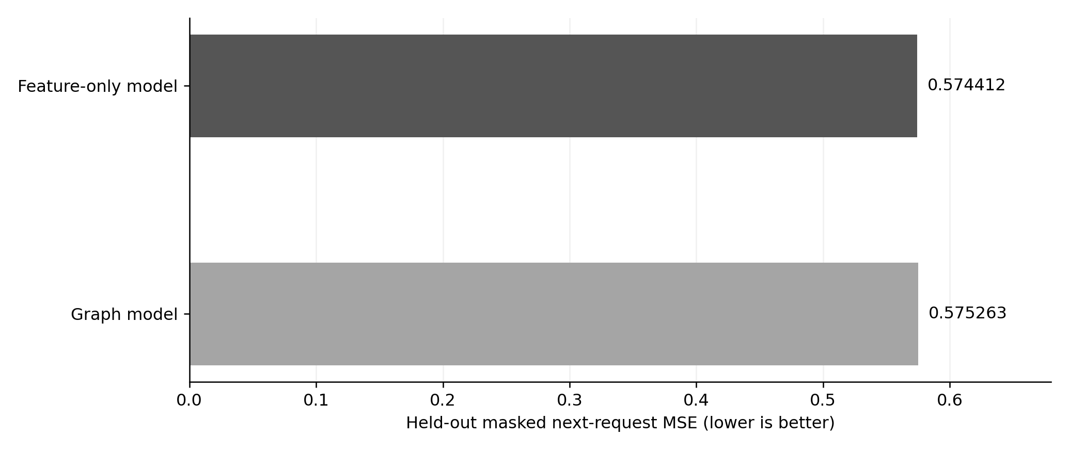
Figure 4. Held-out prediction error for compatible banking graph and feature-only models. Lower values indicate smaller prediction error.
The graph predictor was evaluated on a compatible measured banking graph. It did not improve normal next-request prediction error or controlled root localization over the feature-only comparison. The primary root-cause ranking therefore retained direct measured execution evidence.

10.4 Preserved External Benchmark Results
Independent, earlier recorded research results included Microsoft median/MAD F1 = 0.3269, RCAEval RE1 service Top-1 = 60% and Top-3 = 86.67% on 30 held-out cases, and a separate five-case RE2 graph comparison tied at 60% Top-1 for graph and identity baselines. These values concern different sources and test designs; they were not pooled or presented as banking-lab accuracy.

10.5 Results Summary
The frozen banking study demonstrated anomaly detection, probable Ledger Service origin, application-processing-delay evidence, conditional guidance, and measured return toward baseline. The new AWS integration separately demonstrated publication and retrieval of genuine banking telemetry and its presentation in Cloud Monitoring. Numerical research conclusions remain tied to the frozen banking report; the ten-request cloud subset verifies integration behavior only.

11. Discussion, Limitations, and Risk Analysis

11.1 Discussion
Trace-level own-time attribution was useful in separating inherited banking API latency from execution time spent in the Ledger Service. Independent fault annotations provided a meaningful check on predicted service and mechanism labels. However, the laboratory scope was deliberately narrow, and the GNN comparison did not establish improved accuracy.

11.2 Limitations
- The academic banking workload ran on one local Windows machine with a dedicated SQLite database, not on AWS.
- The controlled fault study contained only three repetitions of one intentionally introduced application-delay mechanism.
- PostgreSQL locking, packet loss, memory saturation, and live AWS banking faults were not independently demonstrated.
- Graph-based prediction did not outperform the feature-only baseline; graph evidence was not used as the final root-service ranking authority.
- The observed 0/54 normal false alarms is a small same-machine result, not a reliability guarantee.
- Benchmark sources have different schemas and labels; their results cannot be merged into one banking-wide accuracy figure.
- Fault-label agreement and subsequent latency improvement do not constitute formal proof of physical causality.

11.3 Risk Assessment and Mitigation
Risk | Control in implemented study | Remaining exposure
Accidental operational disruption | Dedicated localhost services; bounded explicit intervention | Other untested fault types
Incorrect diagnosis | Evidence hypotheses and independent verification | Limited mechanism coverage
Sensitive data disclosure | Fictitious accounts; runtime files/credentials excluded | Not certified for real banking data
Cloud permission or cost | Read-only discovery; no new cloud resource created | Cloud metric freshness varies by permission
Reproducibility | Frozen report selection and Git version reference | Machine-specific latencies and narrow sample

12. Team Contribution and GitHub Management
The project submission is attributed to Haris K (24BIT0468), Keshav Gokaram (24BIT0454), and Harish Kumar (24BIT0472), Third Year B.Tech Information Technology, VIT Vellore. This report presents the shared project deliverable. The repository record is used to establish implemented features and dated revisions; it is not treated as a reliable measure of individual contribution percentages.

12.1 GitHub Management
Source code, benchmark adapters, model definitions, scripts, and immutable experimental results are maintained in the project repository under the MIT license. Historical research artifacts remain available, while credentials, local operational databases, and raw monitored telemetry are excluded. The final review build was published on the main branch as commit 839b525 on 16 October 2026.

12.2 Contribution Evidence
The collective deliverable includes literature analysis, banking application implementation, observability integration, statistical and graph model experiments, dashboard development, reproducible testing, and submission documentation. Individual task assignment and review-paper allocation were not encoded in the verified repository metadata; no unsupported allocation is asserted.

13. Conclusion and Future Enhancements

13.1 Conclusion
The completed academic system connects actual test banking transactions with measured performance telemetry and a sequential root-cause investigation interface. In the frozen three-case application-delay study, the system detected the slowdown, localized the Ledger Service, identified a matching processing-delay hypothesis, and measured return toward the frozen reference. The compatible banking GNN did not establish an advantage over the feature-only predictor. The AWS extension additionally published ten genuine existing banking requests and retrieved their measurements through CloudWatch, with a dedicated dashboard panel and explicit local-workload provenance. CloudWatch storage and display are verified; cloud hosting, generalized cloud anomaly accuracy and causal recovery remain unestablished.

13.2 Future Enhancements
Potential subsequent work includes independently instrumented PostgreSQL wait and lock experiments, larger fault-type coverage, held-out cross-machine banking workloads, improved detector calibration, and verified cloud deployment of the banking services. The implemented CloudWatch integration requires longer independently labelled normal and abnormal banking windows before cloud anomaly performance, mechanism identification, or follow-up recovery can be evaluated.

References
Research publications (APA-style references):
Wu, L., Tordsson, J., Elmroth, E., & Kao, O. (2020). MicroRCA: Root cause localization of performance issues in microservices. In NOMS 2020 - IEEE/IFIP Network Operations and Management Symposium (pp. 1–9). https://doi.org/10.1109/NOMS47738.2020.9110353
Yu, G., Chen, P., Chen, H., Guan, Z., Huang, Z., Jing, L., Weng, T., Sun, X., & Li, X. (2021). MicroRank: End-to-end latency issue localization with extended spectrum analysis in microservice environments. In Proceedings of the Web Conference 2021 (pp. 3087–3098). https://doi.org/10.1145/3442381.3449905
Deng, A., & Hooi, B. (2021). Graph neural network-based anomaly detection in multivariate time series. Proceedings of the AAAI Conference on Artificial Intelligence, 35(5), 4027–4035. https://doi.org/10.1609/aaai.v35i5.16523
Liu, D., He, C., Peng, X., Lin, F., Zhang, C., Gong, S., Li, Z., Ou, J., & Wu, Z. (2021). MicroHECL: High-efficient root cause localization in large-scale microservice systems. In 2021 IEEE/ACM International Conference on Software Engineering: Software Engineering in Practice (pp. 338–347). https://doi.org/10.1109/ICSE-SEIP52600.2021.00043
Ying, Z., Bourgeois, D., You, J., Zitnik, M., & Leskovec, J. (2019). GNNExplainer: Generating explanations for graph neural networks. In Advances in Neural Information Processing Systems, 32. https://proceedings.neurips.cc/paper_files/paper/2019/hash/d80b7040b773199015de6d3b4293c8ff-Abstract.html
Guan, S., Zhao, B., Dong, Z., Gao, M., & He, Z. (2022). GTAD: Graph and temporal neural network for multivariate time series anomaly detection. Entropy, 24(6), 759. https://doi.org/10.3390/e24060759
Lee, C., Yang, T., Chen, Z., Su, Y., & Lyu, M. R. (2023). Eadro: An end-to-end troubleshooting framework for microservices on multi-source data. In Proceedings of ICSE 2023 (pp. 1750–1762). https://doi.org/10.1109/ICSE48619.2023.00150
Pham, L., Ha, H., & Zhang, H. (2024). BARO: Robust root cause analysis for microservices via multivariate Bayesian online change point detection. Proceedings of the ACM on Software Engineering, 1(FSE), 2214–2237. https://doi.org/10.1145/3660805
Pham, L., Ha, H., & Zhang, H. (2024). Root cause analysis for microservice system based on causal inference: How far are we? In Proceedings of the 39th IEEE/ACM International Conference on Automated Software Engineering (pp. 706–715). https://doi.org/10.1145/3691620.3695065
Lin, C.-M., Chang, C., Wang, W.-Y., Wang, K.-D., & Peng, W.-C. (2024). Root cause analysis in microservice using neural Granger causal discovery. Proceedings of the AAAI Conference on Artificial Intelligence, 38(1), 206–213. https://doi.org/10.1609/aaai.v38i1.27772
Zhao, Z., Zhang, T., Shen, Z., Dong, H., Ma, X., Liu, X., & Yang, Y. (2024). CHASE: A causal heterogeneous graph based framework for root cause analysis in multimodal microservice systems [Preprint]. arXiv. https://arxiv.org/abs/2406.19711
Pham, L., Zhang, H., Ha, H., Salim, F., & Zhang, X. (2025). RCAEval: A benchmark for root cause analysis of microservice systems with telemetry data. In Companion Proceedings of the ACM Web Conference 2025 (pp. 777–780). https://doi.org/10.1145/3701716.3715290
Pham, L., Ha, H., Zhang, X., & Zhang, H. (2026). TORAI: Multi-source root cause analysis for blind spots in microservice service call graph. Proceedings of the ACM on Software Engineering, 3(FSE), 2928–2951. https://doi.org/10.1145/3808137
Pham, L., Nicolet, V., Dodds, J., Guan, H., & Kroening, D. (2026). EventADL: Open-box anomaly detection and localization framework for events in cloud-based service systems. Proceedings of the ACM on Software Engineering, 3(FSE), 4070–4093. https://doi.org/10.1145/3808186
Ding, C., Sun, S., & Zhao, J. (2022). MST-GAT: A multimodal spatial-temporal graph attention network for time series anomaly detection. Information Fusion, 89, 527–536. https://doi.org/10.1016/j.inffus.2022.08.011

Datasets, Software, and Project Sources
Alibaba Group. (2021). Cluster trace data: Microservices 2021 [Data set]. https://github.com/alibaba/clusterdata/tree/master/cluster-trace-microservices-v2021
Microsoft. (n.d.). Cloud monitoring dataset [Data set]. https://github.com/microsoft/cloud-monitoring-dataset
Pham, L. (2025). RCAEval: A benchmark for root cause analysis of microservice systems [Software and data]. https://github.com/phamquiluan/RCAEval
Google Cloud. (n.d.). Bank of Anthos [Reference application]. https://github.com/GoogleCloudPlatform/bank-of-anthos
Amazon Web Services. (n.d.). Amazon CloudWatch documentation. https://docs.aws.amazon.com/AmazonCloudWatch/
Haris757518. (2026). Explainable AI-based cloud performance analytics for digital banking using graph neural networks [Project repository]. https://github.com/Haris757518/ExplainableAI_Cloud_Banking_Cloud_Project_2026

Appendix A. Reproducibility and Recorded Artifacts
The following commands reproduce the local banking application and run the documented tests on a suitable Windows computer with Python and Node.js dependencies installed. The explicit delay command operates on the isolated test service only.
1. Start: .\scripts\start_banking.ps1
2. Normal workload: .\.venv\Scripts\python.exe scripts/banking_workload.py --normal --per-operation 90
3. Bounded local condition: .\.venv\Scripts\python.exe scripts/banking_workload.py --application-delay --confirm-local-test --duration 12 --delay-ms 150
4. Backend tests: .\.venv\Scripts\python.exe -m pytest -q
5. Frontend build: npm --prefix frontend run build
6. Browser regression: npm --prefix frontend run test:e2e
7. AWS preview: .\.venv\Scripts\python.exe scripts/aws_banking_telemetry.py --dry-run --limit 10
8. Explicit AWS publication: .\.venv\Scripts\python.exe scripts/aws_banking_telemetry.py --publish --confirm-publish --limit 10
9. AWS retrieval: .\.venv\Scripts\python.exe scripts/aws_banking_telemetry.py --read --lookback-minutes 1440
The publication command advances to the next unpublished measured requests; it must not be used to repeat the already completed ten-request verification. Detailed AWS checks and troubleshooting are in docs/AWS_BANKING_INTEGRATION.md.
Frozen banking report: results/banking/measured_20261016/report.json; selected by results/banking/FINAL.json. Research artifacts: results/research_v3/ and results/research_v4/. Authoritative project handover: docs/FINAL_HANDOVER.md.

Appendix B. Screenshot Evidence Register
Figures 5–8 are saved captures from frontend/test-results in the supplied project; their file-save times are 16 October 2026 at approximately 19:33–19:45 local time. Figure 9 was captured from the updated application after live AWS verification on 16 October 2026 at approximately 21:50 IST. Its collection timestamp and original measurement timestamp are separately displayed. The review server uses an isolated copy of the banking runtime while its publication preview reads the original telemetry database in read-only mode. Screenshots retain actual values and source labels. Crops remove surrounding interface area only.
Figure | Final capture content
Figure 5 | final-banking-overview-1366.png; full recorded dashboard
Figure 6 | final-banking-overview-1920.png; crop of test transfer controls
Figure 7 | final-banking-explanation-1920.png; crop of recorded transfer dependency graph
Figure 8 | banking-investigation-1920.png; crop of independent verification and measured follow-up
Figure 9 | cloudwatch-banking-live.jpg; new live banking CloudWatch panel capture, cropped to publication and latency evidence

