Detection of Flying Object Using
Hybrid Deep Learning Techniques
ACADEMIC PROJECT REVIEW 2
Karan Chander S R | Haris K
Vellore Institute of Technology, Vellore
October 2026

Abstract
The study presents the development of a hybrid deep-learning framework for six categories of airborne objects: airplane, bird, helicopter, kite, parachute and unmanned aerial vehicle (UAV). The combined AOD-4 and Multi-Background Airborne Object Detection (MBAOD) dataset was consolidated into a six-class annotation scheme. Dataset audit records identify 57,622 pooled images, of which 55,409 were retained after removal of 2,210 duplicate or conflicting copies and three invalid samples, yielding 86,254 annotated object instances. Preprocessing includes annotation validation, duplicate detection, class remapping, bounding-box correction and data partitioning. An active 20,620-image training pool was allocated into ten stratified partitions; conditional generative adversarial network (cGAN) augmentation was developed for selected airborne classes. A YOLO-based detection baseline and five hybrid architectures were specified alongside a surveillance interface. The present findings establish dataset preparation, preprocessing outcomes, class-wise distributions and implementation status. Complete six-class hybrid-model evaluation and cross-validation performance remain outside the completed experimental scope.
Keywords: Airborne object detection; UAV; YOLO; CNN; LSTM; Transformer; conditional GAN; dataset preprocessing; cross-validation.

1. Introduction and Objectives
Reliable airborne-object recognition is challenging when distant drones and birds exhibit similar silhouettes, occupy only a small image region, or appear against cluttered backgrounds. Conventional frame-based detectors estimate object category and position from spatial features, whereas movement patterns may provide additional discriminative information. The proposed approach therefore combines spatial localisation, feature refinement, temporal modelling and generative data augmentation as complementary components [1, 2, 5, 6, 20, 29].

1.1 Research problem
Develop a multi-class surveillance pipeline that can localise flying objects, support discrimination between visually similar classes, and represent both spatial appearance and temporal movement while managing noisy images and class-distribution differences.

1.2 Research Objectives
• To consolidate and characterise a six-class image dataset with consistent YOLO annotations.
• To analyse class distributions and document preprocessing, data cleaning and augmentation.
• To establish reproducible dataset partitions and stratified K-fold preparation.
• To develop a YOLO-based baseline and five hybrid model architectures for airborne-object recognition.
• To assess implementation outcomes and define the experimental validation required for comparative evaluation.

1.3 Scope of the Implemented Work
The present stage covers dataset preparation, the construction of model modules and the development of inference and surveillance-interface components. Dataset partitions and architecture implementations do not constitute evidence of trained six-class model performance. The available pretrained detection weights correspond to YOLOv8n; references to YOLO12 in the original proposal represent the intended architecture rather than a verified trained YOLO12 checkpoint.

2. Literature Review and Research Gap
Thirty selected publications (2021-2026), emphasising recent work from 2025-2026, are reviewed in Table 1. Studies are grouped by their contributions to small-object detection, spatial/temporal modelling, synthetic datasets and sensor fusion. The table records prior research, not results claimed for the present implementation.
Table 1. Literature survey of 30 verified publications and their methodological relevance
Reference and year | Approach / contribution | Relevance to research
[1] A. Nesteruk et al. (2026) | Bidirectional LSTM trained on coordinate and apparent-size trajectories. | Directly motivates motion-based bird/drone discrimination.
[2] Y. Yao et al. (2026) | Kinematic fractal and time-frequency descriptors separate visually tiny UAVs from birds. | Supports temporal features when image appearance is weak.
[3] S. Peng and H. Li (2026) | VMD/STFT features combined with a weighted probabilistic classifier for low-SNR bird/UAV separation. | Illustrates nonvisual alternatives; radar features not used in the present dataset.
[4] T. Zhang and X. Song (2026) | Dual-band radar micro-Doppler fusion with serialized Mamba state-space classification. | Highlights complementary motion signatures but requires radar sensors.
[5] C. Han et al. (2026) | YOLOv11 high-resolution P2 head plus residual channel/spatial attention. | Motivates multiscale refinement of distant drones and bird distractors.
[6] J. Guo et al. (2026) | Scene-guided synthetic drone composites and YOLO-compatible annotations. | Provides a strong external precedent for carefully labelled synthetic augmentation.
[7] K. Zou et al. (2026) | Multi-view feature alignment and smoothing for tiny low-contrast UAV recognition. | Supports feature-fusion ideas; multiple cameras exceed current image-only scope.
[8] R. Zhang et al. (2026) | Cross-modal RGB/event sparse mutual guidance for motion-blurred tiny UAVs. | Informs robustness to lighting and motion blur; event streams absent locally.
[9] J. Samu and C. Yang (2026) | Systematic review of airport ground-surveillance sensors for drones and birds. | Grounds the surveillance motivation and limits of single-modality detection.
[10] Y. Du et al. (2026) | Hierarchical granularity and context modulation preserve weak small-object features. | Supports CNN attention/scale-focused hybrid design.
[11] K. Lv et al. (2026) | YOLO variant combining dual-branch feature gathering and attention. | Provides a recent efficient detector comparison concept.
[12] M. T. Ghenescu et al. (2026) | Acoustic array geometry and neural networks for passive drone localisation. | Frames the limitation of optical-only observations.
[13] D. Kaur et al. (2026) | Preprint presenting attention-enhanced YOLO and BirDrone dataset. | Direct bird-versus-drone benchmark; preprint, not verified peer reviewed.
[14] J. Zhu et al. (2026) | Multimodal YOLOv10-based visible, infrared, radar and audio feature fusion. | Shows value and hardware costs of multi-sensor bird/drone systems.
[15] L. Wen et al. (2026) | Review of small-object detection under scale, viewpoint and resource constraints. | Useful method background; most surveyed targets are seen from UAVs rather than flying objects.
[16] S. Luesutthiviboon et al. (2026) | Trajectory features supplement tiny-target visual classification. | Strong justification for future sequence-aware components.
[17] L. Zhao et al. (2025) | IUAV-YOLO adds global/local contextual processing for small infrared targets. | Motivates atmospheric/low-contrast image feature enhancement.
[18] X. Cheng et al. (2025) | Background subtraction plus context-aware YOLO for infrared anti-drone detection. | Motivates separating small targets from sky/background clutter.
[19] N. Habash et al. (2025) | Survey of real-time aerial detectors and speed-complexity trade-offs. | Provides deployment and metric-selection context.
[20] N. S. H. Al-Zadjali et al. (2025) | Bio-inspired spatial-temporal motion network for distinguishing UAVs from birds. | Supports CNN/recurrent feature hybridization.
[21] W. Hua and Q. Chen (2025) | Review of deep-learning methods for small targets in aerial images. | Explains challenges of tiny boxes and multiscale annotation modelling.
[22] M. Larrat and C. Sales (2025) | Comparative radar classification with bionic bird and drone returns. | Relevant non-visual comparison for difficult bird-versus-drone cases.
[23] J. Leng et al. (2024) | Survey of aerial object detection and multiscale imbalance challenges. | Provides broad image-detection background; overhead imagery differs from ground surveillance.
[24] Z.-W. Sun et al. (2025) | Public surveillance-video flying-bird dataset; archived copy is its earlier arXiv preprint. | Supports flight-background and negative bird sample interpretation.
[25] H. Lee et al. (2023) | CNN classification combining radar, audio and optical sensory features. | Highlights complementarity beyond the six-class image-only dataset.
[26] S. K. Shandilya et al. (2023) | YOLO-format segmented bird/drone object annotations as a benchmark resource. | Supports label-format and sample-annotation analysis.
[27] H. J. Al Dawasari et al. (2023) | Visible-image detector with tiling for particularly small drone targets. | Supports crop/tiling strategies for long-range object detection.
[28] R. M. Narayanan et al. (2023) | Radar micro-Doppler spectrogram experiments on drone-bird discrimination. | Reinforces temporal features as alternatives to purely spatial classification.
[29] A. Coluccia et al. (2021) | Foundational deep-learning video challenge with drone/bird distractors. | Supports held-out video evaluation and false-alarm-focused study.
[30] G. Tang et al. (2024) | Review of architecture, class imbalance, scale variation and complex backgrounds. | Methodological overview; emphasis is UAV-captured aerial images.

The reviewed work indicates continuing challenges in small-target detection, drone-versus-bird discrimination, diverse backgrounds and reliable temporal modelling. In the present work, these ideas motivate six-class dataset harmonisation, YOLO-based localisation, candidate hybrid architectures and a separate cGAN augmentation pipeline. Empirical improvements from the proposed hybrids have not yet been established.

3. Dataset Description and Source Links

3.1 Dataset provenance
Table 2. Primary source datasets and local derived dataset
Dataset | Classes / scope | Source link
AOD-4 | Four airborne categories: airplane, bird, drone, helicopter. Published collection: 22,516 images. | https://doi.org/10.1016/j.dib.2024.110801
MBAOD | Six airborne categories across differing backgrounds and object scales. | https://data.mendeley.com/datasets/zfc8hndczp/1
comb DSF (local derivative) | Unified six-class canonical merged data, cleaned and relabelled. | Local source: E:\AI project\DS\comb DSF

Dataset provenance is documented using the original source publications, class definitions, dataset configuration files and preprocessing audit records. The available metadata establishes aggregate counts; comprehensive verification of image-level lineage would require the complete source dataset manifests.

3.2 Dataset attributes
Table 3. Dataset characterisation and measured/recorded properties
Attribute | Dataset characteristics
Type | Supervised multi-class 2D object detection using still images and bounding-box labels
File formats | JPG/JPEG/PNG images; UTF-8 YOLO .txt annotations
Annotation fields | class_id, x_center, y_center, width, height, normalised to [0,1]
Class count | 6; airplane, bird, helicopter, kite, parachute, UAV
Canonical images | 55,409 retained images; audit metadata
Canonical bounding boxes | 86,254 total ground-truth object instances
Background images | 1,174 with empty annotation files
Image sizes | Source examples in ZIP are 1024 × 1024 pixels; supplied synthetic composites are 640 × 640 pixels
Dataset physical size | Not independently determined from the available dataset metadata; source archive sizes cover multiple configurations.

3.3 Class labels and distribution
Table 4. Canonical class-wise annotated bounding-box distribution (N = 86,254)
ID | Class | Train boxes | Val boxes | Test boxes | Total boxes | Share
0 | Airplane | 11,612 | 2,488 | 2,488 | 16,588 | 19.23%
1 | Bird | 11,846 | 2,538 | 2,538 | 16,922 | 19.62%
2 | Helicopter | 11,445 | 2,453 | 2,453 | 16,351 | 18.96%
3 | Kite | 6,650 | 1,425 | 1,425 | 9,500 | 11.01%
4 | Parachute | 6,650 | 1,425 | 1,425 | 9,500 | 11.01%
5 | UAV (Drone) | 12,167 | 2,609 | 2,617 | 17,393 | 20.16%
— | Total | 60,370 | 12,938 | 12,946 | 86,254 | 100.00%

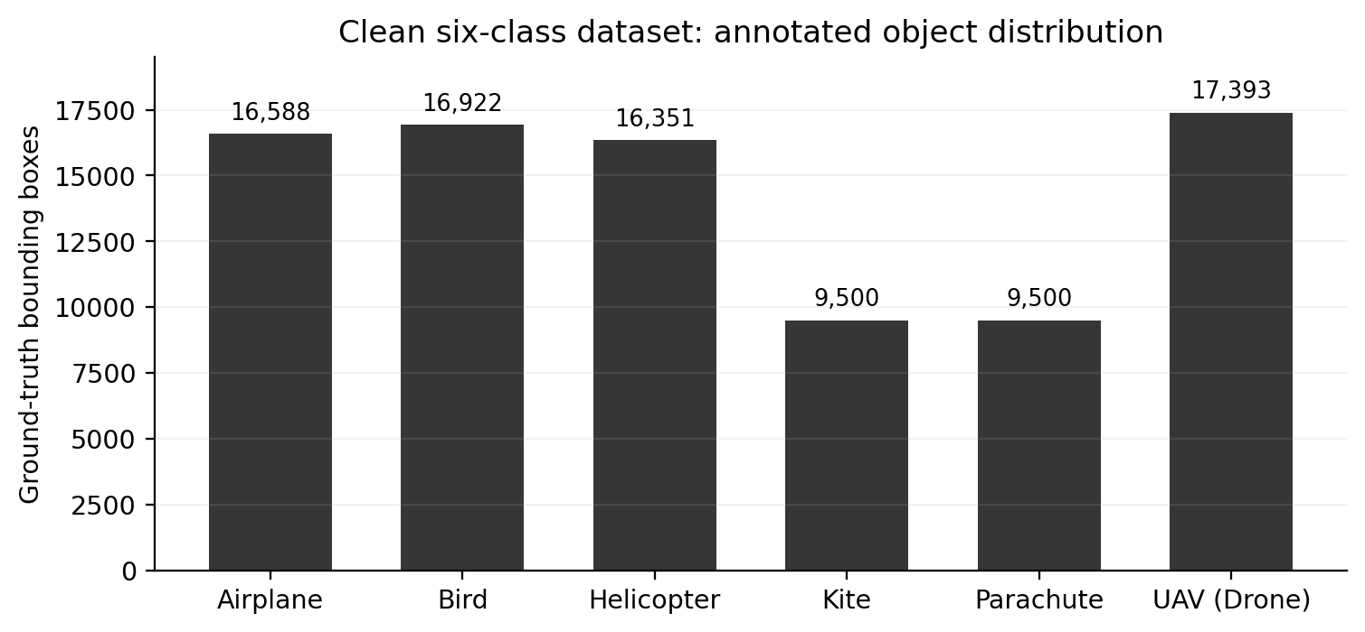
Figure 1. Distribution of ground-truth bounding boxes across the six classes.
Kite and Parachute represent the smallest annotated categories, each with 9,500 object instances (11.01%), whereas UAV has the highest annotation frequency, with 17,393 instances (20.17%). All values refer to bounding-box annotations rather than the number of distinct images containing an individual class.

4. Sample Data: Class Presence and Absence
Class presence and absence are illustrated using ground-truth samples. A positive (YES) example contains at least one annotation for the specified class; a negative (NO) example does not contain that class, although another airborne object may be present. These examples demonstrate class-specific label membership within a multiclass object-detection task. Bounding boxes are drawn using the corresponding YOLO annotation coordinates.
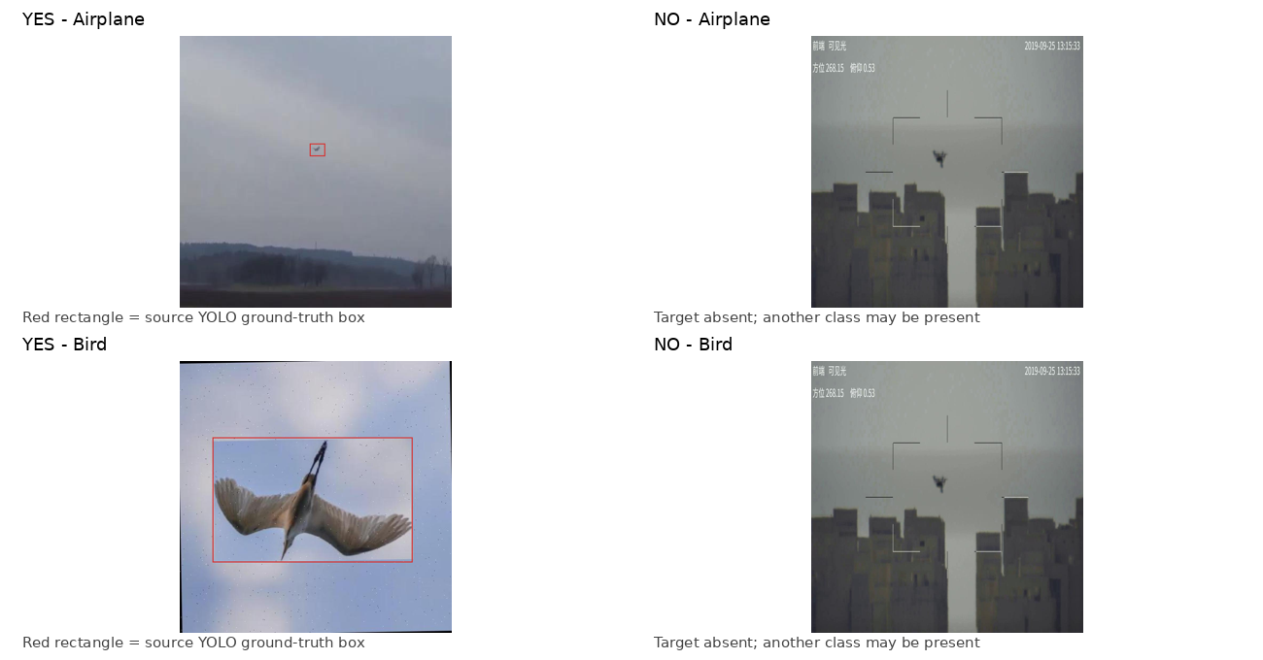
Figure 2. YES/NO source-image examples: Airplane and Bird; labels from test-set annotation files.
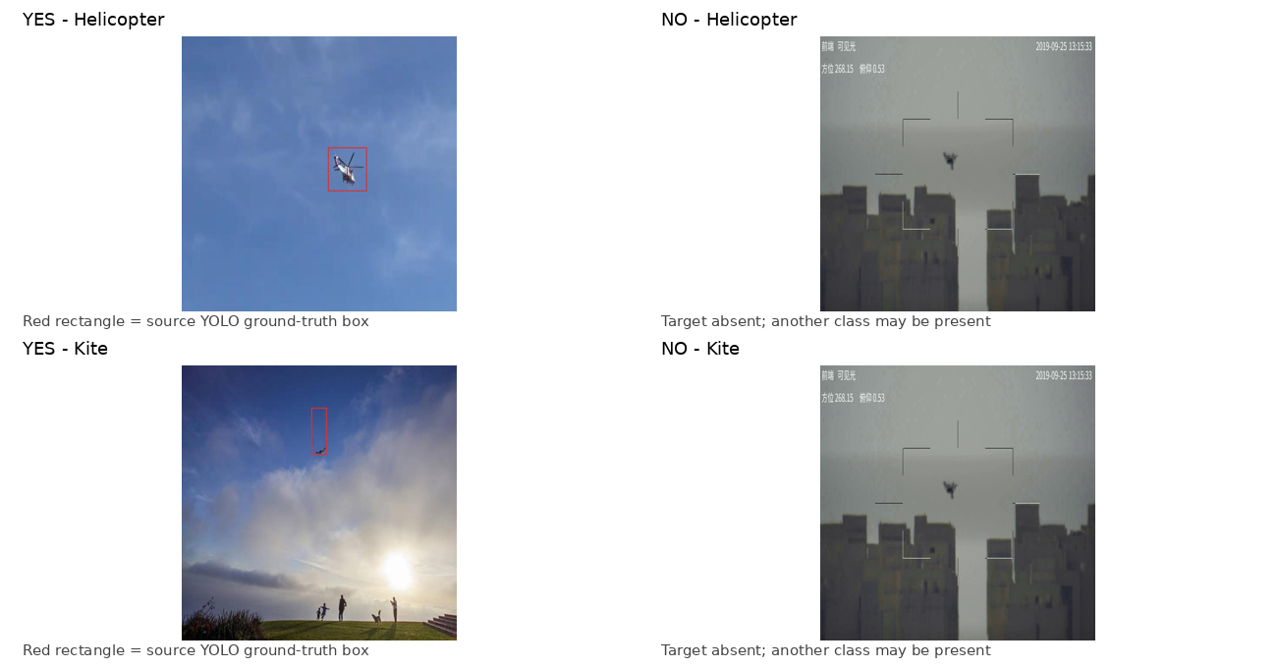
Figure 3. YES/NO source-image examples: Helicopter and Kite; labels from test-set annotation files.
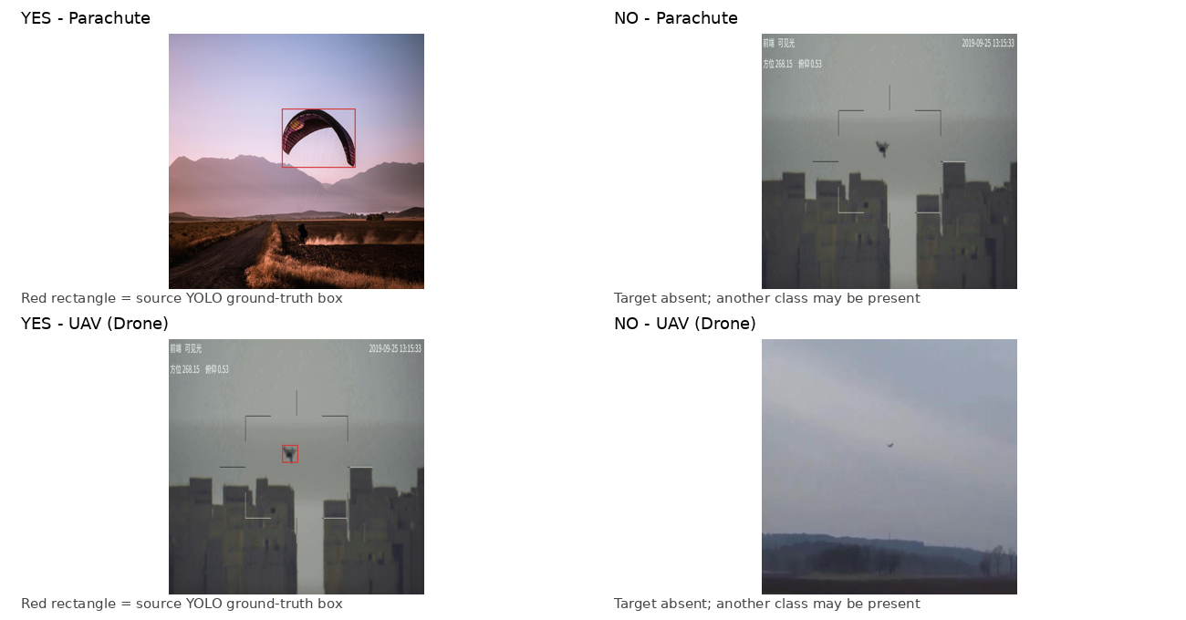
Figure 4. YES/NO source-image examples: Parachute and UAV; labels from test-set annotation files.
A background example with an empty label file is also included to illustrate imagery with no annotated target objects. Sample images originate from the holdout partition and serve solely as illustrations of the dataset and annotations.
.

5. Dataset Preprocessing and Cleaning
1. Dataset acquisition and ingestion. AOD-4 and MBAOD images are linked with their associated YOLO annotation files while preserving source-class information.
2. Image integrity screening. Image files and annotations are examined for validity; three invalid samples were quarantined according to the dataset audit.
3. Exact-duplicate elimination. Duplicate or conflicting source copies are identified and consolidated. The recorded preprocessing stage excludes 2,210 such images.
4. Near-duplicate grouping. Perceptual hashing and structural similarity (SSIM) are used to identify related captures for grouping, reducing the risk of closely related frames appearing across evaluation partitions.
5. Class-label harmonisation. AOD-4 class identifiers are mapped to the unified categories airplane (0), bird (1), helicopter (2), kite (3), parachute (4) and UAV (5); MBAOD annotations follow the corresponding six-class scheme.
6. Bounding-box correction. Normalised coordinates that exceed valid image boundaries are clipped or corrected; 55 affected bounding boxes are recorded.
7. Canonical dataset partitioning. The consolidated dataset is documented using 70% training, 15% validation and 15% test partitions.
8. Experimental partition preparation. A distinct 20,620-image training pool is organised into ten stratified partitions for subsequent cross-validation experiments.
9. Conditional-GAN augmentation. Selected training-region crops are used in a cGAN workflow to produce additional labelled synthetic composites, stored separately from the canonical dataset.

5.1 Before and after dataset cleaning
Table 5. Raw-versus-cleaned image-count reconciliation
Stage | Image count | Change from prior stage
Raw pooled source images | 57,622 | —
Exact duplicates/conflicting copies removed | 55,412 | −2,210
Invalid images quarantined | 55,409 | −3
Canonical cleaned set | 55,409 | Retained

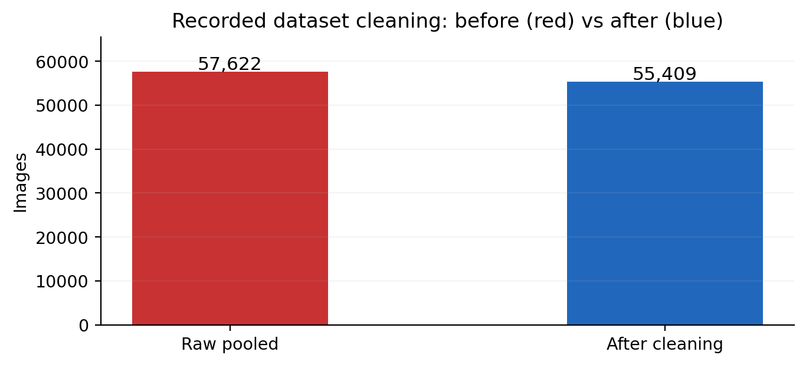
Figure 5. Genuine before/after cleaning comparison (red = raw; blue = retained).
Dataset cleaning reduced the recorded image count from 57,622 to 55,409. This is a data-integrity operation and should not be interpreted as class balancing. Original per-class annotation counts before cleaning are unavailable; therefore a class-wise original-versus-cleaned comparison cannot be established from the existing records.

6. Conditional GAN Augmentation and Before/After Tables

6.1 Implemented augmentation pipeline
The conditional-GAN implementation uses training-region crops for Bird, Helicopter and UAV. The augmentation records describe 300 crops from each class (900 in total), resized to 64 × 64 pixels, with latent dimension 100 and class-embedding dimension 32. The recorded generator checkpoint is cgan_generator.pth. The augmentation process is documented as producing 450 labelled synthetic composites, distributed equally among the three selected classes. Fifteen representative composite images and annotations are available for inspection; the entire generated collection was not included in the supporting material.
The augmentation strategy prioritises classes of operational interest for drone discrimination rather than correcting dataset-wide frequency imbalance. Kite and Parachute remain the least represented categories. The generated composites are maintained separately from the canonical training images, and their effect on model performance has not been measured.

6.2 Before and after count comparison
Table 6. Baseline training-annotation counts and additional cGAN label counts (arithmetic comparison)
Class | Canonical train boxes | Stored synthetic labels | Baseline + synthetic labels* | Change
Airplane | 11,612 | 0 | 11,612 | 0.00%
Bird | 11,846 | +150 | 11,996 | 1.27%
Helicopter | 11,445 | +150 | 11,595 | 1.31%
Kite | 6,650 | 0 | 6,650 | 0.00%
Parachute | 6,650 | 0 | 6,650 | 0.00%
UAV (Drone) | 12,167 | +150 | 12,317 | 1.23%
Total | 60,370 | +450 | 60,820 | +0.75%

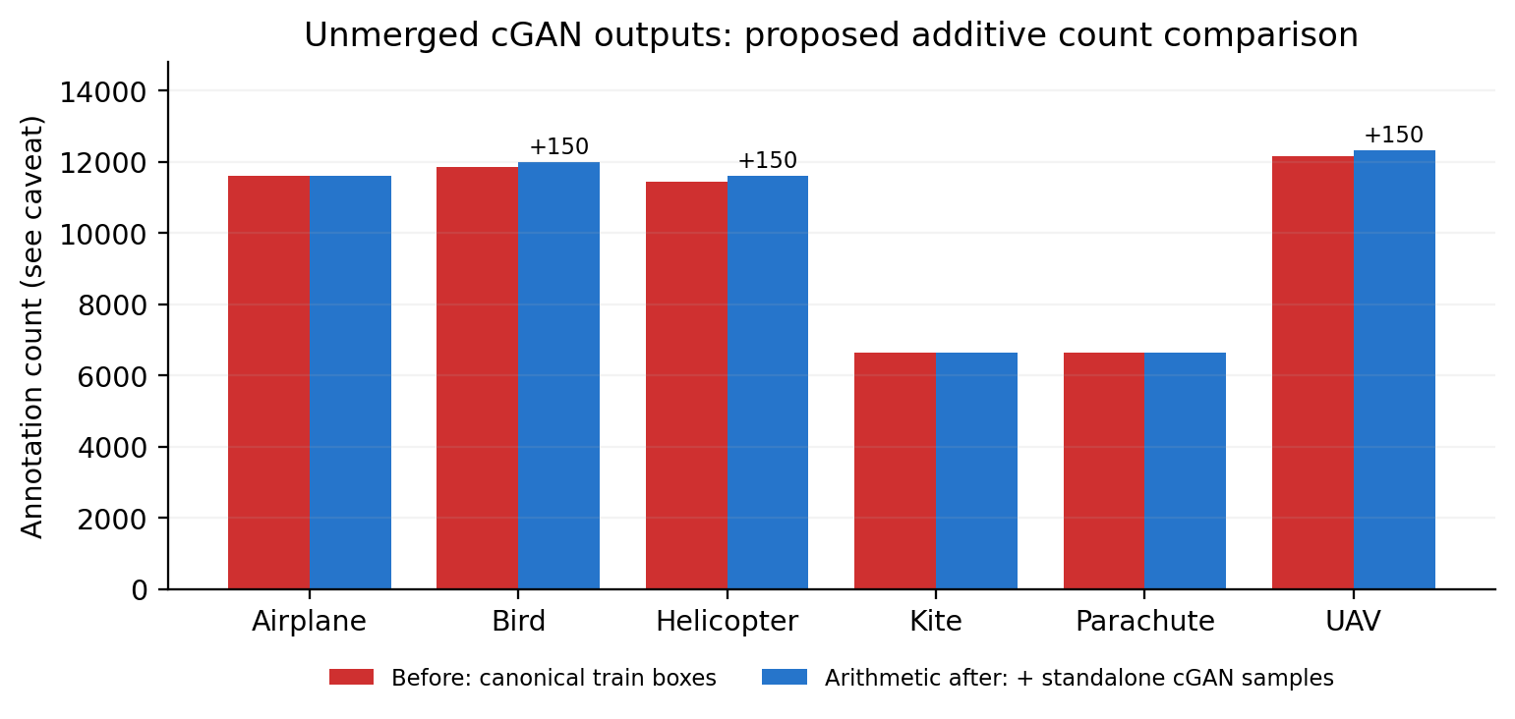
Figure 6. Comparison of baseline annotations (red) and baseline plus separately stored synthetic labels (blue); the latter is an arithmetic projection.
The augmented totals in Table 6 are calculated by adding the recorded synthetic-label counts to the canonical training-annotation counts. They do not represent a verified merged training dataset or measured model improvement. Because the synthetic crops were prepared from a separate active training configuration, the comparison is descriptive rather than an experimental before/after evaluation.
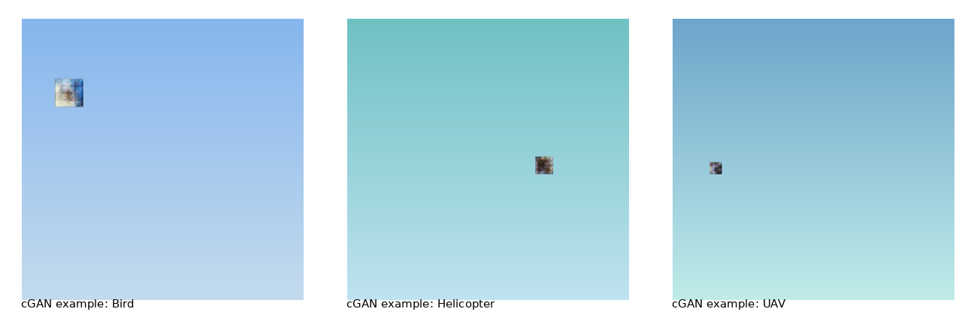
Figure 7. Representative conditional-GAN composite images for Bird, Helicopter and UAV.
The representative generated images contain composited target patches against simplified background scenes. Their visual fidelity, label consistency and effects on detection performance require further experimental assessment.
Data source: cGAN augmentation records, gan_augmentation.py and representative synthetic-image annotations.

7. Train–Test Split and Fold-Wise Study

7.1 Canonical dataset split
Table 7. Canonical split recorded in audit.json
Partition | Images | Share | Bounding boxes
Train | 38,786 | 70.00% | 60,370
Validation | 8,311 | 15.00% | 12,938
Test | 8,312 | 15.00% | 12,946
Total | 55,409 | 100.00% | 86,254

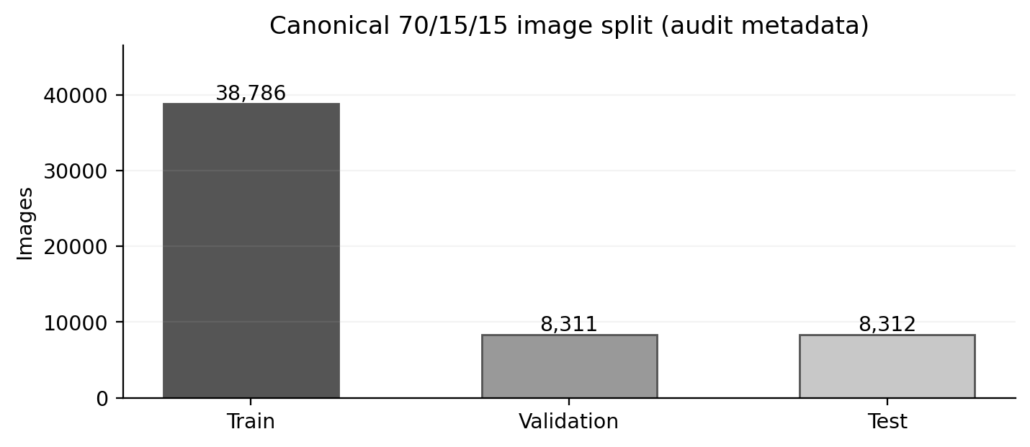
Figure 8. Canonical image counts by train/validation/test split.

7.2 Active experimental training pool
Two distinct dataset organisations are documented. The canonical audit contains 55,409 images with 70/15/15 training, validation and test allocations. The active experimental configuration contains 20,620 training entries and 8,312 holdout entries, representing 71.27% and 28.73% of its 28,932-image subset, respectively. The relationship between the active subset and all canonical partitions has not been fully reconciled; results from these configurations must therefore be interpreted separately.
Table 8. Canonical and active experimental dataset configurations
Dataset configuration | Training images | Validation images | Holdout images | Total
Canonical dataset audit | 38,786 | 8,311 | 8,312 | 55,409
Active experimental subset | 20,620 | Ten-fold within train pool | 8,312 | 28,932

7.3 Ten-fold partitioning
The active K-fold manifest contains 20,620 distinct image entries and assigns each entry to one of ten validation folds. Each fold contains 2,062 validation images and 18,558 training images. The partitioning script uses StratifiedKFold with shuffle enabled and random_state = 42, based on a selected primary class per image. Fold assignment and configuration files have been generated; fold-wise model training and performance evaluation have not been completed.
Table 9. Stratified ten-fold partition sizes in the active training pool
Fold | Training images | Validation images | Train-pool total
Fold 1 | 18,558 | 2,062 | 20,620
Fold 2 | 18,558 | 2,062 | 20,620
Fold 3 | 18,558 | 2,062 | 20,620
Fold 4 | 18,558 | 2,062 | 20,620
Fold 5 | 18,558 | 2,062 | 20,620
Fold 6 | 18,558 | 2,062 | 20,620
Fold 7 | 18,558 | 2,062 | 20,620
Fold 8 | 18,558 | 2,062 | 20,620
Fold 9 | 18,558 | 2,062 | 20,620
Fold 10 | 18,558 | 2,062 | 20,620

7.4 Class coverage verification in the active fold pool
Table 10. Class-specific sample representation in the active fold pool
Class | Images containing class | Labelled objects
Airplane | 8,191 | 11,206
Bird | 5,136 | 11,601
Helicopter | 3,440 | 5,492
Kite | 0 | 0
Parachute | 2 | 2
UAV (Drone) | 3,761 | 4,247
Background images | 529 (primary-label code 6) | 0

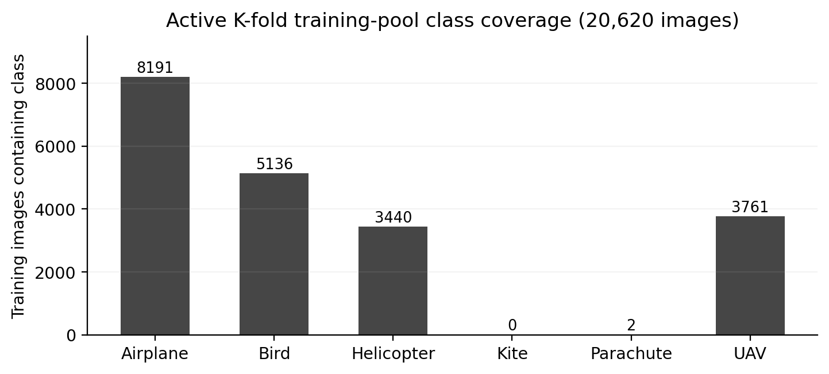
Figure 9. Class representation in the active 20,620-image K-fold pool.
The active fold pool contains no annotated Kite objects and only two annotated Parachute objects. As a result, the present fold configuration does not adequately represent all six classes, despite their inclusion in the canonical dataset. This limitation must be addressed before meaningful six-class cross-validation can be undertaken.
Data source: kfold_manifest.csv, data_fold_0.yaml–data_fold_9.yaml, data_70_30.yaml and audit.json.

8. Model Architectures and Algorithm Status
The detection framework comprises a YOLO baseline and five hybrid extensions based on convolutional, recurrent, attention and generative components. The available source modules establish the intended architectures, but trained six-class hybrid checkpoints and matching evaluation histories are not available. The deployed baseline dependency is YOLOv8n; the term YOLO12 is retained only where it appears in the proposed design or module naming.
Table 11. Architecture components and current implementation status
Architecture | Source / runtime | Functional intent | Implementation status
Baseline YOLO | Ultralytics YOLOv8n | Frame-level localisation: box, confidence and class. | Pretrained weight referenced; six-class trained checkpoint not provided.
Technique 1: YOLO + CNN | model_1_yolo_cnn.py | CNN refinement head for visual crop discrimination. | Module code only; no trained six-class classifier evidence.
Technique 2: YOLO + LSTM | model_2_yolo_lstm.py | 16-step sequence of 8 motion/box features; 2-layer LSTM. | Module code; runtime wrapper may operate with untrained LSTM.
Technique 3: YOLO + Transformer | model_3_yolo_transformer.py | Patch embeddings and multi-head self-attention for crop context. | Module code only; no trained result logs.
Technique 4: YOLO + BiLSTM-Attention | model_4_yolo_bilstm_attention.py | Bidirectional temporal encoding with attention-weighted states. | Module code; no converged weights.
Technique 5: YOLO + cGAN + Transformer | model_5_yolo_gan_transformer.py | Generator-created crop composites; ViT classification pipeline. | cGAN work documented; trained full hybrid checkpoint missing.

Quantitative measures such as accuracy, precision, recall, F1-score, mean average precision (mAP) and training loss require independently recorded model evaluation. Hard-coded demonstration metrics are not included as measured findings.

8.1 Implemented runtime and post-processing
The desktop and web applications implement detection visualisation, atmospheric-image enhancement and airspace alert components. The processing logic includes contrast-limited adaptive histogram equalisation (CLAHE), morphological top-hat filtering and non-maximum suppression. Runtime throughput remains unverified because the available materials do not include controlled timing measurements tied to a specified hardware and input configuration.

9. Proposed Methodology and Evaluation Framework
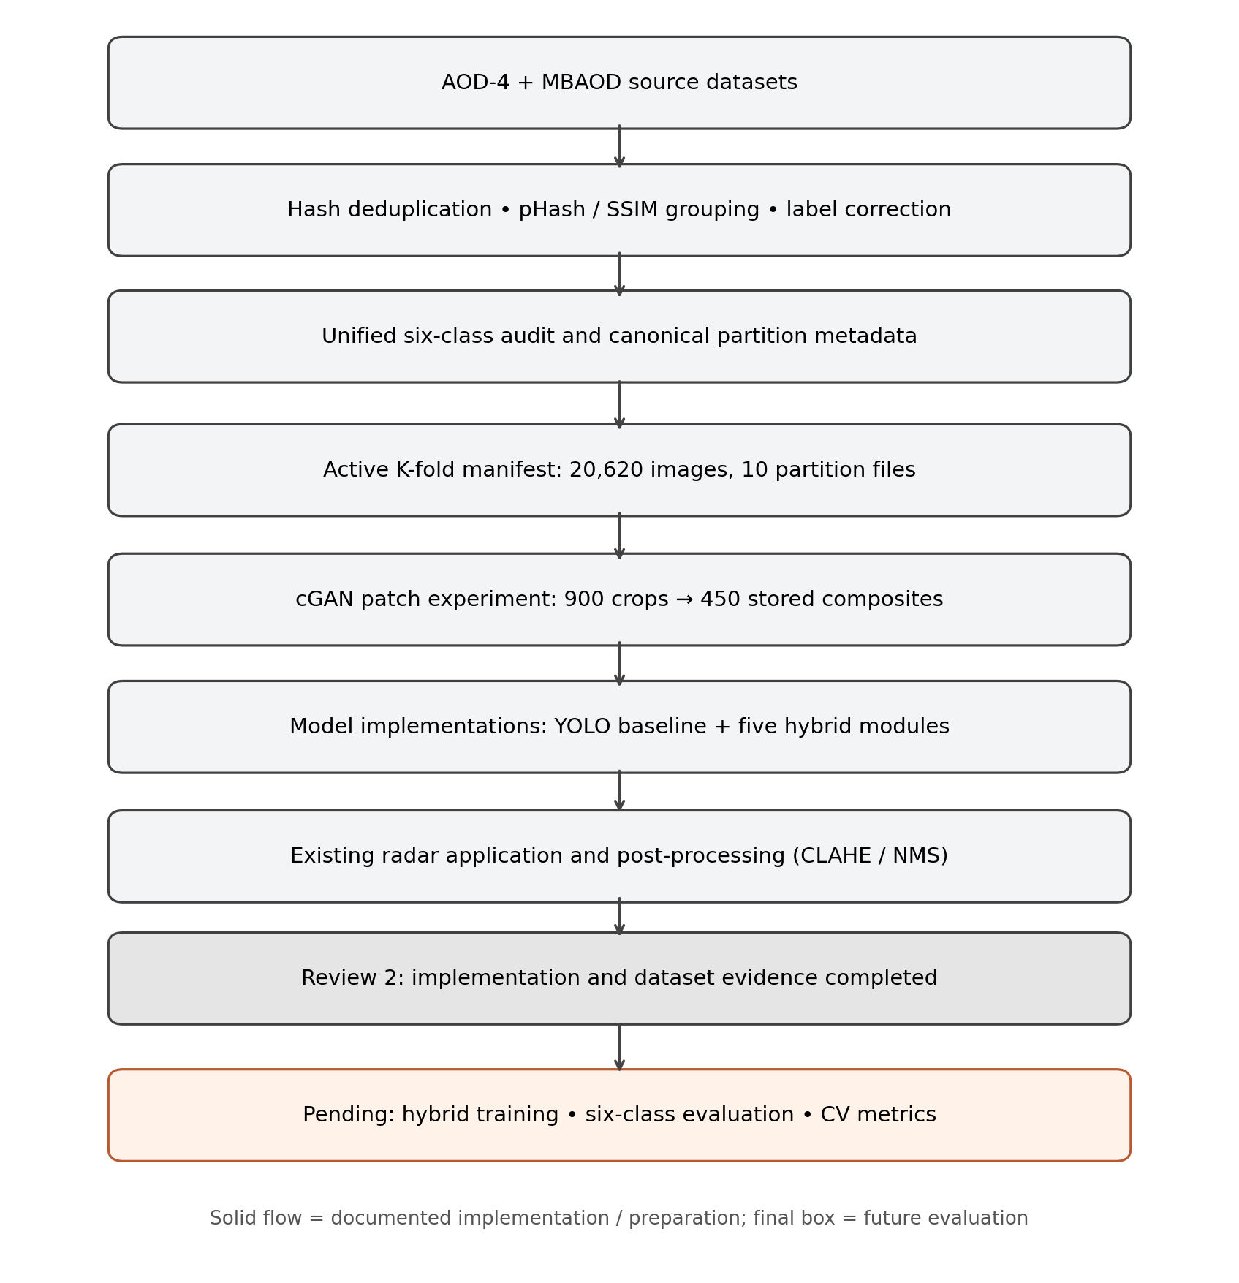
Figure 10. Proposed processing sequence, implemented modules and pending evaluation stages.

9.1 Sequential Methodology
Step 1. Dataset acquisition. AOD-4 and MBAOD are selected to provide annotated samples across six airborne-object categories.
Step 2. Data validation. Image files, annotation availability and class definitions are inspected for consistency and integrity.
Step 3. Duplicate analysis. Exact hashing, perceptual hashing and SSIM are used to identify duplicate and visually related samples.
Step 4. Label harmonisation. Source-class identifiers are transformed into the common six-class label scheme.
Step 5. Bounding-box sanitisation. Annotation coordinates are constrained to valid normalised bounds; empty annotations are retained for background images.
Step 6. Canonical data partitioning. Training, validation and holdout partitions are defined and documented for the cleaned dataset.
Step 7. Stratified fold preparation. The active training subset is assigned to ten folds for planned cross-validation. Class-coverage limitations are identified.
Step 8. Target-region extraction. Training images are used to extract Bird, Helicopter and UAV regions for conditional-GAN data generation.
Step 9. Synthetic-sample production. A conditional generator produces labelled composite samples that are stored separately from the original dataset.
Step 10. Hybrid architecture definition. YOLO, CNN, LSTM, Transformer, BiLSTM-attention and cGAN-Transformer components are defined in the research codebase.
Step 11. Application integration. Detection output is connected to image enhancement, tracking, visualisation and airspace alert modules.
Step 12. Experimental evaluation. Controlled six-class detection metrics, augmented-versus-original performance, fold-wise model evaluation and generalisation analysis are designated for subsequent work.

9.2 Evaluation Protocol
Comparative evaluation requires an identical held-out test partition for each trained model. Object-detection performance should be assessed using mAP@0.5, mAP@0.5:0.95 and class-wise precision and recall. Secondary crop-classification modules should also report macro-averaged F1-score on matching held-out samples; crop-classification and full-frame detection metrics are not interchangeable. Evaluation of augmentation effects requires common splits and reproducible prediction records. K-fold mean and standard deviation values can be reported only after completion of the corresponding model experiments.

10. Results and Discussion

10.1 Dataset and Implementation Results
Table 12. Dataset-preparation outcomes and current model-evaluation status
Component | Established result or component | Scientific interpretation
Dataset consolidation | Audit counts: 57,622 raw; 55,409 retained; 86,254 boxes | Dataset integrity recorded at aggregate level; a full image inventory is not included in the supporting subset.
Class labels and samples | Six-class YAML plus YES/NO annotated JPG/TXT examples | Six-class label scheme and representative annotated examples established.
cGAN augmentation | Generator script, saved sample composites, reported checkpoint | Generator and representative synthetic samples documented; effect on model performance not evaluated.
Cross-validation setup | 20,620-row manifest; ten 2,062-image folds | Ten partitions created; class coverage incomplete for Kite and Parachute.
Models and interface | Six model scripts plus radar/web pipeline scripts | Architecture and interface code available; six-class hybrid checkpoint results pending.
Empirical metric validation | No six-class hybrid training/evaluation logs in package | Quantitative improvement cannot be claimed without measured evaluation records.

10.2 Exclusion of Non-Empirical Benchmark Values
The existing analytical benchmark scripts contain predefined figures, including 97.70% classification accuracy and 96.30% mAP@0.5, that are not derived from recorded six-class model evaluation. Consequently, those values, and figures generated from them, are excluded from the empirical results and comparative conclusions of this study.

10.3 Limitations
• Aggregate image counts are supported by dataset audit records; the complete canonical image collection was not available for an independent file-by-file recount.
• The active K-fold dataset differs from the canonical dataset and lacks sufficient representation of Kite and Parachute.
• The cGAN before/after class-count comparison is an arithmetic illustration; integrated-training and controlled evaluation results are not available.
• Trained six-class hybrid checkpoints and epoch-wise training histories are not available for empirical generalisation or overfitting analysis.
• Controlled runtime-benchmark records are unavailable for the deployed surveillance interface.

11. Conclusion and Future Work
The implementation establishes a six-class annotation taxonomy, consolidated dataset statistics, image-integrity and deduplication procedures, representative positive and negative examples, conditional-GAN augmentation components, stratified fold manifests and candidate hybrid model architectures. These outcomes demonstrate progress in dataset preparation and system design. The remaining research activities concern reconciliation of the canonical and active dataset partitions, adequate representation of all target classes within validation folds, integration of synthetic data through reproducible training manifests and controlled evaluation of trained hybrid models. Quantitative model-performance improvements cannot be concluded from the available experimental records.

References
[1] A. Nesteruk, V. Nikitin, Y. Albrekht, L. Scislo, D. Grela, and P. Krol, "Distinguishing a Drone from Birds Based on Trajectory Movement and Deep Learning," Sensors, 26(3), 755, 2026. https://doi.org/10.3390/s26030755
[2] Y. Yao, J. Geng, G. Chen, T. Lei, L. Jiang, and Y. Cui, "Non-Appearance-Based Discrimination of UAVs and Birds in Optical Remote Sensing: Using Kinematic and Time-Frequency Features," Drones, 10(2), 98, 2026. https://doi.org/10.3390/drones10020098
[3] S. Peng and H. Li, "A Classification Recognition Method of UAVs and Birds Based on a Fusion Measure with the VMD-Driven Model and Time-Frequency Spectrum Segmentation," Sensors, 26(19), 6113, 2026. https://doi.org/10.3390/s26196113
[4] T. Zhang and X. Song, "A Classification Algorithm of UAV and Bird Target Based on L/K Dual-Band Micro-Doppler and Mamba," Drones, 10(4), 265, 2026. https://doi.org/10.3390/drones10040265
[5] C. Han, M. R. Ullah, A. Kayes, K. Hasan, M. A. Rouf, M. R. Hasan, S. Tao, G. Gengli, and M. M. Billah, "Real-Time Small UAV Detection in Complex Airspace Using YOLOv11 with Residual Attention and High-Resolution Feature Enhancement," Journal of Imaging, 12(3), 140, 2026. https://doi.org/10.3390/jimaging12030140
[6] J. Guo, J. Chen, T. Zhang, and Q. Feng, "SynthAirDrone: Synthetic Drone Detection Dataset for Airport-Runway Environments," Drones, 10(4), 306, 2026. https://doi.org/10.3390/drones10040306
[7] K. Zou, H. Zhao, X. Yan, W. Wang, Y. Zhang, and Y. Zhang, "MVFF: Multi-View Feature Fusion Network for Small UAV Detection," Drones, 10(4), 264, 2026. https://doi.org/10.3390/drones10040264
[8] R. Zhang, J. Hou, Y. Shi, X. Dai, K. Zhang, and J. Diao, "SMG-UAV: Sparse Mutual Guided RGB-Event Fusion for Robust UAV Detection in Challenging Dynamic Environments," Drones, 10(7), 486, 2026. https://doi.org/10.3390/drones10070486
[9] J. Samu and C. Yang, "Airport Ground-Based Aerial Object Surveillance Technologies for Enhanced Safety: A Systematic Review," Drones, 10(1), 22, 2026. https://doi.org/10.3390/drones10010022
[10] Y. Du, Z. Dai, T. Wu, Q. Zhu, C. Hu, and S. Wei, "Eagle-YOLO: Enhancing Real-Time Small Object Detection in UAVs via Multi-Granularity Feature Aggregation," Drones, 10(2), 112, 2026. https://doi.org/10.3390/drones10020112
[11] K. Lv, Z. Xiao, H. Ren, X. Li, and P. Lan, "DGE-YOLO: Dual-Branch Gathering and Attention for Efficient Accurate UAV Object Detection," Applied Sciences, 16(8), 4004, 2026. https://doi.org/10.3390/app16084004
[12] M. T. Ghenescu, V. Ghenescu, and S. V. Carata, "Acoustic Source Drone Detection System Using Tetrahedral Microphone Array and Deep Neural Networks," Sensors, 26(6), 1778, 2026. https://doi.org/10.3390/s26061778
[13] D. Kaur, N. Battish, A. Bhavsar, and S. Poddar, "YOLOBirDrone: Dataset for Bird vs Drone Detection and Classification and a YOLO Based Enhanced Learning Architecture," arXiv preprint, arXiv:2601.08319, 2026. https://doi.org/10.48550/arXiv.2601.08319
[14] J. Zhu, J. Rong, W. Kou, Q. Zhou, and P. Suo, "Robust Real-Time Recognition of Drones and Birds in Complex Scenarios: A Multimodal Data Fusion Recognize Approach," Complex & Intelligent Systems, 12, article 8, 2026. https://doi.org/10.1007/s40747-025-02117-y
[15] L. Wen, A. Gong, C. Ma, S. Ma, and Y. Zhang, "Deep Learning-Based Small-Object Detection in UAV Imagery: A Symmetry-Informed Review of Scale Variation and Scenario Constraints," Symmetry, 18(9), 1548, 2026. https://doi.org/10.3390/sym18091548
[16] S. Luesutthiviboon, G. C. H. E. de Croon, A. Altena, M. Snellen, and M. Voskuijl, "Improving Visual Differentiation of Drones and Birds in Aerial Surveillance Using Trajectory Features," Neural Computing and Applications, 38, 477, 2026. https://doi.org/10.1007/s00521-026-12080-5
[17] L. Zhao, Y. Zhang, Y. Li, and H. Zhong, "Global and Local Context-Aware Detection for Infrared Small UAV Targets," Drones, 9(11), 804, 2025. https://doi.org/10.3390/drones9110804
[18] X. Cheng, F. Wang, X. Hu, X. Wu, and M. Nuo, "IRWT-YOLO: A Background Subtraction-Based Method for Anti-Drone Detection," Drones, 9(4), 297, 2025. https://doi.org/10.3390/drones9040297
[19] N. Habash, A. A. Alqumsan, and T. Zhou, "Recent Real-Time Aerial Object Detection Approaches, Performance, Optimization, and Efficient Design Trends for Onboard Performance: A Survey," Sensors, 25(24), 7563, 2025. https://doi.org/10.3390/s25247563
[20] N. S. H. Al-Zadjali, S. Balasubaramanian, C. Savarimuthu, and E. O. Rances, "Bio-Inspired Motion Detection Models for Improved UAV and Bird Differentiation: A Novel Deep Learning Framework," Scientific Reports, 15, article 15521, 2025. https://doi.org/10.1038/s41598-025-99951-4
[21] W. Hua and Q. Chen, "A Survey of Small Object Detection Based on Deep Learning in Aerial Images," Artificial Intelligence Review, 58, article 162, 2025. https://doi.org/10.1007/s10462-025-11150-9
[22] M. Larrat and C. Sales, "Classification of Flying Drones Using Millimeter-Wave Radar: Comparative Analysis of Algorithms Under Noisy Conditions," Sensors, 25(3), 721, 2025. https://doi.org/10.3390/s25030721
[23] J. Leng, Y. Ye, M. Mo, C. Gao, J. Gan, B. Xiao, and X. Gao, "Recent Advances for Aerial Object Detection: A Survey," ACM Computing Surveys, 56(12), article 296, pp. 1-36, 2024. https://doi.org/10.1145/3664598
[24] Z.-W. Sun, Z.-X. Hua, H.-C. Li, Z.-P. Qi, X. Li, Y. Li, and J.-C. Zhang, "FBD-SV-2024: Flying Bird Object Detection Dataset in Surveillance Video," Scientific Data, 12, article 530, 2025. https://doi.org/10.1038/s41597-025-04872-6
[25] H. Lee, S. Han, J.-I. Byeon, S. Han, R. Myung, J. Joung, and J. Choi, "CNN-Based UAV Detection and Classification Using Sensor Fusion," IEEE Access, 11, pp. 68791-68808, 2023. https://doi.org/10.1109/ACCESS.2023.3293124
[26] S. K. Shandilya, A. Srivastav, K. Yemets, A. Datta, and A. K. Nagar, "YOLO-Based Segmented Dataset for Drone vs. Bird Detection for Deep and Machine Learning Algorithms," Data in Brief, 50, article 109355, 2023. https://doi.org/10.1016/j.dib.2023.109355
[27] H. J. Al Dawasari, M. Bilal, M. Moinuddin, K. Arshad, and K. Assaleh, "DeepVision: Enhanced Drone Detection and Recognition in Visible Imagery through Deep Learning Networks," Sensors, 23(21), 8711, 2023. https://doi.org/10.3390/s23218711
[28] R. M. Narayanan, B. Tsang, and R. Bharadwaj, "Classification and Discrimination of Birds and Small Drones Using Radar Micro-Doppler Spectrogram Images," Signals, 4(2), pp. 337-358, 2023. https://doi.org/10.3390/signals4020018
[29] A. Coluccia, A. Fascista, A. Schumann, L. Sommer, A. Dimou, D. Zarpalas, M. Mendez, D. de la Iglesia, I. Gonzalez, J.-P. Mercier, G. Gagne, A. Mitra, and S. Rajashekar, "Drone vs. Bird Detection: Deep Learning Algorithms and Results from a Grand Challenge," Sensors, 21(8), 2824, 2021. https://doi.org/10.3390/s21082824
[30] G. Tang, J. Ni, Y. Zhao, Y. Gu, and W. Cao, "A Survey of Object Detection for UAVs Based on Deep Learning," Remote Sensing, 16(1), 149, 2024. https://doi.org/10.3390/rs16010149
Dataset sources (separate from the 30 research papers): AOD-4, Data in Brief (2024), https://doi.org/10.1016/j.dib.2024.110801; MBAOD, Mendeley Data, https://doi.org/10.17632/zfc8hndczp.1.

Appendix A. Data Sources and Reproducibility
The principal datasets, preprocessing statistics, sample labels, algorithm implementations and validation limitations are supported by the project records listed in Table 13. Source filenames are provided to facilitate reproducibility and subsequent research verification.
Table 13. Research data provenance and supporting records
Study element | Supporting dataset record or source file
Raw and canonical dataset totals | 02_Dataset_Information/audit.json
Canonical class counts and class scheme | CLASS_DISTRIBUTION_TABLES.txt; data.yaml
YES/NO and background examples | 08_Sample_Images/*/*.jpg and corresponding .txt files
cGAN script and examples | 04_Balancing_and_Augmentation/gan_augmentation.py; synthetic_samples/
Active fold counts and labels | 05_Splits_and_KFold/kfold_manifest.csv
Model implementations | 06_Model_Architectures/model_1 through model_5 Python scripts
Non-empirical benchmark exclusion | 07_Genuine_Experimental_Results/GENUINE_RESULTS_AUDIT.txt
Review 1 literature and authors | 10_Existing_Reports/Flying_object_Detection_Review_1.docx

