VELLORE INSTITUTE OF TECHNOLOGY
SCHOOL OF COMPUTER SCIENCE ENGINEERING
AND INFORMATION SYSTEMS
B.Tech – Information Technology
BITE305L – Computer Networks
COURSE PROJECT REPORT
PERFORMANCE ANALYSIS OF DISTANCE VECTOR AND LINK STATE ROUTING PROTOCOLS
Using Cisco Packet Tracer and an Interactive Python Dashboard
TEAM MEMBERS: To be filled from official course registration
FACULTY NAME: To be filled
IMPLEMENTATION REPORT DRAFT
Actual Packet Tracer experiment results and 15 verified recent papers still required.

Contents
1. Abstract
2. Introduction
3. Objective
4. Problem Statement
5. Literature Review – 15 recent papers
6. Architecture Diagram
7. Proposed Methodology
8. Coding and Implementation
9. Screenshots and Results
10. Conclusion and Future Development
11. References
Use Word > References > Table of Contents if automatic pagination is required. This contents list follows the supplied faculty template.

1. Abstract
This course project develops a controlled Cisco Packet Tracer topology and a Python Streamlit visualization dashboard to compare two interior routing protocols: Routing Information Protocol version 2 (RIPv2), a distance-vector protocol, and Open Shortest Path First version 2 (OSPFv2), a link-state protocol. Both are configured on the same five-router topology with two alternative paths between the source and destination LANs. The planned tests examine baseline route selection, response to an R2–R4 link failure, route restoration and a separate OSPF cost example. The dashboard calculates expected topology paths, accepts manually collected measurements, validates packet counts and provides charts only for recorded observations. Packet Tracer experiment outcomes are not yet entered and must be verified before a measured conclusion is reported.

2. Introduction
Routing enables end hosts on separate networks to exchange traffic. Dynamic routing protocols adapt routing tables as link availability and metrics change. RIPv2 advertises reachability using hop count, while OSPFv2 calculates shortest paths using a link-state database and cumulative interface cost. Under failures, both protocols must discover an alternative path; convergence depends on protocol behavior, topology and timer configuration. Comparing them requires a consistent network and a clearly documented timing and packet-delivery measurement method.

3. Objective
• Implement and verify RIPv2 and OSPFv2 separately on an equivalent five-router Packet Tracer topology.
• Observe baseline paths and the reroute after an identical controlled R2–R4 failure.
• Repeat tests and record reliable evidence of route selection, packet delivery and recovery.
• Demonstrate the difference between RIP hop count and OSPF interface cost in a separate scenario.
• Present verified observations through an interactive Python dashboard without inventing measurements.

4. Problem Statement
Network connectivity can be temporarily disrupted when a router-to-router link fails. Different routing protocols select available paths and update forwarding information using different information and metrics. Students need an understandable, repeatable environment to compare the behavior of a distance-vector and a link-state protocol under the same network conditions. This project solves the educational evaluation problem by building an identical network for RIP and OSPF, triggering the same link outage, recording the resulting path and recovery evidence, and summarizing comparisons through a transparent dashboard.

5. Literature Review – 15 Recent Papers
REQUIRED BEFORE SUBMISSION: The faculty template specifies 15 research papers from the recent three years (2024–2026 as of October 2026). This draft does not invent paper titles, authors, findings or DOIs. Fill and verify all 15 rows of docs/LITERATURE_REVIEW_15_PAPERS.csv, then insert a concise comparative synthesis and full citations here.
Review theme | What the literature review must establish
Convergence behavior | Prior experimental designs and the conditions that influence recovery time.
Protocol metrics | Cost-based shortest-path selection vs hop-count selection.
Network simulation | Evidence on strengths and limitations of Packet Tracer or comparable simulators.
Reproducibility | Methods for repeated trials and comparable packet-delivery windows.
Gap addressed | An explicit evidence-first instructional dashboard with paired scenarios.

6. Architecture Diagram
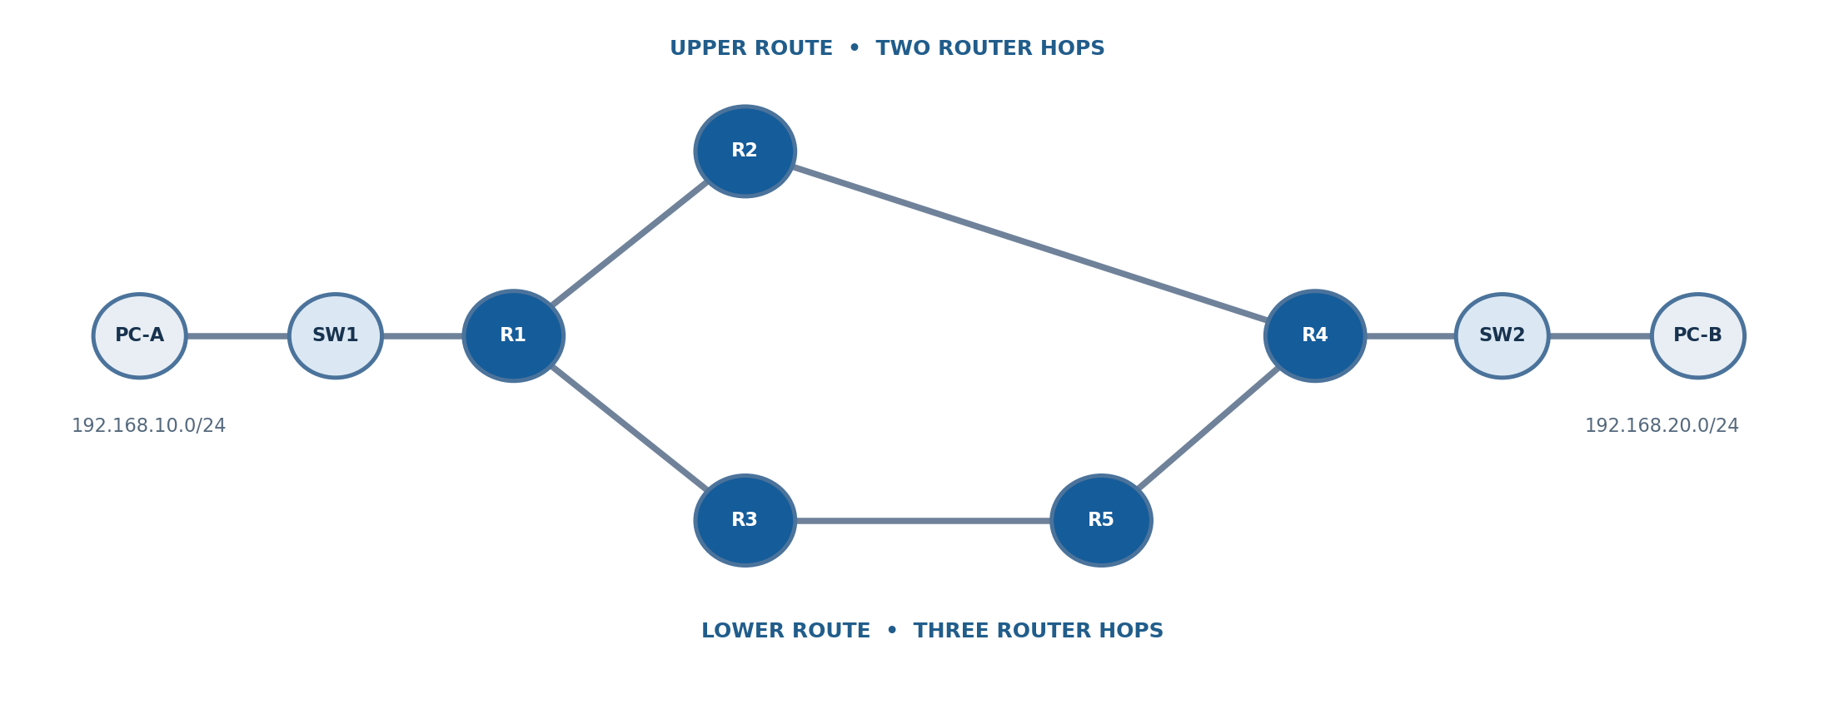
Figure 1. Planned logical topology (author-created diagram, not a Packet Tracer screenshot).
Path A: R1–R2–R4 (two inter-router hops). Path B: R1–R3–R5–R4 (three inter-router hops). The two end LANs use 192.168.10.0/24 and 192.168.20.0/24. Switch SW1 connects PC-A to R1; SW2 connects R4 to PC-B.
Inter-router link | Subnet | Router interfaces
R1–R2 | 10.0.12.0/30 | R1 Gi0/1; R2 Gi0/0
R2–R4 | 10.0.24.0/30 | R2 Gi0/1; R4 Gi0/1
R1–R3 | 10.0.13.0/30 | R1 Gi0/2; R3 Gi0/0
R3–R5 | 10.0.35.0/30 | R3 Gi0/1; R5 Gi0/0
R5–R4 | 10.0.45.0/30 | R5 Gi0/1; R4 Gi0/2

7. Proposed Methodology
A. Build
Construct five 2911 routers, two 2960 switches and two PCs. Apply the saved addressing and physical port map.
B. Configure
Create distinct RIPv2 and OSPFv2 Packet Tracer projects. Verify route installation and OSPF adjacency.
C. Baseline
Collect ICMP/traceroute evidence and the selected network route after convergence.
D. Failure
Shutdown R2 Gi0/1. Observe routing-table changes and delivery resumption on the remaining three-hop path.
E. Restore
Enable R2 Gi0/1 again and document whether/when the upper path returns.
F. Cost scenario
Apply upper-link OSPF cost 100 and lower-link cost 10 in a separate OSPF copy; compare path choice.
G. Analyze
Record at least three matched trials per measurable condition in CSV and view charts in Streamlit.

8. Coding and Implementation
Cisco configuration files are stored under configs/base, configs/rip and configs/ospf. For simplified setup, configs/paste_ready contains combined CLI commands for every router and protocol. RIP configuration uses router rip, version 2 and no auto-summary; OSPF uses router ospf 1, distinct router IDs, area 0 and a passive LAN interface on the edge routers. The Python dashboard uses Streamlit, Pandas and Plotly and is launched by START_DASHBOARD_WINDOWS.bat.
The dashboard offers six tabs: Overview, Network lab, Experiments, Measurements, Algorithms and Submission. Its local routing model uses breadth-first shortest-hop selection for RIP and a Dijkstra shortest-cost model for OSPF. These are pedagogical static models, not emulations of protocol message exchange, timers or Packet Tracer device state.
Input validation rejects negative packet counts, impossible received > sent values, non-integer hop measurements and convergence values without a declared timing basis. Delivery percentage is computed as 100 × received / sent. The dashboard groups timings only under the same reported measurement basis.

9. Screenshots and Results
TO COMPLETE AFTER EXECUTION: Insert actual Packet Tracer screenshots here. Do not substitute the author-created topology diagram for router verification screenshots. Provide RIP and OSPF baseline routing tables, failed-link alternatives, OSPF neighbor output, restoration evidence and cost-override evidence.
Protocol | Case | Run | Measured recovery (s) | Sent / Received | Observed path
RIP | Failure | 1–3 | Not measured | Not measured | To verify
OSPF | Failure | 1–3 | Not measured | Not measured | To verify
RIP | Restoration | 1–3 | Not measured | Not measured | To verify
OSPF | Restoration | 1–3 | Not measured | Not measured | To verify
The table intentionally contains NO fabricated experimental numbers. After testing, replace it with exported CSV summaries and real evidence. If the simulator does not offer sufficiently reliable convergence timestamps, report qualitative state transitions rather than precision timing.

10. Conclusion and Future Development
The project implementation supplies a reproducible dual-protocol network design and visualization interface. The expected baseline is the two-hop route via R2; following R2–R4 failure the three-hop path via R3 and R5 remains physically available. Separately configured OSPF link costs can favor the lower route even when RIP selects fewer hops. These are model predictions and routing principles, NOT confirmed Packet Tracer measurements. A final claim about which protocol recovered faster requires the actual experiment data. Future work can use an emulator with programmatic telemetry, additional topologies and controlled link delays to support higher-fidelity convergence analysis.

11. References
• RFC 2453. Malkin, G. (1998). RIP Version 2. https://www.rfc-editor.org/rfc/rfc2453
• RFC 2328. Moy, J. (1998). OSPF Version 2. https://www.rfc-editor.org/rfc/rfc2328
• Cisco Systems. Cisco IOS IP Routing: RIP Command Reference. https://www.cisco.com/c/en/us/td/docs/ios/iproute_rip/command/reference/irr_book/irr_rip.html
• Cisco Systems. What Does the show ip ospf interface Command Reveal? https://www.cisco.com/c/en/us/support/docs/ip/open-shortest-path-first-ospf/13689-17.html
• Additional 15 recent peer-reviewed research references: TO BE VERIFIED AND INSERTED FROM THE ATTACHED REVIEW WORKSHEET.

Declaration
We hereby declare that the report entitled “Performance Analysis of Distance Vector and Link State Routing Protocols Using Cisco Packet Tracer and an Interactive Python Dashboard” submitted for BITE305L – Computer Networks to Vellore Institute of Technology represents work carried out by the team under the supervision of the faculty member named on the finalized title page.
This working draft requires names, faculty verification and completed experiment evidence before it may be signed and submitted.
Place: Vellore
Date: ________________________
Signature of Candidate 1: _______________________
Signature of Candidate 2: _______________________
Signature of Candidate 3 (if applicable): _______________________

