Question 2 — Fine-Tuning Report
Course: Agentic AI (AI4015)
Assignment: Beta
Student ID: 23k-6005
Base model: Qwen2.5-1.5B-Instruct

1. What I did
In this analysis, I evaluated four different methods for fine-tuning the same language model: LoRA, QLoRA, DoRA, and AdaLoRA. I also assessed the original model without any fine-tuning to determine if training had an impact.
I utilized 2,000 instances from the Glaive function-calling dataset: 1,800 for training and 200 for testing purposes. The preparation script eliminated repeated user prompts and ensured that the training and test questions remained distinct. The experiments were conducted on my laptop GPU, which is an RTX 4050.
To ensure a fair comparison, I maintained consistent parameters, including the same model, training examples, random seed (42), one epoch, learning rate (0.0002), cosine learning-rate schedule, effective batch size (8), and target modules. All models were evaluated on the identical set of 200 examples, without any random sampling in their responses.
I evaluated three aspects: whether the model produced valid JSON, whether it selected the appropriate tool, and whether both the tool name and all arguments corresponded with the expected answer. Additionally, I recorded training duration, GPU memory usage, and evaluation time.

2. Results of the five main tests
Model | Trainable parameters | Peak training GPU memory | Training time | Valid JSON | Correct tool | Full match | Evaluation time per query
Original model | 0 (0%) | Not applicable | Not applicable | 200/200 | 200/200 | 187/200 | 0.404 s
LoRA (r=8) | 9,232,384 (0.5945%) | 4.13 GB | 11.5 min | 200/200 | 200/200 | 192/200 | 0.998 s
QLoRA (r=8) | 9,232,384 (0.5945%) | 2.81 GB | 16.3 min | 200/200 | 200/200 | 191/200 | 0.855 s
DoRA (r=8) | 9,877,504 (0.6358%) | 4.14 GB | 57.9 min | 200/200 | 200/200 | 191/200 | 5.618 s
AdaLoRA (initial r=12, target r=8) | 13,851,124 (0.8893%) | 4.40 GB | 16.8 min | 200/200 | 200/200 | 187/200 | 0.691 s
All models returned valid JSON and chose the correct function across 200 test questions. The variations stemmed from the argument values used in the function calls.
LoRA achieved the highest rate of full matches: 192 correct answers out of 200, translating to 96%. This marked an improvement over the original model’s performance of 187 out of 200 (93.5%). QLoRA was nearly as precise but required the least amount of GPU memory. DoRA scored 191 out of 200, yet it necessitated significantly more training time and exhibited a noticeable slowdown during evaluation in this setup. These are measurements from my laptop, not general speed guarantees for these methods.

3. Does using a higher LoRA rank help?
LoRA had the best full-match result, so I tested it again with ranks 4, 16 and 32. The rank-8 result from the first comparison was also included.
Rank | Trainable parameters | Peak GPU memory | Correct tool | Full match
4 | 4,616,192 | 4.06 GB | 200/200 | 191/200 (95.5%)
8 | 9,232,384 | 4.13 GB | 200/200 | 192/200 (96.0%)
16 | 18,464,768 | 4.26 GB | 200/200 | 192/200 (96.0%)
32 | 36,929,536 | 4.58 GB | 200/200 | 191/200 (95.5%)
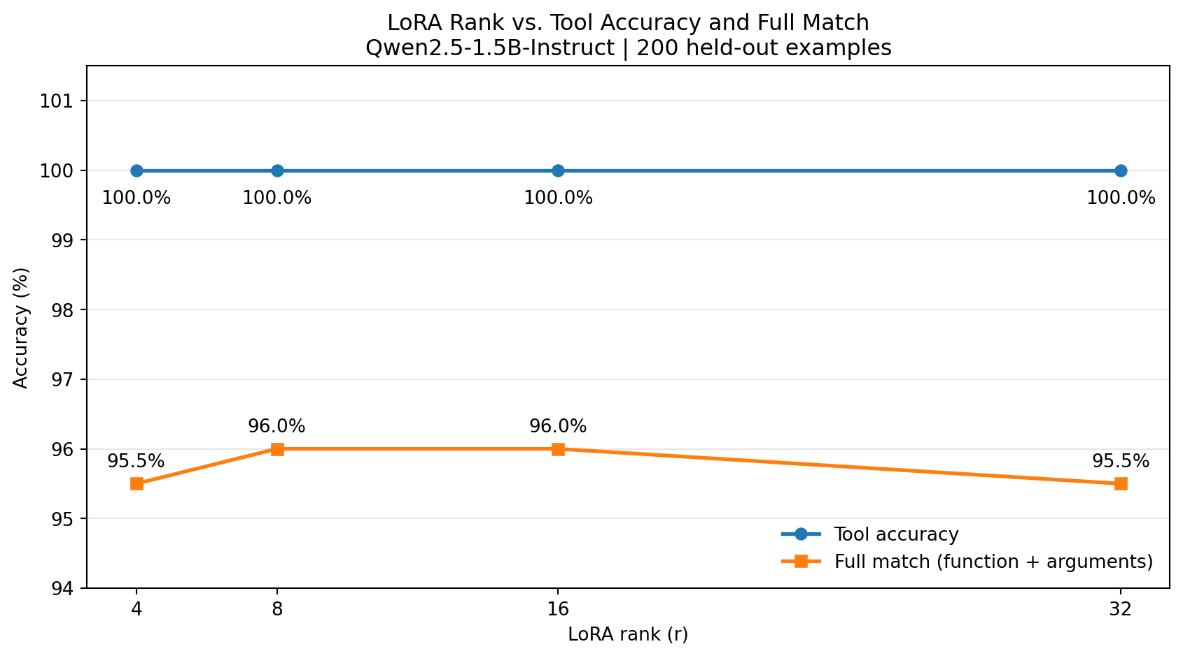
LoRA Rank vs Accuracy
LoRA rank on the x-axis (4, 8, 16, 32) and tool accuracy (%) on the y-axis (100%, 100%, 100%, 100%). The full-match accuracy line is 95.5%, 96%, 96%, 95.5%.
Employing a higher rank did not enhance the accuracy of tool selection, as every rank achieved 100%. Rank 16 achieved the same full-match accuracy as rank 8 but required double the number of adapter parameters. Rank 32 consumed even more memory and parameters without yielding any improvement in scores. From these experiments, I would opt for rank 8. The variations in training times were not consistent enough to determine that rank was solely responsible for the timing fluctuations.

4. Which method would I use?
I would select LoRA with rank 8 for this evaluation. It provided the highest full-match score, completed its training in 11.5 minutes, and had a peak training memory usage of 4.13 GB, which was suitable for my laptop GPU.
If GPU memory were the main concern, I would consider QLoRA. It only utilized 2.81 GB and lagged just one full match behind LoRA. I would not opt for DoRA in this specific setup, as it took significantly longer without demonstrating improved accuracy.
This does not indicate that LoRA will be the optimal choice for an actual online store. My experiments were conducted using a general function-calling dataset, rather than a specialized set focused on refund, order-status, and shipment inquiries. Prior to deploying it with customers, I would evaluate the model on those specific tasks, verify that its arguments conform to the backend’s JSON schema, and ensure it requires proper authorization for actions like refunds. Additionally, the evaluation times were recorded with the adapters used in this test; they do not represent a controlled comparison of merged production models.

5. Five mistakes made by the best model
The following examples are taken from the saved predictions of LoRA rank 8. In each case, the function name was right but at least one argument was different from the expected answer.
# | Customer message | Expected function call | Model’s function call | Type of mistake
1 | “I am looking for a mystery book by Agatha Christie.” | search_books(query="mystery", author="Agatha Christie") | search_books(query="", author="Agatha Christie", genre="mystery") | Put the word in a different field and left query empty
2 | “I’m looking for a Mexican recipe that uses chicken and tomatoes. I’m also lactose intolerant.” | search_recipes(cuisine="Mexican", ingredients=["chicken", "tomatoes"], dietary_restrictions=["lactose intolerant"]) | search_recipes(cuisine="Mexican", ingredients=["chicken", "tomatoes"], dietary_restrictions=["lactose"]) | Shortened an argument value
3 | “I am looking for a book but I can’t remember the full title. It’s something like ‘To Kill a’.” | search_book(query="To Kill a") | search_book(query="To Kill") | Left out part of the title
4 | “Hi, I need to get from New York to Los Angeles. Can you help me with the directions?” | get_directions(origin="New York", destination="Los Angeles", mode="driving") | get_directions(origin="New York", destination="Los Angeles") | Left out the expected mode argument
5 | “I’m looking for a good Italian restaurant in New York. Can you help?” | search_restaurants(location="New York", cuisine="Italian", price_range="medium") | search_restaurants(location="New York", cuisine="Italian") | Left out the expected price range
I noticed a common pattern: the model understood which tool to call, but sometimes it shortened, moved or missed an argument. For an actual shopping website, I would check every tool call against its expected JSON schema before running it. If important information is missing, the chatbot should ask the customer or repair the call instead of guessing.

6. How LoRA could help in a multi-agent system
Imagine an online store utilizing three different AI agents: one designated for request routing, another for managing refunds, and a third for handling shipping. Instead of developing three distinct complete models, the organization could maintain a single base model and implement a small LoRA adapter tailored for each specific function. This approach should minimize both storage requirements and training resource consumption.
A potential risk involves the possibility of loading an incorrect adapter while the system interacts with customers. For instance, a question regarding refunds might inadvertently be addressed with the shipping adapter. Consequently, each request must be associated with the appropriate adapter, and the system should ensure that there is no unsafe transition between requests.

7. What surprised me
I anticipated that fine-tuning would enhance the model’s selection of tools. However, the original model correctly identified the appropriate function in all 200 test cases. The majority of the enhancement was in selecting the specific argument values. I was also taken aback to find that increasing the LoRA rank beyond 8 did not yield a better final score. Rank 16 matched rank 8, while rank 32 performed slightly worse.

8. AI tools used
I utilized ChatGPT/Codex to assist with Python scripts, verify calculations, create tables and graphs, and revise the report. I executed the training and evaluation commands locally on my laptop. The findings and five error examples included in this report originate from the saved experiment files. I compared those findings with the output logs.

