QPI Queries on Client Services

# Point 1

* Under Client Data, the “Info” column should be the last column. The “Directory” column should be to the left of that. **Done in CCI Sub-Site**

<https://qpihealthcareservices.sharepoint.com/ClientServices/CODECREATORS/>

**This should look like the Old Sub- Site. Columns from left to right are Location → Directory → Info.**

**Old Sub-Site:**

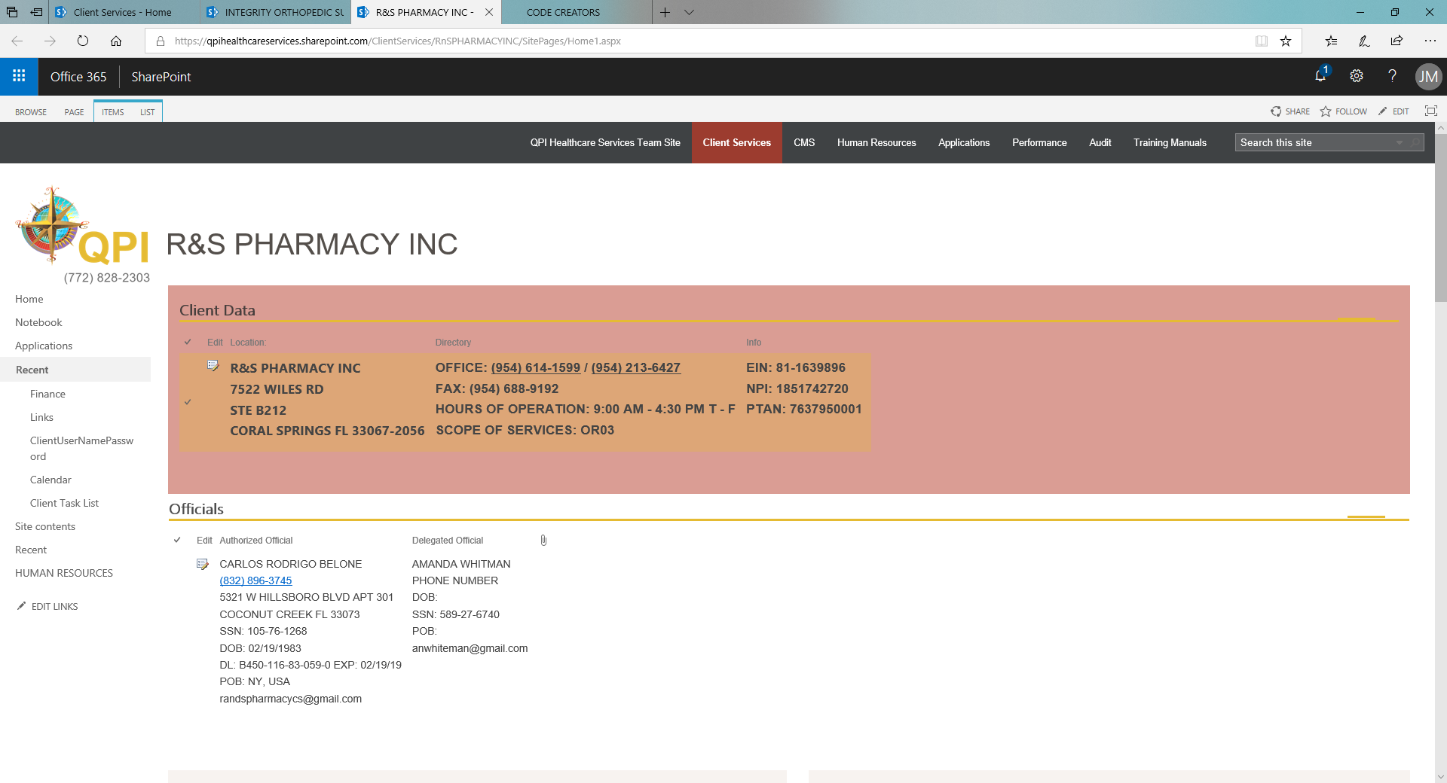

**New Sub-Site:**

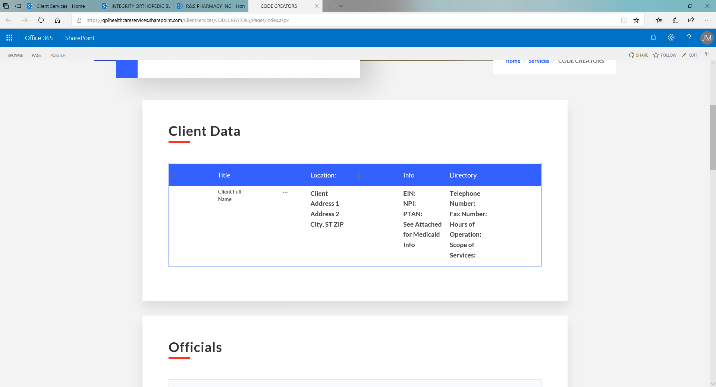

# Point 2

* Will we have the ability to add multiple Authorized Officials and Delegated Officials to the Officials section? We can only see 1 of each for now. That’s mostly ok for our companies under sole ownership, but in rare instances, there are 50/50 partnerships. We’d like to know how to add more than 1 Authorized Official, and subsequently 1 more Delegated Official.

**I’ve attached a Screen Recorder for the steps through which you can add multiple officials.**

**This looks great. Thank you!**

# Point 3

* On the QPI Task List and the Client Task List:
  + Add Company Info

**It’s already available in QPI Client task list section when someone creates a new QPI task list as shown in screenshot. Did you want to get it added on Client task list?**

**No. That’s fine. I forgot we had that there.**

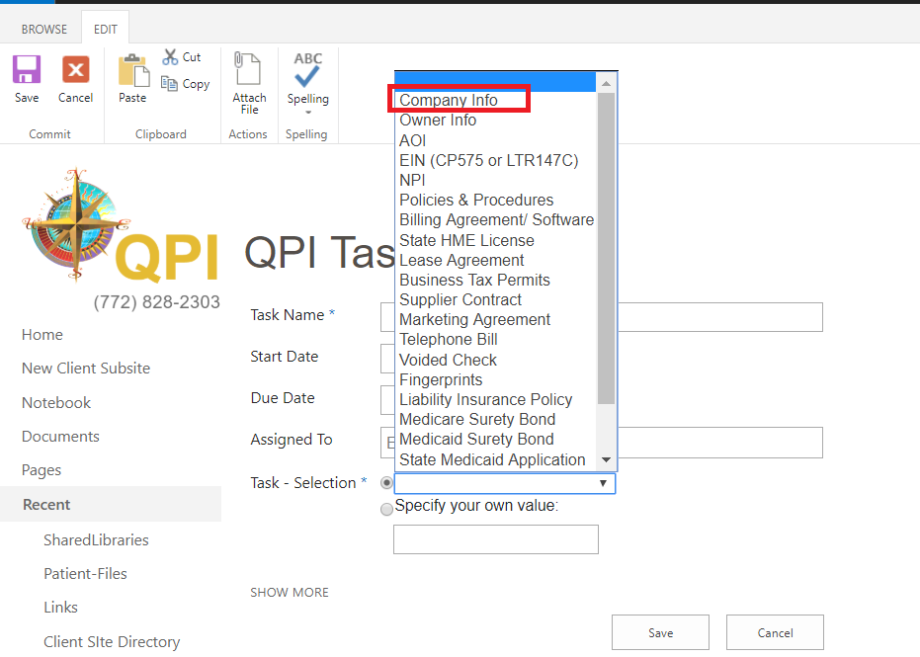

* + Revise “Lead Generation Agreements/ BAA’s” to “Marketing Agreements”

**“The Marketing Agreements is already there when someone creates new task in QPI list as shown in screen shot. One thing that we‘ve found that the task already created with the name “Lead Generation Agreements/BAA’s” is not renamed to Marketing Agreement. Did you like us to rename that?**

**Yes, please. This was originally changed in the template with Innovative Architects, but not made to our existing clients. That may have been the issue. So long as it is changed everywhere, that’s fine.**

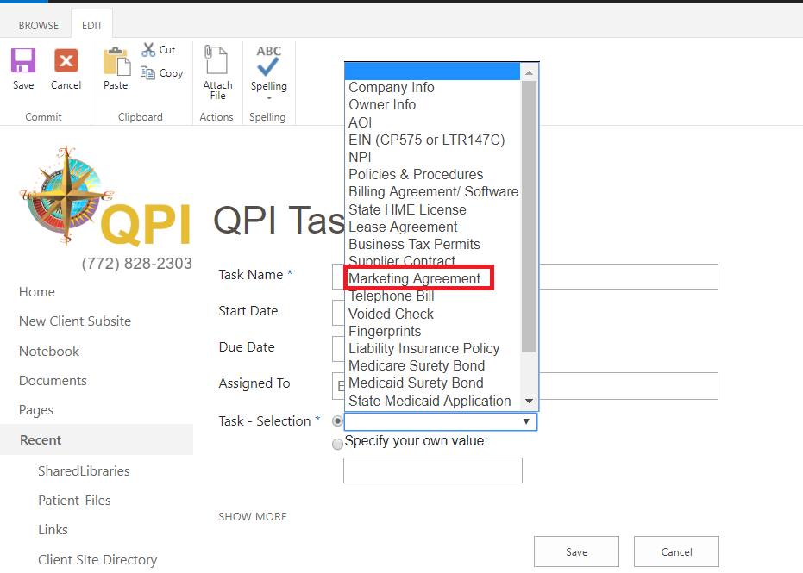

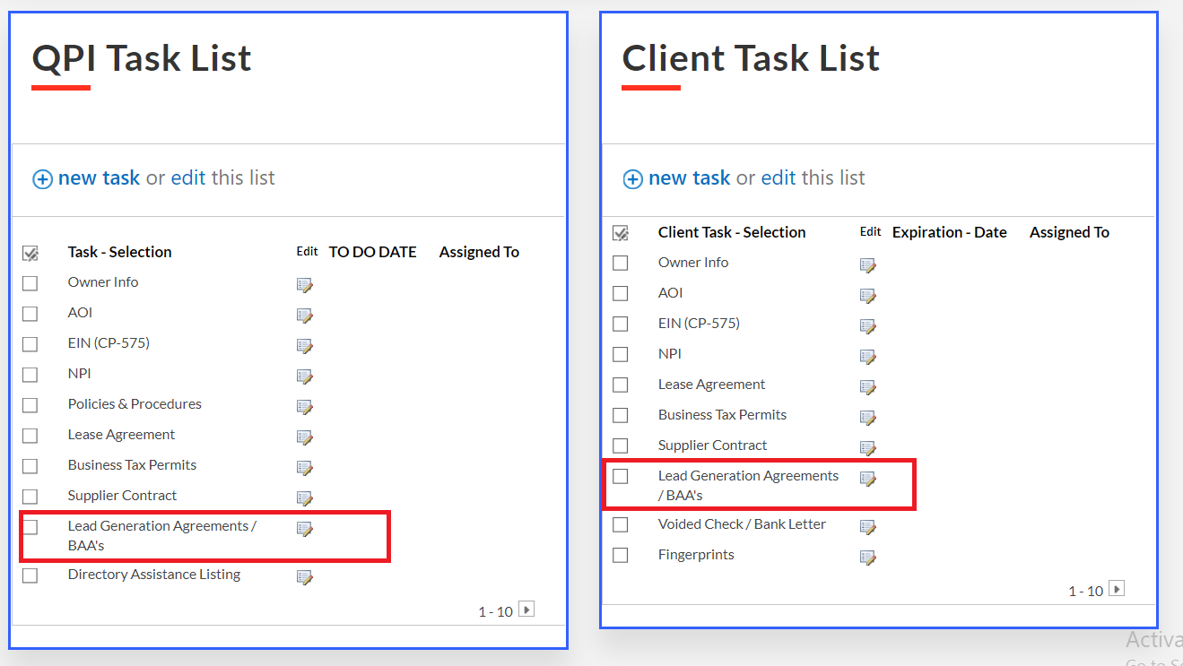

* + Add Billing Info/ Agreements

**Are Billing Agreement/Software and Billing Info/Agreements the same? If it’s different we can add. Please, let us know if we have to add it on QPI task list or client task list?**

**No, they are not different. It typically hasn’t appeared in the QPI Task List on new-starts. Can you see if this is showing, please?**

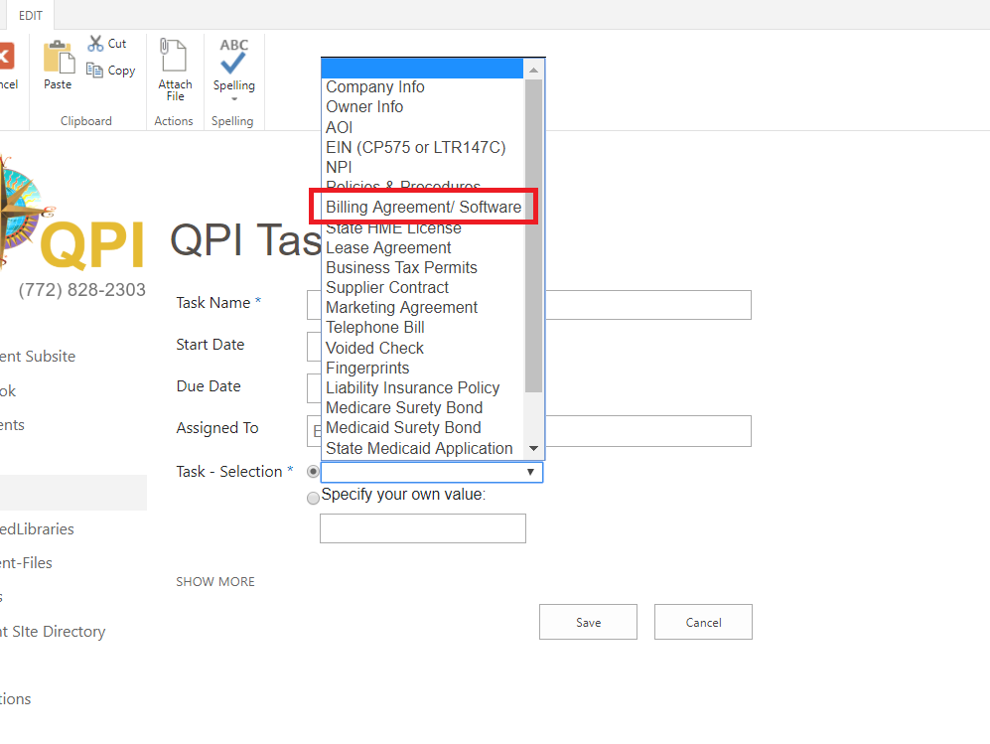

* + Revise “Directory Assistance Listing” to “YellowPages Listing”

**Currently the Directory Assisting Listing is not available on a task selection LOV’s. The custom name is assigned to the task. Would you like us to add a task with the name Yellow Pages Listing”**

**Yes, please add the task. This is a crucial part to setting up our DME companies.**

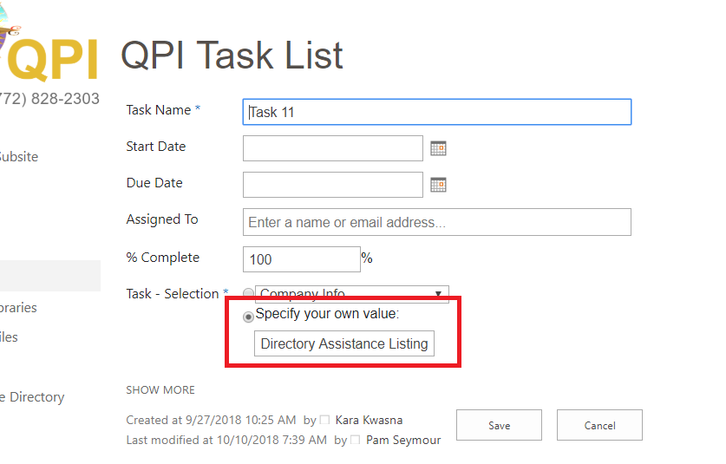

* + Add Phone Bill

**This needs to be added in QPI task list or client task list?**

**QPI Task List.**

* + There are some duplicates (ex: Business Tax Permits) on the Client Task List.

Yes, this was just added to check the color code for our testing. The duplication will not be there when we go live.

**Ok, great!**

**General Question and Notes:**

* Could you please, specify in front of each task whether its to be added on QPI task list or client task list or both so that we can add accordingly.

**Yes, going forward. I don’t think we need to add anything else though.**

* Currently, when a sub-site is created the tasks appear by default on the QPI task list and the client task list. Did you want to add it in by default sub-site creation or we can remove the default setting too?

**We’d like to keep the default. We select those tasks as complete as we receive the data from the DME company owner.**