# Point 1

* The client data should like the Old Sub-Site. Columns from left to right are Location → Directory → Info.

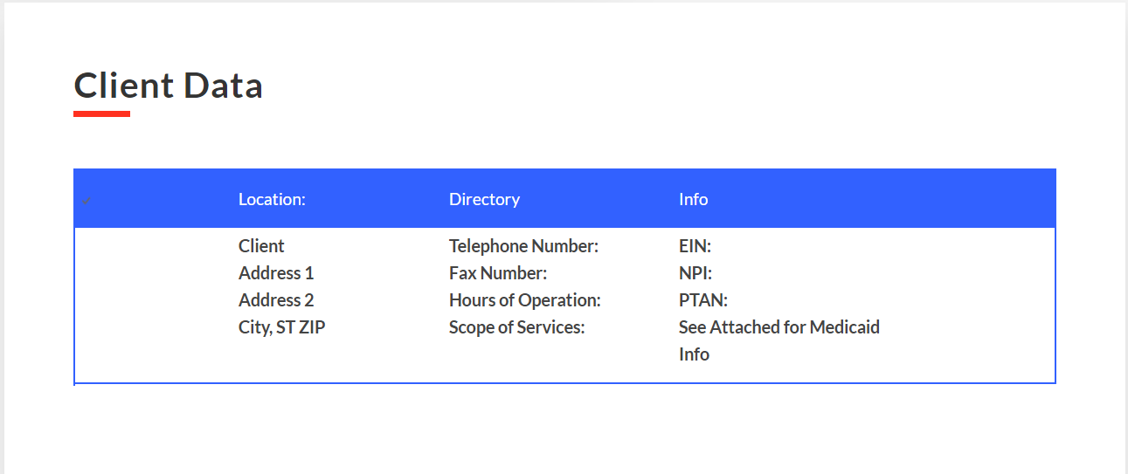

# Point 2

* Revising “Lead Generation Agreements/ BAA’s” to “Marketing Agreement” was done by the previous agency. We’ve edited the name in CCI sub-site. Like this after the downtime when the changes on each sub-site are done we’ll be editing the name “Lead Generation Agreements/ BAA’s” to “Marketing Agreement” by going on each sub-site.

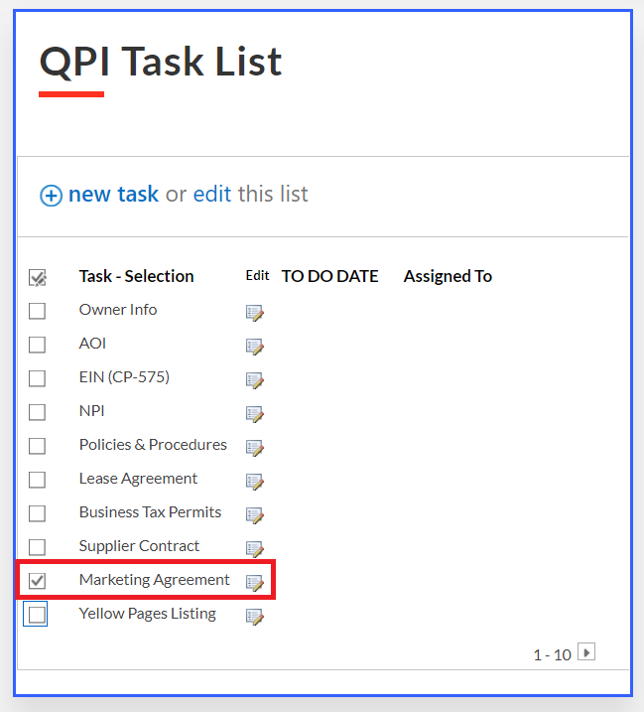

# Point 3

* “Billing Agreement/Software” and “Billing Info/Agreements” are the same. So, we’ve renamed “Billing Agreement/Software” to “Billing Info/ Agreements”.

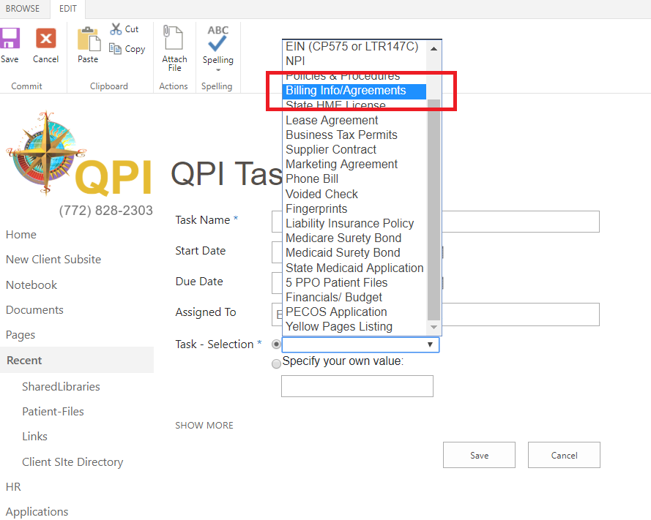

# Point 4

* “YellowPages Listing” task is added in the LOV’s of QPI task list. We’ve done in the CCI page. Like this we’ll be doing in all sub-sites during the downtime.

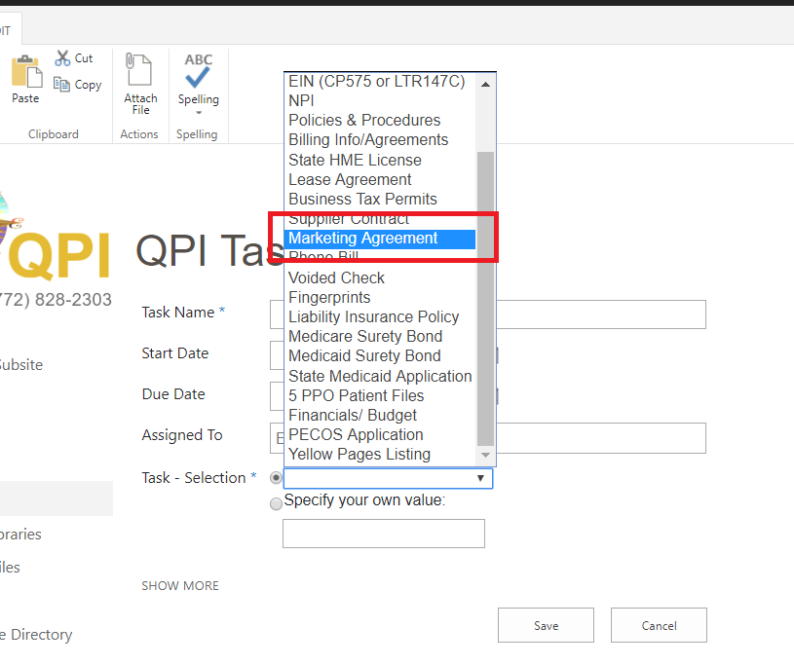

# Point 5

* “Phone Bill” is added in QPI Task list. We’ve done in the CCI page. Like this we’ll be doing in all sub-sites during the downtime.

