AI-Powered Meeting Summarizer - User Manual

1. Overview
The AI-Powered Meeting Summarizer is a Windows desktop application that automatically:
- Transcribes meeting audio
- Summarizes long discussions
- Extracts Action Items
- Extracts Important Dates
- Generates a clean, shareable PDF Report
Users only need to run the EXE file - no installation or technical steps required.
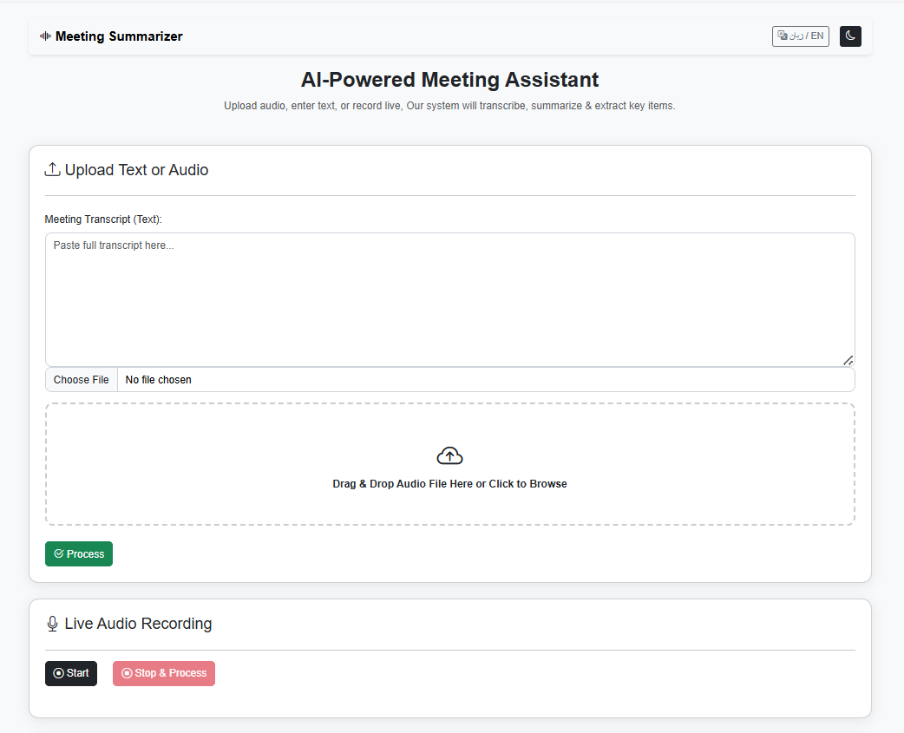
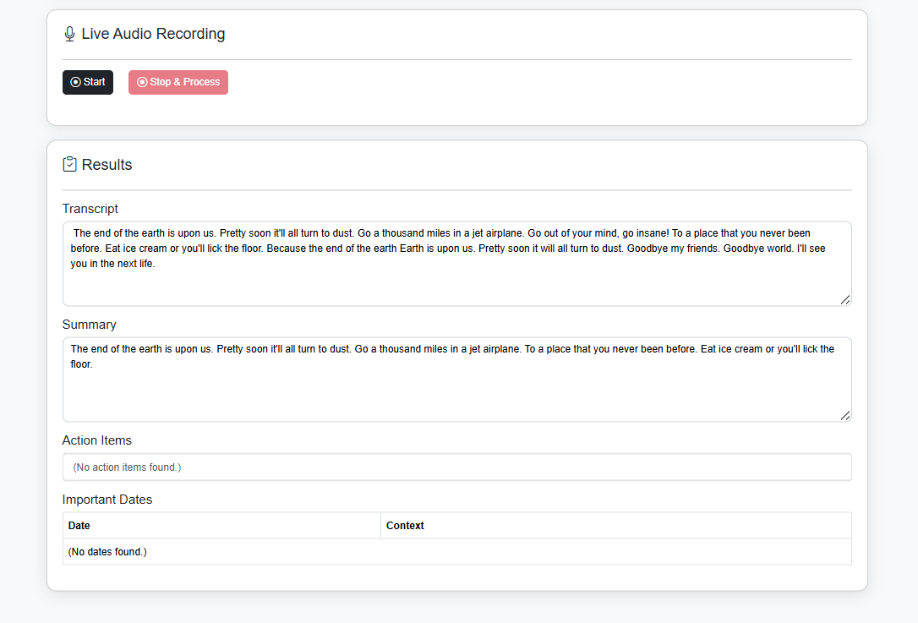

2. System Requirements

Hardware
- CPU: Intel i3 or higher
- RAM: 4 GB+
- Storage: ~300 MB free
- Internet (first run only)

Software
- Windows 10 or newer
- No support for Linux/Mac/Mobile devices
- No additional setup required

3. Running the Application

3.1 Starting the EXE
- Double-click the provided file:
AI-Meeting-Summarizer.exe
- A terminal window will open.
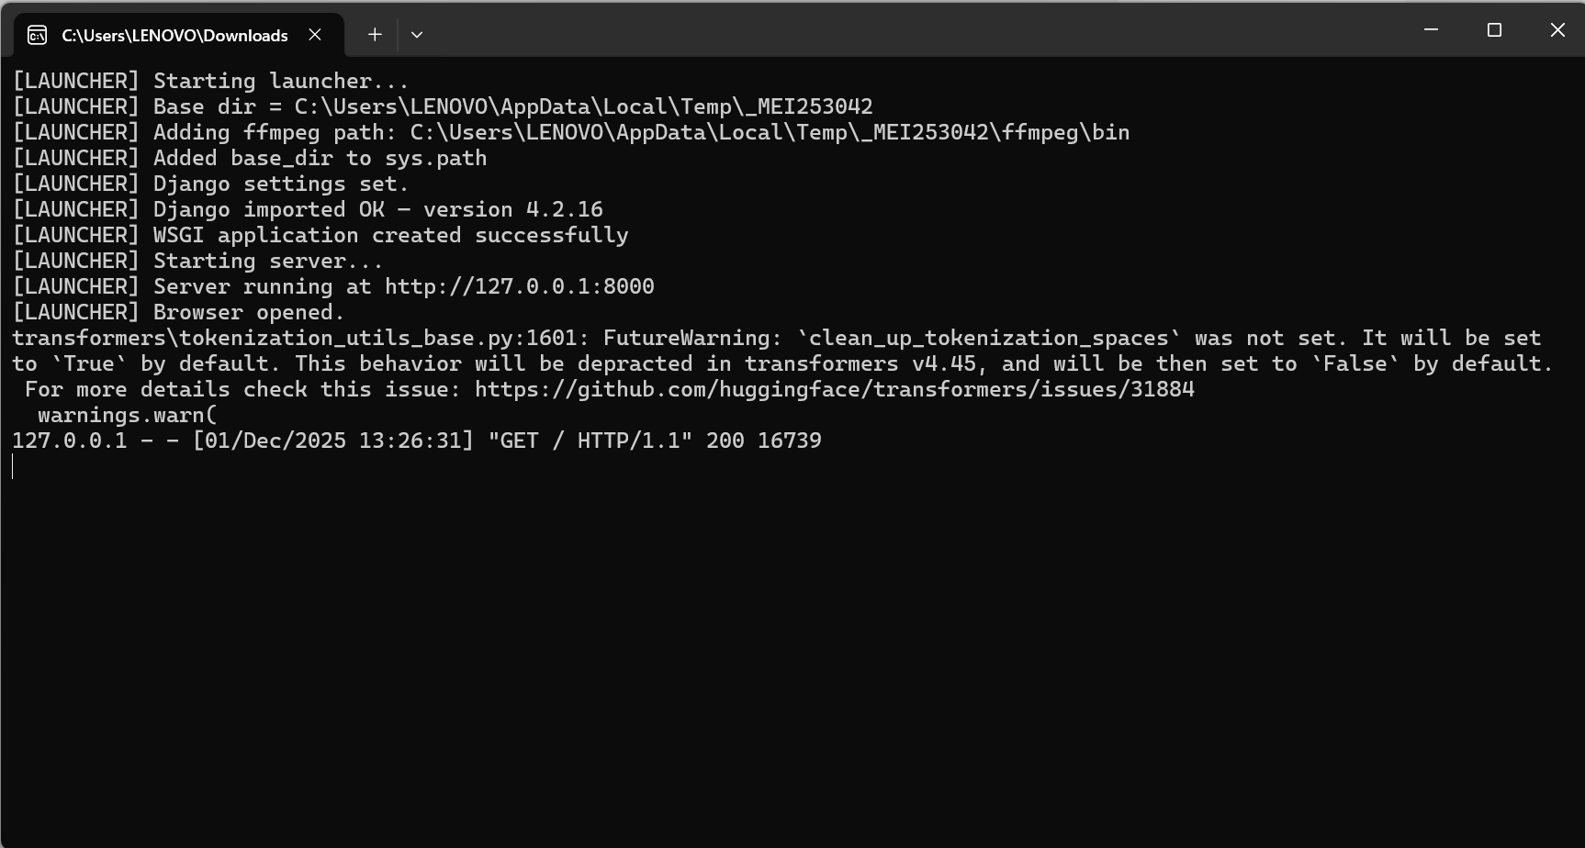

3.2 First-Time Model Downloads
During the first run:
- Whisper model downloads for audio transcription
- BART model downloads for summarization
The terminal will show logs such as:
- “Downloading model…”
- “Loading Whisper…”
- “BART model initialized.”
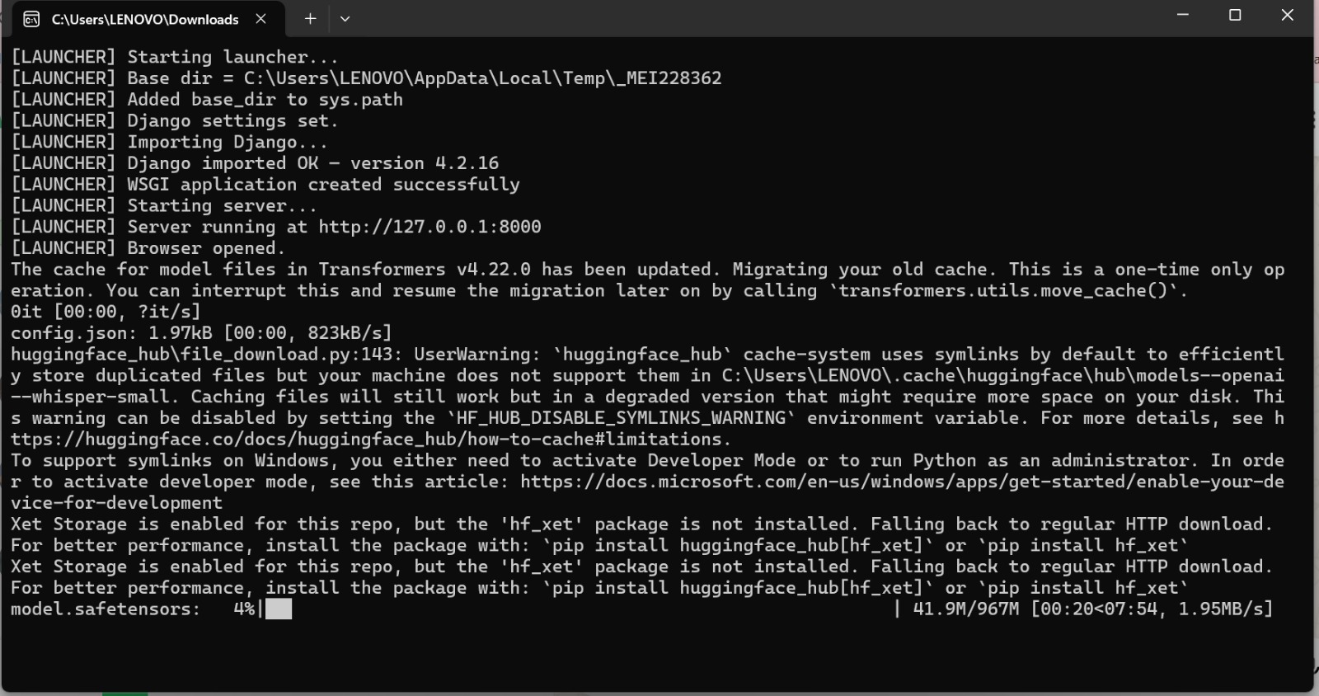
This requires an active internet connection but only once.

3.3 Automatic UI Launch
Once the server is ready:
- Your browser will automatically open at
http://127.0.0.1:8000
If not, open it manually.
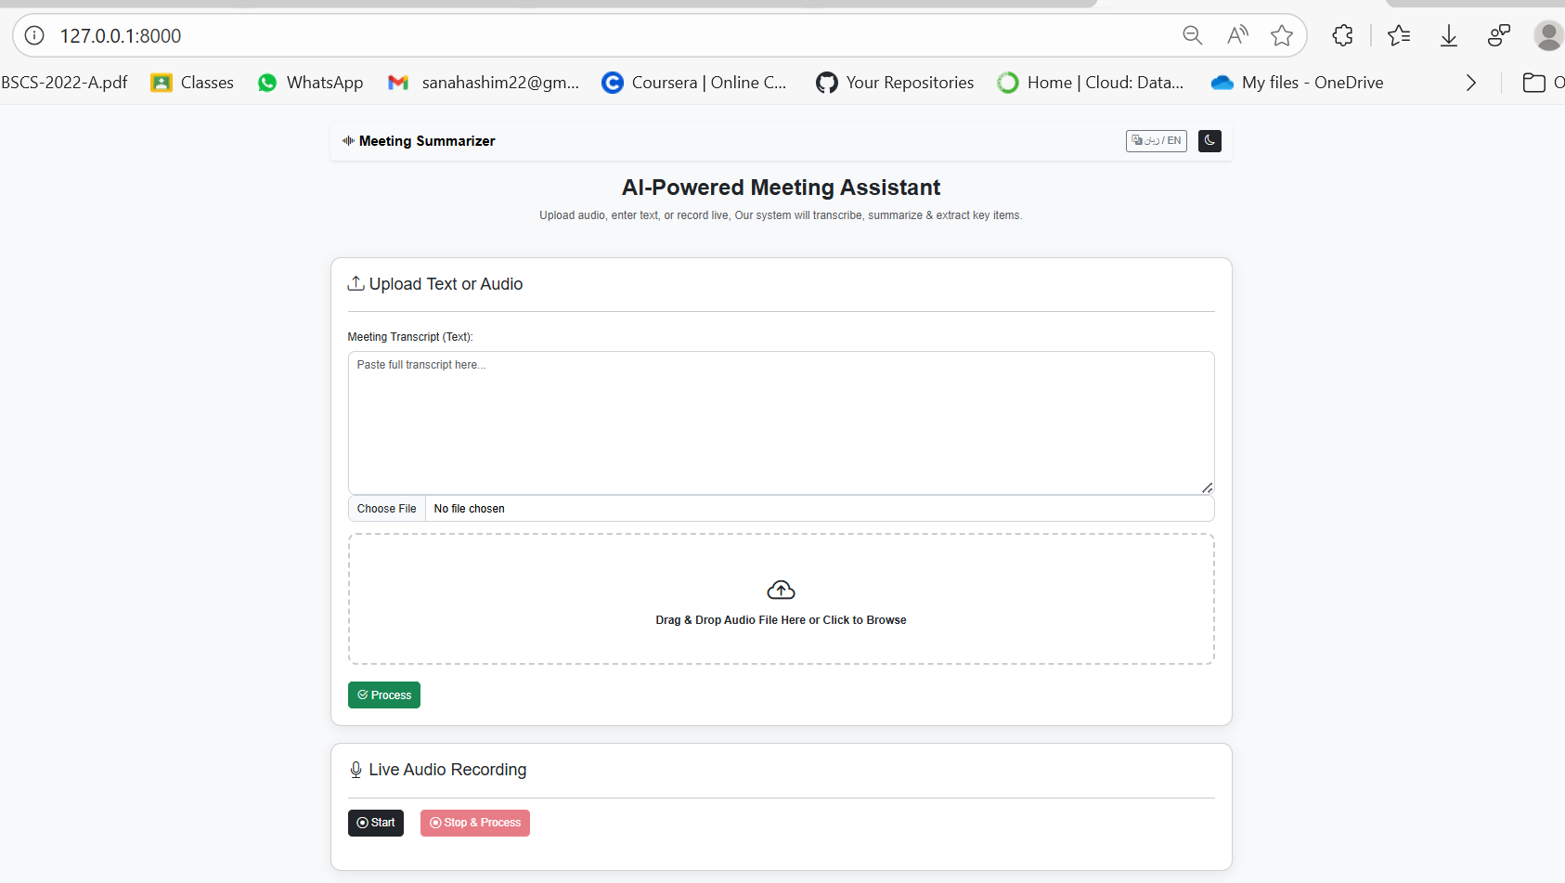

4. Using the Application

4.1 Upload Text or Audio
The main interface provides:
- Text box for typing or pasting transcripts
- Button to choose an audio file
- Drag & drop audio upload area
- Live audio recording

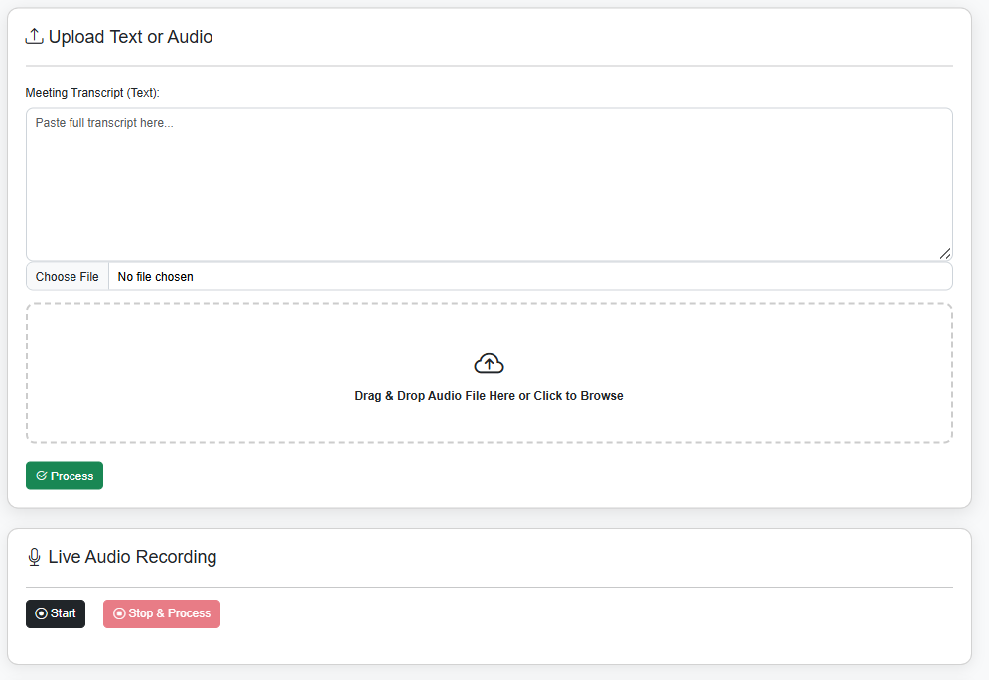

4.2 Audio Upload Progress
When audio is uploaded:
- Progress bar shows 0% → 100%
- Status changes from Uploading… to Upload Complete
- Selected file name appears
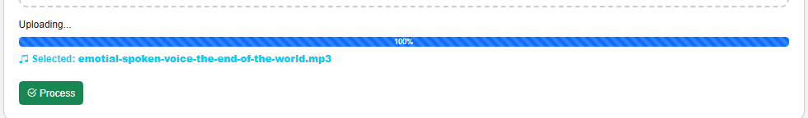

4.3 Processing the Input
After uploading audio or entering text:
- Click Process
- The system will:
  - Convert audio → text (Whisper)
  - Generate summary (BART)
  - Detect action items
  - Extract important dates
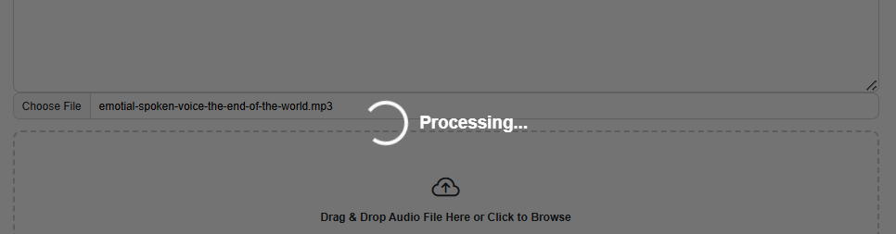

5. Results Section
After processing, four sections appear:

5.1 Transcript
Shows the full meeting transcript.
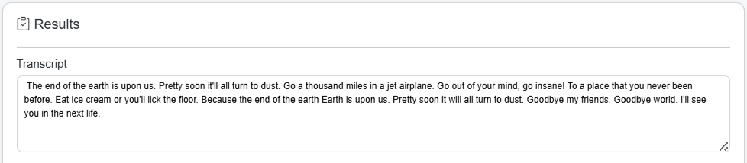

5.2 Summary
Displays a concise summary generated by the AI.
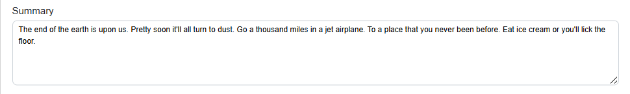

5.3 Action Items
Lists tasks extracted from the transcript.
If none: “(No action items found.)”

5.4 Important Dates
Shows all dates detected within the content.
Each date includes context.


6. Export to PDF
Click the blue floating button to export results.
The PDF contains:
- Summary
- Transcript
- Action Items
- Important Dates
 Export PDF button

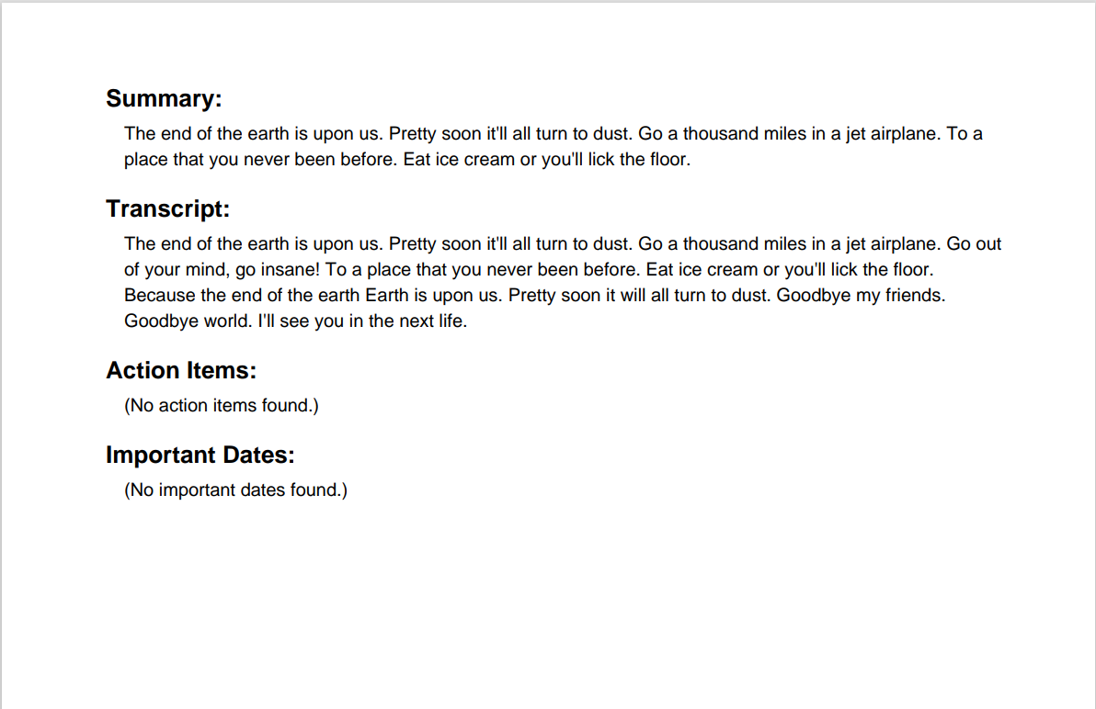

7. Terminal Logs & Debug Messages
The terminal always stays active while the app is running.
It displays:
- Server information
- Model loading status
- Processing logs
- Errors (if any occur)
This helps diagnose issues such as:
- Failed model downloads
- Audio processing errors
- Summarization failures
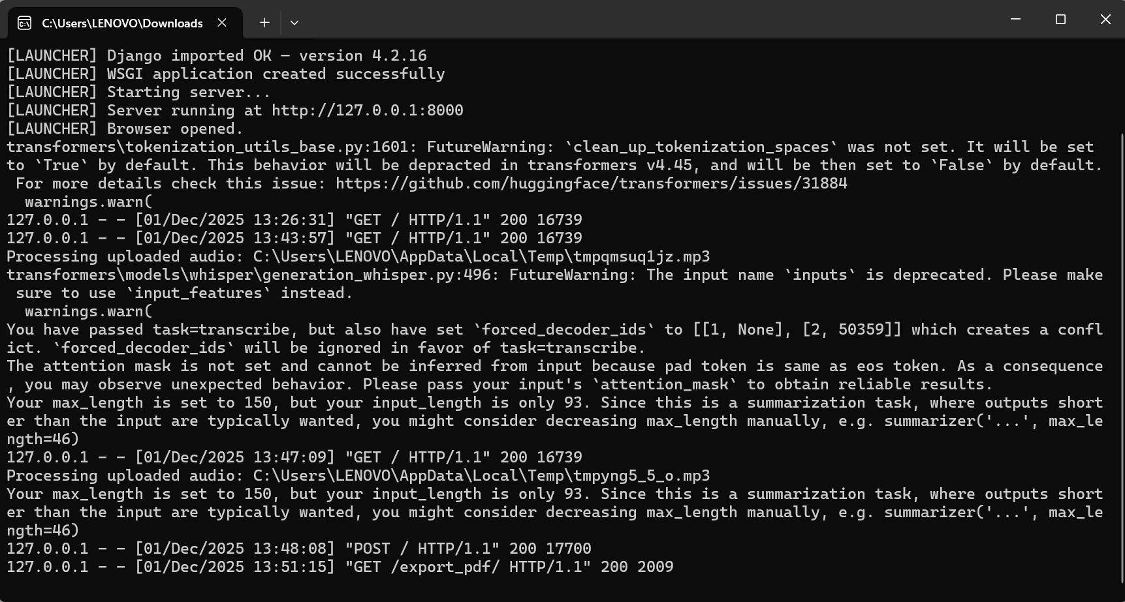

8. Stopping the Application
To safely close everything:
- Close the terminal or press Ctrl + C.
The system will then:
- Shut down the server
- Release the models
- Close background processes
- Exit cleanly

9. Features & Limitations

Features
- Simple EXE
- Browser-based clean UI
- Automatic transcription
- AI-powered summarization
- PDF export
- Real-time progress feedback
- Built-in error logging

Limitations
- Windows-only
- Internet required
- No mobile or Linux support
- Terminal must remain open during use

10. Tips for Best Results
- Keep the EXE in a simple folder path (not in OneDrive, avoid special characters)
- Ensure stable internet on first launch
- For long audio files, allow extra processing time
- Do not close the terminal during processing

11. Contact / Support
For any help or issues:
- Developer: Haris Majeed Raja, Sana Hashim
- Email: bscs22017@itu.edu.pk, bscs22101@itu.edu.pk
- Share screenshots of:
  - Terminal logs
  - UI errors
  - Uploaded file details
This speeds up troubleshooting.

