AIM

To create login page and change background color

PROCEDURE

STEP 1:select the canvas or frame according to size

STEP 2:select suitable font size and style

STEP 3:create login button

STEP 4:create circle add color to it and place it on top

STEP 5:change background color ,using “FILL TOOL”

BEFORE

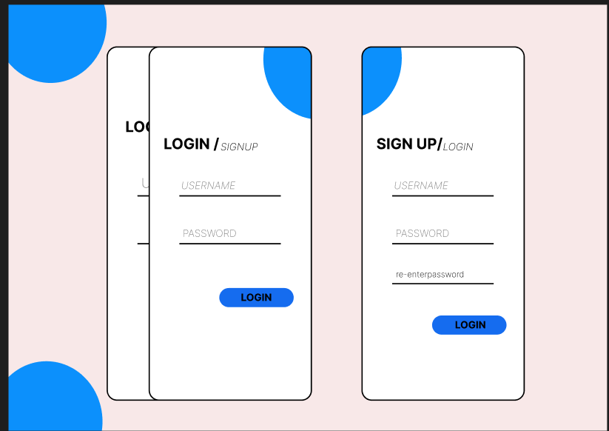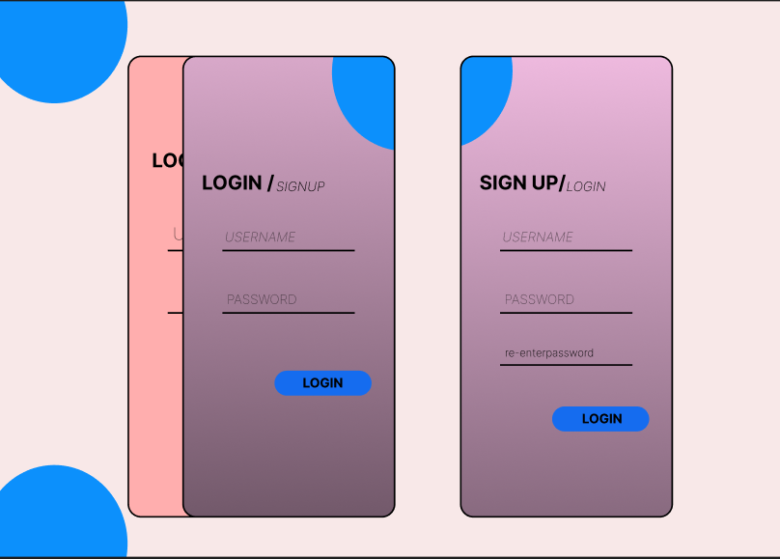

RESULT:

Therefore the background color is changed and studied