# **TASK 2: Geospatial and Open-Source Section**

# 2.1 Basic wrangling tasks and questions

1. How many GADM2 regions are present in India?

The number of GADM2 regions in India are 690.

2. Calculate population weighted pollution average of all years at country (GADM0) level.

a. Save the country level file as a CSV.

Saved as Country level population weighted avg.csv.

b. What are the 10 most polluted countries in 2021?

Bangladesh, India, Nepal, Pakistan, Mongolia, Myanmar, Democratic Republic of the Congo, Republic of the Congo, Rwanda, Burundi

3. What was the most polluted GADM2 region in the world in 1998, 2005 and 2021?

The most polluted GADM2 region in the world in 1998 was Unnao with a pollution level of 78.55 micrograms per cubic meter.

The most polluted GADM2 region in the world in 2005 was NCT of Delhi with a pollution level of 98.75 micrograms per cubic meter.

The most polluted GADM2 region in the world in 2021 was NCT of Delhi with a pollution level of 126.51 micrograms per cubic meter.

4. Plot a population weighted pollution average trendline plot for Uttar Pradesh from 1998 to 2021. Save this plot as a high-quality PNG file.

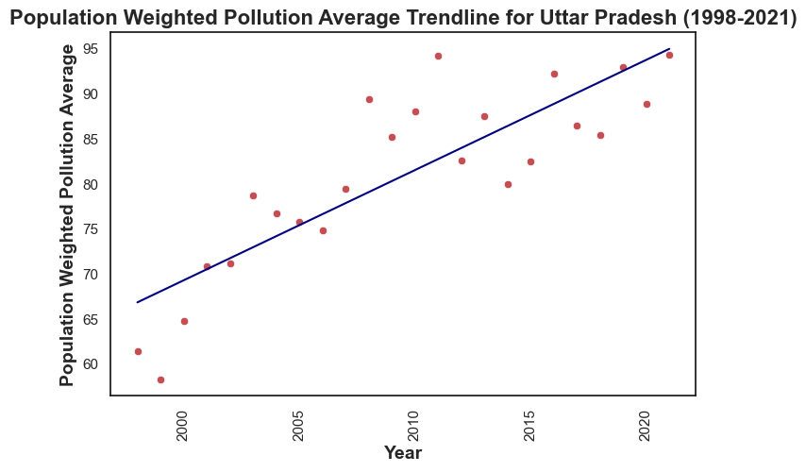

2.2 Geospatial tasks and questions

1. Plot a bar graph for the life years lost relative to the WHO guideline in the 10 most polluted countries in the world and plot them on a global country level map. For the map, the 10 most polluted country boundaries should be filled in with “dark red” and the rest of the map should be grayed out. Save both the bar graph and the map as high-quality PNG files.

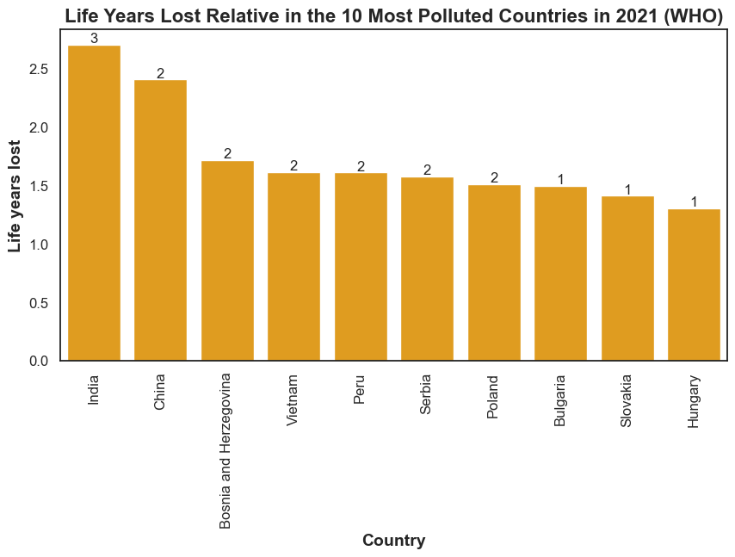

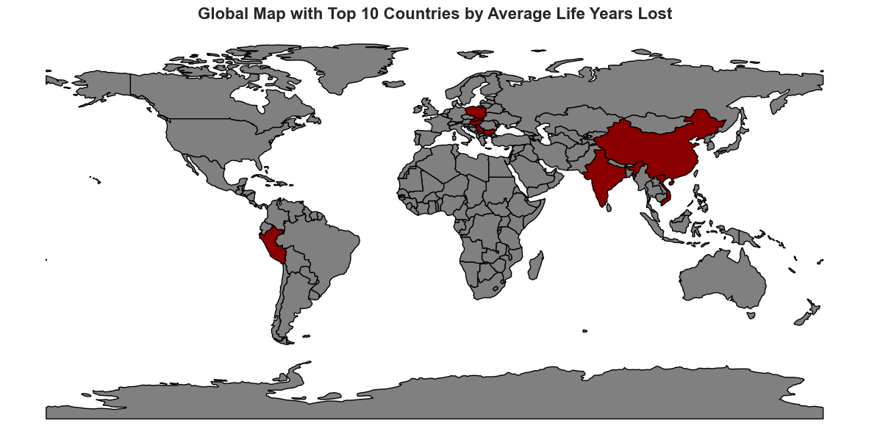

2. Create a potential gain in life expectancy (relative to the WHO guideline) map of eastern v/s western europe at GADM level 2 and save it as a high-quality PDF.

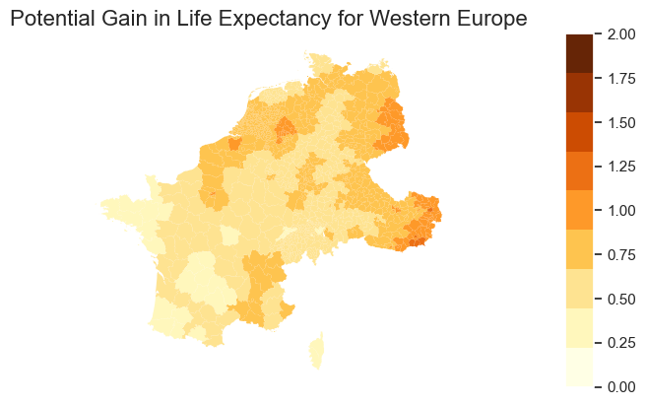

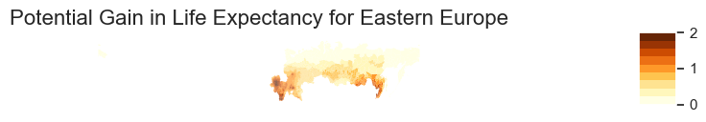

*Note: There is an issue here as some parts of Eastern Europe are not will the major part and that needs to be modified at the shapefile. Would be much easier to make that edit using GIS as we can easily identify those polygons. Tried preparing both the maps into a single pdf similar to earlier plots but it showing the following error - AttributeError: 'numpy.ndarray' object has no attribute 'plot'.*

3. Look at the AQLI website > switch to Air pollution tab > plot a static version of the global

pollution map you see there, in those “exact” same colors. Export it as a high quality (320

dpi) SVG file.

