# **Written Test I AQLI-Senior Research Associate I EPIC India**

**Task 2.2**

# Harisankar Krishnadas

GitHub report: <https://github.com/Harisankar13/Krishnadas_Harisankar_RA_Task2.2.git>

# **TASK 2: Geospatial and Open-Source Section**

2.2 Geospatial tasks and questions

1. Plot a bar graph for the life years lost relative to the WHO guideline in the 10 most polluted countries in the world and plot them on a global country level map. For the map, the 10 most polluted country boundaries should be filled in with “dark red” and the rest of the map should be grayed out. Save both the bar graph and the map as high-quality PNG files.

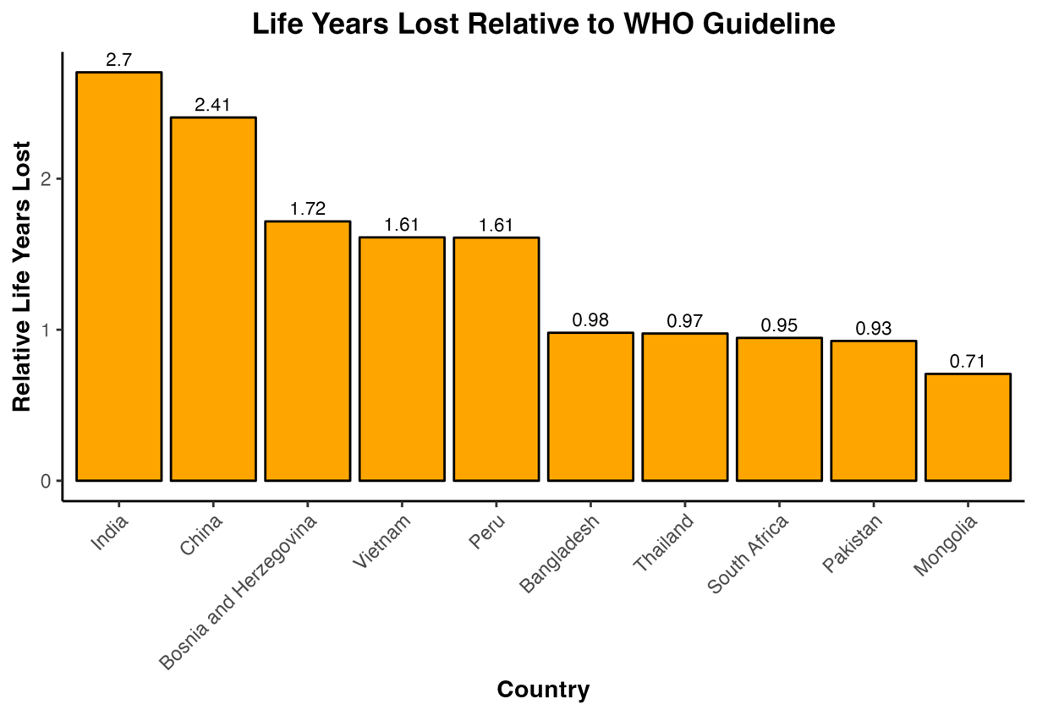

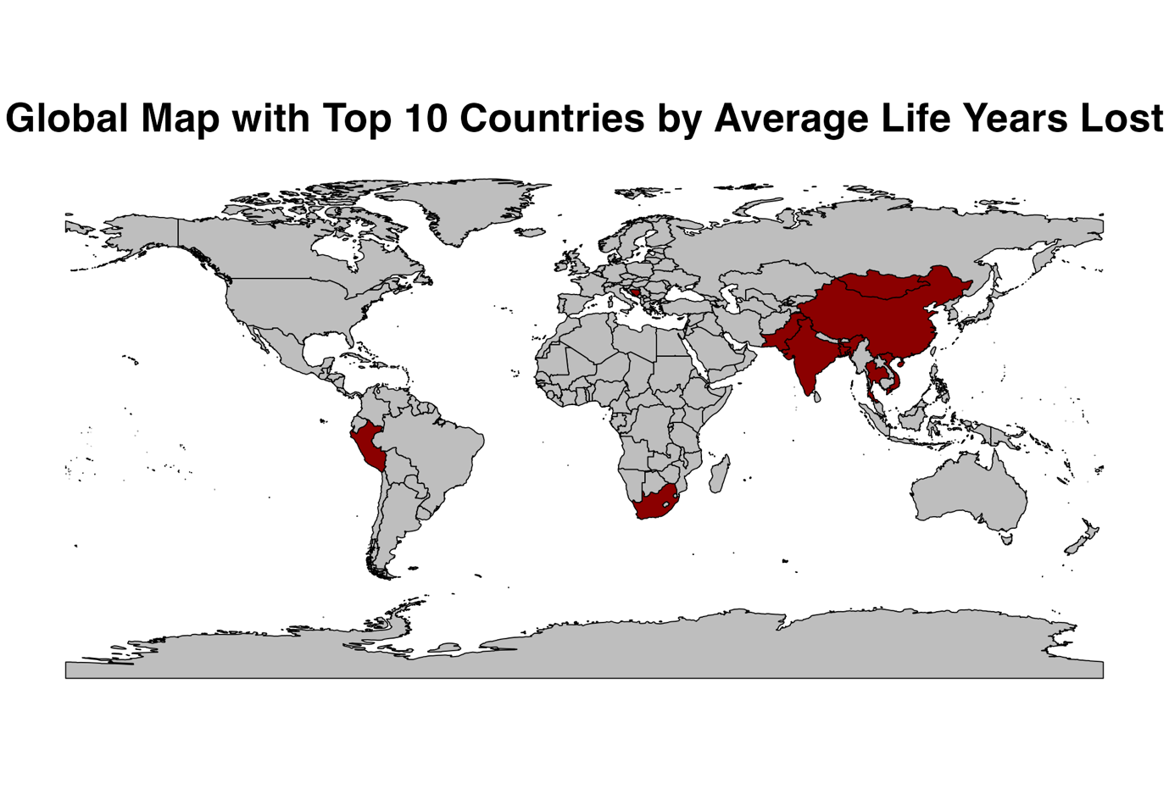

2. Create a potential gain in life expectancy (relative to the WHO guideline) map of eastern v/s western europe at GADM level 2 and save it as a high-quality PDF.

*Combined Map*

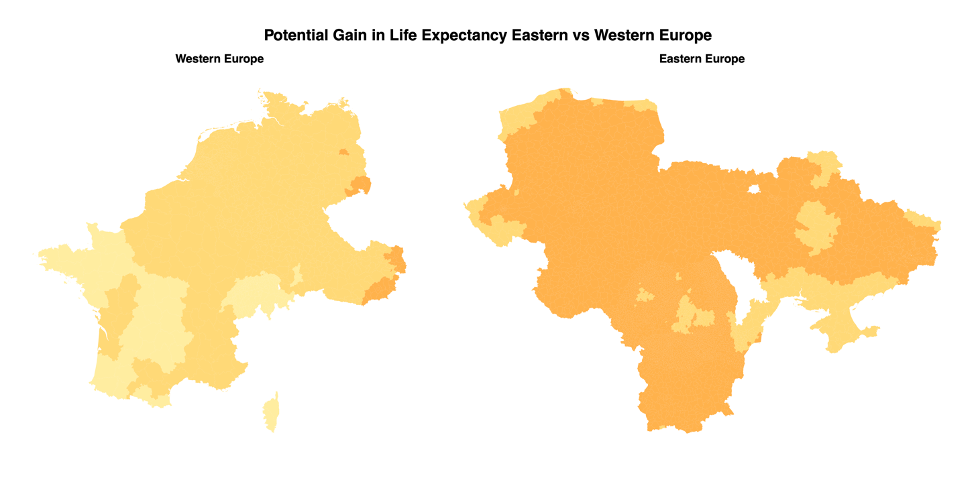

*Separate Maps for Western and Eastern Europe*

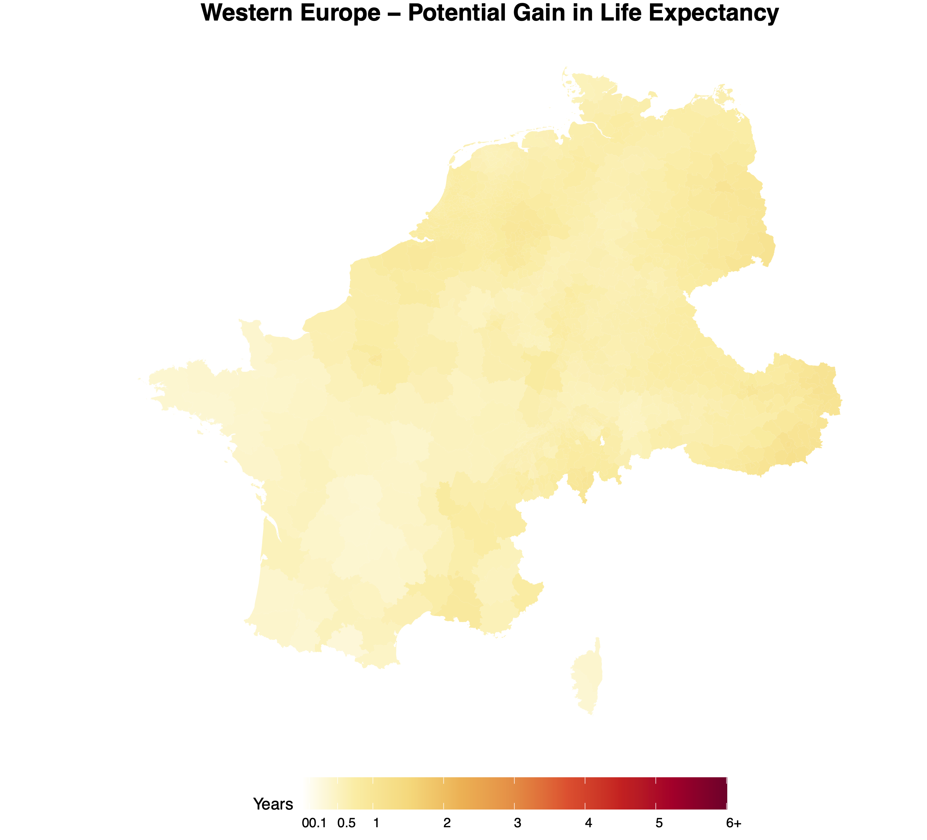

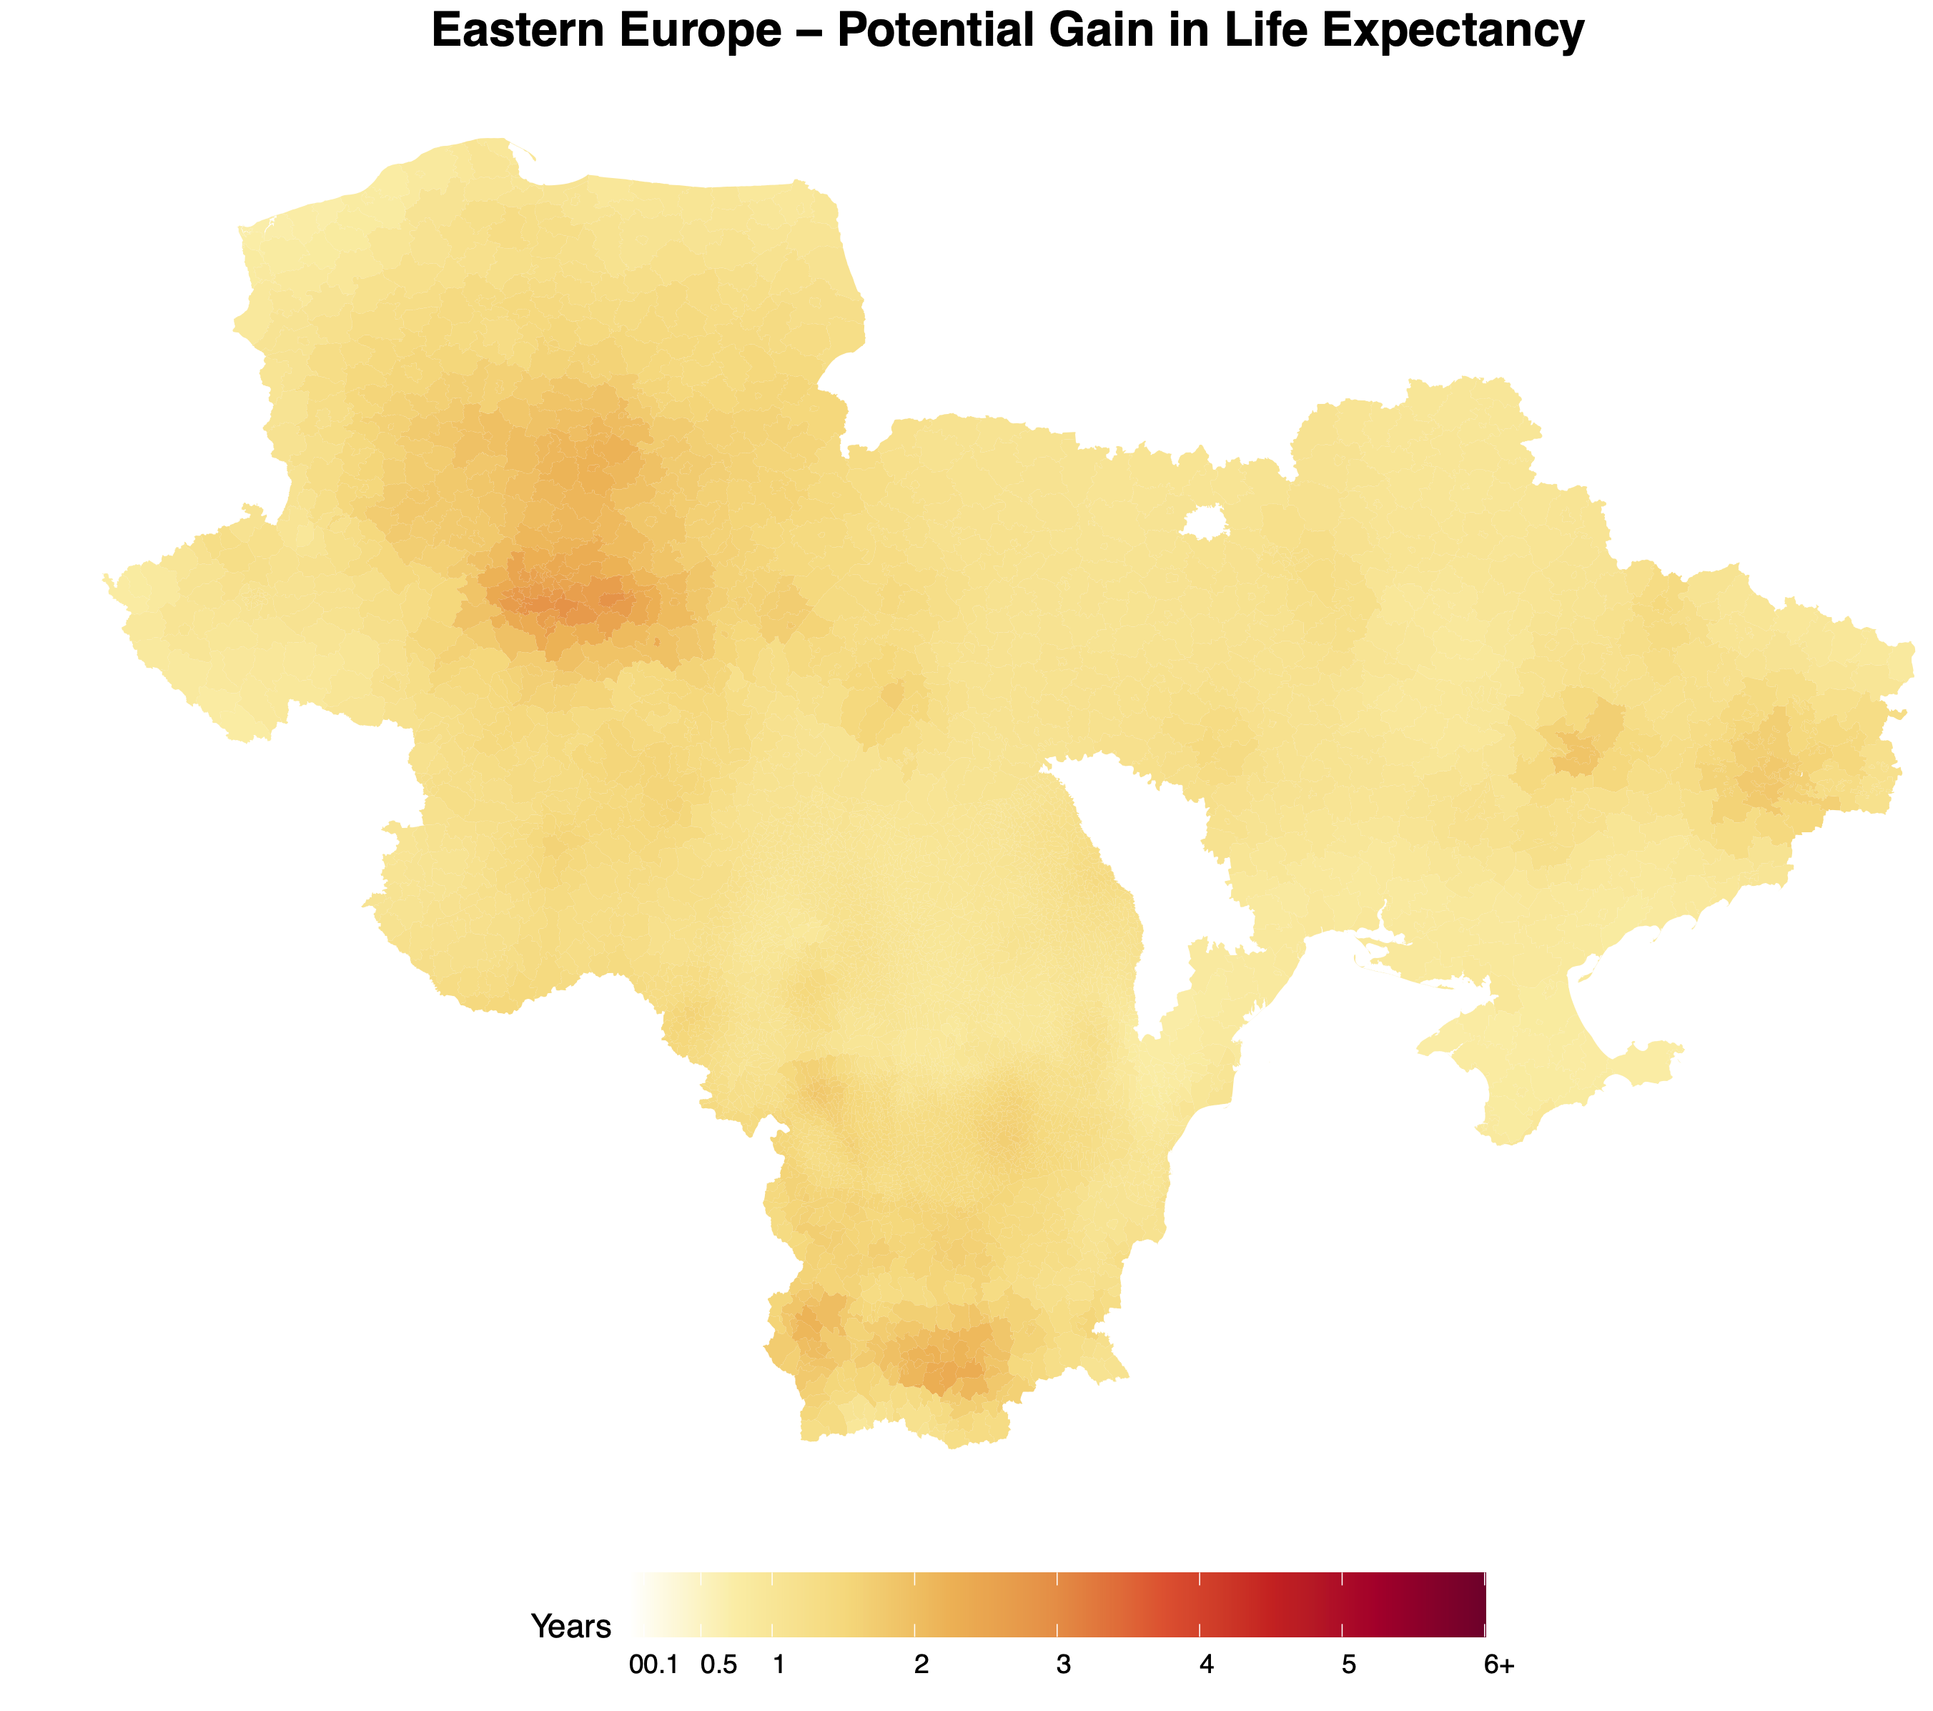

*Note: There was an issue with generating legends for combined map. Hence separate maps with legends were also created based on the color scheme used in the AQLI map on the website.*

3. Look at the AQLI website > switch to Air pollution tab > plot a static version of the global

pollution map you see there, in those “exact” same colors. Export it as a high quality (320

dpi) SVG file.

