EVENTPULSE: A CAMPUS EVENT MANAGEMENT PLATFORM FOR REGISTRATIONS, VOLUNTEERS AND CROWD SAFETY
A PROJECT REPORT
Submitted by
(NAME:Harisaran A)
(REGISTER NUMBER:240701170)
in partial fulfilment of the End Semester Examination for the course
CB23F35 –
LOW-CODE APPLICATION DEVELOPMENT USING ZOHO CREATOR
in
BACHELOR OF ENGINEERING
COMPUTER SCIENCE AND ENGINEERING

RAJALAKSHMI ENGINEERING COLLEGE
(An Autonomous Institution, Affiliated to Anna University, Chennai)
Rajalakshmi Nagar, Thandalam, Tamil Nadu – 602 105
[11/2026]

RAJALAKSHMI ENGINEERING COLLEGE
(An Autonomous Institution, Affiliated to Anna University, Chennai)
BONAFIDE CERTIFICATE
Certified that this project report titled “EventPulse: A Campus Event Management Platform for Registrations, Volunteers and Crowd Safety” is the bonafide work of [Harisaran A] ([240701170]), who carried out the individual project work on the Zoho Creator low-code platform for the course CB23F35 – Low-Code Application Development using Zoho Creator, during the academic year [2026–2027], Semester [V], under my supervision.
SIGNATURE  [MANORANJINI J]  HEAD OF THE DEPARTMENT  Department of [Computer Science And Engineering]  Rajalakshmi Engineering College  Thandalam – 602 105 | SIGNATURE  [JINU SOPHIA]  COURSE FACULTY  [ASSISTANT PROFESSOR]  Department of [Computer Science And Engineering]  Rajalakshmi Engineering College

Submitted for the End Semester Examination (Individual Project) held on [DD Month YYYY].
INTERNAL EXAMINER | EXTERNAL EXAMINER

DECLARATION
I, [Harisaran A] ([240701170]), hereby declare that the project report titled “EventPulse: A Campus Event Management Platform for Registrations, Volunteers and Crowd Safety”, submitted for the End Semester Examination of the course CB23F35 – Low-Code Application Development using Zoho Creator, is a record of original work carried out by me individually. The Zoho Creator application described in this report — including its data model, forms, reports, pages, Deluge scripts, workflows and integrations — was designed and developed by me.
I further declare that this work has not been submitted, in part or in full, for the award of any other degree or course credit. Every template, sample application, AI-assisted feature (such as Zia or the AI application builder), code snippet or external resource used in this work has been duly acknowledged in the report.
Place: Chennai SIGNATURE OF THE STUDENT
Date: [DD Month YYYY] [Harisaran A]
[240701170]

ACKNOWLEDGEMENT
I express my sincere gratitude to our Chairman [Thiru. S. Meganathan], Chairperson [Dr. (Mrs.) Thangam Meganathan] and Vice-Chairman [Mr. M. Abhay Shankar] for providing the infrastructure and facilities that made this work possible.
I am grateful to our Principal, [Dr. S.N. Murugesan], Rajalakshmi Engineering College, for the constant encouragement extended to students to take up industry-relevant learning.
I thank [MANORANJINI J], Head of the Department, Department of [Computer Science And Engineering], for the guidance and support provided throughout the course.
I owe my sincere thanks to my course faculty, [JINU SOPHIA], [ASSISTANT PROFESSOR], for the valuable guidance, reviews and feedback that shaped this application and report.
I also acknowledge [Zoho Corporation] for providing access to the Zoho Creator platform and learning resources, and I thank my family and friends for their unwavering support.

[Harisaran A]

ABSTRACT
Colleges conduct a large number of events such as symposiums, hackathons and workshops, yet their coordination is still handled through scattered forms, spreadsheets and messaging groups. Event details, participant lists, volunteer assignments, event requirements and safety observations are kept in separate files with no single live view. This leads to overbooking, because seat capacity and registration deadlines are not checked automatically, to poor coordination of volunteers and event needs, and to a slow response when crowd-related issues are reported informally.
This project presents EventPulse, a campus event management application built on the Zoho Creator low-code platform, which brings these activities into one connected system. The low-code approach allowed the application to be assembled quickly from visual building blocks, with business rules added through Deluge scripting. EventPulse comprises six linked forms (Events, Participants, Registrations, Volunteer Tasks, Event Requirements and Crowd Safety Reports) held in the built-in Creator database, eleven reports including a campus event calendar and a volunteer kanban board, and a dashboard page with four KPI tiles and three charts. Five automated Deluge rules reject events whose registration deadline falls after the event date, block registrations that arrive after the deadline or beyond venue capacity, send a confirmation email on successful registration, and email the administrator whenever a crowd-safety incident is reported. A scheduled event reminder is configured but currently inactive. No external APIs are used; emails are sent through the platform’s sendmail task.
The rules were defined as test cases covering late registration, full capacity, invalid event dates and safety alerts, and the application is used through a web browser by the administrator and event users. The result is one live view of every event, in which invalid registrations are stopped before they are saved and safety incidents reach the administrator immediately. Reminders and confirmations currently go to the logged-in user rather than to each participant, and access is not yet split by role between administrators, volunteers and participants; both are identified as future enhancements.
Keywords: Low-Code Development; Zoho Creator; Deluge Scripting; Campus Event Management; Workflow Automation; Crowd Safety

PROJECT AT A GLANCE
Attribute | Details
Project Title | EventPulse: A Campus Event Management Platform for Registrations, Volunteers and Crowd Safety
Application Domain | Education – Campus Event Management
Student Name & Register No. | Harisaran A – 240701170
Zoho Creator Edition | Education / Free / Standard / Professional – specify
Application Name (Link Name) | EventPulse
Published / Live URL | https://creatorapp.zoho.in/...
Demo Credentials (per role) | Admin: 1| Event User: 3
Number of Forms / Subforms | 6 / 0 (no subforms used)
Number of Reports (by type) | Total: 11 – List: 9 | Kanban: 1 | Calendar: 1 | Pivot/Chart: 0 | Others: 0
Number of Pages / Dashboards | 1 dashboard page (4 KPI tiles, 3 charts)
Number of Workflows | Form: 5 (DS-01 to DS-05) | Schedule: 1 (configured, inactive) | Approval: 0 | Blueprint: 0 | Batch: 0
Deluge Functions / Custom Actions | 5 form-event scripts and 1 schedule script; custom functions: 0
Integrations | None (emails sent through the built-in sendmail task; no external APIs)
Roles & Profiles Defined | Administrator and Event User (role-based permission profiles planned)
Environments Used | Development → Stage → Production – confirm
Date of Production Deployment | DD Month YYYY

TABLE OF CONTENTS
ABSTRACT iv
PROJECT AT A GLANCE v
LIST OF TABLES ix
LIST OF FIGURES xi
LIST OF ABBREVIATIONS xii
INTRODUCTION 1
1.1 Background 1
1.2 Problem Statement 1
1.3 Objectives 2
1.4 Scope of the Project 2
1.5 Justification for a Low-Code Approach 2
1.6 Organisation of the Report 3
LITERATURE SURVEY AND SYSTEM STUDY 4
2.1 Study of the Existing System 4
2.2 Limitations of the Existing System 4
2.3 Low-Code versus Traditional Development 5
2.4 Literature Survey 6
2.5 Emerging Trends in Low-Code Development 6
2.6 Proposed System 7
REQUIREMENT ANALYSIS 8
3.1 Stakeholders and User Roles 8
3.2 Functional Requirements 8
3.3 Non-Functional Requirements 5
3.4 Hardware and Software Requirements 10
3.5 Use Case Model 10
SYSTEM DESIGN 13
4.1 System Architecture 13
4.2 Data Model 13
4.3 Form Design 15
4.4 Process and Workflow Design 17
4.5 User Interface and Navigation Design 18
4.6 Access Control Design 19
IMPLEMENTATION 20
5.1 Application Setup 20
5.2 Forms and Data Capture 20
5.3 Reports 21
5.4 Pages and Dashboards 22
5.5 Deluge Scripting 23
5.6 Workflows and Automation 24
5.7 Integrations 25
5.8 User Management and Role-Based Access 26
5.9 AI and Analytics Features 26
5.10 Pro-Code Extension 26
5.11 Mobile and Portal Access 27
TESTING AND DEBUGGING 28
6.1 Testing Strategy 28
6.2 Test Cases 28
6.3 Debugging Deluge Scripts 30
6.4 Defect Log 30
6.5 User Acceptance Testing 31
DEPLOYMENT, SECURITY AND GOVERNANCE 32
7.1 Environments and Deployment Strategy 32
7.2 Performance Optimisation 32
7.3 Security Features 34
7.4 Governance and Administration 34
RESULTS AND DISCUSSION 36
8.1 Application Output 36
8.2 Achievement of Objectives 37
8.3 Comparison with the Existing System 38
8.4 Limitations of the Low-Code Approach 38
8.5 Reflection on the No-Code → Low-Code → Pro-Code Spectrum 39
CONCLUSION AND FUTURE ENHANCEMENTS 40
9.1 Conclusion 40
9.2 Future Enhancements 40
9.3 Learning Outcomes and Career Relevance 40
REFERENCES 41
APPENDIX A – ZOHO CREATOR FEATURE COVERAGE CHECKLIST 42
APPENDIX B – COURSE OUTCOME MAPPING 45
APPENDIX C – COMPLETE DELUGE SOURCE CODE 46
APPENDIX D – USER MANUAL 48
D.1 Accessing the Application 48
D.2 Instructions for the Administrator 48
D.3 Instructions for the Event User 48
APPENDIX E – EVALUATION RUBRIC 49
APPENDIX F – VIVA-VOCE RECORD SHEET 51

LIST OF TABLES
Table 2.1: Comparison of Low-Code and Traditional Development for the Proposed Application 5
Table 2.2: Summary of Literature Survey 6
Table 3.1: Stakeholders and User Roles 8
Table 3.2: Functional Requirements 8
Table 3.3: Non-Functional Requirements 10
Table 3.4: Hardware and Software Requirements 10
Table 3.5: Use Case Description – Register a Participant for an Event 11
Table 3.6: Use Case Description – Report a Crowd-Safety Incident 12
Table 4.1: Entities and Relationships 14
Table 4.2: Field Specification – Events Form 15
Table 4.3: Field Specification – Participants Form 16
Table 4.4: Field Specification – Registrations Form 16
Table 4.5: Field Specification – Volunteer Tasks Form 16
Table 4.6: Field Specification – Event Requirements Form 17
Table 4.7: Field Specification – Crowd Safety Reports Form 17
Table 4.8: Role–Permission Matrix (Target Design) 19
Table 5.1: Reports Implemented 21
Table 5.2: Deluge Scripts Implemented 23
Table 5.3: Workflows Implemented 25
Table 5.4: Integrations Implemented 26
Table 6.1: Test Cases 28
Table 6.2: Defect Log 30
Table 6.3: User Acceptance Feedback 31
Table 7.1: Deployment Checklist 32
Table 7.2: Performance Optimisation Results 34
Table 7.3: Security Controls Implemented 34
Table 8.1: Mapping of Objectives to Outcomes 37
Table 8.2: Existing System versus Proposed Application 38
Table A.1: Feature Coverage Checklist 42
Table B.1: Mapping of Course Outcomes to Report Chapters 45
Table E.1: Evaluation Rubric for the Individual Project 49
Table E.2: Performance Level Descriptors 50
Table F.1: Viva-Voce Questions and Responses 51
Table F.2: Marks Summary 51

LIST OF FIGURES
Figure 2.1: As-Is Process Flow of the Existing Campus Event Management Process 4
Figure 3.1: Use Case Diagram of EventPulse 11
Figure 4.1: System Architecture of EventPulse 13
Figure 4.2: Entity–Relationship Diagram of EventPulse 14
Figure 4.3: Workflow / Process Flow for Registration and Safety Reporting 18
Figure 4.4: Navigation Structure and Wireframe of the Dashboard Page 19
Figure 5.1: EventPulse Application Home and Navigation Sections 20
Figure 5.2: Registrations Form in the Form Builder 21
Figure 5.3: Registrations Form in Live Mode with Alert 21
Figure 5.4: Open Safety Reports Report 22
Figure 5.5: EventPulse Dashboard (KPIs and Charts) 23
Figure 5.6: Registrations Form Workflow Configuration 25
Figure 6.1: Deluge Debug Output 30
Figure 7.1: Environments and Publish to Production 32
Figure 7.2: Audit Trail and Administration Settings 35
Figure 8.1: Scenario Step 1 – Registration Blocked with an Alert 36
Figure 8.2: Scenario Step 2 – Volunteer Tasks on the Kanban Board 36
Figure 8.3: Scenario Step 3 – Safety Report Email to the Administrator 37
Figure 8.4: Scenario Step 4 – Dashboard with KPIs and Charts 37

LIST OF ABBREVIATIONS
Abbreviation | Expansion
A/V | Audio/Visual
API | Application Programming Interface
DS | Deluge Script (script identifier)
ER | Entity–Relationship
ERP
ESEM | Empirical Software Engineering and Measurement
FR | Functional Requirement
KPI | Key Performance Indicator
NFR | Non-Functional Requirement
QR | Quick Response
RBAC | Role-Based Access Control
TC | Test Case
UI | User Interface
URL | Uniform Resource Locator
Zia | Zoho’s AI assistant

CHAPTER 1

INTRODUCTION

1.1 Background
Educational institutions organise a continuous stream of events: technical symposiums, hackathons, workshops, cultural programmes and guest lectures. Every event involves several groups of people. Organisers plan it, students register for it, volunteers support it, and administrators are responsible for the safety of everyone present. This project addresses the event-management process of a typical engineering college campus and has been developed in the context of Rajalakshmi Engineering College, Chennai.
Today the process is stitched together from several tools. Event details are noted in one file, participants register through separate forms or messages, volunteer duties are allotted over chat groups, requirements such as seating, food, audio-visual equipment and decoration are communicated informally, and crowd-related problems are reported by call or message. Because none of these records are connected, organisers cannot see at a glance how many seats are left, which tasks are pending or which safety issues are still open.
EventPulse was built on Zoho Creator to bring these activities into one connected application, with automatic checks on registrations and instant alerts for safety incidents.

1.2 Problem Statement
Campus events are often run with scattered forms, sheets and messages, with no single live view. As a result, registrations are accepted without checking seat capacity or the registration deadline, volunteer work and event needs are difficult to follow, and safety issues may not reach the administrator in time. The college needs one connected system that enforces the registration rules automatically and raises instant alerts for crowd-safety incidents.
- Scattered data: events, participants and tasks sit in separate files, so the same information is duplicated and soon becomes inconsistent.
- Overbooking: there is no automatic check on seat capacity or the registration deadline, so late and excess registrations are accepted.
- Slow safety response: crowd issues are reported informally and can be missed by the administrator.
- Poor coordination: volunteer work and event requirements are hard to track, and no live status is available.

1.3 Objectives
- To design six linked forms that manage events with their date, time, venue, capacity, registration deadline and status.
- To register participants for events and to track the registration and check-in status of each participant.
- To block late and over-capacity registrations automatically using Deluge validation rules.
- To track volunteer tasks and event requirements through reports and a kanban board.
- To capture crowd-safety incidents, alert the administrator by email, and present a live dashboard, calendar and task board for all events.

1.4 Scope of the Project
In scope: six linked forms (Events, Participants, Registrations, Volunteer Tasks, Event Requirements and Crowd Safety Reports); eleven reports including a campus event calendar and a volunteer kanban board; a dashboard page with four KPI tiles and three charts; five automated Deluge rules covering event-date validation, registration deadline, venue capacity, confirmation email and safety alert email; and web-browser access for the administrator and event users.
Out of scope for this version: integration with external APIs or other Zoho services, payment or ticketing, role-based permission profiles for administrators, volunteers and participants, delivery of confirmations and reminders to each participant’s own email address, automatic promotion of waitlisted registrants, and a dedicated mobile layout or customer portal. These are listed as future enhancements in Section 9.2.

1.5 Justification for a Low-Code Approach
Low-code platforms allow an application to be assembled largely through visual configuration, with hand-written code limited to the business rules that really need it [1]. In Zoho Creator, forms, reports and pages are configured in the builder and the business logic is written in Deluge, the platform’s scripting language [2]. Bock and Frank describe low-code platforms as development environments that raise productivity and allow people close to the business, often called citizen developers, to build applications, which in turn improves organisational agility [3]. These characteristics suit EventPulse for five reasons. First, the six linked forms, the reports and the dashboard are standard Creator components that are configured rather than coded. Second, the few rules that need logic, namely the deadline and capacity checks and the email alerts, are short Deluge scripts. Third, hosting, the database, user sign-in and the web interface are provided by the platform, so no separate server had to be built or maintained. Fourth, a field, a report or a rule can be changed in the builder without a conventional release cycle, which suits events whose requirements change from semester to semester. Fifth, the application is available from any browser on campus without installation.

1.6 Organisation of the Report
Chapter 2 reviews the existing system and related low-code literature. Chapter 3 presents the requirement analysis. Chapter 4 describes the system design. Chapter 5 details the implementation on Zoho Creator. Chapter 6 covers testing and debugging. Chapter 7 discusses deployment, performance optimisation, security and governance. Chapter 8 presents results and discussion, and Chapter 9 concludes the report with future enhancements.
CHAPTER 2

LITERATURE SURVEY AND SYSTEM STUDY

2.1 Study of the Existing System
In the existing arrangement an organiser plans an event and records its date, venue and capacity in a spreadsheet or document. Participants register through separate forms or messages, and their details are collected in another file. Seat availability and the registration deadline are checked by hand, if they are checked at all. Volunteer tasks and event requirements such as seating, food, audio-visual equipment and decoration are shared through chat messages. If a crowd-related problem occurs, it is reported informally by call or message. Finally, the organiser has to compile the status of the event from all of these sources manually. Figure 2.1 shows this as-is flow.

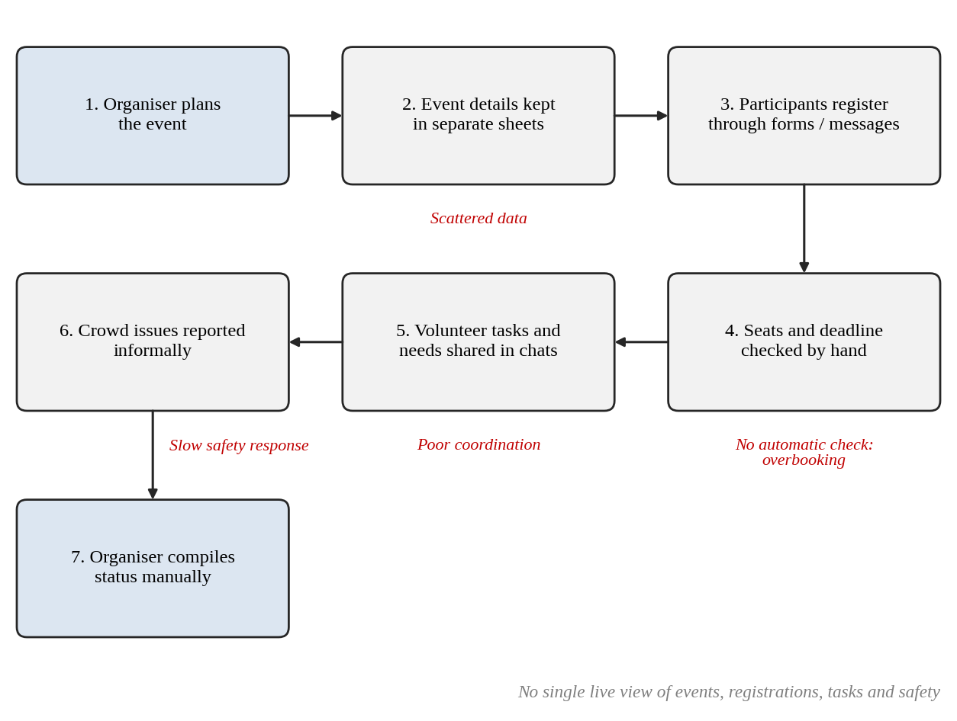
Figure 2.1: As-Is Process Flow of the Existing Campus Event Management Process

2.2 Limitations of the Existing System
- Data is scattered across separate files, so the same event, participant or task information is stored in several places and soon becomes inconsistent.
- There is no automatic check of seat capacity or registration deadline, which allows overbooking and late registrations.
- Safety issues are reported informally and may be missed or delayed, because there is no alert to the administrator.
- Volunteer work and event requirements cannot be tracked centrally, and no live dashboard is available to the organisers.

2.3 Low-Code versus Traditional Development
Table 2.1: Comparison of Low-Code and Traditional Development for the Proposed Application
Criterion | Traditional (Pro-Code) Development | Low-Code on Zoho Creator
Development time | Estimated 8–10 weeks to build the database, back end, web front end and hosting | Estimated 2–3 weeks to build and test the six forms, eleven reports and workflows
Skills required | Web front-end, server-side programming, database design and deployment skills | Understanding of forms, reports and workflows, plus basic Deluge scripting
Hosting & infrastructure | Server, database and domain must be provisioned, secured and maintained | Hosted and maintained by the platform; no server set-up
Mobile application | Separate mobile application or a responsive redesign is needed | Creator applications can be opened in the Zoho Creator mobile app; not configured separately in this version
Security & access control | Authentication, sessions and role logic are coded and tested by the developer | Sign-in is provided by the platform; role-based permission profiles are available (planned for EventPulse)
Maintenance & change | Code change, testing and redeployment for every change | Fields, reports and rules are edited in the builder and published
Customisation limits | Virtually unlimited | Bound by the platform’s components and Deluge limits, which are adequate for this scope
Cost | Developer time plus hosting and licence costs | Per-user platform subscription; no infrastructure cost

2.4 Literature Survey
Table 2.2: Summary of Literature Survey
S.No. | Author(s) / Source & Year | Title / Product | Key Findings | Relevance to this Project
1 | W. Rosam and O. Kalnichevski [1] | Low-Code Development: A Practical Guide (book) | Practical guidance on building business applications on low-code platforms | Guides the overall approach and the decision to use low-code for EventPulse
2 | Zoho Corporation [2] | Zoho Creator Help Documentation | Describes forms, reports, pages, workflows, Deluge scripting and deployment in Creator | Primary reference for configuring every EventPulse component
3 | A. C. Bock and U. Frank, 2021 [3] | Low-Code Platform, Business & Information Systems Engineering | Characterises low-code platforms and discusses citizen development, productivity and organisational agility | Supports the justification for a low-code approach in Section 1.5
4 | R. Sanchis et al., 2020 [4] | Low-Code as Enabler of Digital Transformation in Manufacturing Industry, Applied Sciences | Presents low-code platforms as a means to build and automate enterprise applications and so support digital transformation | Shows that low-code suits operational, process-oriented applications such as event handling
5 | Y. Luo et al., 2021 [5] | Characteristics and Challenges of Low-Code Development: The Practitioners’ Perspective, ESEM | Analyses practitioner discussions and reports that low-code is favoured where automated processes and workflows are needed, while views on its limits are mixed | Supports the workflow focus of EventPulse and the limitations discussed in Section 8.4
6 | Zoho Corporation [6] | Deluge Script Reference Guide | Documents the Deluge language: form events, fetch, conditions, alerts and sendmail | Basis of the validation and email scripts in Section 5.5

2.5 Emerging Trends in Low-Code Development
Four trends in low-code development are relevant to this project. The first is citizen development, in which people close to the business build and maintain applications themselves [3]; EventPulse follows this idea because an organiser-level user can change a field, report or rule in the builder. The second is workflow automation: practitioners favour low-code where processes and workflows must be automated [5], and EventPulse automates its registration checks and safety alerts through Deluge rules. The third is AI-assisted application building, in which a platform can generate forms or scripts from a description; the application described here was designed and written directly, and AI-assisted generation is identified only as a possible aid for future enhancements. The fourth is composable applications, in which small modules are combined into larger solutions. EventPulse is organised in the same spirit, as six linked modules that could be extended with further Zoho services or external APIs without redesigning the data model.

2.6 Proposed System
The proposed system, EventPulse, is a Zoho Creator application that holds all event information in six linked forms and acts on it through Deluge rules, reports and a dashboard. It overcomes the limitations listed in Section 2.2 as follows. Scattered data is replaced by one database in which registrations, tasks, requirements and safety reports are linked to their event through lookup fields. Overbooking and late registration are prevented by validation rules that run when a registration is submitted and stop it with an alert if the deadline has passed or the venue capacity has been reached. Slow safety response is addressed by an email to the administrator whenever a crowd-safety report is submitted, together with filtered reports for open and critical incidents. Poor coordination is addressed by a volunteer kanban board, event requirement records, a campus event calendar and a dashboard with four KPI tiles and three charts that give one live view of every event.
CHAPTER 3

REQUIREMENT ANALYSIS

3.1 Stakeholders and User Roles
Table 3.1: Stakeholders and User Roles
Role | Description | Key Responsibilities in the Application
Administrator | Manages the whole application and receives safety alerts | Create and edit events; view all records, reports and the dashboard; review and close crowd-safety reports; receive email alerts
Event User (Organiser) | Signed-in person who runs an event | Add participants and registrations; record check-in; assign volunteer tasks and event requirements; report safety incidents
Volunteer | Student who supports an event (tracked as task records; separate access planned) | Carry out assigned tasks and update task status on the kanban board
Participant | Student who registers for an event (tracked as a record; separate access planned) | Registered for events and checked in on the day

3.2 Functional Requirements
Table 3.2: Functional Requirements
FR ID | Requirement | Role(s) | Priority
FR-01 | The system shall allow creation and maintenance of events with category, date, time, venue, capacity, registration deadline and status. | Admin, User | High
FR-02 | The system shall reject an event whose registration deadline is after the event date. | Admin, User | High
FR-03 | The system shall record participants with student ID, email, phone, department and year. | Admin, User | High
FR-04 | The system shall register a participant for an event and record registration and check-in status. | Admin, User | High
FR-05 | The system shall block a registration submitted after the registration deadline and show an alert. | Admin, User | High
FR-06 | The system shall block a registration when the venue capacity is reached and show an alert. | Admin, User | High
FR-07 | The system shall send a confirmation email when a registration is saved. | Admin, User | Medium
FR-08 | The system shall track volunteer tasks with priority, due date and status, and display them on a kanban board. | Admin, User | Medium
FR-09 | The system shall record event requirements (seating, food, A/V, decoration) with quantity. | Admin, User | Medium
FR-10 | The system shall record crowd-safety reports with issue type and severity and email the administrator on submission. | Admin, User | High
FR-11 | The system shall track a safety report through the statuses Open, Assigned, In Progress, Resolved and Closed. | Admin | Medium
FR-12 | The system shall display a dashboard with four KPI tiles and three charts. | Admin, User | Medium
FR-13 | The system shall provide a campus event calendar and filtered reports such as Open Safety Reports and Critical Incidents. | Admin, User | Medium
FR-14 | The system shall send scheduled event reminders (configured, currently inactive). | Admin | Low

3.3 Non-Functional Requirements
Table 3.3: Non-Functional Requirements
NFR ID | Category | Requirement
NFR-01 | Performance | Reports and the dashboard shall load within a few seconds for the expected volume of campus event data.
NFR-02 | Security | Only signed-in users shall access the application; role-based restriction of data is planned as a future enhancement.
NFR-03 | Usability | The application shall be usable from a standard web browser without installation.
NFR-04 | Availability | The application shall be hosted on the Zoho cloud and be available whenever an internet connection exists.
NFR-05 | Maintainability | Fields, reports and rules shall be changeable in the Creator builder without redeploying a server.
NFR-06 | Auditability | Record changes shall be traceable through the platform’s audit trail.
NFR-07 | Data integrity | Invalid registrations and invalid event dates shall be stopped before they are saved.

3.4 Hardware and Software Requirements
Table 3.4: Hardware and Software Requirements
Category | Specification
Platform | Zoho Creator Education
Scripting language | Deluge (Data Enriched Language for the Universal Grid Environment)
Browser | Google Chrome / Microsoft Edge / Mozilla Firefox (latest version)
API testing tool | Not used (no external APIs)
Other Zoho services | None; emails are sent through the built-in sendmail task
Mobile | Not configured separately; the application is accessed through a web browser
Client hardware | Intel Core i3/i5 or above, 8 GB RAM, internet connection

3.5 Use Case Model

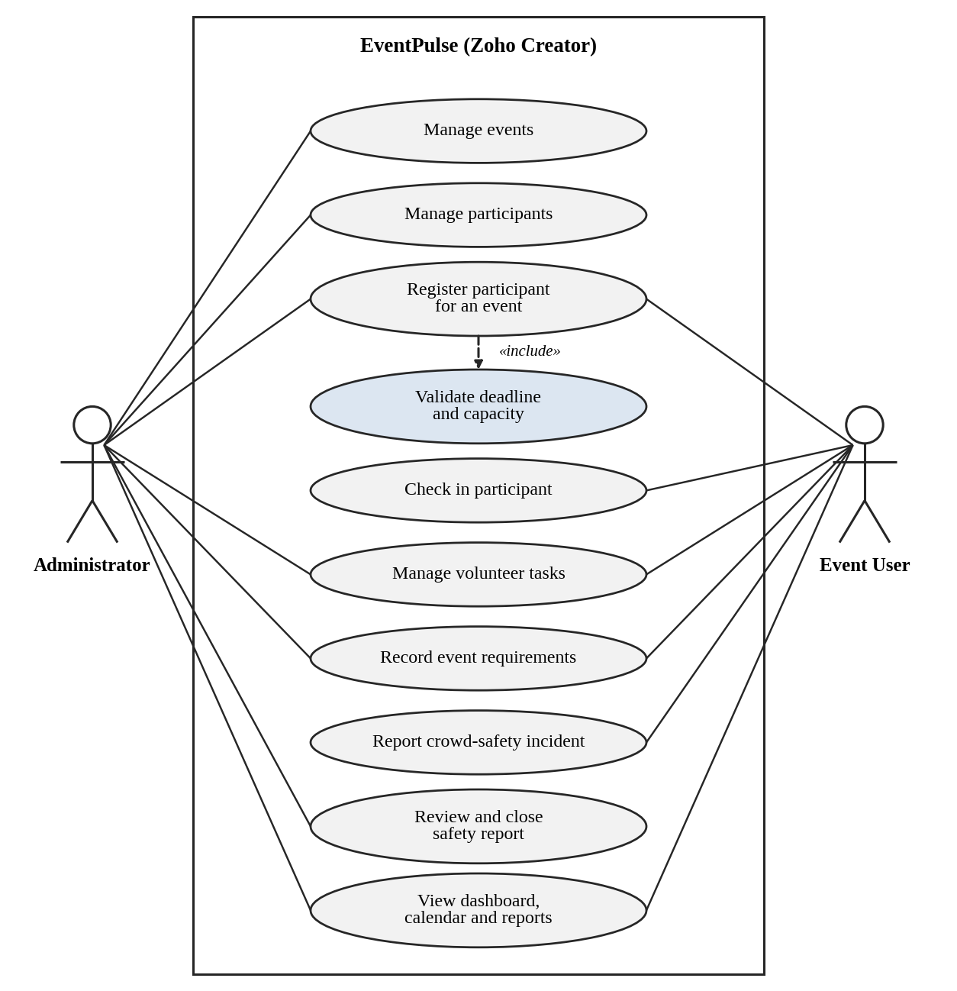
Figure 3.1: Use Case Diagram of EventPulse
Table 3.5: Use Case Description – Register a Participant for an Event
Use Case ID | UC-01
Use Case Name | Register a participant for an event
Actor(s) | Administrator, Event User
Pre-condition | The event and the participant records exist and the user is signed in.
Main Flow | 1. The user opens the Registrations form and selects the event and the participant.  2. The user submits the form.  3. The system checks that the registration deadline has not passed (DS-02).  4. The system checks that seats are still available (DS-03).  5. The registration is saved and a confirmation email is sent (DS-04).  6. Reports and the dashboard reflect the new registration.
Alternate Flow | At step 3 or 4, if the deadline has passed or the capacity is reached, an alert is shown, the submission is cancelled and no record is saved.
Post-condition | A registration record exists for the participant, or no record is created if a check fails.
Related FR | FR-04, FR-05, FR-06, FR-07

Table 3.6: Use Case Description – Report a Crowd-Safety Incident
Use Case ID | UC-02
Use Case Name | Report a crowd-safety incident
Actor(s) | Event User (reporter), Administrator (reviewer)
Pre-condition | The event exists and the user is signed in.
Main Flow | 1. The user opens the Crowd Safety Reports form and selects the event.  2. The user enters the issue type and severity and submits.  3. The report is saved with status Open.  4. The system emails the administrator (DS-05).  5. The administrator reviews the report and moves its status from Open through Assigned, In Progress and Resolved to Closed.
Alternate Flow | If a mandatory field is missing, the form is not submitted and a validation message is shown.
Post-condition | The incident is recorded, the administrator has been alerted, and open and critical incidents appear in the filtered reports.
Related FR | FR-10, FR-11, FR-13
CHAPTER 4

SYSTEM DESIGN

4.1 System Architecture

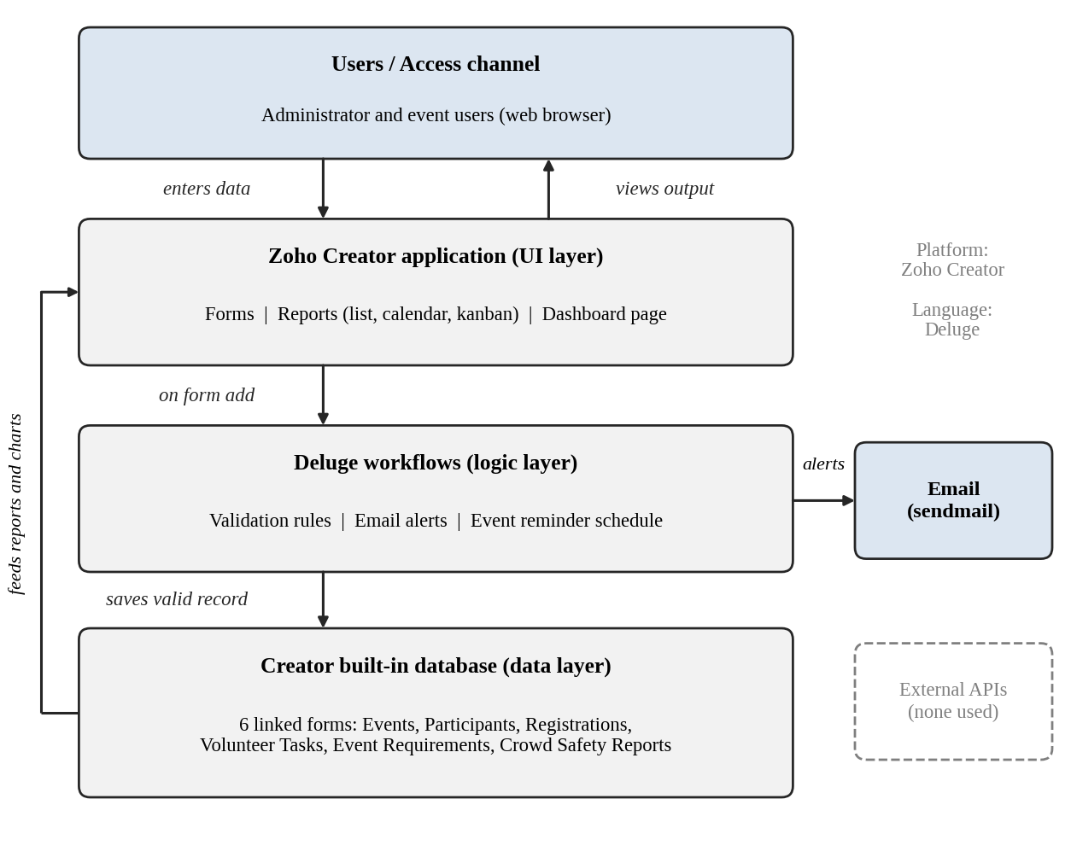
Figure 4.1: System Architecture of EventPulse
EventPulse follows a simple layered architecture, as Figure 4.1 shows. In the access layer, the administrator and event users reach the application through a web browser. The Zoho Creator application layer provides the user interface: forms for data entry, reports (list, calendar and kanban) for viewing data, and a dashboard page with KPI tiles and charts. The logic layer consists of Deluge workflows. Validation rules run when a form is submitted and stop invalid data with an alert; if the data is valid it is saved to the database. Email alerts are sent through the sendmail task, and an event reminder schedule is configured but inactive. The data layer is the Creator built-in database, which holds the six linked forms. Saved data feeds the reports, the charts and the email alerts. No external APIs are used in this version.

4.2 Data Model

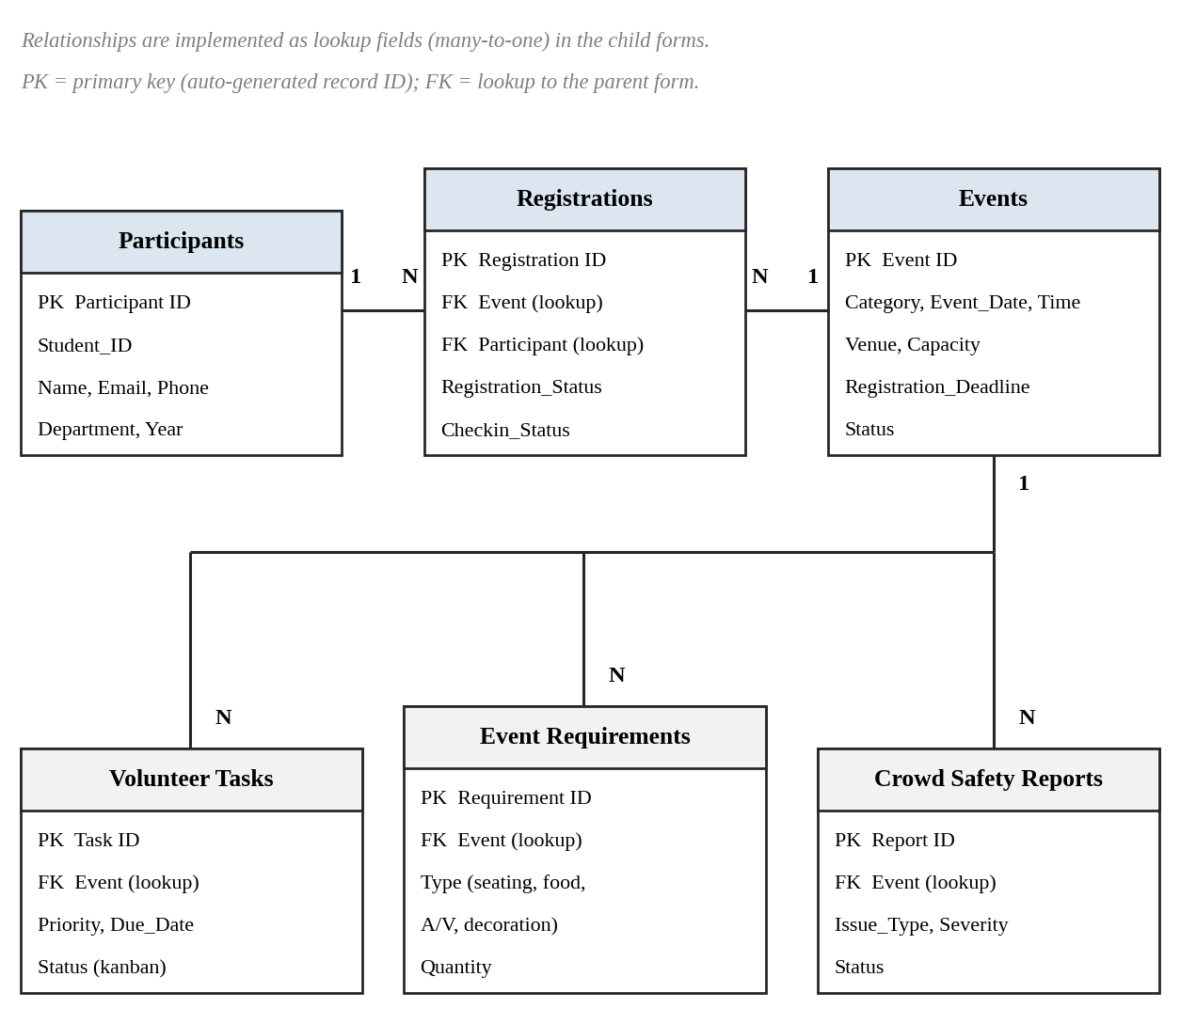
Figure 4.2: Entity–Relationship Diagram of EventPulse
The data model consists of six forms. Events is the central form. Registrations links a participant to an event and therefore resolves the many-to-many relationship between participants and events. Volunteer Tasks, Event Requirements and Crowd Safety Reports each point to the event they belong to. In Zoho Creator these relationships are realised through lookup fields, which let a child form select a record of its parent form. Table 4.1 lists the entities and their relationships.
Table 4.1: Entities and Relationships
Entity (Form) | Key Fields | Related To | Relationship Type | Implemented Using
Events | Event_ID, Event_Name, Category, Event_Date, Capacity, Registration_Deadline, Status | Registrations | One-to-Many | Lookup in Registrations
Participants | Student_ID, Name, Email, Phone, Department, Year | Registrations | One-to-Many | Lookup in Registrations
Registrations | Registration_ID, Registration_Status, Checkin_Status | Events; Participants | Many-to-One (each); Events–Participants is Many-to-Many | Two lookups
Volunteer Tasks | Task, Priority, Due_Date, Status | Events | Many-to-One | Lookup to Events
Event Requirements | Requirement type, Quantity | Events | Many-to-One | Lookup to Events
Crowd Safety Reports | Issue_Type, Severity, Status | Events | Many-to-One | Lookup to Events

4.3 Form Design
Table 4.2: Field Specification – Events Form
Field Label | Link Name | Field Type | Mandatory | Validation / Default | Remarks
Event ID | Event_ID | Auto Number | – | – | System generated
Event Name | Event_Name | Single Line | Yes | – | Title of the event
Category | Category | Drop Down | Yes | – | Symposium, hackathon, workshop, etc.
Event Date | Event_Date | Date | Yes | Not before the registration deadline (DS-01) | –
Time | Event_Time | Time | Yes | – | –
Venue | Venue | Single Line | Yes | – | –
Capacity | Capacity | Number | Yes | Seat limit used by DS-03 | –
Registration Deadline | Registration_Deadline | Date | Yes | Not after Event Date (DS-01) | Used by DS-02
Status | Status | Drop Down | Yes | – | Event status

Table 4.3: Field Specification – Participants Form
Field Label | Link Name | Field Type | Mandatory | Validation / Default | Remarks
Participant ID | Participant_ID | Auto Number | – | – | System generated
Student ID | Student_ID | Single Line | Yes | – | College register number
Name | Name | Name | Yes | – | –
Email | Email | Email | Yes | – | –
Phone | Phone | Phone | Yes | – | –
Department | Department | Drop Down | Yes | – | –
Year | Year | Drop Down | Yes | – | Year of study

Table 4.4: Field Specification – Registrations Form
Field Label | Link Name | Field Type | Mandatory | Validation / Default | Remarks
Registration ID | Registration_ID | Auto Number | – | – | System generated
Event | Event | Lookup | Yes | DS-02, DS-03 run on submit | Lookup to Events
Participant | Participant | Lookup | Yes | – | Lookup to Participants
Registration Status | Registration_Status | Drop Down | Yes | – | Includes a Waitlisted value
Check-in Status | Checkin_Status | Drop Down | Yes | – | Tracks arrival on the event day

Table 4.5: Field Specification – Volunteer Tasks Form
Field Label | Link Name | Field Type | Mandatory | Validation / Default | Remarks
Task ID | Task_ID | Auto Number | – | – | System generated
Task | Task | Single Line | Yes | – | –
Event | Event | Lookup | Yes | – | Lookup to Events
Priority | Priority | Drop Down | Yes | – | –
Due Date | Due_Date | Date | Yes | – | –
Status | Status | Drop Down | Yes | – | Drives the kanban columns

Table 4.6: Field Specification – Event Requirements Form
Field Label | Link Name | Field Type | Mandatory | Validation / Default | Remarks
Requirement ID | Requirement_ID | Auto Number | – | – | System generated
Event | Event | Lookup | Yes | – | Lookup to Events
Requirement Type | Requirement_Type | Drop Down | Yes | – | Seating, food, A/V, decoration
Quantity | Quantity | Number | Yes | – | –

Table 4.7: Field Specification – Crowd Safety Reports Form
Field Label | Link Name | Field Type | Mandatory | Validation / Default | Remarks
Report ID | Report_ID | Auto Number | – | – | System generated
Event | Event | Lookup | Yes | – | Lookup to Events
Issue Type | Issue_Type | Drop Down | Yes | – | –
Severity | Severity | Drop Down | Yes | – | Includes a Critical level
Status | Status | Drop Down | Yes | Default: Open | Open, Assigned, In Progress, Resolved, Closed

4.4 Process and Workflow Design
Two processes are automated. In the registration journey, an organiser creates an event (DS-01 checks that the deadline is not after the event date), adds a participant and submits a registration. On submit, the Deluge rules DS-02 and DS-03 check the deadline and the capacity. If either check fails, an alert is shown and the submission is cancelled; otherwise the record is saved, a confirmation email is sent (DS-04) and the dashboard updates. In the safety reporting process, a submitted report is saved to the database, an email is sent to the administrator (DS-05), and the administrator reviews the report and moves its status from Open to Closed. Figure 4.3 shows both processes and marks where the Deluge scripts run.

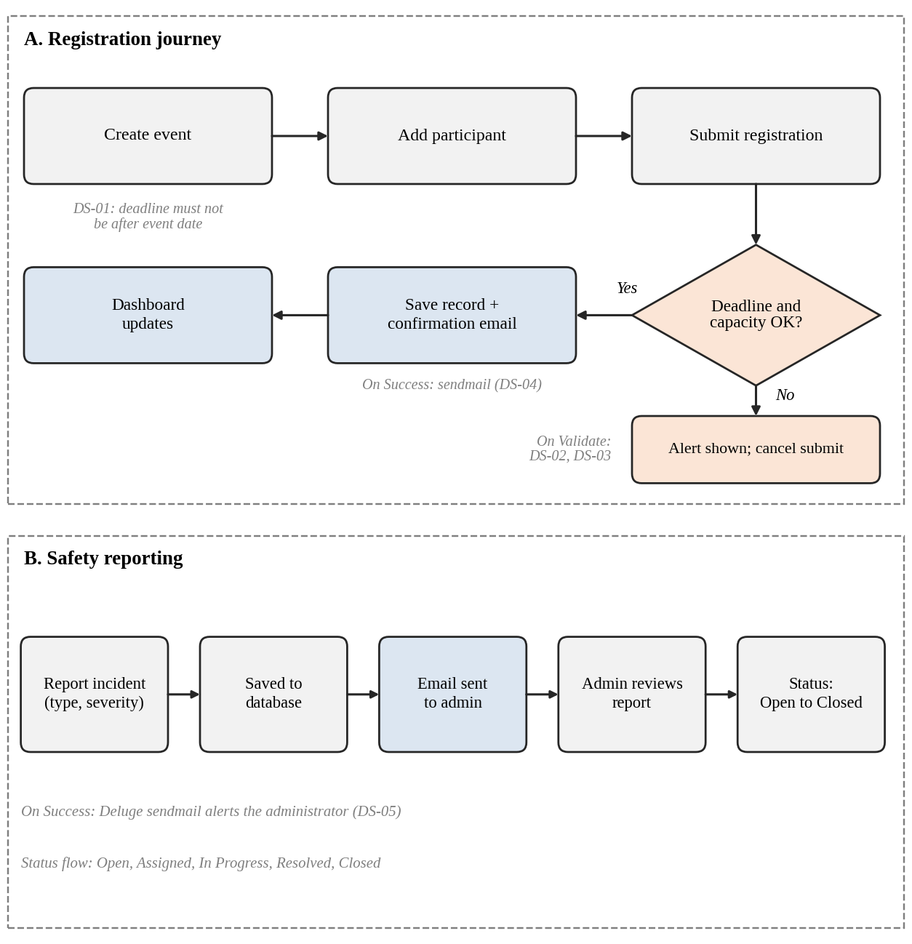
Figure 4.3: Workflow / Process Flow for Registration and Safety Reporting

4.5 User Interface and Navigation Design
The application is organised by module, with one section per form and its reports, as Figure 4.4 shows. The dashboard is the landing view and presents four KPI tiles and three charts. The calendar report is reached from the Events section and the kanban board from the Volunteer Tasks section.
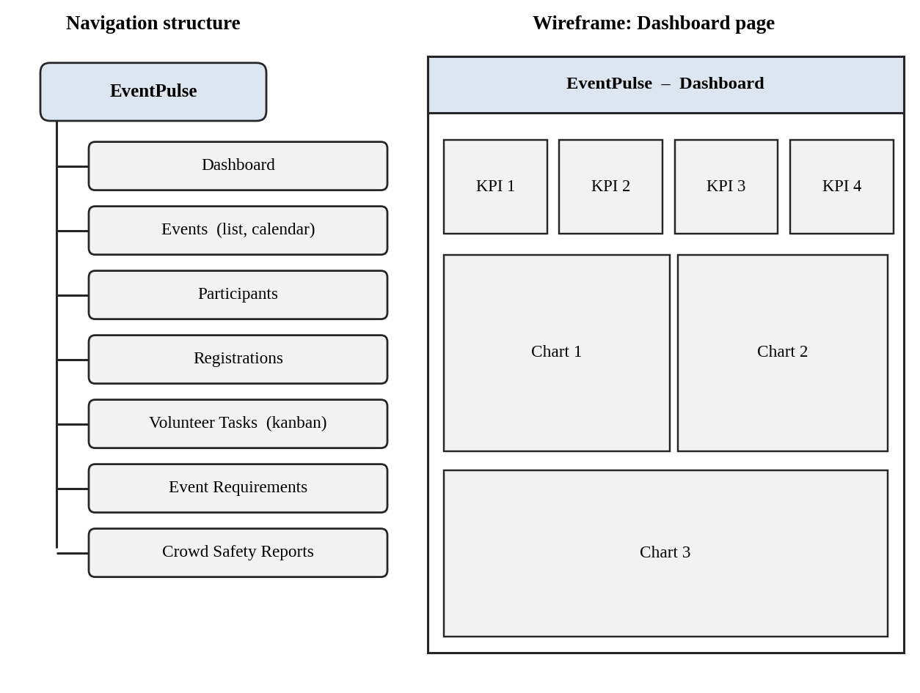
Figure 4.4: Navigation Structure and Wireframe of the Dashboard Page

4.6 Access Control Design
In the current version the application does not yet split access by role: the administrator and event users work with the same components. Table 4.8 therefore defines the target role–permission model for the planned role-based access enhancement, using A = Add, E = Edit, V = View, D = Delete and – = no access. The model introduces Volunteer and Participant roles in addition to the Administrator and Event User.
Table 4.8: Role–Permission Matrix (Target Design)
Component | Administrator | Event User | Volunteer | Participant
Form: Events | A E V D | A E V | V | V
Form: Participants | A E V D | A E V | – | V (own)
Form: Registrations | A E V D | A E V | V | A V (own)
Form: Volunteer Tasks | A E V D | A E V | E V (own) | –
Form: Event Requirements | A E V D | A E V | V | –
Form: Crowd Safety Reports | A E V D | A V | A V | A
Report: Critical Incidents | V | V | – | –
Page: Dashboard | V | V | – | –
CHAPTER 5

IMPLEMENTATION

5.1 Application Setup
EventPulse was created in a Zoho Creator workspace as a single application. The application menu is organised by module: a dashboard, and one section for each of the six forms with its reports (Events with the campus event calendar, Participants, Registrations, Volunteer Tasks with the kanban board, Event Requirements and Crowd Safety Reports). Keeping every module in the same application lets all forms share one database through lookup fields.

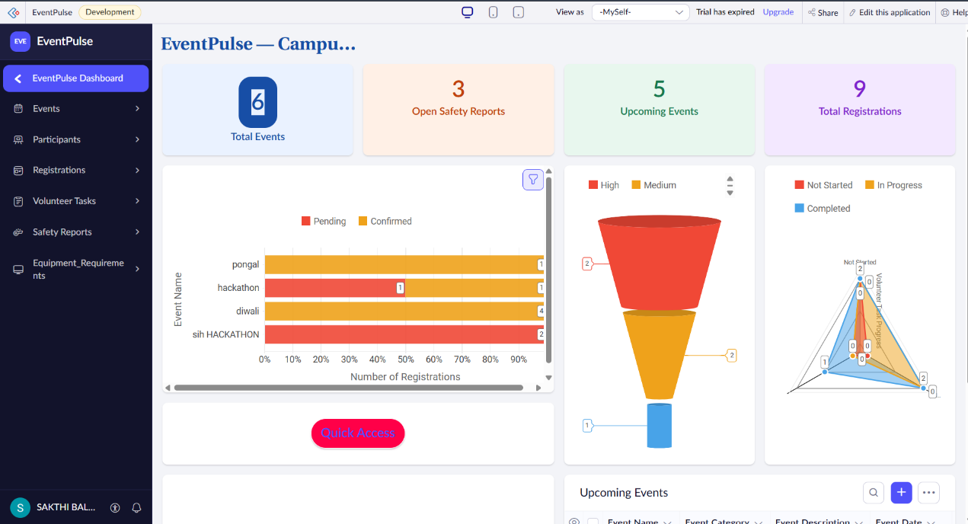
Figure 5.1: EventPulse Application Home and Navigation Sections

5.2 Forms and Data Capture
Six forms capture all event data. Events stores the category, date, time, venue, capacity, registration deadline and status of each event. Participants stores the student ID, email, phone, department and year. Registrations links a participant to an event through two lookup fields and holds the registration and check-in status. Volunteer Tasks holds the priority, due date and status of each task. Event Requirements records seating, food, audio-visual and decoration needs with a quantity. Crowd Safety Reports holds the issue type, severity and status of each incident. Field specifications are given in Section 4.3. Validation is implemented as Deluge rules that run when a record is added: invalid input is stopped with an alert and “cancel submit” (Section 5.5). Figures 5.2 and 5.3 show the Registrations form in the Form Builder and in live mode.

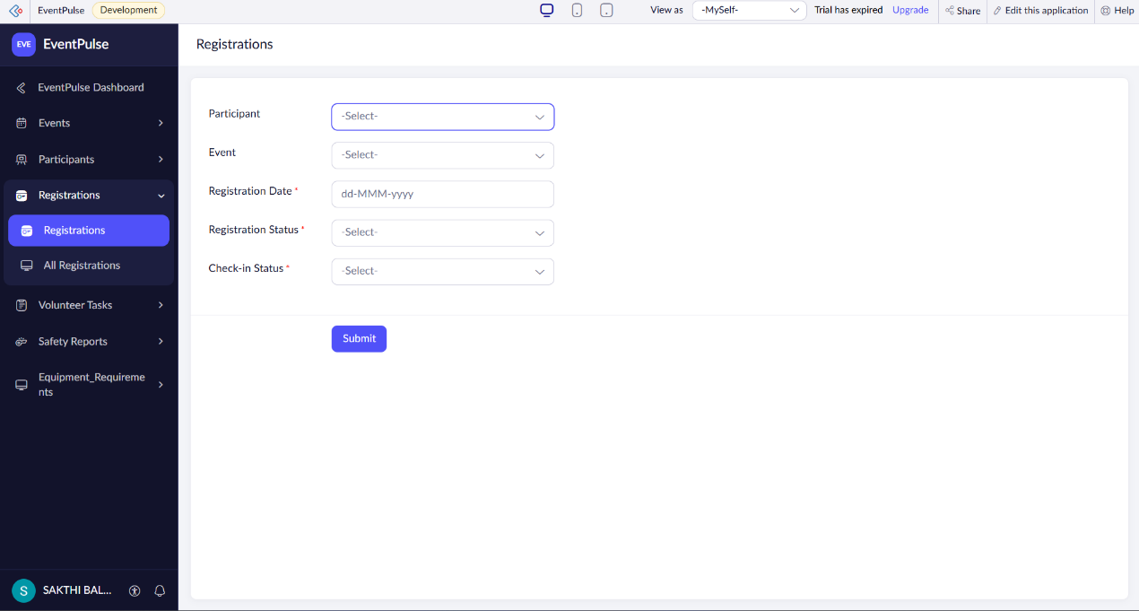
Figure 5.2: Registrations Form in the Form Builder

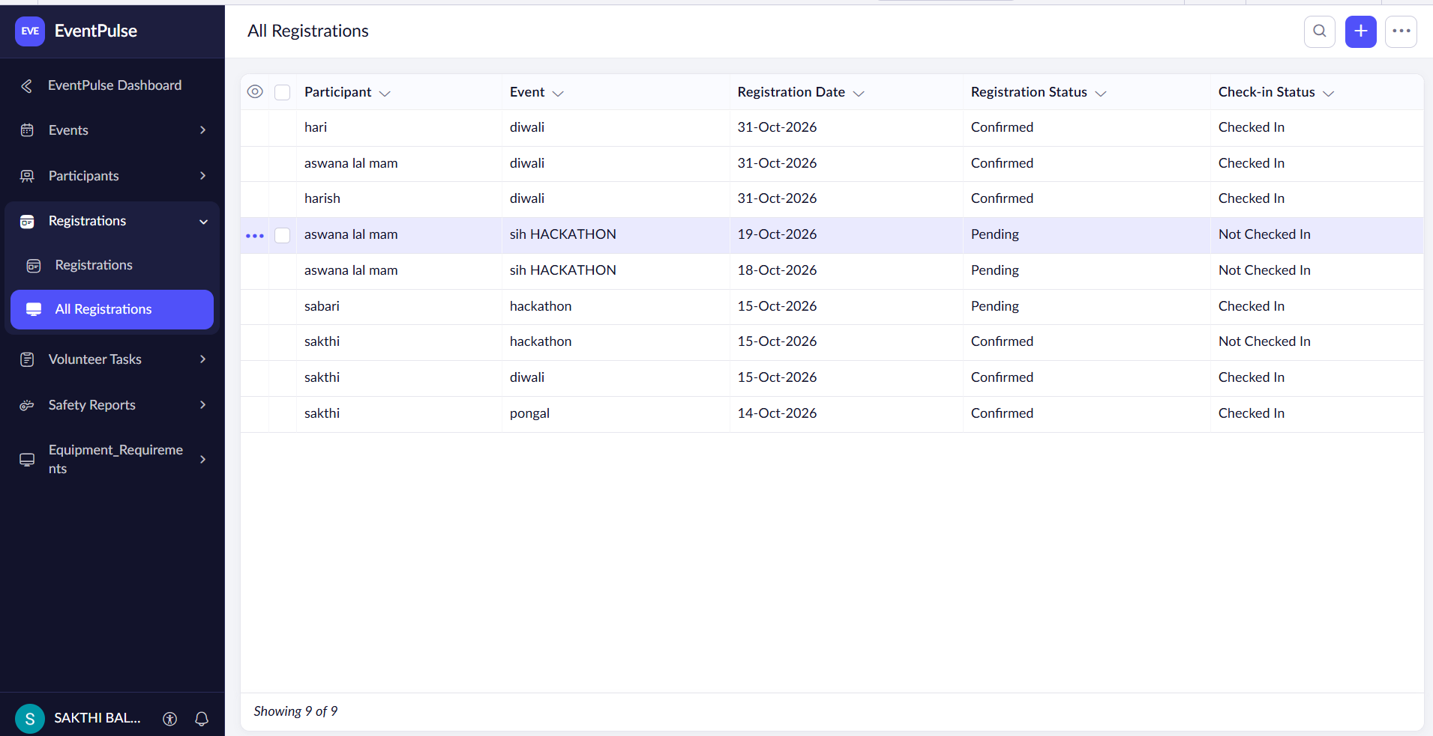
Figure 5.3: Registrations Form in Live Mode with Alert

5.3 Reports
EventPulse provides eleven reports of three types: list, calendar and kanban. Filtered list reports such as Open Safety Reports and Critical Incidents let the administrator focus on incidents that need attention, the calendar shows every campus event by date, and the kanban board shows volunteer tasks grouped by status. The charts used on the dashboard are described in Section 5.4. Table 5.1 lists the reports.
Table 5.1: Reports Implemented
Report Name | Type | Source Form | Filter / Grouping / Sorting | Custom Actions | Roles
All Events | List | Events | – | – | All users
All Participants | List | Participants | – | – | All users
All Registrations | List | Registrations | – | – | All users
All Volunteer Tasks | List | Volunteer Tasks | – | – | All users
All Event Requirements | List | Event Requirements | – | – | All users
All Crowd Safety Reports | List | Crowd Safety Reports | – | – | All users
Open Safety Reports | List (filtered) | Crowd Safety Reports | Filter: status is Open | – | All users
Critical Incidents | List (filtered) | Crowd Safety Reports | Filter: severity is Critical | – | All users
Upcoming Events | List (filtered) | Events | Filter on event date (fixed date in this version) | – | All users
Campus Event Calendar | Calendar | Events | Plotted by Event Date | – | All users
Volunteer Task Board | Kanban | Volunteer Tasks | Columns by Status | Drag a card to change status | All users

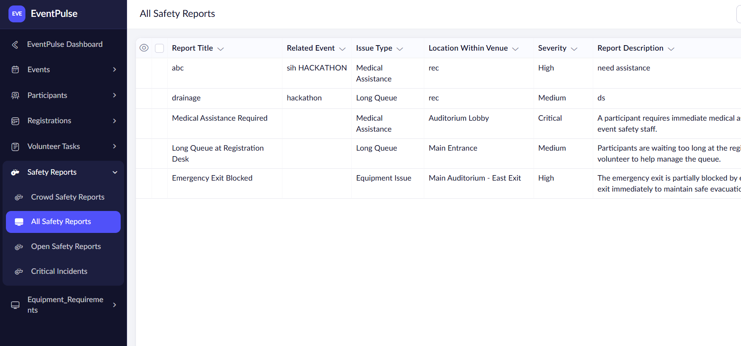
Figure 5.4: Open Safety Reports Report

5.4 Pages and Dashboards
The dashboard page is the single live view of EventPulse. It is intended for the administrator and event users and combines four KPI tiles with three charts built from the data in the six forms, so that the state of events, registrations, tasks and safety reports can be read at a glance. The calendar and the kanban board, described in Section 5.3, complement the dashboard by showing events by date and volunteer tasks by status.

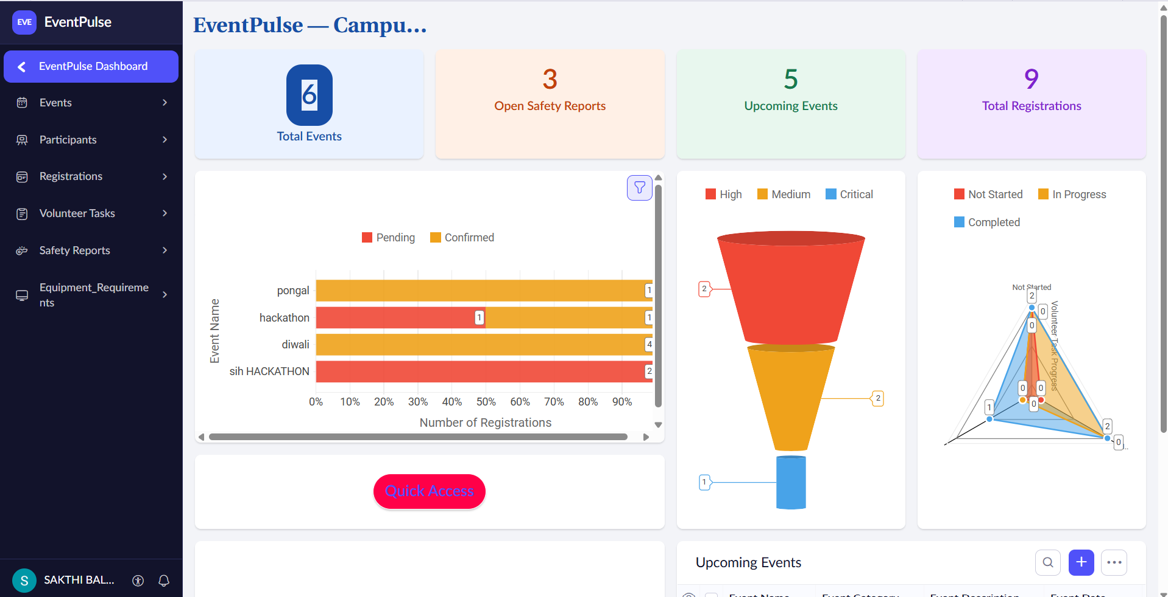
Figure 5.5: EventPulse Dashboard (KPIs and Charts)

5.5 Deluge Scripting
Five Deluge scripts implement the automatic rules of EventPulse and a sixth, a schedule, is configured but inactive. Each script is listed in Table 5.2 with its trigger. Short extracts are given here; the complete scripts are in Appendix C.
Table 5.2: Deluge Scripts Implemented
Script ID | Location / Trigger | Purpose | Deluge Concepts Used
DS-01 | Events → On Validate | Reject an event whose registration deadline is after the event date | if-else, alert, cancel submit
DS-02 | Registrations → On Validate | Block registration after the registration deadline | fetch, date comparison, alert, cancel submit
DS-03 | Registrations → On Validate | Block registration when venue capacity is reached | fetch, count, if-else, alert, cancel submit
DS-04 | Registrations → On Success | Send a confirmation email after a registration is saved | sendmail, string concatenation
DS-05 | Crowd Safety Reports → On Success | Email the administrator about a new safety report | sendmail, string concatenation
DS-06 | Schedule: event reminder (inactive) | Send reminders for upcoming events | schedule, date functions, sendmail

Code 5.1: Registration validation scripts (DS-02 and DS-03)
// DS-02 | Form: Registrations | Event: On Validate
// Purpose: Block registration after the registration deadline
ev = Events[ID == input.Event];
if(zoho.currentdate > ev.Registration_Deadline)
{
alert "Registration is closed for " + ev.Event_Name + ".";
cancel submit;
}

// DS-03 | Form: Registrations | Event: On Validate
// Purpose: Block registration when the venue capacity is reached
ev = Events[ID == input.Event];
seatsTaken = Registrations[Event == input.Event].count();
if(seatsTaken >= ev.Capacity)
{
alert "Seats are full for " + ev.Event_Name + ".";
cancel submit;
}

Code 5.2: Safety alert script (DS-05)
// DS-05 | Form: Crowd Safety Reports | Event: On Success
// Purpose: Email the administrator when a safety report is submitted
sendmail
[
from :zoho.adminuserid
to :zoho.adminuserid
subject :"Crowd safety report: " + input.Issue_Type + " (" + input.Severity + ")"
message :"A new crowd-safety report was submitted for " + input.Event.Event_Name + "."
]

DS-02 fetches the event selected in the registration and compares the current date with its registration deadline. If the deadline has passed, an alert is shown and “cancel submit” prevents the record from being saved. DS-03 counts the registrations already held for the same event and compares the count with the event capacity; when the venue is full the registration is blocked in the same way. Because both scripts run on validation, an invalid registration never reaches the database. DS-05 runs after a safety report is saved and emails the administrator with the issue type and severity, so that incidents are noticed immediately. DS-01 applies the same alert-and-cancel pattern to events, and DS-04 sends the confirmation email after a registration is saved.

5.6 Workflows and Automation
All automation in EventPulse is implemented as form workflows that run Deluge scripts on form events, plus one schedule. Table 5.3 lists them. Approval processes, Blueprints and batch workflows are not used in this version because the event rules are simple validations and notifications rather than multi-step approvals.
Table 5.3: Workflows Implemented
Workflow Name | Type | Trigger / Event | Condition | Action(s) | Script Ref.
Event Date Check | Form Workflow | Events → On Validate | Deadline after event date | Alert; cancel submit | DS-01
Registration Deadline Check | Form Workflow | Registrations → On Validate | Current date after deadline | Alert; cancel submit | DS-02
Capacity Check | Form Workflow | Registrations → On Validate | Registrations count ≥ capacity | Alert; cancel submit | DS-03
Registration Confirmation | Form Workflow | Registrations → On Success | Record saved | Confirmation email | DS-04
Safety Report Alert | Form Workflow | Crowd Safety Reports → On Success | Record saved | Email to administrator | DS-05
Event Reminder | Schedule (inactive) | Scheduled run | Upcoming events | Reminder email (not active) | DS-06
Approval / Blueprint / Batch | – | – | – | Not used in this version | –

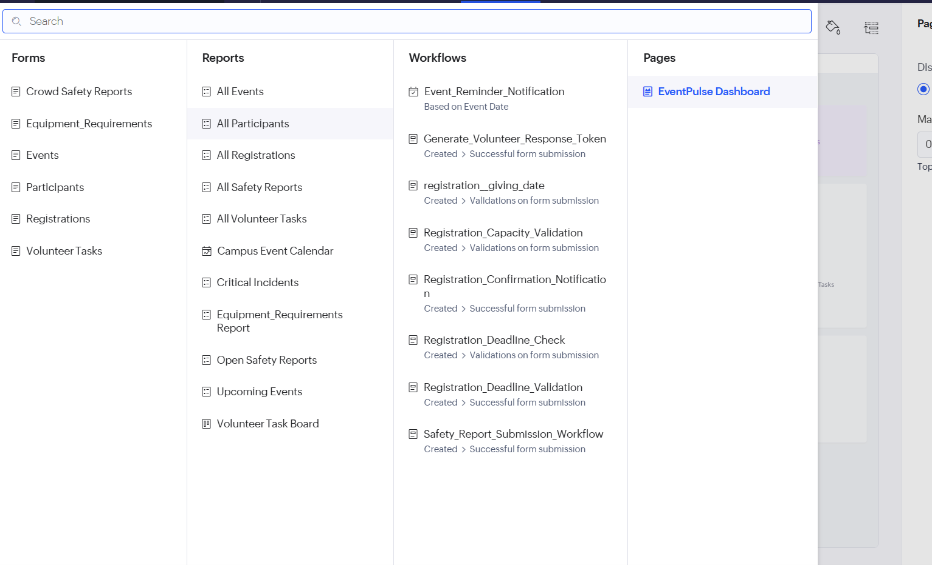
Figure 5.6: Registrations Form Workflow Configuration

5.7 Integrations
EventPulse does not integrate with external APIs or other Zoho services. All data lives in the Creator database, and the only outbound communication is email, sent through the platform’s built-in sendmail task from Deluge (DS-04 and DS-05). Because no external service is called, no connection, OAuth authorisation or API key is needed and no credentials are stored in the application. Table 5.4 records this.
Table 5.4: Integrations Implemented
Integration | Service / Endpoint | Method | Authentication | Data Exchanged / Purpose
Email notification | Zoho Creator built-in email | Deluge sendmail task | Platform-managed; no credentials in code | Registration confirmation and safety alert emails
External APIs | None | – | – | Not used in this version

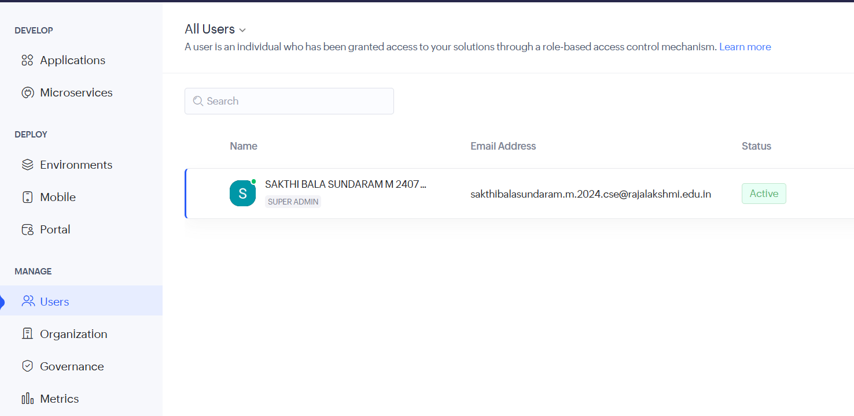

Fig:5.7

5.8 User Management and Role-Based Access
In the current version the application is used by the administrator and event users who sign in to Zoho Creator, and access is not yet split by role. The role–permission model that the application is intended to follow is defined as a target design in Table 4.8 (Section 4.6): the Administrator keeps full control, the Event User manages operational records, Volunteers see and update their own tasks, and Participants add and view their own registrations. Implementing it requires permission profiles for each role and record-level criteria such as “Added User == zoho.loginuser” for own-record access. This is listed as a future enhancement.

5.9 AI and Analytics Features
Analytics is provided by the dashboard, whose KPI tiles and three charts summarise the data of the six forms, and by the filtered reports described in Section 5.3 (see Figure 5.5). No Zia or other AI feature was used in this version, and no part of the application was generated by an AI-assisted builder. Possible uses are noted in Section 9.2.

5.10 Pro-Code Extension
No pro-code extension was used. Every rule in EventPulse is a short Deluge script and the user interface is built from standard Creator components, so Zoho Catalyst, JavaScript widgets and custom Creator REST API integrations were not required. If the application grows, the Creator REST API could expose event data to the college website, a widget could provide a QR-code check-in screen, and a Catalyst function could handle bulk notifications, while the data model would remain in Creator.

5.11 Mobile and Portal Access
The application is accessed through a web browser. A dedicated mobile layout or customer portal for participants was not configured in this version. Participant-facing access is planned together with the role-based access enhancement.

CHAPTER 6

TESTING AND DEBUGGING

6.1 Testing Strategy
Testing follows the four levels used for low-code applications. Unit testing exercises each form and each Deluge rule on its own, by submitting valid and invalid data. Integration testing checks the complete flows, namely that a valid registration is saved, the confirmation email is sent and the dashboard updates, and that a safety report reaches the administrator by email. Role-based access testing, in which each role signs in and its permissions are checked, is not applicable to the current version because access is not yet split by role; it is planned together with that enhancement. User acceptance testing is recorded in Section 6.5. The behaviours defined by the Deluge rules were turned into the test cases of Table 6.1, which cover every functional requirement of Table 3.2.

6.2 Test Cases
Table 6.1: Test Cases
TC ID | FR Ref. | Test Description | Input / Steps | Expected Result | Actual Result | Status
TC-01 | FR-01 | Create an event with all mandatory fields | Fill all mandatory fields; submit | Event saved; shown in report and calendar |  | Pass
TC-02 | FR-02 | Deadline after event date | Deadline later than event date | Alert shown; event not saved |  | Pass
TC-03 | FR-03 | Add a participant with all fields | Fill all fields; submit | Participant saved |  | Pass
TC-04 | FR-03 | Participant with a mandatory field missing | Leave a mandatory field blank | Validation message; record not saved |  | Pass
TC-05 | FR-04 | Register before the deadline with seats available | Valid event and participant; submit | Registration saved |  | Pass
TC-06 | FR-05 | Register after the deadline | Event with past deadline; submit | Alert shown; registration blocked |  | Pass
TC-07 | FR-06 | Register when the event is full | Event at full capacity; submit | Alert shown; registration blocked |  | Pass
TC-08 | FR-07 | Confirmation email | Save a valid registration | Confirmation email sent |  | Pass
TC-09 | FR-04 | Update check-in status | Edit check-in status | Status updated and reflected in reports |  | Pass
TC-10 | FR-08 | Create a volunteer task | Fill task details; submit | Task saved; appears on the kanban board |  | Pass
TC-11 | FR-08 | Move a task on the kanban board | Drag card to another column | Task status updated |  | Pass
TC-12 | FR-09 | Record an event requirement | Type and quantity; submit | Requirement saved against the event |  | Pass
TC-13 | FR-10 | Submit a crowd-safety report | Issue type, severity; submit | Report saved; administrator receives an email |  | Pass
TC-14 | FR-11 | Close a safety report | Set status to Closed | Status updated; leaves Open report |  | Pass
TC-15 | FR-12 | Dashboard update | Add records; open dashboard | KPI tiles and charts reflect the new data |  | Pass
TC-16 | FR-13 | Critical Incidents report | Submit Critical report | Report appears in Critical Incidents |  | Pass
TC-17 | FR-14 | Event reminder schedule | Check schedule | Reminder sent when the schedule is enabled | Schedule currently inactive | Not executed
TC-18 | NFR-02 | Access without signing in | Open link while signed out | Sign-in required |  | Pass

6.3 Debugging Deluge Scripts
Deluge scripts were debugged with info statements that print intermediate values, with the Deluge editor’s execute and debug option, and by submitting forms in live mode and reading the alert or error message returned on submission. One issue found while checking the confirmation and reminder emails was that they are delivered to the logged-in user instead of to the registered participant, because the recipient in the sendmail statement is the signed-in user rather than the participant’s email address. The planned correction is to use the Email field of the participant selected in the registration (BUG-01 in Table 6.2).

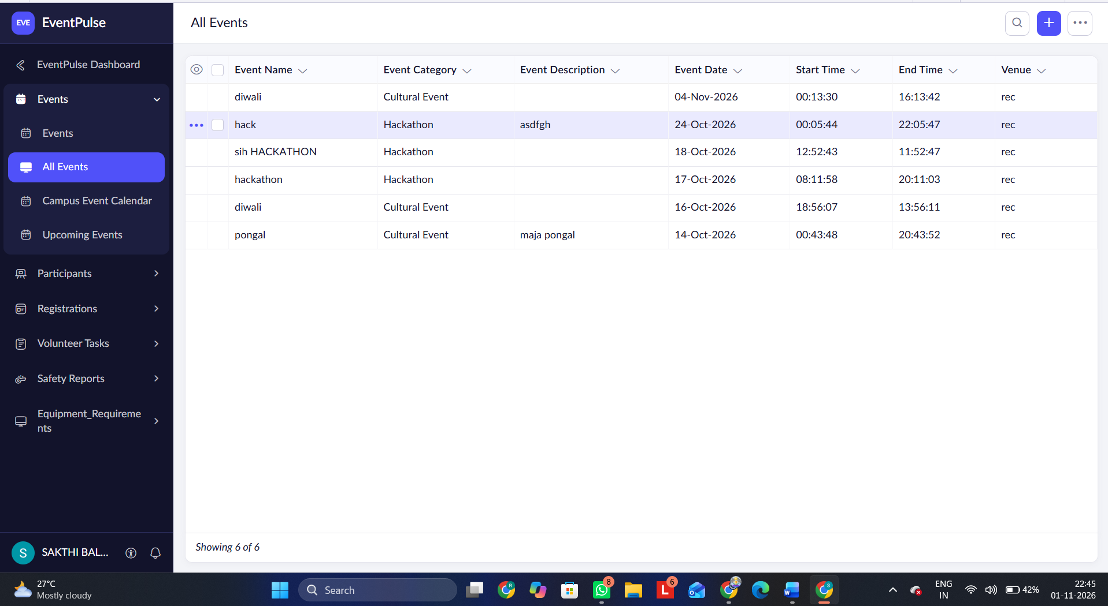
Figure 6.1: Deluge Debug Output

6.4 Defect Log
Table 6.2: Defect Log
Bug ID | Description | Root Cause | Fix Applied | Status
BUG-01 | Confirmation email goes to the logged-in user, not to the registered participant | sendmail recipient is the signed-in user instead of the participant’s email | Planned: use the participant’s Email field from the lookup | Open (future scope)
BUG-02 | Upcoming Events report does not roll forward with time | Report criteria uses a fixed date | Planned: use a rolling date (today) in the criteria | Open (future scope)
BUG-03 | Event reminder schedule does not run | Schedule is configured but switched off | To be enabled after reminders are routed to participants’ own email | Open (deferred)
BUG-04 | Waitlisted registrations are not promoted automatically when seats open | Waitlisted exists only as a status value; no promotion logic | Planned: Deluge rule to promote the earliest waitlisted registrant | Open (future scope)

6.5 User Acceptance Testing
Table 6.3: User Acceptance Feedback
User | Role Tested | Feedback | Action Taken
User 1 | Participants | Feedback | Action taken
User 2 | Volunteers | Feedback | Action taken
CHAPTER 7

DEPLOYMENT, SECURITY AND GOVERNANCE

7.1 Environments and Deployment Strategy
Deployment follows the Creator environment model: the application is built and tested in the Development environment, can be promoted to Stage for acceptance testing, and is published to Production for users, with version notes recorded at each publish and the previous version available for rollback. Table 7.1 is the checklist applied before publishing.

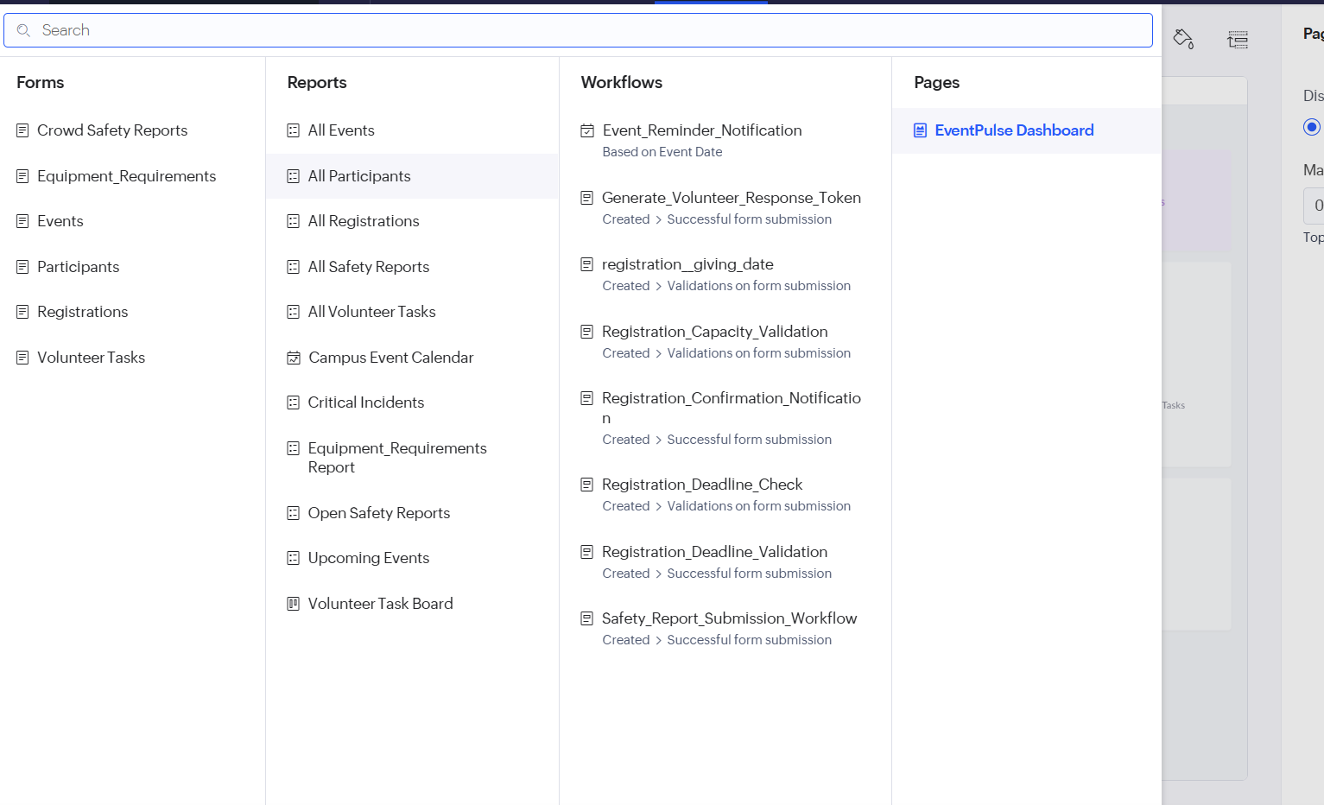
Figure 7.1: Environments and Publish to Production
Table 7.1: Deployment Checklist
S.No. | Checklist Item | Done (✓)
1 | All test cases executed in Development / Stage | [Done ]
2 | Sample/test data removed or isolated | [Done ]
3 | Roles, permissions and users configured in Production | [Done ]
4 | Connections authorised in Production | [Done ]
5 | Schedules and workflows enabled | [Done ]
6 | Application published and URL verified | [Done ]
7 | Version / release notes recorded | [Done ]

7.2 Performance Optimisation
EventPulse keeps its processing light. The registration rules fetch only the one event that the registration refers to, and the capacity check counts the registrations of that event rather than reading all records. Focused reports such as Open Safety Reports and Critical Incidents show only the records that need attention instead of the whole safety table. No before-and-after timings were recorded, so Table 7.2 states this explicitly.
Table 7.2: Performance Optimisation Results
Optimisation Applied | Component | Before | After | Improvement
Fetch only the event referred to by a registration | DS-02, DS-03 | Not measured | Not measured | –
Count registrations of one event instead of reading all records | DS-03 | Not measured | Not measured | –
Filtered reports for open and critical incidents | Open Safety Reports; Critical Incidents | Not measured | Not measured | –

7.3 Security Features
Security in EventPulse relies on the Zoho Creator platform together with the validation rules of the application. Users must sign in with a Zoho account to open the application. Deluge validation stops invalid data before it is saved. Because no external APIs are used, there are no API keys or OAuth connections to protect. Role-based permission profiles and record-level criteria are not yet configured and are planned (Section 5.8). Table 7.3 summarises the controls.
Table 7.3: Security Controls Implemented
Security Control | Where Applied | Threat Mitigated
Authenticated access (Zoho sign-in) | Whole application | Unauthorised access to event data
Server-side Deluge validation | Events and Registrations forms | Invalid or over-capacity records entering the database
No external API or stored keys | Whole application | Credential leakage
Role-based permission profiles (planned) | Future enhancement | Users seeing or changing data outside their role

7.4 Governance and Administration
Zoho Creator provides an audit trail of record changes, application-level administration of users and the ability to export data, and these are the platform facilities through which the application is governed. Forms, fields and reports follow a consistent naming convention based on the module name, for example Registrations and Crowd Safety Reports, and the application owner is responsible for maintaining rules, reports and users.

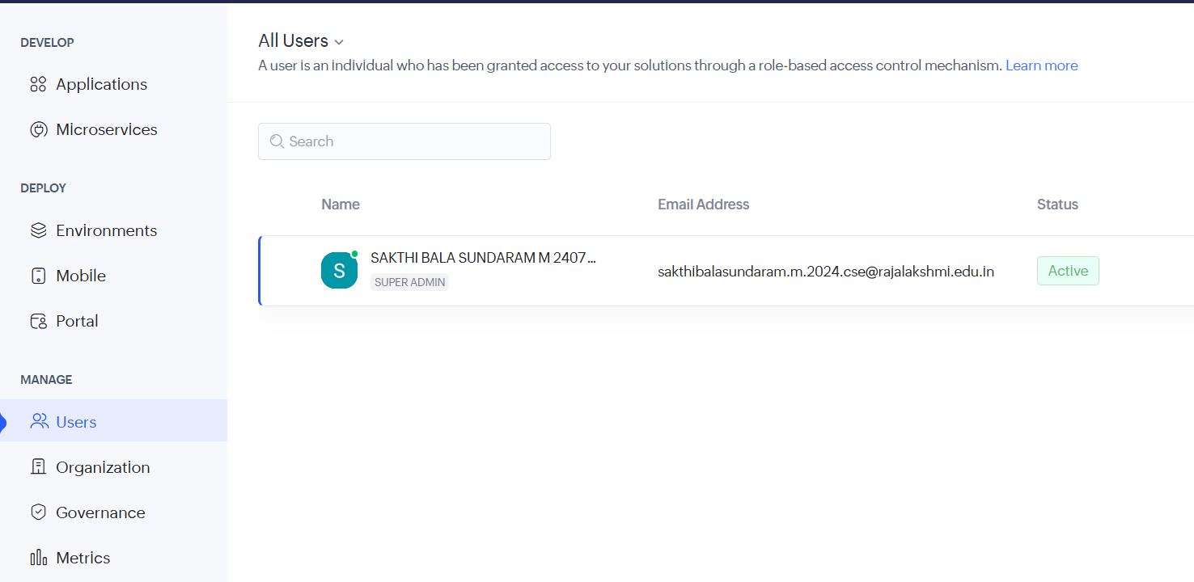
Figure 7.2: Audit Trail and Administration Settings
CHAPTER 8

RESULTS AND DISCUSSION

8.1 Application Output
The following scenario follows one event through the application. An organiser has created an event with a capacity and a registration deadline. When a registration is attempted after the deadline or when the venue is full, the registration form shows an alert and the record is not saved (Figure 8.1). Volunteer tasks for the event are tracked on the kanban board by status (Figure 8.2). When a crowd-safety incident is reported, the report is saved and the administrator receives an email (Figure 8.3). The dashboard then shows the updated KPIs and charts (Figure 8.4).

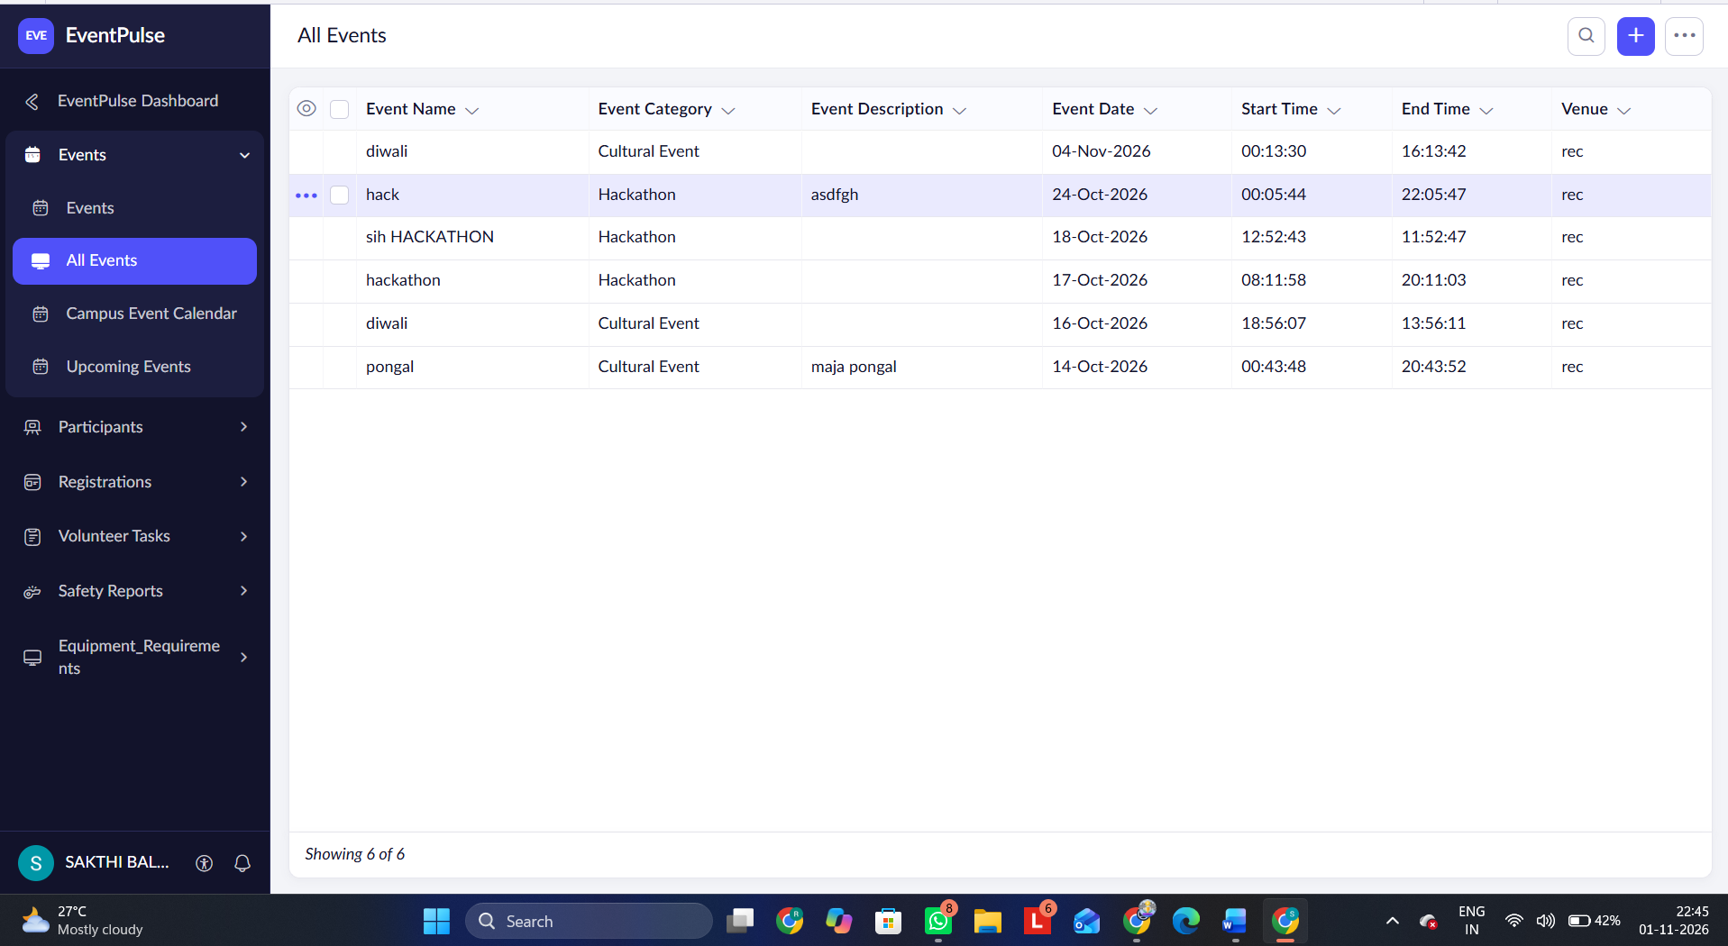
Figure 8.1: Scenario Step 1 – Registration Blocked with an Alert

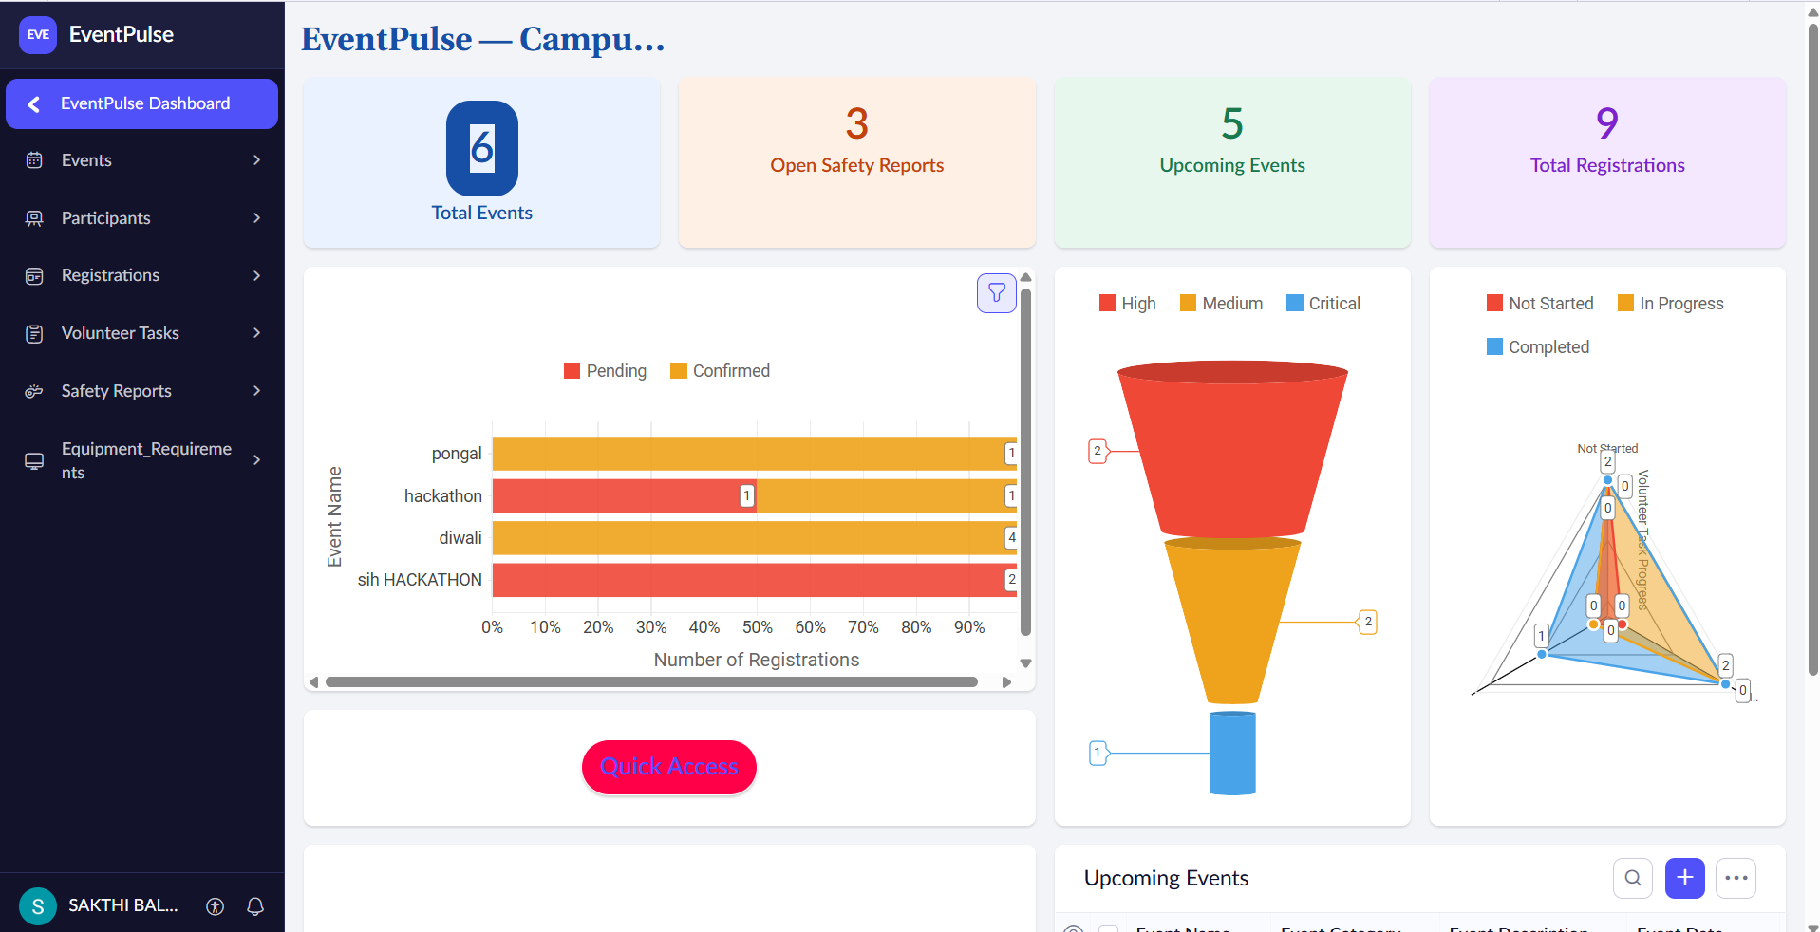
Figure 8.2: Scenario Step 2 – Dashboard with KPIs and Charts

8.2 Achievement of Objectives
Table 8.1: Mapping of Objectives to Outcomes
Objective (Sec. 1.3) | Implemented Through | Outcome / Evidence
Manage events with date, venue, capacity, deadline and status | Events form (5.2); DS-01 | Events are created and checked; calendar shows all events (Table 5.1)
Register participants and track check-in | Participants and Registrations forms (5.2) | Registration and check-in status held per event
Block late and over-capacity registrations | DS-02, DS-03 (5.5) | Alert shown and record not saved when the deadline has passed or seats are full
Track volunteer tasks and event requirements | Volunteer Tasks and Event Requirements forms; kanban board (5.2, 5.3) | Tasks tracked by priority, due date and status on the board
Report safety incidents, alert the administrator and give a live view | DS-05; Crowd Safety Reports; dashboard (5.4, 5.5) | Administrator emailed on every safety report; four KPIs and three charts

8.3 Comparison with the Existing System
Table 8.2: Existing System versus Proposed Application
Parameter | Existing System | Proposed Application | Improvement
Time to process one registration | Entered in a sheet and checked by hand | One form submission with automatic checks | Qualitative: fewer manual checks (not timed)
Manual steps | Compare deadline and seats, update sheets, message volunteers | Deadline and capacity checked by Deluge rules | Registration checks automated
Overbooking control | None | Blocked automatically with an alert | Overbooking prevented
Safety incident response | Informal call or message | Report saved and administrator emailed | Instant alert
Report generation | Compiled manually from several files | Reports, calendar, kanban and dashboard | Live view
Data accessibility | Scattered files | One database with linked forms | Single source of truth

8.4 Limitations of the Low-Code Approach
Working on Zoho Creator exposed several constraints. First, confirmation and reminder emails currently go to the logged-in user rather than to each participant, because the recipient is set to the signed-in user; the workaround is manual forwarding until the participant’s email is used as recipient. Second, the Upcoming Events report uses a fixed date, so it must be edited as time passes; a rolling date in the criteria is the correction. Third, waitlisting is a status value but promotion is not automatic, so the administrator promotes registrants by hand. Fourth, access is not yet separated by role, which means all signed-in users share the same view. Beyond these, any low-code platform limits the user interface to the available components and restricts scripts to the platform’s language and execution limits, and an application remains tied to the vendor’s platform [5]. For the scope of EventPulse these limits did not prevent any required feature.

8.5 Reflection on the No-Code → Low-Code → Pro-Code Spectrum
The parts of EventPulse sit at different points of the no-code to pro-code spectrum. The six forms, their lookups, the eleven reports, the calendar, the kanban board and the dashboard were created by configuration in the builder with no code, which is the no-code end of the spectrum. The five validation and email rules and the inactive schedule needed low-code, in the form of short Deluge scripts. No part needed pro-code. I would move to pro-code if the application had to exchange data with external systems at scale, for example a college-wide ERP, handle thousands of simultaneous registrations, or offer a custom check-in interface, in which case Catalyst functions, widgets or the Creator REST API would complement the Creator data model.
CHAPTER 9

CONCLUSION AND FUTURE ENHANCEMENTS

9.1 Conclusion
EventPulse brings campus event management into one Zoho Creator application. Six linked forms hold events, participants, registrations, volunteer tasks, event requirements and crowd-safety reports. Eleven reports, a campus calendar, a volunteer kanban board and a dashboard with four KPI tiles and three charts give organisers one live view, and five Deluge rules stop late and over-capacity registrations, reject invalid event dates, confirm registrations and alert the administrator about safety incidents.
The project shows that a working business application can be assembled on a low-code platform by combining configuration with a small amount of scripting. Its current limits are known and documented: confirmations and reminders go to the logged-in user, the upcoming-events report uses a fixed date, waitlisting is not automatic and access is not split by role. Section 9.2 sets out how these will be addressed.

9.2 Future Enhancements
- Send confirmations and reminders to each participant’s own email address, and then enable the event reminder schedule.
- Use a rolling date in the upcoming-events report so that it always shows future events.
- Promote waitlisted registrants automatically when seats open, using a Deluge rule.
- Introduce role-based access for administrators, volunteers and participants using permission profiles and record-level criteria, with a participant portal.

9.3 Learning Outcomes and Career Relevance
Building EventPulse taught me to model data as linked forms, to turn business rules into Deluge scripts, to present data through reports and a dashboard, and to document the application, including its known limitations, honestly. These skills correspond to the roles of citizen developer and low-code developer, and the experience of choosing what to configure and what to script is the groundwork for a solutions consultant or automation engineer.

REFERENCES
[1] W. Rosam and O. Kalnichevski, Low-Code Development: A Practical Guide. New Delhi, India: BPB Publications.
[2] Zoho Corporation, “Zoho Creator Help Documentation.” [Online]. Available: https://www.zoho.com/creator/help/ (Accessed:[12/10/2026]).
[3] A. C. Bock and U. Frank, “Low-Code Platform,” Business & Information Systems Engineering, vol. 63, no. 6, pp. 733–740, 2021, doi: 10.1007/s12599-021-00726-8.
[4] R. Sanchis, Ó. García-Perales, F. Fraile, and R. Poler, “Low-Code as Enabler of Digital Transformation in Manufacturing Industry,” Applied Sciences, vol. 10, no. 1, Art. no. 12, 2020, doi: 10.3390/app10010012.
[5] Y. Luo, P. Liang, C. Wang, M. Shahin, and J. Zhan, “Characteristics and Challenges of Low-Code Development: The Practitioners’ Perspective,” in Proc. ACM/IEEE Int. Symp. Empirical Software Engineering and Measurement (ESEM), 2021, pp. 1–11, doi: 10.1145/3475716.3475782.
[6] Zoho Corporation, “Deluge Script Reference Guide.” [Online]. Available: https://www.zoho.com/deluge/ (Accessed:[18/10/2026]).

APPENDIX A – ZOHO CREATOR FEATURE COVERAGE CHECKLIST
Table A.1: Feature Coverage Checklist
Unit | Zoho Creator Feature | Done | Where in the Application | Report Section | Figure / Code No.
I | Application created & sections/menu organised | Y | EventPulse application; menu organised by module | 5.1 | Fig. 5.1
II | Forms with ≥ 8 distinct field types | Y | Six forms (Section 4.3) | 5.2 | Fig. 5.2, 5.3
II | Lookup field (relationship between forms) | Y | Registrations, Volunteer Tasks, Event Requirements, Crowd Safety Reports | 4.2, 5.2 | Fig. 4.2
II | Subform (parent–child data) | N | Not used; registrations are a separate linked form | 4.2, 5.2 | –
II | Field validations / layout rules | Y | Events and Registrations forms (DS-01 to DS-03) | 5.2 | Code 5.1
II | List report with filter, grouping, custom action | Y | Open Safety Reports; Critical Incidents (confirm grouping / custom action) | 5.3 | Fig. 5.4
II | Kanban / Calendar / Timeline / Map report | Y | Volunteer Task Board; Campus Event Calendar | 5.3 | Table 5.1
II | Pivot table / chart report | N | Charts on the dashboard page | 5.3 | Fig. 5.5
II | Page / dashboard built with UI Builder | Y | Dashboard page (4 KPI tiles, 3 charts) | 5.4 | Fig. 5.5
II | Deluge – form events (validate / success / field actions) | Y | DS-01 to DS-05 | 5.5 | Code 5.1, 5.2
II | Deluge – functions, fetch, loops, collections | Y | fetch and count in DS-02, DS-03; custom functions not used | 5.5 | Code 5.1
II | Email / in-app notifications | Y | DS-04, DS-05 | 5.5, 5.6 | Code 5.2
II | Form workflow | Y | Five form workflows | 5.6 | Fig. 5.6
II | Scheduled workflow | Y (inactive) | Event reminder schedule, configured but switched off | 5.6 | –
II | Approval process | N | Not used | 5.6 | –
II | Blueprint | N | Not used | 5.6 | –
II | Batch / report workflow | N | Not used | 5.6 | –
II | Testing & debugging evidence | Y | Table 6.1 test cases | 6 | Fig. 6.1
III | Integration with a Zoho service | N | None; sendmail only | 5.7 | –
III | Connection / REST API call (invokeurl) | N | No external API | 5.7 | –
III | Webhook or Creator REST API | N | Not used | 5.7 | –
III | Users, roles and permission profiles | N | Planned (target design in Section 4.6) | 5.8 | –
III | Record-level access criteria / customer portal | N | Planned | 5.8 | –
III | Zia / AI feature | N | Not used | 5.9 | –
III | Analytics (charts / Zoho Analytics) | Y | Dashboard charts and KPI tiles | 5.9 | Fig. 5.5
IV | Performance optimisation applied & measured | N | Not measured | 7.2 | –
IV | Deployment across environments | N | Development → Production | 7.1 | Fig. 7.1
IV | Security controls (encryption, OAuth, permissions) | N | Platform sign-in and Deluge validation only | 7.3 | –
IV | Governance (audit trail, administration) | Y | Audit trail / administration | 7.4 | Fig. 7.2
V | Pro-code extension (Catalyst / widgets / custom functions) | N | Not used | 5.10 | –
V | Low-code limitations & spectrum analysis | Y | Sections 8.4 and 8.5 | 8.4, 8.5 | –
— | Mobile app / portal access | N | Not configured | 5.11 | –

Total features implemented: 12 / 32

APPENDIX B – COURSE OUTCOME MAPPING
Table B.1: Mapping of Course Outcomes to Report Chapters
CO | Course Outcome Statement | Evidenced In | Self-Assessed Level | Examiner Level
CO1 | Explain the principles, architecture, and business value of low-code application development using Zoho Creator. | Ch. 1, 2 | 3
CO2 | Develop business applications using Zoho Creator forms, reports, workflows, and Deluge scripting. | Ch. 4, 5 (5.1–5.6), 6 | 3
CO3 | Integrate Zoho Creator applications with Zoho services and external systems using APIs, connections, and role-based security. | Ch. 4.6, 5.7–5.9 | 2
CO4 | Deploy, secure, and manage Zoho Creator applications across development and production environments following governance best practices. | Ch. 7 | 2
CO5 | Evaluate low-code development strategies, AI-assisted application development, and the transition from citizen developer to professional developer. | Ch. 5.9, 5.10, 8.4, 8.5, 9.3 | 2

APPENDIX C – COMPLETE DELUGE SOURCE CODE
C.1 Events form – Validation
// Script ID : DS-01
// Location : Events → On Validate
// Purpose : Registration deadline must not be after the event date
if(input.Registration_Deadline > input.Event_Date)
{
alert "Registration deadline cannot be after the event date.";
cancel submit;
}

C.2 Registrations form – Deadline check
// Script ID : DS-02
// Location : Registrations → On Validate
// Purpose : Block registration after the registration deadline
ev = Events[ID == input.Event];
if(zoho.currentdate > ev.Registration_Deadline)
{
alert "Registration is closed for " + ev.Event_Name + ".";
cancel submit;
}
C.3 Registrations form – Capacity check
// Script ID : DS-03
// Location : Registrations → On Validate
// Purpose : Block registration when the venue capacity is reached
ev = Events[ID == input.Event];
seatsTaken = Registrations[Event == input.Event].count();
if(seatsTaken >= ev.Capacity)
{
alert "Seats are full for " + ev.Event_Name + ".";
cancel submit;
}
C.4 Registrations form – Confirmation email
// Script ID : DS-04
// Location : Registrations → On Success
// Purpose : Send a confirmation email after a registration is saved
sendmail
[
from :zoho.adminuserid
to :zoho.loginuserid
subject :"Registration confirmed: " + input.Event.Event_Name
message :"Your registration for " + input.Event.Event_Name + " has been saved."
]
C.5 Crowd Safety Reports form – Admin alert
// Script ID : DS-05
// Location : Crowd Safety Reports → On Success
// Purpose : Email the administrator when a safety report is submitted
sendmail
[
from :zoho.adminuserid
to :zoho.adminuserid
subject :"Crowd safety report: " + input.Issue_Type + " (" + input.Severity + ")"
message :"A new crowd-safety report was submitted for " + input.Event.Event_Name + "."
]
C.6 Event reminder schedule (inactive)
// Script ID : DS-06
// Location : Schedule → Event reminder (configured, inactive)
// Purpose : Remind about events happening the next day
upcoming = Events[Event_Date == zoho.currentdate.addDay(1)];
for each ev in upcoming
{
sendmail
[
from :zoho.adminuserid
to :zoho.adminuserid
subject :"Reminder: " + ev.Event_Name + " is tomorrow"
message :"Event " + ev.Event_Name + " takes place on " + ev.Event_Date
]
}

APPENDIX D – USER MANUAL

D.1 Accessing the Application
Open the application link https://creatorapp.zoho.in/... in a web browser and sign in with your Zoho account. The dashboard opens first. Use the application menu to open a module: Events, Participants, Registrations, Volunteer Tasks, Event Requirements or Crowd Safety Reports.

D.2 Instructions for the Administrator
- Open Events and add an event with its category, date, time, venue, capacity and registration deadline. The deadline must not be after the event date.
- Open Registrations to review who has registered and update check-in status on the event day.
- Open Crowd Safety Reports when an alert email arrives; review the report and update its status from Open to Closed. Use Open Safety Reports and Critical Incidents to see what needs attention.
- Open the Dashboard for the live KPIs and charts, and the Campus Event Calendar for events by date.

D.3 Instructions for the Event User
- Open Participants and add each participant with student ID, email, phone, department and year.
- Open Registrations, select the event and the participant, and submit. If the deadline has passed or the event is full, an alert is shown and the registration is not saved.
- Open Volunteer Tasks to add tasks with priority and due date, and move task cards across the kanban board as work progresses. Record needs in Event Requirements.
- Open Crowd Safety Reports to report an incident with its issue type and severity; the administrator is emailed automatically.

APPENDIX E – EVALUATION RUBRIC
(For Examiner Use Only)
Student Name | Sakthibalasundaram M | Register No. | 240701170
Project Title | EventPulse: A Campus Event Management Platform for Registrations, Volunteers and Crowd Safety | Date

Table E.1: Evaluation Rubric for the Individual Project
S.No. | Criterion | Indicators | Max. Marks | Marks Awarded
1 | Problem Definition & Requirement Analysis | Clarity of problem, measurable objectives, complete FR/NFR, use cases | 10
2 | System Design | Architecture, ER/data model, form specifications, workflow design, permission matrix | 10
3 | Forms, Reports & Pages | Variety of field types, lookups/subforms, report types, UI Builder dashboards | 15
4 | Deluge Scripting & Workflows | Correctness and depth of scripts; form, schedule, approval, Blueprint, batch workflows | 15
5 | Integration, RBAC & AI | Zoho/external integrations, connections, roles & permissions, Zia/analytics | 10
6 | Testing, Deployment, Security & Governance | Test coverage, environments, optimisation, security controls, audit | 10
7 | Live Demonstration | End-to-end working of the application across roles; feature checklist verified | 15
8 | Project Report | Adherence to template and format, clarity, figures, references | 5
9 | Viva-Voce | Understanding of the platform, design decisions and low-code concepts | 10
 | TOTAL |  | 100

Table E.2: Performance Level Descriptors
Level | % of Max. Marks | Descriptor
Excellent | 90–100 | Feature implemented completely, correctly and beyond the basic requirement; student explains design choices confidently.
Good | 70–89 | Feature implemented correctly with minor gaps; explanation adequate.
Satisfactory | 50–69 | Feature partially implemented or works only for the main path; limited explanation.
Needs Improvement | < 50 | Feature missing, non-functional or not understood by the student.

Signature of Internal Examiner  Name: ____________________ | Signature of External Examiner  Name: ____________________

APPENDIX F – VIVA-VOCE RECORD SHEET
(For Examiner Use Only)
Student Name | Sakthibalasundaram M | Register No. | 240701170
Department / Section | Computer Science and Engineering | Date of Viva
Application URL Verified | Yes / No | Demo Duration | ______ min
Table F.1: Viva-Voce Questions and Responses
Q.No. | Question / Topic Asked | Unit | Response (E / G / S / NI) | Remarks
1
2
3
4
5
6
7
8
E – Excellent G – Good S – Satisfactory NI – Needs Improvement
Table F.2: Marks Summary
Component | Max. Marks | Marks Awarded
Criteria 1–8 (Appendix E) | 90
Viva-Voce | 10
TOTAL | 100

Examiners’ Remarks:
____________________________________________________________________
____________________________________________________________________
INTERNAL EXAMINER  Name: ____________________ | EXTERNAL EXAMINER  Name: ____________________

