EXP 5
HARISARAN A
240701170
Event Management Application using Zia
Aim
To create an Event Management Application using Zoho Creator and use Zia to simplify event operations data management and provide quick insights.
Procedure
- Create a new application in Zoho Creator named Event Management.
- Create forms for Attendee Details, Venue Details, Registration Details, and Service Requests.
- Add suitable fields such as attendee name, event type, contact number, event date, ticket price, and registration status.
- Create reports to view and manage attendee and registration information.
- Create workflows to update registration status and manage venue availability and services.
- Use Zia to search, analyze, and obtain useful information from the application data using natural-language queries.
- Test the application by adding sample attendee and venue records and checking the generated reports and Zia responses.
Output
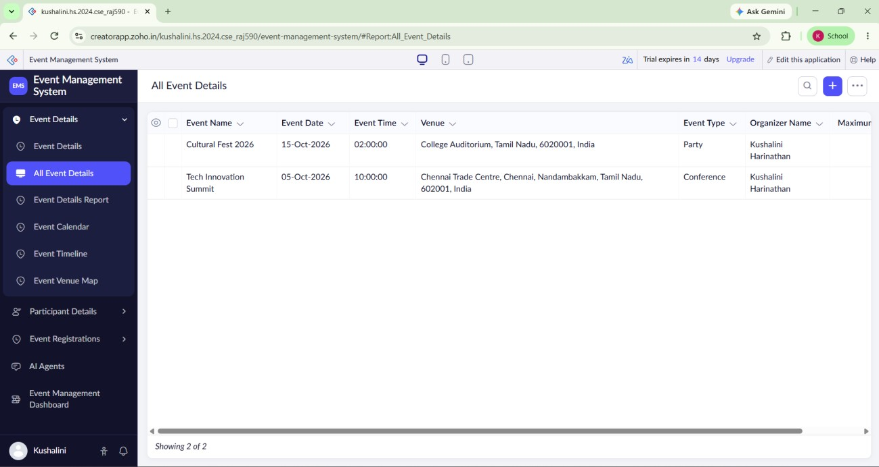

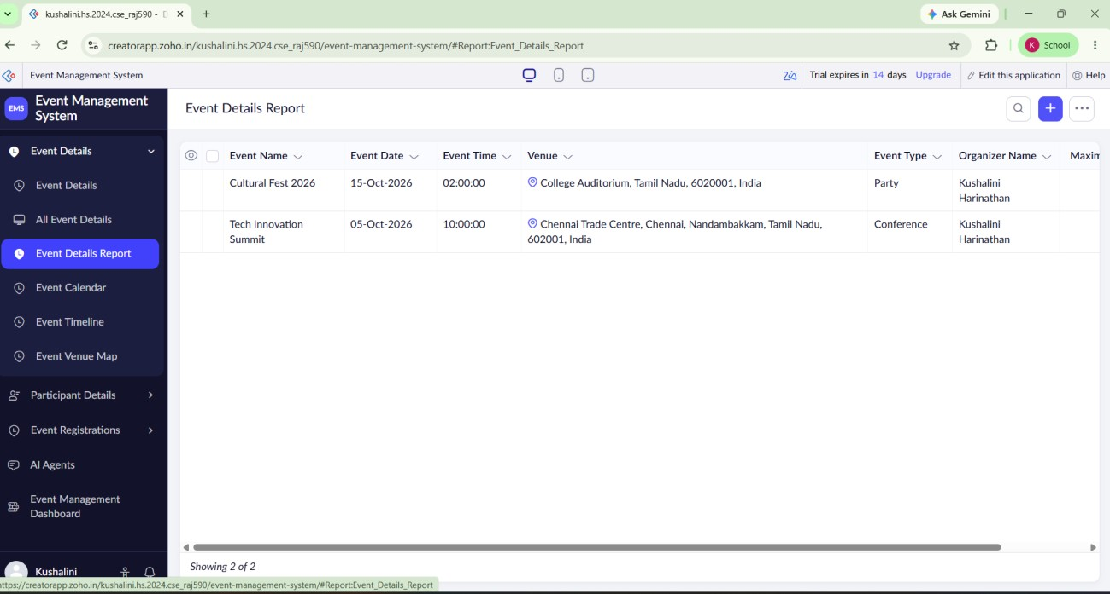
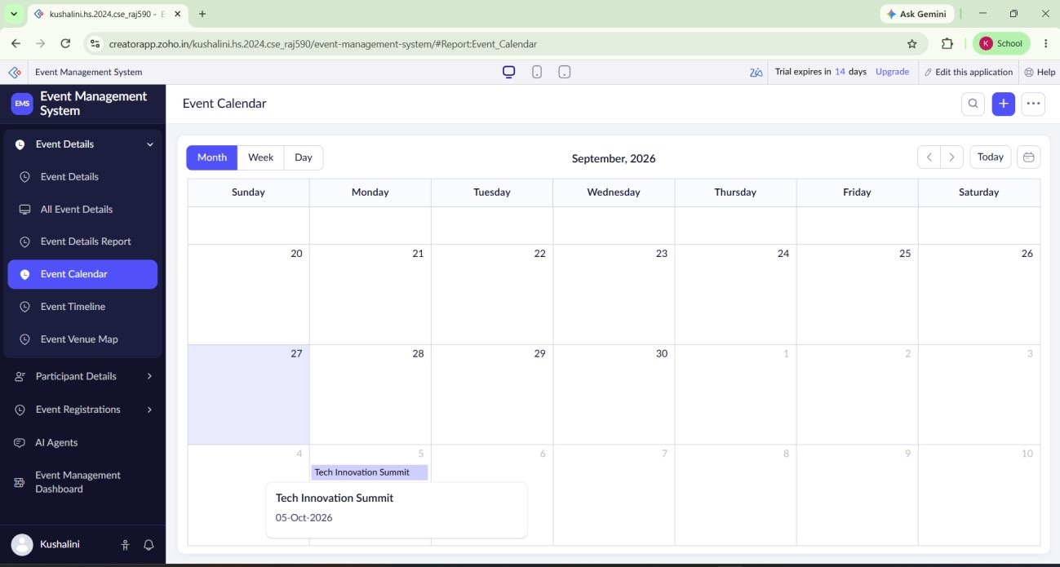
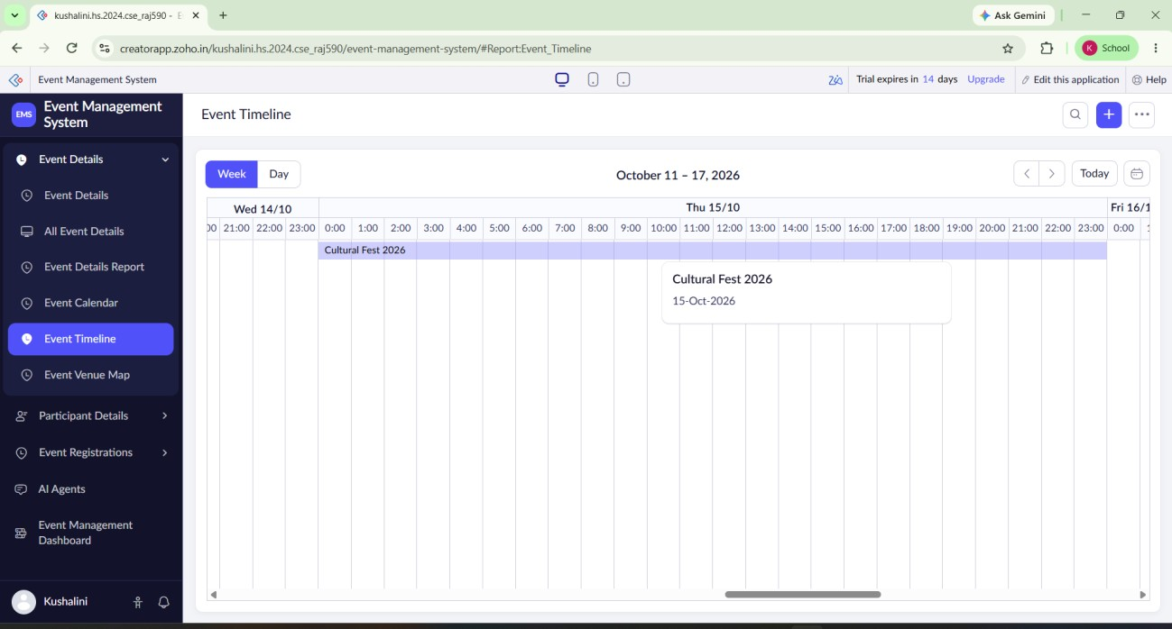
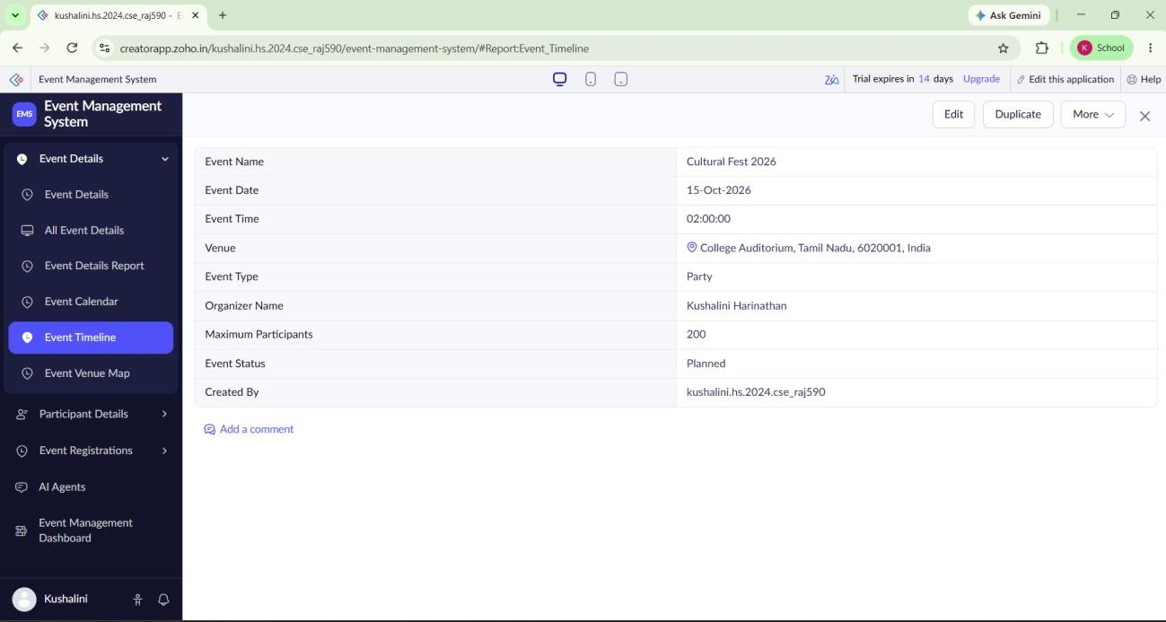
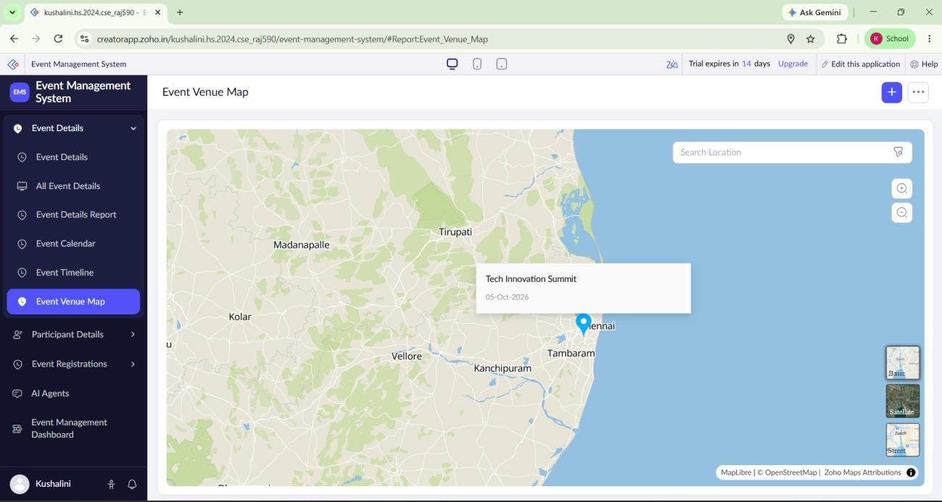
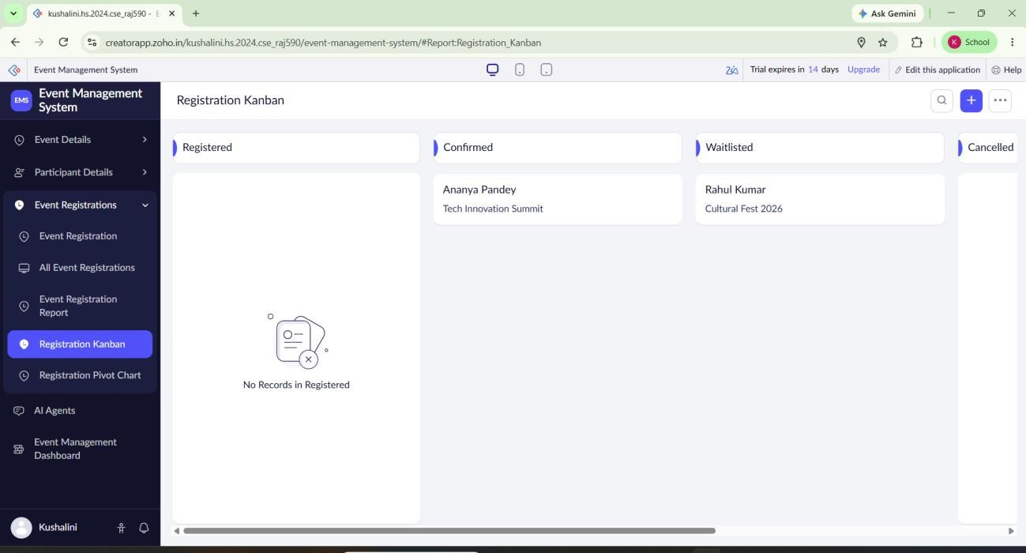
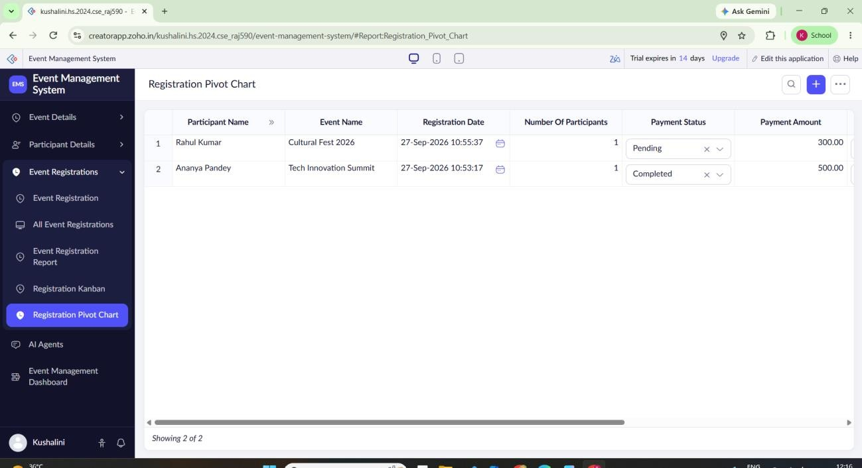
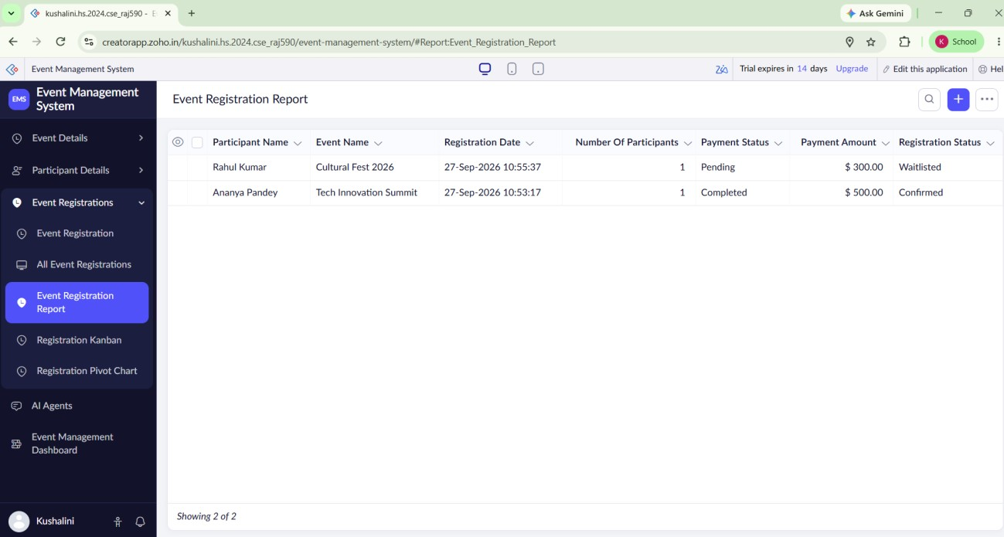
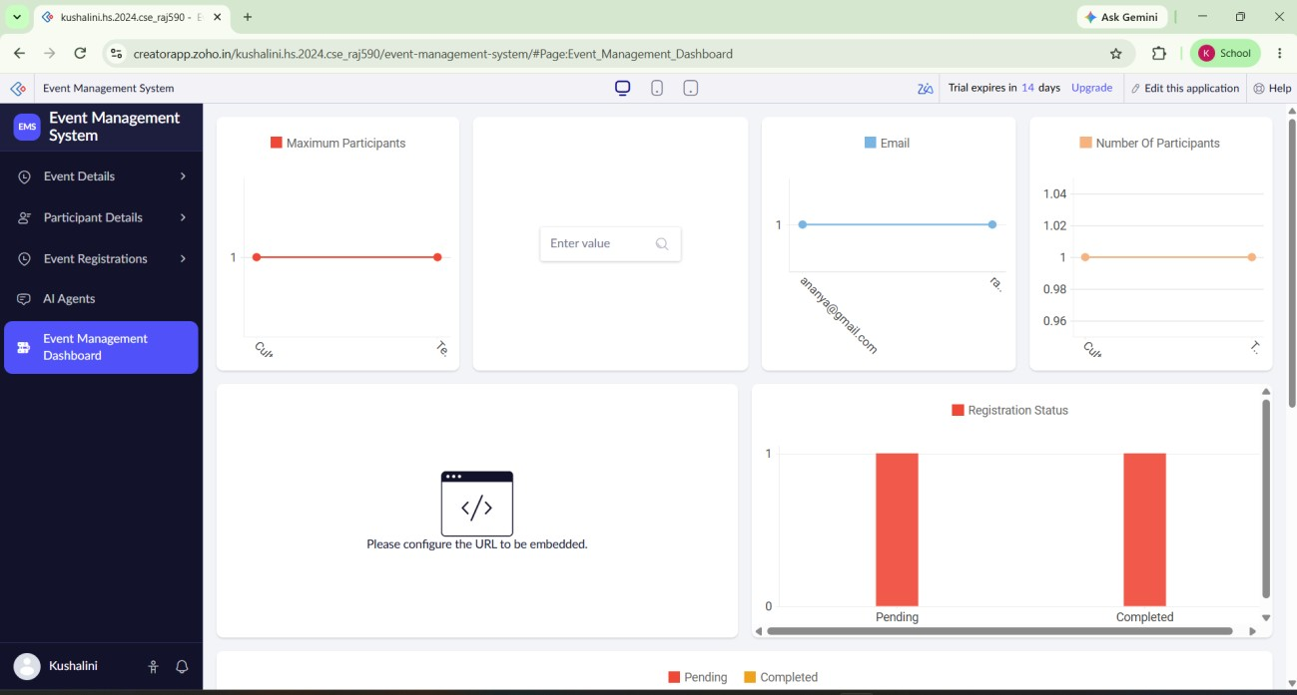
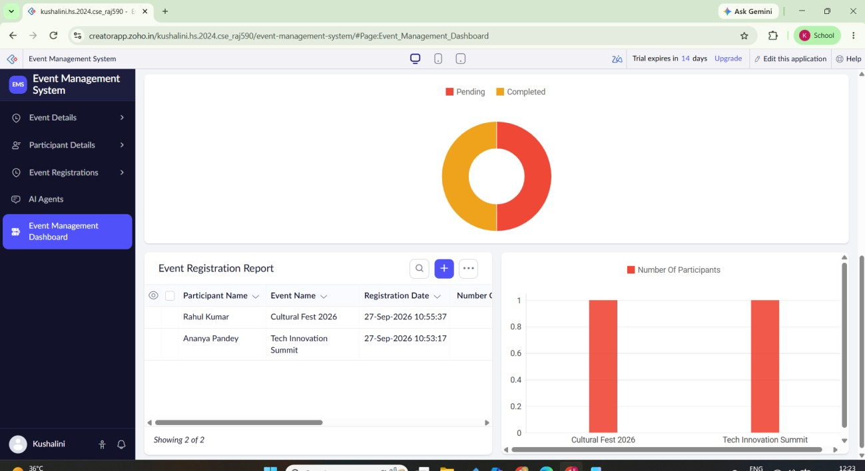
Result
Thus, the Event Management Application was successfully created using Zoho Creator. Zia was used to obtain quick insights from attendee and registration data, making attendee management and event operations easier and more efficient.

