

A Course End Project Report on
StudyBot Academic Assistant

A9513 – Python Programming Laboratory

Submitted by
M.Harish – 25881A0581
M.Ibrahim – 25881A0582

Course Facilitator

Ms P.S.Madhavi
Assistant Professor

Department of Computer Science and Engineering Vardhaman College of Engineering, Hyderabad

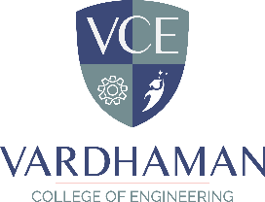
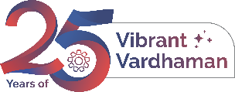
Autonomous Institute, Affiliated to JNTUH,
Approved by AICTE, Accredited by NAAC with A++ Grade Kacharam, Shamshabad, Hyderabad- 501 218, Telangana, India.

DEPARTMENT OF COMPUTER SCIENCE AND ENGINEERING

This is to certify that the Course End Project titled “StudyBot Academic Assistant” is carried out by M. Harish , M. Ibrahim with Roll Numbers 25881A0581, 25881A0582 towards A9513 – Python Programming Laboratory course in partial fulfilment of the requirements for the award of degree of Bachelor of Technology in Computer Science and Engineering during the Academic year 2026-27.

Signature of the Course Faculty
Ms P.S.Madhavi
Assistant Professor, CSE
Signature of the HOD Dr.Y.Vijayalata Professor,Head of the Department & Dean(Student Mentoring ,
CSE

Contents
- Introduction 3
- Literature Review 3
- Objectives 4
- Methodology 6
  - Architectural Diagram 6
  - Hardware and Software Requirements 7
  - Working Principle 7
  - Software Implementation 8
- Results and Discussion 14
- Mapping POs ,PSOs and SDGs 16
  - Program Outcomes (POs) Mapping 16
  - Sustainable Development Goals (SDGs) Mapping 18
- Conclusion 18
Bibliography 19

Abstract

StudyBot AI is a desktop voice-enabled academic assistant built with Python and Tkinter. It helps students with study tips, exam preparation, programming concepts (Python, DSA, Java, C), web development, career guidance, and project ideas through an interactive menu-driven interface. The application supports text input, microphone-based speech recognition (SpeechRecognition), and text-to-speech responses (pyttsx3).

For open-ended questions it optionally integrates Google Gemini (google-genai) to generate concise, spoken-friendly answers. The system demonstrates practical GUI programming, multi-threading for non-blocking audio, optional dependency handling, and the combination of rule-based navigation with generative AI, making it a useful learning companion for Computer Science and Engineering students.

Keywords: Python, Tkinter, Speech Recognition, Text-to-Speech, Gemini AI, Academic Assistant, Study Bot, Desktop GUI.

Introduction

Students in Computer Science and Engineering frequently need quick, structured guidance on study techniques, examination strategy, programming fundamentals, and career skills. Existing resources are often scattered across websites, notes, and videos, making it time-consuming to locate relevant help. A dedicated desktop application that consolidates these topics into a single, easy-to-navigate interface can significantly improve learning efficiency.

StudyBot AI addresses this need by providing a friendly graphical user interface with predefined topic menus (Study Tips, Exam Preparation, Programming, Web Development, Career & Skills, and Project Ideas) together with free-form question answering. Users can type queries or speak into a microphone; the system responds both in text and via speech synthesis. When a question falls outside the curated content, the application can query the Gemini large language model to produce a short, practical answer suitable for text-to-speech playback.

The project showcases several important software-engineering practices: modular menu design, graceful degradation when optional libraries are missing, background threads for audio input/output so that the GUI remains responsive, and secure configuration of API keys through environment variables. By combining classical GUI programming with modern AI capabilities, StudyBot AI serves as both a useful student tool and a demonstration of Python’s versatility in building interactive desktop applications.

- Literature Review

The design of StudyBot AI draws upon three complementary areas: intelligent tutoring systems, speech interfaces, and the Python ecosystem for rapid GUI and AI integration.

Intelligent Tutoring and Academic Assistants. Traditional intelligent tutoring systems (ITS) aim to deliver personalized instruction by modelling student knowledge and adapting content accordingly. Modern lightweight assistants often adopt a simpler rule-based or FAQ-style approach combined with generative AI for open questions. Menu-driven navigation reduces cognitive load for common topics while free-form AI handles the long tail of queries. StudyBot follows this hybrid pattern, offering curated study and programming guidance plus an optional LLM backend.

Speech Recognition and Text-to-Speech. Speech interfaces improve accessibility and allow hands-free interaction. The open-source SpeechRecognition library provides a convenient wrapper around Google’s speech-to-text service, while pyttsx3 offers offline text-to-speech using platform-native engines. Running these operations on background threads is essential to keep a Tkinter mainloop responsive. Prior educational tools have successfully used similar combinations to create voice-enabled tutors and practice applications.

Python GUI and Generative AI Integration. Tkinter remains the standard library for building cross-platform desktop GUIs in Python. Its event-driven model (mainloop, callbacks, and widget configuration) is well-suited to menu-driven applications. For generative capabilities, the google-genai client library enables developers to call Gemini models with system instructions that enforce concise, spoken-friendly replies. Environment-variable configuration of API keys follows security best practices and avoids hard-coding secrets in source code.

Objectives

The primary objective of this project is to develop a Python-based desktop academic assistant that provides structured study and programming guidance together with optional voice interaction and generative-AI answers.

Specific technical and functional objectives include:
- Interactive Menu System – Design a hierarchical, button-driven menu covering Study Tips, Exam Preparation, Programming (Python, DSA, Java, C), Web Development, Career & Skills, and Project Ideas.
- Text and Voice Input – Support typed queries via an entry widget and spoken queries via the SpeechRecognition library with microphone capture.
- Text-to-Speech Output – Convert bot responses into speech using pyttsx3 so that answers can be heard as well as read.
- Optional Generative AI – Integrate Google Gemini for open-ended questions, enforcing concise plain-text answers suitable for speech synthesis.
- Robustness – Handle missing optional dependencies gracefully so that the application still launches and offers core menu functionality even without speech or AI libraries.
- Responsive UI – Use background threads for listening and speaking so that the Tkinter interface never freezes.

Methodology

Architectural Diagram

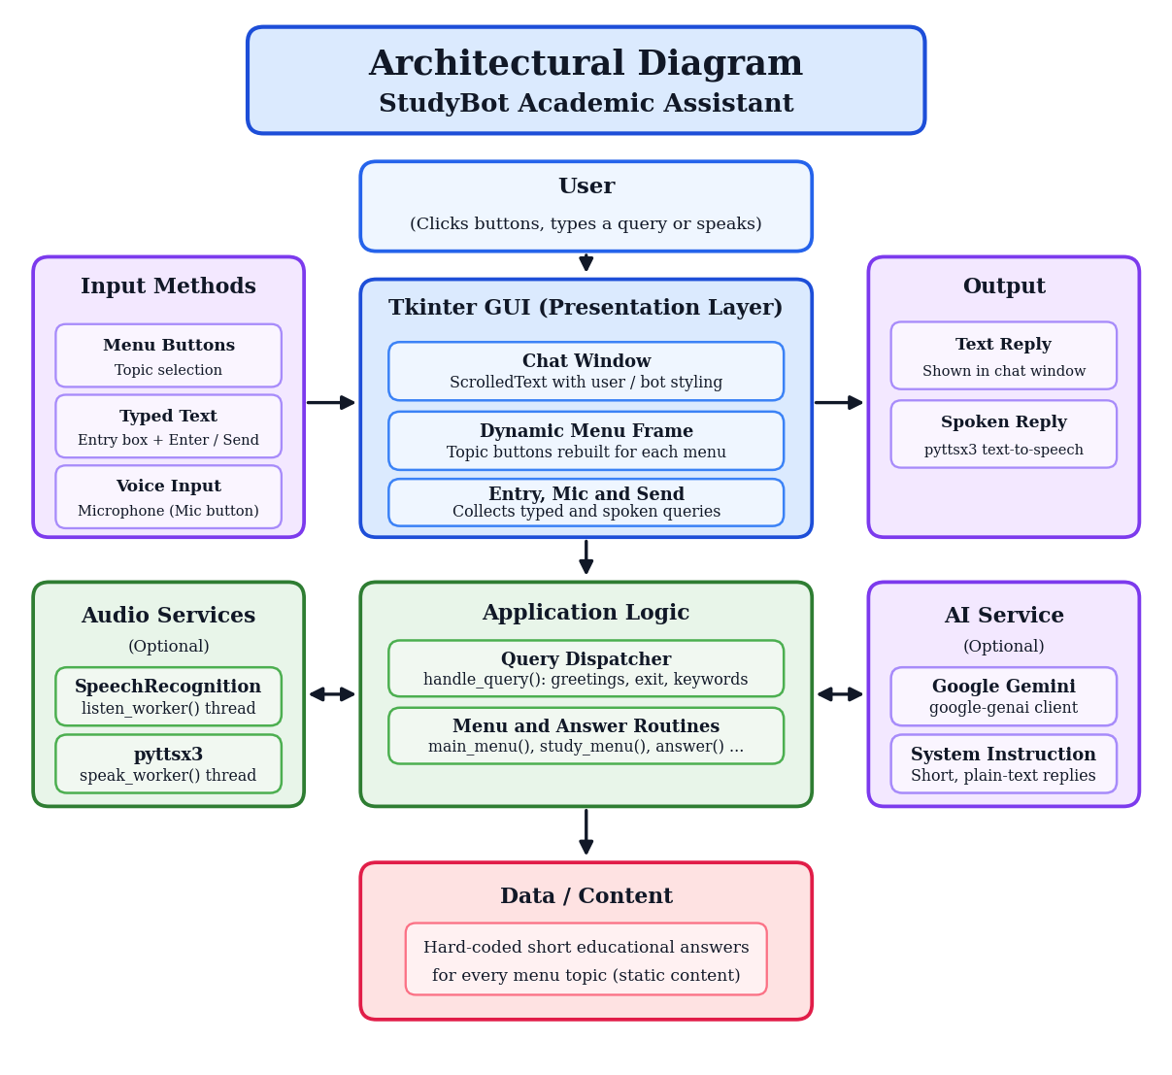
Figure 1: Architectural Diagram

The system follows a layered architecture. The Presentation Layer is the Tkinter window containing a header, scrolled chat area, dynamic menu button frame, text entry, microphone button, and send button. The Application Logic layer consists of menu navigation functions, the query dispatcher (handle_query), and answer routines that insert messages into the chat widget.

The Audio Services layer provides an optional speech-recognition worker and text-to-speech worker, each running on a daemon thread. The AI Service is an optional Gemini client that receives the user prompt and a system instruction constraining response style. The Data / Content layer holds hard-coded short educational responses for each menu topic; synthetic data is not required because the content is static.

User actions (button clicks, Enter key, or microphone) flow into the dispatcher, which either navigates menus, returns a canned answer, or launches an AI worker. All UI updates occur on the main thread; audio and network calls occur off-thread. Thus, the complete architecture provides a simple flow of user input → dispatcher → menu / audio / AI service → response display.

Hardware and Software Requirements

Hardware Requirements:
Processor: dual-core or higher (tested on typical modern laptop CPUs). Memory (RAM): minimum 4 GB; 8 GB or more recommended when using speech and AI features. Storage: approximately 200–500 MB free for Python, virtual environment, and optional libraries. Microphone: required only for voice input (any standard USB or built-in microphone). Speakers or headphones: required for text-to-speech output.
Software Requirements:
Operating System: cross-platform (Windows, macOS, or Linux). Programming Language: Python 3.8 or higher. Standard Library: tkinter, threading, os, importlib. Optional External Packages: SpeechRecognition (microphone input and Google speech-to-text), pyttsx3 (offline text-to-speech), and google-genai (Gemini API client for open questions). Environment Variable: GEMINI_API_KEY (required only when AI answers are desired).

Working Principle
On launch the application creates the main window, displays a welcome message, and populates the main menu buttons. Optional libraries are imported safely; if a Gemini API key is present, a client is created, otherwise AI features remain disabled. Clicking a topic button clears the current menu, records the selection in the chat, and shows sub-topic buttons or a short educational answer.

For a text query, the user types a message and presses Send (or Enter); the text is displayed as a user message and passed to handle_query. For a voice query, pressing the microphone button starts a background listener: ambient noise is adjusted, speech is captured (up to 6 seconds), transcribed via Google, inserted into the entry field, and automatically submitted.
In the dispatch step, simple greetings, exit commands, and topic keywords are handled locally, and all other free-form text is sent to the Gemini worker when available. Finally, answers are appended to the chat widget and spoken via a background TTS thread, so the interface remains fully interactive throughout.

Software Implementation
The implementation is contained in a single Python module (approximately 314 lines) organized as follows:
optional_import() – safely imports optional packages without crashing if they are absent.
speak() / speak_worker() – spawns a daemon thread that initializes a pyttsx3 engine and utters the given text.
start_listening() / listen_worker() – spawns a daemon thread that captures microphone audio, performs recognition, and triggers send_message().
UI construction – header frame, scrolled text chat with coloured tags for bot and user messages, dynamic menu frame, entry widget, Mic and Send buttons.
Menu functions – main_menu, study_menu, exam_menu, programming_menu, python_menu, dsa_menu, web_menu, career_menu, project_menu – each clears the menu frame and packs new buttons.
answer() – displays a user question and a canned bot reply.
ask_ai_worker() – calls Gemini with a system instruction that forces short, plain-text, TTS-friendly answers.
handle_query() – routes greetings, exit, topic keywords, and general questions.
Key design decisions include the use of daemon threads so that the process exits cleanly, environment-variable configuration of the API key, and dynamic button packing so that the same menu frame can host any number of topic choices without hard-coded layouts. The complete source code is shown below.
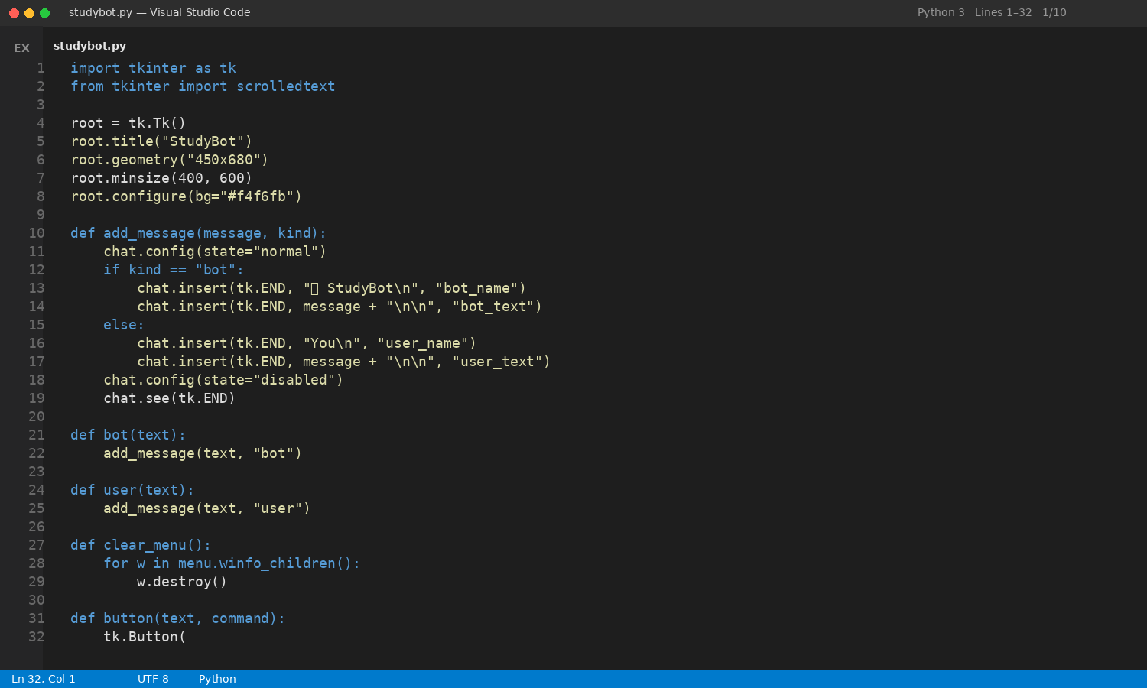
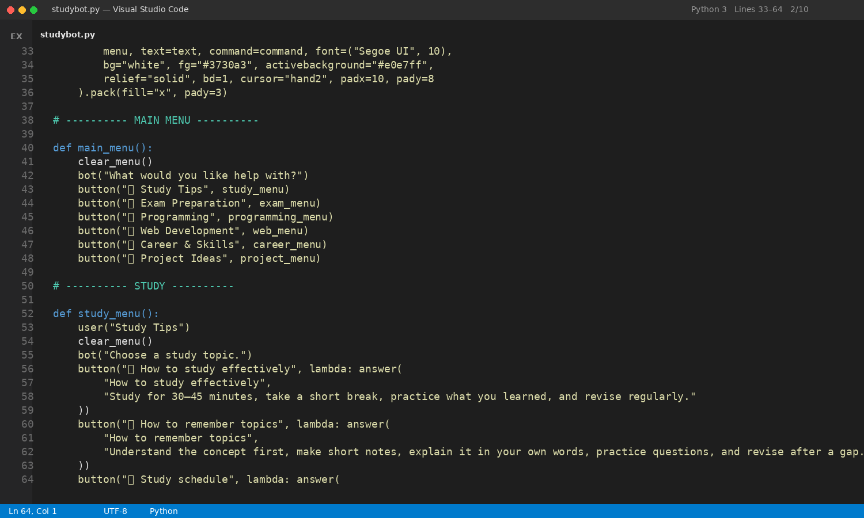
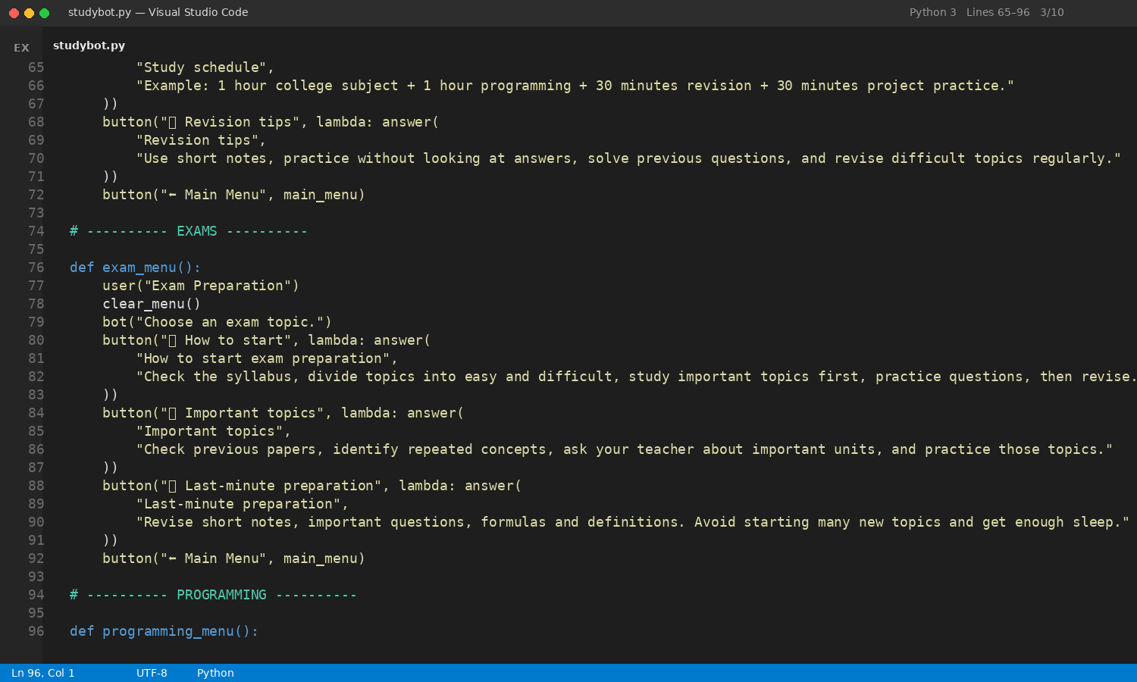
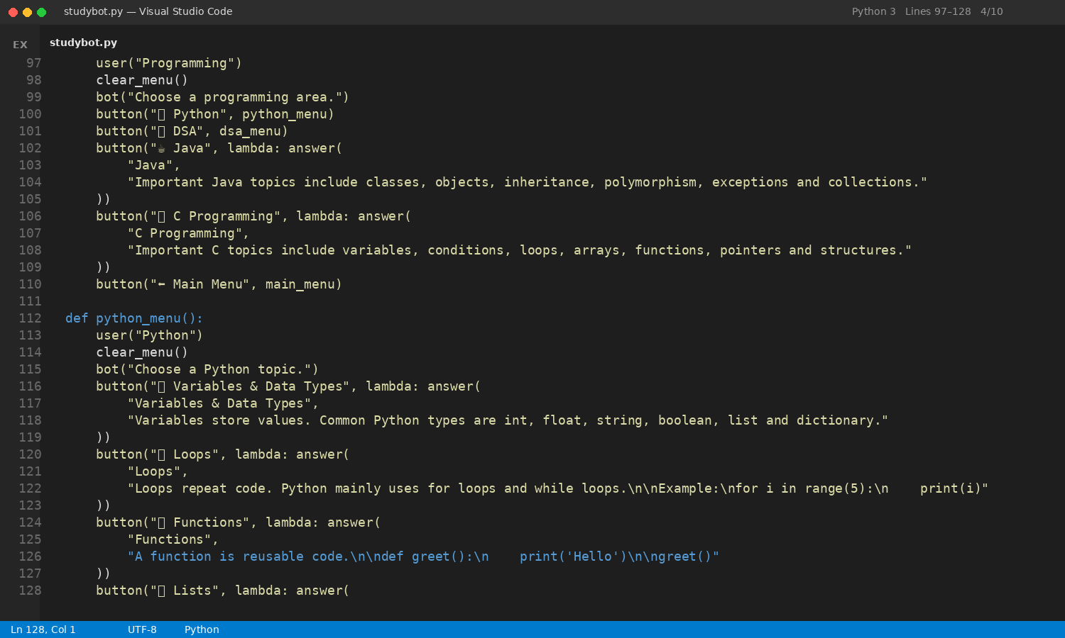
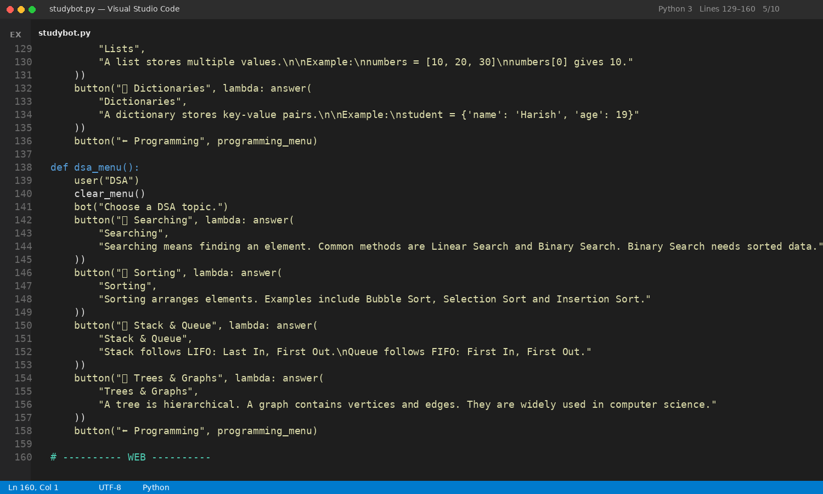
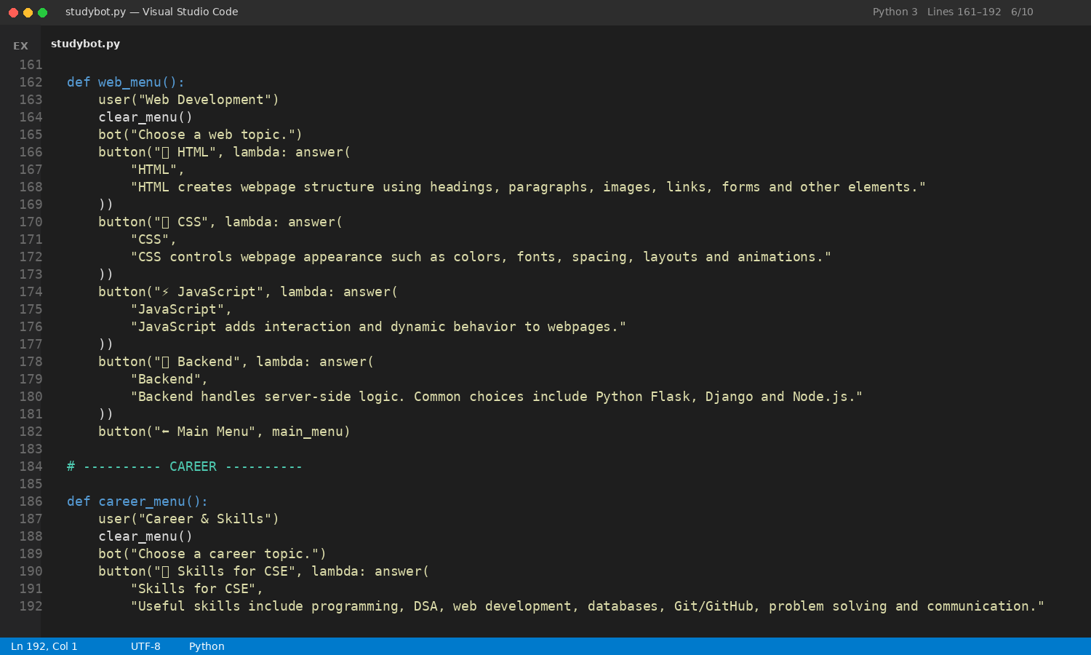
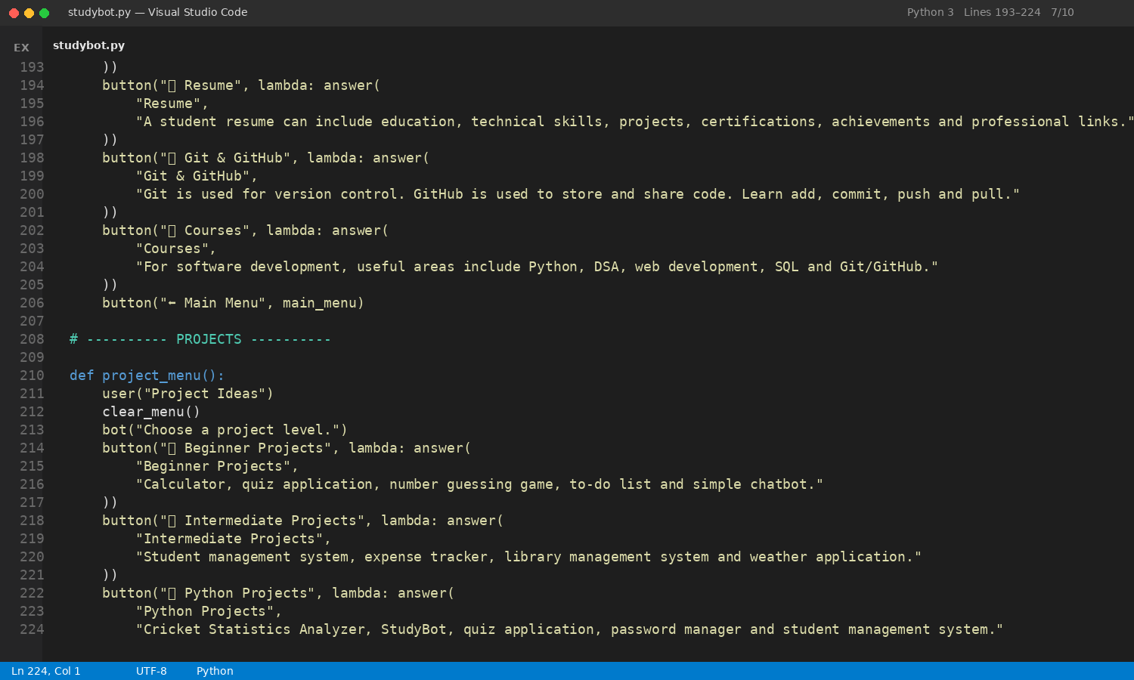
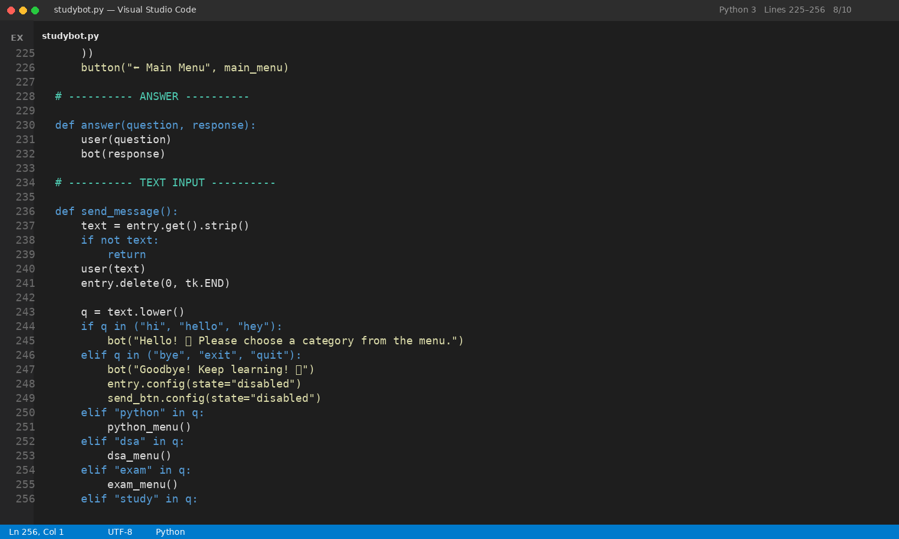
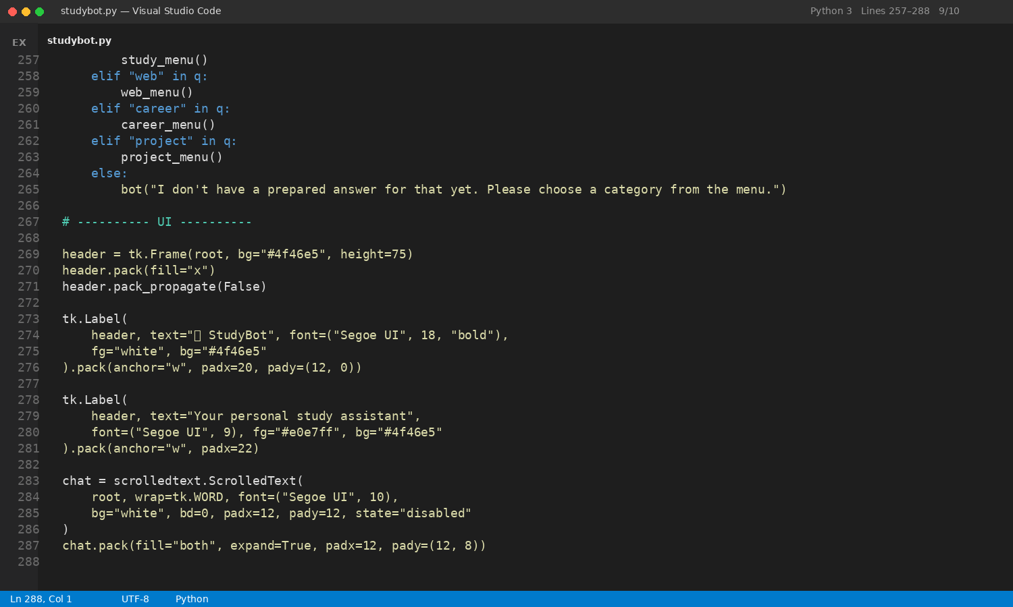
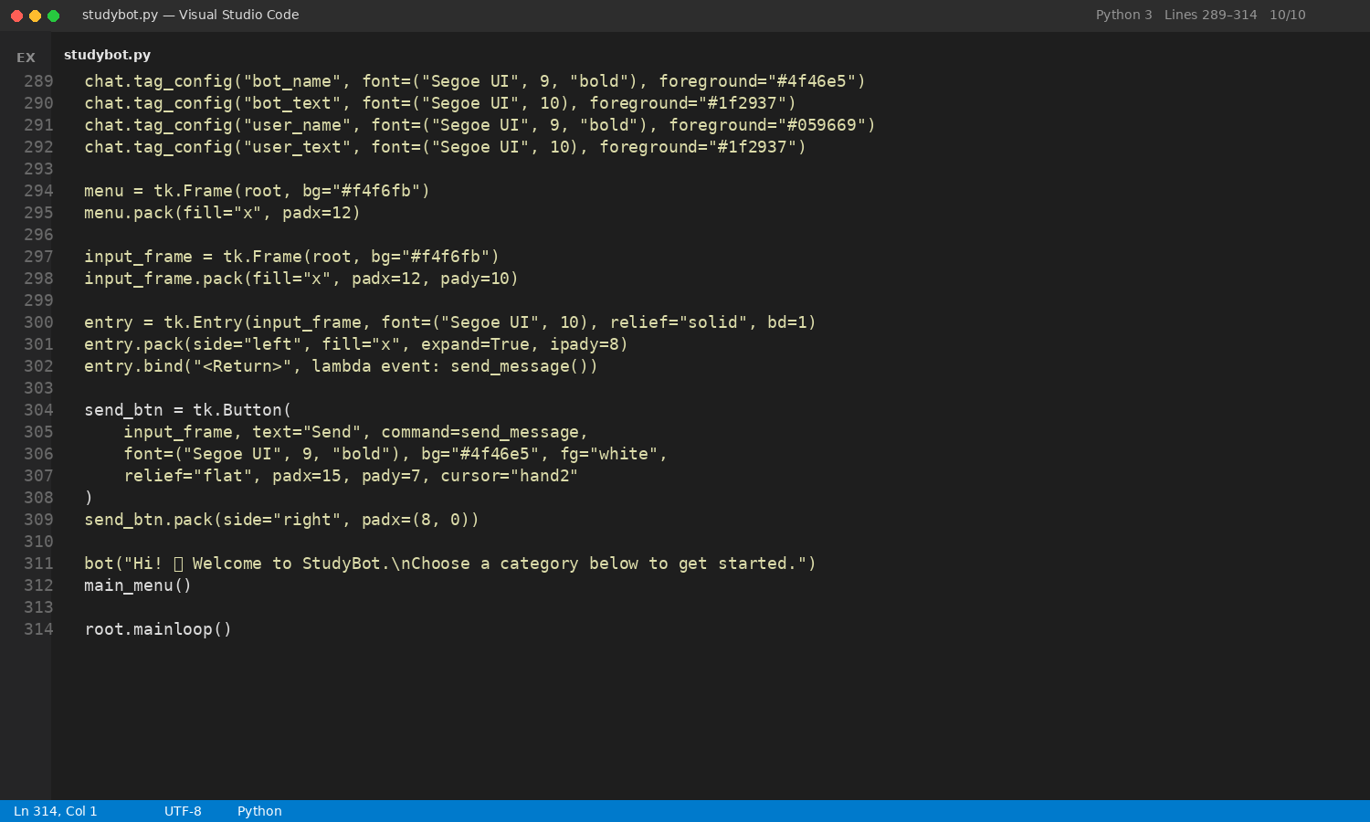

Results and Discussion

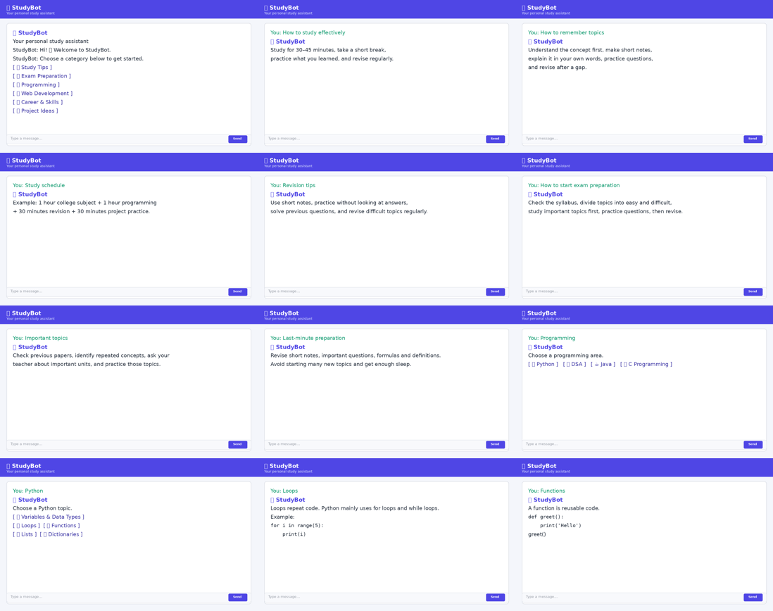
Figure 2: Output screens of StudyBot (Part 1 of 3)
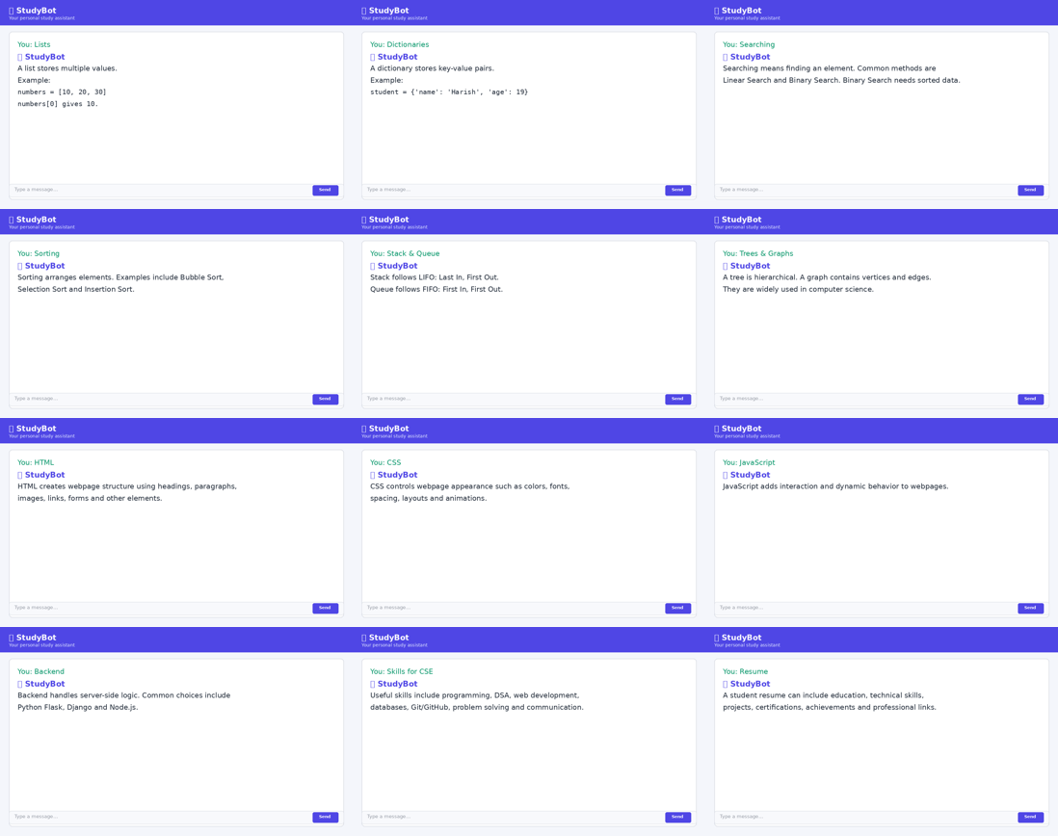
Figure 3: Output screens of StudyBot (Part 2 of 3)
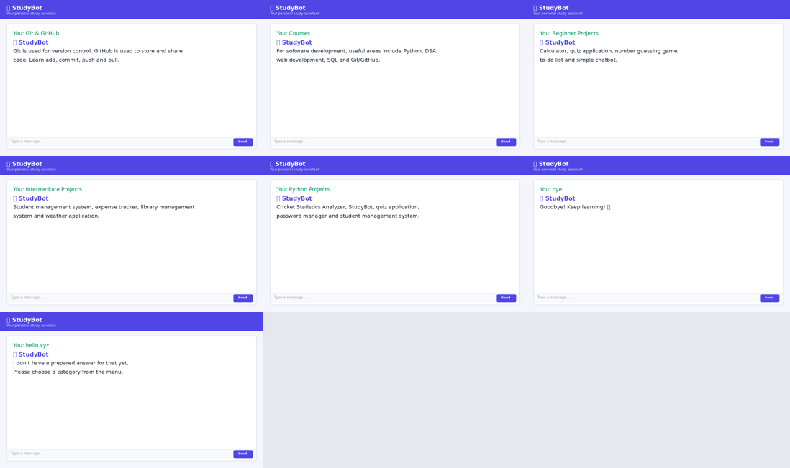
Figure 4: Output screens of StudyBot (Part 3 of 3)

Summary of Results

The completed StudyBot AI application successfully demonstrates the intended features:

Menu Navigation – All hierarchical menus (Study, Exam, Programming, Python, DSA, Web, Career, Projects) open correctly and return informative short answers.

Text Interaction – Typed messages appear in the chat pane with distinct user and bot styling; Enter key and Send button both submit queries.

Voice Input – When SpeechRecognition and a working microphone are available, the Mic button changes colour while listening, captures speech, and automatically submits the transcription.

Speech Output – Bot replies are spoken concurrently with text display; the GUI stays responsive.

AI Fallback – When GEMINI_API_KEY is set and google-genai is installed, open-ended questions receive concise answers; otherwise a clear message indicates that AI is unavailable.

Graceful Degradation – Launching the application without optional packages still provides the full menu-driven experience.

Interpretation

The hybrid design (curated content + optional generative AI) balances reliability and flexibility. Curated answers are instantaneous and pedagogically controlled; generative answers expand coverage for unexpected questions while the system instruction keeps replies short enough for comfortable listening.

Achievement of Objectives

All stated objectives—interactive menus, text and voice input, text-to-speech, optional Gemini integration, robustness to missing libraries, and a responsive UI—were met.

Implications
The application can be used by students as a quick reference tool for study techniques and programming fundamentals. It also serves as a practical example of multi-threaded GUI programming and optional AI integration for future laboratory or mini-project work.

- Mapping POs and SDGs

Program Outcomes (POs) Mapping
Table 1: Mapping of Program Outcomes (POs) to Project Relevance
PO | Program Outcome | Mapping with Project
PO1 | Engineering Knowledge | Applied Python programming, GUI design with Tkinter, multi-threading, and optional AI API integration to build a functional academic assistant.
PO2 | Problem Analysis | Analysed the need for consolidated study guidance and identified the hybrid menu-plus-AI approach as a practical solution for students.
PO3 | Design/Development of Solutions | Designed and implemented a complete desktop application with hierarchical menus, chat interface, voice I/O, and generative-AI backend.
PO4 | Conduct Investigations | Tested speech recognition under varying noise conditions, verified thread safety of UI updates, and evaluated Gemini response quality for educational use.
PO5 | Modern Tool Usage | Utilised Python, Tkinter, SpeechRecognition, pyttsx3, google-genai, and environment-variable configuration to deliver a production-ready prototype.
PO8 | Individual and Team Work | Developed the application collaboratively, dividing responsibilities for UI layout, audio features, AI integration, and documentation.
PO9 | Communication | Documented system design, user interaction flow, and results clearly in the project report and demonstrated the working prototype.
PO11 | Life-long Learning | Explored speech APIs, generative-AI clients, and concurrent programming beyond the core syllabus through self-directed learning.

Sustainable Development Goals (SDGs) Mapping

Table 2: Mapping of Sustainable Development Goals (SDGs) to Project Relevance

SDG No. | Goal | Relevance
SDG 4 | Quality Education | Provides an accessible, interactive learning aid that helps students improve study habits, programming skills, and exam readiness.
SDG 8 | Decent Work and Economic Growth | Builds practical software-development and problem-solving skills that enhance employability in the IT sector.
SDG 9 | Industry, Innovation and Infrastructure | Demonstrates innovative use of voice interfaces and generative AI within a lightweight desktop educational tool.

Conclusion

This project successfully delivered StudyBot AI, a Python desktop application that combines a structured academic menu system with optional voice interaction and generative-AI answering. Students can navigate study tips, exam strategies, programming topics, web development, career advice, and project ideas through a clean Tkinter interface, type or speak queries, and receive both textual and spoken responses. Optional integration with Google Gemini extends the assistant to arbitrary open-ended questions while a carefully written system instruction keeps answers concise and speech-friendly.

The implementation illustrates important engineering practices: graceful handling of missing dependencies, background threads for non-blocking audio, secure API-key management, and modular menu design. All stated objectives were achieved, and the resulting tool is immediately usable for everyday student support.

Future enhancements may include local offline speech models, richer conversation memory, user progress tracking, integration of additional subject domains, packaging as a standalone executable, and a companion mobile or web front-end. Continued development in these directions will further increase the educational value and accessibility of the assistant.

Bibliography

Python Software Foundation. Tkinter Documentation. Available at: https://docs.python.org/3/library/tkinter.html

SpeechRecognition Library. Available at: https://pypi.org/project/SpeechRecognition/

pyttsx3 – Text-to-Speech for Python. Available at: https://pypi.org/project/pyttsx3/

Google AI. Gemini API / google-genai client. Available at: https://ai.google.dev/

Real Python. Using Threads in Python GUI Applications. Available at: https://realpython.com/

Lutz, M. Learning Python (5th ed.). O’Reilly Media, 2013.

Summerfield, M. Rapid GUI Programming with Python and Qt. Prentice Hall, 2007.

Russell, S. and Norvig, P. Artificial Intelligence: A Modern Approach (4th ed.). Pearson, 2020.

