Vendor-Neutral AFK Control Plane
for Cross-Vendor AI Coding Agents
Enhanced Architecture, Security Review & Implementation Blueprint
Revision 2 — Architecture Hardening Pass

Table of Contents

1. Executive Summary
The opportunity. Modern AI coding agents (OpenAI Codex, Claude Code, Google Antigravity, OpenCode, Cline, Cursor) let developers automate work locally in their IDE or terminal, but each vendor ships its own siloed remote-control story. There is no vendor-neutral way to start a task at a desk and supervise it from a phone, regardless of which agent is doing the work.
The proposal. A two-part platform: a local Agent Gateway that runs on the developer's machine and speaks each agent's native CLI/API through a per-agent Adapter, and a cloud Control Plane (web + mobile) that authenticates users, pairs devices, relays encrypted traffic, enforces approval policy, and stores an auditable history. Code, files, and shell execution always stay on the user's machine — the cloud only ever sees an encrypted, redacted stream.
What changed in this revision. The original brief described the concept and a working competitive position well, but treated several load-bearing security properties (sandboxing, device revocation, tamper-evident audit, deny-override policy) as "planned" rather than designed. This revision closes those gaps, adds a mandatory isolation layer, a policy engine that cannot be bypassed by a permissive trust profile, and six implementation-level diagrams (architecture, pairing, session execution, approval flow, state machine, defense-in-depth) so each feature has an unambiguous build target.

2. Problem Definition
Developers increasingly rely on AI agents to write, refactor, and test code autonomously. These agents can run long tasks — large-scale refactors, nightly builds, migrations — that outlast a single sitting at the desk. Developers still need to supervise, steer, and review the agent's output, which today means staying near the machine that is running it.
Existing remote-control options are siloed: Claude Code's remote control only reaches Claude Code sessions; Antigravity's web dashboard only reaches Antigravity's daemon; Codex's mobile story runs through ChatGPT's own cloud execution rather than a user's local machine. A developer who uses more than one agent has to learn, trust, and juggle a different remote path for each one, and none of the vendor solutions were designed to police a mix of tools under one safety policy.

2.1 Design Question
How do we build a single, vendor-neutral control plane that can launch and monitor any coding agent on a user's machine, with security guarantees that do not depend on trusting any individual agent vendor, and a mobile-first interface for approvals — while guaranteeing that code and credentials never leave the machine unencrypted, and, per the fixes below, never leave it un-sandboxed either?

3. Target Users and Scenarios
- Remote/Hybrid Developers — start a long test run from a phone while commuting, review results back at the desk.
- Overnight/Background Automation — trigger nightly builds or migrations before bed and get a push notification only if something needs attention.
- Managers/Team Leads — start or review teammates' agent tasks remotely, and gate production-affecting approvals.
- SecDevOps/Compliance — rely on the audit trail and org-wide policy to enforce review and prevent secret leakage.

Representative flow
On a flight, a developer asks the phone app to "open my project, repair all failing tests, and commit the fixes." They watch the terminal output live, nudge the agent with one text correction, and close the app. Overnight, the fixes are pushed to GitHub; because a production deploy step required approval, a push notification woke the developer briefly to confirm it. Every action — including the approval — is in the audit timeline the next morning.

4. Competitive Landscape
The field splits into two groups: agents with rich local execution but no cross-device story (OpenCode, Cline, Cursor), and agents with a remote-control story that only works within their own vendor stack (Claude Code, Antigravity, Codex/ChatGPT). No product combines local-first execution, a real-time mobile UI, and vendor neutrality.
Agent | Local Exec. | Headless API | Streaming | Mobile/Web UI | Approvals | Note
OpenAI Codex (CLI) | Yes | CLI only | No | Indirect (ChatGPT app) | None | Cloud "Codex" in ChatGPT is a separate, non-local execution path.
Claude Code | Yes | No public API | No public SSE | Yes (web/desktop/mobile) | Built-in prompts | Rich remote control, locked to Claude models.
Antigravity | Yes | Partial (CLI) | No (cloud-mediated) | Yes (web dashboard) | Trusted devices, policies | Headless daemon + Google-authenticated dashboard.
OpenCode | Yes | Yes (HTTP API) | Yes (SSE) | No (API only) | Configurable | Open-source; no first-party mobile UI.
Cline | Yes | Yes (CLI/plugins) | Not documented | Editor only | Custom rules | Slack/CI integrations; no device pairing.
Cursor | Partial (needs net) | Yes (API key) | No | IDE only | PR review only | Cloud-centric editor, not a general remote-control target.
Positioning: the platform does not try to out-build any single vendor's agent — it standardizes the adapter and control layer underneath all of them, so the mobile/approval/audit experience is consistent no matter which agent is doing the work.

5. Capability Matrix
Capability | Proposed Platform | Claude Code | Antigravity | OpenCode | Codex / Cline / Cursor
Local execution | Yes | Yes | Yes | Yes | Yes (Cursor partial)
Headless control API | Yes — adapter per agent | No public API | CLI/daemon | HTTP API | CLI only (Cursor: API key)
Real-time events | Yes — SSE/WS via broker | No | No (cloud-mediated) | SSE | No
Remote mobile/web GUI | Yes — this product | Yes (own agent only) | Yes (own agent only) | No | Indirect / IDE-only
Multi-agent sessions | Yes | Yes | Yes | Yes | Limited
Approval flow with hard overrides | Yes — policy engine + deny-list | Guided prompts | Trust levels | Custom rules | PR review only
Mandatory sandboxing | Yes — required, not optional | No | No | No | No
Tamper-evident audit log | Yes — hash-chained | No | No | No | No
Cross-vendor support in one UI | Yes — the differentiator | No | No | No | No

6. Critical Analysis: Gaps in the Original Design and Fixes
A control-plane product that can start shells and edit files on a developer's machine is, itself, a high-value attack target. Re-reading the original brief against that threat model surfaces ten places where a feature was described as a goal ("planned", "we will") rather than a hard requirement. Each is closed below and reflected in the architecture and diagrams that follow.
Gap in v1 Design | Risk if Unaddressed | Fix in Enhanced Design
Sandboxing was listed under "Security" as something the team will add, but the MVP feature table ships without it. | The very first release would run agent-issued shell commands with the same privileges as the logged-in user — a single prompt-injected or buggy agent step can touch anything on disk. | Sandboxing is promoted to a mandatory architectural component (§7, §8.2): every agent process starts inside a per-session container with a scoped filesystem and default-deny egress, before the MVP, not after.
Device pairing trusts whatever public key the cloud relay receives; there is no check that the relay itself hasn't substituted a key. | A compromised or coerced Control Plane could silently pair an attacker's device as if it were the user's, since the relay brokers the whole exchange. | An out-of-band fingerprint check is added to pairing (§8.1): the Gateway prints the same device fingerprint the cloud shows the app, and the user manually confirms the match before the device is marked trusted.
No mechanism is defined for revoking a lost or stolen phone, or a compromised gateway machine, mid-session. | A stolen, still-logged-in phone (or a machine that's been compromised) keeps full remote control indefinitely. | Device certificates are short-lived and rotate automatically (§8.1, §9); the Control Plane adds an explicit device-revocation action that immediately invalidates a device's token and forces the Gateway to drop its tunnel.
Trust profiles ("Autonomous", "Partial Trust") can auto-approve actions with no absolute ceiling. | A manipulated or buggy agent running under an autonomous profile could force-push to a protected branch or exfiltrate data with zero human check, because the profile itself decides what's safe. | An immutable deny-override list (§8.3) sits above every trust profile: specific action classes (protected-branch force-push, credential export, infra-apply) always require approval, regardless of profile — the policy engine, not the agent's chosen profile, has final say.
Vendor adapters run arbitrary third-party CLIs/binaries with no supply-chain control described. | A poisoned or maliciously updated vendor CLI (Codex, OpenCode, etc.) executes with the Gateway's trust and can act as a foothold to reach other adapters or the host. | Adapters are isolated from each other in their own sandbox instance (§7 diagram), pinned to signed/hash-verified binary versions, and the Gateway's own auto-update pipeline requires signature verification before installing a new adapter version (§9).
Agent stdout/diffs stream to the cloud with no stated filtering step. | Secrets echoed by a build log, an .env dump, or a misbehaving agent could leave the machine even though the design promises "secrets never leave the machine." | A Secret Redaction Proxy sits between the sandbox and the Gateway's outbound tunnel (§7, §8.2) and strips recognizable credential patterns and configured secret paths before anything is forwarded to the cloud.
Audit logs live in an ordinary database row set. | Anyone with DB write access (an insider, or an attacker who compromises the Control Plane) can quietly edit or delete the history that compliance and incident response depend on. | The Audit Service append-only-hash-chains each event to the previous one (§7, §9); any edit breaks the chain and is detectable, and logs can be exported to an external SIEM for a second copy of record.
Two devices (e.g. phone and laptop browser) can both be connected to the same session with no conflict rule. | A stale approval decision from one device could race a fresher one from another, approving something the user already meant to deny. | The Control Plane treats approval decisions as first-writer-wins per request ID and immediately marks the request resolved across all connected devices, so a second, late response is rejected with a clear "already handled" state.
No rate limiting or abuse control is defined for either the Gateway's local API or the Control Plane's public API. | A malicious local process, or a scripted attacker hitting the cloud API, could exhaust resources or brute-force pairing codes. | Pairing codes are single-use with a 2-minute expiry and a strict attempt cap (§8.1); both the Gateway's localhost API and the Control Plane's public API apply per-device and per-user rate limits.
The brief targets "Managers/Team Leads" and org policy but never defines a workspace/tenant or role model. | Without tenancy boundaries, one org's sessions, secrets, or audit logs could be visible to another, and "admin escalation" for approvals has no defined authority. | A workspace/organization model with role-based access control (owner, admin, member) is added to the Control Plane (§9, §14), and admin escalation in the approval flow (§8.3) resolves to a specific org-admin role, not an undefined "admin."

7. Enhanced Architecture
The platform keeps its original two-part shape — a local Agent Gateway and a cloud Control Plane — but the Control Plane is now decomposed into named services with distinct responsibilities, and the Gateway gains two components that were previously described only as "planned": a mandatory sandbox layer and a secret-redaction proxy sitting directly in the data path.
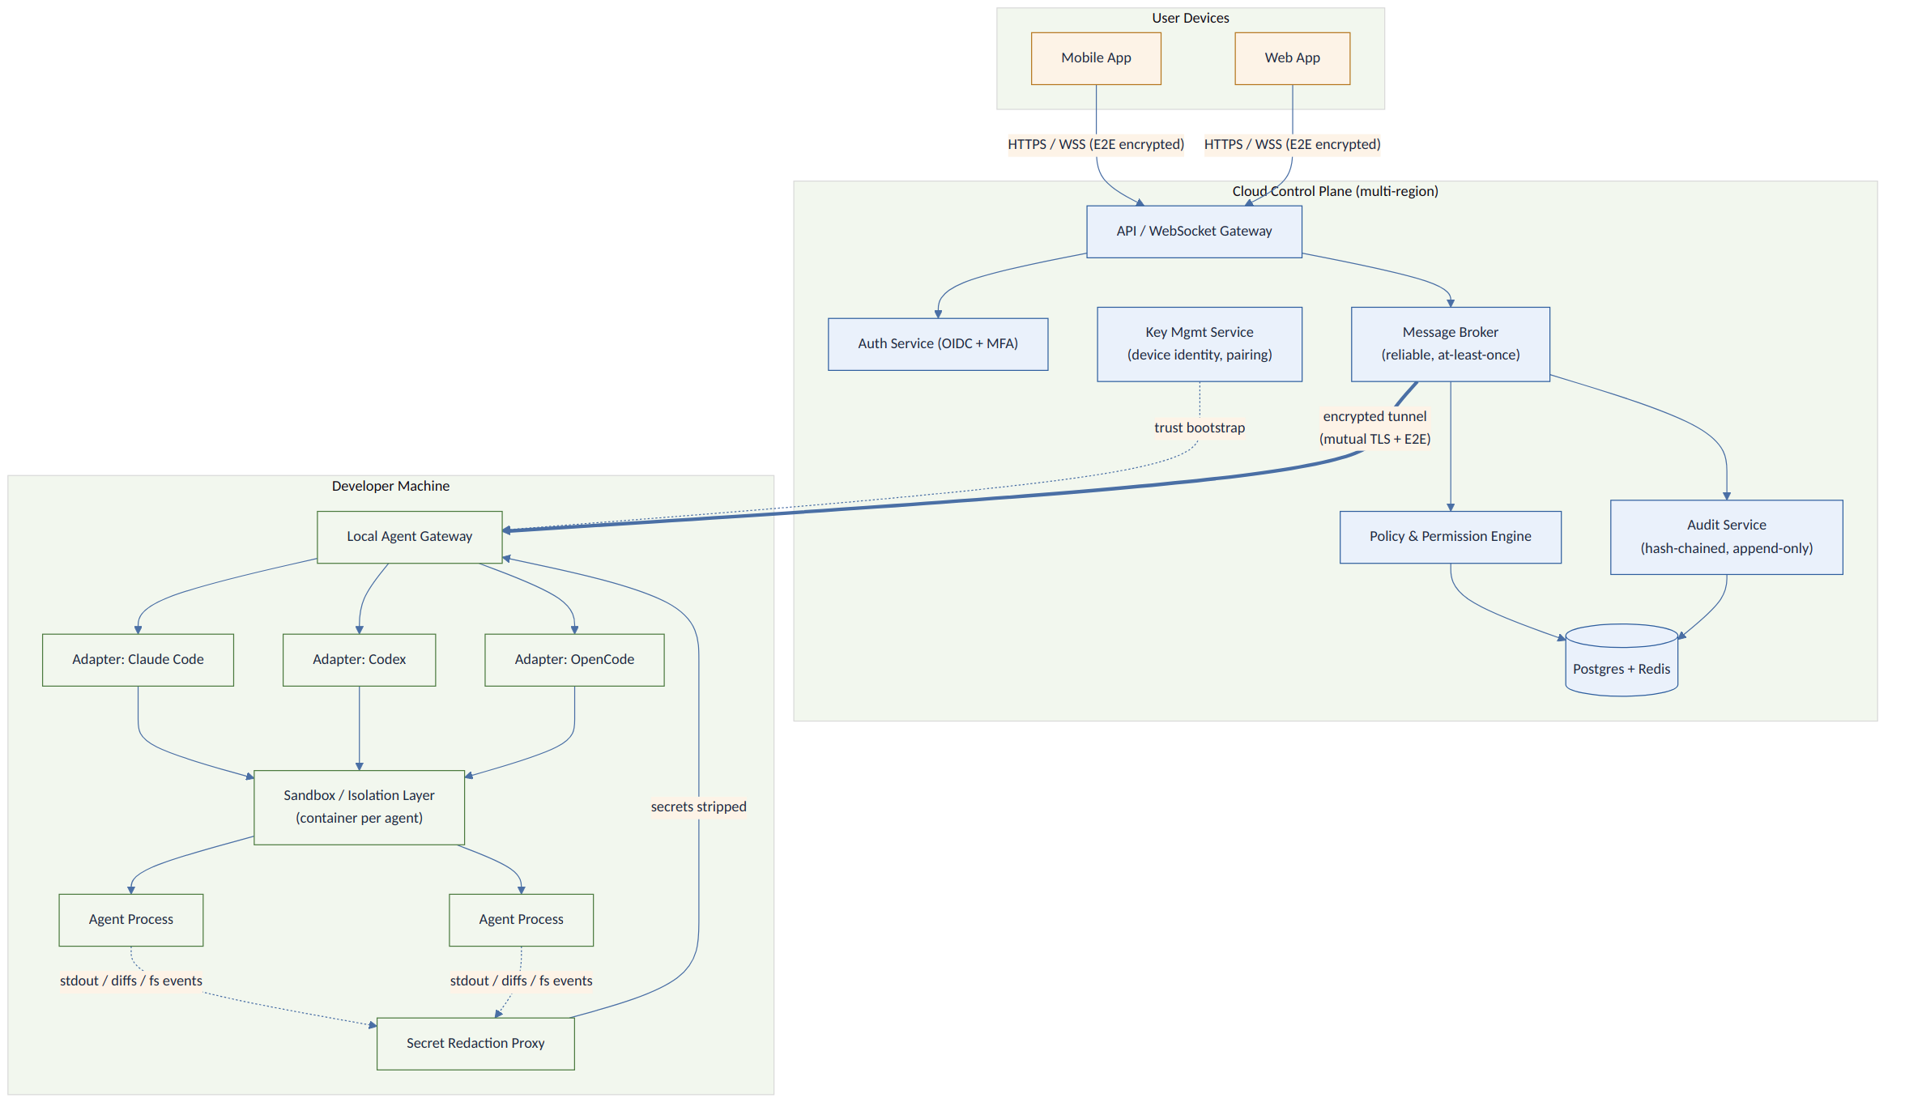
Figure 1 — Enhanced system architecture. Every arrow crossing the machine boundary is encrypted; every agent process is sandboxed before it can touch the filesystem or network.

7.1 Local Agent Gateway
- Adapters — one per supported agent (Claude Code, Codex, OpenCode, Cline, Cursor, Antigravity), each implementing a uniform interface: startSession, sendMessage, requestApproval, abortSession. New agents are added by writing a new adapter, not by changing the core.
- Sandbox/Isolation Layer — every adapter launches its agent process inside a per-session container (or OS sandbox where containers aren't available) with the project directory as its only writable path and an egress firewall that defaults to deny.
- Secret Redaction Proxy — the single choke point through which all agent stdout, diffs, and file events pass before leaving the machine; it strips recognizable credential and token patterns.
- Tunnel client — a persistent, mutually authenticated, end-to-end encrypted connection to the Control Plane's message broker, with automatic reconnect and local checkpointing so a dropped connection doesn't lose in-flight state.

7.2 Cloud Control Plane
- API/WebSocket Gateway — the only externally reachable surface; terminates client and Gateway connections.
- Auth Service — OIDC-based user login with mandatory MFA.
- Key Management Service (KMS) — issues and rotates device certificates, and is the anchor for the out-of-band fingerprint check during pairing.
- Message Broker — at-least-once delivery between clients, the Control Plane's own services, and Gateways, so a brief network blip does not silently drop an approval decision or a task result.
- Policy & Permission Engine — evaluates every protected action against org policy, the user's trust profile, and the immutable deny-override list; the single source of truth for "does this need a human."
- Audit Service — hash-chains every event as it is written and exposes an export path for SIEM ingestion.
- Postgres (durable state: users, orgs, devices, sessions, audit) + Redis (ephemeral state: presence, in-flight approval locks).
This decomposition means a compromise of any single service is contained: the API Gateway cannot itself mint device certificates (that's the KMS), and the Policy Engine's decisions are independent of whichever client happened to send the request.

8. Feature Implementation Detail
Each core feature below is specified to sequence-diagram depth: which service calls which, what is checked, and where the design closes one of the gaps from Section 6.

8.1 Device Pairing
Pairing binds a physical machine (via a Gateway-generated keypair) to a user's account, and — per the fix in §6 — adds a human-verified fingerprint check so the cloud relay cannot silently substitute a key.
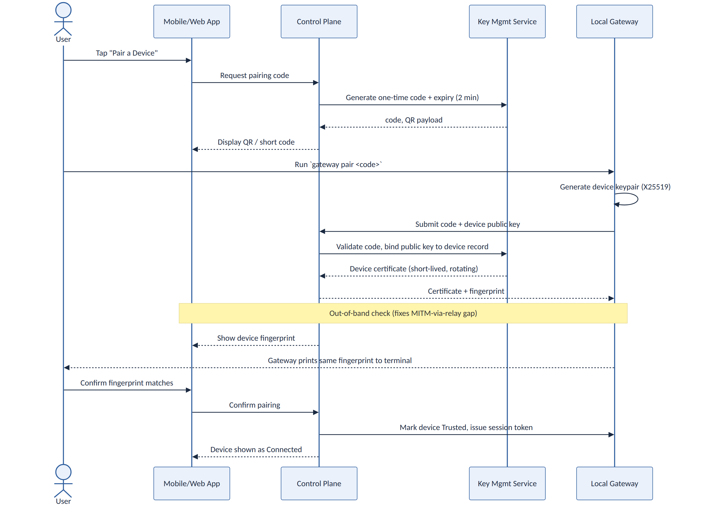
Figure 2 — Device pairing sequence, including the out-of-band fingerprint confirmation.
- Pairing codes are single-use, expire in 2 minutes, and are rate-limited per account to block brute-force guessing.
- The Gateway generates its X25519 keypair locally; the private key never leaves the machine.
- The issued device certificate is short-lived and auto-rotates; a stolen certificate has a small, bounded window of validity even before explicit revocation.
- Device revocation (from any already-trusted device) invalidates the certificate at the KMS immediately and drops the Gateway's tunnel on next heartbeat.

8.2 Session / Task Execution
This is the path a task takes from "user taps Run" to "diff appears on the phone," now routed through the sandbox and redaction proxy that were previously only described in prose.
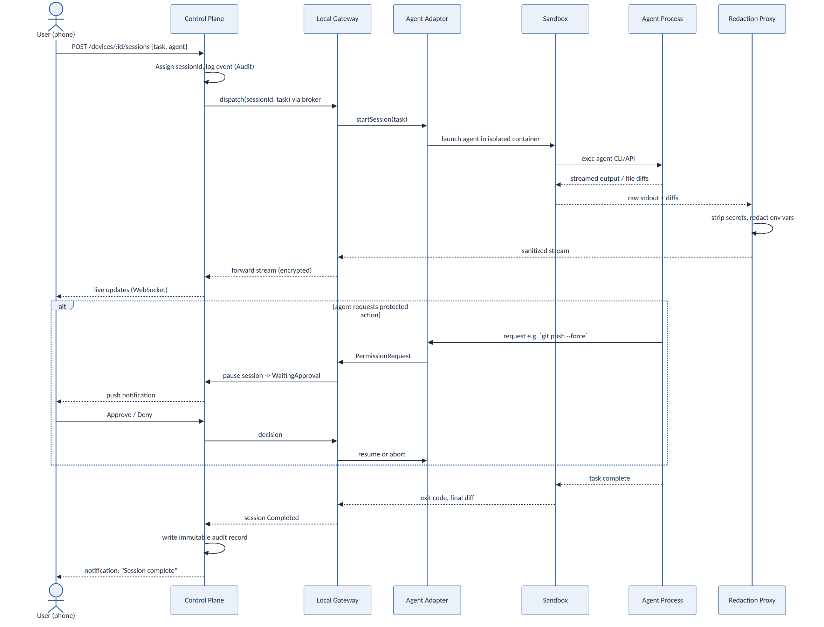
Figure 3 — Session execution flow, showing the mandatory sandbox and redaction steps and an inline approval branch.
- The Control Plane assigns a session ID and writes the initial audit event before dispatch, so even a session that never reaches the Gateway is recorded as attempted.
- The adapter never talks to the agent binary directly outside the sandbox boundary.
- Redaction happens once, centrally, rather than being each adapter's responsibility — new adapters inherit the protection automatically.

8.3 Permission Engine & Approval Flow
Approvals now resolve through a single decision tree that a trust profile can relax for low-risk categories but never fully bypass for the fixed deny-override list.
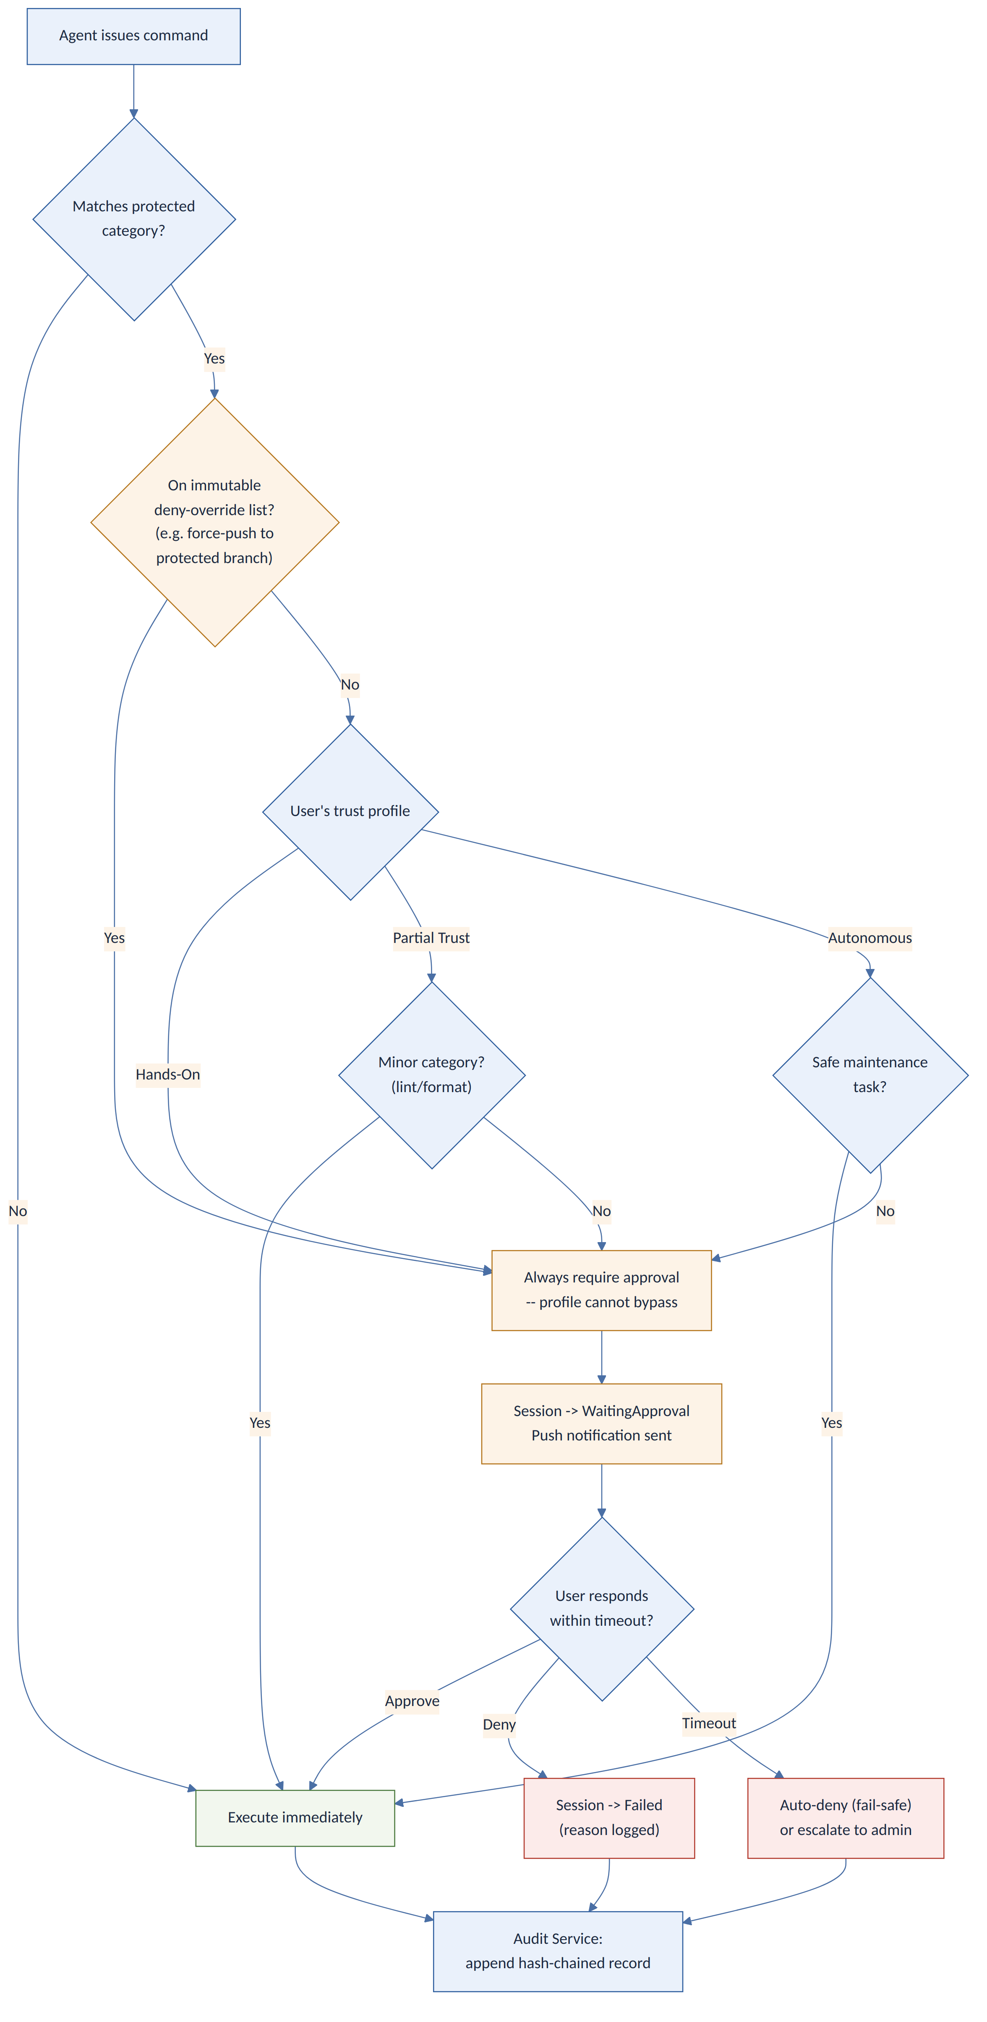
Figure 4 — Approval decision flow. The deny-override list (amber) sits above every trust profile.

Protected action categories (auto-detected)
- Filesystem: deletes, writes outside the working directory, chmod/chown.
- Shell: rm/mv/cp outside /workspace, piping to bash, any use of sudo.
- Network: initiating SSH/SCP, HTTP POST to external endpoints.
- Infrastructure: git push to a protected branch, kubectl apply, terraform apply.
- Secrets: reading environment variables or credential files.

Deny-override list (cannot be bypassed by any trust profile)
- Force-push or history rewrite on a protected branch.
- Credential/secret export or exfiltration-shaped network calls.
- Infrastructure apply against production-tagged environments.

8.4 Session State Machine
Two states are added to the original eight (Idle, Launching, Running, WaitingApproval, Completed, Failed, Cancelled) to make reconnect behavior explicit rather than implicit: Reconnecting and Degraded.
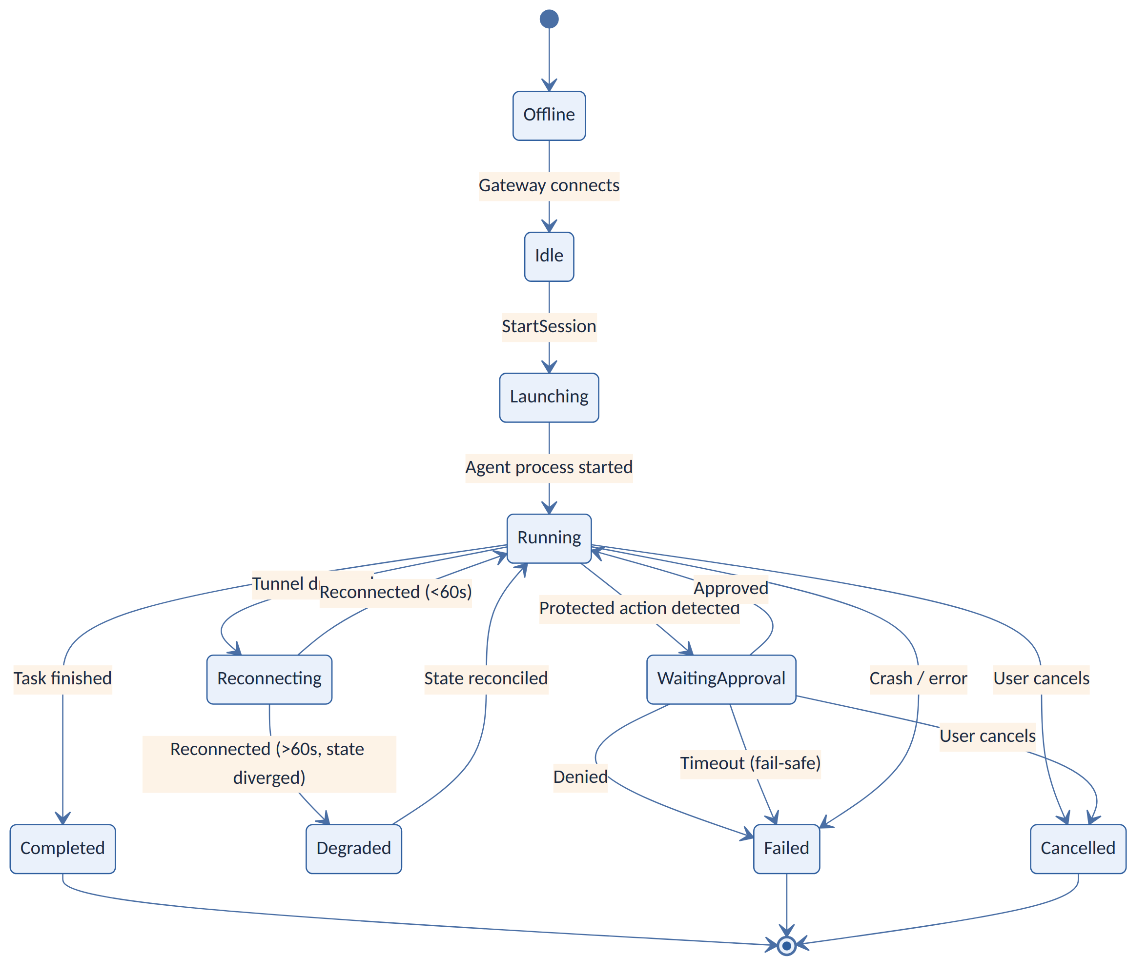
Figure 5 — Session state machine with explicit reconnect handling.
- A tunnel drop moves a Running session to Reconnecting rather than silently freezing the UI.
- A reconnect within 60 seconds resumes Running directly; a longer gap moves to Degraded, which forces a state-reconciliation step (comparing the Gateway's local log to the last event the cloud received) before resuming — this prevents duplicated or lost commands after a long network gap.

8.5 Defense-in-Depth Security Model
Six layers, each independently enforced, so that a failure in one (e.g., a leaked device token) does not by itself grant an attacker code execution or data access.
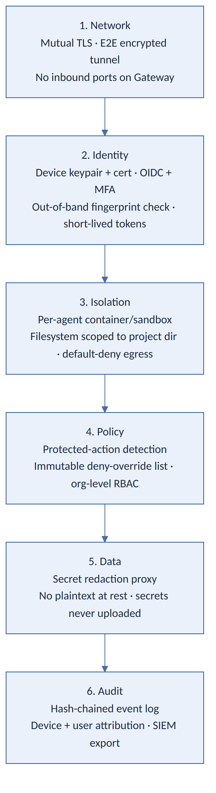
Figure 6 — Defense-in-depth: network, identity, isolation, policy, data, and audit layers.

9. Security & Threat Model
The Gateway runs with real access to the developer's machine, so the platform is designed zero-trust throughout: no component is trusted purely because it is "inside" the system.

9.1 Identity & Transport
- All client-to-cloud and Gateway-to-cloud traffic is HTTPS/WSS with strong TLS ciphers; the Gateway-to-cloud tunnel is additionally end-to-end encrypted so the relay only ever handles ciphertext.
- Every device has a cryptographic identity (keypair + short-lived, rotating certificate); users authenticate via OIDC with mandatory MFA.
- Pairing includes the out-of-band fingerprint check from §8.1, closing the relay-substitution gap in the original design.

9.2 Isolation & Least Privilege
- Every agent process runs inside a per-session sandbox (container or OS-level sandbox) with no elevated privileges and a filesystem view limited to the project directory.
- Outbound network access from the sandbox defaults to deny and is opened only for the specific hosts a task needs.
- Adapter binaries are pinned to signed/hash-verified versions; the Gateway's auto-updater verifies signatures before installing a new Gateway or adapter build, closing the supply-chain gap in §6.

9.3 Policy & Approvals
- The Policy & Permission Engine, not the client or the agent, makes the final call on whether an action needs human sign-off.
- The deny-override list (§8.3) cannot be relaxed by any trust profile, including "Autonomous."
- Approval requests resolve first-writer-wins across devices to avoid the race condition identified in §6.

9.4 Secrets
- Secrets are injected into the agent's sandboxed environment locally and are never uploaded; the Secret Redaction Proxy strips recognizable secret patterns from any stream leaving the machine as a second line of defense.
- An agent attempting to read a credential file outside its declared scope is itself a protected action requiring approval.

9.5 Audit & Accountability
- Every command, approval decision, file diff, and state transition is timestamped and hash-chained by the Audit Service, so tampering after the fact is detectable, and exportable to an external SIEM.
- Workspace/organization roles (owner, admin, member) scope who can view sessions, grant approvals, or revoke devices within a team, closing the tenancy gap in §6.

9.6 Security Checklist
- HTTPS/WSS with strong TLS ciphers everywhere.
- Mutual device authentication (client certs or signed JWTs).
- End-to-end encryption of all agent data in transit.
- Mandatory sandboxing before any shell/file access — not a post-MVP item.
- Default-deny egress from sandboxed agents.
- Input validation on every API surface; injection defenses.
- All file/repo content treated as untrusted input for prompt-injection defense.
- Signed auto-updates for Gateway and adapter binaries.
- Rate limiting on pairing and all public APIs.
- Session timeout and cleanup after prolonged inactivity.
- Hash-chained, exportable audit log.

10. Trust Profiles
Trust profiles set how eagerly the Policy Engine auto-approves low-risk categories; they never touch the deny-override list from §8.3.
Profile | Behavior | Still Always Requires Approval
Hands-On | Every commit, deploy, or destructive action asks first. | Everything on the deny-override list, by definition.
Partial Trust | Auto-approves minor fixes (lint, formatting); asks for infra changes. | Protected-branch force-push, credential export, infra-apply.
Autonomous | Auto-commits safe maintenance tasks (tests, cleanup) without asking. | Protected-branch force-push, credential export, infra-apply.
AFK | Raises notification priority and lowers auto-action rate while the user is away. | Everything the active profile already requires, plus anything time-sensitive is queued rather than auto-run.
Escalation: if the user doesn't respond to an approval within the configured timeout, the system either auto-denies (fail-safe default) or escalates to a workspace admin, per org policy.

11. Attention Engine (Notifications)
Not every event should interrupt the user. Events are tiered:
- Tier 1 (Critical): session completed (success or error), or approval needed — push notification and badge.
- Tier 2 (Informational): milestones such as a sub-agent launching or a plan being created — in-app badge, no push.
- Tier 3 (Debug): intermediate logs and token-usage updates — visible in-app only.
Delivered via APNs/FCM with session ID, status, and a short summary in the payload; tapping routes straight to the session detail screen. Default is to always alert on session end or an approval request; this is per-user configurable.

12. Task Timeline & Audit Trail
- Message log — every prompt and response, timestamped.
- File diff history — every write, stored as a unified diff linked to session and step, so the mobile app can show a changes preview before commit.
- Events — state transitions, approvals, cancels, errors, each hash-chained (§9.5).
- Access logs — which user/device performed which action, e.g. "Admin Alice approved session X."
This supports session replay for debugging, post-mortems, and — in enterprise/organization mode — export into SIEM tooling for compliance.

13. Mobile-First User Experience
- Project & Session Browser — paired machines and their active sessions, each with status and a progress indicator.
- Chat/Terminal View — a live, ANSI-aware terminal feed; the user can type new input or shell commands, with autocomplete, mirroring a desktop terminal on a phone.
- Diff/Review Mode — side-by-side or inline diffs with syntax highlighting; the user can comment, approve lines, and commit or open a GitHub PR directly from the review.
- Approvals Dialog — states exactly what's being requested (e.g. "Agent requests to DELETE src/legacy — approve?") with clear Approve/Deny actions and a "remember for this agent" option scoped to non-deny-override categories only.
- Notifications & Badges — badge count on new activity; completed sessions marked with a clear success/error indicator.
Design flow: session list → session detail (logs/diff) → approval dialogs, optimized for one-handed use and safe default prompts.

14. Integrations
- GitHub/GitLab/Bitbucket — OAuth-linked repos; sessions can push directly to a branch or open a PR with an auto-filled title/body on approval.
- CI/CD — a CLI plugin lets Jenkins/GitHub Actions trigger the platform's CLI against a repo path; results commit automatically once built.
- Cloud IDEs — a VSCode/JetBrains extension surfaces sessions and diffs inline; PR review APIs get agent-generated comments and session links.
- Notification channels — Slack/Teams webhooks post session summaries and approval requests.
- Cloud deployment — infrastructure changes (e.g. Terraform apply) always route through the Permission Engine's deny-override list (§8.3, §9.3); a staging-account dry run is offered before any production apply.
Every integration is optional; at minimum the platform works with local Git.

15. Telemetry & Observability
- Gateway metrics — running sessions, per-agent CPU/RAM, message rates, and tunnel latency, exposed on localhost and scraped by the Control Plane.
- Control Plane logs — structured logs for every API call, event delivery, and user action; key metrics include sessions/day, approval/denial rates, and per-agent failure rates.
- Distributed tracing — a trace ID follows a session's path UI → cloud → Gateway → agent for debugging.
- Alerts — unexpected Gateway disconnects, repeated failures, or internal schema violations page the on-call rotation.

16. Testing Strategy
- Unit tests for Gateway adapters, Cloud APIs, and policy logic, using mock agent CLIs.
- Integration tests spinning up a local Gateway and a test Control Plane instance for end-to-end flows.
- Permission/gate tests specifically verifying the deny-override list cannot be bypassed by any trust profile.
- Failover/resilience tests: interrupt and resume the tunnel, and verify the Reconnecting → Degraded → reconciliation path (§8.4) rather than assuming a clean resume.
- Security testing: red-team prompt-injection attempts, sandbox escape attempts, and confirmation that secrets never appear in cloud-bound streams.
- Performance testing: multiple concurrent sandboxed agents on one machine; many concurrent devices/sessions on the cloud side.
- Usability testing on real phones for terminal input and diff readability.
Target: 80%+ coverage on core modules, with CI running the full suite on every commit.

17. Deployment

17.1 Agent Gateway
- Distributed as signed installers/binaries for Windows, macOS, and Linux (and via Homebrew/apt/Chocolatey).
- Runs as a background service; auto-updates are signature-verified before install, with an opt-out.
- Listens only on localhost and makes outbound connections — no inbound ports are ever opened.

17.2 Cloud Control Plane
- Containerized microservices (API Gateway, Auth, KMS, Broker, Policy Engine, Audit) on a managed Kubernetes platform.
- Managed Postgres for durable state and Redis for ephemeral/presence state; managed identity provider (e.g. Auth0/Cognito) for OIDC.
- Multi-region deployment for latency and availability, with optional EU-only data residency for compliance.
- FCM/APNs for push notifications; CDN for static web assets; blue-green or canary rollout via CI/CD.
- A self-hosting guide is published for enterprises that want the cloud portion on their own infrastructure; the Gateway already runs on-prem by default.

18. MVP and Roadmap
Area | MVP (v1) | Later (v2+)
Agents supported | Codex CLI, OpenCode, Claude CLI, Antigravity CLI via adapters | Cline, Cursor CLI; IDE extensions
Control Plane UI | Pairing, session list, chat/terminal view, approvals, basic diff view | Enhanced diff editor, inline comments, theming, group permissions
Communication | WebSockets with TLS, QR pairing | SSE long-poll fallback; native iOS/Android apps
Security | Mandatory sandboxing, E2E-encrypted pairing, deny-override list, MFA | Enterprise SSO/SCIM, hardware-key (FIDO2) approvals
Integrations | GitHub push/PR on completion | GitLab/Bitbucket, webhooks, Slack/Teams
Observability | Session logging, Prometheus metrics | Dashboards, automated alert rules, session analytics
Platform | Cloud SaaS | On-premise Control Plane option
Testing/QA | Unit + integration tests on main flows | Chaos testing, third-party security audit
Note the shift from the original plan: mandatory sandboxing, the deny-override list, and E2E-encrypted pairing move into the MVP column rather than "planned" — these are the fixes from Section 6 and are treated as launch blockers, not follow-ups.
Post-MVP roadmap: multi-agent coordination (agents spawning sub-agents), scheduled/recurring tasks, refined attention-control rules, metric dashboards, team invite/collaboration features, and a pricing model.

19. Demo & Go-to-Market
Demo scenario: a developer away from her desk asks the phone app to fix a payment-processing validation bug. Codex and Claude Code agents on her machine work in parallel inside their sandboxes; she reviews the diff on her phone, approves the commit, and the platform opens a GitHub PR that runs through her team's normal CI. She reviews the merged change once she's back — the whole loop shows cross-agent orchestration, mobile review, and the approval/audit trail working together.
- Developer conferences and AI/dev meetups with a live demo.
- Technical content: webinars, walkthroughs, blog posts on the architecture.
- IDE-vendor partnerships (VSCode, JetBrains marketplace listings).
- Free tier for individuals; paid tier for team policy, analytics, and enterprise SSO.
- Engagement with the OpenCode community and other open agent ecosystems.

20. Success Metrics
- Adoption — unique users and devices connected; sign-up-to-active conversion.
- Engagement — sessions started per user per week; tasks completed; notifications acknowledged.
- Retention — active users at 1/3/6 months.
- Performance — end-to-end latency (tap → agent output); error rate.
- Safety — approval requests per session; approve/deny split; security incidents (target: zero, tracked explicitly given the threat model in §9).
- Business — subscription and enterprise-license revenue, if monetized.

21. Summary
The core idea — a vendor-neutral Gateway/Control-Plane split that lets any local coding agent be supervised from a phone — holds up well against the competitive landscape; nobody currently offers it across vendors. The main risk in the original plan was treating hard security properties (sandboxing, tamper-evident audit, an unbypassable approval floor, device revocation) as later-stage polish on top of an already-shipped remote-execution surface. This revision pulls those properties into the architecture itself and into the MVP scope, and gives every major feature a diagrammed, buildable specification (§8) so implementation can start directly from this document.

