PROJECT REPORT
NORTHWIND TRADE
Interactive Sales Analysis & Dashboard using Power BI
Field | Details
Student Name | G Harish Kumar
Course | B.Com Fintech with AI
Topic | Northwind Trade – Sales, Product & Customer Analysis
Tool Used | Microsoft Power BI Desktop
Dataset | Northwind (Harish_dataset_3)
Date | October 2026

Table of Contents

1. Introduction
Northwind Traders is a well-known sample trading company that imports and exports speciality food products to customers around the world. Its database records customers, employees, products, categories, shippers, orders and order details, which makes it an ideal case study for learning business data analysis.
This report presents a Power BI analysis of Northwind trade data. The analysis converts raw transactional data into KPIs, charts, tables and interactive filters that help management understand sales performance, customer distribution, product demand and employee productivity.

1.1 Relevance to B.Com Fintech with AI
Modern finance relies on data-driven decisions. Dashboards like this one combine accounting concepts (sales, freight cost, revenue by category) with analytics tools, and form the foundation for AI-based forecasting, customer segmentation and risk analysis that a Fintech with AI student is expected to understand.

2. Objectives
- To analyse overall trade performance of Northwind using key performance indicators (KPIs).
- To identify the best-performing product categories, products and employees.
- To understand the geographic distribution of customers.
- To study the monthly trend of orders and spot seasonality.
- To build an interactive dashboard with slicers for country, category and year.

3. Dataset and Data Model
The report is built on seven related tables loaded into Power BI. Relationships between them (for example orders → customers, order_details → products) allow a single filter to update every visual.
Table | Description
categories | Product categories such as Beverages, Dairy Products, Seafood
customers | Customer names and countries (91 customers)
employees | Sales employees who handled the orders
orders | Order header: order date, customer, employee, shipper, freight
order_details | Line items: product, unit price, quantity, discount
products | Product names and their category
shippers | Shipping companies that delivered the orders

3.1 Tools and Techniques
- Power BI Desktop – data modelling, DAX measures and visual design.
- DAX measures – Total Sales, Total Orders, Total Quantity Sold, Average Freight, Total Freight, Number of Customers.
- Visuals used – KPI cards, line chart, column chart, bar charts, table, slicers and a tooltip page.

4. Dashboard Pages
The Power BI file contains four report pages: Sales Overview, Product & Customer Analysis, Interactive Sales Dashboard and Tool Tip. Each page is explained below with its supporting charts and tables.

4.1 Page 1 – Sales Overview
The first page gives a quick snapshot of the whole business. Six KPI cards are shown at the top, followed by three charts: orders by month, sales by category and orders by employee.

Key Performance Indicators
Metric | Value | Meaning
Average freight | 79.05 | Average shipping cost per order
Total quantity sold | 51K (51,317 units) | Total units sold across all products
Number of customers | 91 | Distinct customers who placed orders
Total freight | 9M (as displayed) | See data-quality note in Section 6
Total orders | 809 | Orders recorded in the report
Total sales | 1.27M (12,65,793.04) | Revenue generated from all order lines

Total Orders by Month
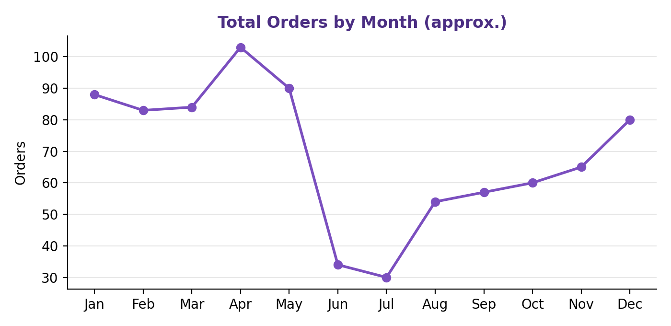
Figure 1: Monthly order trend (values read approximately from the Power BI line chart)
Order volume is high in the early months, peaks around April, then falls sharply in June and July before recovering gradually towards December. This indicates a seasonal pattern that the business should plan stock and logistics around.

Total Sales by Category
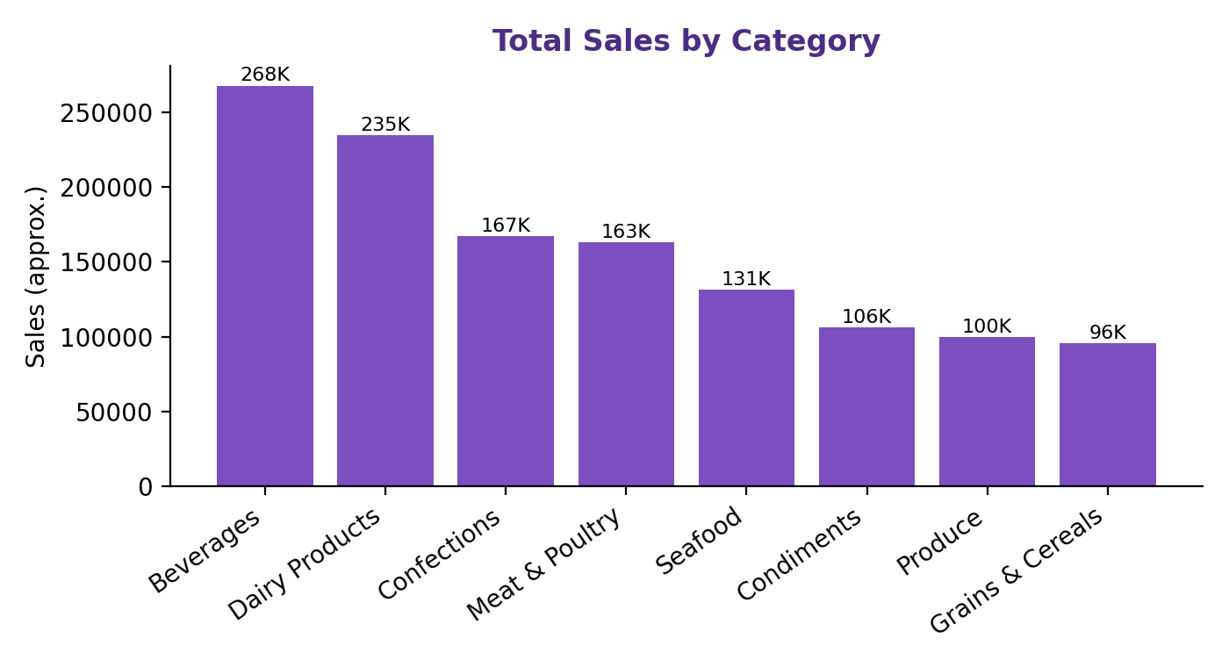
Figure 2: Total sales by product category
Category | Total Sales (approx.) | Share
Beverages | 267,868 | 21.2%
Dairy Products | 234,507 | 18.5%
Confections | 167,357 | 13.2%
Meat & Poultry | 163,022 | 12.9%
Seafood | 131,261 | 10.4%
Condiments | 106,047 | 8.4%
Produce | 99,985 | 7.9%
Grains & Cereals | 95,744 | 7.6%
Total | 1,265,793 | 100%

Beverages and Dairy Products together contribute almost 40% of all sales, making them the core revenue drivers. Grains & Cereals and Produce contribute the least.

Total Orders by Employee
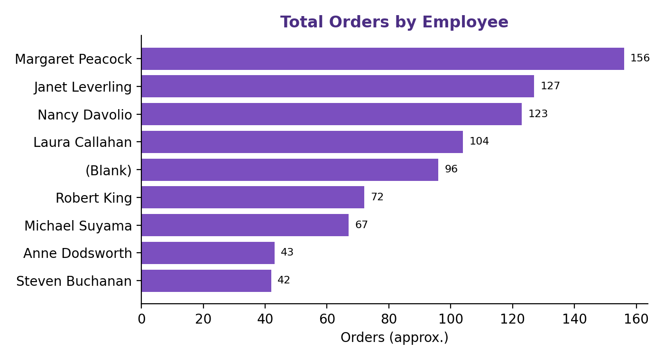
Figure 3: Orders handled by each employee
Rank | Employee | Orders (approx.)
1 | Margaret Peacock | 156
2 | Janet Leverling | 127
3 | Nancy Davolio | 123
4 | Laura Callahan | 104
5 | (Blank) | 96
6 | Robert King | 72
7 | Michael Suyama | 67
8 | Anne Dodsworth | 43
9 | Steven Buchanan | 42

Margaret Peacock handled the largest number of orders, followed by Janet Leverling and Nancy Davolio. One group appears as (Blank), meaning some orders are not linked to an employee name in the data model.

4.2 Page 2 – Product & Customer Analysis
This page analyses where customers come from and how individual products perform. It contains a bar chart of customers by country and a product table showing category, total sales and quantity sold.

Number of Customers by Country
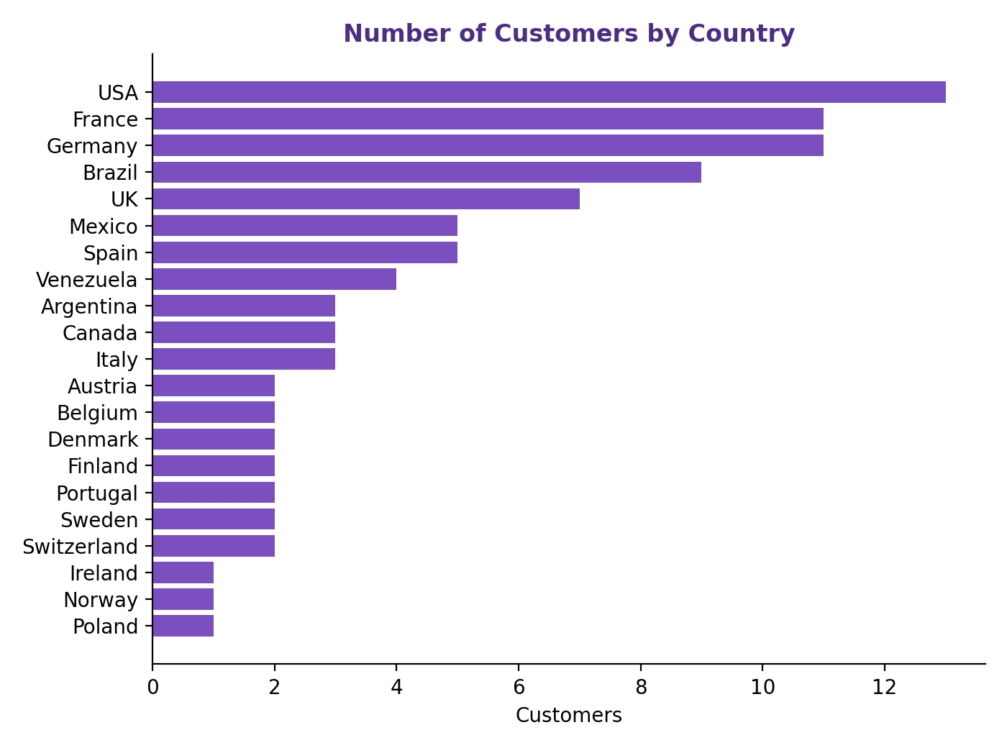
Figure 4: Customer count by country
Country | Customers
USA | 13
France | 11
Germany | 11
Brazil | 9
UK | 7
Mexico | 5
Spain | 5
Venezuela | 4
Other 13 countries | 1–3 each

The USA has the most customers (13), followed by France and Germany (11 each) and Brazil (9). Together these four countries account for 44 of the 91 customers, which is almost half of the customer base.

Product Performance Table
The table below shows a sample of products from the report. The grand total row matches the KPI cards on Page 1 (sales of 12,65,793.04 and 51,317 units).
Product | Category | Total Sales | Qty Sold
Alice Mutton | Meat & Poultry | 32,698.38 | 978
Aniseed Syrup | Condiments | 3,044.00 | 328
Boston Crab Meat | Seafood | 17,910.63 | 1,103
Camembert Pierrot | Dairy Products | 46,825.48 | 1,577
Carnarvon Tigers | Seafood | 29,171.88 | 539
Chai | Beverages | 12,788.10 | 828
Chang | Beverages | 16,355.96 | 1,057
Chartreuse verte | Beverages | 12,294.54 | 793
Chef Anton's Cajun Seasoning | Condiments | 8,567.90 | 453
Chef Anton's Gumbo Mix | Condiments | 5,347.20 | 298
Chocolade | Confections | 1,368.71 | 138
Côte de Blaye | Beverages | 1,41,396.74 | 623
Escargots de Bourgogne | Seafood | 5,881.68 | 534
Filo Mix | Grains & Cereals | 3,232.95 | 500
Flotemysost | Dairy Products | 19,551.03 | 1,057
Grand Total (all products) |  | 12,65,793.04 | 51,317

Côte de Blaye is the highest-earning product with sales of about 1.41 lakh even though only 623 units were sold, which shows it is a premium-priced item. Camembert Pierrot, in contrast, earns well through high volume (1,577 units).

4.3 Page 3 – Interactive Sales Dashboard
The third page, titled "Northwind Interactive Sales Dashboard", combines KPI cards and charts on a single screen and adds three slicers: Country, Category Name and Year (2013, 2014, 2015 and Blank). Selecting any slicer value filters all KPI cards and charts at the same time, allowing users to answer questions such as "How did Beverages perform in Germany in 2014?".
Slicer | Field | Purpose
Country | customers[country] | View performance for a single country
Category | categories[categoryName] | Focus on one product category
Year | orders[year] | Compare performance year by year

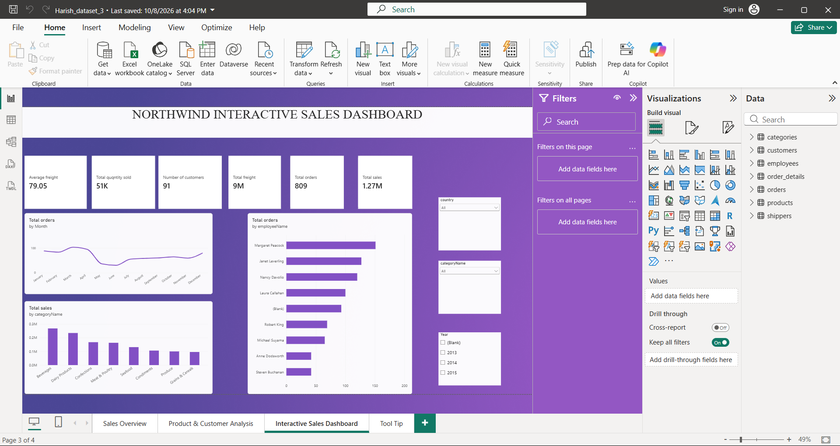
Figure 5: Interactive Sales Dashboard page with slicers

4.4 Page 4 – Tool Tip
The fourth page is a custom tooltip page. When a user hovers over a chart on the dashboard, a small pop-up card appears showing Total Orders (809), Total Sales (1.27M) and Total Quantity Sold (51K) for the highlighted data point. This gives extra detail without cluttering the main dashboard.
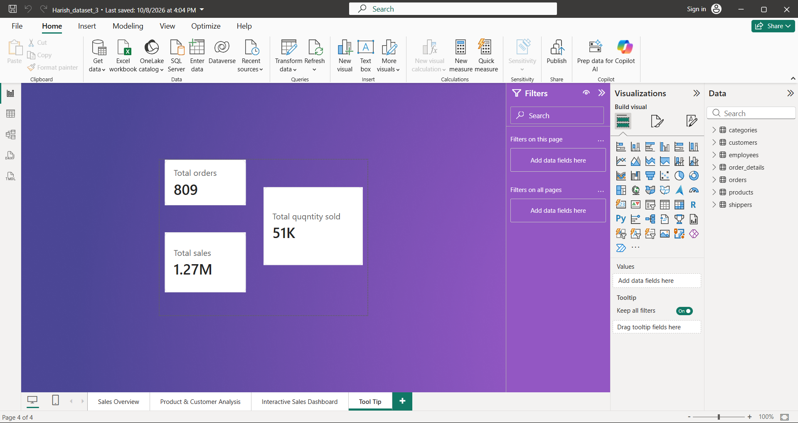
Figure 6: Tooltip page design

5. Key Findings
- Northwind generated total sales of about 1.27 million from 809 orders and 51,317 units sold.
- Average freight per order is 79.05, a significant logistics cost that should be monitored.
- Beverages (about 21%) and Dairy Products (about 18.5%) are the top two categories by sales.
- Order volume is seasonal, with a peak in April and a dip in June–July.
- The USA, France, Germany and Brazil together hold almost half of the 91 customers.
- Employee performance varies widely: the top employee handled roughly 156 orders versus about 42 for the lowest.
- Premium products (e.g., Côte de Blaye) earn high revenue from low volumes, while others depend on volume.

6. Data-Quality Observations
- Total freight is displayed as 9M, but average freight (79.05) multiplied by 809 orders is only about 64,000. The 9M figure is likely inflated because freight at order level is being summed across order-detail rows; the measure should be recalculated at order level.
- A (Blank) employee appears in the employee chart, showing missing or unmatched employee records.
- Employee, month and category values in the charts are approximate readings of the Power BI visuals; exact values can be seen by hovering over the visuals in Power BI.
- The label "Total quqntity sold" contains a spelling mistake and should be corrected to "Total quantity sold".

7. Recommendations
- Increase stock and marketing focus on Beverages and Dairy Products, the main revenue drivers.
- Run promotions in the low-order months (June–July) to reduce seasonality.
- Strengthen relationships with customers in the USA, France, Germany and Brazil, and explore growth in countries with only one customer.
- Review shipping contracts to reduce average freight cost.
- Use the monthly and category data as input for AI-based sales forecasting models.
- Share training and best practices from top-performing employees with the rest of the team.

8. Conclusion
The Northwind Trade dashboard shows how Power BI can turn a relational sales database into clear, interactive business insights. The analysis covers overall sales, category and product performance, employee productivity and customer geography, and the interactive page lets decision makers explore the data by country, category and year. With the data-quality points corrected, this model can serve as a base for forecasting and AI-driven decision support, which directly connects to the learning outcomes of the B.Com Fintech with AI programme.

Appendix – Power BI Report Screenshots
Pages 1 and 2 of the report are shown below for reference.
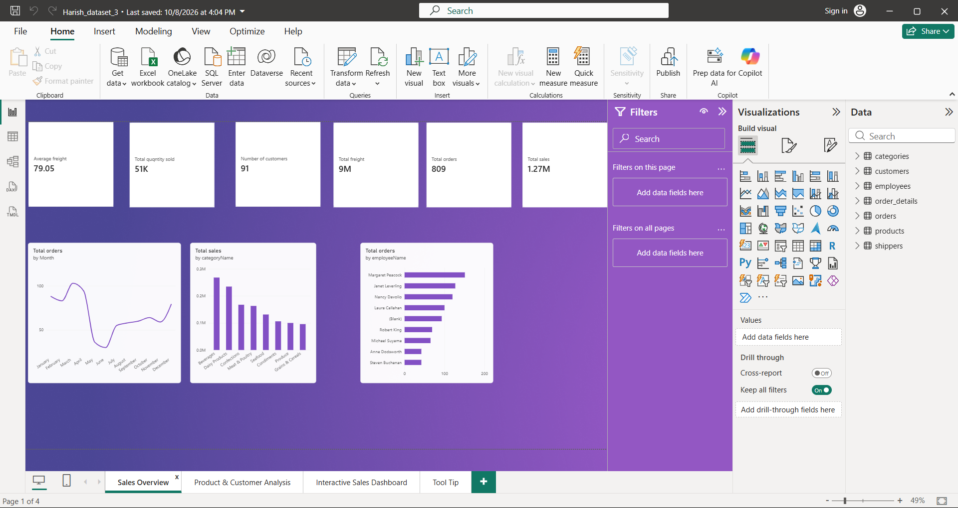
Appendix A: Page 1 – Sales Overview
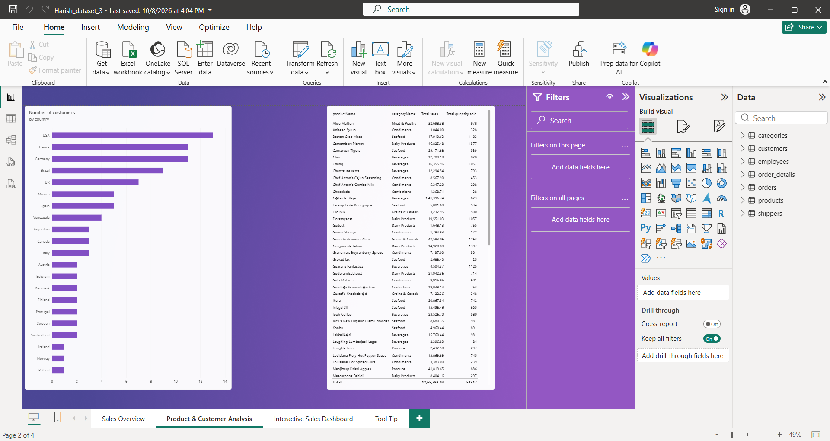
Appendix B: Page 2 – Product & Customer Analysis

