PROJECT REPORT
IBM – Anti-Money Laundering Dataset
Transaction & Fraud Analysis using Microsoft Power BI
Name | G. Harish Kumar
Course | B.Com Fintech with AI
Topic | IBM – Anti-Money Laundering Dataset
Tool Used | Microsoft Power BI Desktop
Power BI File | Harish_Dataset_4
Date | 20 October 2026

Contents
1. Abstract
2. Objectives of the Study
3. About the IBM Anti-Money Laundering Dataset
4. Tools and Methodology
5. Dashboard Page 1 – KPI Page
6. Dashboard Page 2 – Interactive Dashboard
7. Dashboard Page 3 – Tooltip Page
8. Key Findings and Analysis
9. Relevance to Anti-Money Laundering (AML) Compliance
10. Limitations and Recommendations
11. Conclusion

1. Abstract
Money laundering is the process of disguising the origin of illegally obtained funds so that they appear to come from legitimate sources. Banks and fintech companies must monitor millions of transactions to detect this activity, and artificial intelligence is increasingly used to support that monitoring. This report presents an analytical dashboard built in Microsoft Power BI on the IBM Anti-Money Laundering (AML) transaction dataset, which contains account, transaction and alert records.
The dashboard has three pages: a KPI page, an interactive dashboard and a tooltip page. It summarises about 1.32 million transactions across 10,000 accounts, with a total transaction value of 153.48 billion. Only 1,719 transactions (0.13%) are flagged as fraudulent, which shows the strong class imbalance that makes AML detection difficult. The report explains each page, the charts and tables used, the findings and their relevance to AML compliance.

2. Objectives of the Study
- To understand the structure of the IBM Anti-Money Laundering dataset (accounts, transactions and alerts).
- To build key performance indicators (KPIs) that summarise transaction volume, value and fraud.
- To visualise the trend of transactions over time and compare fraudulent and non-fraudulent activity.
- To analyse the types of AML alerts generated, such as cycle and fan_in patterns.
- To create an interactive Power BI dashboard with slicers and tooltips for easy exploration.
- To relate the findings to real-world AML compliance practice in banking and fintech.

3. About the IBM Anti-Money Laundering Dataset
The IBM AML dataset is a synthetic (simulated) banking dataset created to support research on detecting money laundering. Because real banking data is confidential, simulated data lets students and researchers test detection methods safely. The data contains normal transactions together with transactions that follow known laundering patterns, and the suspicious ones are flagged.
In the Power BI data model, the data is organised into three tables:

Table | Description
accounts | One row per customer account (10,000 accounts). Holds account details such as the initial balance, which totals 2.80M.
transactions | One row per transaction (about 1.32 million). Includes the TIMESTAMP, the transaction amount and the IS_FRAUD flag showing whether the transaction is fraudulent.
alerts | Records AML alerts raised on suspicious activity. Each alert has an ALERT_ID and an ALERT_TYPE (for example cycle or fan_in).
Table 1: Tables in the Power BI data model

Key fields used in the dashboard
Field | Table | Use in the report
TIMESTAMP | transactions | X-axis of the transaction trend line chart
IS_FRAUD | transactions | Splits transactions into fraud and non-fraud; used in the donut chart, column chart and slicer
Transaction amount | transactions | Measures total and average transaction value
ALERT_ID | alerts | Counted to show the number of alerts
ALERT_TYPE | alerts | Category axis of the alert chart and a slicer
Table 2: Key fields used in the visuals

4. Tools and Methodology
The analysis was done in Microsoft Power BI Desktop (file name: Harish_Dataset_4). The work followed these steps:
- Data loading: the accounts, transactions and alerts tables were imported into Power BI.
- Data modelling: the tables were related so that accounts, transactions and alerts can be analysed together.
- Measures: DAX measures were created for Total Transaction, Total Transaction Amount, Average Transaction Amount, Fraudulent Transactions, Total Accounts and Total Initial Balance.
- Visualisation: KPI cards, a line chart, a column chart, a donut chart, a bar chart and slicers were added in a dark theme.
- Interactivity: slicers for IS_FRAUD and ALERT_TYPE and a custom tooltip page were configured.

5. Dashboard Page 1 – KPI Page
The first page gives a quick overview of the whole dataset through six KPI cards placed at the top, followed by four supporting charts. A reader can understand the scale of the data and the level of fraud within a few seconds.
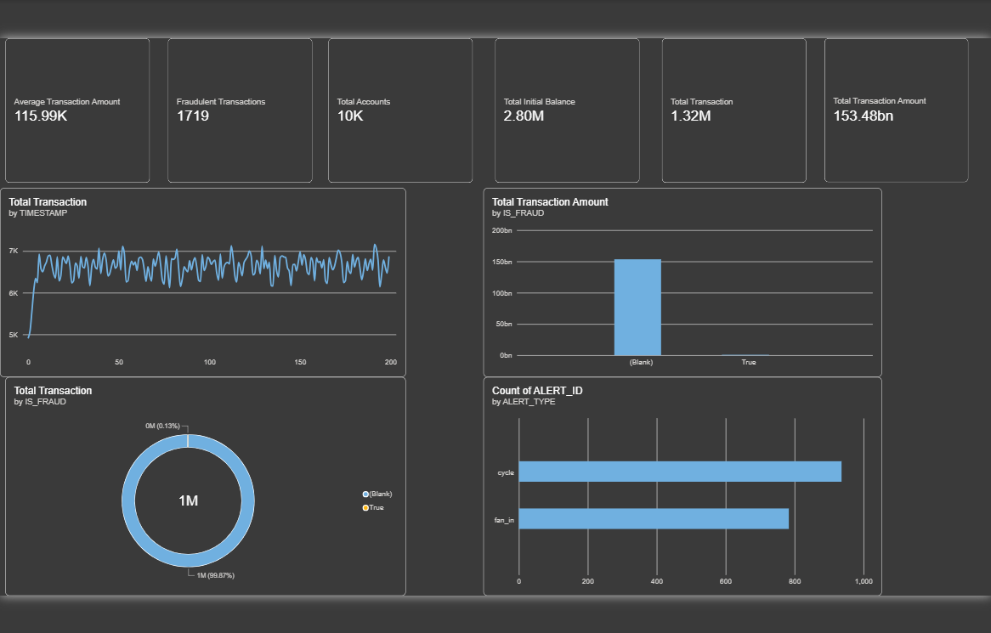
Figure 1: Power BI KPI page – KPI cards and summary charts
KPI | Value | Meaning
Average Transaction Amount | 115.99K | Average value of a single transaction
Fraudulent Transactions | 1,719 | Number of transactions flagged as fraud (IS_FRAUD = True)
Total Accounts | 10K | Number of customer accounts in the dataset
Total Initial Balance | 2.80M | Sum of the opening balances of all accounts
Total Transaction | 1.32M | Total number of transactions recorded
Total Transaction Amount | 153.48bn | Total value of all transactions
Table 3: KPI values shown on the dashboard

Charts on this page
- Total Transaction by TIMESTAMP (line chart): shows how transaction volume moves over time. After a sharp rise at the start, the line stays in a narrow band between about 5K and 7K, with regular ups and downs. This indicates steady, repeating activity with no major spike or crash.
- Total Transaction Amount by IS_FRAUD (column chart): almost the entire 153.48bn value sits in the non-fraud column, while the fraud column is barely visible.
- Total Transaction by IS_FRAUD (donut chart): non-fraud transactions make up 99.87% (about 1M+) and fraud transactions only 0.13%.
- Count of ALERT_ID by ALERT_TYPE (bar chart): shows how many alerts were raised for each laundering pattern – cycle and fan_in.

6. Dashboard Page 2 – Interactive Dashboard
The second page is titled “AIML Transaction & Fraud Analysis”. It repeats the KPI cards and the four charts but adds two slicers on the right: IS_FRAUD (False / True) and ALERT_TYPE. When the user selects a value in a slicer, every chart and KPI on the page updates at once (cross-filtering). This makes it possible to look only at fraudulent transactions or only at a particular alert type.
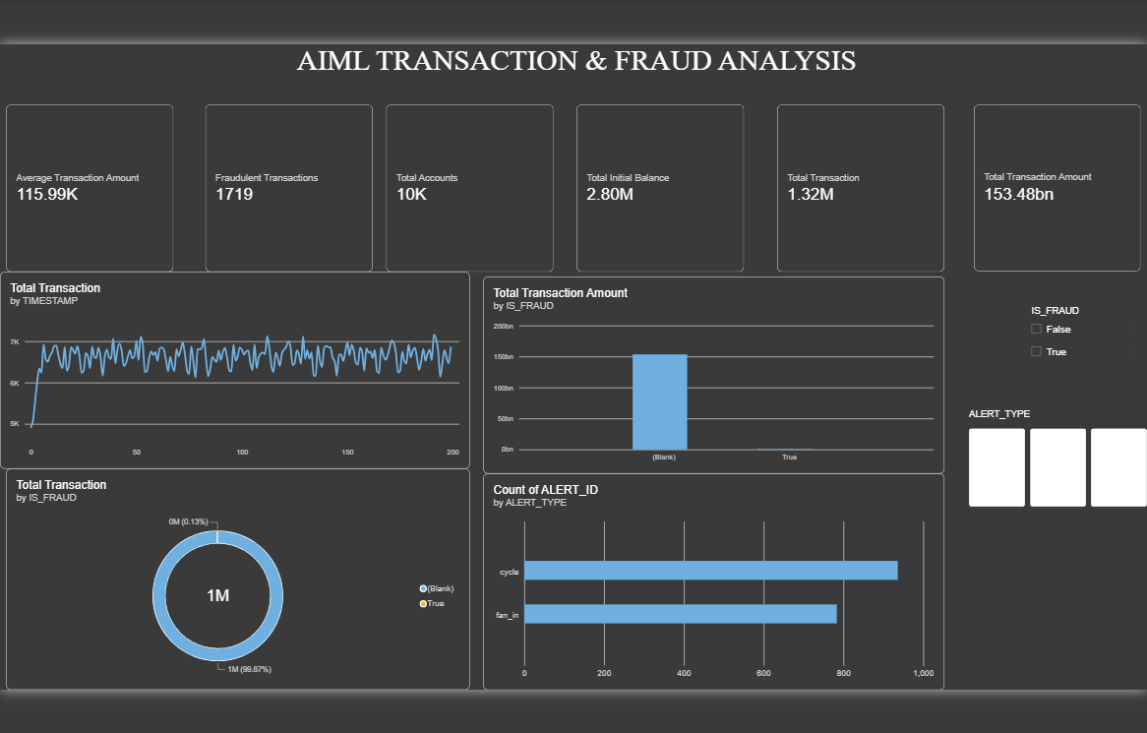
Figure 2: Interactive dashboard page with slicers
Interactive element | Purpose
IS_FRAUD slicer | Filter the whole page to fraud (True) or non-fraud (False) transactions
ALERT_TYPE slicer | Filter alerts by laundering pattern (cycle, fan_in)
Cross-filtering | Clicking a bar or a donut segment filters the other visuals on the page
Title banner | Gives the page a clear heading for presentation and reporting
Table 4: Interactive features on Page 2

7. Dashboard Page 3 – Tooltip Page
The third page is a tooltip page. A tooltip page is a small hidden page that appears as a pop-up when the user hovers the mouse over a visual on another page. It displays three compact cards – Total Transaction (1.32M), Fraudulent Transactions (1,719) and Total Transaction Amount (153.48bn). This gives extra context without crowding the main dashboard.
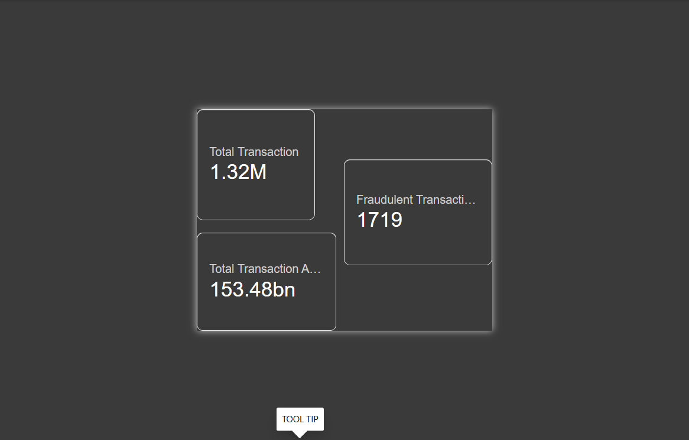
Figure 3: Tooltip page design in Power BI

8. Key Findings and Analysis

8.1 Fraud is extremely rare compared with normal activity
Out of about 1.32 million transactions, only 1,719 are fraudulent, which is 0.13% – roughly 1 in every 770 transactions. This is a typical feature of AML data: suspicious activity is hidden inside a very large volume of normal transactions.
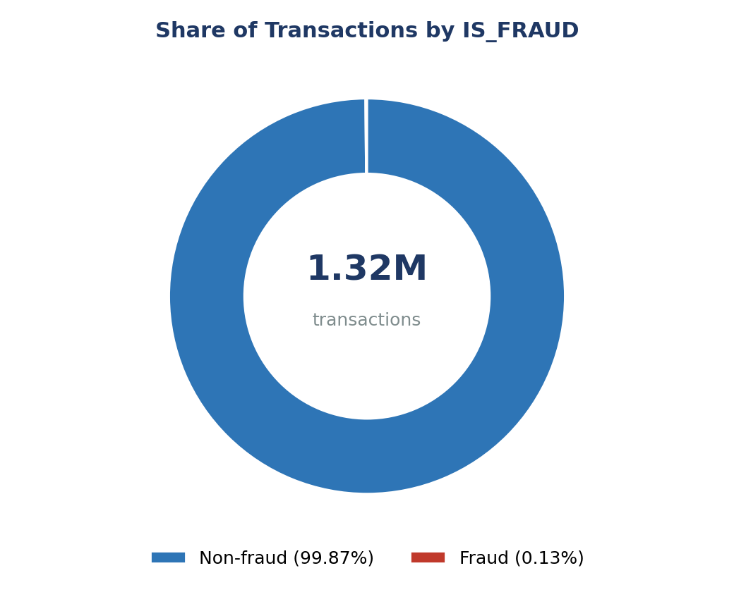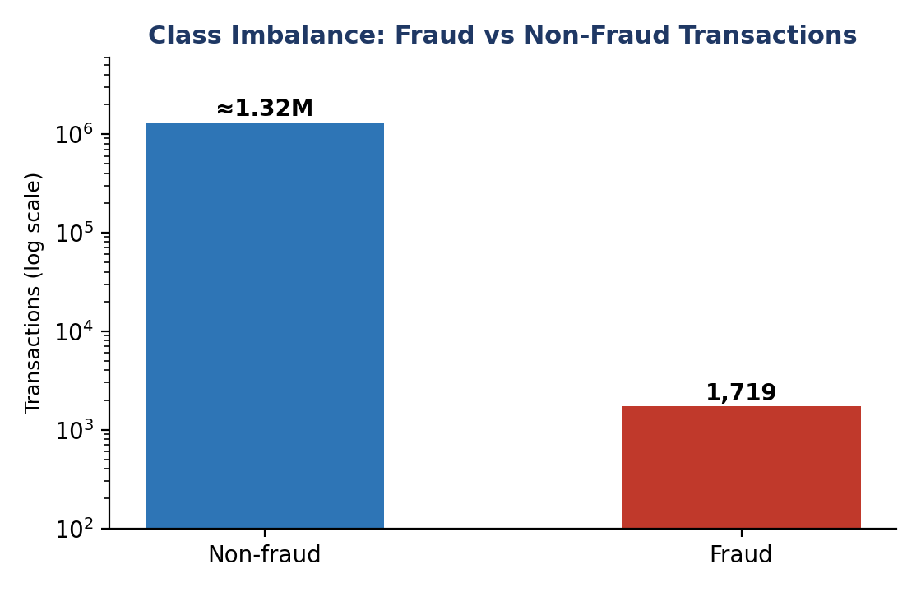
Figure 4: Fraud share (left) and class imbalance on a log scale (right)

8.2 Derived metrics
The following figures were calculated from the six KPI values shown on the dashboard:
Metric | Calculation | Result
Fraud rate | 1,719 ÷ 1.32M | ≈ 0.13%
Average transactions per account | 1.32M ÷ 10,000 | ≈ 132 per account
Average initial balance per account | 2.80M ÷ 10,000 | ≈ 280 per account
Average amount check | 153.48bn ÷ 1.32M | ≈ 116K (matches the 115.99K KPI)
Table 5: Metrics derived from the KPI cards

8.3 Alert patterns
Two alert types appear in the data: cycle and fan_in. Cycle alerts are the more frequent (about 940), followed by fan_in (about 790). The values are read from the chart axis, so they are approximate.
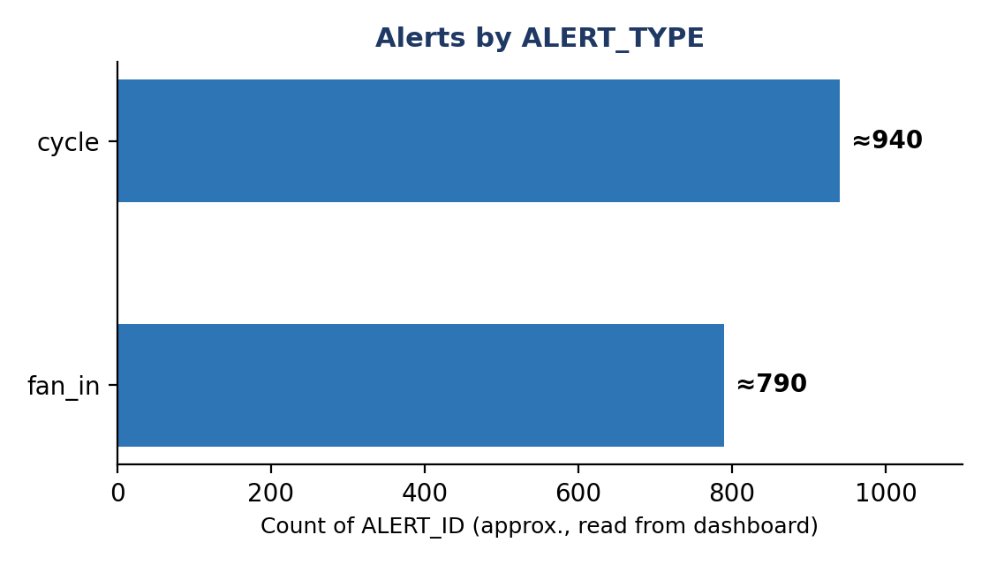
Figure 5: Number of alerts by alert type (approximate)
Alert type | Typical laundering behaviour | What it looks like
cycle | Money moves through a chain of accounts and returns to the account it started from | A → B → C → A, to hide the true origin of funds
fan_in | Many accounts send money to a single account | Many small deposits are combined into one account (aggregation)
Table 6: Alert types found in the dataset

8.4 Transaction trend
The line chart shows stable transaction activity after the initial ramp-up, ranging between about 5K and 7K transactions per time period. Since there is no large spike, fraud in this dataset cannot be spotted from volume alone; it must be detected from transaction patterns and account relationships.

9. Relevance to Anti-Money Laundering (AML) Compliance
Money laundering normally happens in three stages: placement (introducing illegal cash into the system), layering (moving it through many transactions to hide its source) and integration (bringing it back as apparently clean money). The cycle and fan_in alert types in this dataset are examples of layering and aggregation behaviour.
In India, AML obligations arise from the Prevention of Money Laundering Act, 2002 (PMLA). Banks and other reporting entities must follow Know Your Customer (KYC) norms, monitor transactions and report suspicious transactions to the Financial Intelligence Unit – India (FIU-IND). Internationally, the Financial Action Task Force (FATF) sets the standards. A dashboard of this type helps compliance teams to:
- Track the overall volume and value of transactions and the fraud rate.
- Prioritise alerts by type so that investigators focus on the riskiest patterns.
- Reduce false alarms by drilling down using slicers and tooltips.
- Present findings clearly to management and auditors.
The 0.13% fraud rate also explains why AI and machine-learning models need care in this field. A model that labels every transaction as “not fraud” would be 99.87% accurate yet would catch no laundering at all. For this reason, metrics such as precision, recall and F1-score are used instead of accuracy alone.

10. Limitations and Recommendations

Limitations
- The data is synthetic, so patterns may be simpler than in real banking data.
- In the charts the non-fraud category appears as “(Blank)” because the IS_FRAUD value is empty for those rows; the data should be cleaned so that it reads “False”.
- The dashboard shows counts and totals but does not yet show fraud amount, account-level risk or geography.
- Alert counts were read visually from the chart axis and are approximate.

Recommendations
Recommendation | Benefit
Replace blank IS_FRAUD values with False | Cleaner legends, slicers and labels
Add a measure for fraud amount and fraud % | Shows the financial impact of fraud, not only the count
Add top-risk accounts table | Helps investigators focus on high-risk accounts
Add more alert types if available (e.g. fan_out, scatter-gather) | Wider coverage of laundering typologies
Build a machine-learning model and evaluate with precision/recall | Moves from reporting to automated detection
Table 7: Suggested improvements

11. Conclusion
The Power BI dashboard on the IBM Anti-Money Laundering dataset gives a clear picture of 1.32 million transactions worth 153.48 billion across 10,000 accounts. Fraud is very rare (0.13%), and the alerts show two main laundering patterns, cycle and fan_in. The KPI page offers a quick summary, the interactive page allows detailed exploration through slicers, and the tooltip page adds context on demand.
The project shows how business intelligence tools can support AML monitoring and how data analytics and AI can help fintech professionals detect financial crime. With further data cleaning and predictive modelling, the same dashboard can grow into a full fraud-monitoring solution.

References
- IBM – Anti-Money Laundering (AML) transaction dataset (synthetic data for AML research).
- Prevention of Money Laundering Act, 2002 (India).
- Financial Action Task Force (FATF) – Recommendations on money laundering.
- Microsoft Power BI documentation.

