**Assignment 1**

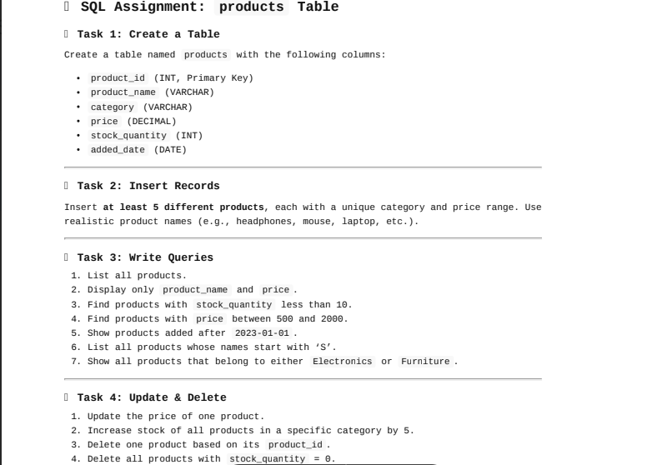

**-- Task 1 create table**

create table products(

product_id int primary key,

product_name varchar(50),

category varchar(50),

price decimal(10,2),

stock_quantity int,

added_date date

);

**-- Task 2 Insert records**

Insert into products values

(1,'Wireless Mouse','Electronics',599.99,10,'2025-07-11'),

(2,'Office Chair','Furniture',2499.00,5,'2025-07-25'),

(3,'Notebook A5','Stationery',45.00,50,'2025-07-10'),

(4,'Water Bottle 1L','Home Essentials',199.00,25,'2025-07-15'),

(5,'Shoes','Footwear',999.00,20,'2025-07-17');

**-- Task 3 write queries**

-- 1. all products

select * from products;

-- 2. only product and price

select product_name,price from products;

-- 3. stock_quantity < 10

select * from products where stock_quantity<10;

-- 4. price b/w 500 and 2000

select * from products where price between 500 and 2000;

-- 5. added after 2023-01-01

select * from products where added_date>"2023-01-01";

-- 6. product name start with s

select * from products where product_name like 'S%';

-- 7. products belong to Electronics or Furniture

select * from products where category in ('Electronics','Furniture');

**-- Task 4 Update and delete**

-- 1. update price of 1 product

Update products set price= 2000.00 where product_id=2;

-- 2. increase stock qunaty by 5 for a specific category

Update products set stock_quantity=stock_quantity+5 where category='Notebook';

-- 3.delete one product on product_id

delete from products where product_id=1;

-- 4. delete all product stock =0

delete from products where stock_quantity=0;

select * from products;

**Assignment 2**

create database store;

use store;

create table departments(

dept_id int primary key,

dept_name varchar(30)

);

insert into departments values

(1,'Human Resources'),

(2,'Engineering'),

(3,'Marketing');

create table employees(

emp_id int primary key,

emp_name varchar(100),

dept_id int,

salary int

);

insert into employees values

(101,'Amit Sharma',1,30000),

(102,'Neha Reddy',2,45000),

(103,'Faizan Ali',2,40000),

(104,'Divya Mehta',3,35000),

(105,'Ravi varma',NULL,28000);

-- 1. all employees with department name

select e.emp_name,d.dept_name

from employees e

left join departments d

on e.dept_id=d.dept_id;

-- 2. employees do not belong to any department

select e.emp_name

from employees e

left join departments d

on e.dept_id=d.dept_id

where d.dept_id is null;

-- 3. Total no of employees in each depart

select d.dept_name,count(emp_id) as No_of_Employees

from departments d

left join employees e

on d.dept_id = e.dept_id

group by d.dept_name;

-- 4. departments with no employee

select d.dept_name

from departments d

left join employees e

on d.dept_id = e.dept_id

where e.emp_id is null;

-- 5. emp name and dept name slary>40000

select e.emp_name,d.dept_name

from departments d

right join employees e

on d.dept_id=e.dept_id

where e.salary > 40000;