**MYSQL**

**SQL (Structured Query Language)** is a standard programming language used to manage and manipulate **relational databases**. It allows you to **create, read, update, and delete** data — commonly referred to as **CRUD operations**.

MySQL is an **open-source relational database management system (RDBMS)** developed by **Oracle Corporation**. It stores data in **tables (rows and columns)** and uses **SQL (Structured Query Language)** for querying and managing the data.

(https://onecompiler.com/sqlserver/)

1.Domain Driven Design

Educational Application

           Student, Teacher, Course, Department, Subject

Banking Application

           Account, Customer, Fund Transfer …

Retail Application

           Product, Order, Cart, Payment

**Crud Operation**

-- create

create database manage;

use manage;

create table students (

student_id int primary key,

name varchar(20),

course varchar(25),

joining_date date

);

-- insert

insert into students values

(1,'Harish','Data Science','2025-07-17'),

(2,'Vishal','Data Engineering','2025-07-18'),

(3,'Vasanth','Data Science','2025-07-20'),

(4,'Saravanan', 'Data Engineering','2025-07-20');

-- fetch

-- select * from students;

-- select name,course from students;

-- Using where

-- select * from students where course='Data Engineering';

-- select * from students where joining_date > '2025-07-18';

-- VARIATIONS – (and, in, between)

-- select * from students where course='Data Engineering' and joining_date='2025-07-20';

-- select * from students where course in ('Data Science','Python');

-- select * from students where joining_date between '2025-07-18' and '2025-07-22';

-- LIKE

-- select * from students where name like 'V%';

-- select * from students where name like '%l';

-- select * from students where name like '%an%';

-- UPDATE

-- update students set course='Advanced Data Engineering' where student_id=1;

-- update students set joining_date='2025-07-18' where name='Harish';

-- DELETE

delete from students where student_id=2;

delete from students where joining_date<'2025-07-18';

select * from students;

**Learning Subquery**

CREATE DATABASE simple_sql;

USE simple_sql;

CREATE TABLE employees (

emp_id INT PRIMARY KEY,

emp_name VARCHAR(100),

department VARCHAR(50),

salary INT,

age INT

);

INSERT INTO employees VALUES

(1, 'Amit', 'HR', 30000, 25),

(2, 'Neha', 'IT', 45000, 28),

(3, 'Rahul', 'IT', 50000, 30),

(4, 'Divya', 'Sales', 40000, 26),

(5, 'Kiran', 'Sales', 35000, 24),

(6, 'Meena', 'HR', 32000, 29);

SUBQUERY

* A **subquery** is a query **nested inside another SQL query**. It returns a value or result set used by the main query.
* Used in where, having, select.
* Acts as value or condition

INLINE SUBQUERY

* A subquery **used inside the FROM clause** and treated like a temporary table (alias required).
* The outer query queries the **result set** of the inner query.
* Used in from
* Acts as a temporary table needs alias name

-- SUBQUERY

select * from employees

where salary>

(select avg(salary) from employees);

-- INLINE QUERY

select dept_avg.department,dept_avg.avg_salary

from(

select department,avg(salary) as avg_salary

from employees

group by department) as dept_avg;

-- RANK

select emp_name,department,salary,

rank() over (order by salary desc) as salary_rank

from employees;

**Joins**

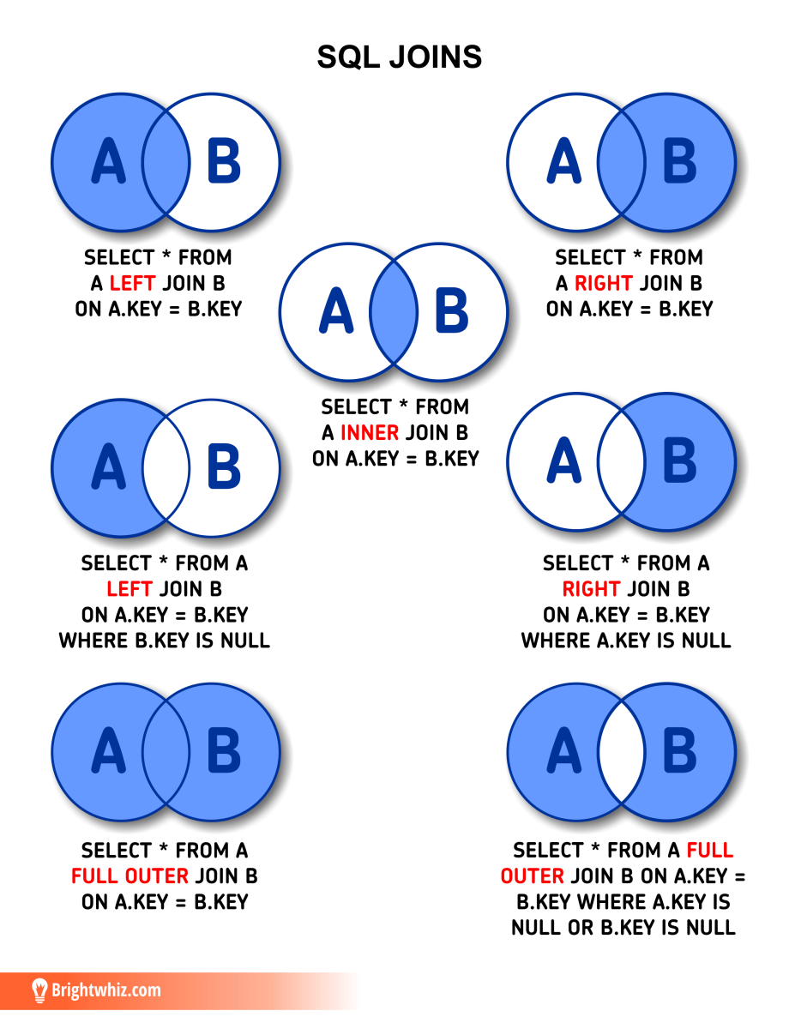

create database analytics_practice;

use analytics_practice;

CREATE TABLE customers (

customer_id INT PRIMARY KEY,

customer_name VARCHAR(100),

city VARCHAR(50)

);

INSERT INTO customers VALUES

(1, 'Amit Sharma', 'Delhi'),

(2, 'Neha Reddy', 'Hyderabad'),

(3, 'Rahul Iyer', 'Mumbai'),

(4, 'Divya Mehta', 'Chennai');

CREATE TABLE orders (

order_id INT PRIMARY KEY,

customer_id INT,

product_name VARCHAR(100),

order_amount INT,

FOREIGN KEY (customer_id) REFERENCES customers(customer_id)

);

INSERT INTO orders VALUES

(101, 1, 'Laptop', 55000),

(102, 2, 'Mouse', 500),

(103, 1, 'Keyboard', 1500),

(104, 3, 'Monitor', 7000),

(105, 2, 'Printer', 8500);

-- INNER JOIN

select customers.customer_name,orders.product_name,orders.order_amount

from customers

inner join orders

on customers.customer_id=orders.customer_id;

-- LEFT JOIN

select customers.customer_name,orders.product_name

from customers

left join orders

on customers.customer_id=orders.customer_id;

-- RIGHT JOIN

select orders.product_name,customers.customer_name

from customers

right join orders

on customers.customer_id=orders.customer_id;

-- JOINS WITH CONDITION

select customers.customer_name,orders.product_name,orders.order_amount

from customers

join orders

on customers.customer_id=orders.customer_id

where orders.order_amount>5000;

select o.order_id,c.customer_name,c.city,o.product_name,o.order_amount

From orders o

join customers c

on o.customer_id=c.customer_id;

-- JOIN WITH GROUP BY

select c.customer_name,count(o.order_id) as Total_orders

from customers c

join orders o

on o.customer_id = c.customer_id

group by c.customer_name

having Total_orders >1;

select c.customer_name,sum(order_amount) as total_spent

from customers c

join orders o

on c.customer_id = o.customer_id

group by c.customer_name;

select c.customer_name

from customers c

left join orders o

on c.customer_id=o.customer_id

where o.order_id is null;

select c.city,count(o.order_id) as Order_count

from customers c

join orders o

on c.customer_id=o.customer_id

group by c.city;