**Assignment-UI/UX**

**Remote App**

Aim:

To create a platform for All in one Remote.

Procedure:

Step 1: Collect the Information about the Remote.

Step 2: Create a Canvas for the App/Webpage.

Step 3: Add Various elements/Images

Step 4: Make a Platform for the Users to operate

Step 5: Add Prototyping to the Canvas

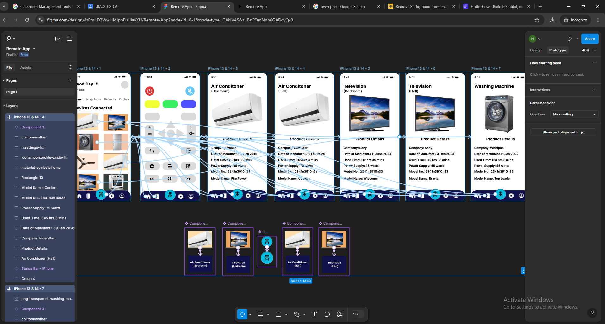

Result:

Hence the Design is Created and the Output is verified.