**Assignment-UI/UX**

**Wayanad Donation Drive**

Aim:

To create a platform for Donation of Wayanad Landslide.

Platform:

Step 1: Collect the Information about the Wayanad Incident.

Step 2: Create a Canvas for the App/Webpage.

Step 3: Add Various elements/Images

Step 4: Make a Platform for the Donors to Donate

Step 5: Add Prototyping to the Canvas

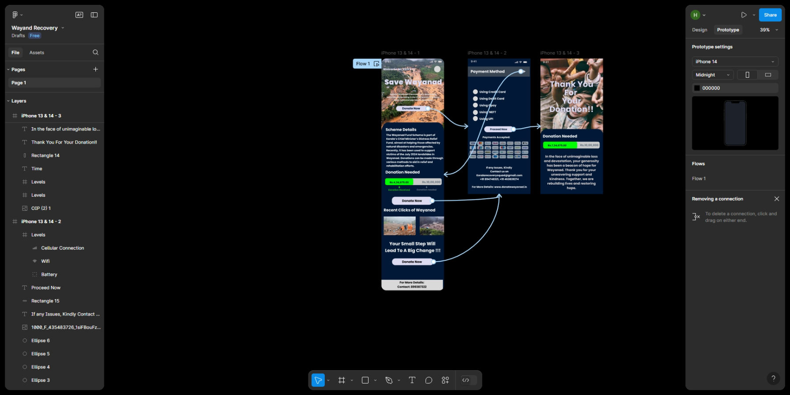

Result:

Hence the Design is Created and the Output is verified.