**Research on Working Dogs for the Dog Hall of Fame Project**

Harish Nidamaneni

Department of Technology, Wilmington University

DSN 6050, Markup Lang Adv Authoring

Instructor: [John Driban](https://wilmu.instructure.com/courses/69136/users/4344)

November 03, 2024

**Research on Working Dogs for the Dog Hall of Fame Project**

For many years, dogs have held an important place in human life, society, friendship, and as an assistant of unbelievable powers. Among the general functions of dogs, working dogs are really outstanding with special capacity and roles in different fields of human life, such as in police forces, therapies, and rescue functions. This paper looks at the different types of dogs that have done a lot of service in these areas: Hero Dogs, Working Dogs, and Companion Dogs. It is the hope of this research to acknowledge their contributions and pay tribute to their role in improving the quality of life of both the person and community by enumerating feats performed by these creatures that are remarkable.

Working dogs are trained for a variety of important functions, including guarding and the service of people with disabilities. The training and specialized abilities of working dogs reflect not only the human-canine bond but also the realities of human ingenuity applied to the capabilities of dogs. This report reviews various forms of working dogs in nature, and critical functions they execute to assist humans.

**Hero Dogs**

***Lucca***

Before being injured in her last patrol, as a military working dog, Lucca had located more than 40 Improvised Explosive Devices in Afghanistan. She showed her strong resilience and earned the award of PDSA Dickin Medal in 2016. That made history because she was the first U.S. Marine dog to receive such an honor (Pierce, 2022).

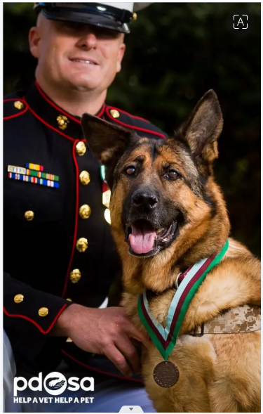

Photo1: [PDSA](https://twitter.com/PDSA_HQ/status/717279043696140288" \t "_blank)

***Todd***

Todd, the Golden Retriever, jumped in front of his owner Paula Godwin when he saw a rattlesnake and bit it instead to protect her in Arizona. His unselfish heroic deed went viral on social media and made him a true hero-there may not be any awards given to him, but he will be remembered by the people (Pierce, 2022).

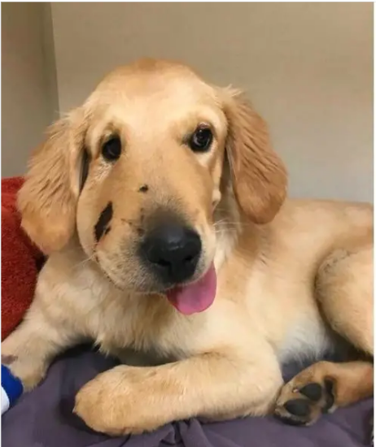

Photo2: [Paula Godwin](https://www.facebook.com/paula.godwin.7/posts/10215860868137457" \t "_blank)

**Working Dogs**

***Cheyenne***

Cheyenne was a Pit Bull puppy who served as the critical emotional support system for her master, Senior Airman David Sharpe, suffering from post-traumatic stress disorder. Her gentle nature would keep him looking for a reason to survive at the height of the crisis. This made her an unofficial therapy dog to get through his struggle (Spies, n.d.)

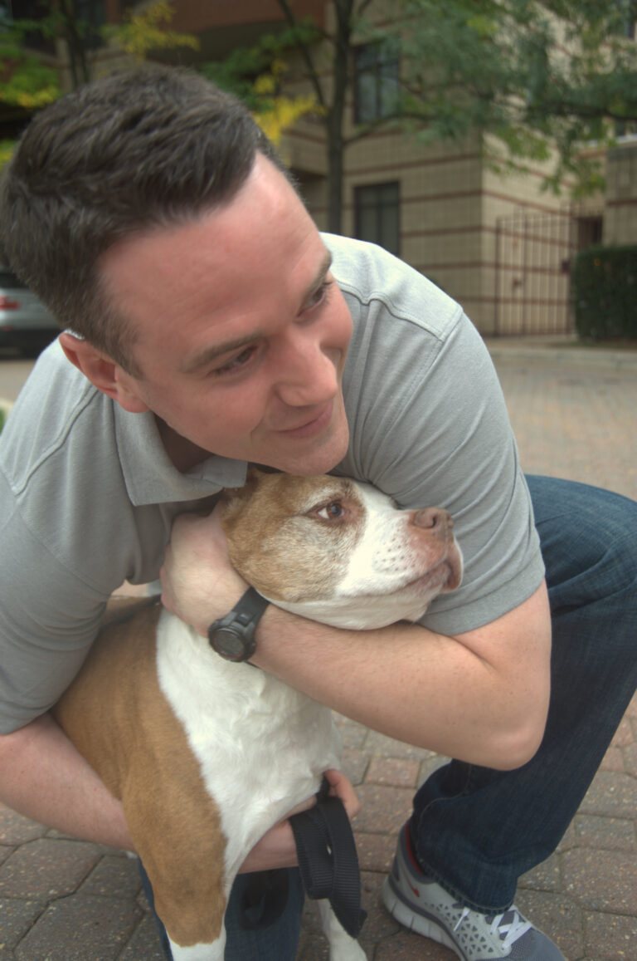

Photo3: [U.S. Air Force photo](https://www.airforcemedicine.af.mil/News/Display/Article/426348/a-life-for-a-life-by-saving-her-he-saved-himself/" \t "_blank)/Tech. Sgt. Mareshah Haynes

***Roselle***

On 9/11, Roselle, a guide dog, helped her blind handler, Michael Hingson, and 30 others escape the North Tower amidst chaos. Her dedication and ability to navigate through smoke and debris showcased the powerful bond between guide dogs and their handlers (Spies, n.d.)

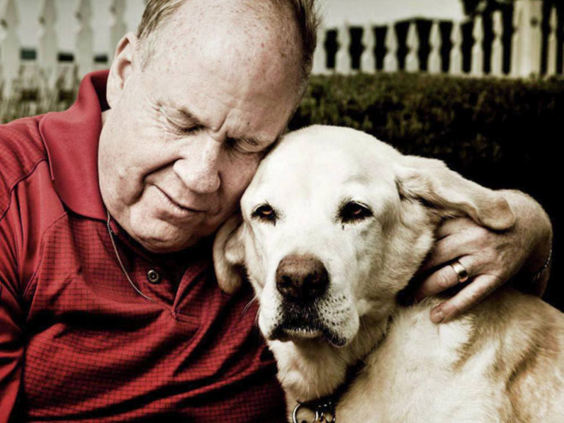

Photo4: [@Roselle911GuideDog/Facebook](https://www.facebook.com/Roselle911GuideDog/photos/a.177985545562459/2925146890846297/?type=3&theater" \t "_blank)

**Companion Dogs**

***Laika – The Space Dog***

Laika was a dog that, for the first time, orbited Earth; it was launched by the Soviet Union in 1957. The poor dog's one-way trip showed the sacrifices made for space exploration; this was a significant milestone in human history and our journey into space (Cahn, 2022)

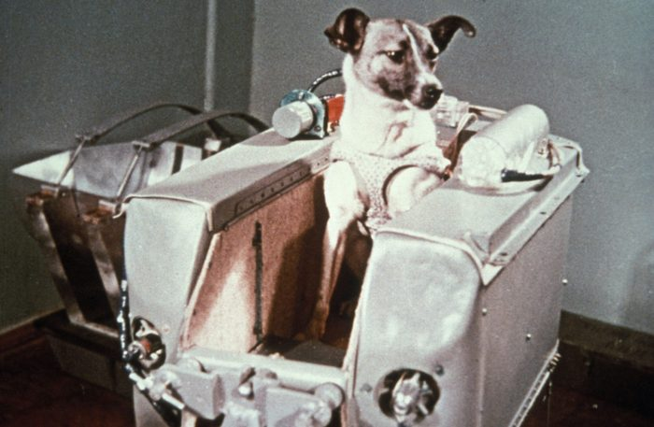

Photo5: Sovfoto/Universal Images Group/Shutterstock

***Nemo – The Hero Dog of the Vietnam War***

Nemo was a German Shepherd dog who fought in the Vietnam War and warned his handler about the presence of enemy soldiers; the dog was seriously injured. Still, he continued to guard his human until he became the first watch dog to be honorably discharged from duty officially (Cahn, 2022).

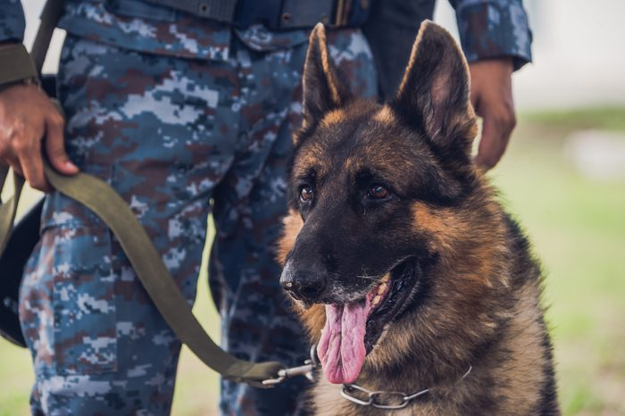

Photo6: [ANURAKE SINGTO-ON/Shutterstock](https://dogs-in-history.blogspot.com/2016/06/nemo-one-of-few-vietnam-war-dogs-to.html" \t "_blank)

***Jake – The Rescue Dog***

Working dogs are trained to perform essential tasks that range from providing protection to assisting individuals with disabilities. Their training and specialized skills not only exemplify the bond between humans and dogs but also showcase the remarkable capabilities of these animals. This document will delve into the various types of working dogs, their characteristics, and the essential roles they play in our lives (Cahn, 2022).

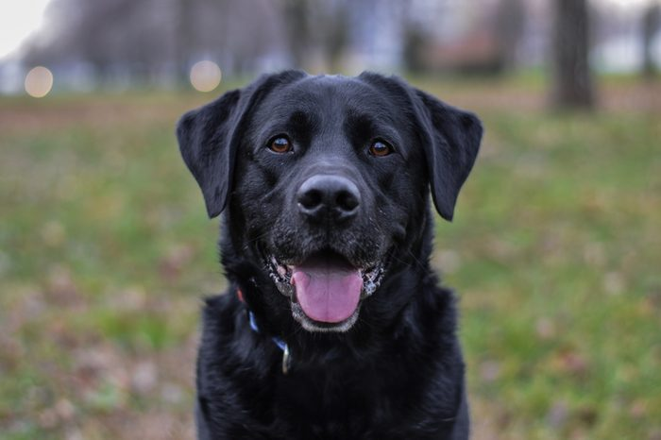

Photo7: kphotograph/Shutterstock

**References**

Cahn, L. (2022, December 2). 13 of the Bravest Dogs in History. Reader’s Digest. Retrieved November 3, 2024, from <https://www.rd.com/list/bravest-dogs-in-history/>

Pierce, B. (2022, March 9). 10 Real-Life Heroic dogs who saved the day | Puplore. *Puplore.* <https://puplore.com/heroic-dogs/>

Spies, M. (n.d.). *12 Incredible Hero Dogs That Saved Human Lives*. iHeartDogs.com. <https://iheartdogs.com/12-incredible-stories-about-dogs-saving-humans-lives/>