1.1 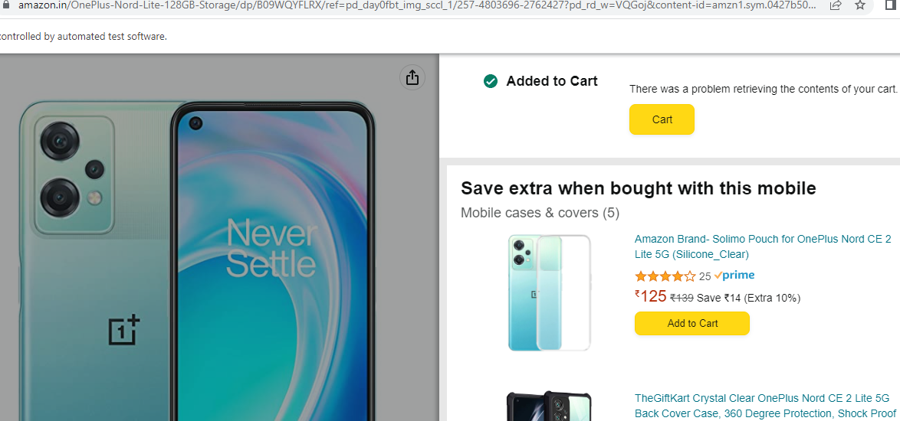

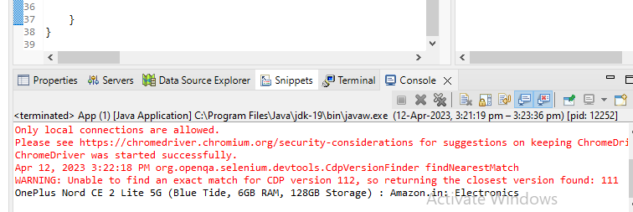

**package** com.selenium.testing.selenium65;

**import** org.openqa.selenium.By;

**import** org.openqa.selenium.JavascriptExecutor;

**import** org.openqa.selenium.Keys;

**import** org.openqa.selenium.WebDriver;

**import** org.openqa.selenium.chrome.ChromeDriver;

**import** org.openqa.selenium.chrome.ChromeOptions;

**import** io.github.bonigarcia.wdm.WebDriverManager;

/**

* Hello world!

*

*/

**public** **class** App

{

**public** **static** **void** main( String[] args )

{

// System.out.println( "Hello World!" );

WebDriverManager.*edgedriver*().setup();

ChromeOptions co=**new** ChromeOptions();

co.addArguments("--remote-allow-origins=*");

WebDriver driver=**new** ChromeDriver(co);

//WebDriver driver=new EdgeDriver();

//open link and maximize

driver.get("https://www.amazon.in/OnePlus-Nord-Lite-128GB-Storage/dp/B09WQYFLRX/ref=pd_day0fbt_img_sccl_1/257-4803696-2762427?pd_rd_w=VQGoj&content-id=amzn1.sym.0427b508-4960-48fb-ab19-7fd7b277d557&pf_rd_p=0427b508-4960-48fb-ab19-7fd7b277d557&pf_rd_r=S3E8SJ0N2Z2NGRK062JC&pd_rd_wg=VXUsQ&pd_rd_r=d8f07c09-1b67-4356-9b67-56f354768b9d&pd_rd_i=B09WQYFLRX&th=1%5C");

driver.manage().window().maximize();

JavascriptExecutor js=(JavascriptExecutor) driver;

js.executeScript("window.scrollBy(0,1000)","");

driver.findElement(By.*name*("submit.add-to-cart")).sendKeys(Keys.***ENTER***);

String t=driver.getTitle();

System.***out***.println(t);

}

}

1.2

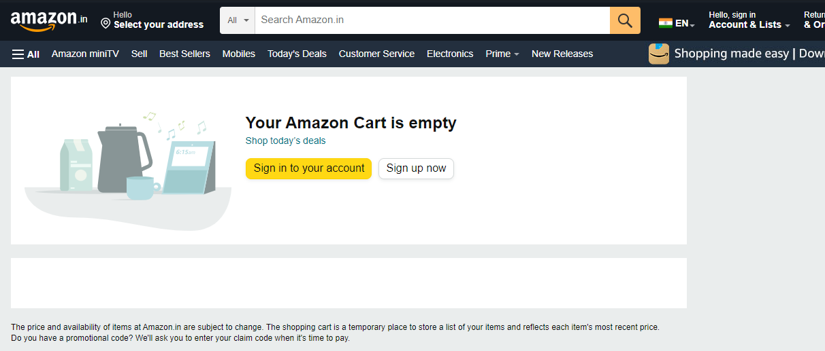

**package** com.selenium.testing.selenium65;

**import** org.openqa.selenium.By;

**import** org.openqa.selenium.JavascriptExecutor;

**import** org.openqa.selenium.Keys;

**import** org.openqa.selenium.WebDriver;

**import** org.openqa.selenium.chrome.ChromeDriver;

**import** org.openqa.selenium.chrome.ChromeOptions;

**import** io.github.bonigarcia.wdm.WebDriverManager;

/**

* Hello world!

*

*/

**public** **class** App

{

**public** **static** **void** main( String[] args )

{

// System.out.println( "Hello World!" );

WebDriverManager.*edgedriver*().setup();

ChromeOptions co=**new** ChromeOptions();

co.addArguments("--remote-allow-origins=*");

WebDriver driver=**new** ChromeDriver(co);

//WebDriver driver=new EdgeDriver();

//open link and maximize

driver.get("https://www.amazon.in/gp/cart/view.html/ref=cart-ajax-error?dt=Desktop");

driver.manage().window().maximize();

JavascriptExecutor js=(JavascriptExecutor) driver;

driver.findElement(By.*name*("submit.delete.525831df-dbd2-42a5-8eda-1e11141337d3")).sendKeys(Keys.***ENTER***);

String t="removed";

System.***out***.println(t);

}

}

1.3

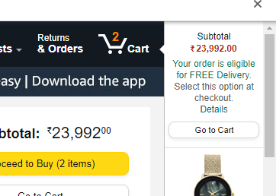

package com.selenium.testing.selenium65;

import org.openqa.selenium.By;

import org.openqa.selenium.WebDriver;

import org.openqa.selenium.WebElement;

import org.openqa.selenium.chrome.ChromeDriver;

import org.openqa.selenium.chrome.ChromeOptions;

import org.openqa.selenium.support.ui.Select;

import io.github.bonigarcia.wdm.WebDriverManager;

public class Q1 {

public static void main( String[] args ) throws InterruptedException

{

WebDriverManager.chromedriver().setup();

ChromeOptions co=new ChromeOptions();

co.addArguments("--remote-allow-origins=*");

WebDriver driver=new ChromeDriver(co);

driver.manage().window().maximize();

driver.get("https://www.amazon.in/Anne-Diamond-Analog-Womens-Watch-AK3686BKGB/dp/B0968Q7L3M/ref=sr_1_1_sspa?crid=293FS4VHUVN6K&keywords=watches&qid=1681287782&sprefix=watches%2Caps%2C323&sr=8-1-spons&sp_csd=d2lkZ2V0TmFtZT1zcF9hdGY&psc=1");

driver.findElement(By.id("add-to-cart-button")).submit();

String t=driver.getTitle();

System.out.println(t);

String cart=driver.findElement(By.xpath("//*[@id=\"NATC_SMART_WAGON_CONF_MSG_SUCCESS\"]/span")).getText();

if(cart.equals("Added to cart"));

System.out.println("1. Verified that Product added to cart ");

driver.navigate().back();

WebElement sort1=driver.findElement(By.xpath("//*[@id=\"quantity\"]"));

sort1.click();

Select select=new Select(sort1);

select.selectByIndex(1);

String drop=driver.findElement(By.xpath("//*[@id=\"quantity\"]")).getText();

if(drop.equals("2"))

System.out.println("3. Verified that Product is updated to cart ");

}

}

1.4

package com.selenium.test2.selenium1;

import org.openqa.selenium.By;

import org.openqa.selenium.WebDriver;

import org.openqa.selenium.chrome.ChromeDriver;

import org.openqa.selenium.chrome.ChromeOptions;

import io.github.bonigarcia.wdm.WebDriverManager;

public class T4

{

public static void main( String[] args ) throws InterruptedException

{

WebDriverManager.chromedriver().setup();

ChromeOptions co=new ChromeOptions();

co.addArguments("--remote-allow-origins=*");

WebDriver driver=new ChromeDriver(co);

driver.manage().window().maximize();

driver.get("https://www.amazon.in/gp/product/B09FXM3WDR/ref=ox_sc_act_title_1?smid=A14CZOWI0VEHLG&psc=1");

driver.findElement(By.id("add-to-cart-button")).submit();

driver.get("https://www.amazon.in/gp/cart/view.html?ref_=nav_cart");

driver.findElement(By.name("proceedToRetailCheckout")).submit();

String t=driver.getTitle();

System.out.println(t);

if(t.equals("Amazon Sign In")) {

System.out.println("Checkout Successful");

}

}

}

3.1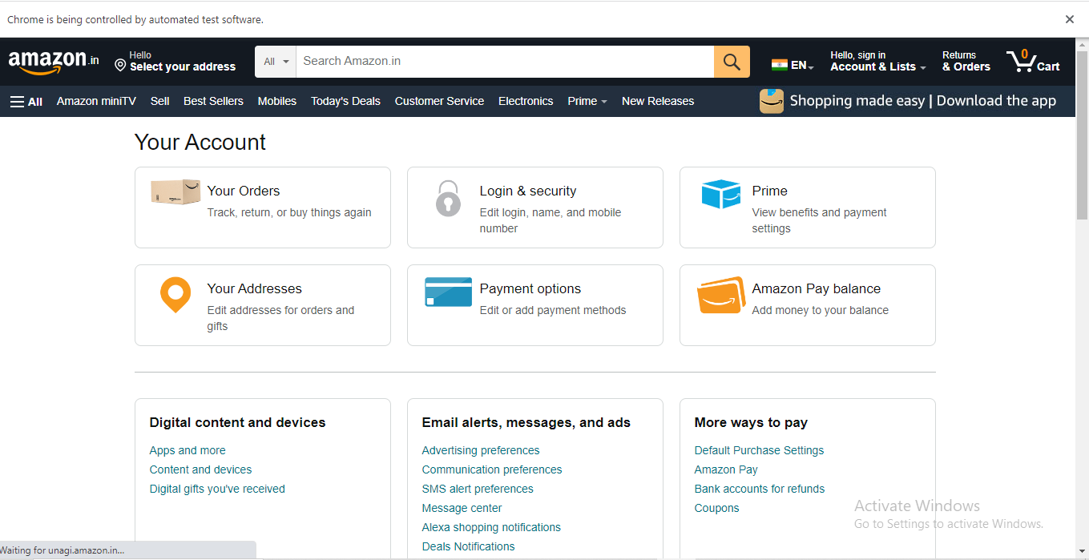

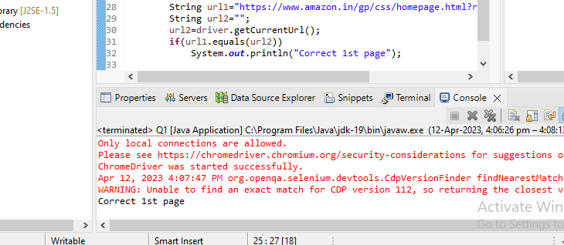

**package** com.selenium.testing.selenium65;

**import** org.openqa.selenium.By;

**import** org.openqa.selenium.JavascriptExecutor;

**import** org.openqa.selenium.WebDriver;

**import** org.openqa.selenium.WebElement;

**import** org.openqa.selenium.chrome.ChromeDriver;

**import** org.openqa.selenium.chrome.ChromeOptions;

**import** org.openqa.selenium.support.ui.Select;

**import** io.github.bonigarcia.wdm.WebDriverManager;

**public** **class** Q1 {

**public** **static** **void** main( String[] args ) **throws** InterruptedException

{

WebDriverManager.*chromedriver*().setup();

ChromeOptions co=**new** ChromeOptions();

co.addArguments("--remote-allow-origins=*");

WebDriver driver=**new** ChromeDriver(co);

//WebDriver driver=new EdgeDriver();

//open link and maximize

driver.get("https://www.amazon.in/gp/css/homepage.html?ref_=nav_AccountFlyout_ya");

driver.manage().window().maximize();

JavascriptExecutor js=(JavascriptExecutor) driver;

//js.executeScript("window.scrollBy(0,1000)","");

String url1="https://www.amazon.in/gp/css/homepage.html?ref_=nav_AccountFlyout_ya";

String url2="";

url2=driver.getCurrentUrl();

**if**(url1.equals(url2))

System.***out***.println("Correct 1st page");

}

}

3.2

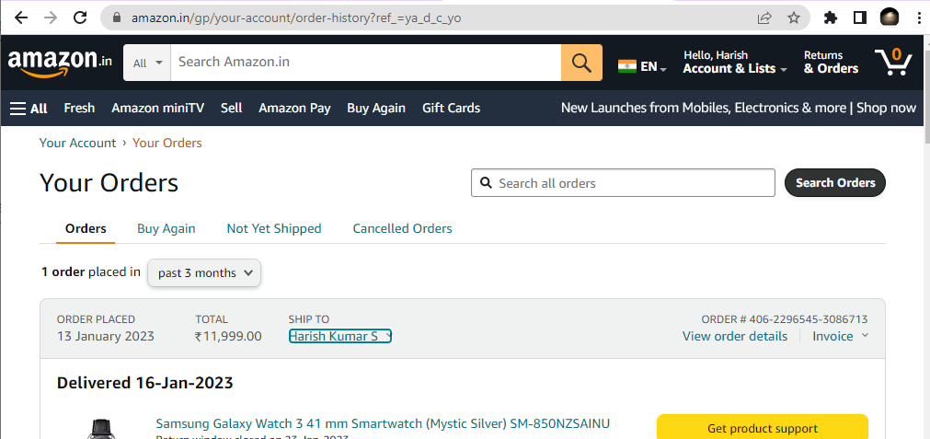

**package** com.selenium.testing.selenium65;

**import** org.openqa.selenium.By;

**import** org.openqa.selenium.JavascriptExecutor;

**import** org.openqa.selenium.WebDriver;

**import** org.openqa.selenium.WebElement;

**import** org.openqa.selenium.chrome.ChromeDriver;

**import** org.openqa.selenium.chrome.ChromeOptions;

**import** org.openqa.selenium.support.ui.Select;

**import** io.github.bonigarcia.wdm.WebDriverManager;

**public** **class** Q1 {

**public** **static** **void** main( String[] args ) **throws** InterruptedException

{

WebDriverManager.*chromedriver*().setup();

ChromeOptions co=**new** ChromeOptions();

co.addArguments("--remote-allow-origins=*");

WebDriver driver=**new** ChromeDriver(co);

//WebDriver driver=new EdgeDriver();

//open link and maximize

driver.get("https://www.amazon.in/gp/your-account/order-history?ref_=ya_d_c_yo");

driver.manage().window().maximize();

JavascriptExecutor js=(JavascriptExecutor) driver;

//js.executeScript("window.scrollBy(0,1000)","");

String url1="https://www.amazon.in/gp/your-account/order-history?ref_=ya_d_c_yo";

String url2="";

url2=driver.getCurrentUrl();

**if**(url1.equals(url2))

System.***out***.println("Correct");

}

}

3.3

**package** com.selenium.testing.selenium65;

**import** org.openqa.selenium.By;

**import** org.openqa.selenium.JavascriptExecutor;

**import** org.openqa.selenium.WebDriver;

**import** org.openqa.selenium.WebElement;

**import** org.openqa.selenium.chrome.ChromeDriver;

**import** org.openqa.selenium.chrome.ChromeOptions;

**import** org.openqa.selenium.support.ui.Select;

**import** io.github.bonigarcia.wdm.WebDriverManager;

**public** **class** Q1 {

**public** **static** **void** main( String[] args ) **throws** InterruptedException

{

WebDriverManager.*chromedriver*().setup();

ChromeOptions co=**new** ChromeOptions();

co.addArguments("--remote-allow-origins=*");

WebDriver driver=**new** ChromeDriver(co);

//WebDriver driver=new EdgeDriver();

//open link and maximize

driver.get("https://www.amazon.in/gp/your-account/order-history?ref_=ya_d_c_yo");

driver.manage().window().maximize();

JavascriptExecutor js=(JavascriptExecutor) driver;

//js.executeScript("window.scrollBy(0,1000)","");

String url1="https://www.amazon.in/gp/your-account/order-history?ref_=ya_d_c_yo";

String url2="";

url2=driver.getCurrentUrl();

**if**(url1.equals(url2))

System.***out***.println("order is placed");

}

}

AS TRACKING MY ORDER IS NOT AVAILABLE

AS I DIDN’T PLACE ANY ORDER

3.4