**practice DQL statement :**

Write SQL statement for the following :

1. To find all managers with salary >1500

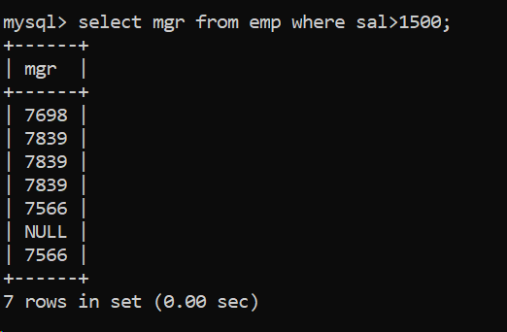

2. list all employees with sal >1200 and < 2000

2. list all employees with sal is 1600 or sal is 800 or sal is 1900

4. list all employees with R at second last position in name

5. List all employees with name starts with A and ends with N

Q2. Solve