Wireframe Documentation Amazon Food Sales Data Analysis

# Contents

1. Key Insights 3
   1. Cards 3
   2. Monthly Sales Trend 3
   3. Revenue by Country 4
2. Sales Analysis 4
   1. Revenue vs Sales Quantity can be drilled through year , month and quarter 5
   2. Data Table of countries based on Revenue, YOY sales, Revenue Contribution, Profit contribution 5
3. Customer Analysis 6
   1. The revenue, sales quantity, Last purchase date of selected customer ……………………………6
   2. Revenue categorize by region 6
   3. Data table for customer based on revenue contribution , profit contribution 7
   4. Top products tooltip for selected customers 7
4. Product Analysis 8
   1. Top 20 Product slicers w.r.t revenue 9
   2. Detail Cards of Sales Quantity, YOY Sales Growth%, Profit Margin 9
   3. Detailed Overall sales using waterfall chart for selected date 10

# Key Insights

* 1. Cards

The card slicers that shows Revenue, Revenue Last Year, Total Sales Quantity, Total Profit Margin

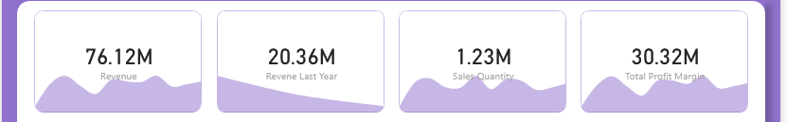

* 1. Monthly Sales Trend

The area chart for monthly, yearly and quarterly sales

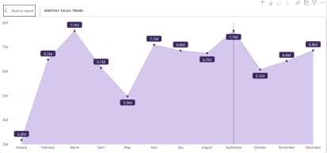

* 1. 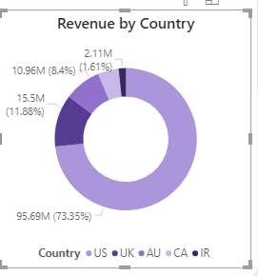Revenue by Country

# Sales Analysis

* 1. 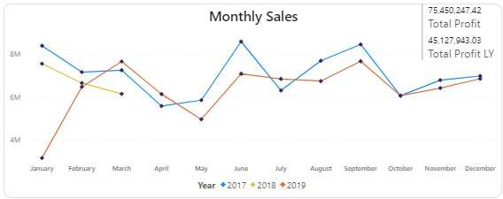Monthly Sales for 2017 , 2018, 2019
  2. 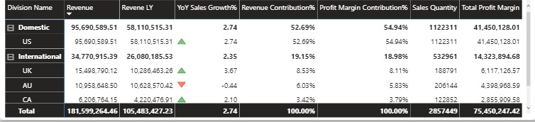Data Table of countries based on Revenue, YOY sales, Revenue Contribution, Profit contribution

# Customer Analysis

* 1. 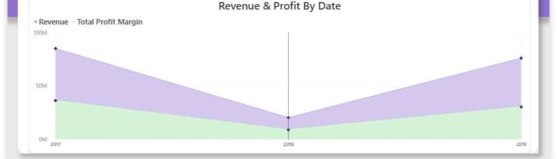Revenue and Profit categorize by region
  2. 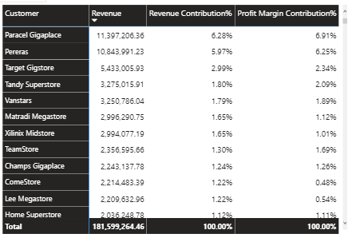Data table for customer based on revenue contribution , profit contribution.
  3. Top products tooltip for selected customers

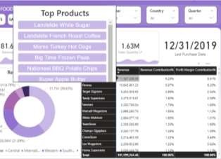

# Product Analysis

* 1. 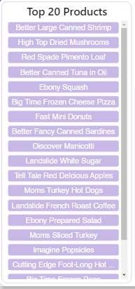Top 20 Product slicers w.r.t revenue
  2. Detail Cards of Sales Quantity, YOY Sales Growth%, Profit Margin

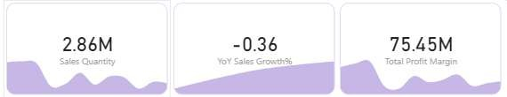

* 1. 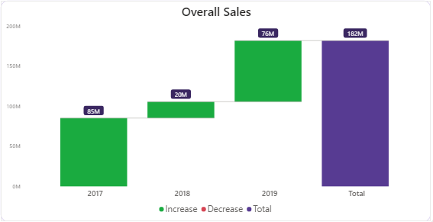Detailed Overall sales using waterfall chart for selected date