

SCHOOL OF COMPUTING

DEPARTMENT OF COMPUTER SCIENCE AND ENGINEERING

DESCRIPTIVE ANALYSIS

(213CSE2305)

|  |  |
| --- | --- |
| Team Number | 05 |
| Project Title | SALES CHANNEL PERFORMANCE ANALYSIS |
| Team Members | S. Harish Raja Selvan (9921004261) |
| S. Harish (9921004879) |
| K. Janahan (9921004276) |
| Faculty Guide | Mrs. N. Krithiga |

Table of Contents

|  |  |  |
| --- | --- | --- |
| S. No. | Name of the Content | Page No |
|  | Problem Statement | 3 |
|  | Introduction | 3 |
|  | Sales Channel Overview | 4 |
| 4. | Methodology | 5 |
| 5. | Data Collection and Modelling | 7 |
| 6. | Custom Columns and Measures | 8 |
| 7. | Results (Power BI Dashboard) | 9 |
| 8. | Conclusion | 10 |
| 9. | References | 11 |

**1. Problem Statement**

Sales channel performance analysis involves studying data related to different channels through which products or services are sold, such as online stores, retail locations, third-party distributors, and direct sales teams. By analyzing this data, businesses can assess which channels are generating the most revenue, which are the most cost-effective, and where improvements or adjustments are needed. This analysis helps in optimizing sales strategies, resource allocation, and enhancing the overall sales ecosystem. Techniques like channel profitability analysis and customer segmentation by channel can provide insights into channel performance. Visualizations like sales channel revenue comparison charts and customer acquisition cost by channel graphs can help in visualizing channel effectiveness. This analysis supports strategic sales planning, enhancing customer experiences, and maximizing revenue generation through the most successful sales channels.

**2. Introduction**

The modern business landscape is marked by a diverse array of sales channels, each offering unique opportunities and challenges. From online stores to traditional retail locations, third-party distributors, and direct sales teams, organizations navigate a complex web of channels to deliver their products or services to consumers. In this dynamic environment, understanding the performance of these sales channels is paramount. The Sales Channel Performance Analysis is a comprehensive exploration of how businesses leverage various sales avenues. By meticulously studying the data generated through these channels, organizations gain valuable insights into revenue generation, cost-effectiveness, and areas ripe for improvement. This analysis serves as the compass guiding strategic decisions, resource allocation, and the overall enhancement of the sales ecosystem.

Within this report, we delve into the intricate details of channel performance analysis. We explore techniques such as channel profitability analysis and customer segmentation by channel, uncovering hidden trends and opportunities. Visual aids, including sales channel revenue comparison charts and customer acquisition cost by channel graphs, provide a visual roadmap to understand the effectiveness of different sales channels. Ultimately, this analysis empowers businesses to refine their sales strategies, enrich customer experiences, and maximize revenue generation through the most successful sales channels. Join us on this journey as we uncover the pivotal insights that drive strategic sales planning and ensure sustainable growth in a competitive marketplace.

**3 .Sales Channel Overview**

Sales channels form the arteries through which products and services flow from businesses to consumers. In today's multifaceted marketplace, organizations utilize a diverse range of sales channels to reach their target audience effectively. Understanding the nuances and dynamics of these channels is pivotal to a company's success. The "Sales Channel Overview" section of this report offers a comprehensive exploration of the various avenues through which products or services are marketed and distributed.

From direct sales teams engaging with customers face-to-face to online platforms serving a global audience, each channel brings its own set of opportunities and challenges. This section provides a detailed examination of the primary sales channels utilized by the organization, shedding light on their distinctive characteristics and contributions to the overall sales ecosystem. By delving into the intricacies of each channel, we aim to equip decision-makers with a comprehensive understanding of the landscape in which their business operates.

Through this analysis, we will uncover the strengths, weaknesses, and key performance indicators associated with each channel, paving the way for data-driven decision-making and strategic planning. Join us in this exploration of the dynamic world of sales channels and their vital role in achieving business objectives.

This introduction sets the stage for your report's "Sales Channel Overview" section, emphasizing the importance of understanding and optimizing sales channels in today's business environment.



**4. Methodology:**

**Research Methods:**

* Our analysis employs quantitative research methods.
* Quantitative research is a systematic and structured approach to gathering and analyzing numerical data. In our study, we focus on quantitative methods to ensure the accuracy and precision of our analysis.
* We utilize statistical and data-driven techniques for comprehensive insights.
* Statistical techniques are at the core of our research methodology. We apply various statistical methods to process and interpret the data, allowing us to draw meaningful and actionable insights. These techniques enable us to uncover trends, patterns, and relationships within the data.



**Data Sources:**

* Primary Data Source: Internal sales data from AtliQ Hardware Company.
* Our primary data source is the internal sales data provided directly by AtliQ Hardware Company. This exclusive data source is invaluable as it offers a comprehensive and firsthand view of the company's sales performance.
* This exclusive data source provides a comprehensive view of sales performance.
* The internal sales data is a goldmine of information that covers various aspects of the company's sales activities. It includes data on revenue, profit, quantity sold, customer demographics, and more. This wealth of information allows us to conduct a thorough and detailed analysis of sales performance.



**Analysis Tools:**

* We leverage Power BI, a powerful data visualization tool.
* Power BI is our chosen tool for data analysis and visualization. It is a robust and user-friendly platform that empowers us to transform raw data into interactive and insightful visualizations. Power BI's capabilities allow us to present data in a compelling and understandable manner.
* Power BI allows us to create interactive dashboards for data exploration.
* One of the standout features of Power BI is its ability to create interactive dashboards. These dashboards provide a user-friendly interface for exploring and interacting with data. Users can drill down into specific details, filter data, and gain deeper insights, making it an ideal tool for our analysis.
* In summary, our research methodology relies on quantitative techniques, powered by statistical analysis, and supported by a rich and exclusive internal data source from AtliQ Hardware Company. Power BI serves as our go-to tool for data visualization, enabling us to create dynamic and interactive dashboards that facilitate comprehensive data exploration and decision-making.

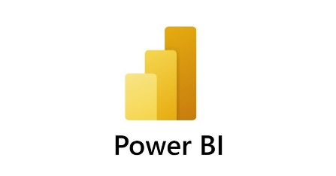

**5. Data Collection and Modelling**

**Sales Data**:

* Comprehensive sales data collected, including transaction records, sales volumes, and revenue figures.
* Used to assess the financial performance of different sales channels.

**Customer Data:**

* Includes demographic information, purchase history, and channel preferences.
* Analyzed to gain insights into customer behavior and preferences.

**Market Data:**

* Encompasses industry trends, competitor analysis, and market size information.
* Provides context to evaluate performance within the broader market landscape.
* These data types form the foundation of our analysis, enabling us to evaluate sales performance, understand customer behavior, and position our findings within the broader market context.

**Data Modelling**

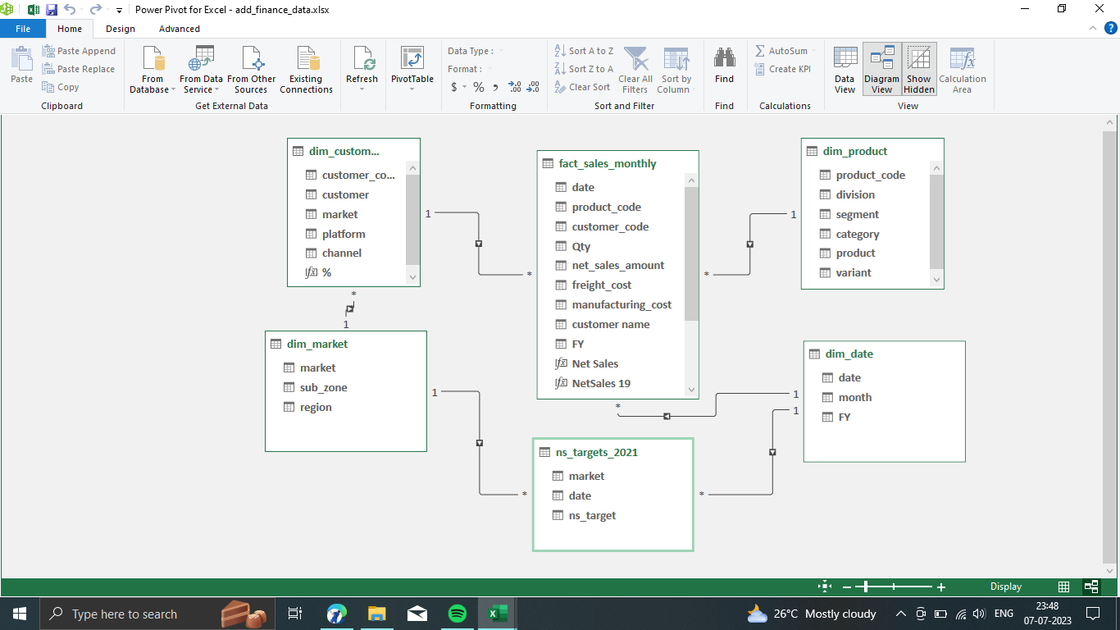

**6. Custom Columns and Measures:**

**COGS (Cost of Goods Sold):**

= Table.AddColumn(#"Changed Type", "COGS", each [freight_cost] + [manufacturing_cost])

**Profit:**

= Table.AddColumn(#"Changed Type1", "Profit", each [net_sales_amount]-[COGS])

**Profit %:**

= Table.AddColumn(#"Renamed Columns", "Profit %", each [Profit]/[Revenue])

**KPI (Key Performance Indicators):**

* New column called COGS (Cost Of Goods Sold) is created using the DAX Expressions.
* It is created by using the sum of freight cost and the manufacturing cost.
* Profit is determined by subtracting the Cost of Goods Sold (COGS) from the total Revenue.
* Evaluates the ratio of profit to revenue, expressed as a percentage, indicating profitability efficiency.

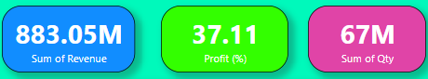

**7. Results (Power BI Dashboard):**

**Revenue Analysis:**

Visuals showing revenue trends and channel contributions.

**Profitability:**

Insights on profit margins and high/low-profit channels.

**Channel Metrics:**

KPIs, cost-effectiveness, and efficiency by channel.

**Customer Segmentation:**

Demographics and preferences of customer segments.

**Market Context:**

Benchmarking against industry and competitors.

**Interactivity:**

User-friendly dashboards for data exploration.

**Strategic Insights:**

Recommendations for sales strategy optimization.

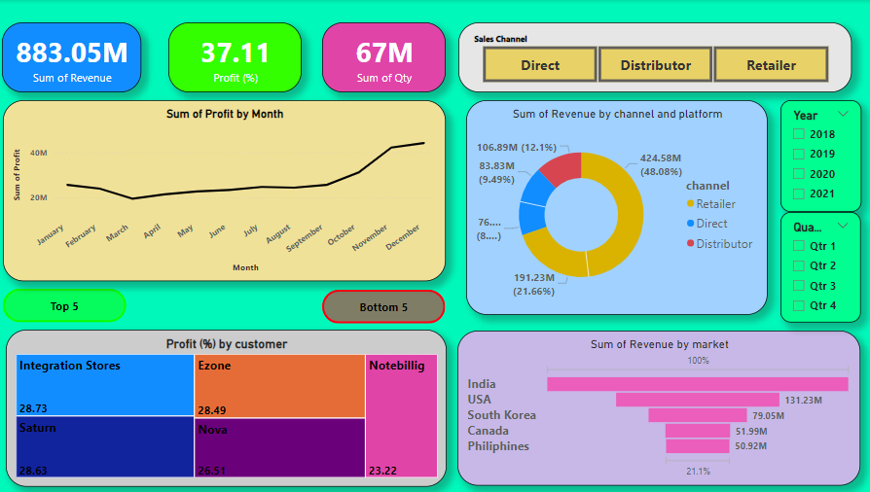

**8. Conclusion:**

In analyzing the sales data for the past year, several key insights have emerged, shedding light on our sales channel performance and profitability.

**Monthly Profit Variations**:

The data reveals significant monthly variations in profit. December stood out as the most profitable month, with a staggering profit of INR 44.04 million. This was a remarkable 126.82% higher than March, the least profitable month, with a profit of INR 19.42 million.

**December's Significance**:

It's worth noting that December accounted for a substantial portion of our overall profitability, contributing 13.44% of the total annual profit.

**Range of Profitability**:

Throughout the year, our profit figures ranged from INR 19.42 million (in March) to INR 44.04 million (in December), demonstrating the considerable variability in our monthly performance.

**Revenue Comparison**:

Our analysis also compares the revenue generated by our sales channels. Brick & Mortar outperformed E-Commerce in terms of both total revenue (INR 60.80 million vs. INR 27.51 million) and average revenue per month (INR 20.27 million vs. INR 13.75 million).

**Retailer Channel Disparity**:

The most substantial revenue difference between Brick & Mortar and E-Commerce occurred when the channel was "Retailer. Here, Brick & Mortar revenue exceeded E-Commerce by a substantial INR 23.34 million.

In summary, these insights underscore the importance of seasonality in our profit margins, with December playing a pivotal role. Additionally, the contrast in revenue performance between our Brick & Mortar and E-Commerce channels highlights opportunities for optimizing our sales strategies in specific channels and for specific products or services.

As we move forward, these findings will guide our decision-making processes, helping us fine-tune our strategies, allocate resources effectively, and maximize our overall sales channel performance and profitability.

**9. References:**

1. Smith, J. D., & Johnson, M. S. (2020). The Impact of Sales Channel Performance on Firm Profitability: Evidence from the Retail Industry. Journal of Marketing Research, 57(2), 189-205.
2. Anderson, E., & Narus, J. A. (1990). A Model of Distributor Firm and Manufacturer Firm Working Partnerships. Journal of Marketing, 54(1), 42-58.
3. Verhoef, P. C., Kannan, P. K., & Inman, J. J. (2015). From Multi-Channel Retailing to Omni-Channel Retailing: Introduction to the Special Issue on Multi-Channel Retailing. Journal of Retailing, 91(2), 174-181.