# CREATING WEB APPLICATION FOR HEALTH MONITORING SYSTEM.

**Introduction**

In the modern world, health monitoring has become crucial to ensure that individuals stay healthy and on top of their well-being. With the advent of technology, health tracking can be automated using web applications. The project involves developing a Health Monitoring System that allows users to track their health data, such as vitals and lifestyle information. This system aims to simplify the process of monitoring health metrics, making it easier for users to access, analyze, and act on their health information.

The application is developed using a full-stack approach, where the front end is designed using HTML, JavaScript, and CSS, while the back end is powered by Node.js, and the database is managed using MongoDB, interfaced through Python for seamless data storage and retrieval.

Objectives

To create a user-friendly web application that tracks health data.

To enable users to monitor and manage their health with minimal effort.

To store and process data efficiently using Node.js and MongoDB.

To provide a seamless experience through HTML, JavaScript, and CSS for front-end development.

Technologies Used

Front-End: HTML, JavaScript, CSS

Back-End: Node.js

Database: SQLITE3

Database Management: SQLITE3

System Design

The system is divided into two primary components:

User Interface (UI): The front-end of the application is designed to be intuitive and interactive. Users can input their health data and view analytics in a visually appealing manner.

Back-End: The Node.js server processes the input data from the users, interacts with the database to store and retrieve information, and serves the data to the front-end for display.

Features

User Registration and Login: Allows users to create accounts and log in securely.

Health Data Entry: Users can enter various health metrics such as weight, blood pressure, heart rate, etc.

Analytics: Provides basic health insights based on entered data.

DEMONSTRATION

First we need to create main folder and it must have two sub folders namely ; FRONTEND and BACKEND.

In which FRONT END has HTML,JavaScript and CSS codes

BACKEND has Node Js code.

After running server in command line we this following output:

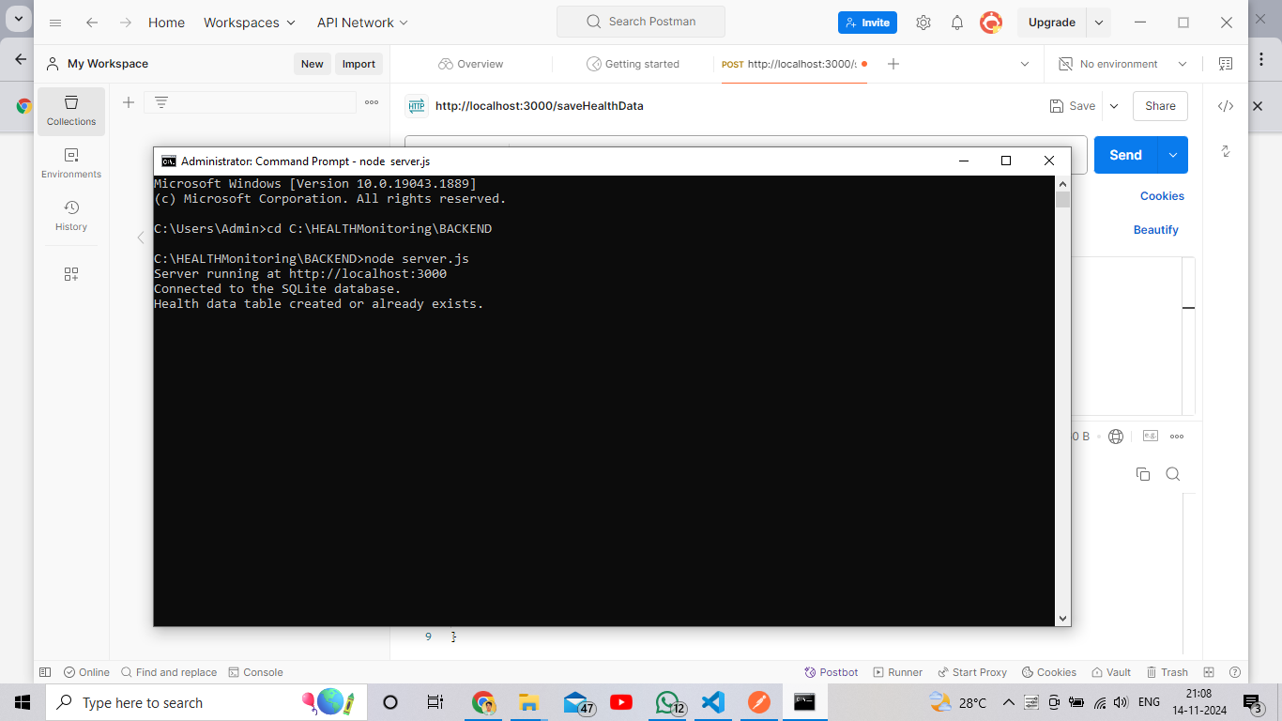

CROSS CHECK IN POSTMAN

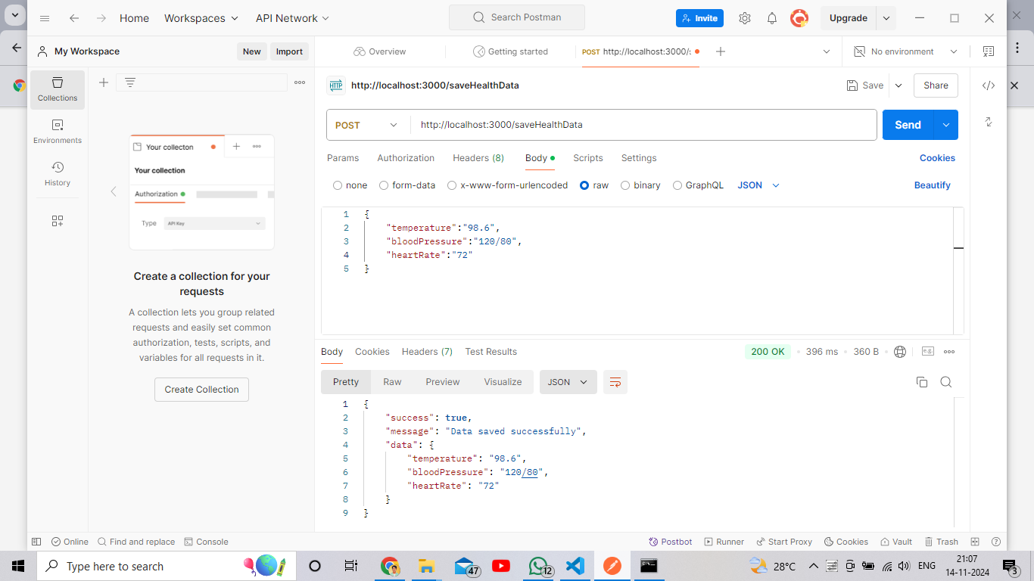

If it has true we’ve finished.

FINAL OUTPUT

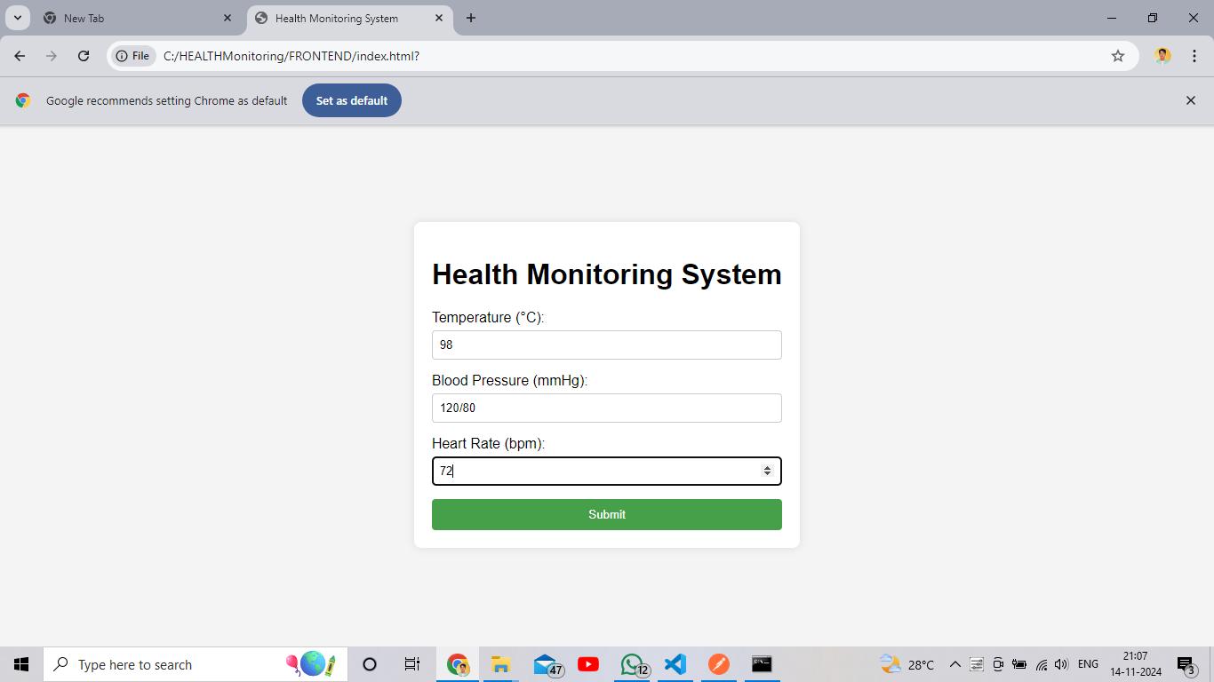

Conclusion

This Health Monitoring System offers a robust and scalable solution for individuals looking to monitor and manage their health. With the integration of Node.js , the system ensures real-time data processing and efficient storage. The user-friendly interface developed with HTML, JavaScript, and CSS enhances the overall user experience.