SIMATS ENGINEERING
ASSESSMENT TOOL 2

COURSE NAME: INTERNET PROGRAMMING
COURSE CODE: CSA43
NAME: B. Harishwar Reddy
REG.NO.: 192311338

COURSE OUTCOME COVERED

CO-3: Implement dynamic web applications by utilizing DOM-based client-side scripting and employing Java Servlets for server-side request processing and response handling. (L3)

Assessment Tool : Technical Presentation
Weightage: 20%

QUESTIONS: Total Marks: 20
- Servlet Architecture & Workflow
Question:
Present the architecture of Java Servlets and explain the complete request–response cycle with a neat diagram.
Focus Areas:
- Client–Server interaction
- Role of Web Container
- Request and Response objects

2. Servlet Life Cycle Analysis
Question:
Explain the Servlet Life Cycle with a sequence diagram and analyze the role of init(), service(), and destroy() methods.
Focus Areas:
- Life cycle phases
- Execution flow
- Performance implications

3. GET vs POST Method Evaluation
Question:
Compare GET and POST methods used in form submission. Present scenarios where each method is appropriate.
Focus Areas:
- Data transmission
- Security aspects
- URL limitations

4. Session Tracking Techniques
Question:
Present different session tracking mechanisms (HttpSession, Cookies, URL rewriting). Evaluate their advantages and limitations.
Focus Areas:
- Session persistence
- Security concerns
- Use-case comparison

5. Cookies vs Sessions – Critical Analysis
Question:
Analyze and compare Cookies and Sessions in web applications. Present real-time use cases.
Focus Areas:
- Storage location
- Security risks
- Performance considerations

Code of Conduct:

I ______B. Harishwar Reddy/192311338______________ (Name / Reg No) certify that this submission is my original work and that I have adhered to the guidelines specified for this assessment.
I understand that any violation of academic integrity rules will result in disciplinary action.

Signature of the student: B. Harishwar Reddy

RUBRICS FOR CALCULATION:

Technical Presentation
Criteria | Weightage | Level 4 – Exemplary | Level 3 – Proficient | Level 2 – Developing | Level 1 – Beginning
Technical Content Accuracy | 30 | Highly accurate, in-depth, and insightful technical explanation | Technically correct content with adequate depth and clarity | Basic concepts presented with limited accuracy and depth | Content contains major technical errors; concepts poorly understood
Problem Identification | 25 | Problem rigorously analyzed using appropriate and advanced methods | Problem clearly defined with a logical engineering approach | Problem identified but analysis or methodology is weak | Problem statement unclear or incorrect; no logical approach
Use of Tools | 20 | Advanced tools, well-analyzed data, and highly effective visuals | Appropriate tools and data used effectively with clear visuals | Limited use of tools and basic data interpretation | Minimal or incorrect use of tools and data; poor visuals
Communication | 15 | Highly engaging, confident, and audience-focused delivery | Clear, organized, and professional communication | Understandable but lacks clarity, structure, or confidence | Poor organization, unclear speech, ineffective slides
Professionalism | 10 | Exemplary professionalism, leadership, and ethical awareness | Professional conduct with effective team collaboration | Basic professionalism; uneven team participation | Lacks professionalism; minimal contribution or ethical awareness

ANSWERS

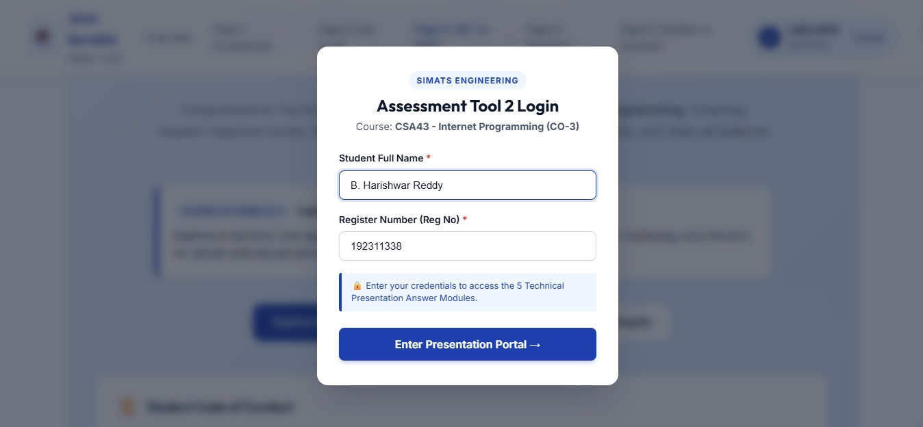

Question-1

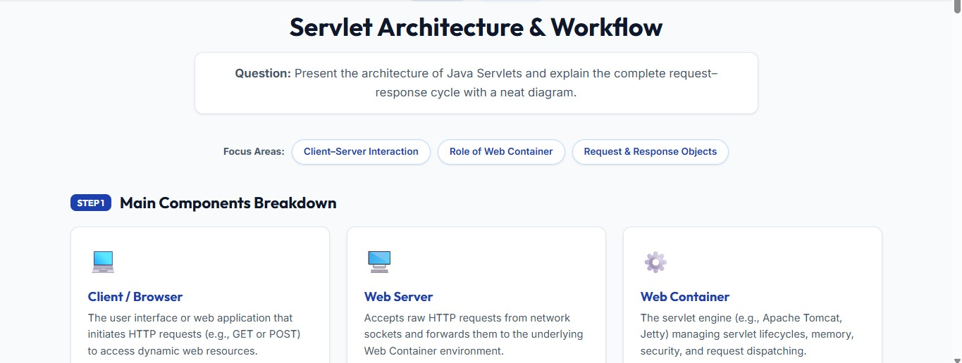

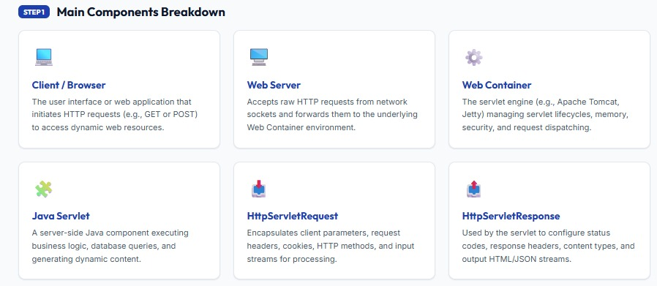
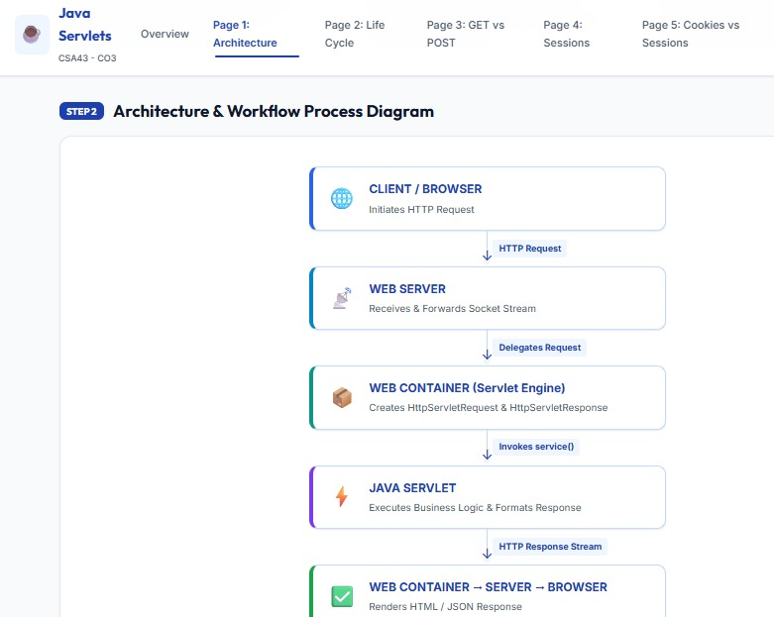

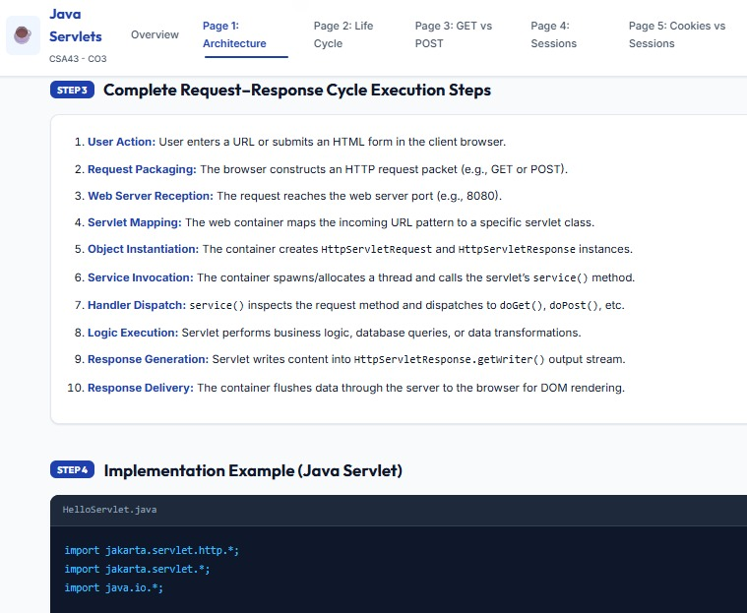

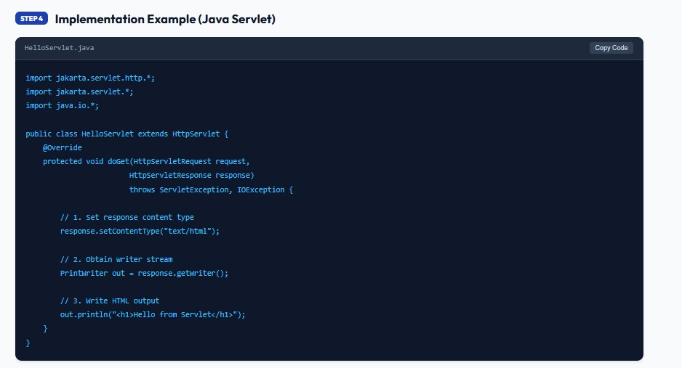

Question-2

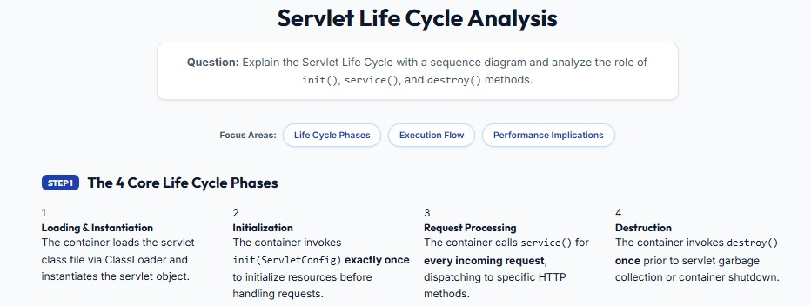

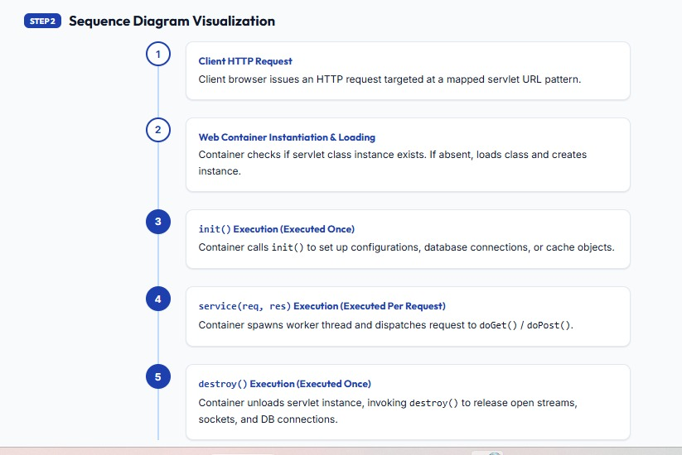
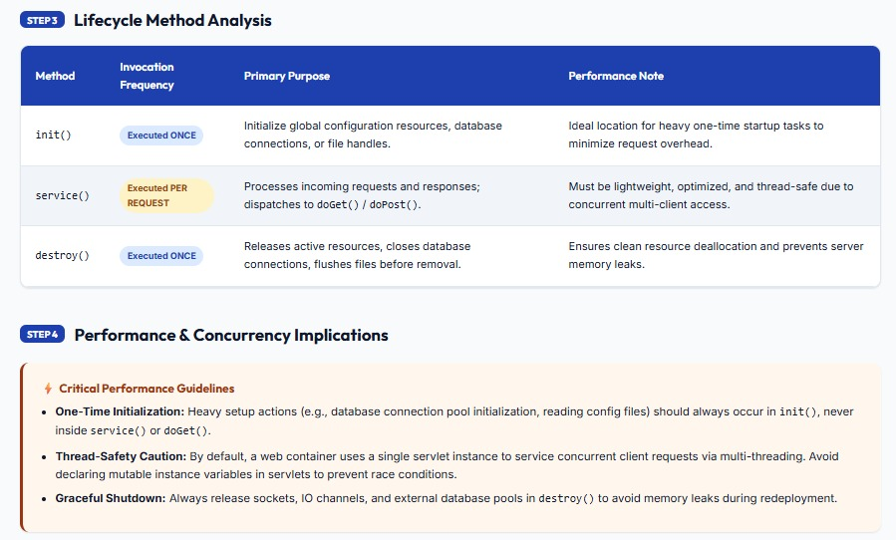

Question-3

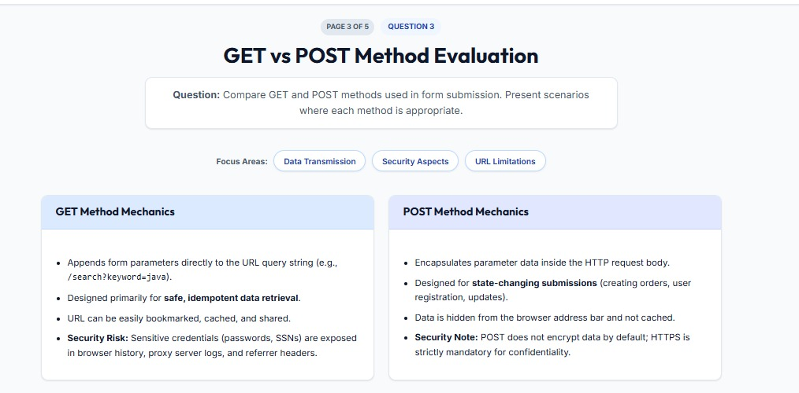
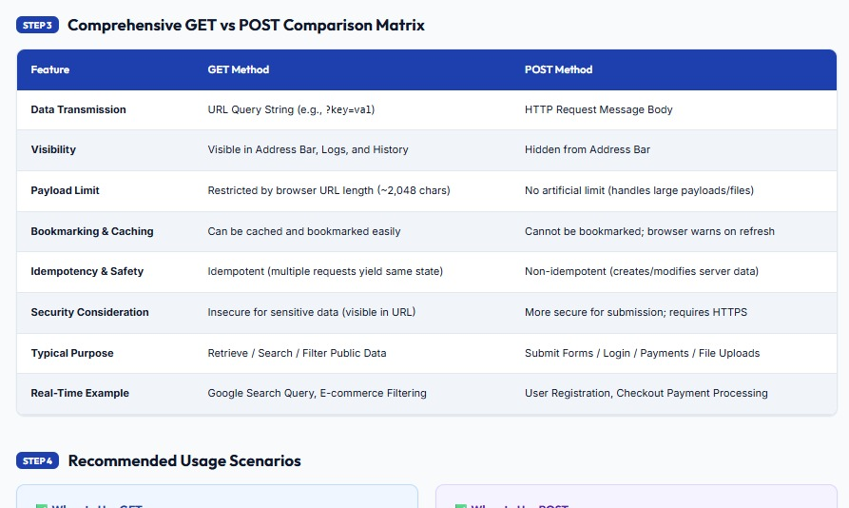

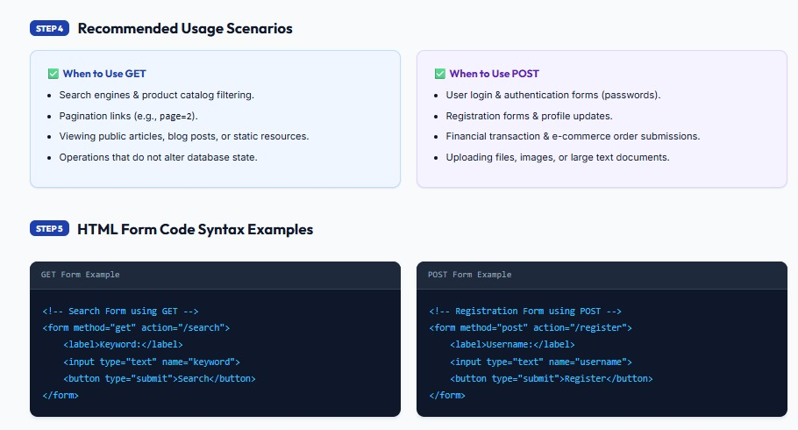

Question-4

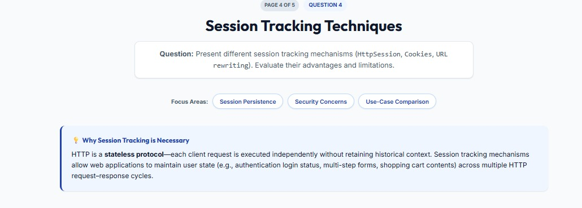

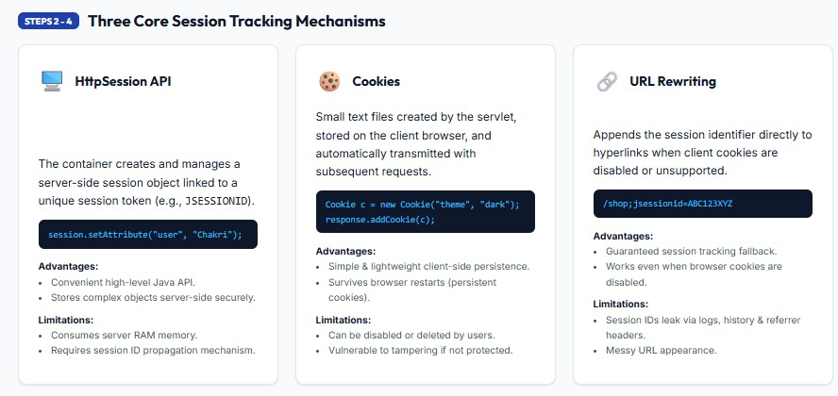

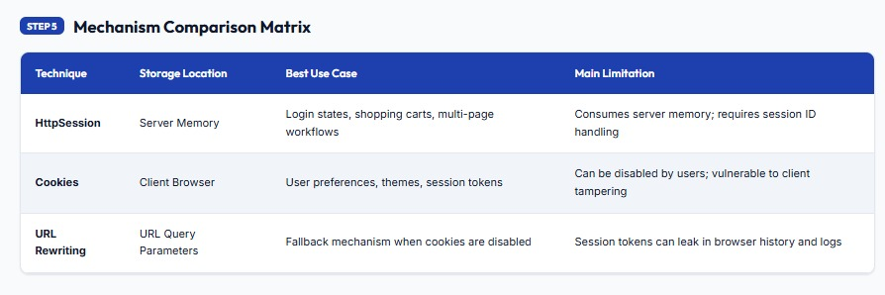

Question-5

