SIMATS ENGINEERING
ASSESSMENT TOOL 1

COURSE NAME: INTERNET PROGRAMMING
COURSE CODE: CSA43
Name : B. Harishwar Reddy
Reg. No. : 192311338

COURSE OUTCOME COVERED

CO-2 : Apply CSS layout and styling techniques to create visually appealing and responsive web interfaces, and use JavaScript to enable interactive client-side behavior. (L3)

Assessment Tool : Short Answer Test

Weightage: 10%

QUESTIONS: Total Marks: 20

Question 1 (5 Marks)
Suppose that a company wants its website to work seamlessly on mobile, tablet, and desktop devices. Explain the concept of responsive web design and its importance. Describe the key CSS techniques used to achieve responsiveness, and explain how CSS Flexbox or Grid can be used to design adaptive layouts. Illustrate your answer with a simple example layout and suggest improvements to enhance user experience across different devices.

Question 2 (5 Marks)
Suppose that a webpage contains a form where user input must be validated before submission. Explain the concept of client-side validation and its purpose. Describe how JavaScript event handling is used in validation and explain the role of regular expressions in validating inputs such as email or phone numbers. Provide a suitable example and suggest improvements for better usability and security.

Question 3 (5 Marks)
Suppose that a webpage layout breaks when the browser window is resized. Explain the CSS box model and its components, and describe how CSS positioning techniques affect layout structure. Identify possible causes of layout breaking and explain how media queries can be used to resolve these issues. Suggest best practices to ensure a stable and responsive layout.

Question 4 (5 Marks)
Suppose that a website requires dynamic content updates without reloading the entire page. Explain the concept of the Document Object Model (DOM) and its role in web development. Describe how JavaScript can be used to manipulate the DOM for updating webpage content dynamically. Provide an example and suggest improvements to enhance performance and user experience.

Code of Conduct:

I __B. Harishwar Reddy / 192311338__________________ (Name / Reg No) certify that this submission is my original work and that I have adhered to the guidelines specified for this assessment. I understand that any violation of academic integrity rules will result in disciplinary action.

Signature of the student: B. Harishwar Reddy

RUBRICS FOR CALCULATION:

Criteria | Weightage | Level 4 – Exemplary (5 Marks) | Level 3 – Proficient (4 Marks) | Level 2 – Developing (2–3 Marks) | Level 1 – Beginning (0–1 Mark)
Conceptual Understanding | 30 | Demonstrates clear and complete understanding of the concept | Good understanding with minor gaps | Basic understanding with some misconceptions | Poor or incorrect understanding
Accuracy of Answer | 25 | Completely correct answer with no errors | Mostly correct with minor errors | Partially correct with noticeable errors | Incorrect or irrelevant answer
Application of Knowledge | 20 | Correctly applies concepts to solve the question/problem | Applies concepts with minor mistakes | Limited or partially correct application | No or incorrect application
Completeness of Response | 15 | Covers all required parts of the question | Covers most parts with minor omissions | Covers only some parts | Incomplete or missing response
Clarity & Presentation | 10 | Clear, concise, and well-organized answer | Understandable with minor issues | Somewhat unclear or poorly structured | Difficult to understand

ANSWERS
Question 1

1. Responsive Web Design (RWD)

Definition:
Responsive Web Design (RWD) is a web design approach that allows a website to automatically adjust its layout, images, and content according to the screen size and resolution of different devices such as mobile phones, tablets, laptops, and desktops. The objective is to provide an optimal viewing and user experience without creating separate websites for different devices.

2. Importance of Responsive Web Design
- Provides a consistent user experience on all devices.
- Automatically adjusts content to fit different screen sizes.
- Improves website accessibility and readability.
- Reduces website maintenance by using a single codebase.
- Enhances SEO (Search Engine Optimization) because search engines favor mobile-friendly websites.
- Increases user engagement and reduces bounce rate.
- Supports future devices with varying screen resolutions.

3. Key CSS Techniques Used for Responsiveness
a) Viewport Meta Tag
The viewport tag ensures that the webpage scales correctly on mobile devices.
b) Flexible Layouts
Instead of fixed pixel values, use relative units such as:
- %
- em
- rem
- vw
- vh
c) Responsive Images
Images should automatically resize according to screen size.
d) Media Queries
Media queries apply different CSS styles based on device width.
4. Using CSS Flexbox
Flexbox is a one-dimensional layout system that arranges elements in rows or columns.
Example:
HTML
CSS
Advantages of Flexbox
- Easy alignment of elements.
- Automatically wraps content.
- Ideal for navigation bars and menus.
5. Using CSS Grid
CSS Grid is a two-dimensional layout system that controls both rows and columns.
Advantages of Grid
- Creates complex webpage layouts easily.
- Automatically adjusts columns according to screen size.
- Suitable for dashboards, galleries, and complete webpages.
7. Improvements to Enhance User Experience
- Use responsive images (max-width:100%).
- Increase button and touch target sizes for mobile devices.
- Use readable font sizes (16px or larger).
- Optimize images and CSS files to improve loading speed.
- Maintain sufficient spacing between elements.
- Use Flexbox or Grid instead of fixed positioning.
- Test the website on multiple devices and browsers.
- Ensure menus are mobile-friendly (e.g., hamburger menu).
Layout Flow
This layout clearly illustrates how the webpage adapts from Desktop → Tablet → Mobile, satisfying the "illustrate with a simple example layout" requirement.
Conclusion
Responsive Web Design ensures that websites function efficiently across mobile, tablet, and desktop devices. By using CSS techniques such as flexible layouts, media queries, responsive images, Flexbox, and Grid, developers can build adaptive websites that improve usability, accessibility, performance, and user satisfaction while reducing maintenance costs.

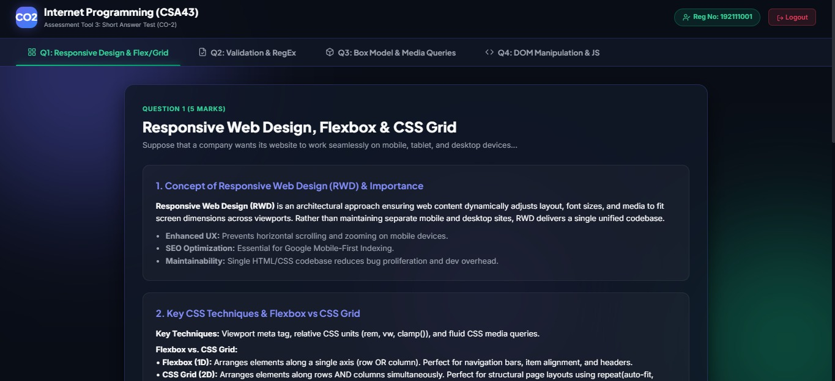

Question 2

Client-Side Validation
Definition
Client-side validation checks user input in the browser before sending data to the server.
Purpose
- Prevent invalid data submission.
- Improve user experience.
- Reduce server workload.
- Provide instant feedback.
JavaScript Event Handling
Common events:
- onsubmit
- onchange
- onkeyup
- onclick

Example:
Role of Regular Expressions
Regular expressions (Regex) validate input formats.
Email Validation
Phone Number Validation
Example
Input
If valid → Form submitted.
If invalid →
Improvements
- Display error messages beside input fields.
- Validate password strength.
- Perform server-side validation also.
- Sanitize user inputs.
- Use HTTPS for secure communication.
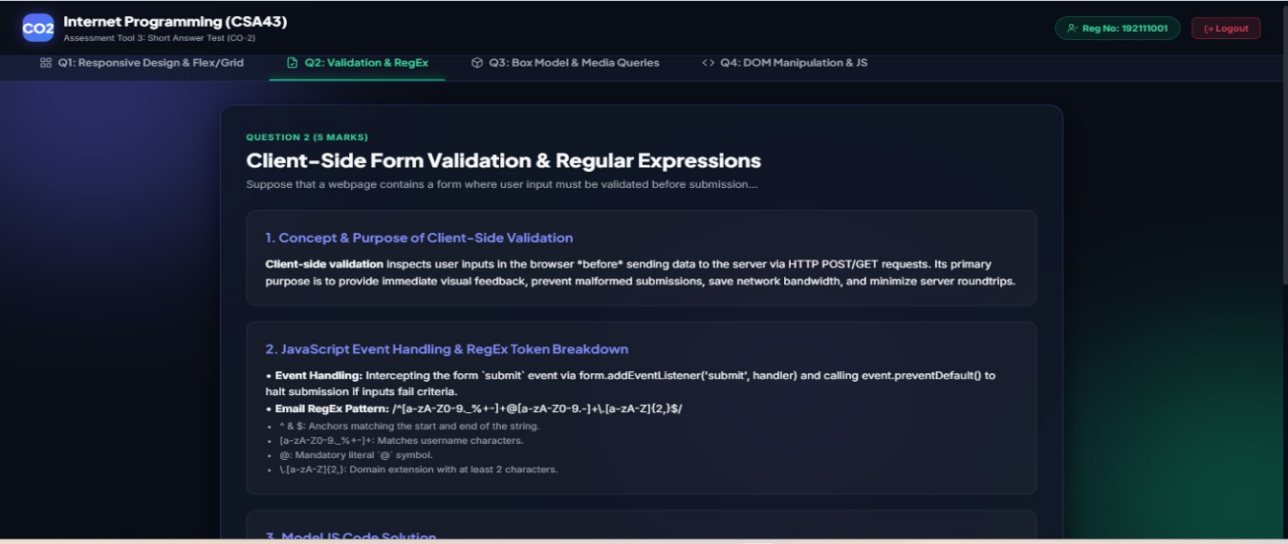
Question 3

CSS Box Model
Definition
The CSS Box Model defines how elements occupy space on a webpage.
Components
- Content
- Padding
- Border
- Margin
CSS Positioning
- Static (default)
- Relative
- Absolute
- Fixed
- Sticky
Example
Reasons Layout Breaks
- Fixed width elements
- Large images
- Overflow content
- Incorrect positioning
- Missing media queries
Media Queries
This changes the layout on smaller screens.

Best Practices
- Use Flexbox/Grid.
- Avoid fixed widths.
- Use percentage widths.
- Optimize images.
- Test on multiple devices.
- Apply responsive typography.
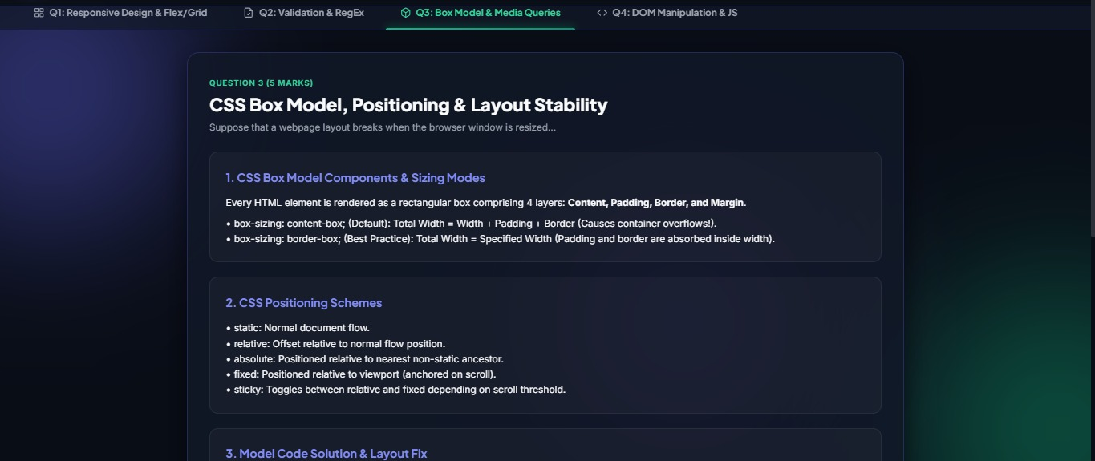
Question 4

Document Object Model (DOM)
Definition
The Document Object Model (DOM) is a tree-like representation of an HTML document. JavaScript uses the DOM to access, modify, add, or remove webpage elements dynamically.
Role of DOM
- Access HTML elements.
- Modify text.
- Change styles.
- Add/Delete elements.
- Handle user interactions.
DOM Structure
JavaScript DOM Manipulation
HTML
JavaScript
Output
Before Clicking
After Clicking
Improvements
- Minimize unnecessary DOM updates.
- Use event delegation.
- Cache frequently used elements.
- Update only required content.
- Use asynchronous requests (AJAX/Fetch) for better performance.
- Optimize animations using CSS.

