CSA0809 – PYTHON PROGRAMMING
Assignment 5 – Course Outcome CO5
City Air-Quality Monitoring Network
Part B: Implementation & Experimental Investigation
25 Marks • Tasks B1 – B4 • Bloom’s levels K3 / K4 / K5
Name | M Ayaan
Register Number | 1965260137
Course | CSA0809 – Python Programming
Nature | Individual – one week
GitHub Repository Link
CSA08-1965260137-Assignment5

Environment and repository
All programs are in the GitHub repository CSA08-1965260137-Assignment5 (link on the cover page), one folder per task: B1, B2, B3, B4. Each folder holds the Python source, input data (or the script that generates it), and outputs/ with the saved text output of every program and the charts. The README.md lists the command for every program.
Item | Value
Python | 3.12.3
Libraries | pandas 3.0.6, matplotlib 3.11.2, numpy 2.5.4 (requirements.txt); csv, sqlite3, statistics, re, logging, cProfile, timeit from the standard library
Data | Synthetic, generated by my scripts with fixed random seeds: 12 stations × 31 days × 24 h for October 2026 (B1), up to 120 stations × 365 days × 24 h (B3), 60 complaints written by me (B4)
Timing | time.perf_counter(), best of 3 runs; memory with tracemalloc. Numbers depend on the computer and will differ slightly when re-run

Task B1: Implement and Validate the Cleaning Pipeline (7 marks)

B1.1 Validate the implementation (2 marks)
The rules of A2 are implemented in B1/cleaning.py (clean_text, read_file_text, min_max, z_score). A 16-row test file sample_raw.csv contains every problem of A1.1. Core of the implementation:
def parse_number(text):
text = (text or "").strip()
if text.upper() in MISSING_TOKENS: # "", NA, N/A, NaN, null, none, -
return None
try: return float(text)
except ValueError: return None # "abc"

# inside clean_text(): range and Fahrenheit rules
if col == "temperature":
if station in fahrenheit: v = round((v - 32) * 5 / 9, 1)
if not -10.0 <= v <= 55.0: v = None
elif not 0.0 <= v <= 999.0: v = None

# forward fill, per station, at most MAX_FILL_GAP = 3 consecutive hours
gap[col] += 1
if col in last and gap[col] <= max_gap: vals[col] = last[col]; filled += 1

Before cleaning (raw file, 16 data rows)
station,date,hour,pm25,pm10,no2,temperature
Adyar,2026-10-01,0,48,90,30,28.5
Adyar,2026-10-01,1,NA,95,32,28.1
Adyar,2026-10-01,2,,97,31,27.9
Adyar,2026-10-01,3,52,99,33,27.7
Adyar,2026-10-01,3,52,99,33,27.7
Adyar,2026-10-01,4,-5,101,34,27.5
Adyar,2026-10-01,5,1500,abc,35,27.4
Guindy,2026-10-01,0,95,160,55,28.0
Guindy,01/10/2026,1,98,165,57,27.8
guindy ,2026-10-01,2,101,170,58,27.6
Velachery,2026-10-01,0,60,110,40,84.2
Velachery,2026-10-01,1,62,112,41,83.3
Velachery,2026-10-01,2,63,115,42,NA
Manali,2026-10-01,0,70,130,45,400
Adyar,2026-13-45,6,50,90,30,28.0
Adyar,2026-10-01,25,50,90,30,28.0

After cleaning (13 rows kept, sorted by station and time)
Station | Date | Hr | PM2.5 | PM10 | NO₂ | Temp °C | Filled
Adyar | 2026-10-01 | 0 | 48.0 | 90.0 | 30.0 | 28.5 | 0
Adyar | 2026-10-01 | 1 | 48.0 | 95.0 | 32.0 | 28.1 | 1
Adyar | 2026-10-01 | 2 | 48.0 | 97.0 | 31.0 | 27.9 | 1
Adyar | 2026-10-01 | 3 | 52.0 | 99.0 | 33.0 | 27.7 | 0
Adyar | 2026-10-01 | 4 | 52.0 | 101.0 | 34.0 | 27.5 | 1
Adyar | 2026-10-01 | 5 | 52.0 | 101.0 | 35.0 | 27.4 | 2
Guindy | 2026-10-01 | 0 | 95.0 | 160.0 | 55.0 | 28.0 | 0
Guindy | 2026-10-01 | 1 | 98.0 | 165.0 | 57.0 | 27.8 | 0
Guindy | 2026-10-01 | 2 | 101.0 | 170.0 | 58.0 | 27.6 | 0
Manali | 2026-10-01 | 0 | 70.0 | 130.0 | 45.0 | NULL | 0
Velachery | 2026-10-01 | 0 | 60.0 | 110.0 | 40.0 | 29.0 | 0
Velachery | 2026-10-01 | 1 | 62.0 | 112.0 | 41.0 | 28.5 | 0
Velachery | 2026-10-01 | 2 | 63.0 | 115.0 | 42.0 | 28.5 | 1

Cleaning report printed by the program: rows_read 16, rejected_row 2, duplicates 1, missing 4, impossible 3, f_to_c 3, filled 6, still_null 1, kept 13. Each rule was checked by an assert in test_cleaning.py (“All assertions passed”):
Problem (A1.1) | Test row | Result after cleaning
Missing (NA / blank) | Adyar hours 1 and 2, pm25 NA and empty | Both forward-filled with 48.0
Negative value | Adyar hour 4, pm25 -5 | Treated as missing → filled with 52.0
Impossibly large | Adyar hour 5, pm25 1500 | Treated as missing → filled with 52.0
Non-numeric text | Adyar hour 5, pm10 abc | Filled with previous pm10, 101.0
Fahrenheit | Velachery 84.2 | 29.0 °C
Impossible temperature | Manali 400 (=204 °C) | NULL (first reading, nothing to fill from)
Duplicate row | Adyar hour 3 twice | Kept once, duplicates = 1
Station name | guindy | Guindy
Date format | 01/10/2026 | 2026-10-01
Invalid date / hour | 2026-13-45, hour 25 | Both rows rejected, rejected_row = 2

B1.2 Compare with the design (1 mark)
The implementation follows A2 closely. Testing exposed the following changes, which I made to the code and which should be read as corrections to the design:
Part A design | Implementation | Reason for the change
Temperature valid range −10 to 55 °C (A2.1) | Range tightened to 5 to 50 °C, applied after °F → °C conversion | The scatter plot of my first version showed temperatures down to −9.5 °C: negative sensor faults smaller than 10 had slipped through the generic range. 5–50 °C is the physically possible range for this city. Converting first is necessary, otherwise Manali’s 400 passes as a number
A gap at the start of a station’s data was not discussed | Stays NULL (no previous value exists) | The test row for Manali showed the situation; inventing a value (e.g. a median) would hide a real gap
Forward fill described per station | Rows are sorted by (station, day, hour) before filling, and gap counters are reset when the station changes | Files can arrive out of order; without sorting, “previous” would be wrong, and a value from one station must never fill another
“Reject invalid rows” was only a one-line rule | Rejection counted as rejected_row; date parse tries YYYY-MM-DD then DD/MM/YYYY | Report numbers are needed to judge data quality
Table readings without a count of estimates | Column filled added and stored | Lets the analyst see how many values were estimated

B1.3 Store and query (2 marks)
generate_data.py writes 12 raw station files (8,949 data lines with injected faults); store_query.py cleans them, creates the two tables of A1.2 and loads 8,928 clean rows with one `executemany` call (23.0 ms). Totals of the cleaning report over the 12 files: duplicates 21, missing 682, impossible 443, Fahrenheit conversions 1,459, forward-filled 1,124, still NULL 1.
con.executemany(
"INSERT INTO readings(station_id, day, hour, pm25, pm10, no2, temp_c, filled) "
"VALUES (?,?,?,?,?,?,?,?)",
[(ids[r[0]], r[1], r[2], r[3], r[4], r[5], r[6], r[7]) for r in all_rows])
con.commit()
Q1 – average PM2.5 of Adyar in October 2026: SELECT ROUND(AVG(r.pm25),2) FROM readings r JOIN stations s USING(station_id) WHERE s.name = ? AND r.day BETWEEN '2026-10-01' AND '2026-10-31' → 62.89 µg/m³. (Pandas on the raw Adyar file without filling gives 62.91; the 0.02 difference is the effect of forward fill.)
Q2 – stations ranked by October mean PM2.5 (GROUP BY s.name ORDER BY mean DESC):
Rank | Station | Mean PM2.5 | Valid readings | Rank | Station | Mean PM2.5 | Valid readings
1 | Ennore | 113.51 | 744 | 7 | Velachery | 78.58 | 743
2 | Kodungaiyur | 106.98 | 744 | 8 | Perungudi | 72.15 | 744
3 | Manali | 102.55 | 744 | 9 | Alandur | 68.92 | 744
4 | Royapuram | 95.07 | 744 | 10 | Adyar | 62.89 | 744
5 | Guindy | 89.95 | 744 | 11 | Anna Nagar | 58.99 | 744
6 | T Nagar | 81.19 | 744 | 12 | Sholinganallur | 56.18 | 744

Q3 – the five hours of the day with the worst air (all stations): 20:00 → 93.93; 21:00 → 91.44; 19:00 → 91.08; 08:00 → 90.14; 07:00 → 87.43.
Velachery has 743 valid readings instead of 744 because one NULL could not be filled (it was a leading gap).

B1.4 Visualise (2 marks)
The charts designed in A3.1 were produced by visualise.py from the SQLite database (matplotlib). Every chart has a title and labelled axes with units.
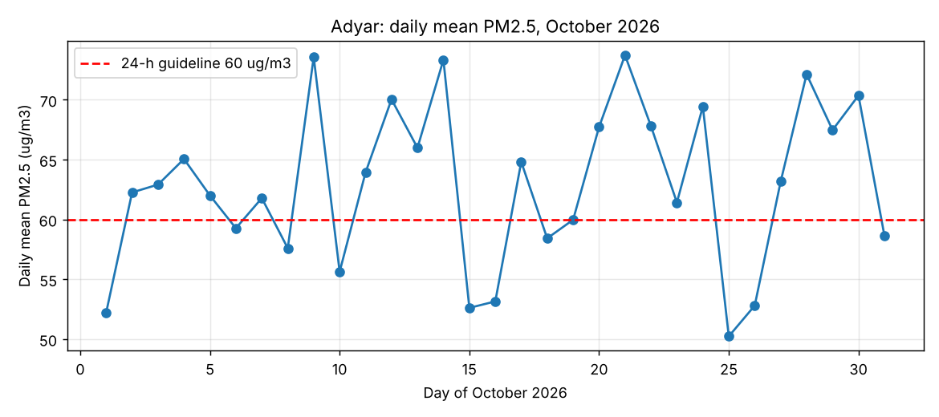
Figure 1 – Trend: Adyar daily mean PM2.5, October 2026 (line chart)
Interpretation. Adyar’s daily mean varies between 50.2 (25 October) and 73.7 (21 October) µg/m³ and was above the 60 µg/m³ guideline on 20 of the 31 days. There is no steady upward or downward trend; the month is dominated by day-to-day swings, so a single day should not be used to judge the station.
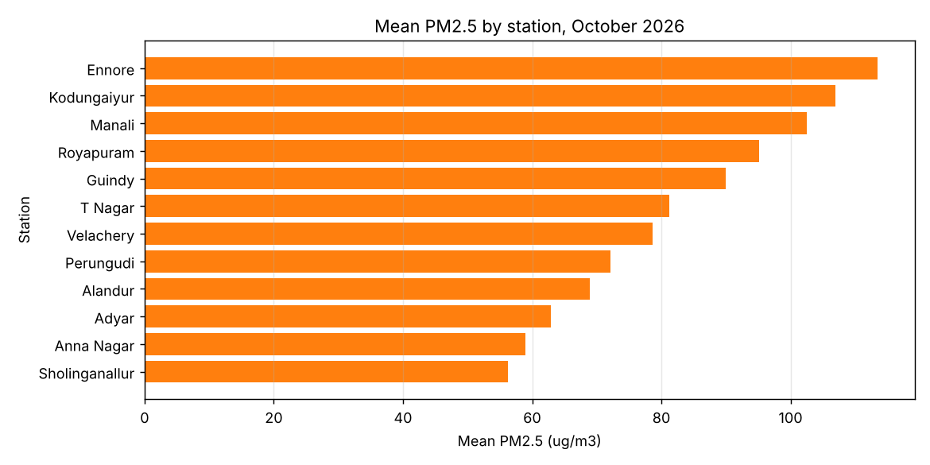
Figure 2 – Comparison: mean PM2.5 by station (bar chart)
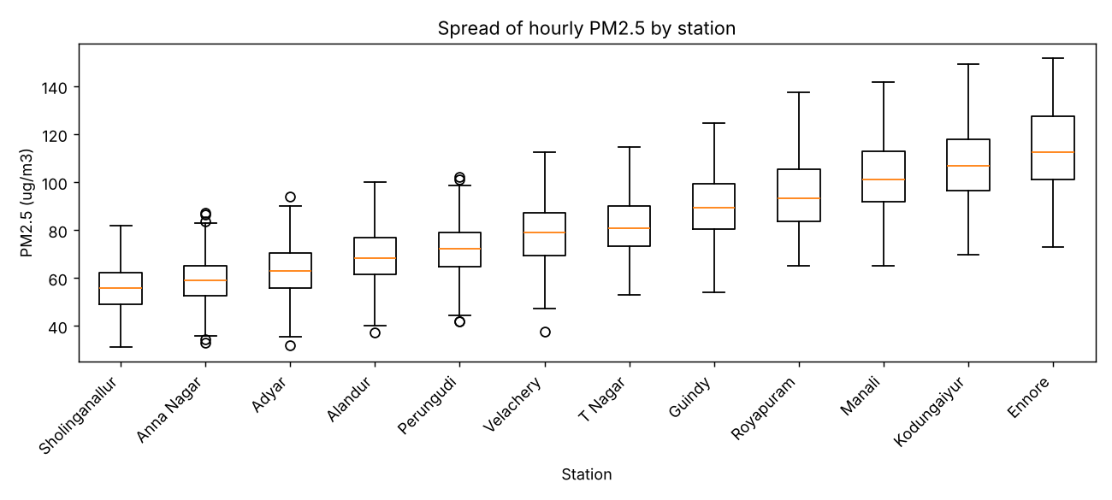
Figure 3 – Spread of hourly PM2.5 by station (box plot)
Interpretation. Ennore (113.5) has twice the mean of Sholinganallur (56.2), a ratio of 2.02. Three stations (Ennore, Kodungaiyur, Manali) average above 100. The box plot shows the higher-mean stations also have a wider spread, so their worst hours are much worse than their averages suggest. (These figures come from synthetic data; they show the method, not real city conditions.)
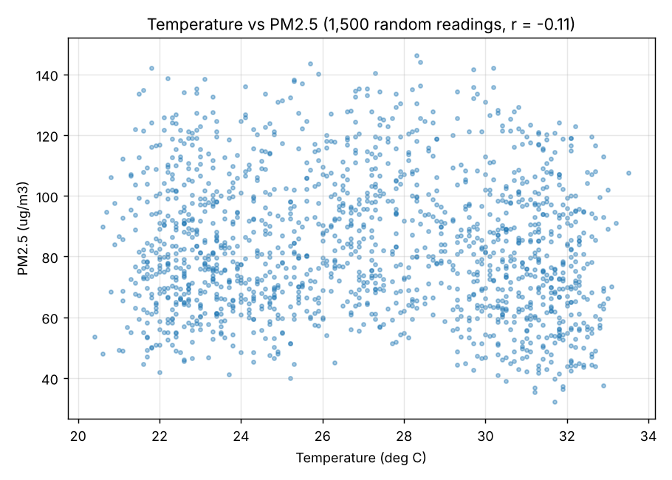
Figure 4 – Relationship: temperature vs PM2.5 (scatter plot, 1,500 readings)
Interpretation. The cloud is wide and nearly flat; the correlation is r = −0.11, a very weak negative relation (temperature explains about 1% of the variation, r² ≈ 0.01). The slight negative tilt is consistent with cooler hours having more pollution, but temperature alone is not a useful predictor of PM2.5 here, and correlation does not prove cause. The denser bands near the lowest and highest temperatures come from the daily temperature cycle, which spends most of its time near its extremes.
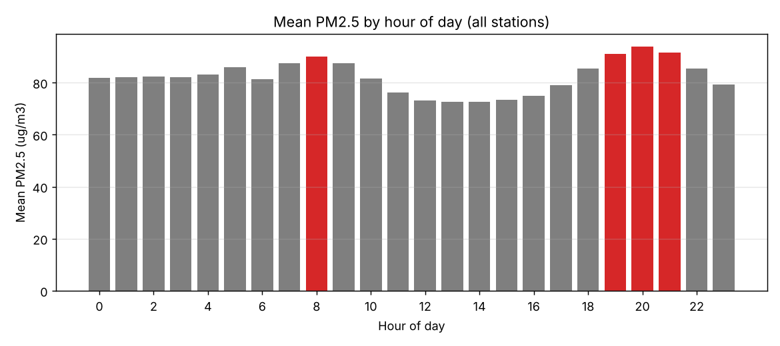
Figure 5 – Mean PM2.5 by hour of day, worst four hours in red (bar chart)
Interpretation. The air is worst at 19:00–21:00 (peak 93.9 at 20:00) and again at 08:00, matching morning and evening traffic; it is cleanest at 14:00 (72.7). The board could therefore target traffic or burning restrictions to these hours.
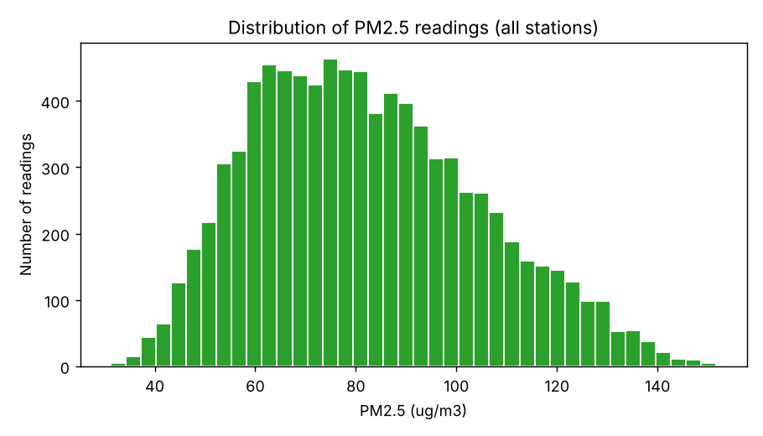
Figure 6 – Distribution of PM2.5 readings (histogram)
Interpretation. The distribution is roughly bell-shaped with a mild tail to the right (mean 82.2, median 79.9, skew 0.40): most readings are between 50 and 110, a few high episodes pull the mean above the median. This supports using z-scores for comparison and warns that min–max scaling is influenced by the high tail.

Complete the Code – B1
TODO 1 and TODO 2 were completed in B1/complete_code.py without changing the rest of the program. The required extra check (pm25 > 999 is skipped) and a test row (Guindy,2026-10-04,5000) were added.
def load_clean(text):
rows = []
for rec in csv.DictReader(io.StringIO(text)): # TODO 1
value = rec["pm25"].strip()
if value == "" or value.upper() == "NA":
continue
pm = float(value)
if pm < 0 or pm > 999: # added check
continue
rows.append((rec["station"], rec["date"], pm))
return rows

def min_max(values): # TODO 2
lo, hi = min(values), max(values)
return [round((v - lo) / (hi - lo), 3) for v in values]
Output (identical to the expected output):
[('Adyar', '2026-10-01', 48.0), ('Guindy', '2026-10-01', 95.0), ('Guindy', '2026-10-03', 121.0)]
[0.0, 0.644, 1.0]
Extra test passed: pm25 = 5000 row was skipped -> 3 rows kept

Alternative Concept and Complexity Analysis – pandas instead of csv loops
Solution with pandas: df = pd.read_csv(io.StringIO(text), na_values=["NA",""]), df = df.dropna(subset=["pm25"]), df = df[(df.pm25 >= 0) & (df.pm25 <= 999)], and norm = (df.pm25 - df.pm25.min()) / (df.pm25.max() - df.pm25.min()). The loop is replaced by vectorised operations running in C.
Rows | csv + loops: time | peak memory | pandas: time | peak memory | Speed-up
1,000 | 0.0009 s | 0.1 MB | 0.0021 s | 0.2 MB | 0.4× (pandas slower)
100,000 | 0.1199 s | 10.8 MB | 0.0304 s | 14.4 MB | 3.9×
1,000,000 | 1.1420 s | 107.7 MB | 0.2536 s | 144.1 MB | 4.5×

- Time: both are O(n); the difference is the constant. For 1,000 rows pandas is slower because of its fixed start-up overhead (building a DataFrame); from 100,000 rows the vectorised code is about 4× faster and the gap is stable.
- Memory: both O(n). Pandas needs about 30% more at 1,000,000 rows (144 vs 108 MB) because it keeps the whole table, with all columns, in memory, whereas the loop keeps only the valid floats. For files that do not fit in memory, read_csv(chunksize=...) or the loop version streams.
- Choice: csv + loops for small files and in places with no pandas; pandas for large files and exploratory work.
Evidence: working code, before-and-after tables, SQL results and interpreted charts (above).

Task B2: Engineer Adversarial Data (5 marks)

B2.1 Hostile files
B2/adversarial_files.py creates seven files and passes each to the pipeline of B1. Observed behaviour:
File | Response of the program | What it reveals about the design
Missing column (no2 absent) | ValueError: missing column(s): ['no2'] | The header is validated before any row is processed – fail early with a clear message
Semicolon delimiter | Accepted: delimiter sniffed and rewritten; 2 rows kept | Delimiter detection works for ;, TAB, | – but only because the first line has no comma
Tab delimiter | Accepted, 2 rows kept | As above
Windows-1252 file (Pérungudi) | Accepted; station read correctly as Pérungudi | The encoding fallback chain works for single-byte encodings
UTF-16 file with BOM | ValueError: missing column(s): [all 7] | Weakness: the fallback chain ends with cp1252/latin-1, which accept any bytes, so UTF-16 is decoded into garbage and only fails later with a misleading message. The BOM (FF FE) should be checked first
Empty file (0 bytes) | ValueError: empty file | Explicit check prevents a confusing StopIteration/None error
Header only | Accepted, 0 rows kept, no warning | Weakness: a station that sent no data is silent; a warning/alert for zero rows should be added

B2.2 Quote character in a station name
sql_injection.py builds the query in two ways. The table contains Adyar, Guindy, O'Brien Road and Ennore.
Input | String concatenation (`"…station = '" + name + "'"`) | `?` placeholder
Adyar | 48.0 | 48.0
O'Brien Road | OperationalError: near "Brien": syntax error | 70.0 (correct)
Adyar' OR '1'='1 | 83.25 – the average of all stations (wrong, data leak) | None (no station has this name)
x'; DROP TABLE aq; -- | ProgrammingError: only one statement at a time (sqlite3 blocks it) | None; table intact

- Concatenation: the quote in the input ends the SQL string literal early. O'Brien Road leaves Brien Road' as invalid SQL → crash. In Adyar' OR '1'='1 the extra text becomes part of the SQL: the WHERE clause is now station = 'Adyar' OR '1'='1', always true, so every row is averaged. An attacker (or just an unlucky name) changes the meaning of the query.
- Placeholder: the SQL text is fixed and compiled first; the value is passed separately and bound as a *value*, never parsed as SQL. The quote is an ordinary character, O'Brien Road works, and the injection string is simply a station name that does not exist.
- Lesson: station names are external data; the design must never build SQL from strings, and a name with an apostrophe is a legitimate input, not only an attack.

B2.3 Adversarial sentences for the sentiment scorer
Category | Sentence | Score | Scorer | Human | Result
Sarcasm | Oh great, the factory is burning plastic again. | 0 | neutral | negative | FAIL
Sarcasm | Wonderful, another dirty day. Thanks a lot. | 0 | neutral | negative | FAIL
Sarcasm | Yeah right, the air is really clean today. | +1 | positive | negative | FAIL
Double negative | I cannot say it is not good. | −1 | negative | positive | FAIL
Double negative | It is not that the service is not helpful. | −1 | negative | positive | FAIL
Double negative | Never again will I say the air is not bad. | +1 | positive | negative | FAIL
Mixed | The staff were polite but the air is still terrible. | 0 | neutral | negative | FAIL
Mixed | Good app, bad data, slow support, clean design. | 0 | neutral | neutral | OK*
Mixed | Air is cleaner now but smoke returns at night. | 0 | neutral | neutral | OK*
Negator distance | The air is not very good. | +1 | positive | negative | FAIL
Unknown words | The stench is unbearable and I feel nauseous. | 0 | neutral | negative | FAIL
Spelling | Aiir is baad, super smokey!! | 0 | neutral | negative | FAIL

Correct on 2 of 12. The two OK* cases are accidents: positive and negative words cancel to 0, which happens to equal the human “neutral”. Where it fails and why:
- Sarcasm: the scorer counts words, not intent; “great”, “wonderful”, “clean” are positive even when meant ironically.
- Double negatives: a negator only flips the *next* word, and nothing handles two negators in a row or “not that … not”. Results depend on word order, not meaning.
- Mixed opinions: a single sum hides that the text contains both a positive and a negative message; “polite staff but terrible air” becomes neutral.
- Negator distance, unknown words, spelling: the one-word window ignores “not very good”; words outside the lexicon (stench, unbearable, “baad”) contribute 0; there is no stemming or spell correction.

What each adversarial input reveals
- Hostile files: validation (header, empty, delimiter) is the strong part of the design; the weakness is the permissive encoding fallback and the silent acceptance of a header-only file – both need extra checks and a logged warning.
- SQL quote: the ? placeholder is not an optional style; it is what makes the storage layer correct for names with apostrophes and safe against injection.
- Sarcasm/negation/mixed: the word-list scorer is only reliable on plain, direct complaints. For analysis it must be reported with its error rate, and flagged complaints (score 0 with many sentiment words) should be sent for human review.

Complete the Code – B2
con.executemany("INSERT INTO aq VALUES (?, ?, ?)", readings) # TODO 1
con.commit()

def station_average(name): # TODO 2
row = con.execute("SELECT AVG(pm25) FROM aq WHERE station = ?", (name,)).fetchone()
return row[0]
Output (identical to expected):
54.0 108.0
None
Why the injection attempt returns `None`: with the ? placeholder the text Adyar' OR '1'='1 is sent to SQLite as one string value, so the query compares station with that whole text. No row has a station with that name, so the WHERE clause matches zero rows; AVG() of zero rows is NULL, which Python shows as None. The OR '1'='1' was never interpreted as SQL.

Alternative Concept and Complexity Analysis – f-string SQL, and executemany vs execute in a loop
f-string SQL: f"SELECT AVG(pm25) FROM aq WHERE station = '{name}'" with Adyar' OR '1'='1 becomes …WHERE station = 'Adyar' OR '1'='1', which is true for every row, so the function would return the average of all readings (83.25 in my test table) – a wrong answer and, in a real system, exposure of other data. It also adds the cost of parsing a new SQL text for every call.
executemany vs a loop (executemany_vs_loop.py, in-memory database, one commit at the end):
Rows | executemany | execute() in a loop | Ratio | Commit after every row (file DB)
1,000 | 0.0005 s | 0.0009 s | 1.8× | 0.672 s
10,000 | 0.0084 s | 0.0158 s | 1.9× | (not run)
100,000 | 0.0570 s | 0.0991 s | 1.7× | (not run)
500,000 | 0.3014 s | 0.5583 s | 1.9× | (not run)

- Time: both are O(n) and the time grows linearly with rows. executemany is about 1.8× faster because the statement is prepared once and the loop over rows runs inside the C module, avoiding n Python-to-C calls.
- Commits: committing after every row on a disk file was about 1,300× slower (0.672 s for only 1,000 rows) because each commit forces a write to disk. One commit per batch is the real saving.
- Space: O(n) for the Python list of rows in both; a generator passed to executemany would reduce this to O(1).
Evidence: hostile inputs, observed behaviour, explanations (above).

Task B3: Loops vs Libraries vs SQL (8 marks)

B3.1 Correctness on small data (2 marks)
Three stations, 1–7 January (21 station-days, 504 readings). Methods in B3/methods.py: (1) csv module + dictionary of lists + statistics.mean; (2) pandas.read_csv + groupby(['station','date']).mean(); (3) SQLite SELECT station, day, AVG(pm25) … GROUP BY station, day. The running-sum alternative is included as a fourth.
groups (station, day): 21 21 21 21
largest difference between methods: 2.84e-14
('S000', '2026-01-01') loops=53.8083 pandas=53.8083 sql=53.8083 running-sum=53.8083
('S000', '2026-01-02') loops=56.2000 pandas=56.2000 sql=56.2000 running-sum=56.2000
('S000', '2026-01-03') loops=59.1042 pandas=59.1042 sql=59.1042 running-sum=59.1042
('S000', '2026-01-04') loops=58.6000 pandas=58.6000 sql=58.6000 running-sum=58.6000
All methods agree.
All 21 groups exist in all methods and the largest difference is 2.8×10⁻¹⁴ (floating-point rounding only), so the three methods agree.

B3.2 Increase the data size (2 marks)
One year hourly (8,760 readings per station) for 1, 12 and 120 stations: 8,760, 105,120 and 1,051,200 rows. Best of 3 runs. File reading is included for loops and pandas; for SQL the query on an already loaded table, and the load + query total, are both shown.
Stations | Rows | Loops + mean | Running sum | Pandas groupby | SQL query only | SQL load + query
1 | 8,760 | 0.017 s | 0.006 s | 0.005 s | 0.003 s | 0.011 s
12 | 105,120 | 0.181 s | 0.088 s | 0.056 s | 0.031 s | 0.147 s
120 | 1,051,200 | 2.059 s | 0.741 s | 0.553 s | 0.448 s | 1.718 s
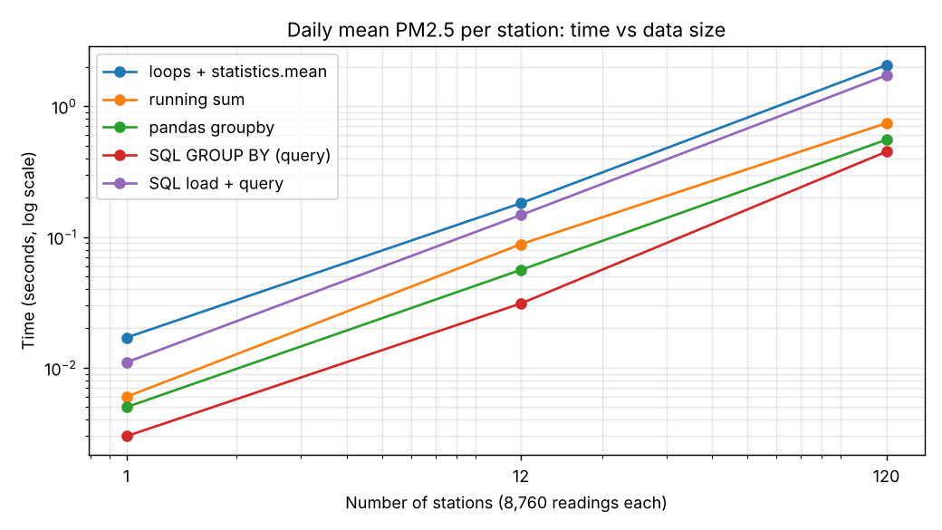
Figure 7 – Time against data size (log–log scale); all methods grow roughly linearly
Rows grow 120× from the first to the last size. The loops version grows about 121× (0.017 → 2.059 s), consistent with O(n); the others also scale roughly linearly.

B3.3 Profile (2 marks)
profile_loops.py runs cProfile on the plain-Python version for 12 stations (105,120 rows, 0.576 s under the profiler). Sorted by internal time:
Function | Calls | Internal time | Cumulative
csv.py: DictReader.__next__ | 105,132 | 0.151 s | 0.234 s
methods.py: loops_store_all (the loop itself) | 1 | 0.068 s | 0.576 s
statistics.py: _sum (inside statistics.mean) | 4,380 | 0.055 s | 0.226 s
builtins.next | 105,144 | 0.042 s | 0.042 s
float.as_integer_ratio | 105,120 | 0.027 s | 0.027 s

Finding. The function with the most internal time is `DictReader.__next__` (csv.py) – building a dictionary for each of the 105,132 rows. The second hot spot is `statistics.mean`: cumulative 0.261 s, about 45% of the run, because it converts every float to an exact fraction (as_integer_ratio, _sum) to be accurate. Replacing DictReader with the plain csv.reader and statistics.mean with sum/count (the running-sum version) removes both, and the measured time fell from 0.181 s to 0.088 s.

B3.4 Engineering trade-off (2 marks)
- Observed: at 1,051,200 rows pandas (0.55 s) and SQL (0.45 s query) are 4–5× faster than the loops with statistics.mean (2.06 s), and 1.3× faster than the optimised running-sum loops (0.74 s). Memory: loops with stored lists 50 MB, running sum 18 MB, pandas 95 MB.
- Why: pandas and SQLite do the repetitive work in compiled code; the loops execute Python bytecode for every row. Pandas keeps the whole table in memory (largest memory), SQL keeps data on disk and streams.
- Note: the SQL query is fast only after the data is loaded; with the load it took 1.72 s, no better than the loops. SQL pays off when the data is loaded once and queried many times.
- Quick one-time analysis → pandas. Shortest code, no schema, instantly explorable, fast enough, and the memory cost is acceptable for a one-off.
- Daily automated report → SQL (SQLite) loaded incrementally, with the cleaning step in Python. Each day’s files are appended once; the report is a GROUP BY on indexed data; constraints keep duplicates out; the history never has to be re-read; the result is reproducible and cheap in memory. Loops only when the environment has no libraries.

Alternative Concept and Complexity Analysis – running sum and count
Solution: one pass, tot[key] += value; cnt[key] += 1, and at the end mean = tot[key] / cnt[key]. No list of readings is ever stored and statistics.mean is not called.
 | Store all, then `statistics.mean` | Running sum and count
Time | O(n) to group + O(n) to average = O(n), with a slow exact-fraction mean | O(n), one pass, plain float arithmetic
Space | O(n): every reading is kept in a list | O(stations × days): two numbers per group (43,800 groups for 120 stations)
Measured time, 1,051,200 rows | 2.059 s | 0.741 s
Measured peak memory, 1,051,200 rows | 50.3 MB | 17.8 MB
Limits | Can compute median, percentile, any statistic | Only sums, counts, means, min, max; no median or percentile without extra structures
Both are O(n) in time, but the running sum is about 2.8× faster and uses a third of the memory; it should be chosen whenever only a mean is required.
Evidence: verified correctness, three-size comparison, profile report, reasoned trade-off.

Task B4: Final Engineering Decision (5 marks)

B4.1 Implement a practical strategy (2 marks)
B4/ai_tools.py contains the sentiment scorer (larger word lists, negation by previous word) and the extractive summariser; complaints_data.py has 60 complaints written by me, each with my own label (positive / negative / neutral) decided before running the code. sentiment_eval.py compares the labels.
Agreement: 53 of 60 = 88.3%.
My label \ scorer | negative | neutral | positive
negative (32) | 29 | 3 | 0
neutral (10) | 2 | 6 | 2
positive (18) | 0 | 0 | 18

The 7 disagreements and the reason for each:
# | Complaint (start) | Mine | Scorer | Why
11 | Please tell me the office timings of the pollution control board… | neutral | negative | “pollution” is in the negative list but here is only a name
33 | Where can I buy a mask for the pollution season? | neutral | negative | Same: a neutral question containing “pollution”
15 | I noticed the monitor at T Nagar shows no data… Thanks. | neutral | positive | The politeness word “thanks” counted as +1
53 | Which station is closest to … bus depot? … Thank you. | neutral | positive | Same: “thank” in a plain question
28 | The service is not bad but the air is still dirty… | negative | neutral | Mixed opinion: “not bad” (+1) cancels “dirty” (−1)
50 | Helpful staff? Not really… Very slow process. | negative | neutral | Sarcastic question: “helpful” +1 cancels “slow”; “not really” not handled
54 | …It showed good air but there was heavy smoke. Not reliable. | negative | neutral | “good” +1 cancels “smoke”; “not reliable” unknown word

All 7 errors are the types found in B2: words that change meaning with context, mixed opinions and sarcasm. The sarcastic complaint #27 (“Oh great, another day of smoke…”) was labelled correctly only by luck, because “smoke”, “dust” and “fumes” outweighed “great” and “thank”.

Summariser
One-sentence summaries were compared with my key-issue word for each complaint (for example *smoke*, *dust*, *sensor*): does the summary mention it?
Method | Key issue present in the summary | Time per complaint
Extractive (most frequent important words) | 50/60 = 83.3% | 15.4 µs
First sentence (alternative) | 56/60 = 93.3% | 2.6 µs

Example #10: full text “The app is not good. It crashes when I open the pollution map. Support never replied.” – extractive keeps *“It crashes when I open the pollution map.”* (the repeated word “pollution” wins), first-sentence keeps *“The app is not good.”* (the main issue). Top words in the 32 negative complaints: not (13), smoke (10), air (9), bad (9), burning (7), dust (7), smell (7).
The extractive method never beat the first-sentence method on my set (it was better in 0 complaints and worse in 6). Complaints here are only three sentences long and the citizen states the problem first, so there is little for frequency to improve on. Extractive summarising is expected to help for longer texts, such as a month of complaints for one station.

B4.2 Check the database (1 mark)
At the new scale of 112 stations × 30 days × 96 readings (every 15 minutes) = 322,560 rows, index_test.py measured two queries before and after CREATE INDEX idx_station_day ON aq(station, day). EXPLAIN QUERY PLAN changed from SCAN aq to SEARCH aq USING INDEX idx_station_day.
Query | No index | With index | Speed-up
Average of one station on one day (point query) | 9.936 ms | 0.019 ms | 533×
Daily summary (MIN/MAX/AVG/COUNT) for one station (GROUP BY day) | 12.522 ms | 0.639 ms | 19.6×

The slowest query (daily summary of one station) became 20× faster; the point query 533×. The index took 0.107 s to build, and inserting 10,000 new rows with the index present took 0.013 s, so the write cost is small. In B1 the UNIQUE (station_id, day, hour) constraint already creates an equivalent index.

B4.3 Production decision (2 marks)
Scale: (12 + 100) = 112 stations × 96 readings/day = 10,752 rows/day ≈ 3.9 million rows/year; 50,000 complaints/month ≈ 1,700/day.
Question | Decision | Evidence from my measurements
Storage | Keep SQLite with the index on (station, day) for now: one writer (the nightly load), reads for the dashboard. Move to PostgreSQL if several programs must write at the same time or the file grows beyond a few GB. | Index: 533× and 20× faster at 322,560 rows; 4 million rows is about 12× that size, and an indexed query grows only like log n. executemany loaded 500,000 rows in 0.30 s; one commit per batch, never per row (1,300×).
Cleaning | Incremental, per day: clean each new file with pandas (vectorised) or the loop code, append to the database; never re-clean old data. Keep the checks of B2 (header, empty file, UTF-16 BOM) and log the report. | pandas was 4.5× faster than loops at 1,000,000 rows (0.25 s vs 1.14 s); one day is only ~10,752 rows so either is fast; a day of data takes milliseconds.
Analysis | SQL `GROUP BY` on the indexed table for the daily automated report, pandas for ad-hoc exploration. Use the running-sum idea if a mean is the only output. | At 1,051,200 rows: SQL query 0.45 s, pandas 0.55 s, loops 2.06 s; running sum used 18 MB vs 95 MB for pandas.
AI – sentiment | Simple word list is good enough for counting and routing, but not for decisions about individuals. Add a human review for score 0 and for the words “thank”, “pollution” in questions. Collect labels for 3–5 thousand complaints and train Naive Bayes (or a library model) when the error rate matters. | Speed is not a problem: 48,000 complaints scored in 0.23 s (4.8 µs each). Accuracy 88.3% on ordinary complaints, but only 2/12 on adversarial text. Naive Bayes trained on just 59 examples reached 83.3% (leave-one-out) – not yet better, so training needs far more data.
AI – summary | Use the simple summariser only on long, grouped text; for single complaints show the first sentence. | First sentence kept the key issue in 93.3% vs 83.3% for the extractive method, and is 6× faster.

Conclusion. The data volumes are modest: nothing in my measurements shows the need for a new technology at 112 stations. The one scaling problem found is full scans of a growing table, solved by the index. The simple AI methods are fast enough and explainable and are good enough as a first version; the case for a trained model rests on accuracy, not speed, and it should be adopted only after enough labelled complaints exist to show that it beats the word list on a held-out test.

Complete the Code – B4
def score(text):
words = text.lower().replace(".", " ").replace(",", " ").split()
total = 0
for i, w in enumerate(words): # TODO 1
value = 1 if w in POSITIVE else -1 if w in NEGATIVE else 0
if value != 0 and i > 0 and words[i - 1] in NEGATORS:
value = -value
total += value
return total
Output (identical to expected):
positive | Roads are clean and the bus was fast.
negative | Smoke from the factory, air is bad.
negative | The staff were not helpful.
positive | Not bad, service improved.
A complaint labelled wrongly: “The air is not very good.” – the program says *positive* although the meaning is negative. The negator “not” is not the word directly before “good” (“very” is), so the sign is not flipped and “good” counts +1. The scorer looks only one word back.

Alternative Concept and Complexity Analysis – first k sentences as the summary
Solution: sentences(text)[:k] – no word counting, no ranking.
 | Most frequent important words | First k sentences
Quality on my 60 complaints | Key issue present in 50/60 (83.3%) | Present in 56/60 (93.3%); chose a better sentence in 6 cases, never worse
Time | O(w + s log s): count words, score and sort sentences; measured 15.4 µs per complaint | O(1) in the number of words if the text is split lazily; O(w) with a simple split; measured 2.6 µs per complaint
Space | O(w): frequency table, scores | O(k): only the k sentences returned (O(w) while splitting)
For short complaints in which the problem is stated first, the simple method is better and cheaper. Frequency-based selection becomes valuable for long documents and groups of complaints.

Chatbot demonstration (from `B4/chatbot.py`)
You: What is the PM2.5 in Adyar today?
Bot: The average PM2.5 in Adyar on 2026-10-31 was 58.6 ug/m3.
You: Which station is worst?
Bot: The station with the highest mean PM2.5 is Ennore (113.5 ug/m3).
You: Will it rain tomorrow?
Bot: Sorry, I did not understand. Try asking about PM2.5 at a station.
You: pm2.5 in Adyr today <- typo
Bot: Which station? I know: Adyar, Alandur, Anna Nagar, Ennore, Guindy, ...
Evidence: working AI functions with a measured agreement (53/60), index timings, and an evidence-based production decision.

