* Find all the information about each products *

_ db.users.find() _

# RESULTScreenshot 2024-04-06 14.22.31.png

Find the product price which are between 400 to 800

Db.users.find({product_price:{$gt:400,$lt:800}})

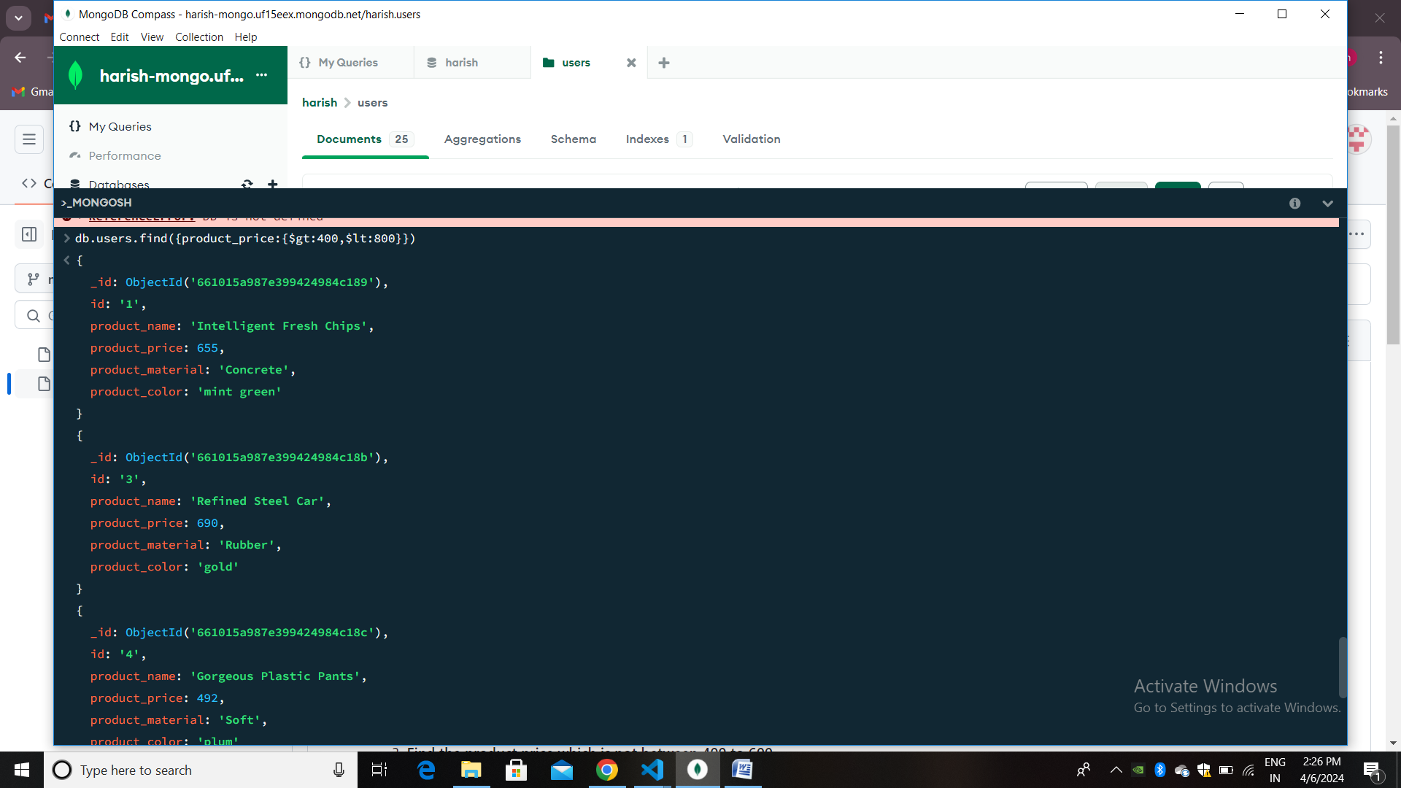

Find the product price which are not between 400 to 600

Db.users.find({product_price:{$not:{$gte:400,$lte:600}}})

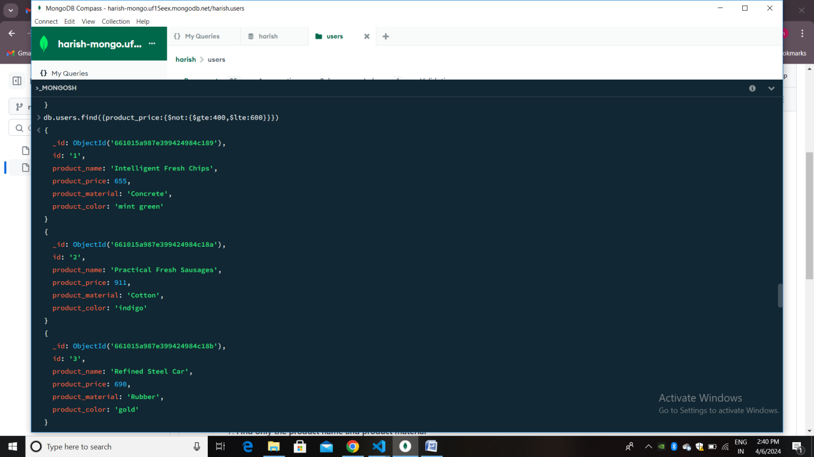

List the four product which are greater than 500 in price

Db.users.find({product_price:{$gt:500}).limit(4)

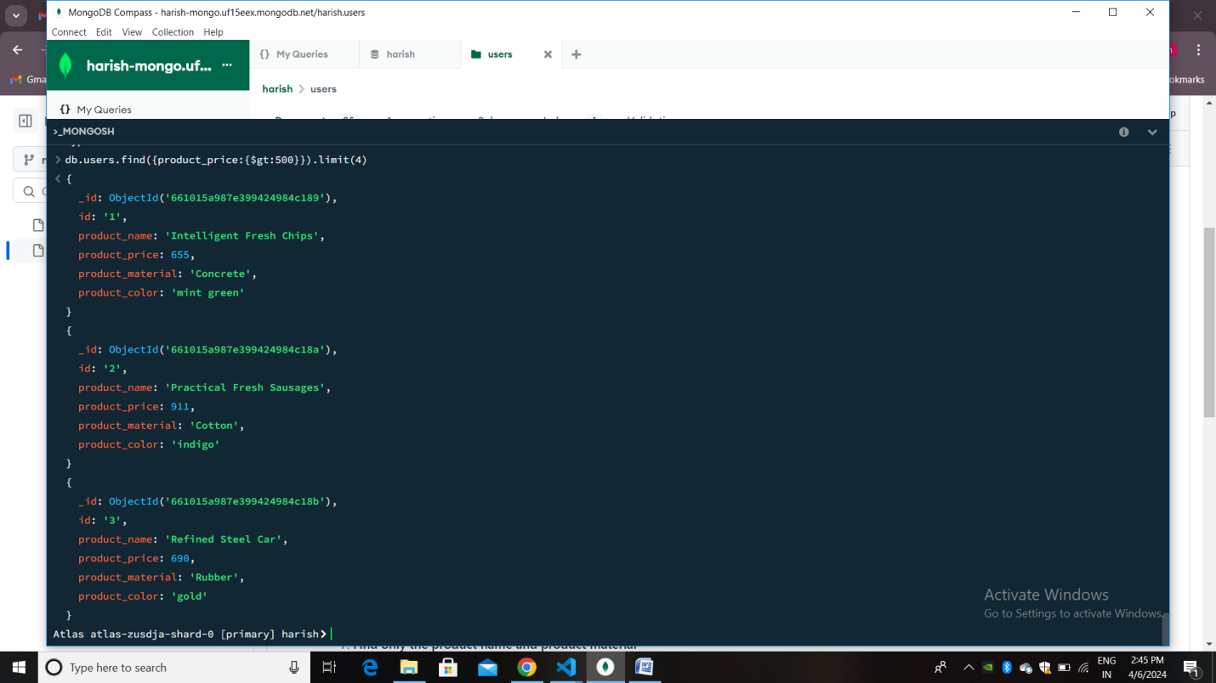

Find the product name and product material of each products

Db.users.find({},{product_name:1,product_material:1})

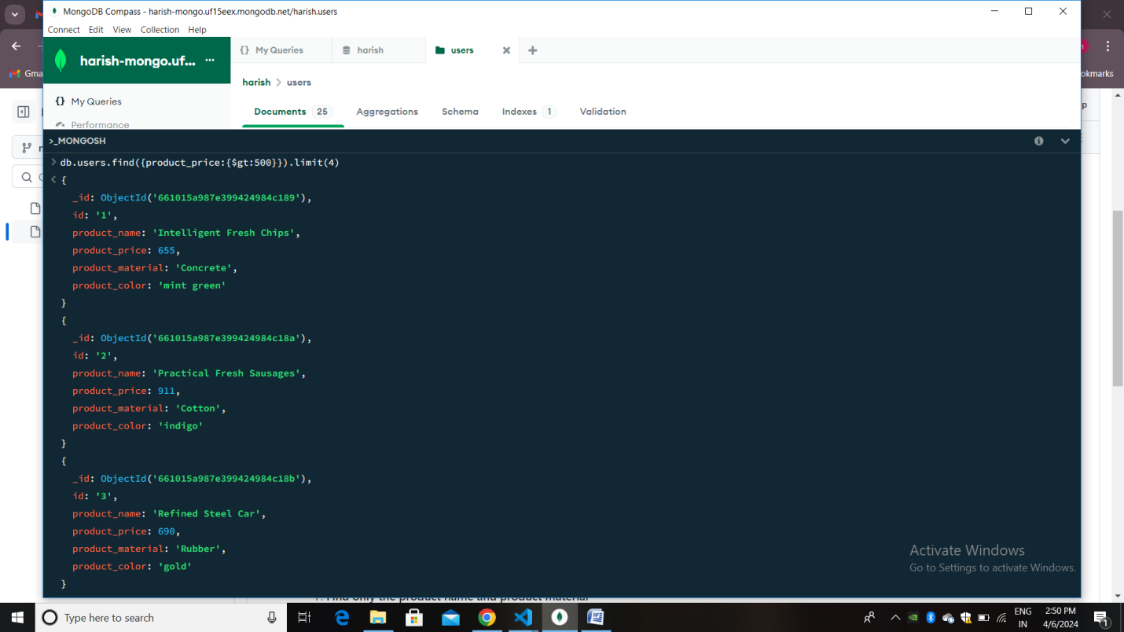

Find the product with a row id of 10

Db.users.find({id:{$eq:"10"})

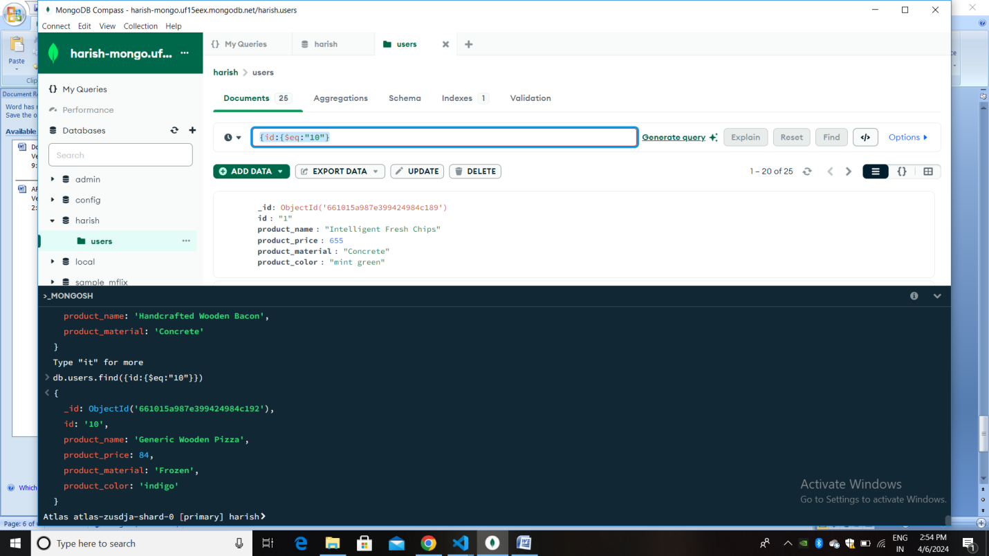

Find only the product name and product material

db.users.find({},{product_name:1,product_material:1,id:0})

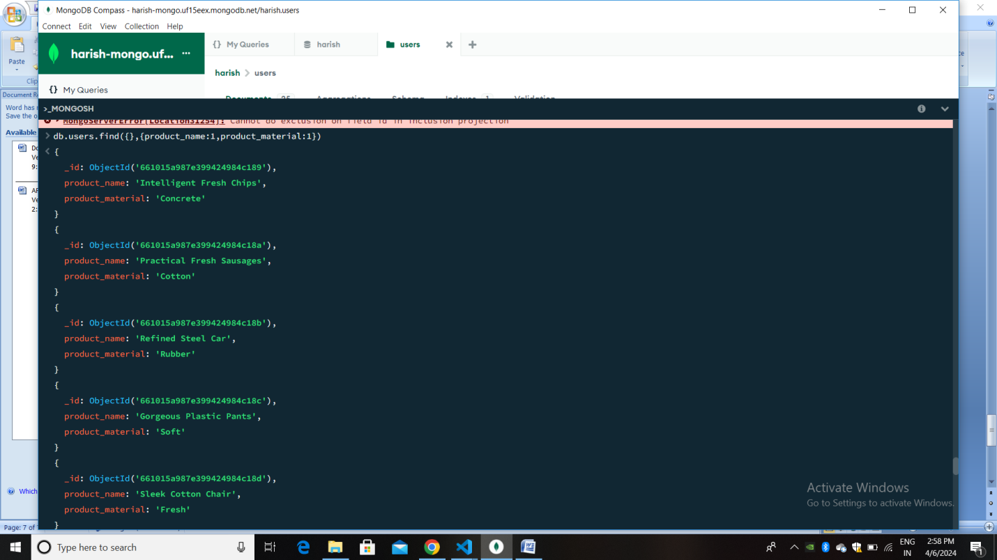

Find all products which contain the value of soft in product material

db.users.find({product_material: 'Soft'})

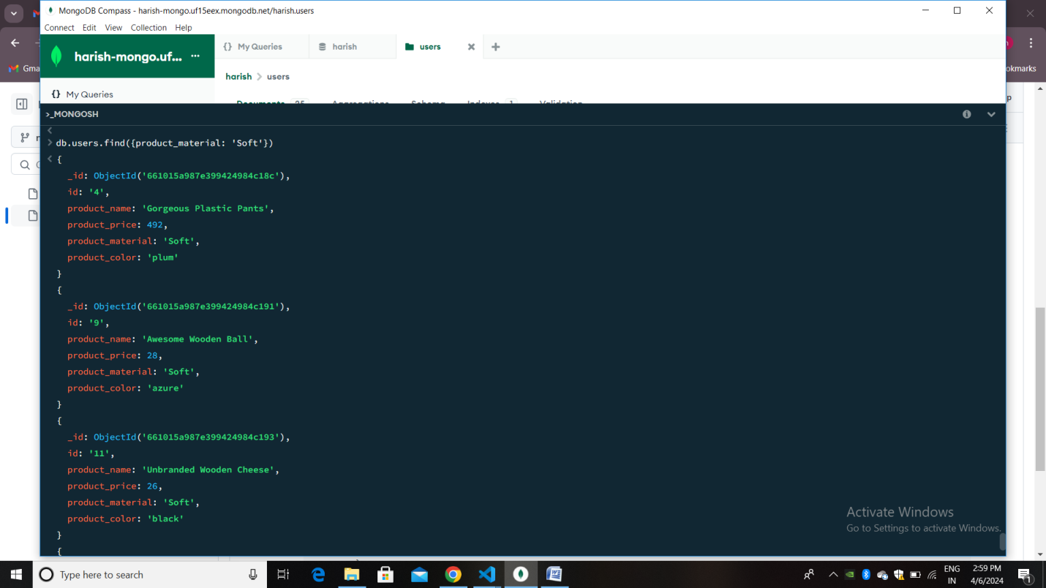

Find products which contain product color indigo  and product price 492.00

db.users.find({$or:[{product_color:'indigo'},{product_price:'492.00'}]})

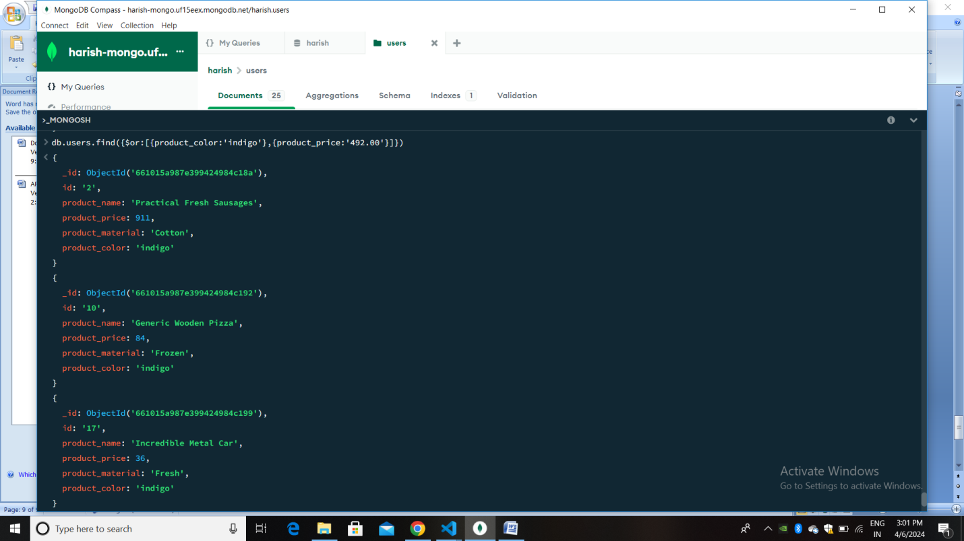

Delete the products which product price value are 28

Db.users.deleteOne({product_price:’28’})

