Project Title: E-Commerce Product & Review Analytics Web Application.
Team Members: Karthikeyan Sundara Anandam, Ganeshkumar Ashok, Harish Maheswaran.

Introduction
The purpose of this project is to design, implement, and deploy a full-stack Review Management Web Application that demonstrates our ability to work with NoSQL databases, perform CRUD operations, develop data-driven interfaces, and deploy a functioning web service.
The application allows users to browse products, read user-submitted reviews, and interact with the system by creating, updating, or deleting reviews. The backend is implemented using Flask, the database layer uses MongoDB Atlas, and the application is deployed on Render, making it publicly accessible.

Live Application
- https://github.com/Karthii9080/ADT_Project
- https://adt-project-wrik.onrender.com/

Admin Password to access dashboard in application:
Email: admin@iu.edu
Password: Admin@123

HOME PAGE:
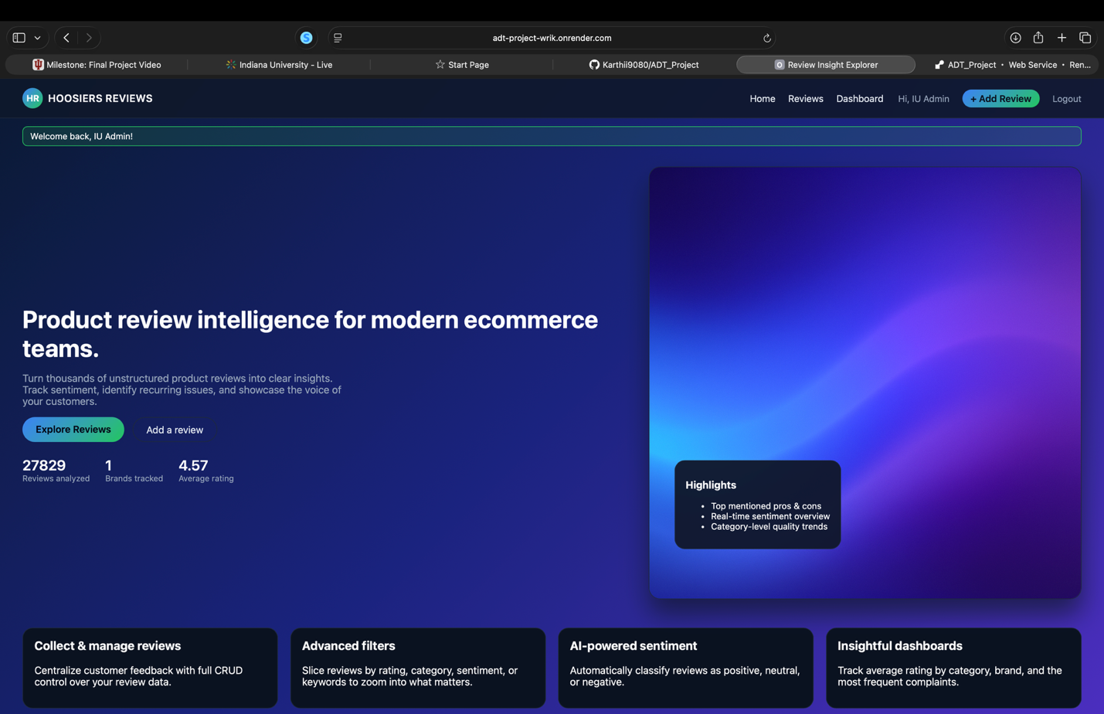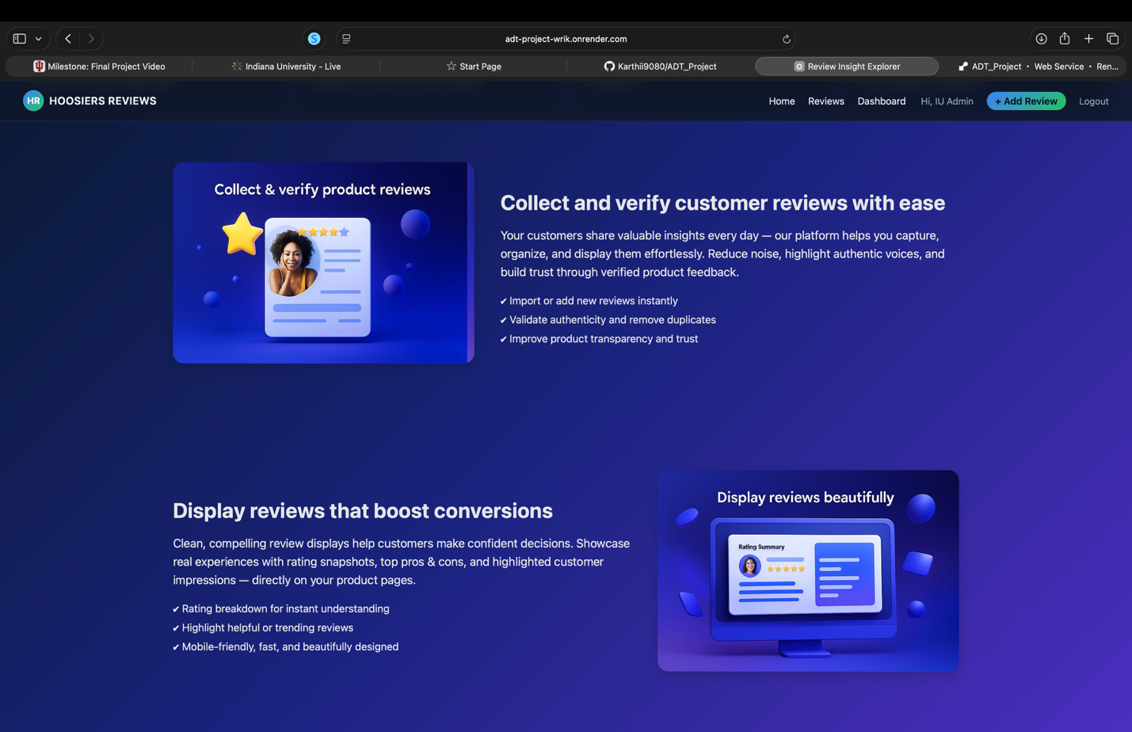

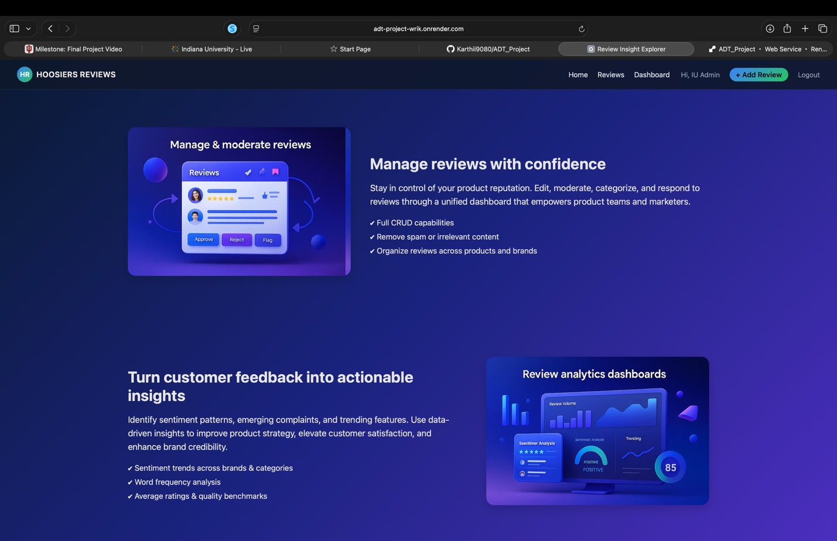
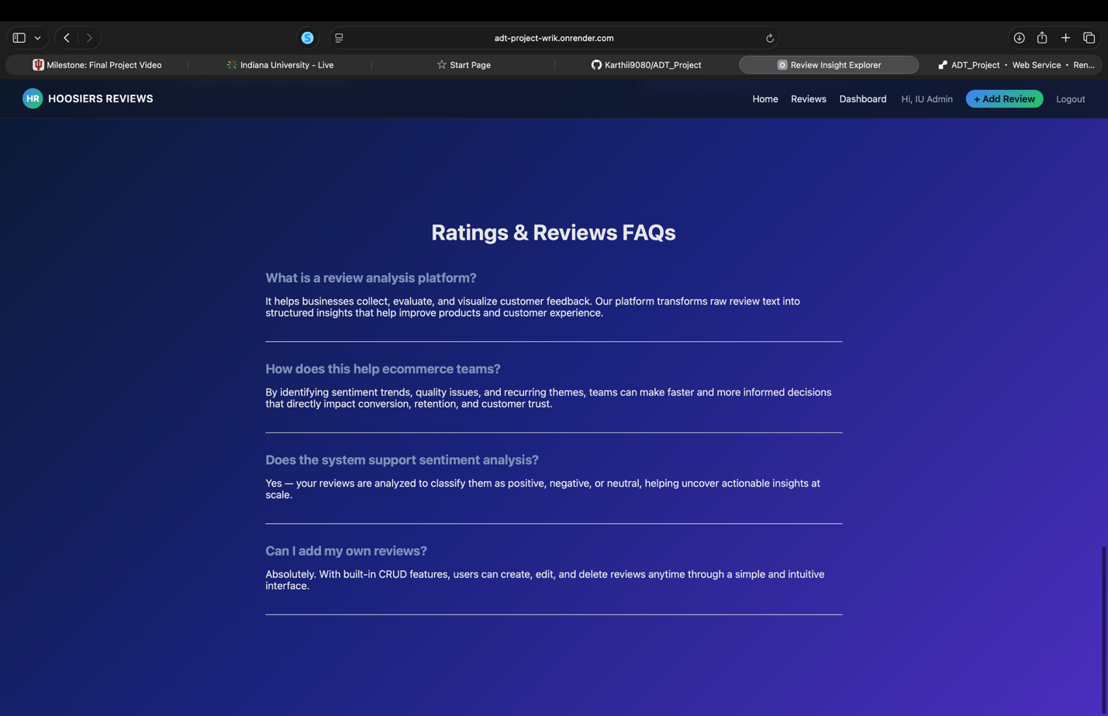

REVIEWS PAGE:

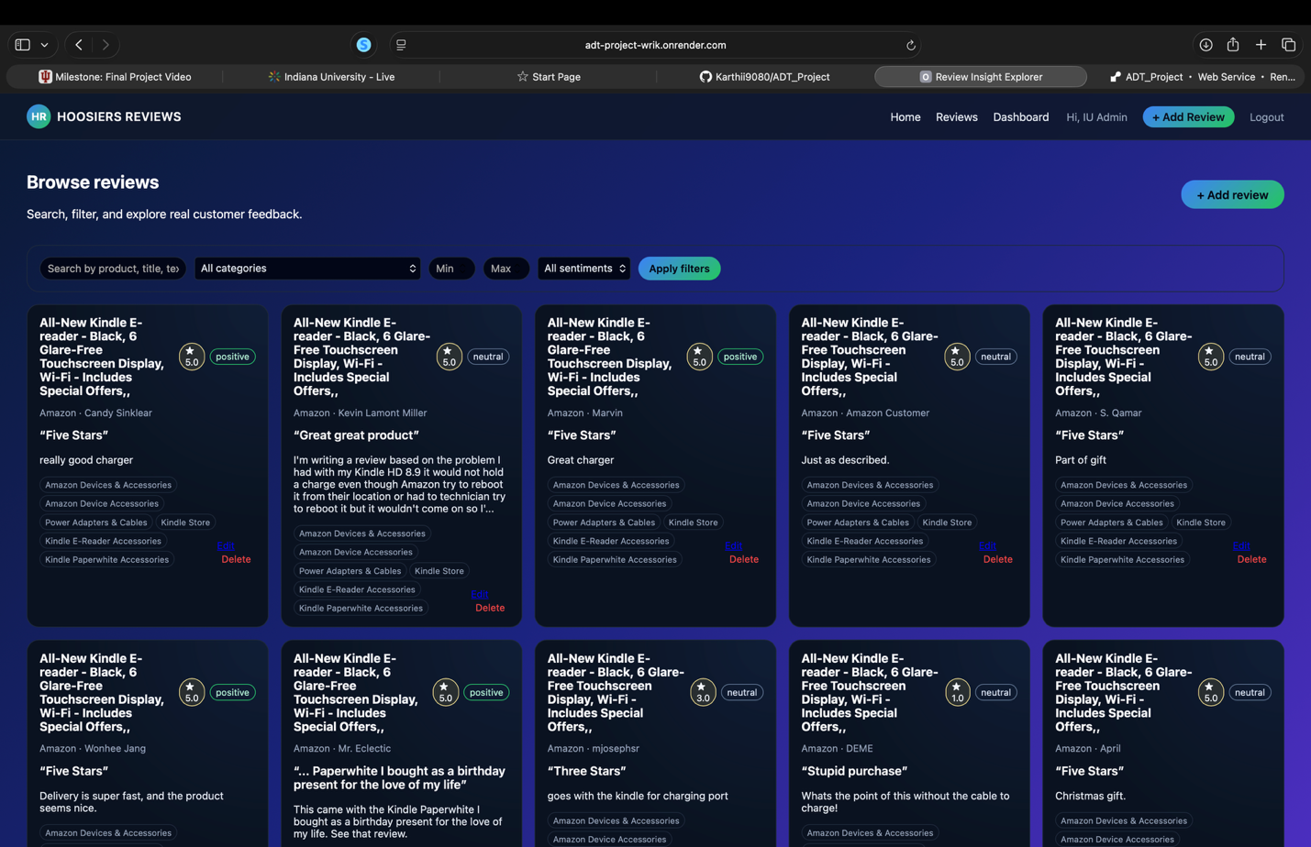
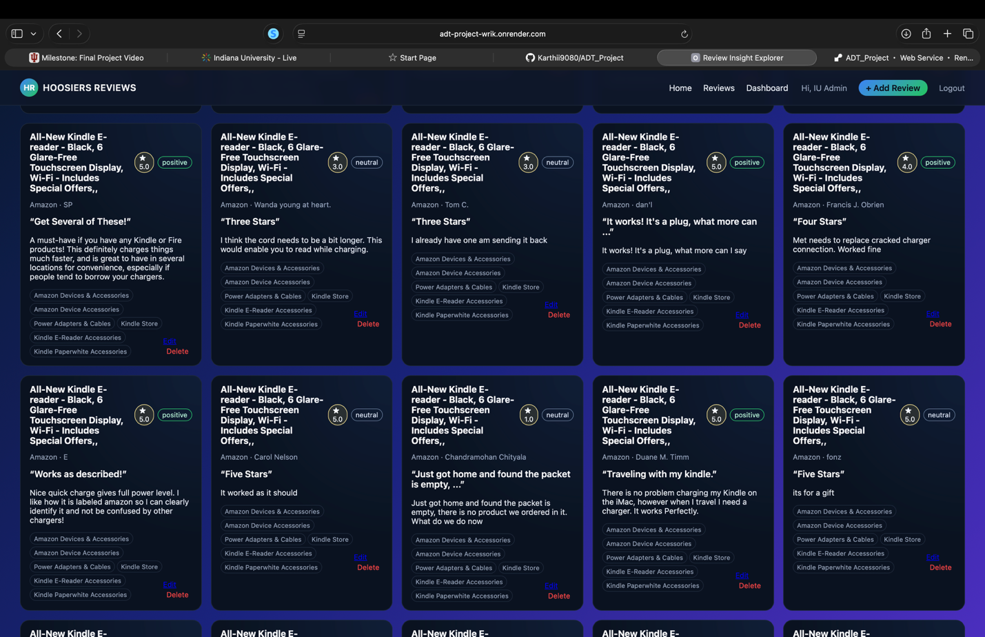

ADDING NEW REVIEW:

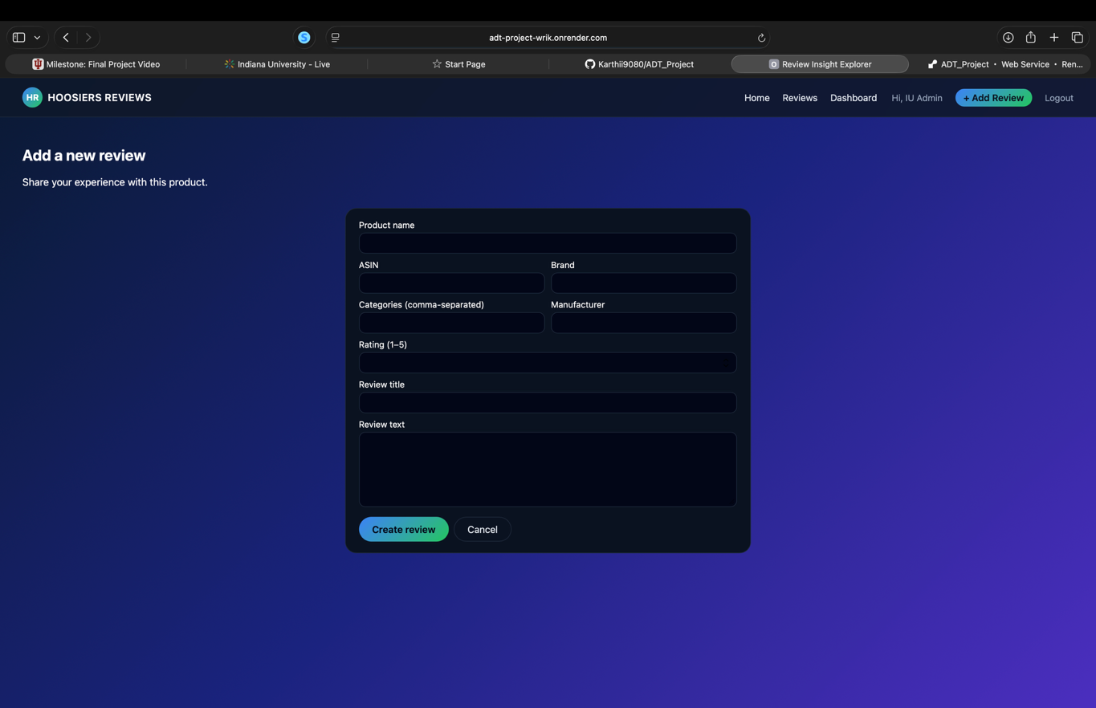

EDITING EXISTING REVIEW:

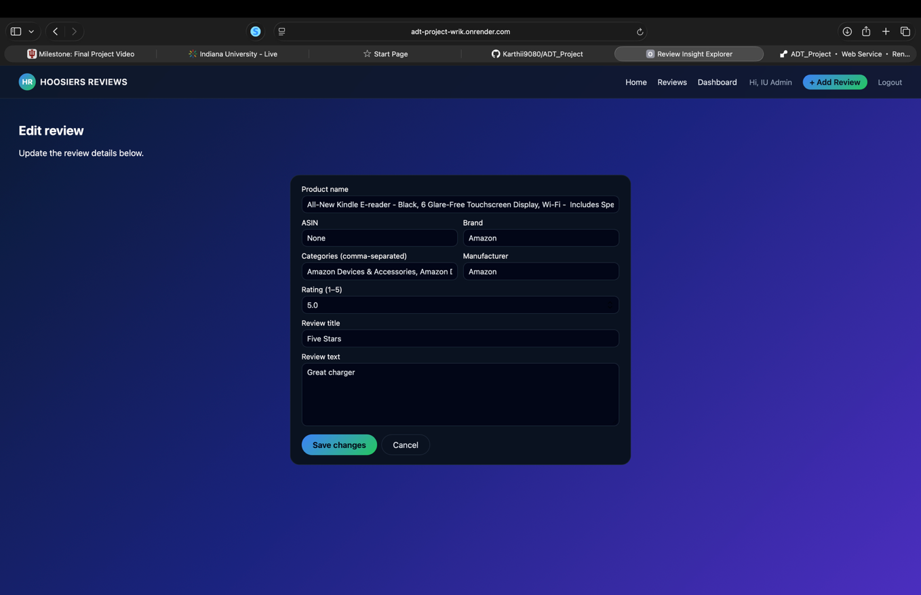

DELETING REVIEW:

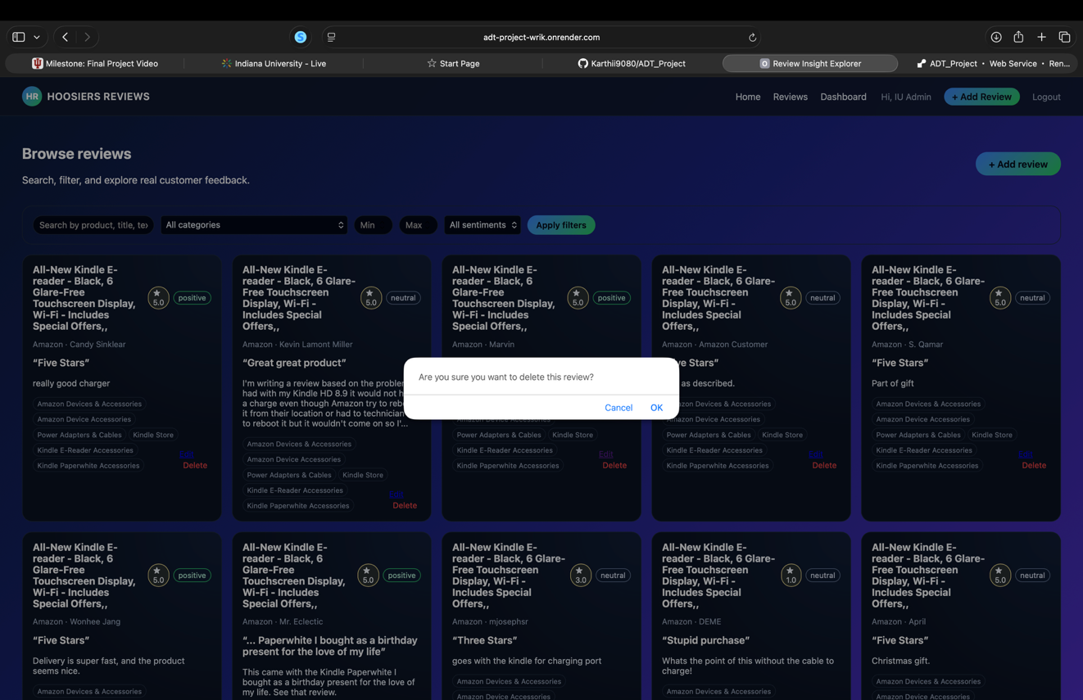

LOG IN PAGE:

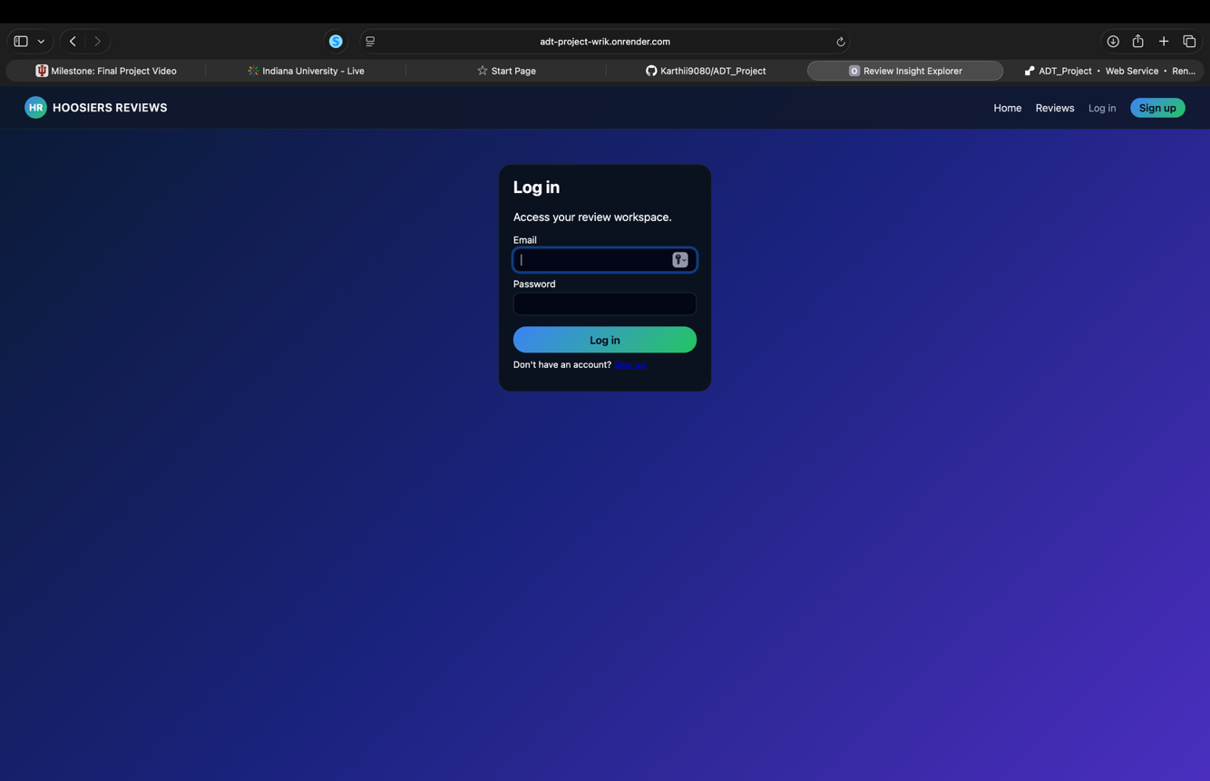

SIGN UP PAGE:

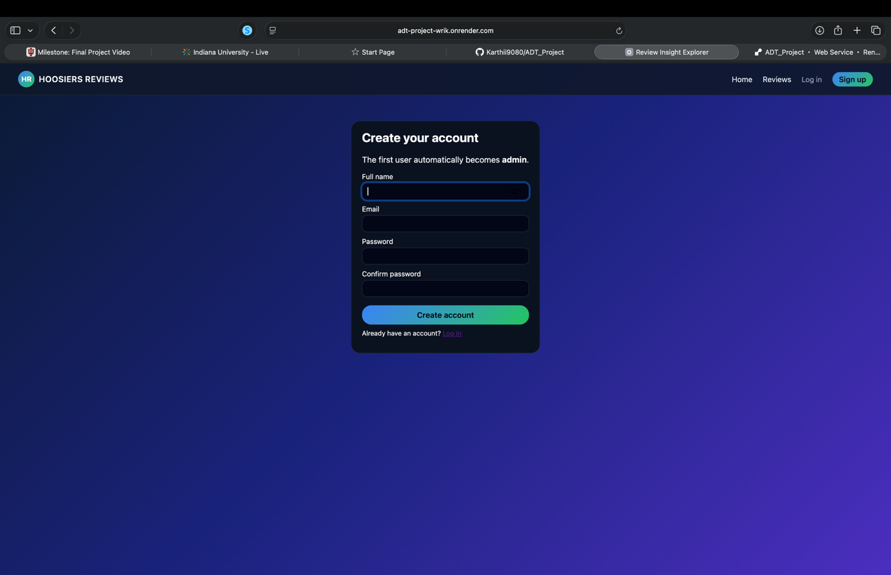

MONGODB DATABASE:

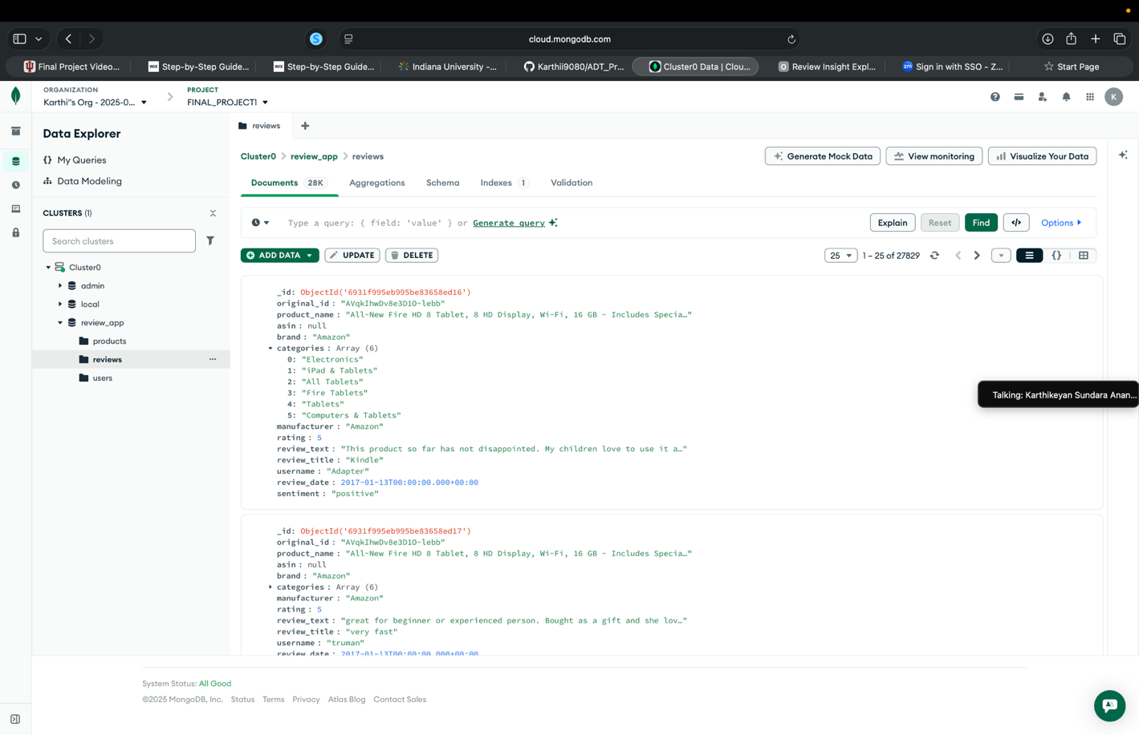

DASHBOARD PAGE:
We have created this application by implementing the authentication function where ADMIN could only view the dashboards. Where normal users can’t view the dashboards page.
So to access the dashboards page you need to log in using the credentials:
Email: admin@iu.edu
Password: Admin@123

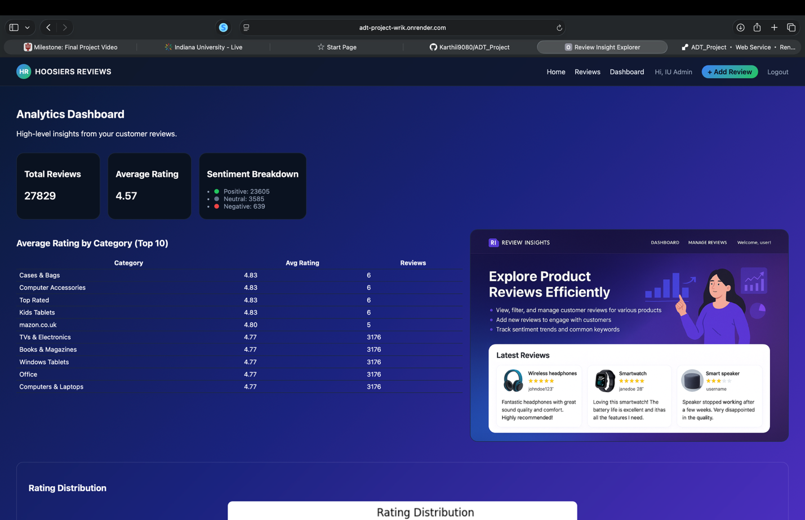
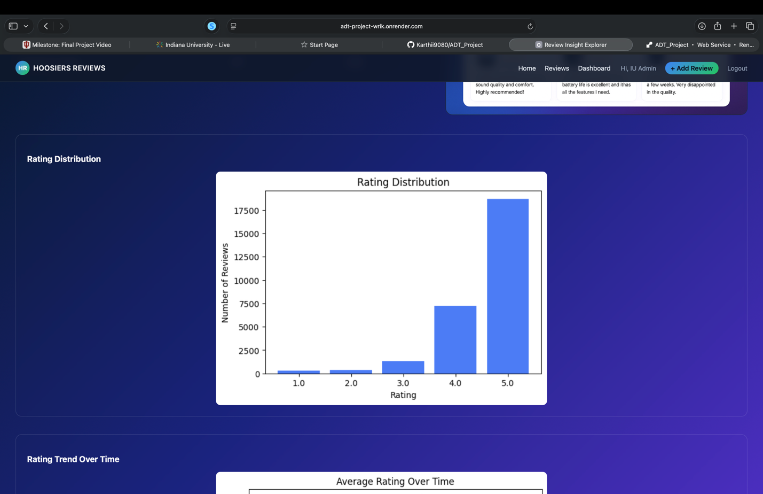
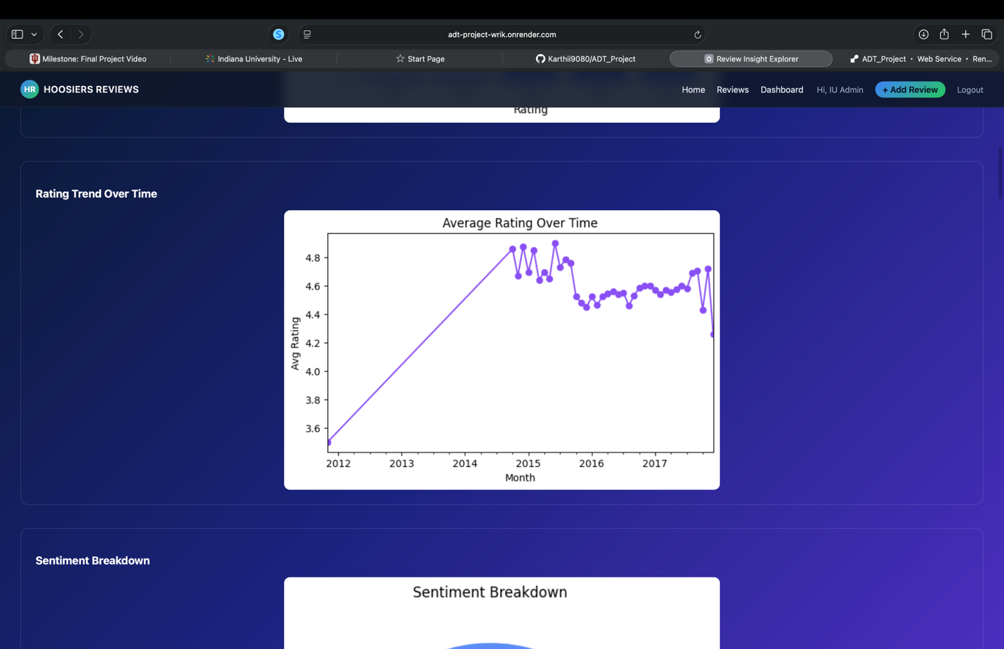

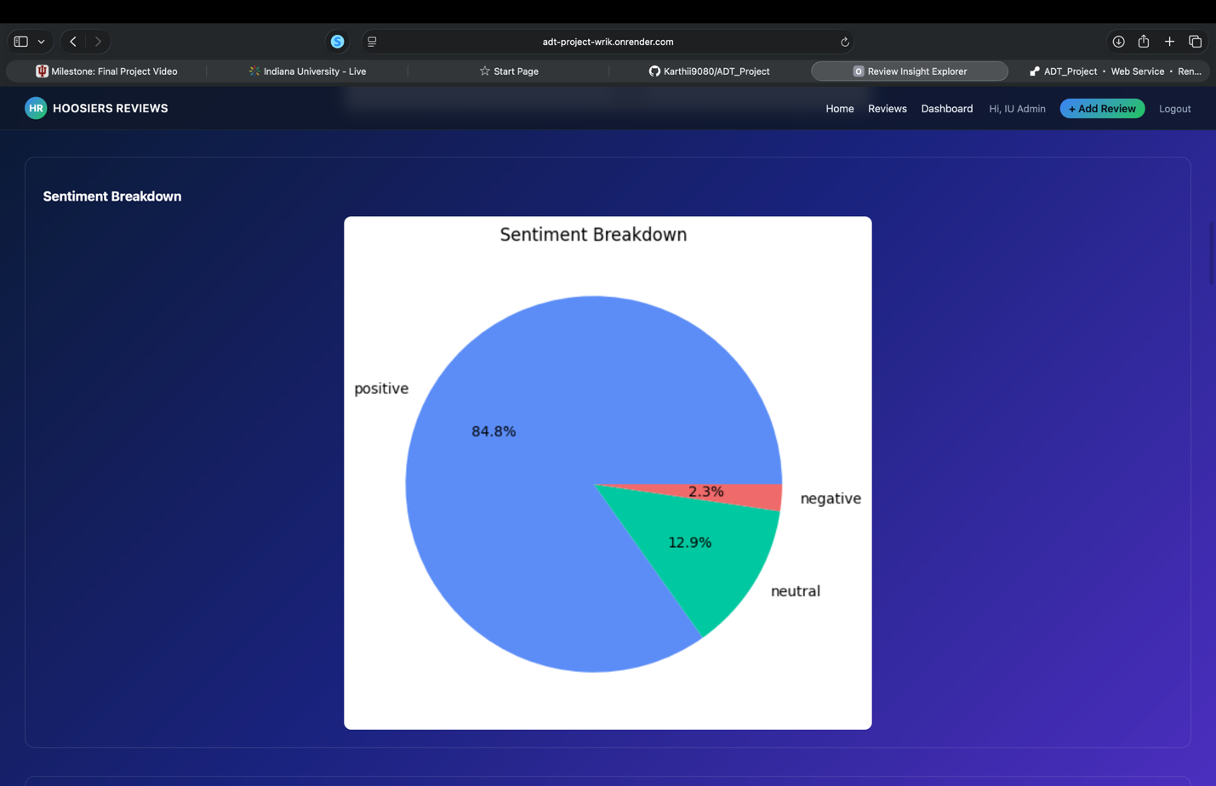

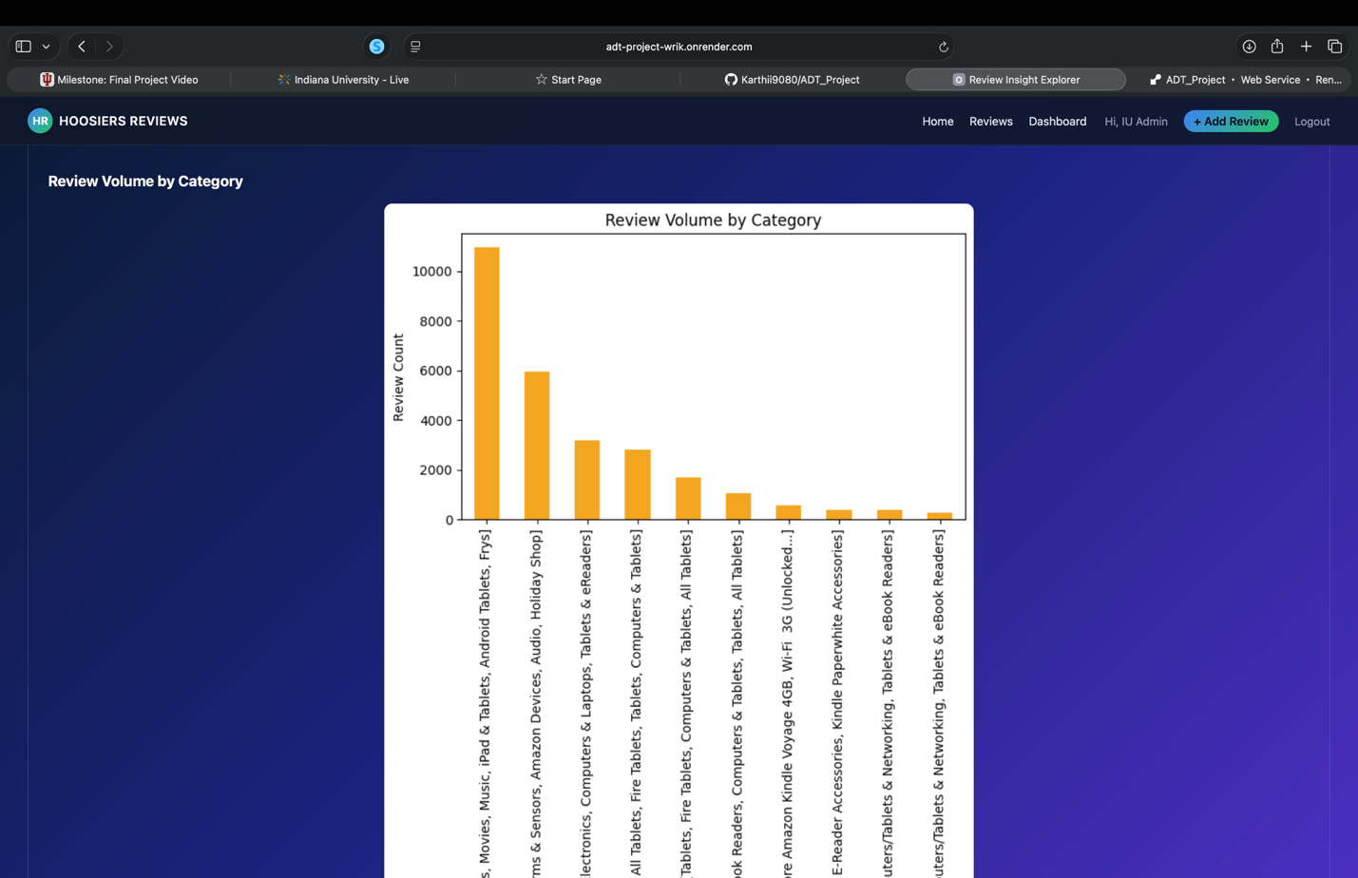
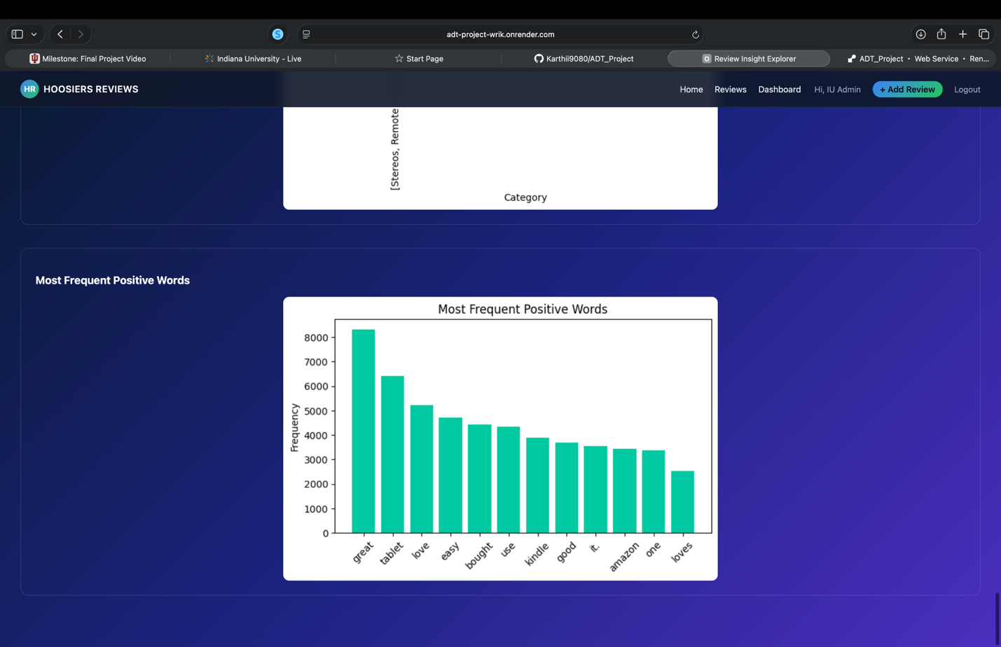
REPORT:
1. Purpose & Audience:
A large volume of modern data, especially customer-generated content—does not fit neatly into relational tables. Product reviews vary widely in structure, length, and completeness, making MongoDB an ideal choice due to its flexible document-based model.
The goal of our application is to simulate how an e-commerce platform might store and manage reviews in a scalable NoSQL environment.

Intended Audience:
- E-commerce platform users who want to explore product feedback.
- Business analysts are interested in customer sentiment and review trends.
- Academic evaluators assessing technical understanding of schema design, queries, and deployment.

Project Objectives
- Demonstrate mastery of NoSQL database design.
- Implement a live web application using modern backend tools.
- Perform full CRUD operations on a MongoDB collection.
- Showcase analytical operations using aggregation pipelines.
- Deploy the working application and provide a public link.

2. App Functionalities:
The Review Management Web Application provides a complete set of functions that simulate how a real e-commerce review platform operates. It integrates a MongoDB database, a Flask backend, and a template-based frontend to allow users to browse products, view reviews, and interact with the system using CRUD operations. Below is a detailed explanation of how each part of the application works.

1. Home Page – Product Browsing & Overview
The Home Page is the landing screen of the application and introduces users to the platform’s purpose: analyzing retail product reviews on a scale.
It blends UI design with backend integration to deliver a modern, data-driven browsing experience.

Functionalities:
- Hero Overview Section displays total number of reviews analyzed, number of brands tracked, and the global average rating across all reviews.
- Navigation buttons to explore reviews or sign up/log in.
- Description and highlights including top-mentioned pros and cons, category-level insights, and sentiment overview.
- Feature cards showcasing capabilities such as collecting and managing reviews, advanced filters, AI-powered sentiment analysis, and analytical dashboards.
This homepage serves as a contextual introduction, preparing the user for deeper analytics within the system.

2. Product Detail Page – View Reviews & Insights
When a user selects a product, they are taken to the Product Detail Page, which provides an in-depth breakdown of product reviews and aggregated insights.

a. Product Information
Displays:
- Product name
- Brand
- Category & subcategories
- Additional metadata pulled from MongoDB

b. Review Display
Fetched dynamically from the reviews collection using product_id.
Displayed fields include:
- Review title
- Username
- Rating
- Review text
- Sentiment label (positive / neutral / negative)
- Category tags for each review

c. Insights
The system also calculates:
- Average rating for the product
- Sentiment distribution among its reviews
- Growth or decline in review count
This page combines structured data and user-generated content to support decision-making.

3. Add a New Review (CREATE)
The platform allows authenticated users to add new reviews for any product.

Functionalities:
- Input fields for review title, username, rating, and review text
- Validation to ensure:
  - Rating is numeric
  - Text fields are not empty
- Automatic insertion into MongoDB using insert_one ()
- Flash messages provide instant feedback on successful submission
This feature demonstrates the CREATE part of CRUD operations.

4. Edit Review (UPDATE)
Users can update previously submitted reviews.

Functionalities:
- Editable fields:
  - Review title
  - Review text
  - Review rating
- Error handling for invalid or missing inputs
- MongoDB update performed via:

update_one({"_id": ObjectId(review_id)}, {"$set": {...}})
- Redirects back to the product detail page after update
- Flash notifications confirm successful editing
This reflects the UPDATE component of CRUD.

5. Delete Review (DELETE)
Users (admin or authorized roles) can delete inappropriate, incorrect, or outdated reviews.

Functionalities:
- Review identified using unique _id
- Deletion executed using:

delete_one({"_id": ObjectId(review_id)})
- Prevents removal of invalid/non-existent reviews
- Redirects to the product view after deletion
- Flash message confirms the removal
This completes the DELETE component of CRUD.

6. Analytics Dashboard – Visual Insights & Data Exploration:

1. Rating Distribution Dashboard
The Rating Distribution chart provides a clear overview of how customers rate products across the entire dataset.

Purpose:
To help users understand the overall satisfaction levels of customers by visualizing how ratings are spread from 1 to 5 stars.

Features:
- Displays a bar chart showing the number of reviews for each rating.
- Highlights trends such as:
  - Large concentrations of 4-star and 5-star ratings (indicating high customer satisfaction).
  - Fewer negative reviews (1-star and 2-star).
- Helps identify customer sentiment at a high level before drilling down into individual reviews or sentiments.

Business Use Case:
- Brands can quickly identify how well products are performing.
- A high number of low ratings signals quality concerns requiring action.

2. Rating Trend Over Time Dashboard
The Average Rating Over Time chart presents how customer satisfaction evolves month by month.

Purpose:
To reveal changes in customer perception over time and detect seasonal or event-driven fluctuations.

Features:
- A time-series line graph showing monthly average ratings.
- Identifies patterns such as:
  - Sudden drops in rating (e.g., due to a product quality issue or recall).
  - Gradual improvements after updates or redesigns.
- Combines both continuous trend lines and scatter points for precise interpretation.

Business Use Case:
- Helps product teams monitor long-term product performance.
- Enables data-driven decisions based on shifts in customer satisfaction.

3. Sentiment Breakdown Dashboard
The Sentiment Breakdown pie chart categorizes customer reviews into positive, neutral, and negative sentiments using a sentiment classifier.

Purpose:
To provide an at-a-glance snapshot of customer feelings toward the product.

Features:
- Pie chart displays percentage share of each sentiment category.
- Automatically analyzed using sentiment classification logic.
- Insights include:
  - Considerably high percentage of positive reviews.
  - Smaller proportions of neutral and negative reviews.

Business Use Case:
- Helps companies gauge the emotional tone of customer feedback.
- Useful for marketing teams, quality assurance, and customer support strategy.

4. Review Volume by Category Dashboard
The Review Volume by Category chart visualizes the number of reviews available for each product category.

Purpose:
To highlight which categories, receive the most customer engagement.

Features:
- Bar chart listing product categories on the x-axis and corresponding review counts on the y-axis.
- Shows disproportionately high review volumes for categories like:
  - Tablets
  - Amazon devices
  - Computer accessories
- Categories with fewer reviews indicate areas with limited customer interaction.

Business Use Case:
- Helps identify high-traffic product categories.
- Assists companies in prioritizing resources, marketing focus, and inventory planning.

5. Most Frequent Positive Keywords Dashboard
The Most Frequent Positive Words chart analyzes text data from positive reviews to extract commonly used words.

Purpose:
To uncover what customers, appreciate the most about products.

Features:
- Displays a bar chart of the most frequently occurring positive keywords such as:
  - “great”
  - “tablet”
  - “love”
  - “easy”
  - “use”
- Indicates major themes in customer praise—such as usability, quality, and performance.

Business Use Case:
- Help marketing teams highlight strengths in promotional material.
- Allow product teams to understand which features customers value the most.

3. Link to Hosted Application & Deployment Notes:
The Hoosiers Reviews application has been successfully deployed and is fully accessible online. The live application can be accessed at:
Hosted Application URL:
https://adt-project-wrik.onrender.com/
The complete project codebase and development history are publicly available on GitHub:
GitHub Repository:
https://github.com/Karthii9080/ADT_Project.git

Deployment Challenges & Solutions:
Deploying the Hoosiers Reviews application to Render presented several practical challenges. Below is a concise summary of the main issues faced and how they were resolved.

1. Environment Variables Not Detected
Issue: The app failed to start because Render did not automatically recognize Flask environment variables like FLASK_APP, SECRET_KEY, and the MongoDB connection string.
Solution: Added all required variables manually in Render → Environment settings. This allowed Flask and MongoDB to initialize correctly.

2. Missing Python Dependencies
Issue: The deployment failed because several packages (e.g., pymongo, matplotlib, python-dotenv) were missing from requirements.txt.
Solution: Regenerated the file using pip freeze > requirements.txt and redeployed. Render built the app successfully afterward.

3. MongoDB Atlas Connection Blocked
Issue: MongoDB initially rejected requests from Render due to restricted network access.
Solution: Whitelisted Render’s IP range (0.0.0.0/0) in MongoDB Network Access. The app was then able to load and save review data.

4. Static File Path Errors
Issue: CSS and JS files did not load properly in production, causing broken page layouts.
Solution: Ensured all static files were placed in Flask’s /static folder

5. Slow Dashboard Loading
Issue: Dashboard analytics (over 27k reviews) caused slow first-time loading on Render.
Solution: Optimized data processing applied lightweight aggregations, and cached repeated operations.
4.Technical Development:
The development of our eCommerce Review Management Application involved the design and integration of multiple technical components across backend development, database design, frontend interface creation, and system integration. Each team member contributed strategically to ensure that the final system aligned with project requirements for CRUD functionality, data visualization, and user interaction with a MongoDB-backed dataset. Below is a detailed summary of the technical work completed.

1. Backend Development (Flask Application):
Our backend was implemented using the Flask web framework, which served as the central hub for routing, request handling, and communication between the front-end UI and the MongoDB database. Key technical accomplishments include:
RESTful Route Design:
We structured the application using a RESTful approach with clear separation of concerns:
- GET routes for retrieving product lists, product details, and associated reviews.
- POST routes for creating reviews, editing existing reviews, and deleting entries.
- Error handling through Flask’s flash() system to provide real-time user feedback.
Database Connectivity:
We implemented secure and dynamic MongoDB connectivity using:
MongoClient(MONGODB_URI)
This allowed direct interaction with the two main collections:
- products
- reviews
Through the PyMongo driver, we designed efficient commands for querying, inserting, updating, and deleting review data.
Business Logic Functions:
The backend implements computation logic, such as:
- Calculating average product rating dynamically.
- Sorting reviews by date.
- Aggregating analytics via MongoDB pipeline ($group, $avg, $sort, $limit) for the /api/top_products endpoint.
These technical features demonstrate correct use of NoSQL operations and backend service design.
2. Database Design & Integration (MongoDB):
Our database was structured to efficiently store both static and dynamic information.
Collections and Structure:
We worked with two interconnected collections:
(a) Products Collection:
Contains descriptive product metadata such as
- product ID
- asin
- brand
- categories
(b) Reviews Collection:
Stores all user-generated review content:
- review title
- review text
- rating
- username
We ensured consistency using numeric product_id values across both datasets, enabling seamless joins and queries.
CRUD Implementation:
Each database operation is fully implemented:
- Create - insert new review documents
- Read - query products and fetch related reviews
- Update - update review title, text, or rating
- Delete - delete review document by _id
The design ensures proper linking of user input to persistent storage in MongoDB.

3. Front-End Development (HTML, Jinja Templates):
The user interface was developed through HTML and Jinja template rendering, which allows dynamic page updates based on backend data.
Interface Functionalities:
- Product listing page with pagination
- Product detail page with complete review list
- Interactive review submission form
- Edit and delete review options integrated into each review entry
4. Application Integration & Workflow Architecture:
The entire system follows a three-layer architecture:
- Presentation Layer
- HTML + CSS+ JS
- Displays product and review information.
Application Layer:
Flask routes handle:
- user requests
- form validation
- data routing
- business logic computations
Contributions:
- Development of the Hoosiers Reviews application was a collaborative effort carried out by Karthikeyan Sundara Anandam, Harish Maheswaran, and Ganeshkumar Ashok. Each team member contributed significantly to different aspects of the project, ensuring successful completion of the system design, implementation, analytics, and deployment. The detailed contributions are listed below:

1. Karthikeyan Sundara Anandam - Backend, Database Integration & Deployment:
- Karthikeyan played a key role in building the backend infrastructure and connecting the application to the MongoDB Atlas database. He implemented the Flask routes, CRUD operations, and review management logic. He also ensured the connection between Python, MongoDB, and the dashboard analytics worked correctly.
- In addition, he was responsible for deploying the application on Render, configuring environment variables, resolving deployment errors, and hosting the live version of the system.

2. Harish Maheswaran - Data Processing, Sentiment Analysis & Dashboard Analytics:
- Harish focused mainly on data processing, cleaning, and building the sentiment analysis pipeline. He prepared the review dataset, designed preprocessing logic, and implemented sentiment classification to categorize reviews into positive, neutral, and negative.
- He also contributed significantly to generating the analytical dashboards, including rating distribution, rating trends over time, sentiment breakdown, category insights, and frequent keyword charts.

3. Ganeshkumar Ashok — Frontend Design & User Interface Development:
- Ganeshkumar was responsible for designing the user interface and ensuring a clean, intuitive user experience. He developed the HTML and CSS layouts for the homepage, product detail pages, review cards, and dashboard interface.
- He also integrated Bootstrap to create responsive layouts and styled sentiment labels, rating badges, forms, and navigation components.

Overall Team Collaboration:
- All three team members collaborated closely throughout the project lifecycle. Tasks were divided logically based on technical strengths, while regular communication ensured smooth progress. The final system reflects combined efforts in backend engineering, data analytics, UI development, and cloud deployment.

5.References:
The development of the Hoosiers Reviews application involved the use of various technical resources, official documentation, and learning materials. These references supported the implementation, debugging, and optimization of the system across backend development, frontend design, sentiment analysis, data processing, visualization, and deployment.
Below is the complete list of references consulted during the project:
1. Official Documentation:
These sources provided technical guidance and best practices for tools used in the project:
- Flask Documentation
https://flask.palletsprojects.com/
- MongoDB Atlas Documentation
https://www.mongodb.com/docs/atlas/
- PyMongo Documentation
https://pymongo.readthedocs.io/
- Jinja2 Template Documentation
https://jinja.palletsprojects.com/
- Bootstrap Documentation
https://getbootstrap.com/docs/
- Matplotlib Documentation
https://matplotlib.org/stable/
- TextBlob Documentation (Sentiment Analysis)
https://textblob.readthedocs.io/
- Render Deployment Documentation
https://render.com/docs
2. Python & Data Processing Resources
- Pandas User Guide — https://pandas.pydata.org/docs/
- NLTK/Text Processing Concepts — https://www.nltk.org/
These resources supported the dashboard’s data processing and visualization features.
3. Academic Articles & Tutorials Consulted:
The following tutorials and articles helped reinforce concepts used in the project:
- “Building Dashboards with Flask and Matplotlib” — Real Python
- “MongoDB Schema Design Best Practices” — MongoDB Blog
4. AI Tools Used for Debugging, Optimization, and Explanation:
No AI coding assistant was used to generate code, but AI tools were used strictly for debugging, fixing errors, optimizing logic, and clarifying concepts.
This usage complies with academic integrity rules.
Tools Used:
- ChatGPT by OpenAI
Assisted with debugging Flask route errors, MongoDB connection issues, deployment troubleshooting, and explanation of errors.
Statement of Work:
All code in this project was written manually by the authors:
Karthikeyan Sundara Anandam, Harish Maheswaran, and Ganeshkumar Ashok.
Any external tools or resources were used only for guidance, debugging, and clarification - not for direct code generation.
6. Reflections:

What We Learned:
Through this project, we learned how to design and build a complete full-stack web application from scratch. We gained experience in working with Flask for backend development, MongoDB Atlas for database storage, and Jinja templates for dynamic UI rendering. We also learned how to process real-world datasets, clean and prepare data, and apply sentiment analysis to classify customer review text. Developing the analytics dashboard helped us improve our understanding of data visualization and how to convert raw information into
meaningful insights.
Most Challenging Parts:
The most challenging aspect of the project was integrating all components - backend routes, database operations, review management, sentiment predictions, and dashboard charts - into one unified system. Handling deployment on Render also presented several obstacles, including missing dependencies, environment variable configuration, and MongoDB network permissions. Debugging these issues taught us how real production environments behave differently from local development.
Most Interesting Parts:
The most interesting part of the project was building the analytics dashboard. Creating charts for sentiment breakdown, rating distribution, and review keywords showed how data analysis can reveal patterns that are not obvious from raw text. It was exciting to see how user-generated reviews could be transformed into visual insights that help businesses understand customer behavior and product performance.

What We Would Improve with More Time:
If we had additional time to enhance the application, there are several improvements and advanced features we would incorporate to make the platform more robust, user-friendly, and closer to real-world industry standards.
1. Integration with Amazon Product Advertising API:
One major improvement would be integrating the Amazon Product Advertising API. This would allow the application to automatically fetch:
- Real-time product details
- Live customer reviews
- Up-to-date review counts and ratings
- Product metadata such as price, availability, and categories
This would eliminate the need for static datasets and transform the platform into a constantly updating, real-time review analysis system.
2. Product Images and Visual Display:
Currently, the application only displays text-based metadata for products. With more development time, we would add:
- High-quality product images.
- Image galleries for each product.
- Thumbnail previews on the Product Explorer page.

Adding images would significantly improve user experience, making the platform visually appealing and more like commercial e-commerce interfaces.
3. Direct Links to Real Product Pages:
Another enhancement would be providing URL links to the actual Amazon product pages. This would allow users to:
- Visit the official product page
- Check updated ratings
- Compare customer feedback
- View related products
Integrating product URLs would increase usability and connect the application more closely with real e-commerce ecosystems.
4. Additional Features We Would Consider:
With even more time, we would explore enhancements such as:
- User authentication and login system
- More advanced NLP models for sentiment analysis (e.g., BERT)
- Interactive dashboards with live charts
- Real-time search suggestions
- Product comparison insights

Summary:
In summary, with additional time, we would expand the system by integrating external APIs, adding visuals, and making the platform more interactive and closer to commercial-grade review analytics tools. These enhancements would substantially improve both functionality and user engagement.

