**Ingestion data from http web address to Azure Data Lake (ADLS gen2)**

1. **Parameterized Linked service –** To fetch source data we use HTTP linked service to fetch the data from ECDC website. Since we are fetching more than one source file, we created a parameterized linked service.  
     
   A screenshot of a computer

   AI-generated content may be incorrect.
2. **Parameterized dataset –** Parameterized linked service has been invoked and dataset parameter for both Base URL and Relative URL has been created and passed at runtime.  
     
   A screenshot of a computer

   AI-generated content may be incorrect.
3. **Parameterized Sink dataset –** Parameterized sink dataset has been created, and data values are passed at runtime.  
     
   A screenshot of a computer

   AI-generated content may be incorrect.
4. **Config file –** The JSON config file has been created with all required parameters including Base URL, Relative URL and Sink File names.  
     
   A computer screen shot of a computer code

   AI-generated content may be incorrect.
5. **Dataset for the config file –** One more dataset has been created and pointed to the JSON config file.  
     
   A screenshot of a computer

   AI-generated content may be incorrect.
6. **Pipeline – Lookup** activity makes use of the JSON data set to return the JSON data. We will have **ForEach** activity to loop through each array item and execute the **Copy** activity within  
     
   A screenshot of a computer

   AI-generated content may be incorrect.  
     
   A screenshot of a computer

   AI-generated content may be incorrect.
7. **Copy activity –** Copy activity source and sink has been parameterised to invoke the array item values from the ForEach activity.  
     
   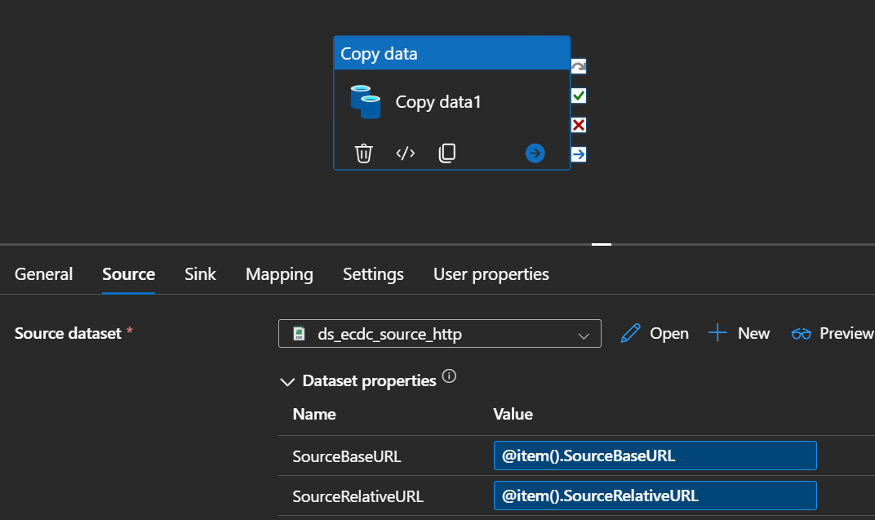  
     
   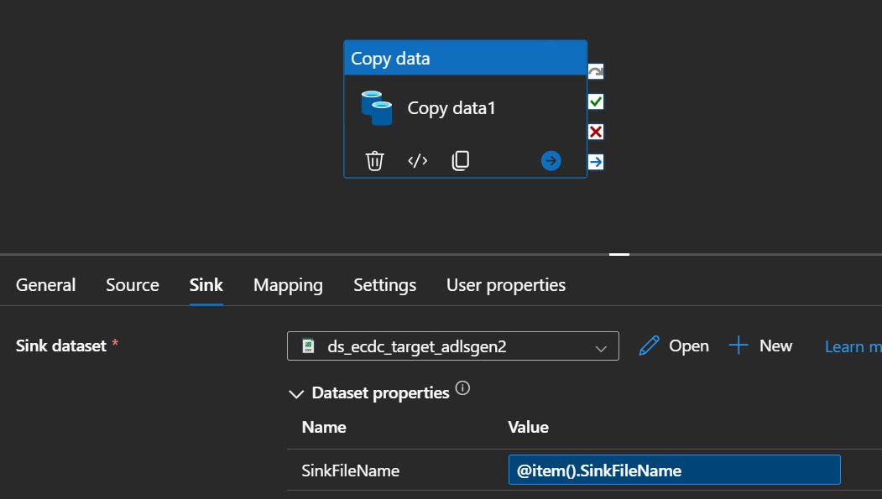
8. Once the pipeline has been completed, we have created a schedule trigger and associated the trigger with pipeline.  
     
   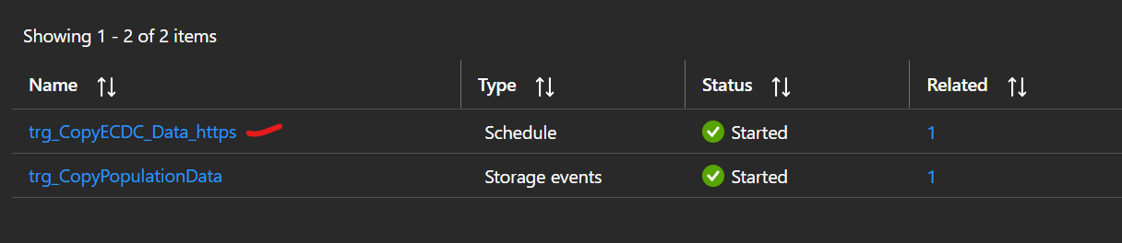

**Job Run:**The schedule trigger successfully triggers the pipeline at the scheduled time.  
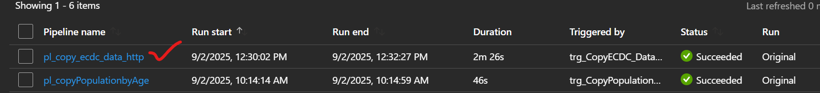

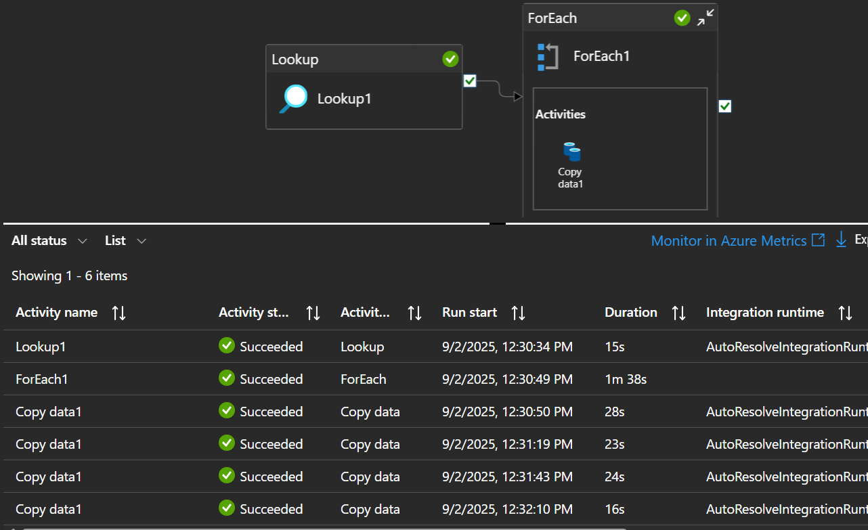

**File Loaded in the data lake path:**

