**Generated reports using PowerBI Desktop for the data loaded in SQL Database**

**Report 1:**

**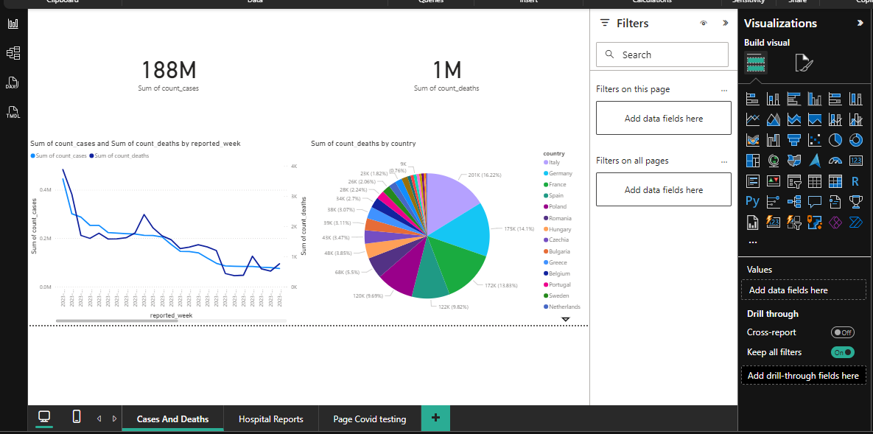  
  
 Key Metrics (Top Left)**

* 188M – Total COVID-19 cases (Sum of count_cases)
* 1M – Total COVID-19 deaths (Sum of count_deaths)

**Line Chart (Bottom Left)**

* + Title: Sum of count_cases and Sum of count_deaths by reported_week
  + X-axis: reported_week (time progression)
  + Y-axis:
    - Left: sum of count_cases (blue line)
    - Right: sum of count_deaths (orange line)
  + Purpose: Shows how cases and deaths evolved weekly over time.

**Pie Chart (Bottom Right)**

* + Title: Sum of count_deaths by country
  + Segments: Represent different countries
  + Legend: Shows percentage and count of deaths per country
  + Purpose: Highlights the distribution of deaths across countries.

**Report 2:**

1. **Hospital Occupancy Chart:**
   * Title: Sum of hospital occupancy_count by reported_date and country
   * Type: Stacked area chart
   * Countries: Austria, Bulgaria, Germany, Ireland
   * Time Range: July 2020 to January 2023
   * Purpose: Shows how hospital occupancy varied over time across these countries.
2. **ICU Occupancy Chart:**
   * Title: Sum of icu_occupancy_count by reported_date and country
   * Type: Stacked area chart
   * Same countries and time range
   * Purpose: Tracks ICU usage trends during the same period.

**Dashboard Features:**

* Field and filter options: Tools to add data fields and apply filters across pages.
* Tabs:
  + Cases And Deaths
  + Hospital Reports
  + Page Covid testing
  + These suggest the dashboard is part of a broader COVID-19 analytics report.

**Report-3**

**Top-Level Metrics**

* 188M – Total COVID-19 cases (Sum of count_cases)
* 1M – Total COVID-19 deaths (Sum of count_deaths)

**Line Chart (Left Side)**

* + Title: Sum of count_cases and Sum of count_deaths by reported_week
  + X-axis: reported_week (time progression)
  + Y-axis:
    - Left: sum of count_cases (blue line)
    - Right: sum of count_deaths (orange line)
  + Purpose: Tracks weekly trends in cases and deaths, helping identify peaks and declines over time.

**Pie Chart (Right Side)**

* + Title: Sum of count_deaths by country
  + Segments: Represent different countries
  + Legend: Shows percentage and count of deaths per country
  + Purpose: Highlights how deaths are distributed across countries.