**Note:** Initially planned to perform this transformation using HD Insights activity by using HQL statements. But due to exhausted quotas, I cannot perform the activity.

**HQL:**



**Transform Covid testing data from ECDC website**

The data on Covid-19 testing for the Europe region has been copied form ECDC (European Centre for Disease Prevention and Control) to Azure DataLake storage raw container.

Data:

**Requirement to transform the data:**

1. Firstly, to derive 2 digit and 3-digit code values from another Country LookUp data using LookUp transformation where Join condition on ‘country’.
2. We then performed LookUp transformation on Dim date table and renamed columns using select transformation as ‘reported_week_start_date’ and ‘reported_week_end_date’.
3. Then we loaded the rest of the columns as it is.

**LookUp data – Dim Country:**

**LookUp data – Dim Date:**

**Data flow transformation:**

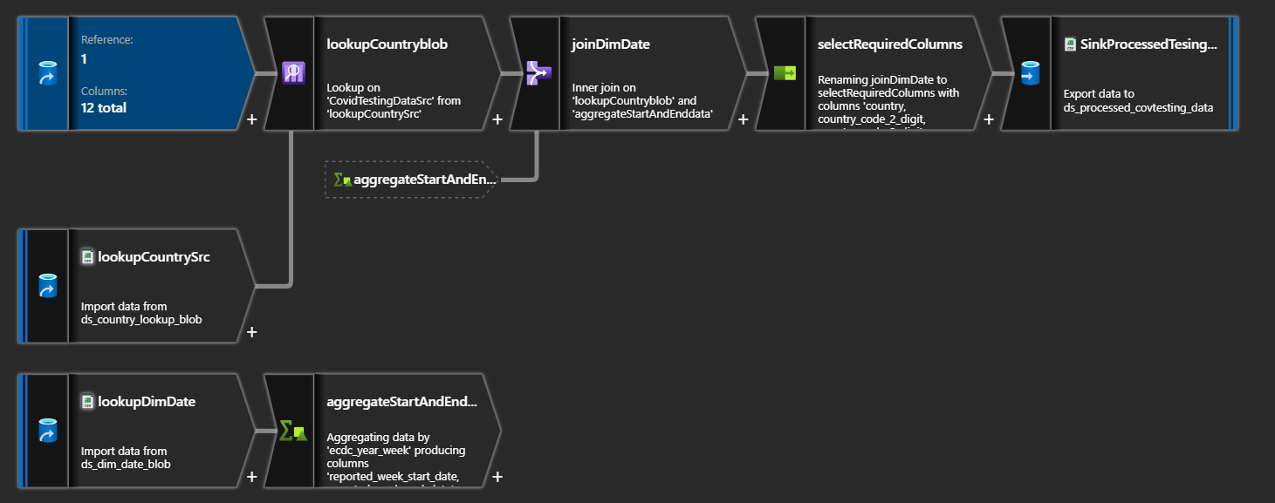

**Result Dataset:**

The transformed data are loaded in the Azure DataLake processed folder after successful pipeline on data flow activity.

**Transformed data:**

