**Transform Hospital Admissions data from ECDC website**

The data on Covid-19 patients admitted to Hospital and ICU admissions data for the Europe region has been copied form ECDC (European Centre for Disease Prevention and Control) to Azure DataLake storage raw container.

Data:

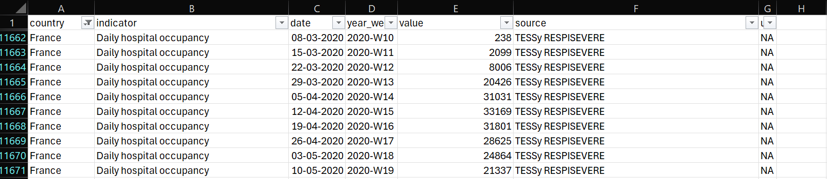

**Requirement to transform the data:**

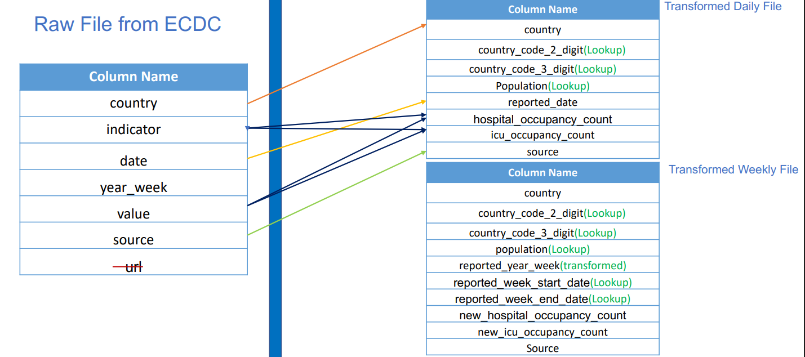

1. Firstly, to derive 2 digit and 3-digit code values from another Country LookUp data using LookUp transformation where Join condition on ‘country’.
2. The Column ‘Population’ needs to be added from the LookUp transformation.
3. The Column ‘date’ needs to be renamed to ‘Reported’ date.
4. Then we will spit the data using Conditional Split transformation, one stream to load the daily information on hospital and ICU admission and other stream is to load the weekly information.  
     
   Logic for conditional split,
   1. indicator == 'Daily hospital occupancy' || indicator == 'Daily ICU occupancy'
   2. indicator == 'Weekly new hospital admissions per 100k' || indicator == 'Weekly new ICU admissions per 100k'

1. The column ‘Indicator’ then pivoted on its values ‘Daily hospital occupancy’ and ‘Daily ICU occupancy’ to load pivoted column ‘hospital_occupancy_count’ and ‘ICU_occupancy_count’ which then be renamed using select transformation.
2. In weekly data stream, the column ‘Indicator’ has been pivoted as above and group by all columns.
3. In weekly data stream, we used dimension date table and performed LookUp transformation to bring columns ‘Week Start date’ and ‘Week End Date’ for each week in a month from 2019 to 2022.

**LookUp data – Dim Date:**

Used aggregate transformation, to perform max(date) and min(date) then group by the derived column ‘ECDC date’ using derived column transformation.

The sorted the records by those dates on Ascending to perform analytics easier.

**Data flow transformation:**

**Result Dataset:**

The transformed data are loaded in the Azure DataLake processed folder after successful pipeline on data flow activity.

**Daily data:**

**Weekly data:**

