https://awesomeopensource.com/projects/kubectl-plugins

https://krew.sigs.k8s.io/docs/user-guide/setup/install/

Kubectx -> helps to change between different contexts and clusters.
Kubens -> helps to change between name namespaces
https://github.com/ahmetb/kubectx/releases

KREW Installation:

(
set -x; cd "$(mktemp -d)" &&
OS="$(uname | tr '[:upper:]' '[:lower:]')" &&
ARCH="$(uname -m | sed -e 's/x86_64/amd64/' -e 's/\(arm\)\(64\)\?.*/\1\2/' -e 's/aarch64$/arm64/')" &&
KREW="krew-${OS}_${ARCH}" &&
curl -fsSLO "https://github.com/kubernetes-sigs/krew/releases/latest/download/${KREW}.tar.gz" &&
tar zxvf "${KREW}.tar.gz" &&
./"${KREW}" install krew
)

Add following in ~/.bashrc and reboot.
export PATH="${KREW_ROOT:-$HOME/.krew}/bin:$PATH"

root@ip-192-168-1-100:~# kubectl krew
krew is the kubectl plugin manager.
You can invoke krew through kubectl: "kubectl krew [command]..."

kubectl krew search

https://krew.sigs.k8s.io/plugins/

alias kk='kubectl krew'
kubectl krew install tree - kubectl tree deploy app1
kubectl krew install neat
ku create deployment app2 --image nginx:latest --replicas 3 --dry-run -o yaml | kubectl neat

kubectl krew install outdated
kubectl krew install whisper-secret
kubectl whisper-secret generic my-secret-2 --from-literal username --from-literal password -- -n default #Prompts for Username and Sectet

kubectl krew install view-secret
kubectl krew view-secret my-secret
kubectl krew install unlimited
kubectl krew install ice
kubectl krew install popeye
kubectl krew install ktop
kubectl krew install example - kubectl example deploy
kubectl krew install mtail - ku mtail app=hello
ku krew install view-utilization - ku view-utilization -n kube-system -h
https://github.com/derailed/k9s/releases
kubectl dig:
apt install golang-go
go get -u github.com/sysdiglabs/kubectl-dig/cmd/kubectl-dig
cd go/bin/

ku krew install view-utilization
ku view-utilization -n default
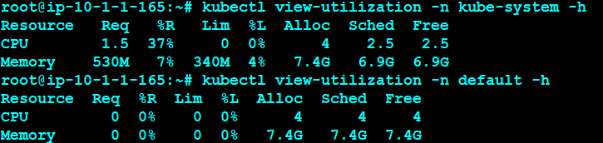

ku krew install tree
ku run hello --image=sreeharshav/rollingupdate:v5 --replicas 3
ku tree deployment hello

ku krew install example
ku example deployment
kk install iexec
ku krew install topology
ku topology pod node

https://www.redhat.com/sysadmin/capture-packets-kubernetes-ksniff
kubectl krew install sniff

ku krew install rbac-view
kubectl rbac-view
http://ec2-18-206-64-91.compute-1.amazonaws.com:8800/index.html

ku krew install tail

ku krew install service-tree
ku expose deployment hello --port=8300 --target-port=80 --type=NodePort --name hello3
kubectl service-tree

kk install popeye
kubectl popeye

kk install pod-logs
kubectl pod-logs

kk install iexec
ku iexec hello-d4d6db749-bmzht bash
alias exec='kubectl iexec'
exec hello-d4d6db749-fzdff bash

kk install deprecations
kubectl deprecations

alias ku='kubectl'
alias deps='kubectl get deploy'
alias pods='kubectl get pods'
alias allpods='kubectl get pods --all-namespaces'
alias svcs='kubectl get svc'
alias nodes='kubectl get nodes'
alias all='kubectl get pods,deploy,svc'
alias des='kubectl describe'
alias ns='kubectl get ns'
alias clustercreate='kops create cluster --name=sreek8s.xyz --state=s3://sreek8s --zones=us-east-1a --node-co$
alias clusterdelete='kops delete cluster --name sreek8s.xyz --yes --state s3://sreek8s'
export KOPS_STATE_STORE=s3://sreek8s
export CLUSTER_NAME=sreek8s.xyz
export EDITOR=nano

K9S:
