Industrial Internship Report on
Weed Detection System Prepared by
Harish.Na
Executive Summary
This report provides details of the Industrial Internship provided by upskill Campus and The IoT Academy in collaboration with Industrial Partner UniConverge Technologies Pvt Ltd (UCT).
This internship was focused on a project/problem statement provided by UCT. We had to finish the project including the report in 6 weeks’ time.
My project was (Tell about ur Project)
This internship gave me a very good opportunity to get exposure to Industrial problems and design/implement solution for that. It was an overall great experience to have this internship.

TABLE OF CONTENTS
1 Preface 3
2 Introduction 4
2.1 About UniConverge Technologies Pvt Ltd 4
2.2 About upskill Campus 8
2.3 Objective 9
2.4 Reference 9
2.5 Glossary 10
3 Problem Statement 11
4 Existing and Proposed solution 12
5 Proposed Design/ Model 13
5.1 High Level Diagram (if applicable) 13
5.2 Low Level Diagram (if applicable) 13
5.3 Interfaces (if applicable) 13
6 Performance Test 14
6.1 Test Plan/ Test Cases 14
6.2 Test Procedure 14
6.3 Performance Outcome 14
7 My learnings 15
8 Future work scope 16

Preface
Summary of the whole 6 weeks’ work.
About need of relevant Internship in career development.
Brief about Your project/problem statement.
Opportunity given by USC/UCT.
How Program was planned
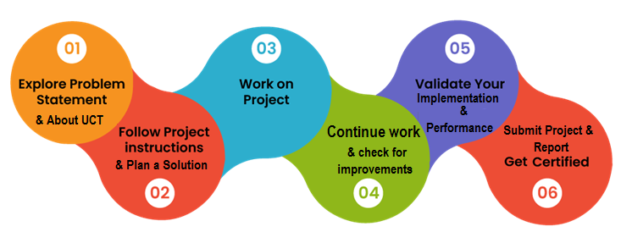
Your Learnings and overall experience.
Thank to all (with names), who have helped you directly or indirectly.
Your message to your juniors and peers.

Introduction

About UniConverge Technologies Pvt Ltd
A company established in 2013 and working in Digital Transformation domain and providing Industrial solutions with prime focus on sustainability and RoI.
For developing its products and solutions it is leveraging various Cutting Edge Technologies e.g. Internet of Things (IoT), Cyber Security, Cloud computing (AWS, Azure), Machine Learning, Communication Technologies (4G/5G/LoRaWAN), Java Full Stack, Python, Front end etc.

- UCT IoT Platform ()
UCT Insight is an IOT platform designed for quick deployment of IOT applications on the same time providing valuable “insight” for your process/business. It has been built in Java for backend and ReactJS for Front end. It has support for MySQL and various NoSql Databases.
- It enables device connectivity via industry standard IoT protocols - MQTT, CoAP, HTTP, Modbus TCP, OPC UA
- It supports both cloud and on-premises deployments.
It has features to
• Build Your own dashboard
• Analytics and Reporting
• Alert and Notification
• Integration with third party application(Power BI, SAP, ERP)
• Rule Engine

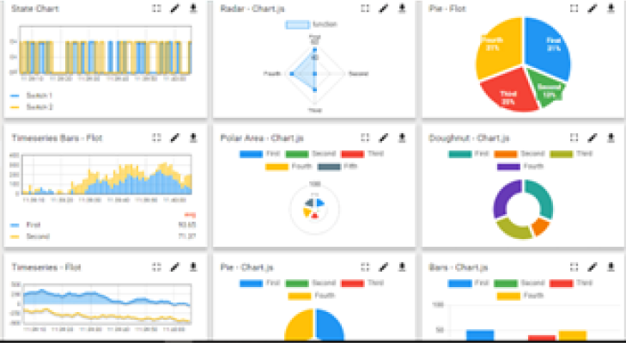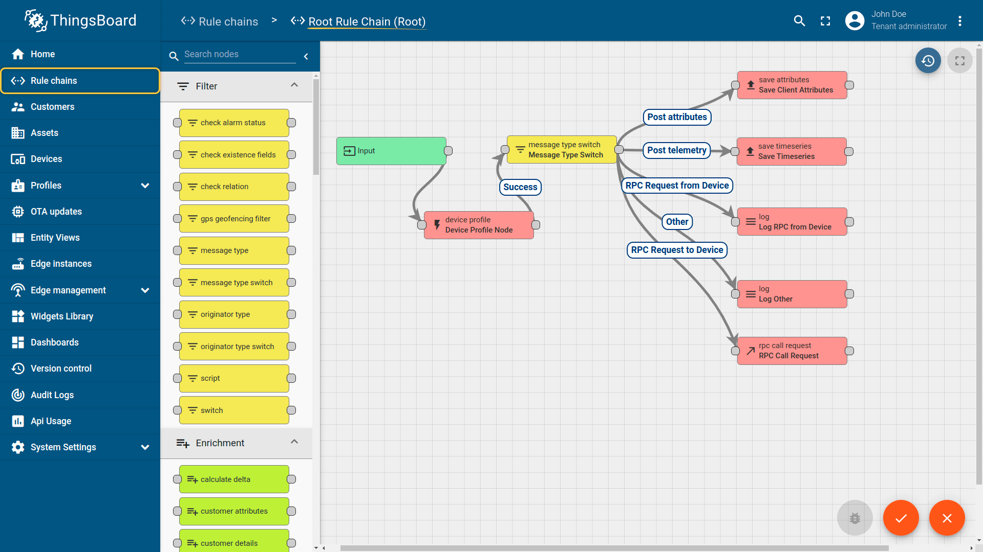

- Smart Factory Platform ()
Factory watch is a platform for smart factory needs.
It provides Users/ Factory
- with a scalable solution for their Production and asset monitoring
- OEE and predictive maintenance solution scaling up to digital twin for your assets.
- to unleased the true potential of the data that their machines are generating and helps to identify the KPIs and also improve them.
- A modular architecture that allows users to choose the service that they what to start and then can scale to more complex solutions as per their demands.
Its unique SaaS model helps users to save time, cost and money.
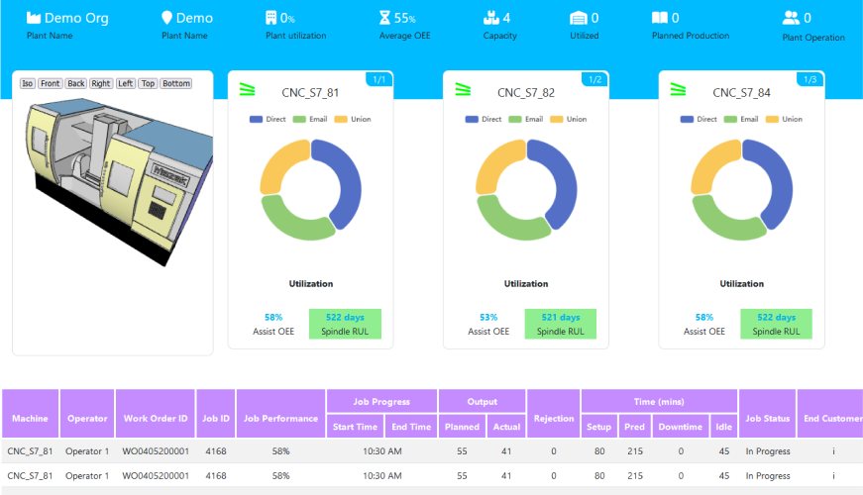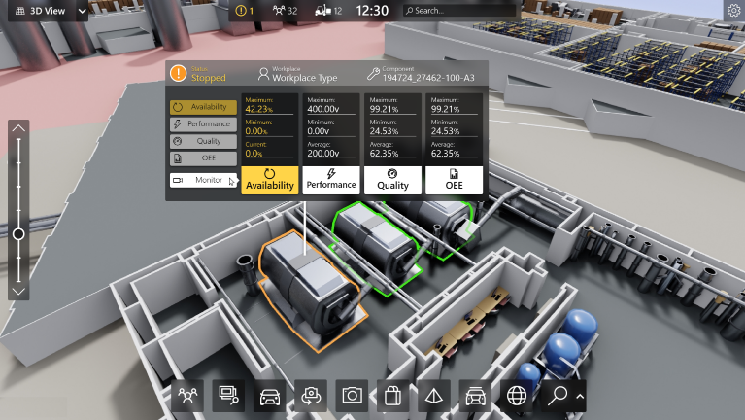

-  based Solution
UCT is one of the early adopters of LoRAWAN teschnology and providing solution in Agritech, Smart cities, Industrial Monitoring, Smart Street Light, Smart Water/ Gas/ Electricity metering solutions etc.
- Predictive Maintenance
UCT is providing Industrial Machine health monitoring and Predictive maintenance solution leveraging Embedded system, Industrial IoT and Machine Learning Technologies by finding Remaining useful life time of various Machines used in production process.
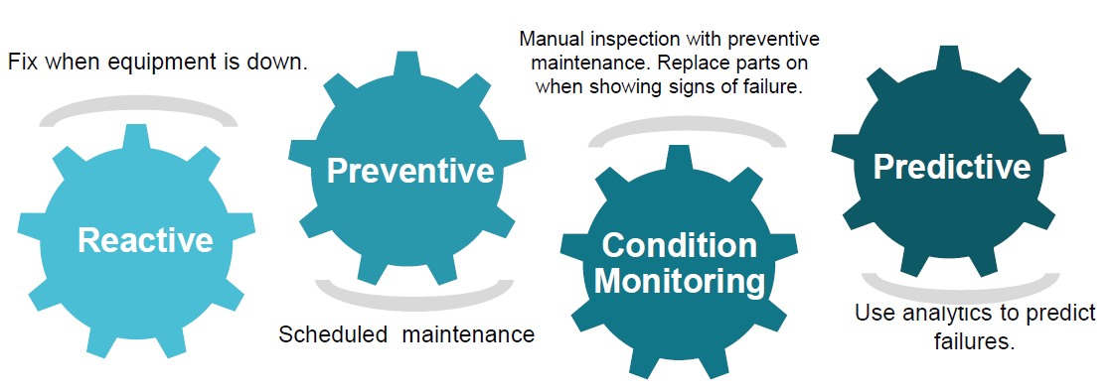

About upskill Campus (USC)
upskill Campus along with The IoT Academy and in association with Uniconverge technologies has facilitated the smooth execution of the complete internship process.
USC is a career development platform that delivers personalized executive coaching in a more affordable, scalable and measurable way.




Seeing need of upskilling in self paced manner along-with additional support services e.g. Internship, projects, interaction with Industry experts, Career growth Services
https://www.upskillcampus.com/
upSkill Campus aiming to upskill 1 million learners in next 5 year

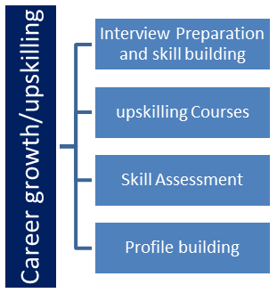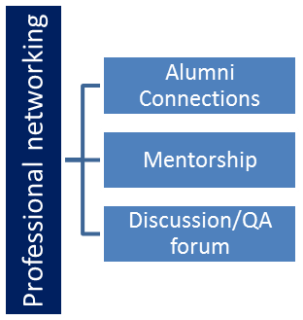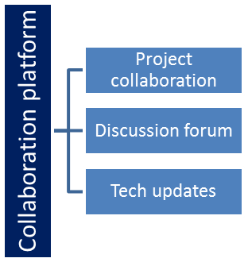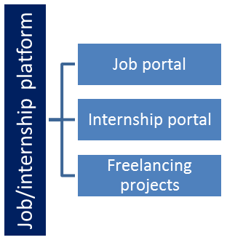

The IoT Academy
The IoT academy is EdTech Division of UCT that is running long executive certification programs in collaboration with EICT Academy, IITK, IITR and IITG in multiple domains.

Objectives of this Internship program
The objective for this internship program was to
☛ get practical experience of working in the industry.
☛ to solve real world problems.
☛ to have improved job prospects.
☛ to have Improved understanding of our field and its applications.
☛ to have Personal growth like better communication and problem solving.

Reference
[1] https://www.geeksforgeeks.org/convolutional-neural-network-cnn-in-machine-learning/

Glossary
Terms | Acronym

Problem Statement
In the assigned problem statement
Building a machine learning model that can acuurately classify between weeds and crops and using the model to classify the image

Existing and Proposed solution

Provide summary of existing solutions provided by others, what are their limitations?
Previous solutions uses pre-trained model such as VGG16, Inception-v3, ResNet-50 and Xception . Although this is good enough it could be made better to fit our use case
What is your proposed solution?
Building own model using CNN we get a greater flexibility and a detection system that fully uses our own dataset instead of relying on other datasets like DeepWeeds and Agriculture-Vision challenge 2020
What value addition are you planning?

Code submission (Github link)
https://github.com/Harish0311/py-ml-weed-detection.git

Report submission (Github link) :

Project Link

Proposed Design/ Model

- First we clean the dataset using a program that automatically classifies the images from the dataset as weed or crop.
- Then we take 80 percentage of those images for training purpose and 20 purpose for validation purpose.
- We then build a model that can classify the images using the training images
- Load the model into another program that takes image as input and classifies them using our model
Done!

Interfaces (if applicable)
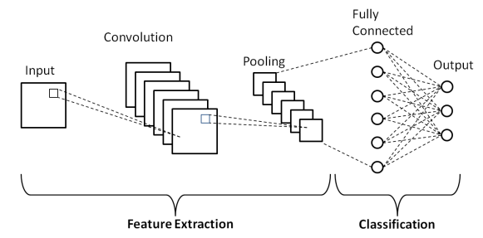

Performance Test

The only constrain that happens is the memory allocation while training the model. But this is not big of an issue , since we only train the model once and use it as much as we want

But if we really want to optimize on the memory we can increase or decrease the batch size based on the total available physical memory (both GPU memory and physical RAM). This program is currently optimized for 16gb physical RAM and 6GB GPU RAM

Test Procedure
We use a prediction program that reads the list of images to be predicted and gives us the type of crop it belongs to

Performance Outcome
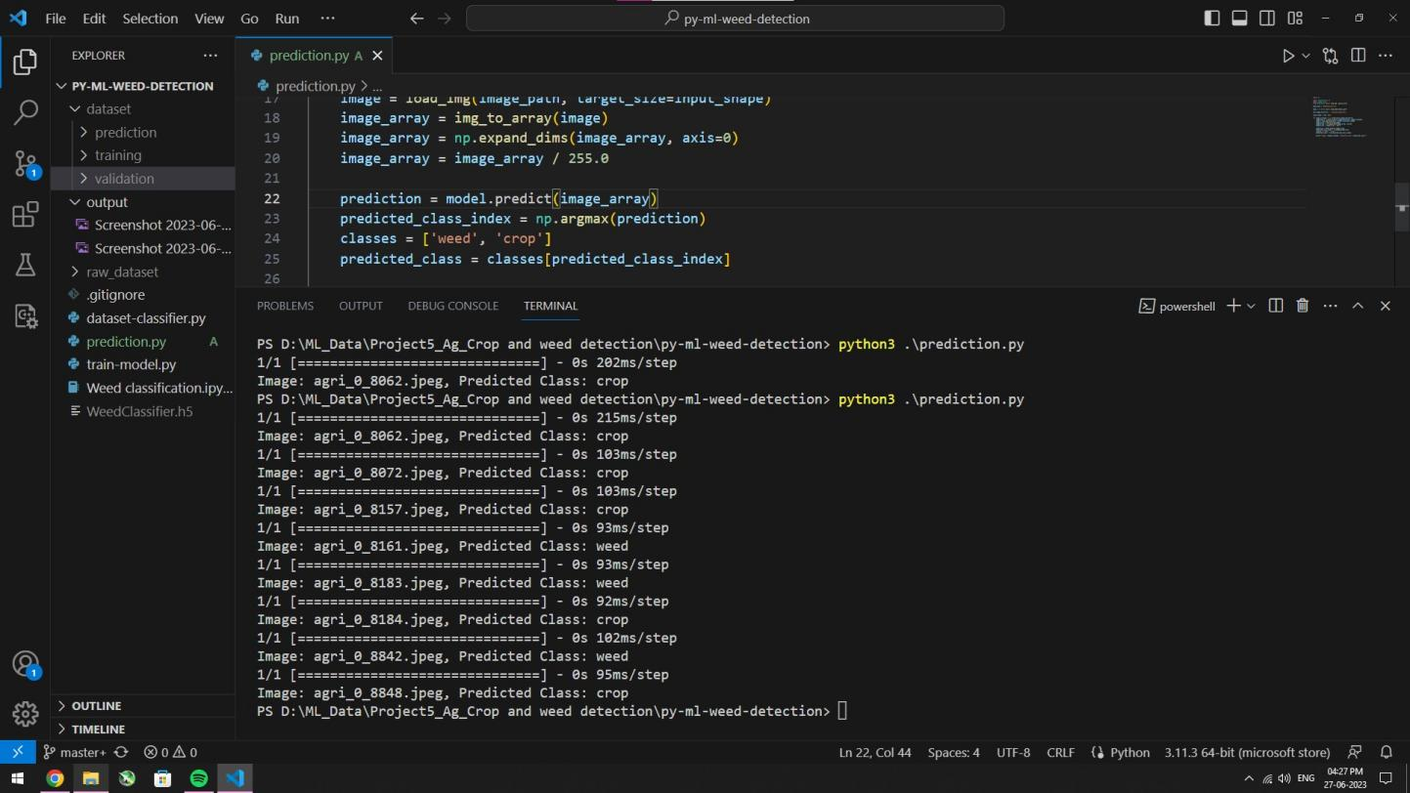
This program successful achieve 100 percent accuracy when tested with images that are excluded from the training process

My learnings

I had a ton of fun working on this project . Being my second machine learning project, I learned a lot intricacies that needs to be followed to correctly build a model such as optimizing the batch size. I’ve also learned to completely build a model from the scratch as my previous project include a pre-trained model

Future work scope

An advanced dataset can be used that contains various types of crops and weeds instead of simply crops and weed.

P.S : I really want to thank uct and upSkill campus for providing me this opportunity to show my skill. I genuinely had fun doing this project and came to learn a lot from it .Thanks a lot !

