Input :  
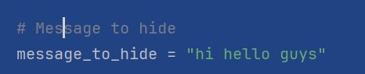

Output:

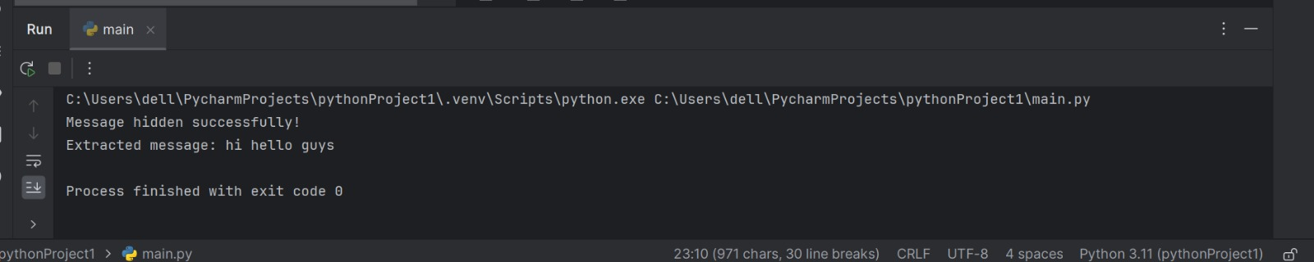

Result :

It generated stegano image which have secret Message

