HireAI
Project Documentation
  - Full-stack Hiring Intelligence Dashboard
Prepared for Knownvation Task
Repository: Harish2B3/Hire-AI
Document Scope
This report documents the current HireAI project by analyzing the repository structure, Django backend, React frontend, data model, external integrations, security flow, setup process, APIs, and future enhancement opportunities.

Contents
Section | Description
Abstract | Project documentation section
Introduction | Project documentation section
Problem Statement | Project documentation section
Solution Introduced | Project documentation section
Technologies Used | Project documentation section
System Architecture and Component Connectivity | Project documentation section
Folder Structure | Project documentation section
Database Design | Project documentation section
APIs and Usage | Project documentation section
Installation and Setup | Project documentation section
Security and Ethical Considerations | Project documentation section
Screens and User Workflow | Project documentation section
Future Enhancements | Project documentation section
Conclusion | Project documentation section

Abstract
HireAI is a full-stack Hiring Intelligence Dashboard designed to help recruiters and HR teams collect, organize, analyze, and act on hiring-market data. The application combines a Django REST backend, a React and TypeScript frontend, Playwright-based collection scripts, AI-assisted requirement extraction, recruiter and company enrichment, MFA-secured authentication, and dashboard analytics. It transforms fragmented job listings and recruiter/company records into searchable openings, hiring trends, technology-demand charts, recruiter intelligence, and export-ready reports.
The project is implemented as a practical local deployment that can later evolve into a production-grade intelligence platform. Its core design principle is to keep privileged API keys and sensitive operations on the server while giving the browser a clean, authenticated API surface.

Introduction
Recruitment teams often work across job boards, spreadsheets, emails, applicant tracking systems, and manual market reports. This fragmentation makes it difficult to answer basic strategic questions such as which companies are hiring aggressively, what skills are trending, which sources are producing the most openings, and which recruiters or company contacts matter for outreach.
HireAI addresses that gap by acting as a centralized hiring intelligence workspace. It collects job signals from public sources and local exports, normalizes them into a common data model, enriches company and people information through third-party services, and presents the results in an interactive dashboard built for search, filtering, analytics, resume matching, and reporting.

Problem Statement
The main problem is the lack of a unified, secure, and analytics-ready system for recruitment market intelligence. Hiring teams need to monitor public job demand, understand competitor movement, identify trending skills, connect roles to recruiter/company information, and create reports without manually stitching data from multiple platforms.
- Hiring data is scattered across platforms such as LinkedIn, Naukri, Indeed, Glassdoor-style exports, and internal records.
- Manual job analysis is slow and inconsistent, especially when extracting skills, experience, salary, and seniority.
- Third-party API credentials are risky if exposed directly in frontend code.
- Recruiter and company intelligence is often separated from job-opening analytics.
- Decision makers need dashboards and exportable reports instead of raw scraped data.

Solution Introduced
HireAI introduces a modular full-stack solution that combines data collection, normalization, AI extraction, enrichment, authentication, analytics, and reporting in one dashboard. The frontend focuses on user workflows, charts, search, exports, and resume matching, while the backend owns authentication, persistence, provider calls, scraping orchestration, and aggregation logic.
- A Django REST API aggregates internal openings, stored scraped jobs, cached platform jobs, recruiter data, company analytics, and hiring trends.
- Playwright and local JSON automation scripts collect and normalize public job listings from supported hiring sources.
- OpenAI/Gemini-backed requirement extraction converts unstructured job descriptions into role, skills, and experience fields, with a heuristic fallback.
- Apollo.io and CompanyEnrich calls are proxied through the backend so secrets remain server-side.
- JWT authentication is paired with OTP-based MFA, resend cooldowns, challenge expiry, and role-aware permissions.
- React, Recharts, jsPDF, and XLSX create an interactive dashboard with charts, analytics, and export-ready reports.

Technologies Used
Layer | Technology | Purpose
Frontend | React, TypeScript, Vite, Tailwind CSS | Single-page dashboard, responsive UI, stateful workflows
Charts and UI | Recharts, lucide-react, motion | Visual analytics, icons, animations, and dashboard controls
Exports | jsPDF, jspdf-autotable, XLSX | PDF, tabular, and spreadsheet export support from frontend data
Backend | Django, Django REST Framework | API layer, serializers, views, routing, and ORM-backed data access
Authentication | Simple JWT, custom MFA models | JWT access/refresh tokens with OTP verification
Automation | Playwright, BeautifulSoup, lxml | Browser automation and parsing for public job-source collection
Background Jobs | Celery, Redis | Asynchronous scraping refresh and dynamic job search caching
Database | SQLite via Django ORM | Local relational storage for users, jobs, recruiters, analytics, and cache records
AI/LLM | OpenAI API, Gemini API, heuristic extractor | Requirement extraction and resume/profile analysis workflows
Enrichment | Apollo.io, CompanyEnrich | Company, recruiter, and people intelligence through secure backend proxies

System Architecture and Component Connectivity
The project is connected as a layered client-server system. The React frontend never talks directly to privileged provider APIs. Instead, it calls authenticated Django endpoints. Django then reads or writes SQLite data, starts Celery jobs, uses Redis for cache/broker behavior, calls third-party providers through server-side environment variables, and returns normalized JSON to the dashboard.
Public job sources / local exports
-> Playwright automation and JSON normalization
-> Celery tasks and Redis cache
-> Django REST API and SQLite models
-> AI extraction + enrichment provider proxies
-> React dashboard, charts, filters, search, resume matching, exports

How the Main Parts Are Connected
Step 1: The user signs in through the React UI. The backend starts login or registration and sends an OTP challenge by email.
Step 2: After OTP verification, the backend issues JWT access and refresh tokens. The frontend stores them in session storage or local storage depending on the remember-me choice.
Step 3: Authenticated dashboard requests call /api/tasks/dashboard-data/. Django combines internal JobOpening rows, cached platform jobs, dynamic ScrapedJob rows, HiringTrend data, Recruiter data, and CompanyAnalytics data.
Step 4: Search and filters are sent as query parameters. The backend filters stored and cached records, deduplicates job rows, calculates KPIs, source effectiveness, technology demand, company trends, and hiring signals.
Step 5: Dynamic search calls /api/tasks/dynamic-search/. The backend queues a Celery task that runs external job fetching, persists ScrapedJob rows, and updates Redis cache for quick status updates.
Step 6: Company/recruiter intelligence is requested through backend endpoints such as Apollo organizations, CompanyEnrich companies, and people search. API keys stay in backend environment variables.
Step 7: The frontend renders charts and pages with Recharts, supports report generation, and exports selected data with jsPDF and XLSX.

Folder Structure
Knownvation Task/
|-- backend/
| |-- authentication/ User roles, MFA, JWT login, password reset, permissions
| |-- core/ Django settings, root URLs, ASGI/WSGI, Celery app
| |-- tasks/ Dashboard APIs, scraping, AI extraction, enrichment, analytics
| |-- tasks/automation/ Playwright and source-specific collection scripts
| |-- manage.py Django management command entry point
| |-- requirements.txt Backend dependency list
| `-- db.sqlite3 Local SQLite development database
|-- frontend/
| |-- src/
| | |-- api.ts API client, token storage, typed payload helpers
| | |-- App.tsx Main SPA, dashboard screens, auth, charts, exports
| | |-- index.css Global styling
| | `-- main.tsx React entry point
| |-- package.json Frontend scripts and dependencies
| |-- vite.config.ts Vite configuration
| `-- index.html Vite HTML shell
|-- database/ Database design documentation
|-- documentation/ Architecture, APIs, security, reports, this DOCX builder
|-- screenshots/ UI screenshots
|-- ppt/ Presentation export
|-- README.md Main setup and project overview
`-- test.py Local test helper
Generated or local-only directories such as backend/venv, frontend/node_modules, frontend/dist, __pycache__, and .git are excluded from the tree because they are not source documentation.

Database Design
Model/Table | Purpose | Important Fields
User / auth_user | Django user identity and login account | username, email, password hash, staff flags
UserProfile | Application role assignment | user, role: admin/recruiter/analyst
MfaChallenge | OTP flow for registration, login, and password reset | purpose, email, code_hash, attempts, expires_at, consumed_at
Task | Generic user-owned task records | user, title, description, status
JobOpening | Internal openings used in dashboard analytics | title, department, status, location, applicants, skills
ScrapedJob | Persisted external job listings | source, external_id, search_query, title, company, location, skills, raw
Recruiter | Recruiter/contact intelligence | company, name, designation, email, linkedin, phone, roles, performance
CachedPerson | Cached people-search records | source, source_id, search_query, name, company, linkedin_url, raw
CompanyAnalytics | Company applicant and hired counts | company, applicants, hired
HiringTrend | Monthly hiring volume history | month, hired, applied, recorded_on
GlassdoorCompany | Company profile and employer metrics | rating, job_count, headquarters, industry, CEO, awards, raw

APIs and Usage
The backend exposes a JSON API under http://127.0.0.1:8000. Most dashboard and data endpoints require an Authorization header in the form Bearer <access_token>. Public auth-start routes are intentionally unauthenticated but rate-limited.
Endpoint | Method | Usage
/api/register/ | POST | Starts registration and sends an MFA OTP challenge.
/api/register/verify/ | POST | Verifies registration OTP, creates user, returns JWT tokens.
/api/token/ | POST | Starts login and sends an MFA OTP challenge, except bootstrap admin flow.
/api/token/verify/ | POST | Verifies login OTP and returns JWT tokens.
/api/mfa/resend/ | POST | Resends an active OTP challenge with cooldown enforcement.
/api/password/forgot/ | POST | Starts password reset challenge.
/api/password/reset/verify/ | POST | Verifies reset OTP and updates password.
/api/token/refresh/ | POST | Refreshes JWT access token.
/api/bootstrap-admin/setup/ | POST | Converts temporary bootstrap account into real admin.
/api/tasks/dashboard-data/ | GET | Returns KPIs, openings, trends, recruiters, source effectiveness, tech demand, hiring signals.
/api/tasks/admin-dashboard/ | GET | Returns admin-only operational monitoring and user-management data.
/api/tasks/extract-requirements/ | POST | Extracts role, skills, and experience from a job description.
/api/tasks/gemini/generate/ | POST | Server-side Gemini generation proxy.
/api/tasks/refresh-sources/ | POST | Refreshes platform job cache and queues background refresh.
/api/tasks/dynamic-search/ | POST | Starts a Celery-backed external job search for a query.
/api/tasks/dynamic-search/status/ | GET | Checks the Celery task state for dynamic search.
/api/tasks/indeed-autocomplete/ | GET | Returns job-title suggestions from Indeed autocomplete.
/api/tasks/apollo-organizations/ | GET | Server-side Apollo company search proxy.
/api/tasks/company-enrich/ | GET | Server-side CompanyEnrich company search proxy.
/api/tasks/people-search/ | GET | People/recruiter search with CompanyEnrich, Apollo fallback, and cache.

Example API Usage
POST /api/token/
{
"username": "recruiter@example.com",
"password": "Password123!"
}

POST /api/token/verify/
{
"challenge_id": 456,
"code": "654321"
}

GET /api/tasks/dashboard-data/?search=python&skills=django,react&dateRange=last-30-days
Authorization: Bearer <access_token>

Installation and Setup

Prerequisites
- Python 3.10 or higher
- Node.js 18 or higher with npm
- Redis server for Celery broker/cache workflows
- Git
- External API keys as needed: Gemini, OpenAI, Apollo.io, CompanyEnrich

Backend Setup
cd backend
python -m venv venv
.\venv\Scripts\activate
pip install -r requirements.txt
playwright install chromium
copy .env.example .env
python manage.py migrate
python manage.py createsuperuser
python manage.py runserver

Frontend Setup
cd frontend
npm install
copy .env.example .env
npm run dev

Celery Worker Setup
redis-cli ping
cd backend
.\venv\Scripts\activate
celery -A core worker -l info -P solo

# Optional scheduled tasks
celery -A core beat -l info

Environment Connection Points
Variable | Used By | Purpose
SECRET_KEY | Django | Cryptographic signing and core Django security
DEBUG / ALLOWED_HOSTS | Django | Runtime and host behavior
DATABASE_URL | Django ORM | Database connection, SQLite by default
CELERY_BROKER_URL | Celery | Redis broker connection
CELERY_RESULT_BACKEND | Celery | Task result backend
OPENAI_API_KEY / OPENAI_MODEL | Backend AI extractor | OpenAI requirement extraction
GEMINI_API_KEY / GEMINI_MODEL | Backend Gemini proxy | Gemini generation and extraction workflows
APOLLO_API_KEY | Backend provider proxy | Apollo organization/person lookup
COMPANY_ENRICH_API_KEY | Backend provider proxy | Company and people enrichment
VITE_API_URL | Frontend | API origin used by fetch helpers

Security and Ethical Considerations
- MFA challenges store hashed OTP codes, expire automatically, track attempts, and are marked consumed after use.
- JWT access/refresh tokens are issued only after successful login or registration verification.
- Authentication routes use scoped throttling to reduce brute-force attempts and resend abuse.
- Provider API keys are loaded from backend environment variables and are not exposed to the browser.
- Role permissions distinguish admin/recruiter capabilities from regular authenticated access.
- Scraping should remain limited to publicly available, non-authenticated data and must respect platform terms and robots.txt.

Screens and User Workflow
The React application includes landing, login/MFA, dashboard analytics, openings, company analytics, recruiter information, reports, settings, and resume-matching workflows. Selected screenshots below are included from the project screenshots folder.

Dashboard Overview
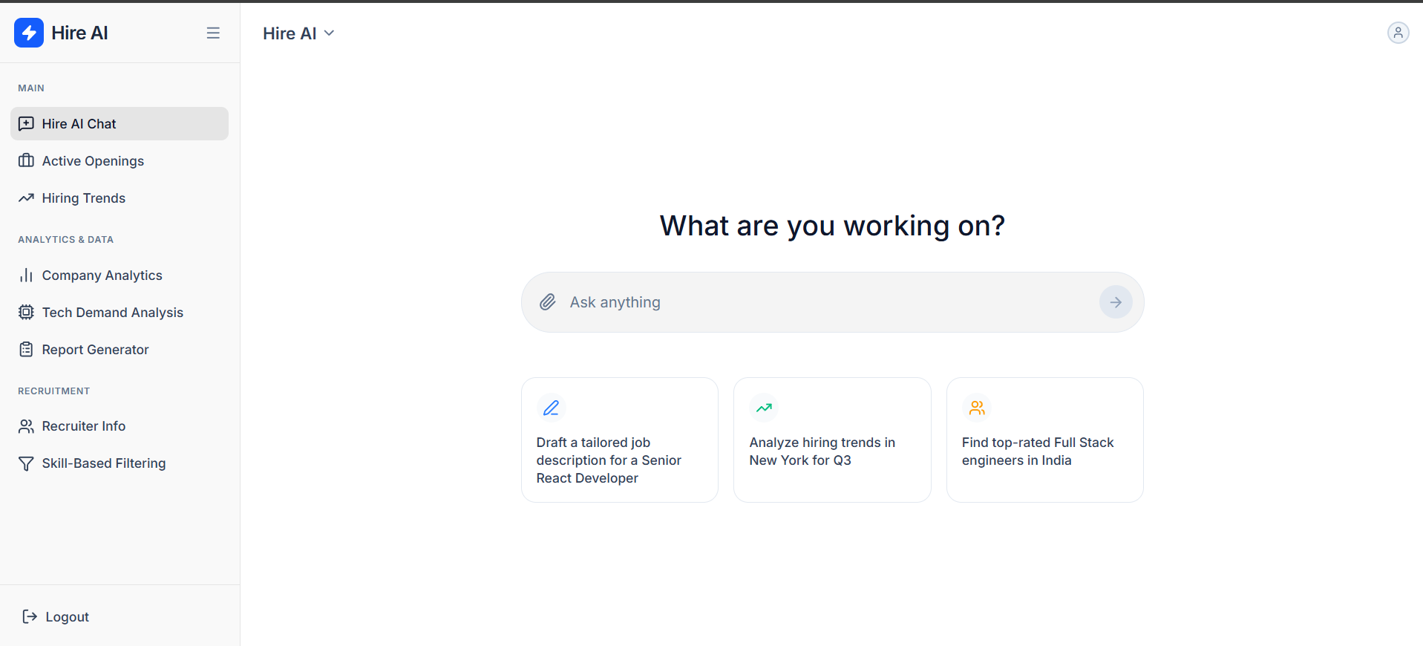

Hiring Trends
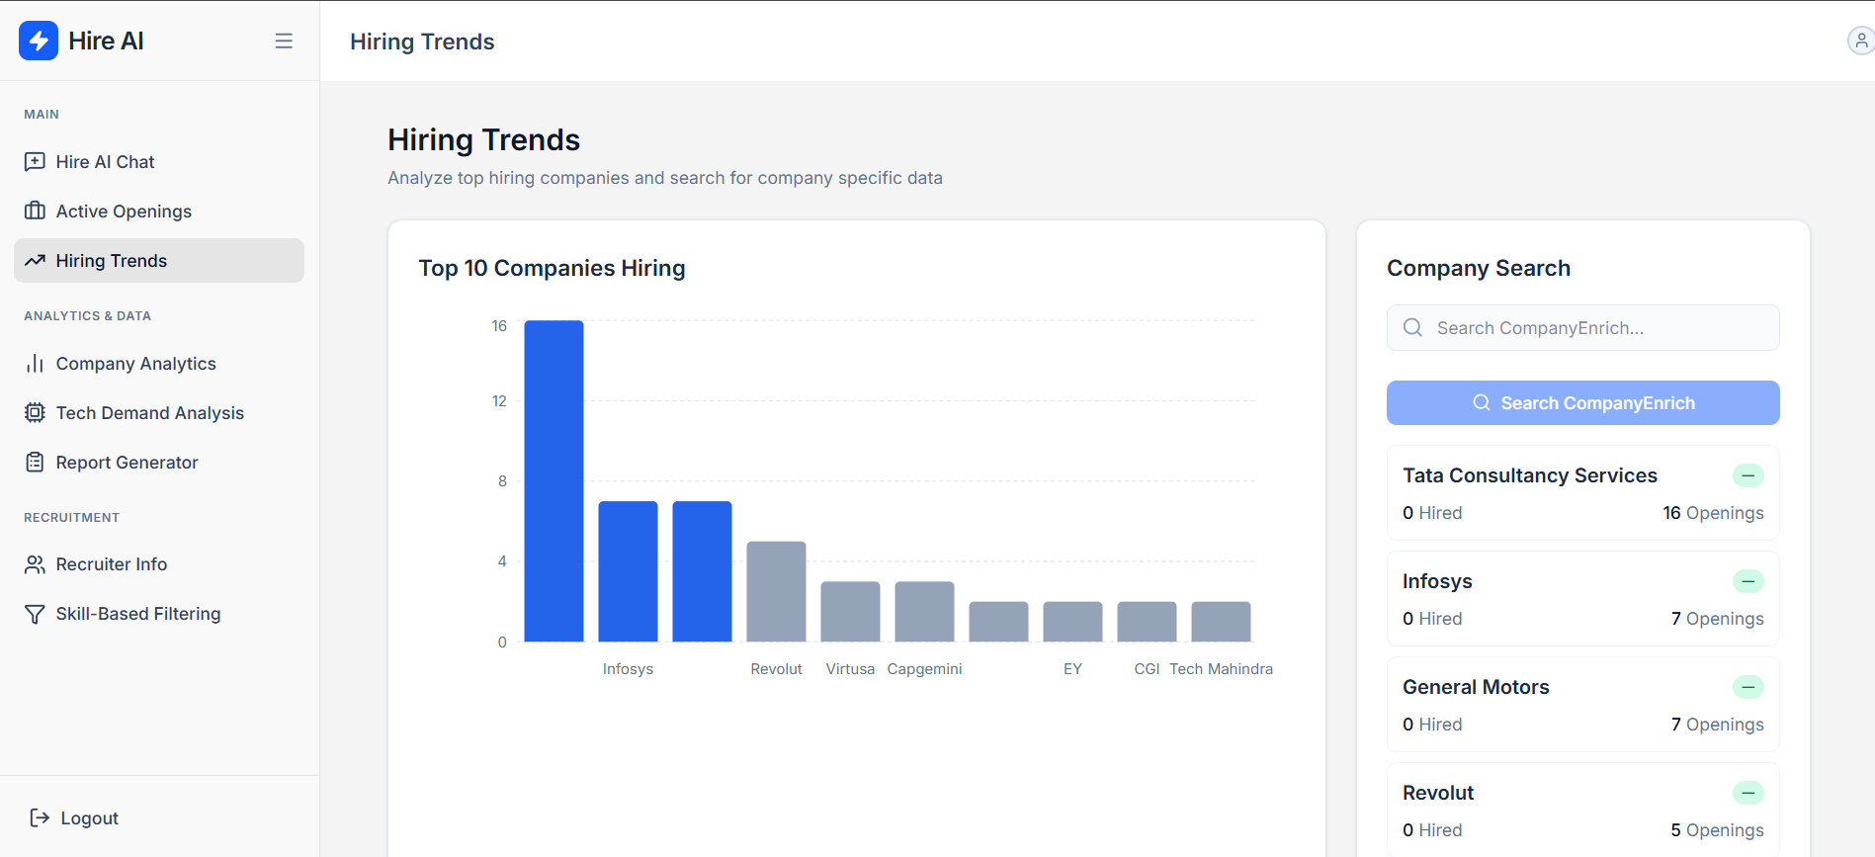

Technology Demand Analysis
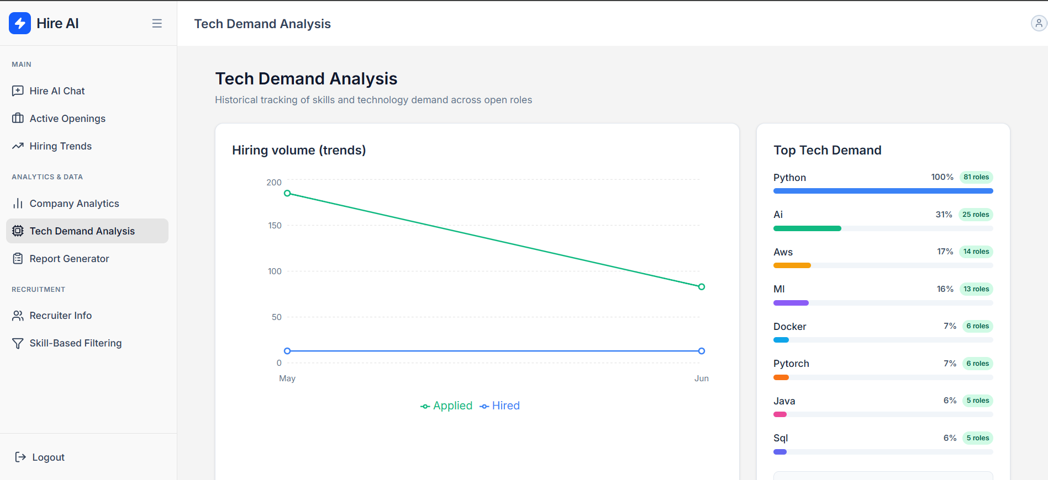

Recruiter Intelligence
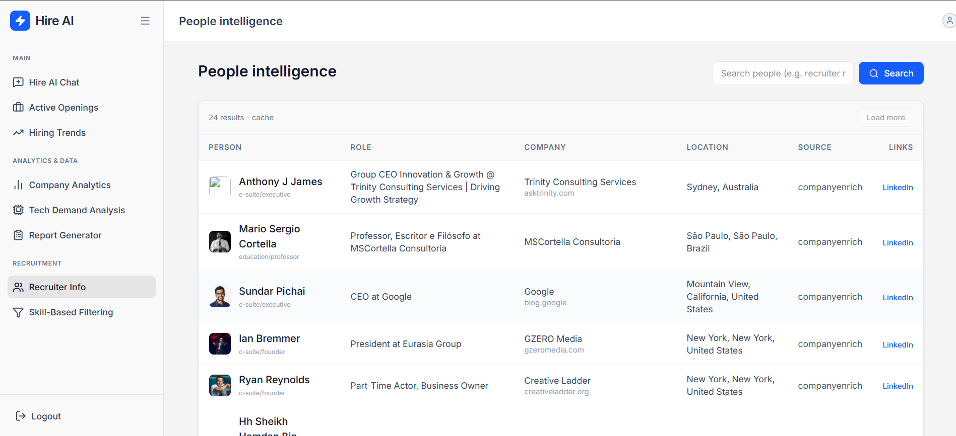

Future Enhancements
- Move from SQLite to PostgreSQL for production-scale relational storage, indexing, and backups.
- Add a queue dashboard for scraping jobs, retries, failures, and per-source health monitoring.
- Add vector search for semantic role matching, candidate matching, and natural-language dashboard queries.
- Introduce organization-level multi-tenancy with separate data boundaries, roles, and audit logs.
- Add scheduled alerts for competitor hiring spikes, skill-demand surges, and target-company activity.
- Improve scraping governance with per-platform rate limits, robots.txt checks, and source compliance logging.
- Add backend-generated PDF/Excel reports for consistent server-side report output.
- Add automated tests for auth, API serialization, dashboard aggregation, dynamic search, and provider fallbacks.
- Add deployment assets such as Docker Compose, production environment templates, and CI/CD workflows.
- Add observability with structured logs, metrics, tracing, and notification hooks for failed background jobs.

Conclusion
HireAI demonstrates a complete hiring intelligence pipeline: data collection, secure backend processing, AI extraction, enrichment, analytics, and export-oriented frontend workflows. The architecture already separates sensitive provider calls from the browser, supports MFA-secured authentication, and uses a modular Django/React split that can grow into a production platform. With stronger production storage, monitoring, test coverage, and deployment automation, the project can mature into a reliable recruitment intelligence system for teams that need continuous insight into hiring markets.

