Executive Summary
UAC Program — System Capacity & Care Load Analytics
Data coverage: Jan 12, 2023 – Dec 21, 2025 (720 reported days) | Prepared: September 27, 2026

Bottom Line
The federal UAC care system carried a combined CBP-and-HHS caseload as high as 11,762 children in December 2023, sustained elevated load through 2024, and then contracted sharply and durably beginning in early 2025. As of the latest reported day (December 21, 2025), total system load stands at 2,502 children — down 78.7% from the series peak — and has held in a stable 2,000–2,500 range for most of 2025.

Current System Snapshot (Latest Reported Day)
TOTAL CHILDREN UNDER CARE  2,502  18 in CBP custody + 2,484 in HHS care | NET INTAKE PRESSURE  +0.3 /day  30-day avg. — essentially balanced
CARE LOAD VOLATILITY  0.49%  30-day avg. — low & stable | DISCHARGE OFFSET RATIO  1.23  30-day avg. — discharges outpacing new transfers

Three-Year Trend
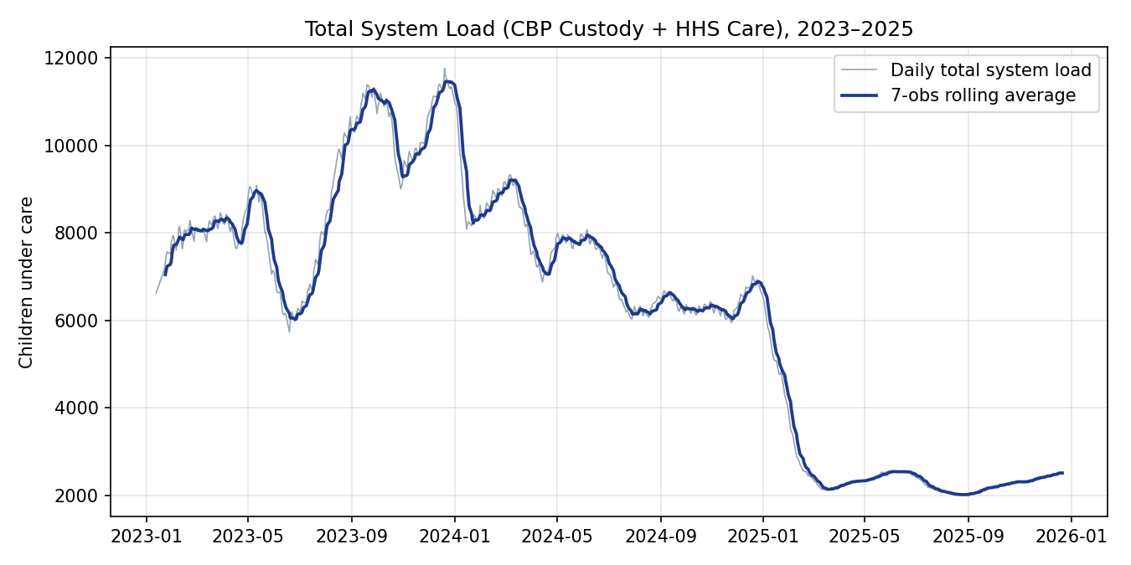
Total system load, 2023–2025. The system moved from a high-load, high-volatility regime (2023–2024) into a much lower, stable regime beginning in early 2025.

Key Findings
- Regime shift: Average HHS care load fell from 8,646 (2023) to 7,043 (2024) to 2,543 (2025) — a 64% year-over-year decline in the most recent full year.
- HHS shelter care, not CBP custody, drives total system load: the HHS care population (avg. 6,061) outweighs CBP custody (avg. 171) by more than 30-to-1, so shelter-side staffing is the higher-leverage planning lever.
- The current low-load period is also low-volatility: Care Load Volatility has fallen from repeated spikes above 2–4% in 2023–2024 to a steady ~0.5% through most of 2025.
- Discharges have kept pace with or exceeded new transfers into HHS care since early 2025 (Discharge Offset Ratio ≥ 1.0), which is the direct mechanical driver of the observed de-population.
- Data quality is solid: no duplicate reporting dates and no instances of discharges exceeding the HHS care population across 720 days. A same-day-timing artifact (transfers-out exceeding the CBP custody snapshot) appears on 11.9% of days and is flagged, not corrected, for transparency.

Recommendations
- Keep tiered, KPI-triggered staffing and shelter plans active — even at current low load — given the historical precedent for rapid, multi-month run-ups (Sections 7.1 of the full report).
- Prioritize HHS shelter-side surge capacity over CBP-side surge capacity, reflecting HHS care's outsized share of total system load.
- Track Discharge Offset Ratio as the earliest single warning sign of building backlog risk; a sustained drop below 1.0 should trigger review.
- Operationalize the five KPIs in this summary as a live, refreshable dashboard (accompanying Streamlit application) for ongoing situational awareness.
Full methodology, data-quality checks, and detailed findings are provided in the accompanying research paper.

