System Capacity & Care Load Analytics
for the Unaccompanied Alien Children (UAC) Program
Research Paper — Exploratory Data Analysis, Insights & Recommendations
Prepared for: U.S. Department of Health and Human Services
Program context: Unified Mentor — Data Analytics Project
Data coverage: January 12, 2023 – December 21, 2025 (720 reported observations)
Report date: September 27, 2026

Abstract
This report applies a structured healthcare-capacity analytics framework to publicly reported daily operational data from the Unaccompanied Alien Children (UAC) care pipeline, spanning Customs and Border Protection (CBP) intake through Department of Health and Human Services (HHS) sheltering and discharge. The dataset covers 720 reported days between January 2023 and December 2025. The analysis quantifies total system load, net intake pressure, care-load volatility, and backlog accumulation, and identifies distinct capacity regimes across the reporting window: a high-load, high-volatility period through late 2023 and 2024 (peaking above 11,700 children under combined care in December 2023), followed by a sharp, sustained contraction beginning in the first quarter of 2025 that brought total system load down to roughly 2,000–2,500 children by mid-to-late 2025 — a decline of nearly 79% from the observed peak. The paper documents the data-quality checks applied, presents the derived Key Performance Indicators (KPIs) requested for the accompanying dashboard, and closes with operational recommendations for staffing, shelter capacity planning, and continued monitoring.

1. Introduction and Background
The UAC Program is a federally mandated care pipeline for children who are apprehended by CBP without a parent or legal guardian and are subsequently transferred to HHS's Office of Refugee Resettlement (ORR) network for medical screening, shelter care, and eventual reunification with a vetted sponsor. Because the population entering this pipeline is driven by external, often volatile factors (migration flows, seasonal patterns, policy changes), the system experiences sustained periods of both capacity strain and capacity relief. Anticipating and monitoring these regimes is a precondition for adequate healthcare staffing, shelter provisioning, and humane care delivery.
HHS collects and publishes daily counts covering five stages of the pipeline: children apprehended and placed into CBP custody, the standing CBP custody population, children transferred out of CBP custody into the HHS system, the standing HHS care population, and children discharged from HHS care to sponsors. This report converts those raw daily counts into a continuous capacity-analytics framework, in line with the primary and secondary objectives set out for this project: quantifying daily and cumulative care load, identifying strain and relief periods, analyzing the intake/discharge balance, and supporting staffing, shelter planning, and policy situational awareness.

2. Data and Methodology

2.1 Data Ingestion and Structuring
The source file contains 720 dated rows (after removing trailing blank rows present in the raw export) spanning January 12, 2023 through December 21, 2025. Dates were parsed from their published “Month DD, YYYY” text format into a proper datetime index and sorted chronologically. Numeric fields that were exported with thousands-separator commas (e.g., HHS care population values above 1,000) were stripped and converted to numeric types.
Reporting is not a strict daily cadence: of the 1,075 calendar days spanned by the dataset, only 720 (67.0%) have a published observation. The gap between consecutive reported dates is 1 day in 77.6% of cases, 3 days (spanning a weekend) in 17.0% of cases, and occasionally longer (up to a 10-day gap), consistent with HHS's typical business-day reporting schedule with intermittent pauses. All rolling-window metrics in this report are therefore computed over reporting observations rather than strict calendar days, and this distinction is preserved as a `gap_days` field in the cleaned dataset so that any consumer of the data can weight or interpolate as appropriate.

2.2 Data Quality and Validation
Two logical constraints were checked across all 720 observations, as specified in the project requirements:
- Children transferred out of CBP custody should not exceed the standing CBP custody population on that day. This constraint was violated on 86 of 720 days (11.9%). This is expected rather than an error: “children in CBP custody” is typically reported as an end-of-day snapshot, while “transferred out” counts flow during the day, so a fast-moving cohort (same-day intake and same-day transfer) can produce a transferred-out count that exceeds the end-of-day snapshot. Each flagged day is retained in the dataset with a boolean flag rather than dropped, preserving transparency.
- Children discharged from HHS care should not exceed the standing HHS care population. No violations of this constraint were found across the 720 observations, which supports the internal consistency of the HHS-side reporting.
No duplicate report dates were found. All five numeric fields were confirmed non-negative. These checks are re-run automatically each time the dashboard's underlying pipeline is refreshed with new data.

2.3 Derived Capacity Metrics
The following metrics were computed for every reported day, in line with the requested forecasting methodology:
- Total System Load = CBP Custody + HHS Care — the full population for which the federal government holds active care responsibility at a point in time.
- Net Daily Intake = Children transferred into HHS − Children discharged from HHS — a positive value indicates the HHS system is absorbing more children than it is releasing on that day (building pressure); a negative value indicates net relief.
- Care Load Growth Rate = day-over-day percentage change in the HHS care population (and, separately, in total system load).
- Backlog Indicator = the length of the current consecutive run of days with positive net daily intake — a proxy for sustained, un-relieved pressure rather than a single noisy day.
- Rolling Averages (7- and 14-observation windows) were computed for HHS care load, total system load, and net intake, to separate the underlying trend from day-to-day reporting noise.
- Care Load Volatility Index = 14-observation rolling standard deviation of the day-over-day percentage change in HHS care load — higher values indicate a less stable, harder-to-plan-for system state.
- Discharge Offset Ratio = discharges from HHS care ÷ transfers into HHS care — values above 1.0 indicate the discharge (sponsor placement) pipeline is outpacing new arrivals; values below 1.0 indicate the system is accumulating population faster than it releases it.

3. Exploratory Data Analysis

3.1 Total System Load Over Time
Figure 1 shows total system load (CBP custody plus HHS care) across the full reporting window. Three regimes are visually apparent. From January through mid-2023, load rose from roughly 6,600 to a local peak near 9,000 in May 2023, before easing to a trough near 6,000 in mid-2023. Load then rose sharply through the second half of 2023 into a sustained high-load plateau, reaching the series maximum of 11,762 children under combined care on December 20, 2023. A second, lower high-load plateau (approximately 9,000–11,500) recurred from roughly November 2023 through March 2024. From mid-2024 onward the series declines in a step-wise fashion, and from approximately February 2025 the system contracts sharply and durably, settling into a materially lower and much flatter band of roughly 2,000–2,500 children under care for the remainder of 2025.
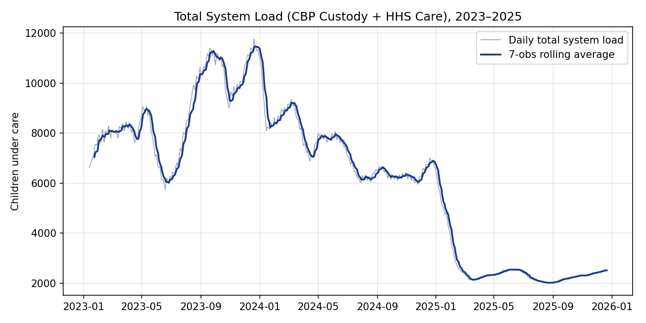
Figure 1. Total system load (CBP custody + HHS care), daily observations with 7-observation rolling average, 2023–2025.

3.2 CBP Custody vs. HHS Care Load
The two components of total system load behave very differently in scale and dynamics, which is why Figure 2 plots them on independent axes. The CBP custody population is short-duration by design (children are meant to move through CBP custody within days) and fluctuates in a comparatively narrow band (roughly 7 to 531 children across the full series, mean 171), tracking intake surges closely. The HHS care population is the dominant driver of total system load by an order of magnitude (mean 6,061 versus mean 171 for CBP) and reflects the much longer average length of stay in shelter care while sponsor vetting is completed. Practically, this means CBP-side metrics are the earlier, higher-frequency warning signal for an incoming surge, while HHS-side metrics reflect the accumulated, slower-moving consequence of that surge.
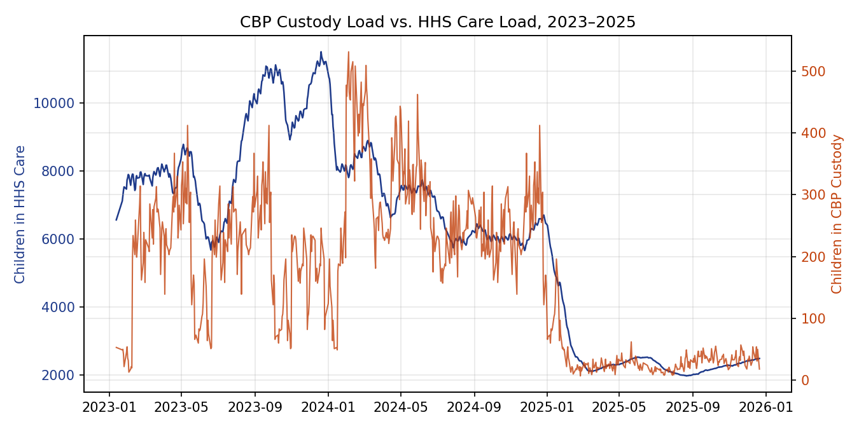
Figure 2. CBP custody load (right axis) versus HHS care load (left axis), 2023–2025.

3.3 Net Intake Pressure and Backlog Dynamics
Figure 3 shows net daily intake (HHS transfers-in minus HHS discharges) together with its 7-observation rolling average. Sustained periods below zero indicate the discharge pipeline is outpacing new transfers and the system is de-populating (as seen through most of 2023 and again from late 2024 into 2025); sustained periods above zero indicate accumulation (most visibly from January through April 2024, when the rolling average held above +50 net children per day for an extended stretch, and briefly again around October 2024). The longest single streak of consecutive positive-net-intake days in the series is 13 observations. Since roughly the second quarter of 2025 the net intake series has flattened close to zero with markedly smaller swings, consistent with the system having entered a lower-throughput, lower-volatility steady state.
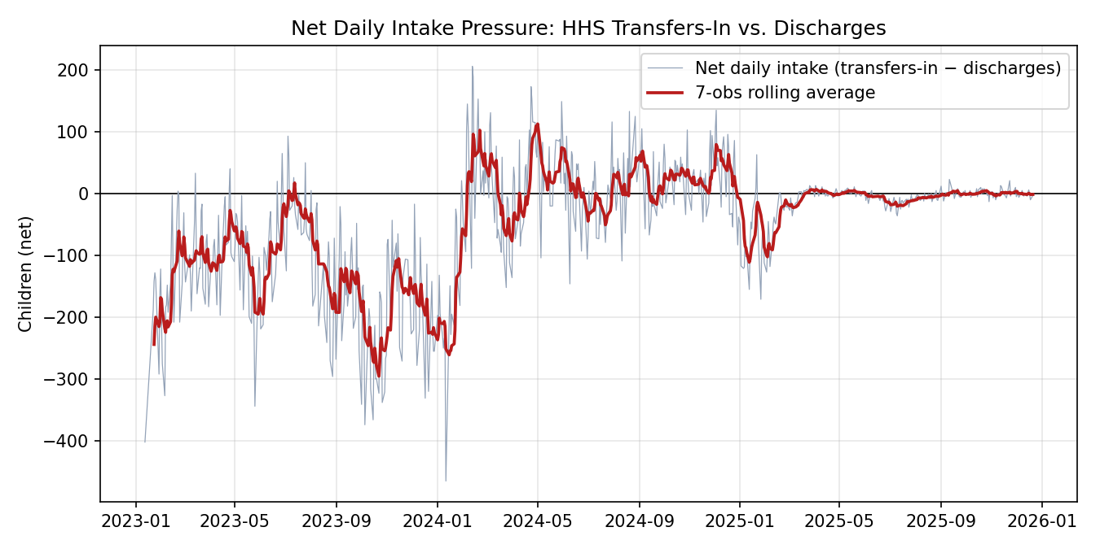
Figure 3. Net daily intake (transfers into HHS minus discharges from HHS), daily observations with 7-observation rolling average. Positive values indicate accumulating pressure; negative values indicate relief.

3.4 Monthly Trend and Period Comparison
Aggregating to monthly averages (Figure 4) makes the regime shift unambiguous. Average HHS care load was 8,646 in 2023 and 7,043 in 2024, before falling to an average of 2,543 in 2025 — a 64% decline in yearly average load from 2024 to 2025 alone. Within 2025, the monthly average fell from 4,991 in January to 2,164 by March, and has since held in a narrow 2,000–2,500 band through December, indicating the contraction was not a brief dip but a sustained change in system state.
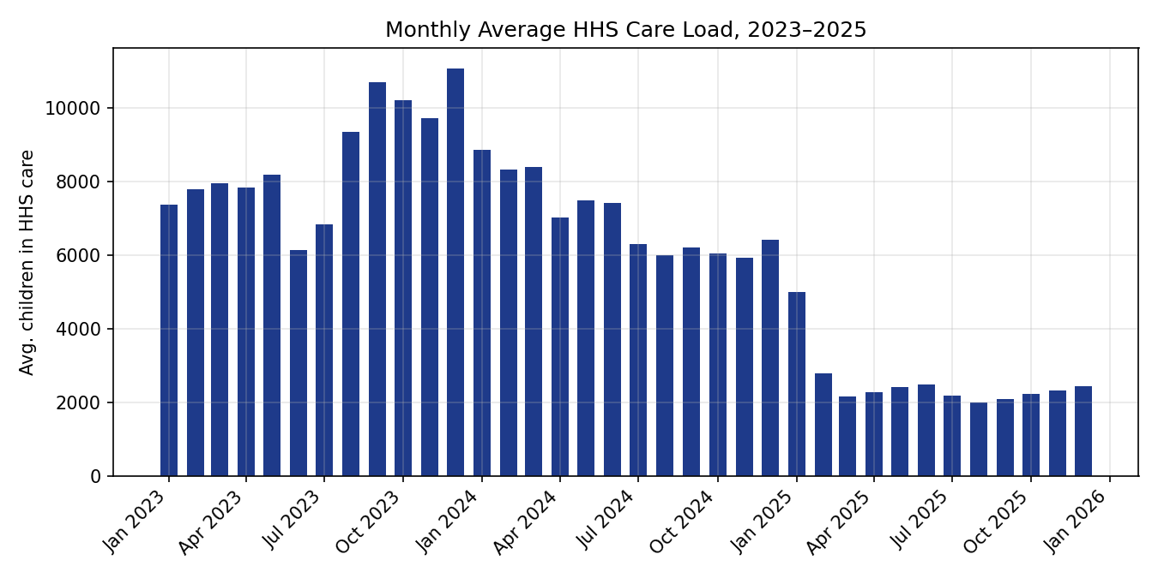
Figure 4. Monthly average HHS care load, 2023–2025.

3.5 Care Load Volatility
Figure 5 plots the Care Load Volatility Index. Volatility was consistently elevated (with repeated spikes above 2–4% daily standard deviation) through 2023 and into 2024, coinciding with the periods of fastest accumulation and relief shown in Figure 3. Volatility has been persistently low since early 2025, reinforcing that the current low-load period is also a low-uncertainty period from a staffing-and-planning perspective — though this also means the system may be more sensitive, in percentage terms, to a comparatively small absolute increase in arrivals.
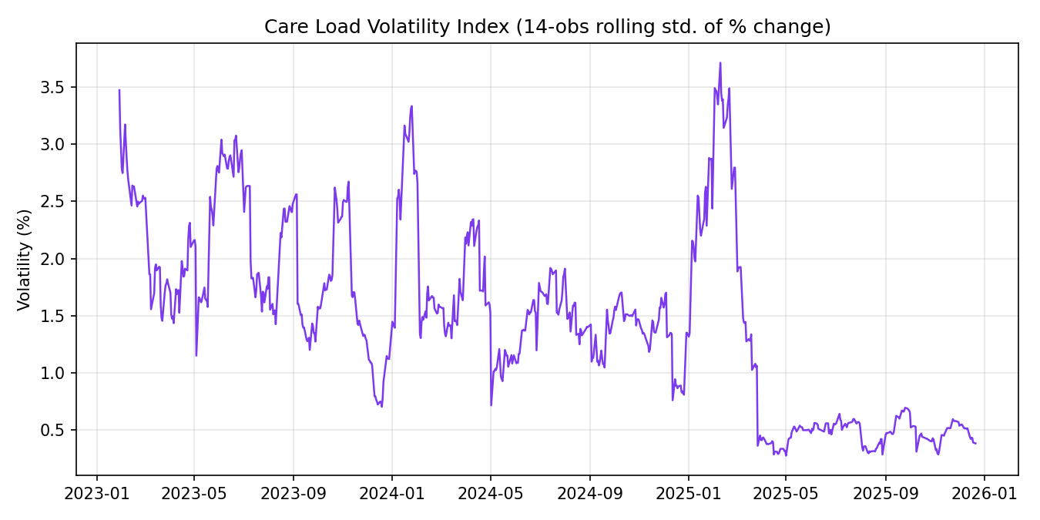
Figure 5. Care Load Volatility Index — 14-observation rolling standard deviation of day-over-day percentage change in HHS care load.

4. Key Performance Indicators
The five KPIs specified for the dashboard are summarized below using the most recent reported observation (December 21, 2025) and, where a trend is more informative than a single day, a trailing 30-observation window.
KPI | Value | Interpretation
Total Children Under Care | 2,502 (latest day) | 18 in CBP custody + 2,484 in HHS care. Down 78.7% from the series peak of 11,762 on Dec. 20, 2023.
Net Intake Pressure | +0.3 / day (30-obs avg) | Essentially balanced: transfers into HHS and discharges from HHS are running at parity in the most recent month of data.
Care Load Volatility Index | 0.49% (30-obs avg) | Low relative to the 2023–2024 period, which repeatedly exceeded 2–4%. Indicates a stable, predictable current caseload.
Backlog Accumulation Rate | 0 (current streak) | No active run of consecutive net-accumulation days as of the latest observation. Longest historical streak: 13 consecutive days.
Discharge Offset Ratio | 1.23 (30-obs avg) | Discharges are running about 23% ahead of new transfers-in over the past month, consistent with the near-zero net intake figure above.

5. Findings and Insights
- The UAC care system has moved through at least three distinct capacity regimes in the observed window: a moderate-load regime in early-to-mid 2023, a sustained high-load, high-volatility regime from mid-2023 through 2024 (peaking near 11,760 children under combined care), and a much lower-load, low-volatility regime that has held since roughly the first quarter of 2025.
- HHS care load — not CBP custody load — is the dominant contributor to total system load and to its variance, because average length of stay in HHS shelter care is far longer than in CBP custody. Capacity planning that focuses only on border-side intake risks missing the accumulated shelter-side burden.
- The discharge (sponsor placement) pipeline has generally kept pace with or outpaced new transfers since early 2025 (Discharge Offset Ratio persistently at or above 1.0), which is the direct mechanical driver of the observed de-population. This is a favorable operational signal but also means current staffing and shelter footprints are calibrated to a much smaller caseload than in 2023–2024.
- Because the current regime is both low-load and low-volatility, it likely understates the shelter and staffing surge capacity that would be required if intake were to revert toward 2023–2024 levels. The historical data show such reversals have happened before (e.g., the run-up from mid-2023 to the December 2023 peak) within a matter of months.
- The 86 days on which reported transfers-out exceeded the reported CBP custody snapshot are best explained by same-day intake-and-transfer dynamics and end-of-day snapshot timing rather than by data error, but they are a useful trigger for HHS's own reporting-quality review given they represent roughly 1 in 8 reported days.

6. Data Quality Notes and Limitations
- Reporting cadence is not strictly daily (roughly two-thirds of calendar days in the window have a published observation), so all trend and rolling-window statistics in this report are computed over reporting observations, not calendar days; a small amount of additional smoothing occurs across multi-day gaps.
- The dataset reflects published aggregate counts only; it contains no demographic, nationality, age, or case-duration detail, which limits root-cause analysis of why a given surge occurred or why length of stay varies.
- The apparent CBP-custody-exceeded-by-transfers condition (Section 2.2) cannot be fully resolved without the underlying hourly or intra-day source system, and is flagged rather than corrected in the cleaned dataset.
- This analysis is descriptive and diagnostic rather than causal: the 2025 contraction coincides with the reporting window but this report does not attempt to attribute it to any specific policy, enforcement, or external migration driver.

7. Recommendations

7.1 Staffing and Shelter Planning
- Maintain a tiered staffing and shelter-capacity plan keyed to the Total System Load and Net Intake Pressure KPIs, with pre-defined activation thresholds (e.g., sustained Net Intake Pressure above a set positive threshold for 5+ consecutive reporting days) rather than reacting only after HHS care load has already risen materially.
- Because HHS care load carries far more weight in total system load than CBP custody load, prioritize shelter-bed and case-management staffing surge plans over CBP-side surge plans when both indicators rise together.
- Preserve, rather than fully stand down, surge-capable shelter capacity and cross-trained staffing pools even during the current low-load period, given the historical precedent for rapid multi-month run-ups in load.

7.2 Monitoring and Situational Awareness
- Operationalize the five KPIs in this report as a standing dashboard (see accompanying Streamlit application) refreshed on each new data release, with the Backlog Accumulation Rate and Care Load Volatility Index used as early-warning indicators, since both moved ahead of the largest visible swings in total system load in the historical data.
- Track the Discharge Offset Ratio as the primary indicator of sponsor-placement pipeline health; a sustained drop below 1.0 is the clearest single leading signal of building backlog risk.
- Route the 86 flagged transfer-exceeds-custody days into a lightweight internal data-quality review to determine whether they reflect a consistent, explainable reporting convention or a subset that warrants source-system correction.

7.3 Policy and Humanitarian Response Evaluation
- Use the identified regime boundaries (mid-2023 build-up, the late-2023/2024 high-load plateau, and the 2025 contraction) as natural before/after windows when evaluating the operational impact of policy or process changes on system load and care throughput.
- Continue publishing and archiving daily counts at the current five-field granularity at minimum; consider adding shelter-level or regional breakdowns in future releases to support geographically targeted staffing and capacity decisions.

8. Conclusion
Applying a structured capacity-analytics framework to HHS's published UAC operational data converts five raw daily counts into a coherent picture of system load, pressure, and stability over nearly three years. The data show a system that experienced sustained, high-volatility strain through 2023 and 2024, peaking near 11,760 children under combined care, followed by a sharp and durable contraction beginning in early 2025 that has since held in a much lower, more stable 2,000–2,500 range. The KPI framework, dashboard, and recommendations in this report are intended to let staffing, shelter, and policy decisions be driven by these leading and lagging indicators on an ongoing basis, rather than by after-the-fact observation of headline caseload alone.

