//Write a java program to throw Arithmetic Exception and ArrayIndex exception.

public class ExceptionExample {

public static void main(String[] args) {

try {

int a = 10, b = 0;

int result = a / b;

} catch (ArithmeticException e) {

System.out.println("Error: " + e.getMessage());

}

try {

int[] arr = {1, 2, 3};

int value = arr[3];

} catch (ArrayIndexOutOfBoundsException e) {

System.out.println("Error: " + e.getMessage());

}

}

}

Output:

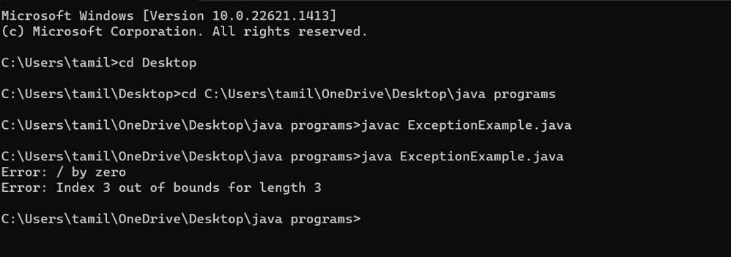

public class MatrixAddition {

public static void main(String[] args) {

int[][] matrix1 = {{1, 2}, {3, 4}};

int[][] matrix2 = {{5, 6}, {7, 8}};

int[][] result = new int[2][2];

for (int i = 0; i < 2; i++) {

for (int j = 0; j < 2; j++) {

result[i][j] = matrix1[i][j] + matrix2[i][j];

}

}

for (int i = 0; i < 2; i++) {

for (int j = 0; j < 2; j++) {

System.out.print(result[i][j] + " ");

}

System.out.println();

}

}

}

Output:

