1.

interface A {

void msg();

}

interface B {

void msg();

}

class C implements A, B {

public void msg() {

System.out.println("Hello World!");

}

public static void main(String[] args) {

C obj = new C();

obj.msg(); // This will call the msg() method implemented in class C.

}

}

Output:

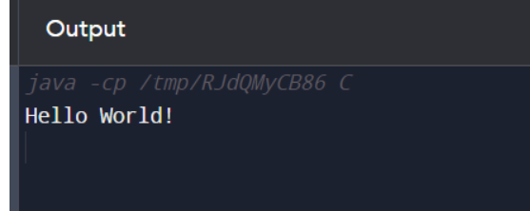

2.

interface Animal {

void eat();

}

interface Dog extends Animal {

void bark();

}

class BabyDog implements Dog {

public void eat() {

System.out.println("eating...");

}

public void bark() {

System.out.println("barking...");

}

public void weep() {

System.out.println("weeping...");

}

}

class TestInheritance2 {

public static void main(String args[]) {

BabyDog d = new BabyDog();

d.weep();

d.bark();

d.eat();

}

}

Output:

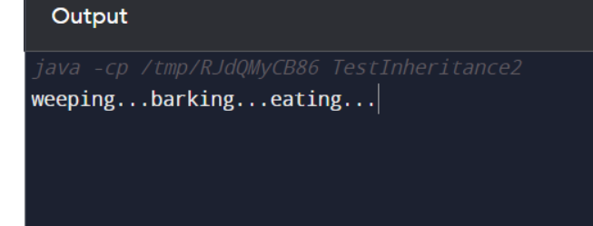

3.

class Q2 Animal {

void eat() {

System.out.println("eating...");

}

}

class Dog extends Animal {

void bark() {

System.out.println("barking...");

}

}

class BabyDog extends Dog {

void weep() {

System.out.println("weeping...");

}

}

class TestInheritance2 {

public static void main(String args[]) {

BabyDog d = new BabyDog();

Animal a = new Animal();

a.eat();

d.bark();

d.weep();

}

}

Output:

