1.

import java.util.Arrays;

public class MatrixEquality {

public static void main(String[] args) {

int[][] matrix1 = {{1, 2, 3}, {4, 5, 6}, {7, 8, 9}};

int[][] matrix2 = {{1, 2, 3}, {4, 5, 6}, {7, 8, 9}};

if (areMatricesEqual(matrix1, matrix2)) {

System.out.println("The matrices are equal.");

} else {

System.out.println("The matrices are not equal.");

}

}

public static boolean areMatricesEqual(int[][] matrix1, int[][] matrix2) {

if (matrix1.length != matrix2.length) {

return false;

}

for (int i = 0; i < matrix1.length; i++) {

if (!Arrays.equals(matrix1[i], matrix2[i])) {

return false;

}

}

return true;

}

}

Output:

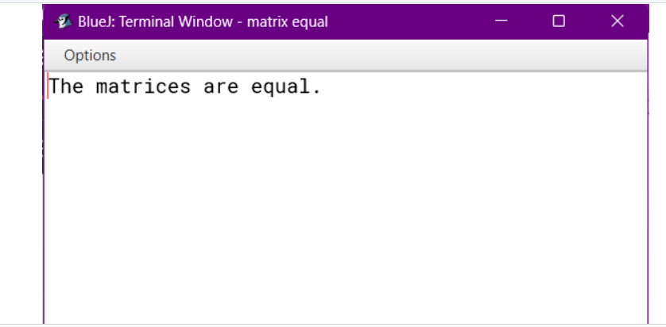

2.

import java.util.Scanner;

public class SubsetsOfString {

public static void main(String[] args) {

Scanner scanner = new Scanner(System.in);

System.out.print("Enter a string: ");

String str = scanner.next();

System.out.println("All subsets of the string are:");

int len = str.length();

// Loop to generate all subsets of the given string

for (int i = 0; i < len; i++) {

for (int j = i + 1; j <= len; j++) {

System.out.println(str.substring(i, j));

}

}

}

}

Output:

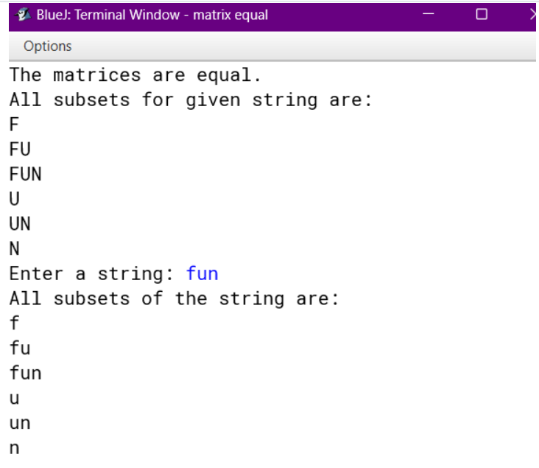  
3.

public class SumNumbers {

public static void main(String[] args) {

int sum = sumNumbers(10);

System.out.println("Sum of numbers up to 10 is: " + sum);

}

public static int sumNumbers(int n) {

if (n == 1) {

return 1;

} else {

return n + sumNumbers(n-1);

}

}

} output:

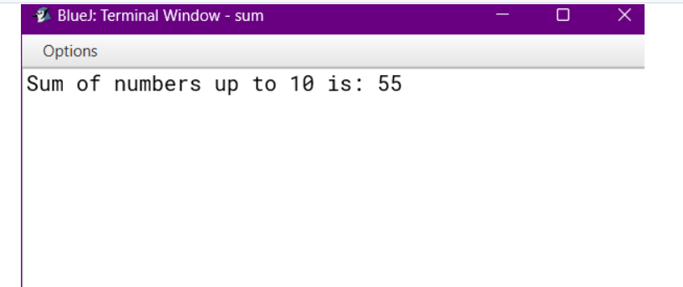

4.

public class TypeCasting {

public static void main(String[] args) {

// Widening Casting

byte numByte = 64;

short numShort = numByte; // no explicit casting required

int numInt = numShort;

long numLong = numInt; // Implicit casting from int to long

float numFloat = numLong; // Implicit casting from long to float

double numDouble = numFloat; // Implicit casting from float to double

System.out.println("byte value: " + numByte);

System.out.println("short value: " + numShort);

System.out.println("Widening Casting:");

System.out.println("int: " + numInt);

System.out.println("long: " + numLong);

System.out.println("float: " + numFloat);

System.out.println("double: " + numDouble);

// Narrowing Casting

double numDouble2 = 123456.789;

float numFloat2 = (float) numDouble2; // Explicit casting from double to float

long numLong2 = (long) numFloat2; // Explicit casting from float to long

int numInt2 = (int) numLong2; // Explicit casting from long to int

char charVal = (char) numInt2; // Explicit casting from int to char

byte byteVal = (byte) charVal;// Explicit casting from char to byte

short shortVal = (short) byteVal;

System.out.println("\nNarrowing Casting:");

System.out.println("double: " + numDouble2);

System.out.println("float: " + numFloat2);

System.out.println("long: " + numLong2);

System.out.println("int: " + numInt2);

System.out.println("char: " + charVal);

System.out.println("byte: " + byteVal);

System.out.println("short: " + shortVal);

}

}

Output:

