**Compressive Output**

**Eureka**

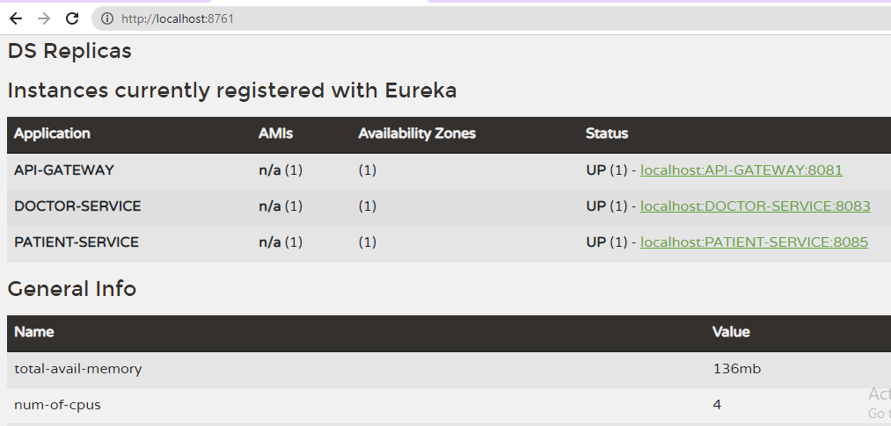

**Angular Home Page**

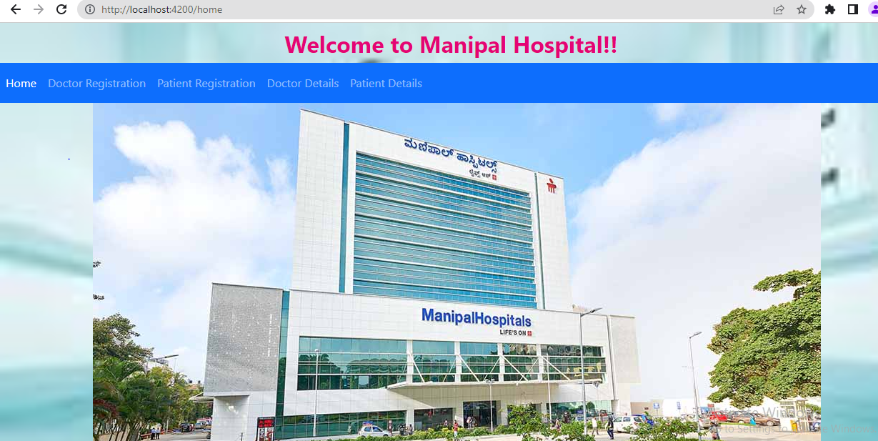

**Doctor Registration**

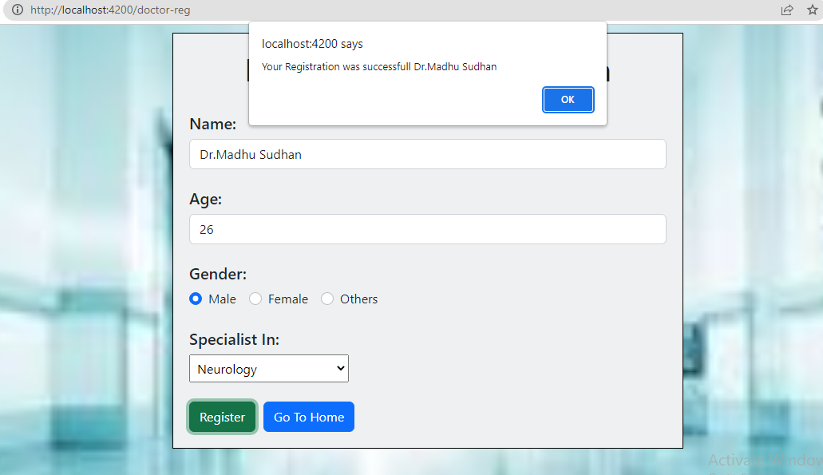

**Doctor Details**

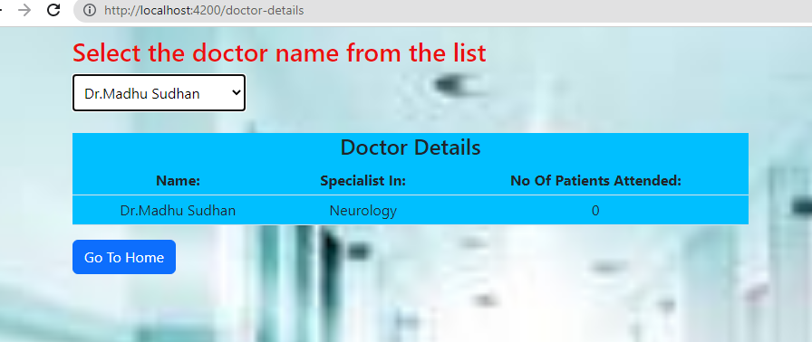

**Patient Registration**

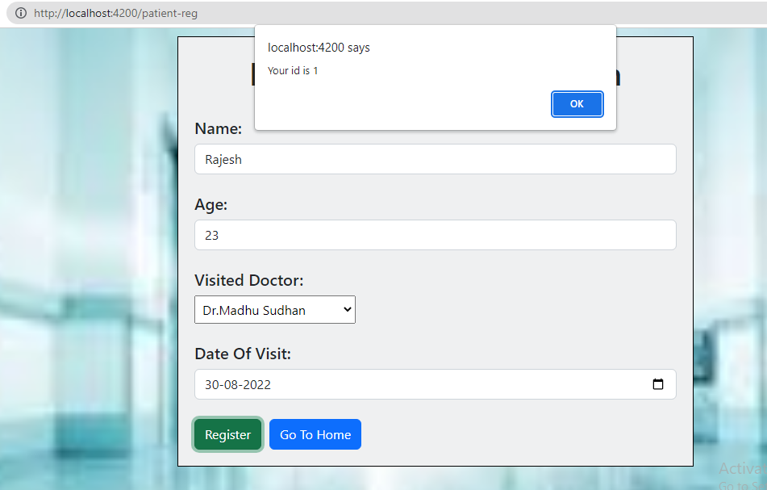

**Patient Details**

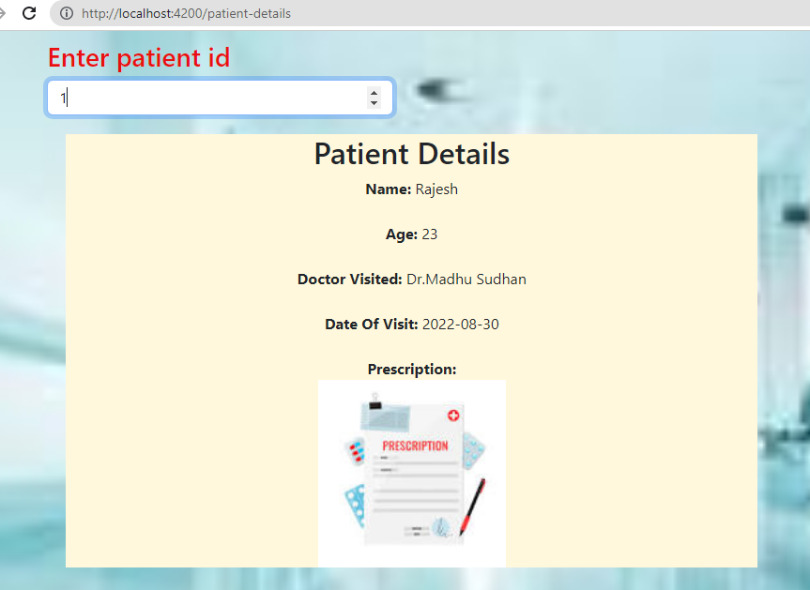

**If Patient Id Not Found**



**Junit testing for Doctor RESTAPI controller layer**

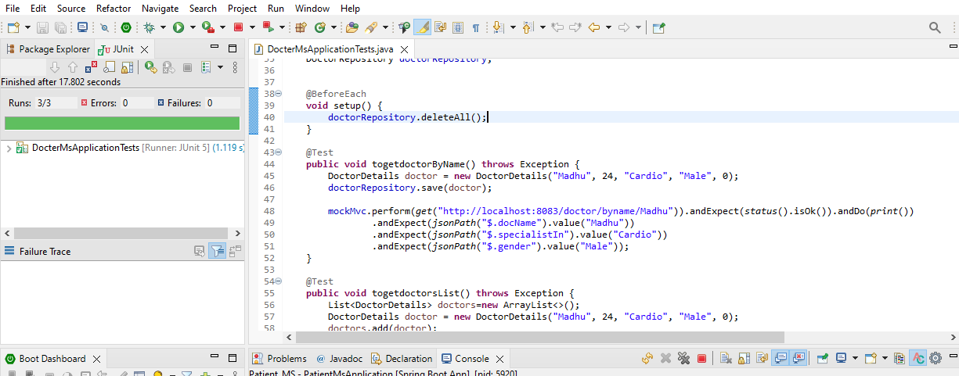

**Junit testing for Patient RESTAPI controller layer**

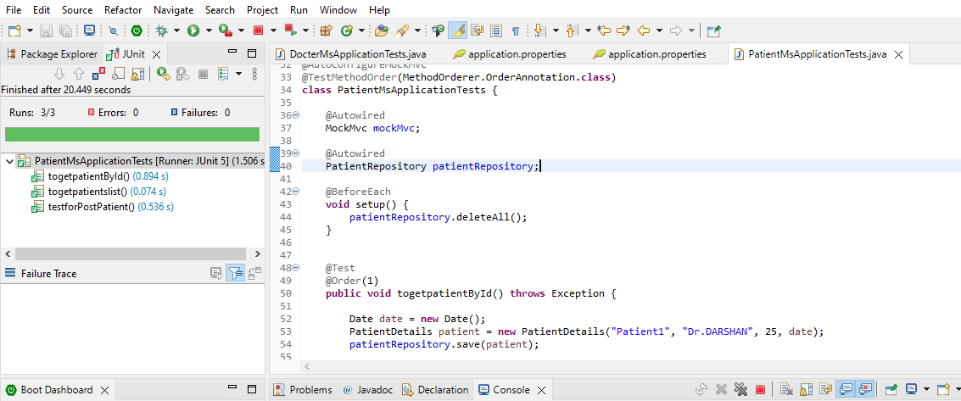

**Maven Build**

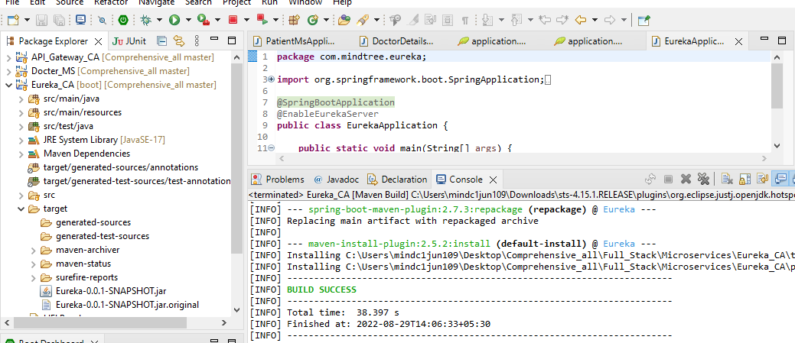

**Git Repository**