English to French Machine Translation Comparison
ICT4403 Foundations of Generative AI Assignment 3
Harish Bharathwaj | Registration 230953594
Three systems completed 200-item evaluation on an identical held-out test set. Llama has the highest recorded BLEU and chrF among them. mT5-small completed two finite-loss LoRA epochs but failed during generation when it emitted a sentinel token despite suppression. Its translation quality and inference cost remain unmeasured.

Dataset and methods
The code uses OPUS Books English-French parallel text, normalized and filtered by sentence length, deduplicated, then shuffled with seed 42. It specifies 4,000 training, 400 validation, and 200 test pairs. The three completed models have the same 200 source/reference rows. Reconstructing their test CSV reproduces the archived SHA-256 8637ba500e2a1b7424a208993427fb431237a6c4f9ab28a2b80853a678f2c1b8. The original split CSVs and dataset manifest were absent from the backup, so train/validation contents could not be rechecked.
The Basic system is a two-layer, four-head encoder-decoder Transformer trained from scratch for 10 epochs. mT5-small used rank-8 LoRA for two epochs in FP32. Llama 3.2 1B Instruct and Gemma 3 270M IT were prompted zero-shot. Primary generation used greedy decoding with at most 64 new tokens. mT5 applied sentinel and repetition controls; causal models used a chat prompt and a plain-prompt retry for empty chat output.

Measured comparison
System | Status | BLEU | chrF | Train s | Infer s/item | Parameters
Basic Transformer | Completed | 0.665 | 12.834 | 28.04 | 0.116 | 4,698,250
mT5-small LoRA | Failed | - | - | Not saved | - | Not saved
Llama 3.2 1B Instruct | Completed | 10.439 | 33.333 | N/A | 0.682 | 1,235,814,400
Gemma 3 270M IT | Completed | 6.103 | 27.482 | N/A | 0.644 | 268,098,176

BLEU and chrF below are the saved SacreBLEU corpus scores, not independently recomputed in this workspace. The audit checked finite score ranges, 200 complete translation records per completed model, identical test rows, timing arithmetic, and digit diagnostics. Inference times exclude model loading.
Llama leads the completed systems at BLEU 10.439 and chrF 33.333, with 1,235,814,400 parameters and 0.682 seconds per sentence. Basic is smallest and fastest (4,698,250 parameters; 0.116 seconds per sentence) but has BLEU 0.665. Gemma has 268,098,176 parameters and BLEU 6.103; 45 of its 200 outputs copy the English source exactly. These results reflect different pretraining, sizes, tokenizers, adaptation, and prompts, so architecture alone does not explain the ranking.
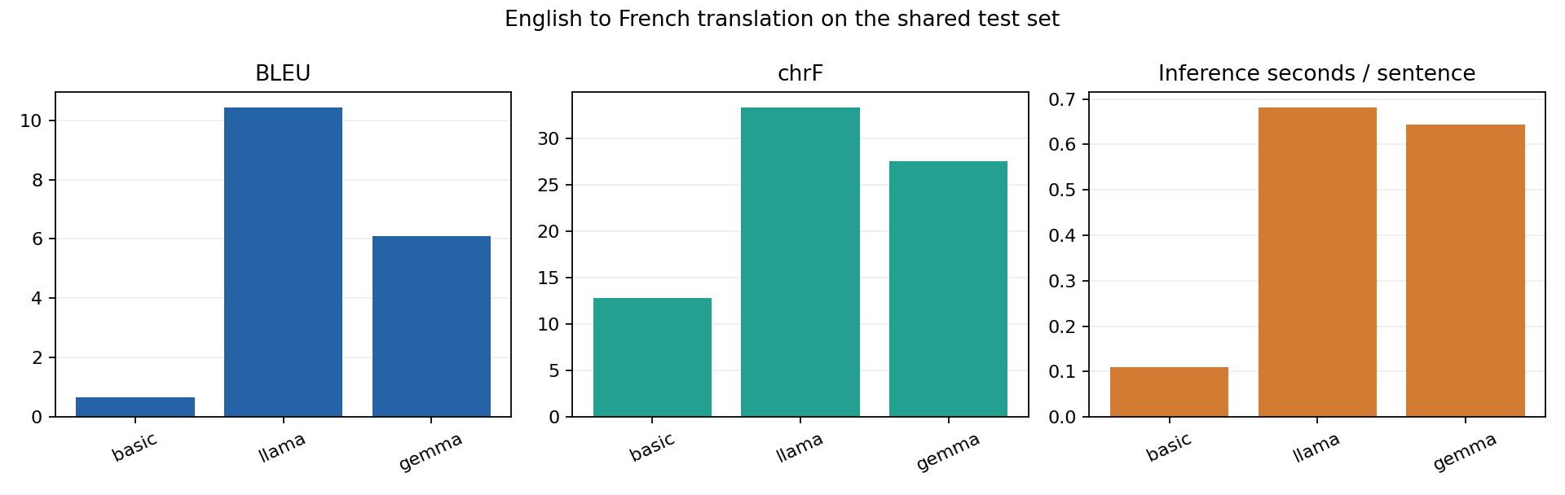
Figure 1. Recorded scores and inference time for completed models only.

Training evidence and failure
Basic training and validation losses fell from 7.173/6.292 to 4.563/5.246 over 10 epochs; its recorded training time was 28.04 seconds. mT5's two finite-loss epochs fell from 7.825/3.908 to 5.098/3.725. Its generation then raised ValueError: mT5 emitted a sentinel token despite suppression. The backup has no validated mT5 metrics or 200-item translation file; training time and parameter count were not saved in a completed mT5 metrics artifact.
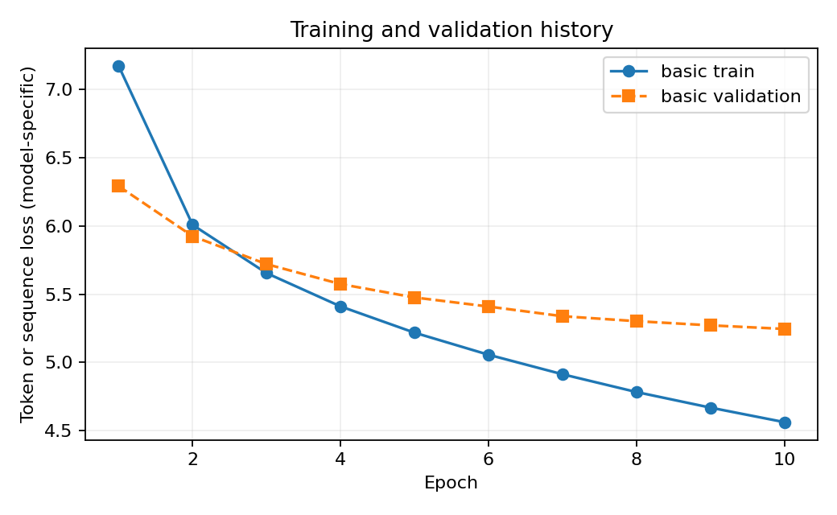
Figure 2. Basic Transformer training and validation loss; mT5 has no validated evaluation.

Saved translation examples
Predictions below are verbatim from the shared test set.

Test item 1
English: Prudence was standing looking around the place; Marguerite, seated on the sofa, was meditating.
Reference French: Prudence, debout, regardait les quelques curiosités de mon salon; Marguerite, assise sur le canapé, réfléchissait.
Basic Transformer: le capitaine, était, le capitaine, le capitaine, le capitaine.
Llama 3.2 1B Instruct: Prudence était assise sur le canapé, regardant autour de la place. Marguerite, assise sur le sofa, méditait.
Gemma 3 270M IT: Prudence était en train de regarder autour de la place; Marguerite, assise sur le canapé, était en méditation.

Test item 2
English: There was a band of brothers!
Reference French: Quelle troupe fraternelle.
Basic Transformer: il y avait une voix!
Llama 3.2 1B Instruct: Il y avait une bande de frères.
Gemma 3 270M IT: There was a band of brothers!

Test item 4
English: "You can vouch for it, Francis!"
Reference French: -- Vous pouvez vous porter garant du combat, Francis?
Basic Transformer: - - - - vous, dit - vous, dit - vous, dit - vous, dit - vous, dit - vous, dit - vous, dit - vous, dit - vous, dit - vous, dit - vous, dit - vous, dit - vous, dit - vous, dit - vous, dit -
Llama 3.2 1B Instruct: "Vous pouvez le prouver, Francis!"
Gemma 3 270M IT: You can vouch for it, Francis!

Error analysis and responsible use
The saved outputs reveal concrete quality risks. Basic repeats 'le capitaine' in item 1. Llama describes Prudence as seated although the source says she was standing. Gemma returns the English source unchanged in item 2 and does so for 45 of 200 items; Llama has 5 exact source copies. A French reference for test item 3 contains an extra sentence absent from its English source, indicating possible alignment noise. Among four sources with digits, all four Basic outputs and two each from Llama and Gemma changed digit sequences.
Stance changes, missing translation, altered numbers, repetition, and possible corpus misalignment can distort people, claims, and cultural context. Bias, gender, politeness, and sensitive-content safety were not systematically measured. For public-facing or high-stakes translation, retain the source, check names and numbers, flag source copies and repetition, review diverse examples with a human translator, and offer correction. BLEU and chrF measure overlap with references rather than adequacy or safety.

Sampling temperature analysis
The optional study sampled only the first eight shared test items at temperatures 0.2, 0.7, and 1.0. These exploratory scores are not comparable to the 200-item greedy results, and eight examples are too few to rank sampling settings reliably. No mT5 temperature result exists.
Model | Temp | BLEU on 8 | chrF on 8 | Empty
Basic Transformer | 0.2 | 1.560 | 15.354 | 0
Basic Transformer | 0.7 | 1.470 | 15.799 | 0
Basic Transformer | 1.0 | 1.006 | 17.521 | 0
Llama 3.2 1B Instruct | 0.2 | 17.489 | 40.125 | 0
Llama 3.2 1B Instruct | 0.7 | 14.521 | 37.458 | 0
Llama 3.2 1B Instruct | 1.0 | 9.829 | 31.557 | 0
Gemma 3 270M IT | 0.2 | 13.607 | 35.209 | 0
Gemma 3 270M IT | 0.7 | 6.535 | 32.487 | 0
Gemma 3 270M IT | 1.0 | 7.896 | 32.176 | 0

Conclusion and limits
Llama is best by the recorded BLEU and chrF among the three completed models. The four-model assignment remains incomplete because mT5 has no validated translation or quality score. The backup also lacks the original data manifest and split CSVs; SacreBLEU could not be independently rerun in the audit workspace. The archived mT5-only status is preserved, and the reconciled status explicitly identifies the combined evidence from multiple runs.

Sources and reproducibility
Dataset: https://huggingface.co/datasets/Helsinki-NLP/opus_books
Models: https://huggingface.co/google/mt5-small ; https://huggingface.co/meta-llama/Llama-3.2-1B-Instruct ; https://huggingface.co/google/gemma-3-270m-it
Repository supplied by student: https://github.com/Harish766/GenAI2.git
Test split SHA-256: 8637ba500e2a1b7424a208993427fb431237a6c4f9ab28a2b80853a678f2c1b8
Evidence: results/REPORT.md, results/validation.json, results/run_status.json, saved metrics, translations, plots, and the archived mT5 attempt status.

