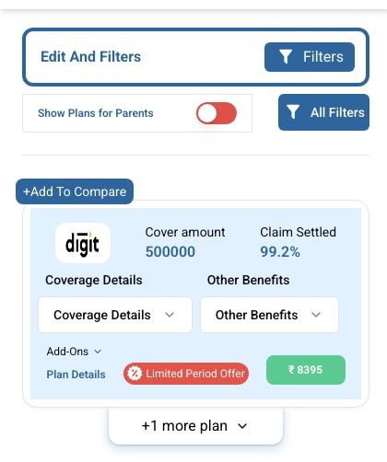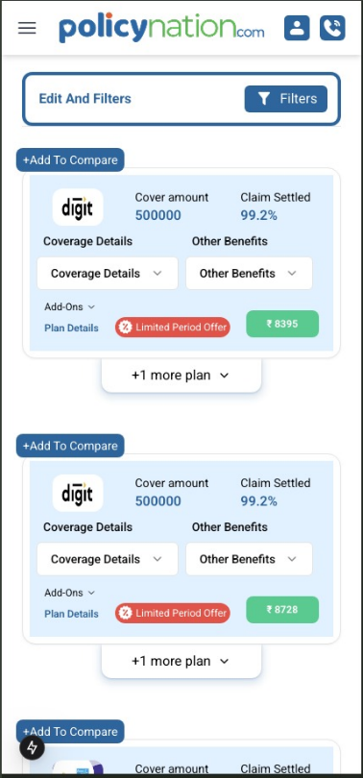  

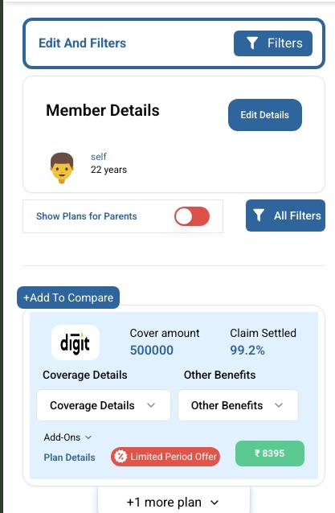

1. Quote page of health insurance this design to be followed
2. When filter is pressed its should show only the filter components
3. When edit and filter is clicked it should show both member details and filter
4. 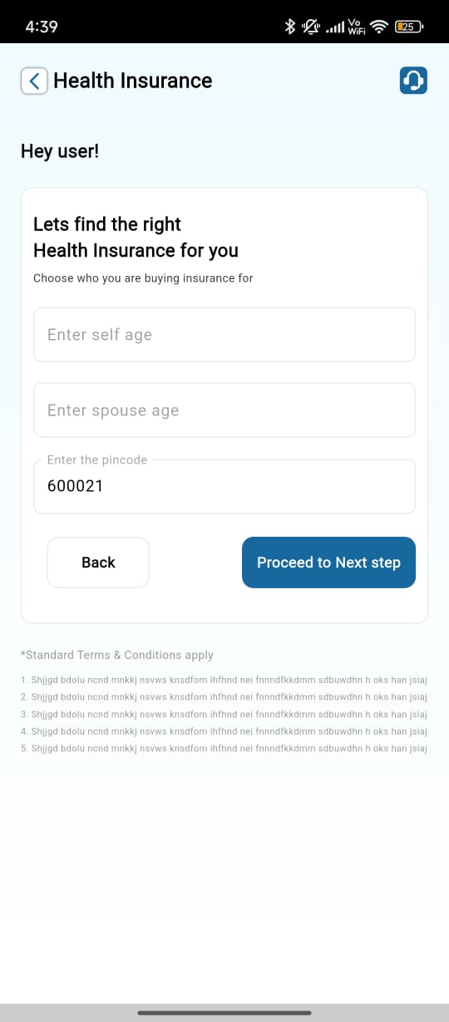Add to compare is not working
5. When edit details is pressed age is not getting patched

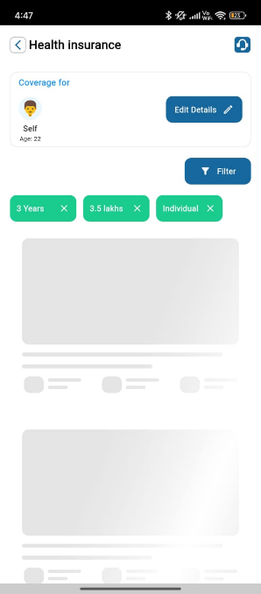

1. When filter is selected but apply filter button is not pressed on refresh getting added.

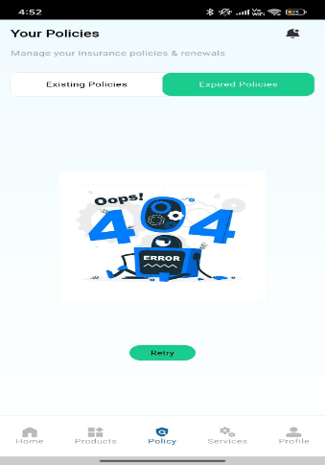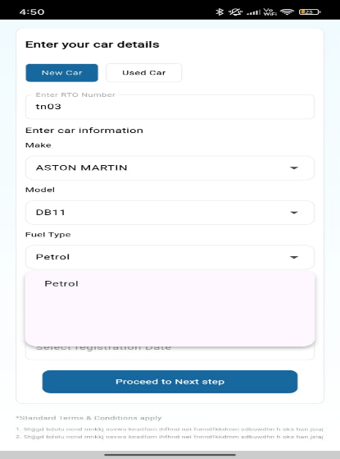

1. Dropdown has empty space.
2. It should show no policy found or any other message instead 404 error

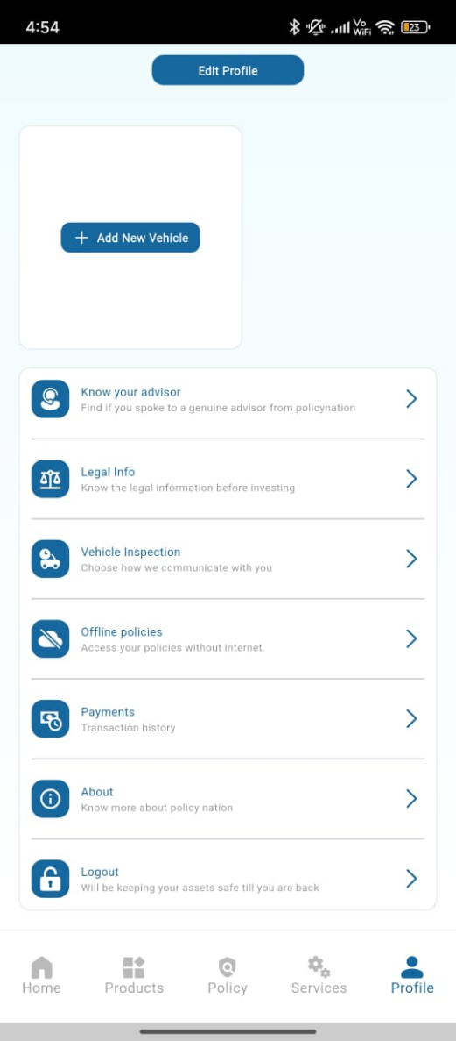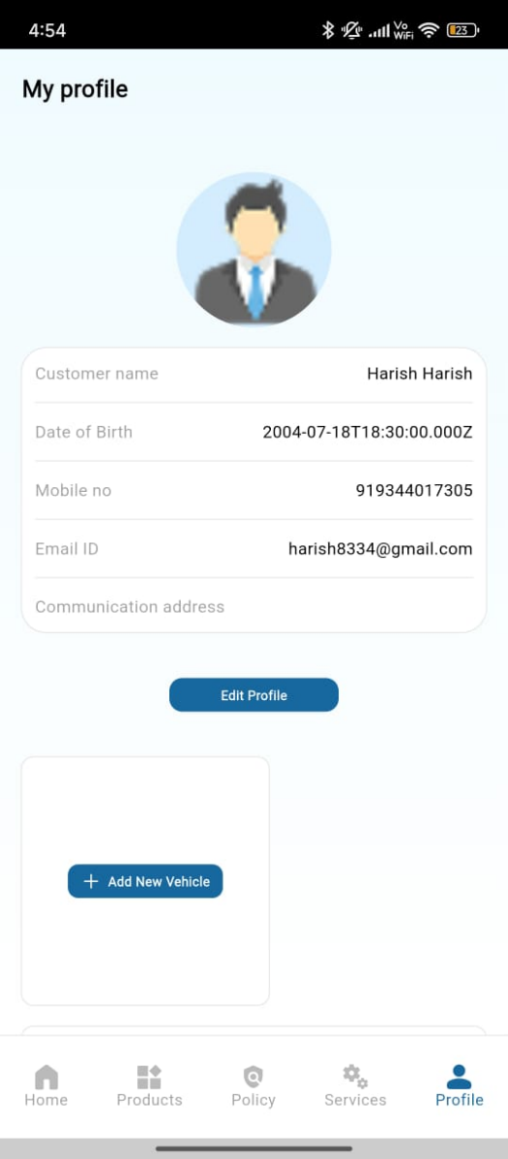  
9. Date of Birth is not in the proper format.

10. in buttons on click works only on clicking text , icons , instead of its should work on clicking the entire button

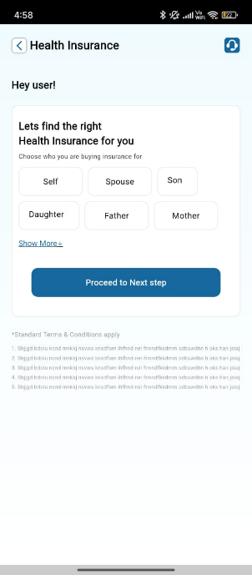

11. touch area of the back buttons must be improve and when the back buttons is pressed its should show a confirmation popup for all back buttons

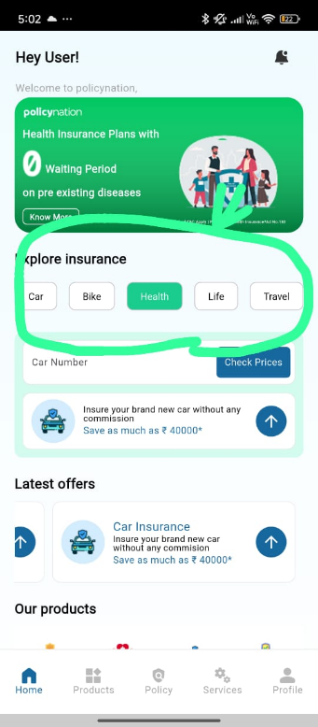

12. This should change dynamically based on the selected insurance

13. Support icon is missing