**IBM- Naan Mudhalvan Data Analytics with Cognos**

**Phase 3**

**Development Part 1**

**Student Name :** Harish A

**Register Number :** 620821104043

**Branch :** B.E CSE

**Year :** 3rd Year

**Topic :** Data Analytics with Cognos

**Title :** Air QualityAnalysis in Tamil Nadu

**College :** Gnanamani College of Technology

## Introduction

## Air Quality Analysis involves the use of machine learning models to gain insights into website user behavior, predict future traffic trends, and optimize various aspects of web content and infrastructure. This document explores the machine learning models commonly used in Air Quality analysis and considerations for incorporating these models into data analytics with Cognos.

**Objectives**

In this phase defines start to building the Project by loading and preprocessing the dataset and perform different analysis and visualization using IBM Cognos.

**Data source**

Dataset is collected from the kaggle.com named “daily-website-visitors.csv” which has a data about the Days, Day of week, Date, page Loads, Unique visits, First-time visits, Returning Visits.

Dataset link: <https://www.kaggle.com/datasets/bobnau/daily-website-visitors>

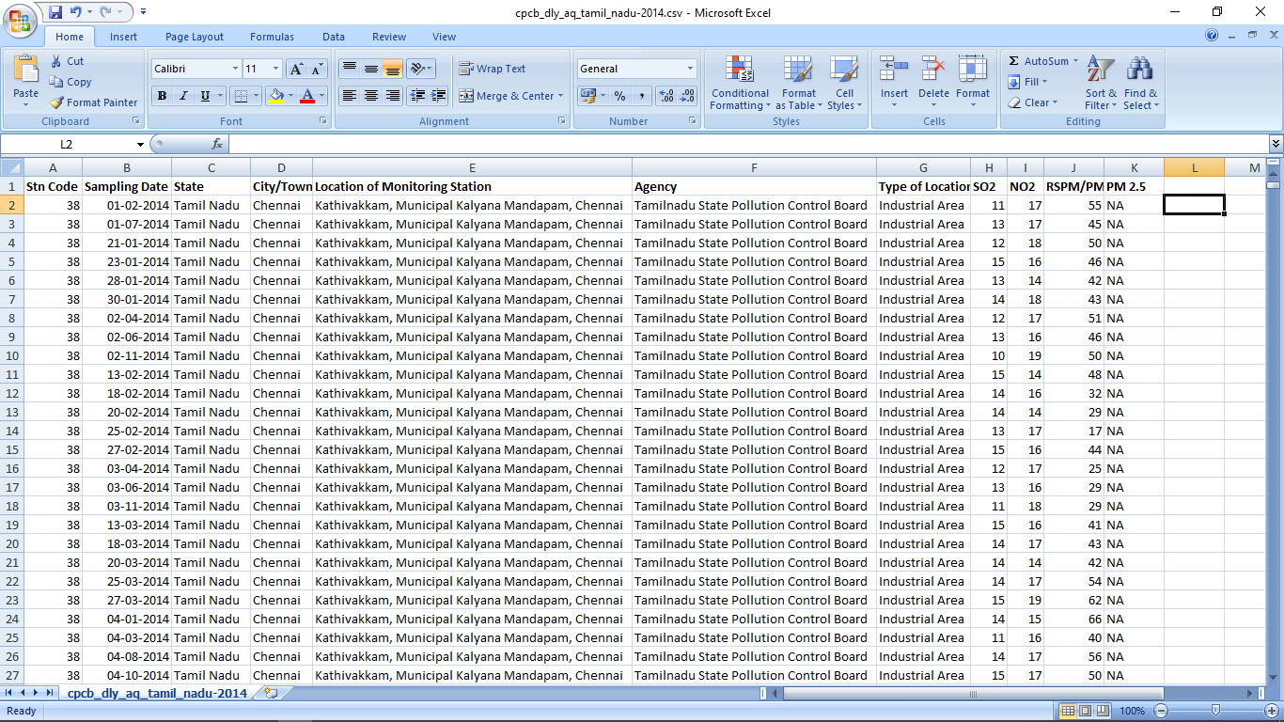

**Data Loading**

Steps Involved in data loading on IBM cognos.

1. Login to your IBM cognos
2. Click more menu from the left side
3. Select new tab

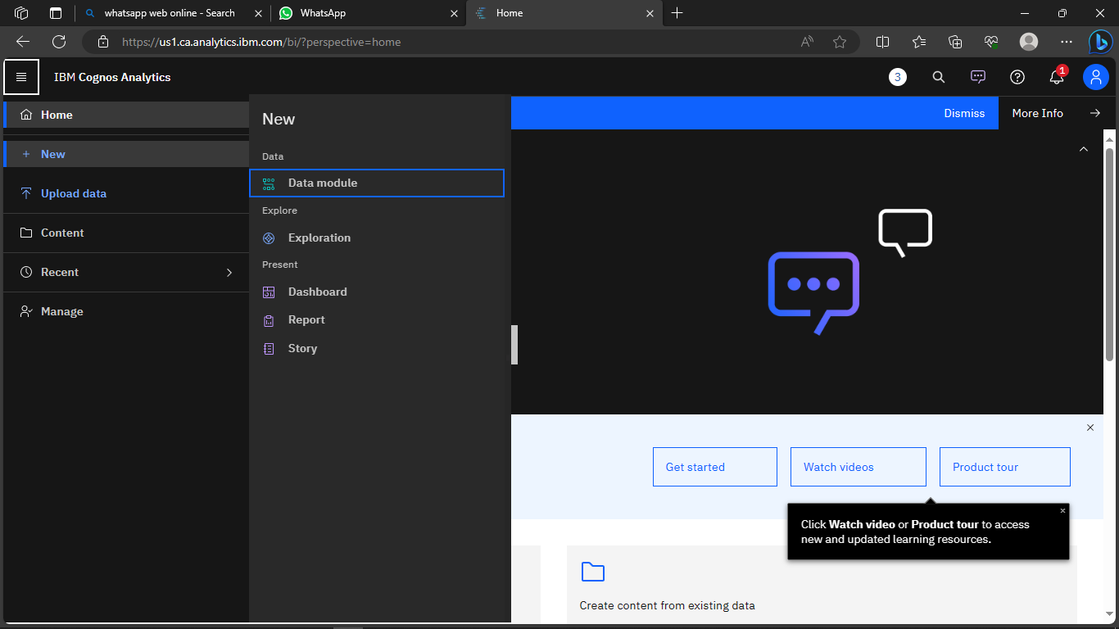

4. Click Data module tab

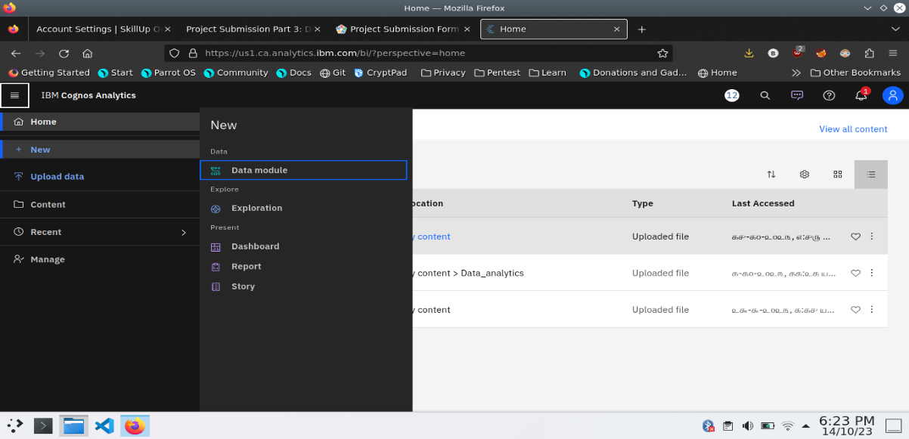

5.Upload the dataset for your project and select the Corresponding file

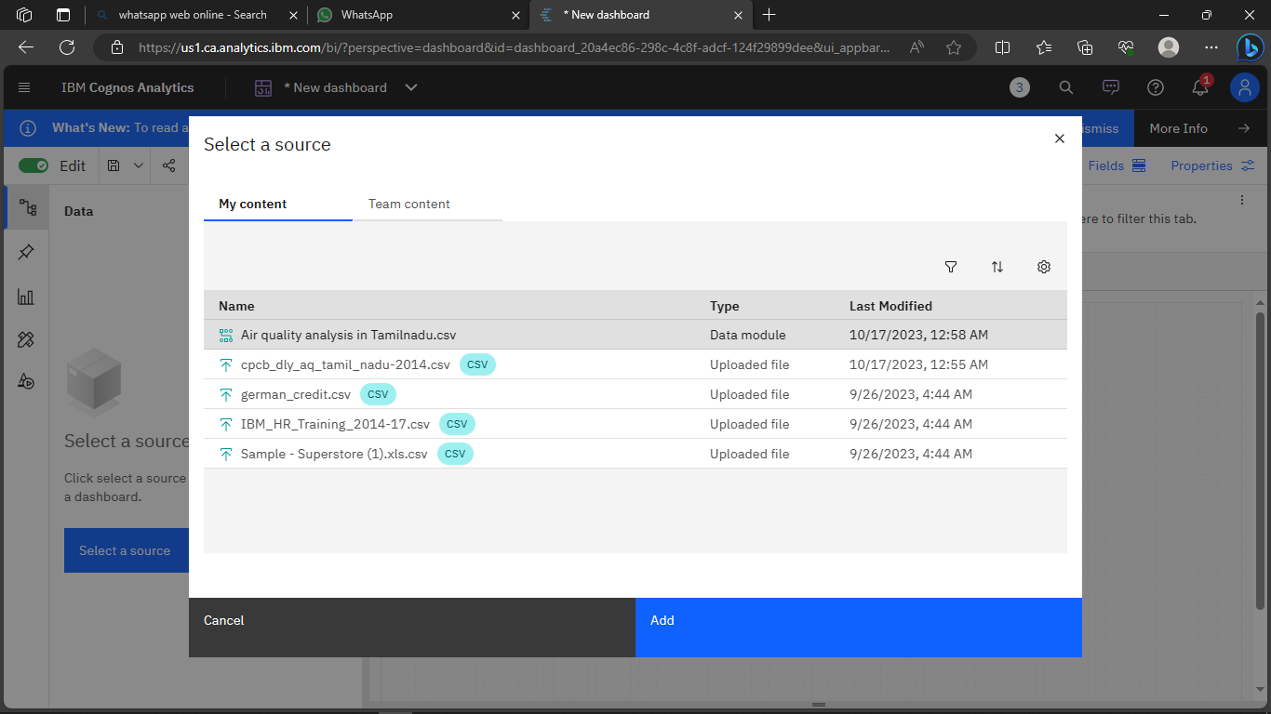

6. preview the data

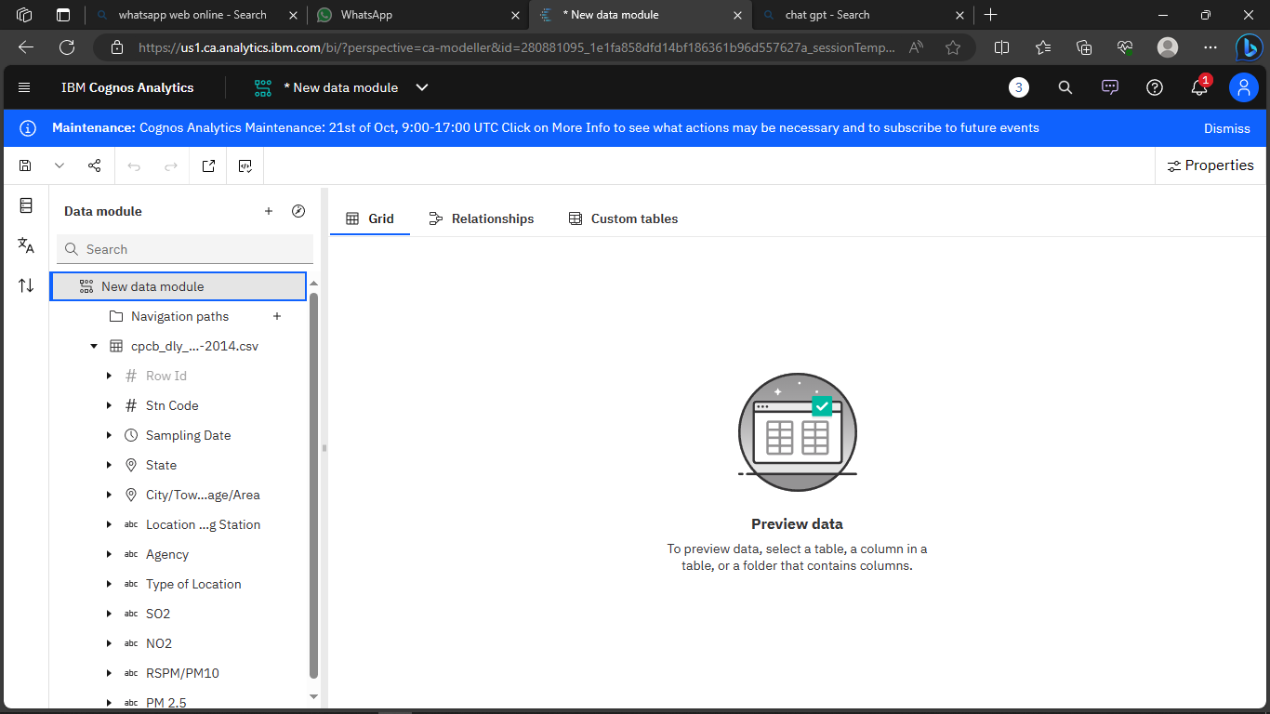

7.Explore the data

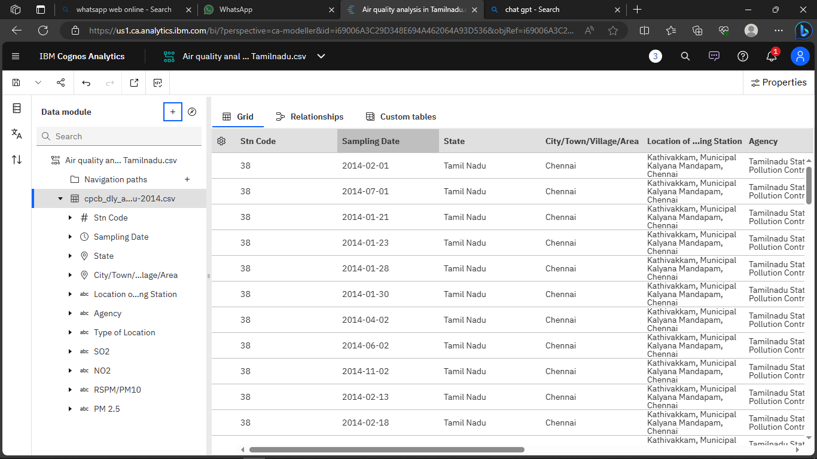

8. save the data module

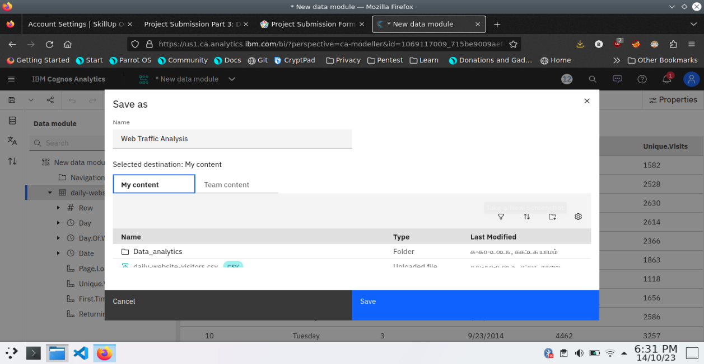

**Data Preprocessing and Cleaning**

In this phase the following steps will taken

* Handling missing data
* Data Transformation
* Data Type Conversion
* Removing Duplicates
* Dealing Outliers

Once you saved the data module. Click the corresponding dataset on IBM cognos and Preview the mosule

Right Click the row where you want to clean the data

It provides the UI to Clean the data and makes the task easy one, Now Updating and Replacing the Null values are simple

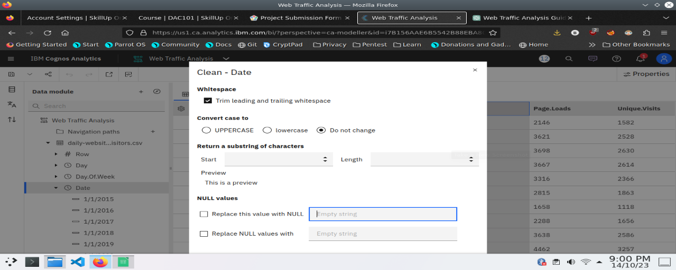

data module will be updated by doing the above process

after the completion of process start creating the dashboard for Visualization

**Dashboard Creation**

Dashboard creation are helpful to visualizing the data

1. Goto Home menu
2. Select the new tab
3. Click dashboard

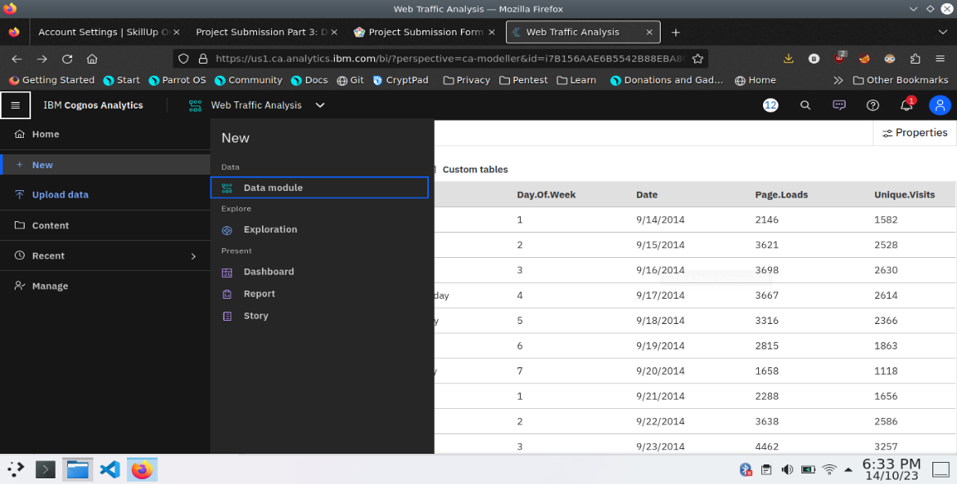

4. Choose the template for your project and click

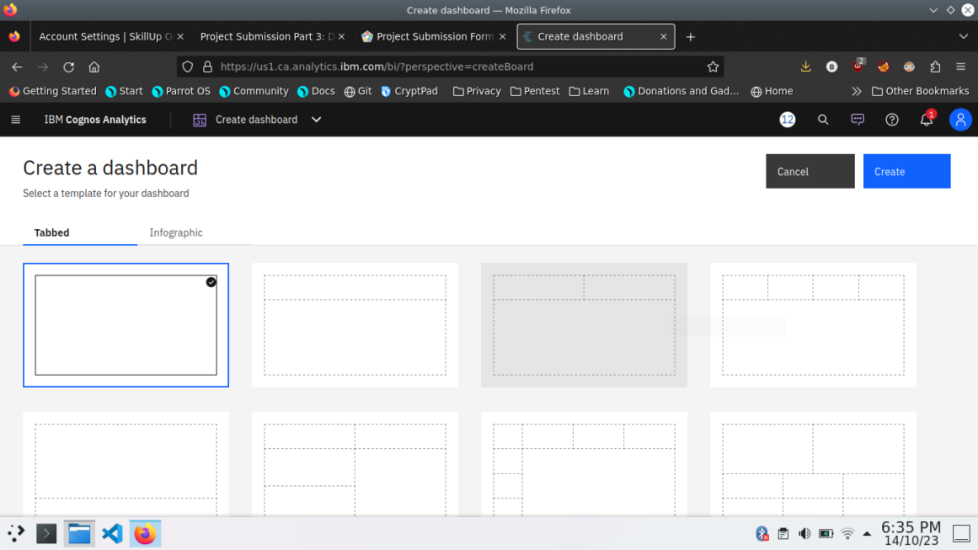

5.Now Dashboard is created

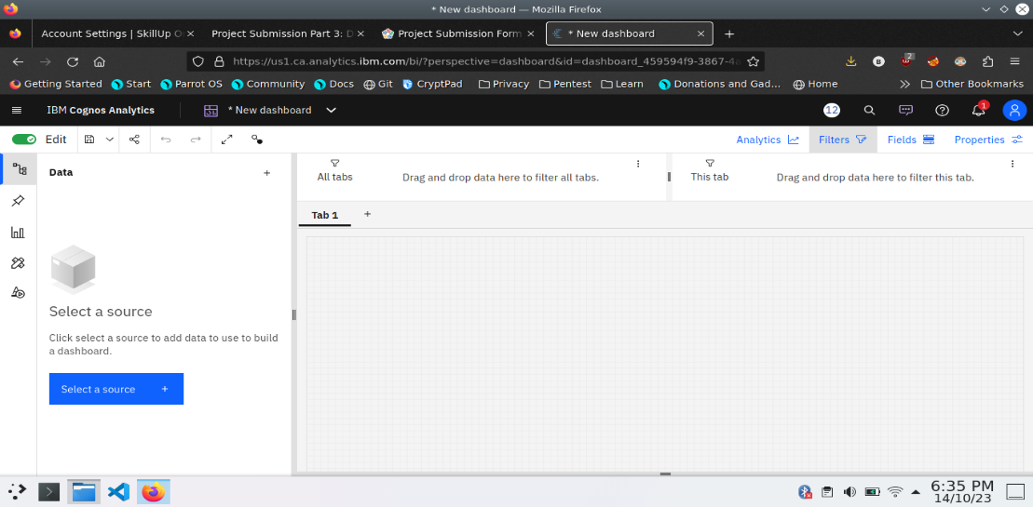

6. Select the data source

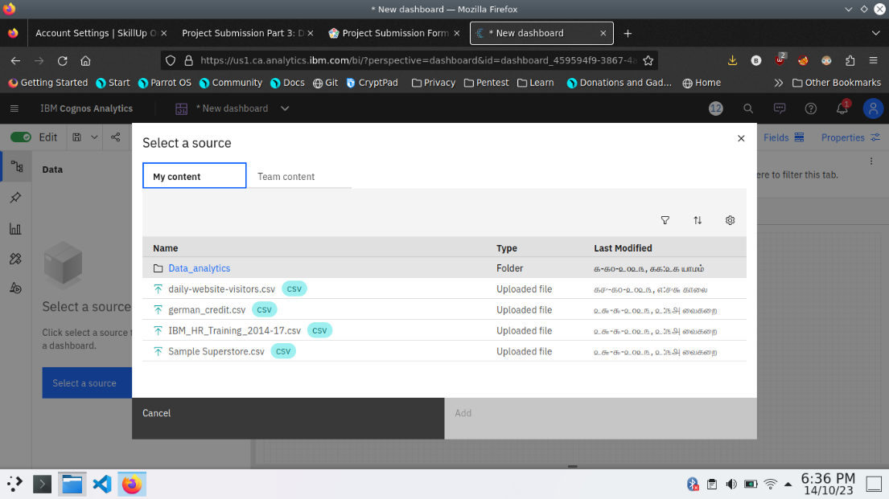

**Visualization**

After creating the dashboard, the next step is to visualize the data

In IBM Cognos

1. Goes to the Corresponding Dashboard

2. select the visualizations tab in the left side of title bar

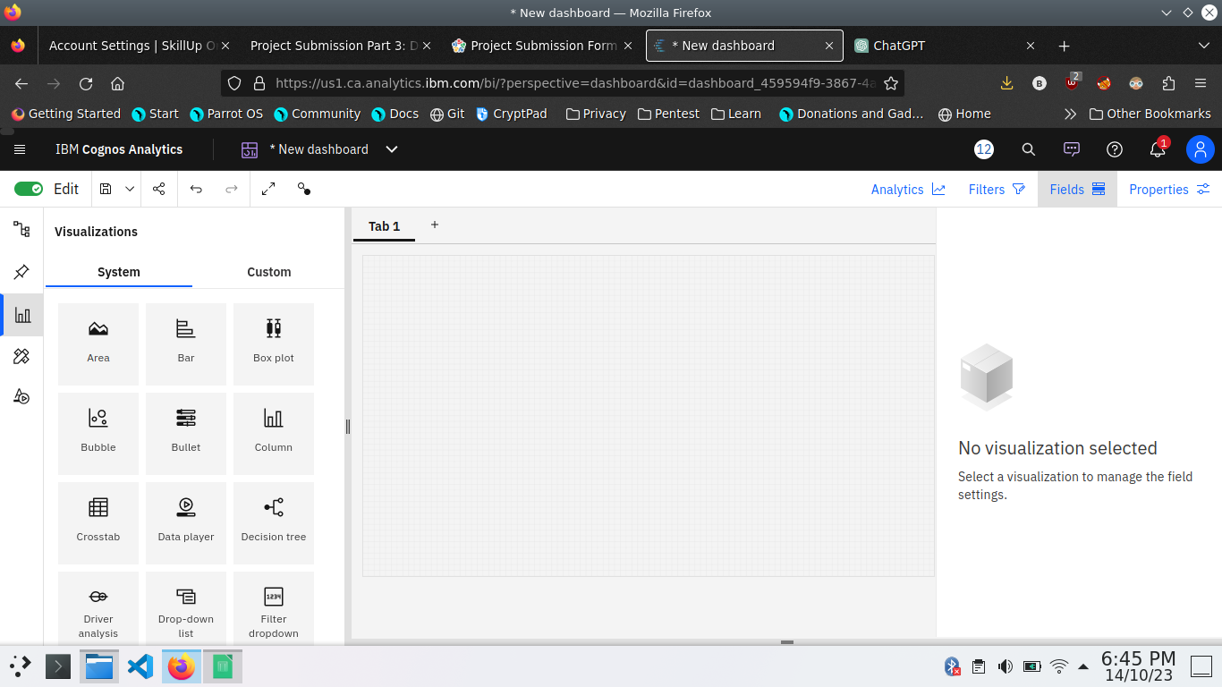

3.Choose the system as you want and put the data source for the required columns

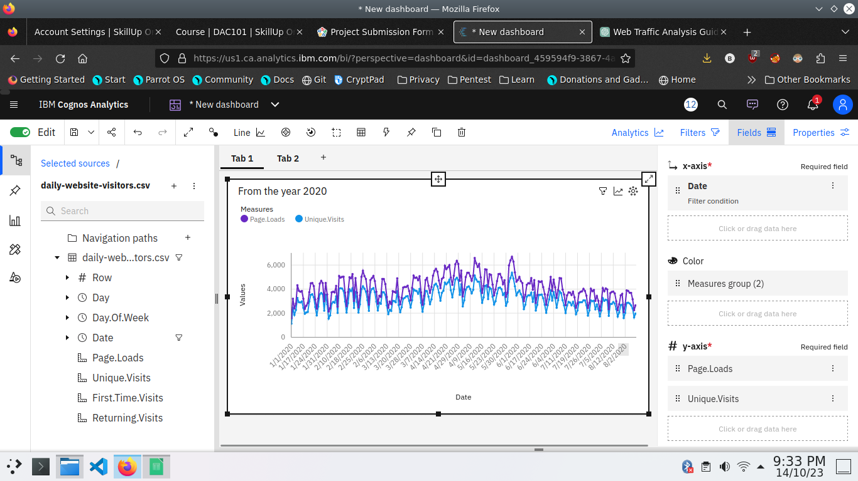

In the above screen shot displays the Line graph and model compares the “ Page.loads” and “Unique.visits” from the time period of 2020

X-axis =Dates

Y-axis = Page.Loads, Unique.visits.

After performing these activities a comprehensive document will be created to demonstrate the ability to Communicate and share finding.

**Conclusion**

This technology project Involves loading and preprocessing a dataset, followed by various analysis and visualizations using IBM Cognos. helpful to make an data-driven decisions and responsive the web Traffic trends