LAB EXERCISE – 14
Naive Bayes Classifier

- Aim of the Experiment:

Implement and demonstrate the working of Naive Bayesian classifier using a sample data set. Build the model to classify a test sample.

- Reference to Text book for Algorithms:

Refer to Section 8.3.1 in Chapter 8 Bayesian Learning to understand the working of the algorithm.
Listing 1:
Sample Dataset Used: Table 8.1
Table 8.1 Training Dataset
S.No. | CGPA | Interactiveness | Practical Knowledge | Communication Skills | Job Offer
1. | ≥9 | Yes | Very good | Good | Yes
2. | ≥8 | No | Good | Moderate | Yes
3. | ≥9 | No | Average | Poor | No
4. | <8 | No | Average | Good | No
5. | ≥8 | Yes | Good | Moderate | Yes
6. | ≥9 | Yes | Good | Moderate | Yes
7. | <8 | Yes | Good | Poor | No
8. | ≥9 | No | Very good | Good | Yes
9. | ≥8 | Yes | Good | Good | Yes
10. | ≥8 | Yes | Average | Good | Yes

3. Python Program with Explanation:
1. Import LabelEncoder to normalize labels.
from sklearn.preprocessing import LabelEncoder

2. Import train_test_split function.
from sklearn.model_selection import train_test_split

3. Import Gaussian Classifier from sklearn.naive_bayes.
from sklearn.naive_bayes import GaussianNB

4. Import preprocessing package to use transformer classes.
from sklearn import preprocessing

5. Import classification_report and confusion_matrix from sklearn.metrics to measure the
quality of predictions.
from sklearn.metrics import classification_report, confusion_matrix

6. Create lists, CGPA, Inter, PK, CS and Job.
CGPA = ['g9','g8','g9','l8','g8','g9','l8','g9','g8','g8']
Inter = ['Y','N','N','N','Y','Y','Y','N','Y','Y']
PK = ['+++','+','==','==','+','+','+','+++','+','==']
CS = ['G','M','P','G','M','M','P','G','G','G']
Job = ['Y','Y','N','N','Y','Y','N','Y','Y','Y']

7. Create labelEncoder le to encode labels with value between 0 and no_of_classes-1.
le = preprocessing.LabelEncoder()

8. Convert non-numeric labels of all features into numbers. Then print and see the encoded labels.
CGPA_encoded = le.fit_transform(CGPA)
print("CGPA:", CGPA_encoded)
Inter_encoded = le.fit_transform(Inter)
PK_encoded = le.fit_transform(PK)
CS_encoded = le.fit_transform(CS)
label = le.fit_transform(Job)
print("Inter:",Inter_encoded)
print ("PK:",PK_encoded)
print ("CS:",CS_encoded)
print("Job:",label)

9. Create a list/dynamic array called ‘features’.
features = []

10. Append all the encoded features to the list created.
for i in range(len(CGPA_encoded)):
features.append([CGPA_encoded[i], Inter_encoded[i], PK_encoded[i], CS_encoded[i]])

11. Split the dataset into training dataset and test dataset by using the function
train_test_split().
X_train,X_test,y_train,y_test=train_test_split(features,label,test_size=0.30,random_state=2)

12. Create a Gaussian Classifier.
model = GaussianNB()

13. Train the model using the training sets.
model.fit(features, label)

14. After training, use the fitted model to predict a new instance.
y_pred = model.predict(X_test)

15. Generate classification report & confusion matrix to measure the quality of predictions.

print(classification_report(y_test, y_pred))
print(confusion_matrix(y_test, y_pred))

16. Predict Output.

# The non-numerical equivalent of the new instance [2, 0, 2, 0] given is [2:‘l8’, 0:‘N’, 2:‘==’, 0:‘G’]
print([2,0,2,0])
if model.predict([[2,0,2,0]])==1:
print("Predicted Value:Got JOB",predicted )
else:
print("Didnt get JOB")

# The non-numerical equivalent of the new instance [0, 1, 0, 1] given is [0:‘g8’, 1:‘Y’, 0:‘+’, 1:‘M’]
print([0,1,0,1])
if model.predict([[0,1,0,1]])==1:
print("Predicted Value:Got JOB",predicted )
else:
print("Didnt get JOB")

Complete Program:
from sklearn.preprocessing import LabelEncoder
from sklearn.model_selection import train_test_split
from sklearn.naive_bayes import GaussianNB
from sklearn import preprocessing
from sklearn.metrics import classification_report, confusion_matrix

CGPA = ['g9','g8','g9','l8','g8','g9','l8','g9','g8','g8']
Inter = ['Y','N','N','N','Y','Y','Y','N','Y','Y']
PK = ['+++','+','==','==','+','+','+','+++','+','==']
CS = ['G','M','P','G','M','M','P','G','G','G']
Job = ['Y','Y','N','N','Y','Y','N','Y','Y','Y']

#creating labelEncoder
le = preprocessing.LabelEncoder()
# Converting string labels into numbers.
CGPA_encoded = le.fit_transform(CGPA)
print("CGPA:", CGPA_encoded)

Inter_encoded = le.fit_transform(Inter)
PK_encoded = le.fit_transform(PK)
CS_encoded = le.fit_transform(CS)
label = le.fit_transform(Job)
print("Inter:",Inter_encoded)
print ("PK:",PK_encoded)
print ("CS:",CS_encoded)
print("Job:",label)

features = []
for i in range(len(CGPA_encoded)):
features.append([CGPA_encoded[i], Inter_encoded[i], PK_encoded[i], CS_encoded[i]])

X_train,X_test,y_train,y_test=train_test_split(features,label,test_size=0.30,random_state=2)
#Create a Gaussian Classifier
model = GaussianNB()

# Train the model using the training sets
model.fit(features,label)

#Predict Output
y_pred = model.predict(X_test)

print(classification_report(y_test, y_pred))
print(confusion_matrix(y_test, y_pred))

print([2,0,2,0])
if model.predict([[2,0,2,0]])==1:
print("Predicted Value:Got JOB")
else:
print("Predicted Value:Didn't get JOB")

print([0,1,0,1])
if model.predict([[0,1,0,1]])==1:
print("Predicted Value:Got JOB")
else:
print("Predicted Value:Didn't get JOB")

Output:
Python 3.8.3 (tags/v3.8.3:6f8c832, May 13 2020, 22:37:02) [MSC v.1924 64 bit (AMD64)] on win32
Type "help", "copyright", "credits" or "license()" for more information.
>>>
=== RESTART: C:\Users\ADMIN\pythonpgms\final\jnf naive bayes sklearn test.py ===
CGPA: [1 0 1 2 0 1 2 1 0 0]
Inter: [1 0 0 0 1 1 1 0 1 1]
PK: [1 0 2 2 0 0 0 1 0 2]
CS: [0 1 2 0 1 1 2 0 0 0]
Job: [1 1 0 0 1 1 0 1 1 1]
precision recall f1-score support

1 1.00 1.00 1.00 3

accuracy 1.00 3
macro avg 1.00 1.00 1.00 3
weighted avg 1.00 1.00 1.00 3

[[3]]
[2, 0, 2, 0]
Predicted Value:Didn't get JOB
[0, 1, 0, 1]
Predicted Value:Got JOB
>>>

Screenshot of the Output:
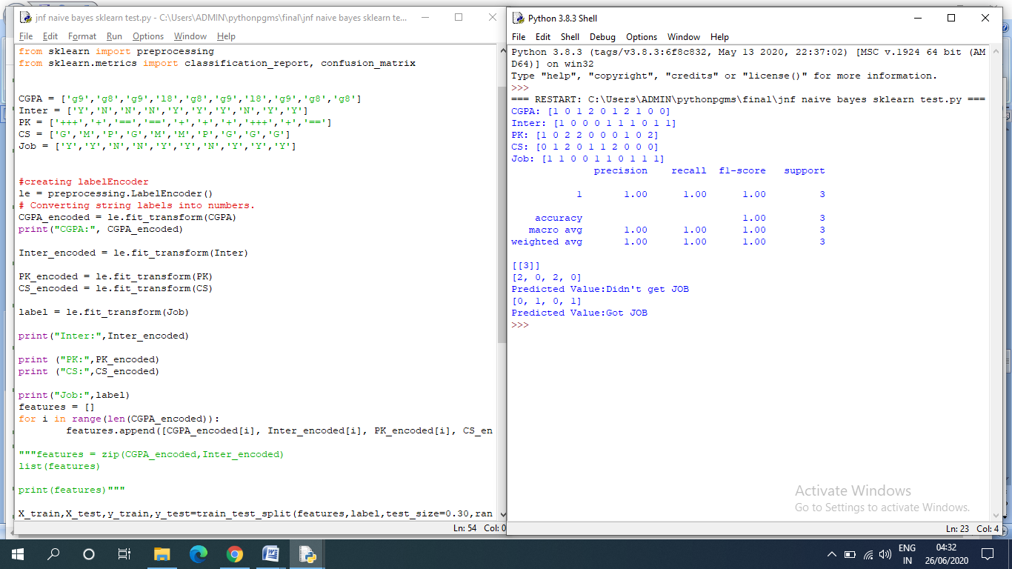

Listing 2:
Program Code:
from sklearn import datasets
from sklearn import metrics
from sklearn.naive_bayes import GaussianNB
from sklearn.metrics import classification_report, confusion_matrix
from sklearn.model_selection import train_test_split

# Load the Iris dataset
dataset = datasets.load_iris()

# Fit a Naive Bayes model to the data
model = GaussianNB()
X_train,X_test,y_train,y_test=train_test_split(dataset.data,dataset.target,test_size=0.30,random_state=2)
model.fit(X_train, y_train)
print(model)

# Make predictions
y_expected = y_test
y_predicted = model.predict(X_test)

# Evaluate the model and print the classification report, Confusion Matrix
print(metrics.classification_report(y_expected, y_predicted))
print(metrics.confusion_matrix(y_expected, y_predicted))

Screen Shot of the Program:
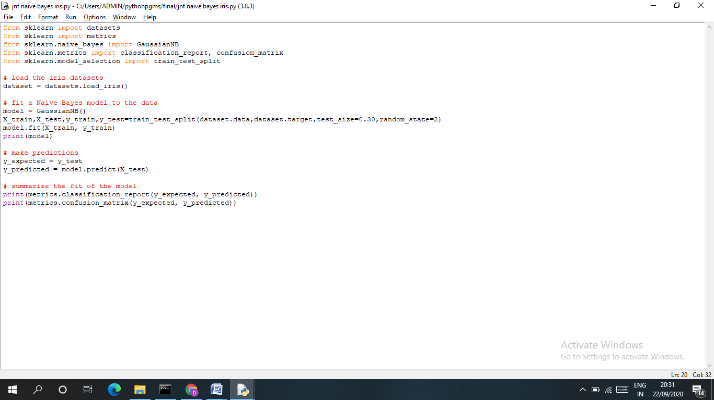

Output:
Python 3.8.3 (tags/v3.8.3:6f8c832, May 13 2020, 22:37:02) [MSC v.1924 64 bit (AMD64)] on win32
Type "help", "copyright", "credits" or "license()" for more information.
>>>
======= RESTART: C:\Users\ADMIN\pythonpgms\Review\jnf naive bayes iris.py ======
GaussianNB()
precision recall f1-score support

0 1.00 1.00 1.00 17
1 1.00 0.93 0.97 15
2 0.93 1.00 0.96 13

accuracy 0.98 45
macro avg 0.98 0.98 0.98 45
weighted avg 0.98 0.98 0.98 45

[[17 0 0]
[ 0 14 1]
[ 0 0 13]]
>>>
Screen Shot of the Output:
